# ## Terminal Homework: ♣♦♠♥ A High Stakes Investigation ♣♦♠♥!

## ## Lucky Duck Security Investigation Instructions

#### #### Dealer Analysis

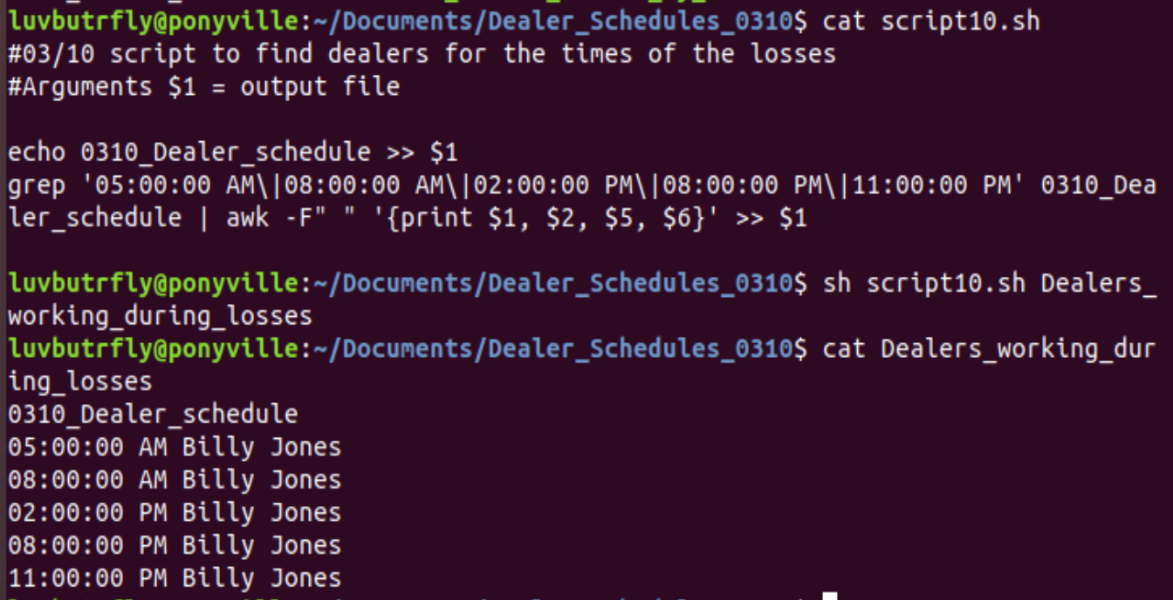

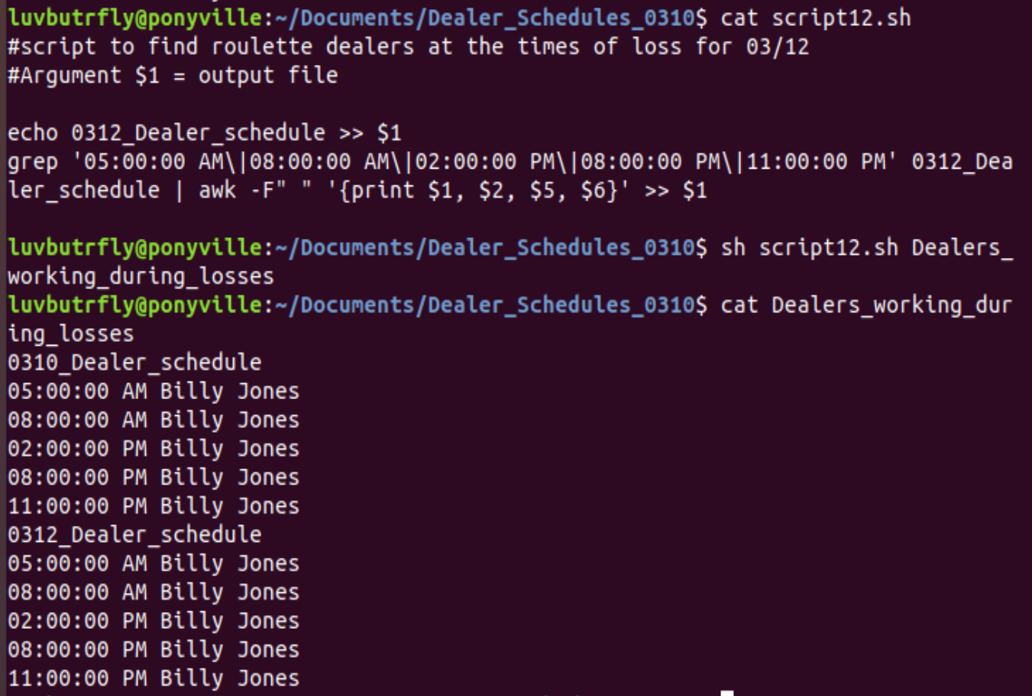

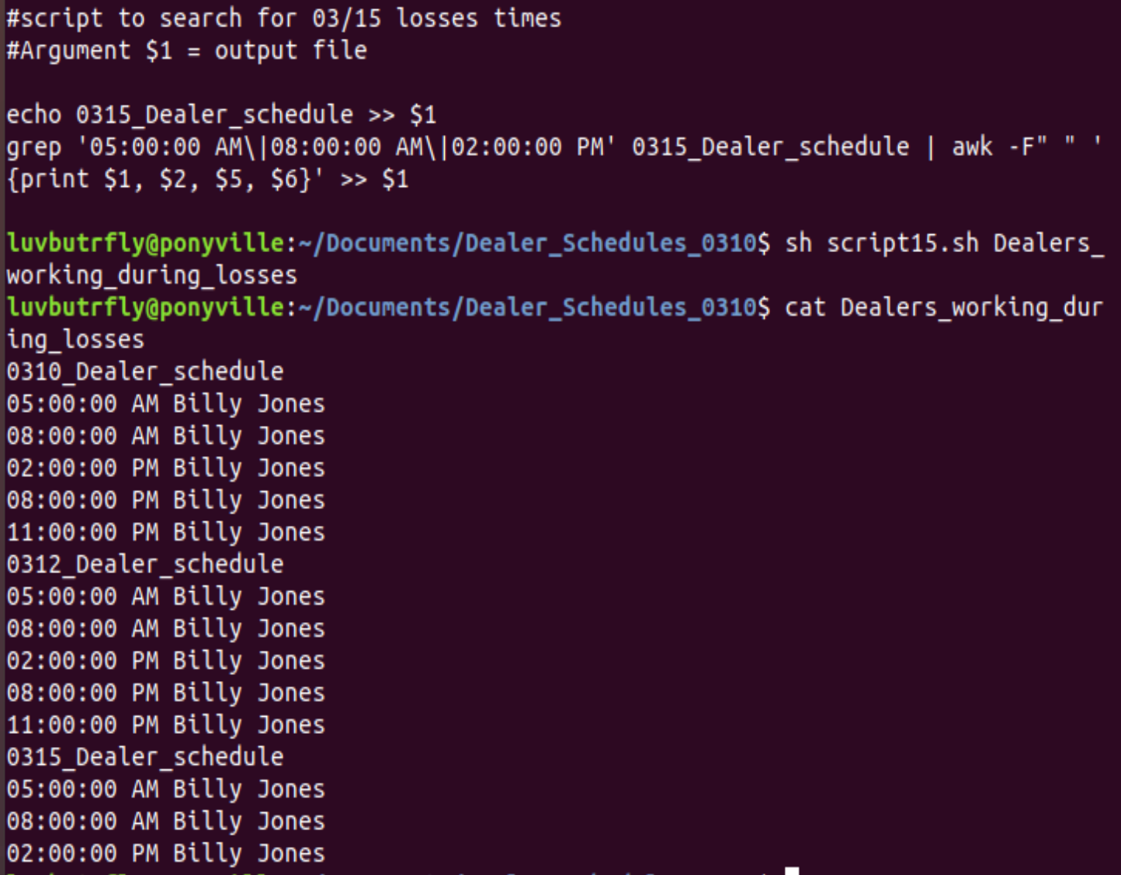

### ### Step 4: Scripting your Tasks

#### **Bonus:** In case there is future fraud on the other Lucky Duck Games, create a shell script called `roulette_dealer_finder_by_time_and_game.sh` that has the three following arguments:

