Ricardo Nunes

**Section 1)**

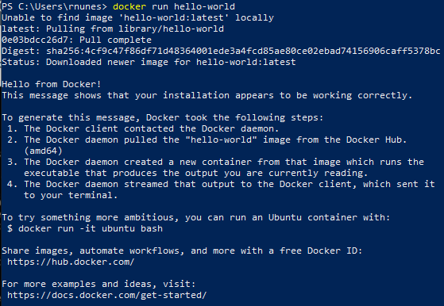

PS C:\Users\rnunes> docker run hello-world

Unable to find image 'hello-world:latest' locally

latest: Pulling from library/hello-world

0e03bdcc26d7: Pull complete

Digest: sha256:4cf9c47f86df71d48364001ede3a4fcd85ae80ce02ebad74156906caff5378bc

Status: Downloaded newer image for hello-world:latest

Hello from Docker!

This message shows that your installation appears to be working correctly.

To generate this message, Docker took the following steps:

1. The Docker client contacted the Docker daemon.

2. The Docker daemon pulled the "hello-world" image from the Docker Hub.

(amd64)

3. The Docker daemon created a new container from that image which runs the

executable that produces the output you are currently reading.

4. The Docker daemon streamed that output to the Docker client, which sent it

to your terminal.

To try something more ambitious, you can run an Ubuntu container with:

$ docker run -it ubuntu bash

Share images, automate workflows, and more with a free Docker ID:

https://hub.docker.com/

For more examples and ideas, visit:

https://docs.docker.com/get-started/

**Section 2)**

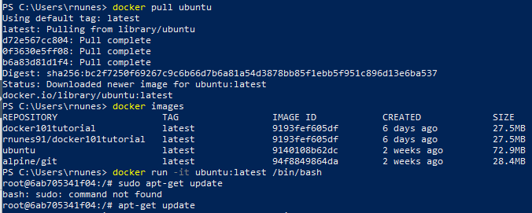

PS C:\Users\rnunes> docker pull ubuntu

Using default tag: latest

latest: Pulling from library/ubuntu

d72e567cc804: Pull complete

0f3630e5ff08: Pull complete

b6a83d81d1f4: Pull complete

Digest: sha256:bc2f7250f69267c9c6b66d7b6a81a54d3878bb85f1ebb5f951c896d13e6ba537

Status: Downloaded newer image for ubuntu:latest

docker.io/library/ubuntu:latest



PS C:\Users\rnunes> docker images

REPOSITORY TAG IMAGE ID CREATED SIZE

docker101tutorial latest 9193fef605df 6 days ago 27.5MB

rnunes91/docker101tutorial latest 9193fef605df 6 days ago 27.5MB

ubuntu latest 9140108b62dc 2 weeks ago 72.9MB

alpine/git latest 94f8849864da 2 weeks ago 28.4MB

**Section 3)**



PS C:\Users\rnunes> docker run -it ubuntu:latest /bin/bash

root@6ab705341f04:/# sudo apt-get update

bash: sudo: command not found

root@6ab705341f04:/# apt-get update

Reading package lists... Done



root@6ab705341f04:/# apt-get install apache2

Reading package lists... Done

Building dependency tree

Reading state information... Done



root@6ab705341f04:/# apt-get install vim

root@6ab705341f04:/# exit

exit

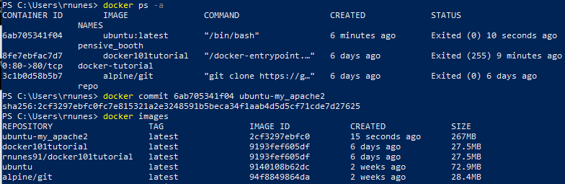

PS C:\Users\rnunes> docker ps -a

CONTAINER ID IMAGE COMMAND CREATED STATUS PORTS NAMES

6ab705341f04 ubuntu:latest "/bin/bash" 6 minutes ago Exited (0) 10 seconds ago pensive_booth

8fe7ebfac7d7 docker101tutorial "/docker-entrypoint.…" 6 days ago Exited (255) 9 minutes ago 0.0.0.0:80->80/tcp docker-tutorial

3c1b0d58b5b7 alpine/git "git clone https://g…" 6 days ago Exited (0) 6 days ago repo

PS C:\Users\rnunes> docker commit 6ab705341f04 ubuntu-my_apache2

sha256:2cf3297ebfc0fc7e815321a2e3248591b5beca34f1aab4d5d5cf71cde7d27625

PS C:\Users\rnunes> docker images

REPOSITORY TAG IMAGE ID CREATED SIZE

ubuntu-my_apache2 latest 2cf3297ebfc0 15 seconds ago 267MB

docker101tutorial latest 9193fef605df 6 days ago 27.5MB

rnunes91/docker101tutorial latest 9193fef605df 6 days ago 27.5MB

ubuntu latest 9140108b62dc 2 weeks ago 72.9MB

alpine/git latest 94f8849864da 2 weeks ago 28.4MB

**Section 4)**

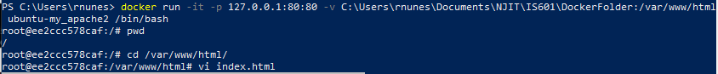

PS C:\Users\rnunes> docker run -it -p 127.0.0.1:80:80 -v C:\Users\rnunes\Documents\NJIT\IS601\DockerFolder:/var/www/html ubuntu-my_apache2 /bin/bash

**Section 5)**



root@ee2ccc578caf:/# pwd

/

root@ee2ccc578caf:/# cd /var/www/html/

root@ee2ccc578caf:/var/www/html# vi index.html

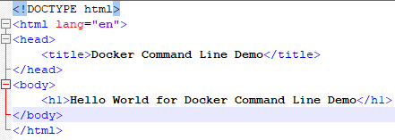

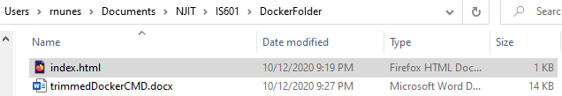

**Section 6)**

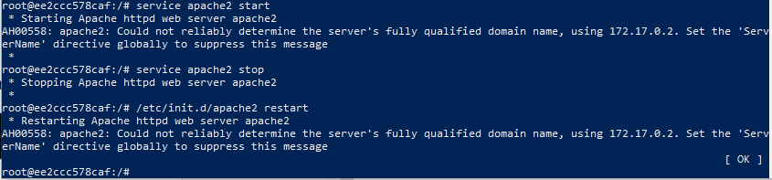

root@ee2ccc578caf:/# service apache2 start

* Starting Apache httpd web server apache2 AH00558: apache2: Could not reliably determine the server's fully qualified domain name, using 172.17.0.2. Set the 'ServerName' directive globally to suppress this message

*

root@ee2ccc578caf:/# service apache2 stop

* Stopping Apache httpd web server apache2 *

root@ee2ccc578caf:/# /etc/init.d/apache2 restart

* Restarting Apache httpd web server apache2 AH00558: apache2: Could not reliably determine the server's fully qualified domain name, using 172.17.0.2. Set the 'ServerName' directive globally to suppress this message

[ OK ]

root@ee2ccc578caf:/#

