

School of Computer Science and Engineering

Faculty of Engineering

The University of New South Wales, Sydney

**COMP3900 – Computer Science Project**

**Term 3 – 2022**

**COMP3900-M10B-Banana Project Proposal**

Tuesday, A Task Management System

Date of Submission: 03/10/22

Tutor: Giuliana De Bellis

|  |  |  |  |
| --- | --- | --- | --- |
| **Student Name** | **Student ID** | **Email** | **Role** |
| Taimoor SHABIH | z5206259 | [z5206259@ad.unsw.edu.au](mailto:z5206259@ad.unsw.edu.au) | Scrum Master Backend Developer |
| Eric DAI | z5204851 | [z5204851@ad.unsw.edu.au](mailto:z5204851@ad.unsw.edu.au) | Frontend Developer |
| Kevin HU | z5207293 | [z5207293@ad.unsw.edu.au](mailto:z5207293@ad.unsw.edu.au) | Backend Developer |
| Luke SIMMONDS | z5209631 | [z5209631@ad.unsw.edu.au](mailto:z5209631@ad.unsw.edu.au) | Backend Developer |
| Vanessa XIA | z5207308 | [z5207308@ad.unsw.edu.au](mailto:z5207308@ad.unsw.edu.au) | Frontend Developer |

**Table of Contents**

1. Background 3

1.1 Identifying the Problem 3

1.2 Existing Systems 3

2. Sprint Schedule 5

3. Sprint 1 Scope 5

4. Functionality 1 6

5. Functionality 2 6

6. Functionality 3 7

7. Functionality 4 7

8. Functionality 5 8

9. Functionality 6 9

10. Functionality 7 9

11. Functionality 8 10

12. Functionality 9 11

13. Functionality 10 11

14. System Architecture 12

14.1 External Actors and System Interaction 12

14.2 System Architecture Diagram 12

References 14

# Background

## 1.1 Identifying the Problem

Tracking tasks is important for any organisation where a team of people are working together on a project or towards a common goal. People often tend to forget to do certain tasks when they are working in a fast paced, high-pressure environment. This can often have detrimental impacts on their workflow and on the progress of the project.

The Tuesday Task Management System will allow users (Task Masters) to enter all the tasks they plan to work on. It will also allow a user to track what tasks other users are working on as well as assign tasks to those users. Such a system will allow users to prioritise different tasks and work on them in a sequential order. It will also help team members figure out how busy their peers are at any given time based on their task load. Tasks can be reassigned by the team leaders accordingly if necessary to ensure a fair workload amongst all the team members. This system will ensure that individuals and teams stay on top of their work and can focus on completing the actual tasks instead of having to worry about forgetting to do certain tasks.

## 1.2 Existing Systems

Two existing systems in the same problem domain are Monday (monday.com) and Teamwork (teamwork.com). While both project management tools offer great functionality and value for their target users such as having an easy-to-use interface, it is also important to consider their drawbacks.

Monday differentiates itself from competitors on the market through its focus on the ‘big picture’ and the processes involved in a project rather than just listing tasks like other project management tools (Mann, 2017). Monday aims to capture these processes beyond marking a task as ‘done’ or ‘in progress’ and the platform strives to improve management and communication between team members through features such as having a visual customizable dashboard and integration with other work apps.

One of Monday’s drawbacks is the inability to create multiple levels of subtasks and task dependencies. Although Monday does allow users to create subtasks for a main task, users cannot create subtasks for subtasks which may be a necessary feature for more complex projects which comprise of larger tasks. Additionally, unlike some of its competitors, Monday also lacks an integrated team chat which would allow team members working on a task to collaborate via team video chat or chat channels which would consequently boost productivity. Another drawback is that tasks created on Monday do not have an assigned id to refer to them by. This is problematic and creates confusion when users need to search for tasks and there are two tasks with the same name or if a task has changed their name or description.

Teamwork is another existing project management tool that aims to enable users to see everything about their project and tasks in one place. In addition to creating and monitoring tasks, there are many advanced features such as budgeting, resource allocation and tracking the amount of billable and non-billable hours spent on a task.

Comparatively, Teamwork has fewer drawbacks than Monday. Although, similar to Monday, one of Teamwork’s drawbacks is the inability to create multiple levels of subtasks. This can be detrimental to users’ productivity as they cannot break down their tasks into smaller and more easily achievable tasks, which can subsequently have a negative impact on their motivation and task completion. Another drawback of Teamwork is the inability to group tasks in the task list into customisable sections or headings, which is a feature that is offered by most competing project management tools like Monday and Asana. This is shown in Figure 1, where users are able to categorise their tasks under different headings, for example ‘First Stage’, ‘Second Stage’ and ‘Third Stage’.

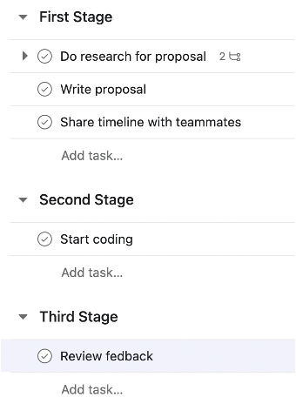

Figure 1. Tasks categorised under customisable sections or headings.

Instead, Teamwork only allows users to add tasks to a single task list as shown in Figure 2, which can lead to a poorer organisation of tasks especially when the number of tasks increase.

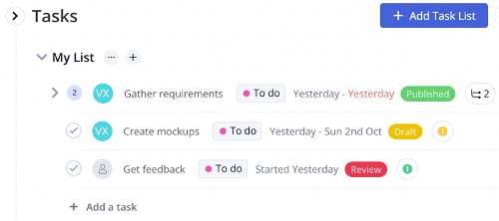

Figure 2. Tasks cannot be categorised under sections or headings in Teamwork.

# Sprint Schedule

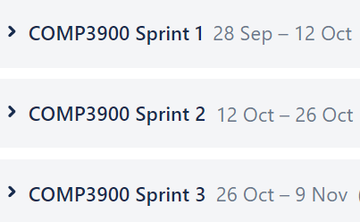

Figure 3. Sprint structure and schedule.

Figure 3 shows the start and end dates for all the sprints. The first sprint started on September 28th and will end on October 12th. The second sprint will start on October 12th and end on October 26th. The third and final sprint will start on October 26th and end on November 9th.

# Sprint 1 Scope

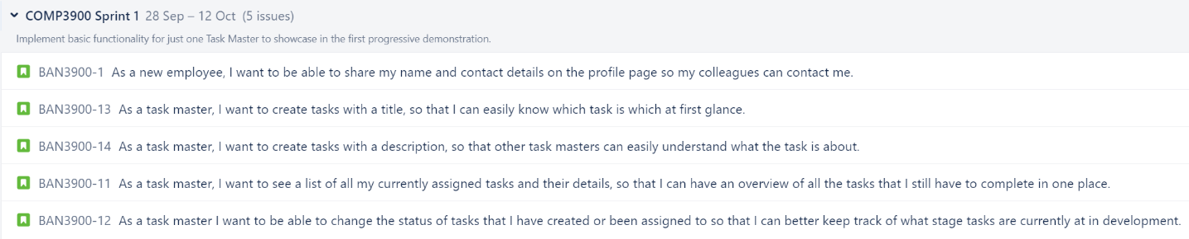

Figure 4. User stories chosen for sprint 1.

The first sprint will involve implementing the functionality captured in the 5 user stories in Figure 4. Only basic functionality for one task master will be implemented in this sprint in order to create a minimum viable product.

# Functionality 1



Users need to share their full name and contact details such as email on their profile so other task masters can more easily identify them and reach out to them if necessary. Users will be prompted to insert these details when they create accounts on Tuesday, but they will be able to change these details later as well. Users can see the other task masters’ profile page if they have been added as a connection.

Figure 5. Functionality 1 storyboard.

# Functionality 2



Users need to be able to add other task masters as friends (connections) so they can find out what tasks they are working on. If a connection hasn’t been formed between the 2 users, then they can’t view each other’s task boards. Access to the task board is important as people often work in teams to achieve a common goal. Tasks for projects are delegated to different members of a team, so a user being able to keep track of what their teammates’ tasks are is a very important functionality.

Figure 6. Functionality 2 storyboard.

# Functionality 3

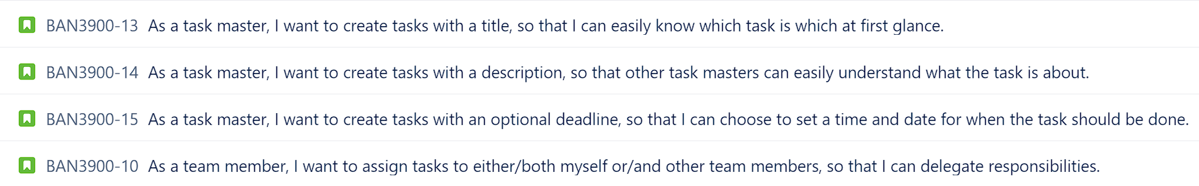

The users need to create tasks with a title, a description and an optional deadline as well as assign it to either themselves and/or their team members, which is highlighted by the set of user stories shown above. These stories accentuate the importance of the third functionality that states task masters must be able to create a task, including a title, description, optional deadline, and assign it to either themselves or one of the task masters they are connected with. Furthermore, users do not want to get confused between tasks, especially if they have the same title, so the system will assign a sitewide unique id for every task created. The title and description fields are compulsory whereas a user can choose to not enter a deadline (making it optional for more flexibility) or assignee (automatically assigning it to themselves).

Figure 7 . Functionality 3 storyboard.

# Functionality 4



The users need to have an easy-to-access list of their currently assigned tasks and details sorted by deadlines are emphasised by the two user stories above. Both stories showcase the significance of the fourth functionality that states users must have access to an assigned task list via their profile sorted by the deadline. This task board will also show details for each task including the title, task id, a preview of the description, deadline (if any), current progress status and any assignees. The tasks are ordered from the earliest deadline to the latest deadline with any tasks without a deadline appearing last.

Figure 8. Functionality 4 storyboard.

# Functionality 5



This story showcases the user’s desire to be able to view the name and email of other task masters they are connected to for the purposes of communication. This captures the functionality of being able to view the name and email on the profile of connected task masters as the user will be able to accomplish their goal by first connecting with another task master, they have an interest in communicating with. Once this connection is accepted, the user can then navigate to the other task master’s profile to obtain the details they seek.

Figure 9. Functionality 5 storyboard.

# Functionality 6



This story reveals the user’s desire to alter the status of tasks they have created or are assigned to allow them to better keep track of the progress of these tasks. This captures the functionality of being able to set the status of created or assigned tasks. By navigating to the task board, the user can select from a range of statuses, specifically "Not Started", "In Progress", "Blocked", and "Completed", to accomplish their goal of tracking task progression.

Figure 10. Functionality 6 storyboard.

# Functionality 7

When users are logged in and navigate to their task board, they will be able to enter search terms so that they can easily find the tasks that match their search. Specifically, users will be able to search tasks by id, name, description and deadline and these scenarios are captured by the user stories above. Users will be shown a list of tasks matching their search criteria, however if there are no tasks matching their search criteria then a message will be displayed informing them that there are no matching results. Thus, these user stories fulfil the requirement for our system to allow task masters to search through all the tasks assigned to themselves and other task masters they are connected to by a combination of id, name, description and/or deadline, and view the full details.

Figure 11. Functionality 7 storyboard.

# Functionality 8



This user story fulfils the project requirement to show the user an estimate of how busy each of their connected task masters will be over the next week. This estimate will be displayed as a percentage with 0% being minimum overloaded and 100% being maximum overloaded and will be calculated based on a combination of the user’s assigned tasks, task states, task deadlines and how long similar tasks have taken to complete in the past. This percentage will be displayed when the user views a list of their connected task masters as well as on the profiles of the connected task master that the user navigates to.

Figure 12. Functionality 8 storyboard.

# Functionality 9



This user story allows task masters the opportunity to filter tasks in a page rank style to order their tasks in an order which they should complete it in accounting for personalised buffers, estimated time to complete tasks, deadlines, and blockers. The second user story also allows task masters to observe the priority rankings of other task masters to observe when potential blockers and tasks will be resolved. This ranking will be displayed as a list on the task page for the current task master and on the profile subpage for other task masters. This functionality is novel as when compared to similar task management systems it is able to sort tasks in a personalised way for the user which no other task management system has done before.

Figure 13. Functionality 9 storyboard.

# Functionality 10



This user story allows task masters to condense feedback from completed tasks and view it summarised and graphically on their profile page. Specifically, task masters are able to view graphically their feedback on past tasks through enjoyability, progression, time taken on tasks, as well as comparisons to other task masters. Task masters are also able to provide goals at the end of tasks and check it off when reflecting on themselves for improvement. This is a novel functionality as it provides a medium for users to reflect and consolidate feedback and lessons from completed tasks which no other task management system offers.

Figure 14. Functionality 10 storyboard.

# System Architecture

## 14.1 External Actors and System Interaction

As this is a task management system, different types of users will be using it. The following are examples of the different types of users that this system will cater to.

* **Solo Users:** These are the users that will be using Tuesday by themselves in isolation and won’t be connecting to other task masters. They will use it to track the tasks only they need to perform and aren’t concerned with keeping track of other users’ tasks.
* **Connected Users:** These are the users who will use Tuesday to keep track of their own tasks as well as the tasks of their colleagues/teammates. They will use Tuesday as a collaborative tool which will help them work more efficiently with their peers. This would include employees in a business and school/university students.
* **Project Managers:** These are the users that occupy a leadership position who wish to oversee a team of people and ensure that team members are completing their designated tasks on time. These users also want to be able to assign tasks to individuals, gauge how productive each employee is, and move around deadlines if necessary. Their job is to ensure the team is functioning as smoothly as possible.

## 14.2 System Architecture Diagram

Figure 15. System architecture diagram.

Figure 15 shows the system architecture of the project. Our team chose the above due to experience and ease of use for the project.

# References

[1] Mann, S. (2017). *Why monday.com is so different from every project management tool on the market*. Monday.com. <https://monday.com/blog/project-management/why-monday-is-so-different-from-every-project-management-tool/>