數位影像處理
HW1

F14081046
周呈陽
系統112

Hw1 Digital halftoning

Design an 8x8 dithering matrix for which the corresponding dot profile
function starts in the highlight areas as a single dot that grows to produce the character
for the first letter of your first name in single dot stroke width. Then at higher
absorptance values, the stroke width gradually widens. As you move into the shadows,
the halftone texture forms a white space that again has the shape of this character. To do
this, you may need to invert the white space character either horizontally or vertically, or
both, or you may need to make it overlap the black dot character.
For your solution, turn in the following:
- Dithering matrix
[ 76 72 68 64 60 56 52 48;
80 176 180 184 188 192 196 200 ;
84 20 16 12 8 4 0 204 ;
88 24 128 132 136 140 144 208 ;
92 28 32 36 40 44 148 212 ;
96 172 168 164 160 156 152 216 ;
100 104 108 112 116 120 124 220 ;
252 248 244 240 236 232 228 224 ; ]

- Print the image using the dithering matrix that you designed.
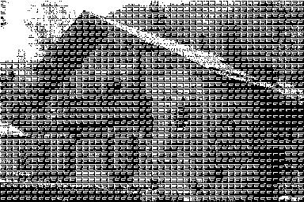

- Your code

clc;clear;close all;
x=imread('house.tif');
D=[ 19 18 17 16 15 14 13 12 ;
20 44 45 46 47 48 49 50 ;
21 5 4 3 2 1 0 51 ;
22 6 32 33 34 35 36 52 ;
23 7 8 9 10 11 37 53 ;
24 43 42 41 40 39 38 54 ;
25 26 27 28 29 30 31 55 ;
63 62 61 60 59 58 57 56 ] ;
r=repmat(D*4,32,48);
x2=x>r;
imshow(x2)
imwrite(x2,'house1.tif')

