**First trial : 3105_2016-2019 (1500 trials)**

Channe time period : 15 to 30 days

Channel multiply : 1.8 to 2.3 (has been slightly tuned before)

Bb time period : 15 to 30 days

Bb multiply : 1.5 to 2.5 (has been slightly tuned before)

* 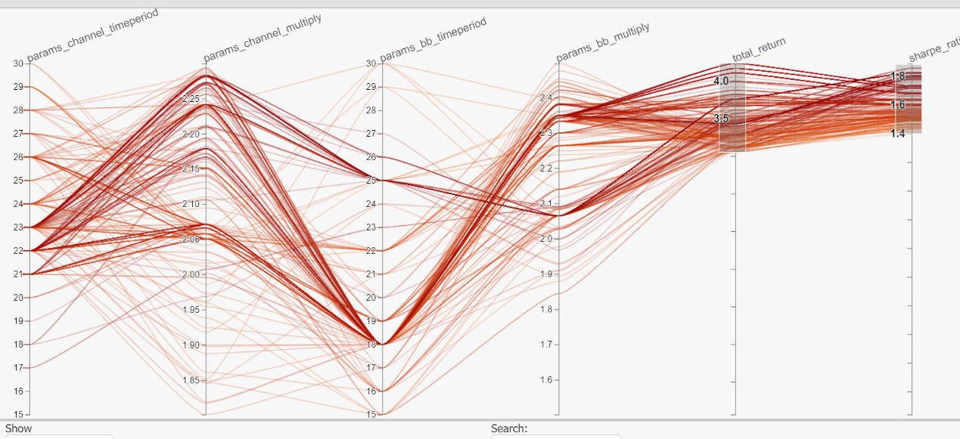target : sharpe ratio above 1.4, total return above 300%

**second trial : 3105_2020-2021 (1500 trials)**

Channe time period : 20 to 26 days

Channel multiply : 2 to 2.3 (has been slightly tuned before)

Bb time period : 16 to 26 days

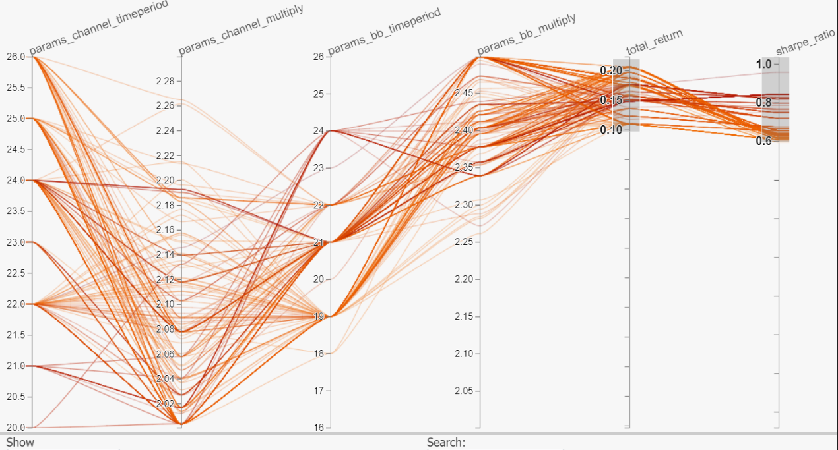Bb multiply : 2 to 2.5 (has been slightly tuned before)

* Target : sharpe ratio above 0.6, total return above 10%

**third trial : 3105_2022-2023 (1500 trials)**

Channe time period : 20 to 26 days

Channel multiply : 2 to 2.3 (has been slightly tuned before)

Bb time period : 19 to 24 days

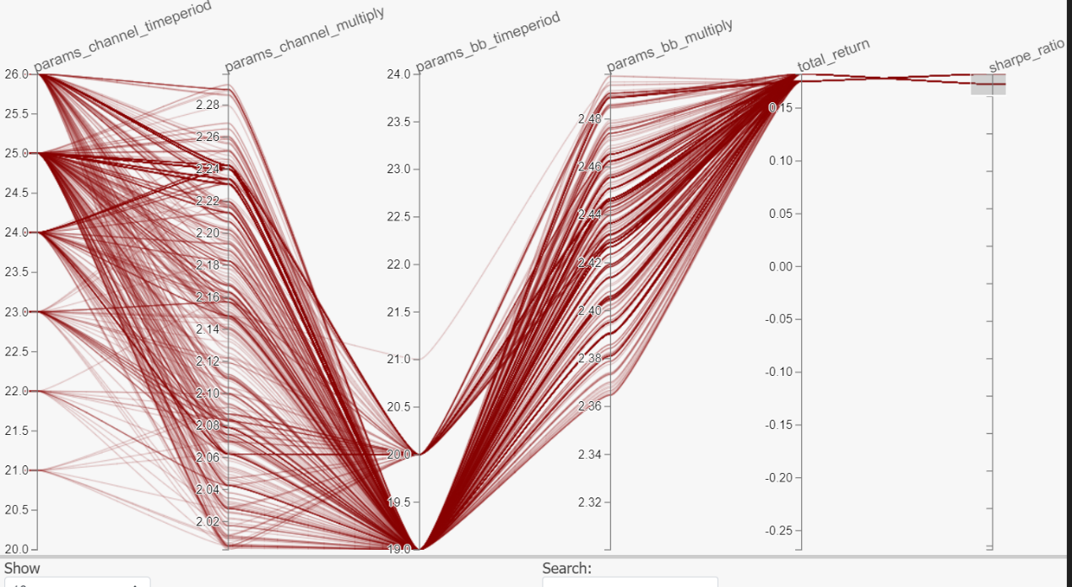Bb multiply : 2.3 to 2.5 (has been slightly tuned before)

* Target : sharpe ratio above 10.6, total return above 20%

**Parameters decided :**

Channe time period : 25 days

Channel multiply : 2.15(has been slightly tuned before)

Bb time period : 19 days

Bb multiply : 2.44 (has been slightly tuned before)

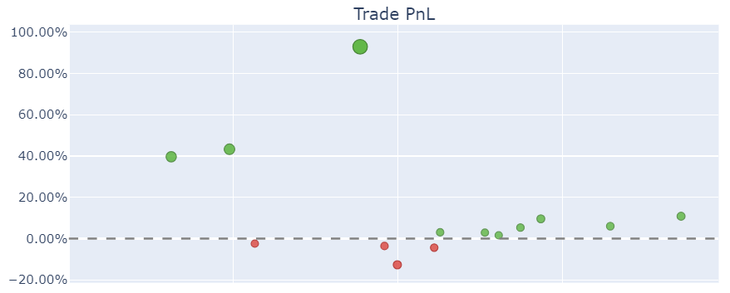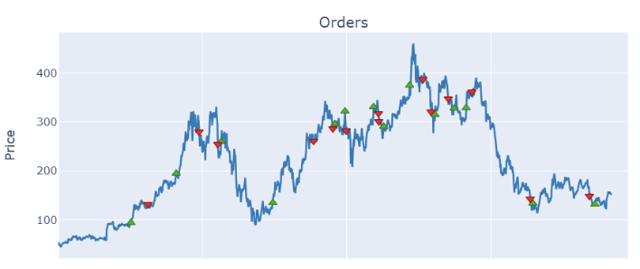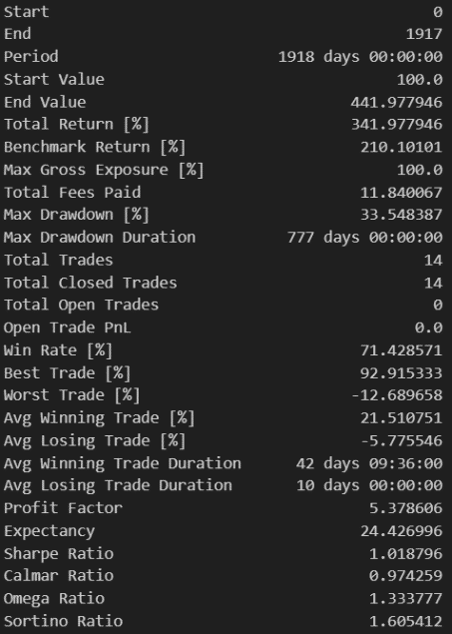

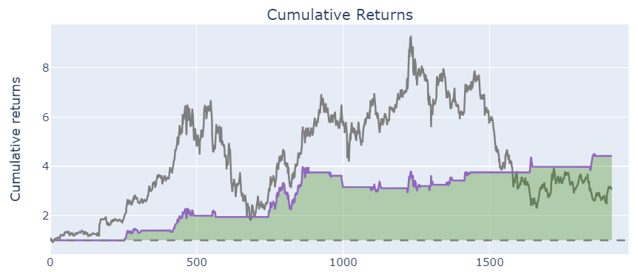**First trial : 2330_2016-2019 (3000 trials)**

Channe time period : 15 to 30 days

Channel multiply : 1.5 to 2.5 (has been slightly tuned before)

Bb time period : 15 to 30 days

Bb multiply : 1.5 to 2.5 (has been slightly tuned before)

* 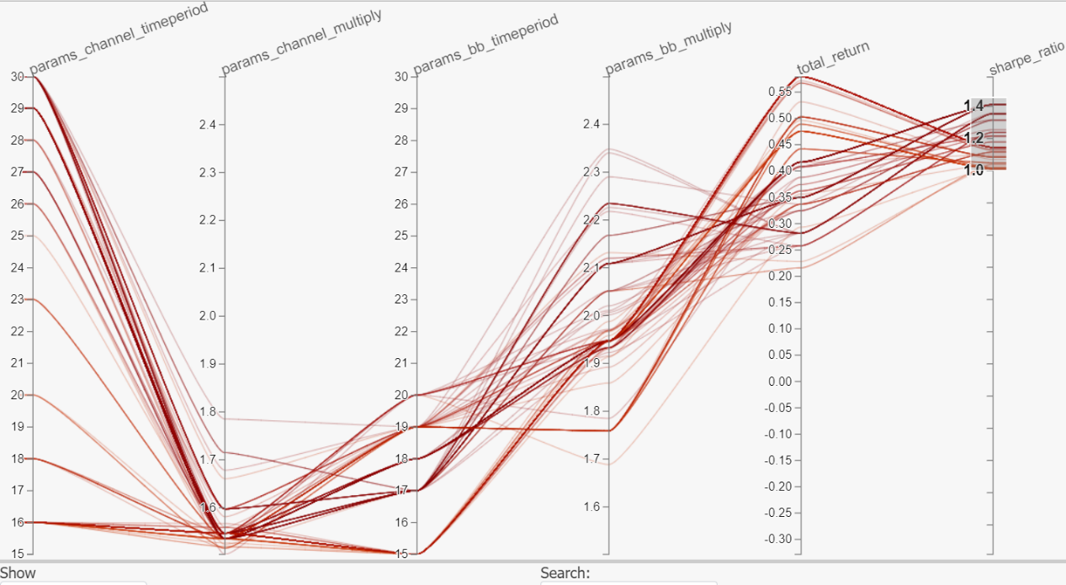target : sharpe ratio above 1.0

**Second trial : 2330_2020-2021 (3000 trials)**

Channe time period : 15 to 30 days

Channel multiply : 1.5 to 1.8

Bb time period : 15 to 20 days

Bb multiply : 1.5 to 2.3

* 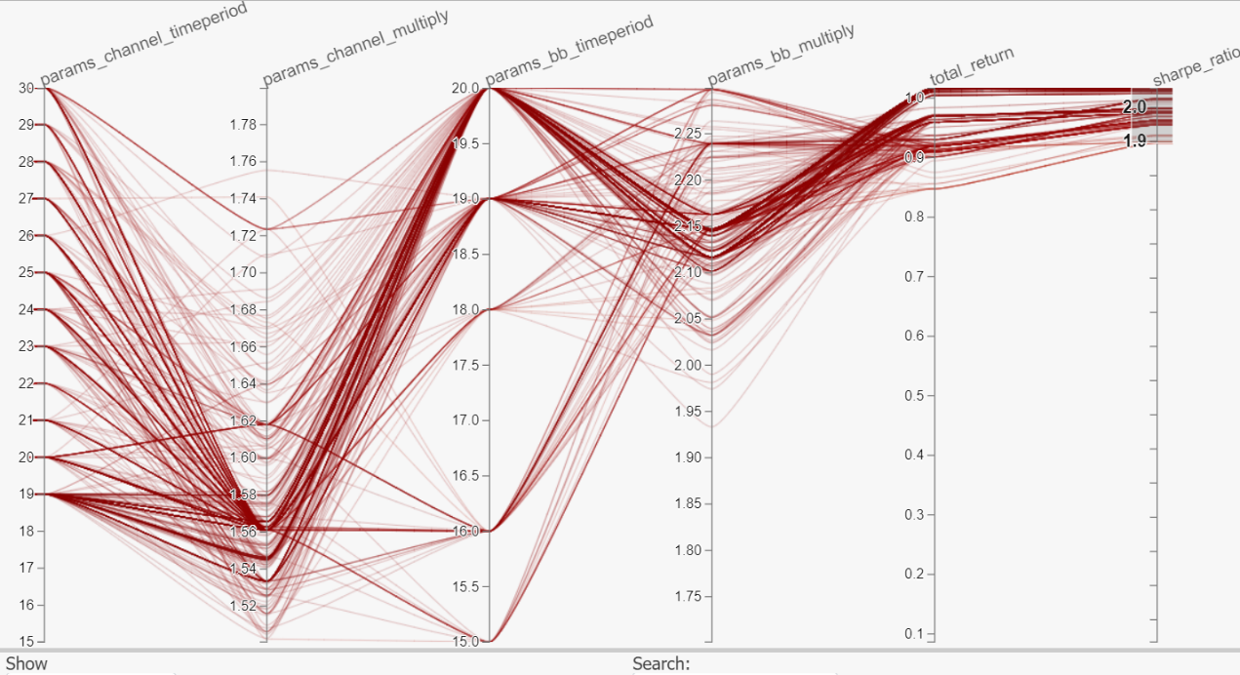target : sharpe ratio above 1.9

**Third trial : 2330_2022-2023 (3000 trials)**

Channe time period : 18 to 30 days

Channel multiply : 1.5 to 1.6

Bb time period : 18 to 20 days

Bb multiply : 2 to 2.3

* 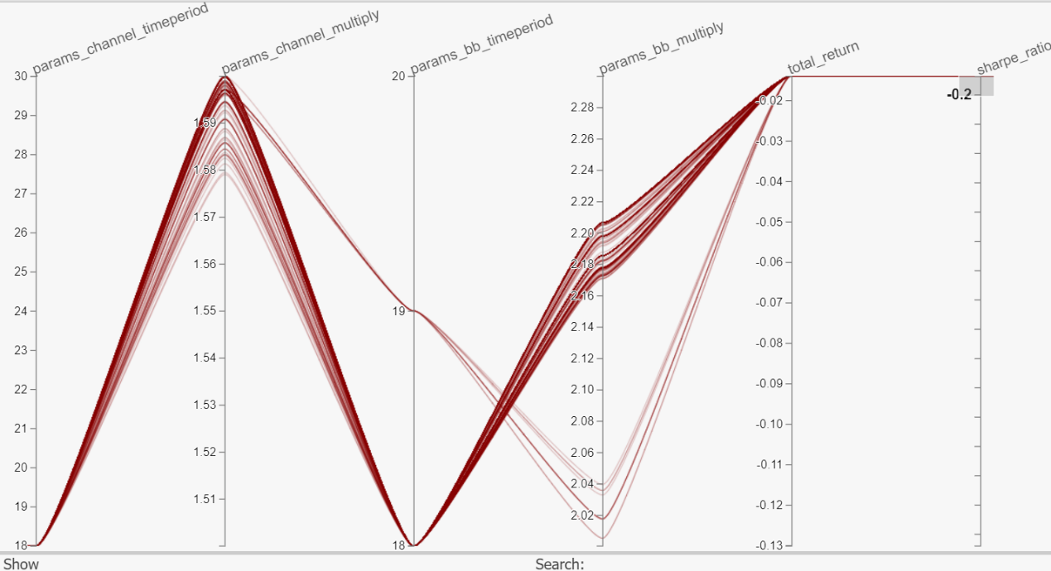target : sharper ratio above -0.2

**Parameters decided :**

Channe time period : 18 days

Channel multiply : 1.6

Bb time period : 18 days

Bb multiply : 2.18