LAB 1

AIM: Familiarization with Arduino Board and Perform necessary Software Installation

Theory:

1: Explain Arduino*( arrr-dween-oh )*.

->It's an open-source physical computing platform based on a simple microcontroller board, and a development environment for writing software for the board.

2: Write down the steps to download Arduino IDE software.

Open Source

Free

Available on-line with resources at:

www.arduino.cc

          OR

 https://www.arduino.cc/en/Main/Software

3. Draw a neat diagram of Arduino and explain the various parts

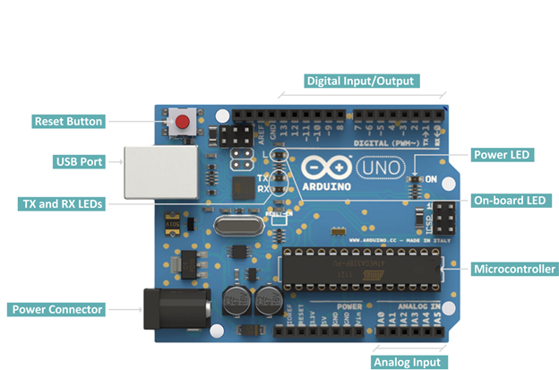

**Digital pins:**

14 digital IO pins

6 are PWM pins (3, 5, 6, 9, 10, and 11).

**Analog pins:**

6 analog pins(A0, A1, A2, A3, A4, and A5)

Takes analog values as an input

Or  
study diagram from net

Conclusion: Familiarization with Arduino Board and perform necessary Software Installation was studied successfully.