Phonetic Issues

1. Website inconsistency. Jar (the second to last result) should be JɔR

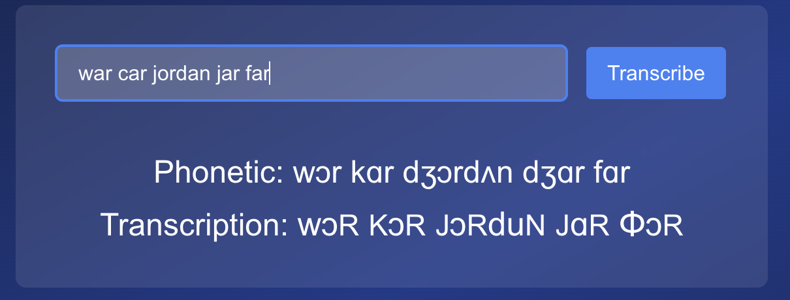

1. CMU has poor pronunciation for “And”. Should be IPA: ænd → aNd
2. Website inconsistency. Which is weird, because I do want ‘eɪ’ to turn into ‘A’, but I don’t think I gave you that in the key, so I don’t know why it’s happening for ‘face’ but not ‘chase’. Either way, I do want that conversion to happen. ‘Chase’ should turn into ‘cAs’

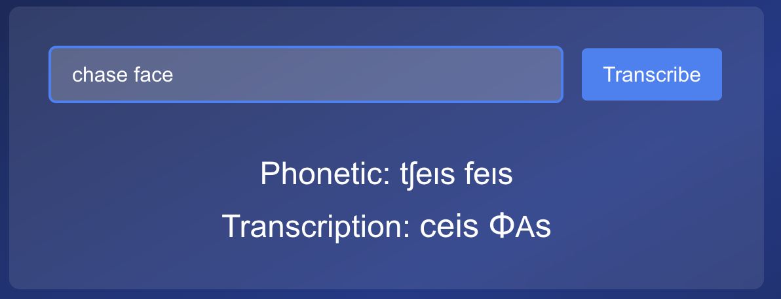

1. CMU has poor pronunciation for “Was”. ‘Was’ should be IPA: ‘wəz’ →’wuz’
2. ‘Advisory’. For some reason the phonetic pronunciation on the site is correct, but the final result has the wrong letter at the end. It does not follow the key.

1. ‘Jesus’. Same thing again. the phonetic pronunciation on the site is correct, but the final result has the wrong letter at the end. It does not follow the key.
2. Website inconsistency. ‘Church’ should result in ‘crc’ just like the other similar words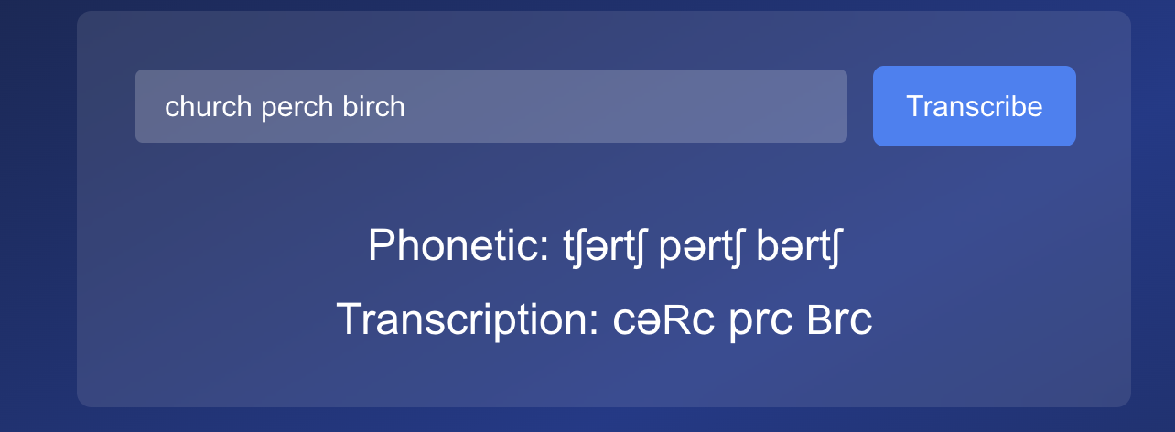

Key updates

1. ‘Tr’ converts to ‘c’
2. ’ɛr’ to ‘Ar’
3. ‘dr’ to ‘JR’
4. At the end of the word: ‘ɪŋ’ to ‘Eng’
5. At the end of the word: ‘ɪŋz’ to ‘Engz’
6. ‘ɪŋ’ when followed by ‘ə’, ‘ɪ’, or ‘d’ turns into ‘Eng’

Website updates:

1. Have the output say ‘?’ instead of ‘word not found’
2. The capital ‘I’ needs to be serif (two crossbars). Can you change change ‘I’ to a different font or something? Worst-case scenario, the font for the whole site may need to change to something like ‘IBM Plex Mono’
3. Get rid of the word ‘transcription:’ in front of the final result
4. For the ‘Phonetic’ result. Change the word ‘Phonetic’ to ‘IPA’. And make the phonetic result light gray or something so it doesn’t stand out as much as the actual final result.
5. Embed the ‘guide’ document to the website underneath the translator, so that people who visit the site can read it and choose to download it
6. The website says ‘word not found’ is a comma follows a word that’s inputed. Can you make it so the website ignores the comma? Worst-case scenario, just delete the comma.
7. Below that, add a note that says: “On the way: Chrome extension, Scrabble pieces, Alphabet song’
8. When I input the word ‘world’ or ‘soul’, the ‘L’ in the final result is still lowercase. Should be uppercase.