**Task 1**

* How did you use connection pooling?

We put our database info inside the context.xml and allowed maximum 100 connection and maximum 30 idle. We also add mapping inside web.xml file.

Whenever we need to use JDBC, we find the datasource instead of creating a new connection instance

* File name, line numbers as in Github

cs122b-winter18-team-65/project5/project5_web/fabflix/src/NFT_search.java

Line 51-56

cs122b-winter18-team-65/project5/project5_web/fabflix/WebContent

/META-INF/context.xml

Line 1-13

* Snapshots

￼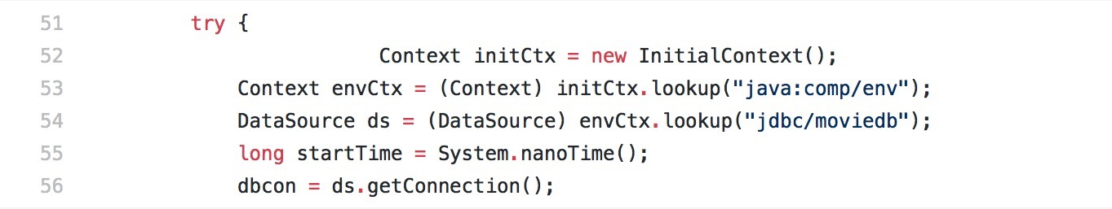

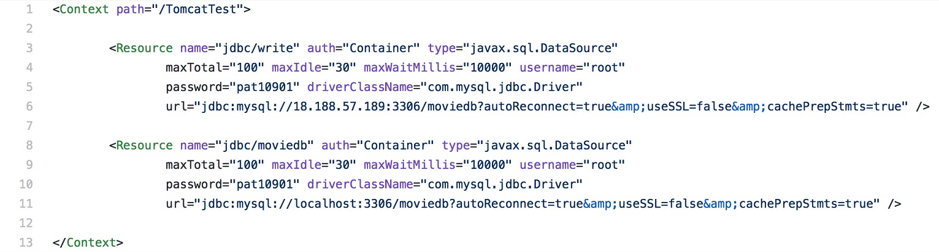

* How did you use Prepared Statements?

We write a prepared statement query and use ? inside to query to represent params.

When we get a new search query in, we first set autocommit to false, then add the params to the prepared statement, execute the prepared statement and set autocommit back to true.

* File name, line numbers as in Github

cs122b-winter18-team-65/project5/project5_web/fabflix/src/NFT_search.java

Line 43-49, 71-76

* Snapshots

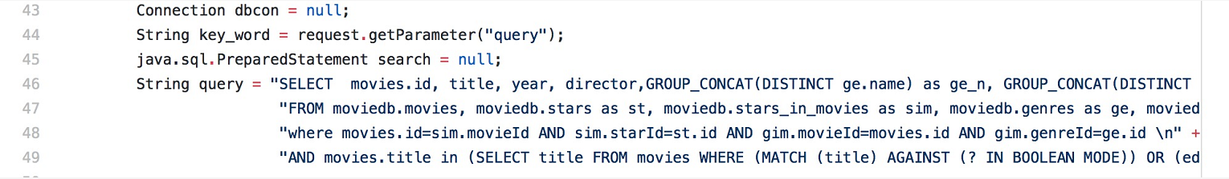

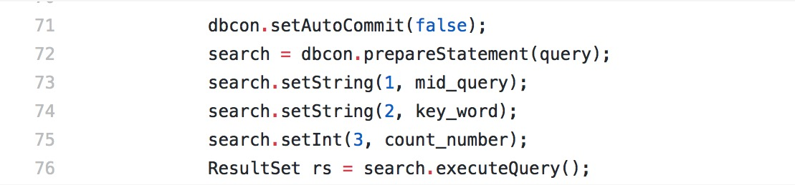

**Task 2**

* Address of AWS and Google instances

Original:13.59.189.185

Master:18.188.57.189

Slave:18.219.75.91

Google instances:35.196:160:161

* Have you verified that they are accessible? Does Fablix site get opened both on Google’s 80 port and AWS’ 8080 port?

Yes, and yes.

* How connection pooling works with two backend SQL?

We created two connection resource one for master and another for slave. For the writing part, we will only use master mysql. For the reading part, it will be either one. The purpose is let the master and slave to be identical.

* + File name, line numbers as in Github

cs122b-winter18-team-65/blob/master/project5/project5_web/fabflix/WebContent/META-INF/context.xml

Line: 3-11

* + Snapshots

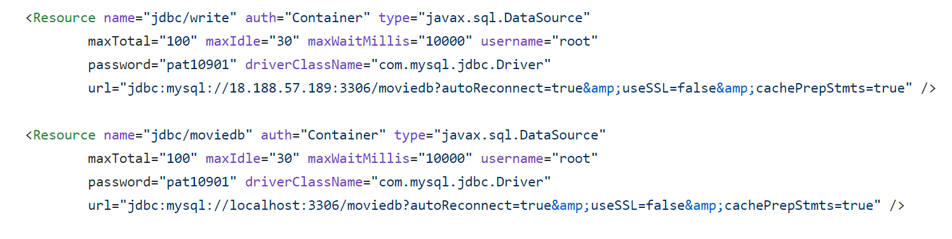

* How read/write requests were routed?

For every write request, it will be sent to master mysql. For read request, it will be sent to the localhost. E.g the add_star, add_movie, checkout are all writing to Master and slave will copy everything that Master added.

* + File name, line numbers as in Github

cs122b-winter18-team-65/blob/master/project5/project5_web/fabflix/WebContent/META-INF/context.xml

Line: 3-11

cs122b-winter18-team-65/blob/master/project5/project5_web/fabflix/src/_AddStar.java

Line: 47-50

* Snapshots



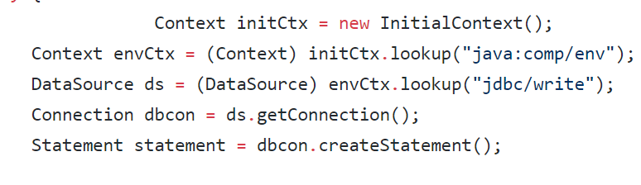

**Task 3**

* Have you uploaded the log file to Github? Where is it located?

Yes,

cs122b-winter18-team-65/tree/master/project5-task3/single

This is for a single instance version

There are 3 subfolder which contain all the log files for a single instance.

cs122b-winter18-team-65/tree/master/project5-task3/scaled

This is for a scaled version

There are 3 subfolder which contain all the log files for a scaled version.

* Have you uploaded the HTML file to Github? Where is it located?

Yes,

https://github.com/UCI-Chenli-teaching/cs122b-winter18-team-65/tree/master/project5-task3/html/report

* Have you uploaded the script to Github? Where is it located?

Yes, cs122b-winter18-team-65/tree/master/project5-task3/script

* Have you uploaded the WAR file and README to Github? Where is it located?

Yes,

ReadME: cs122b-winter18-team-65

WAR file: cs122b-winter18-team-65/tree/master/project5-task3

The whole code about project5:

cs122b-winter18-team-65/tree/master/project5