# Buildbox Game Template - Falling Ball An Addictive Game Android Template + Eclipse Project

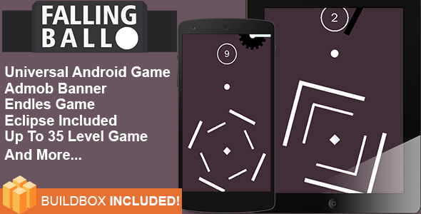

Game Name : Falling Ball

Created on : 07 April 2016

Last Update : 07 April 2016

Game Template By : Ufieklz Studio

Email : [ufieklzblog@gmail.com](mailto:ufieklzblog@gmail.com)

Facebook : <http://www.facebook.com/ufieklz>

Website : <http://ufieklz.net>

## **Thanks You!**

Hello There! Thanks for Purchasing my Items, If you have any questions about this item , feel free to ask me or email me . I will help you to solve your problem !

## **About Falling Ball**

Falling ball is an Addictive game which simple gameplay , You just tap on the screen and avoid the obstacle which will make you fail to beat your score . This game is really Super Addictive because you will beat the game up to 35 Different Level and still updated for next time I promise . this game is based on Cocos2D Library and made by Buildbox Software .

## **Main Features of This Template**

* Universal (phone & tablet)
* Chartboost Interstitial
* AdMob Banner
* Endless Game
* Share buttons
* Fun Game just 1 Tap Play
* Up To 35 Level
* Share Button
* And Many More Again

## **This File Includes**

* Falling Ball Eclipse
* PNG Files ( Game Sprite + Icon Game )
* Sounds ( Gameplay Music , Main Menu , Fail , Destroyed , Tap Sounds)
* Falling Ball.bbdoc (Buildbox Template)

# How To Setup Falling Ball on Eclipse

To setup this game is really simple and you can do this easily but still must do more for that , if you are newbie and don’t understand how to setup this game on eclipse , just follow my instructions below :

## **How To Import Eclipse Project**

1. Open You Eclipse Software
2. Right Click on Left bar or go to File > Import and an Import Windos Should pop Up  
     
   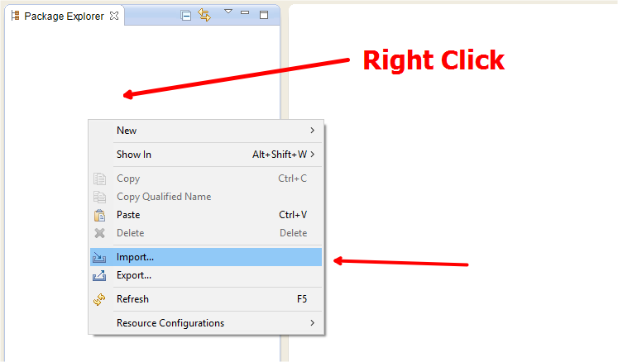
3. Select "Android" as the Import Source and double click the "Existing Android Source Code Into Workspace" field.   
     
   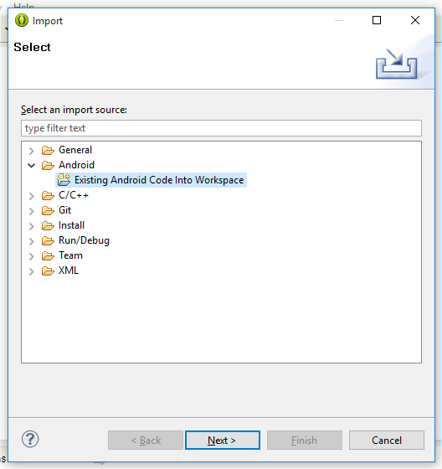
4. In the next window click the Browse button at the top. Browse to the Falling Ball folder and click ok.
5. Then make sure you have the selection as shown below.  
     
   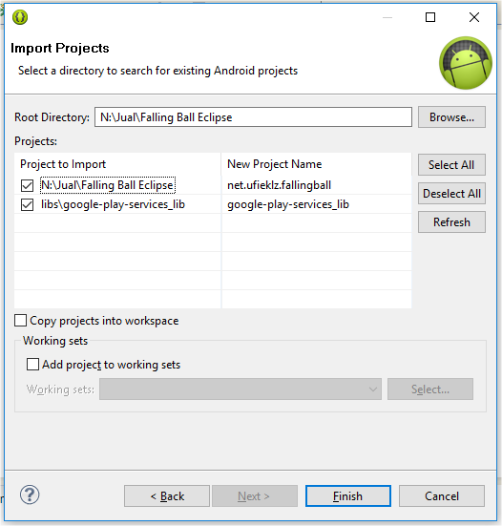
6. Click 'Finish' & let Eclipse import the project.
7. You should now be ready to customize your source code

If you still have errors make sure you have your google play services libraries imported. If you want to add them again just incase follow the steps below.

1. Right click on the project in the Project Explorer and hit the 'Properties' button
2. A new window will pop up, on the left side there are a bunch of tabs.
3. Click android and make sure you have the google play services libraries added
4. It should look like this.  
     
   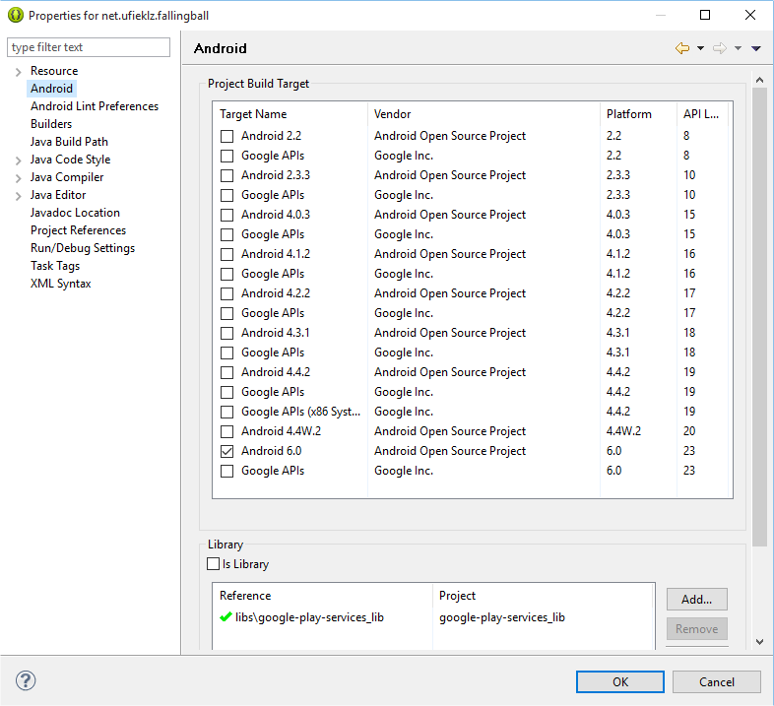
5. If there is none added, click Add and then simply add your google play services lib from there and click 'Apply' and 'Ok'.
6. Your code will not have any errors after this point.
7. If you do please contact support.

## Getting Rid of Errors

1. Right click Falling Ball directory in eclipse > click properties. New pop will open.
2. Select android Lint preferences > click ignore all.
3. Click on apply button and you are ready to customise game code.

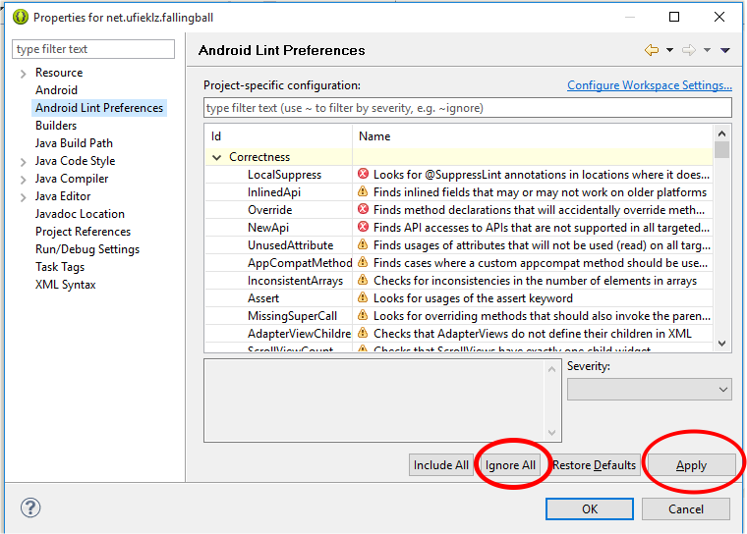

## **Change Version Code , Bundle ID , Name On Device and Admob Interstitial**

1. In your project go to the Assets folder
2. Under Assets, go to Data and then open PTModelGeneralSettings.0.attributes.xml
3. Replace the Marked Selections , for Version Code , Bundle ID , NOD and Admob Interstitial Only .  
     
   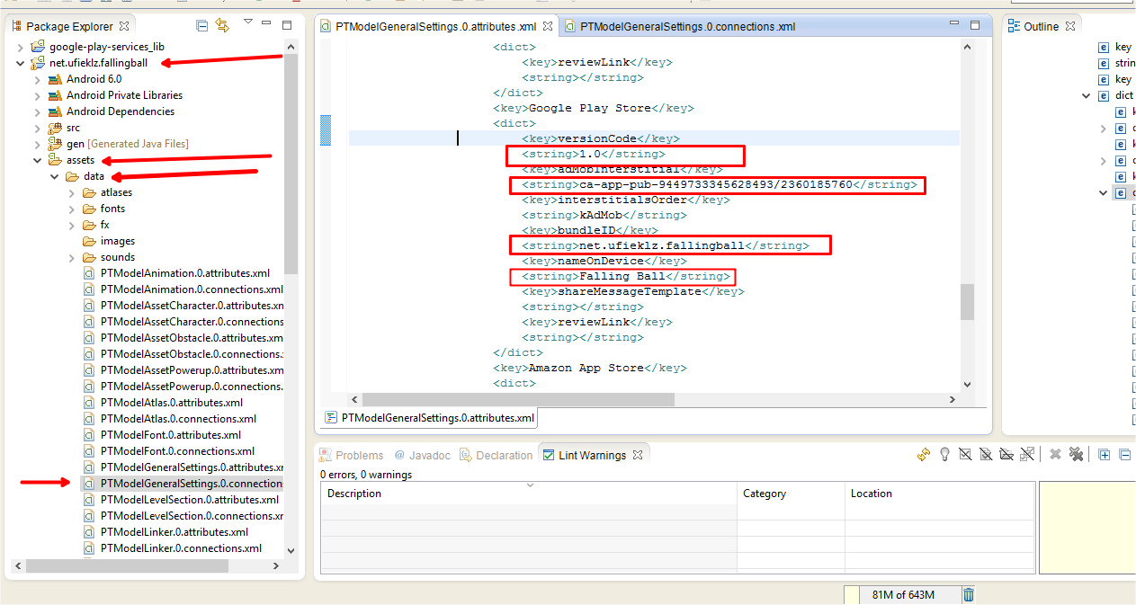

## Changing Game Icon and Splash Screen

### Change Game Icon

1. Go To Project Folder > Res > Drawable
2. And Replace the Icon.png  
     
   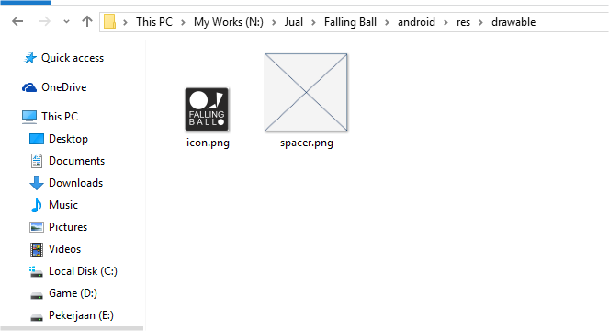

### Change Splash Screen

1. Got To Project Folder > Assets
2. And Replace Default.png  
     
   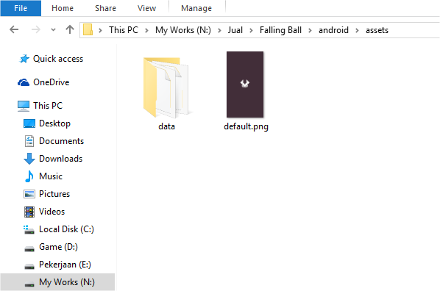

## Change Game Assets

1. Go to Your Project > Assets > Data
2. There are 2 folders you need to works with.

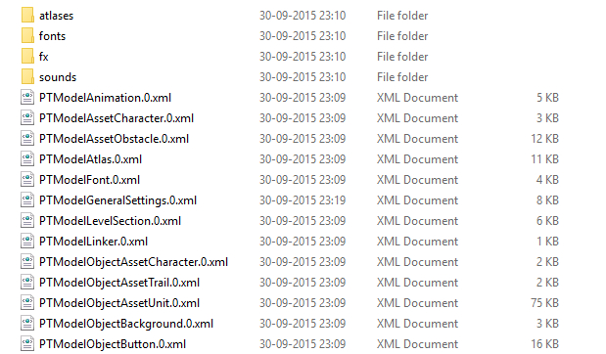

1. **Atlases,** which contains the image assets. I recommend using illustrator or photoshop and simply make your graphics in the atlas and replace the png with the one in the data folder.**(NOTE:*Do not change name of any file.Just change the assets and save with the same name.)***
2. **Sounds,**here all you need to do is replace the mp3 background music file with your own

# How To Setup Falling Ball on Buildbox

in this part you will learn how to setting this game on buildbox , this part is only show you how to **change Bundle ID , Change Version , change Admob Interstitial , change icon,** For Another Tutorial you must learn alone on youtube . There are many Videos There .

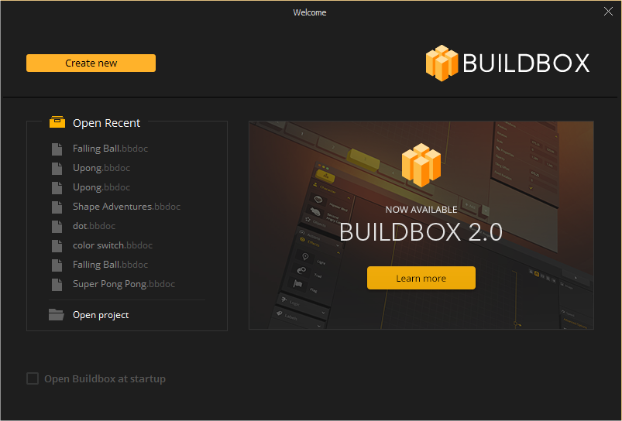

## Download Buildbox

If you don’t have this software you can download from [**http://buildbox.com/**](http://buildbox.com/) **,** Download it and install then request for 30 Days Free trial software if you want to edit this file

## Open Project on Buildbox

1. Open Your Buildbox Software
2. Then Click On Open Project and Choose **File.bbdoc file**
3. And your project should opened

## Change Project Settings

1. Go to Right sidebar and click on gear Icon   
     
   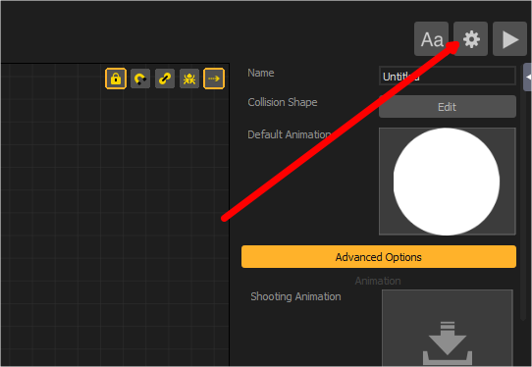
2. Then On General Tab you can Change your Project Settings , For change the Icon you must **DRAG AND DROP YOUR IMAGE** to the Box , for another you can setting up as you want , like bundle id , name , game version , name on device and more   
   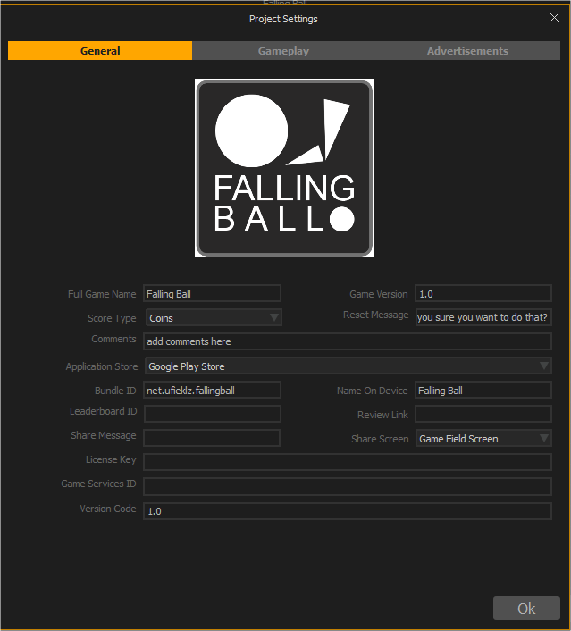

## Change Admob Interstitial ID

1. Go To Right Sidebar and click on Gear Icon
2. Go to Adversttisment Tab , Change Application Store to Google Play
3. Then Change the Admob Interstial ID   
     
   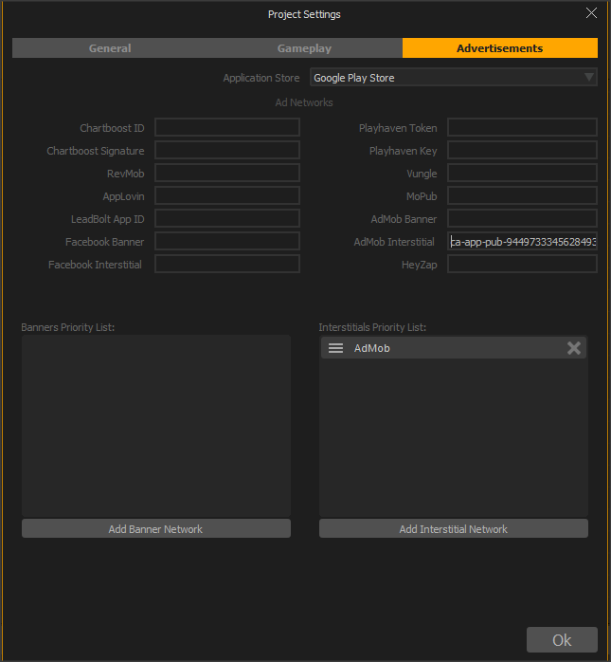

# Thank You Again

Many Thanks once for buy this items , I hope this items usefull and you get what you want , if you have any questions or request anything about this game . You can Contact me on top page . Feel free to ask me and request anything . Please Rate this File and also keep waiting for next amazing Game Template . Thanks .

King Regards ,

**Muhammad Taufik**

**Ufieklz Studio**