# Danger Climber 2 + Admob + Online Leaderboard + Multiple Characters

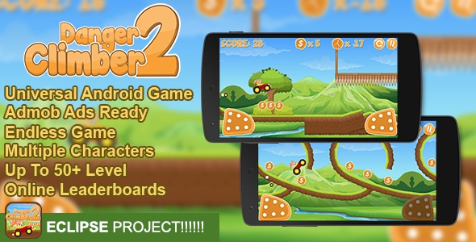

Game Name : Danger Climber 2

Created on : 22 February, 2017

Last Update : 22 February ,2017

Game Engine : Buildbox 2.2.8

Creator : Mobile Game Templates (MobileGTs)

Email : mobilegametemplate@gmail.com

## **Thanks You!**

Hello There! Thanks for Purchasing my Items, If you have any questions about this item , feel free to ask me or email me . I will help you to solve your problem !

## **About Danger Climber 2**

**Danger Climber 2** Is addictive Game , reach higher score on Danger Climber 2 . This game made by buildbox software have over 50+ Random generate level make it more challanger . you can add admob banner and easy to get more revenue from this game . this game also have share button , mute button , shop menu , that you can customize easily .. this Game Based by Cocos2D Library and made by Buildbox Software . and be Warned : this game insanely Addictive!

## **Main Features of This Template**

* Universal (phone & tablet)
* AdMob Banner and Interstitial
* Endless Game
* Tiime Based Gameplay (Fuel)
* Online Leaderboards
* Share buttons
* Up To 50+ Level
* Share Button
* Multiple Character available (3 Characters)
* Mute sound

## **About Ads**

### Main Menu

* Interstitial : no
* Banner :always

### Game Screen

* Interstitial : no
* Banner : Always

### Game Over Screen

* Interstitial : 3 Times
* Banner : Always

### Pause Screen

* Interstitial : 5 Times
* Banner : Always

## **This File Includes**

* Danger Climber 2 Eclipse
* PNG Icon Danger Climber 2
* Documentation Files

# Disclaimer

if You Already Purchase this Items , and you have Problem with my items you must read this before .   
  
**If you want to Build APK , You need ?**Eclipse Juno (Android Developer Tools):

For 32 Bit Version :<http://dl.google.com/android/adt/adt-bundle-windows-x86-20140702.zip>  
For 64 Bit Version : <http://dl.google.com/android/adt/adt-bundle-windows-x86_64-20140702.zip>   
  
**JDK 7 for Your Sistem**  
<http://www.oracle.com/technetwork/java/javase/downloads/jdk7-downloads-1880260.html>  
  
**Another Important !!**

Install API 21 or higher from SDK Manager on ADT Bundle .   
If you want to Preview the Game , you can try on Genymotion or Real Device . Do not use Eclipse Emulator .

Watch on this video if this documentation not help : [**https://www.youtube.com/watch?v=WP4He0O7L7o**](https://www.youtube.com/watch?v=WP4He0O7L7o)

# Get All Important things

## **Get Review Link**

[https://play.google.com/store/apps/details?id=**net.ufieklz.animaljungle**](https://play.google.com/store/apps/details?id=net.ufieklz.animaljungle)

1. Change **net.ufieklz.animaljungle** with your Bundle ID

## **Get APK License**

1. Go to Your Developer Account
2. On The First Scene you should create new Application(if you haven’t create it) click on the right button listed **“Add New Application”**
3. Then on left sidebar Click on **“Services & APIs “** like the picture below  
   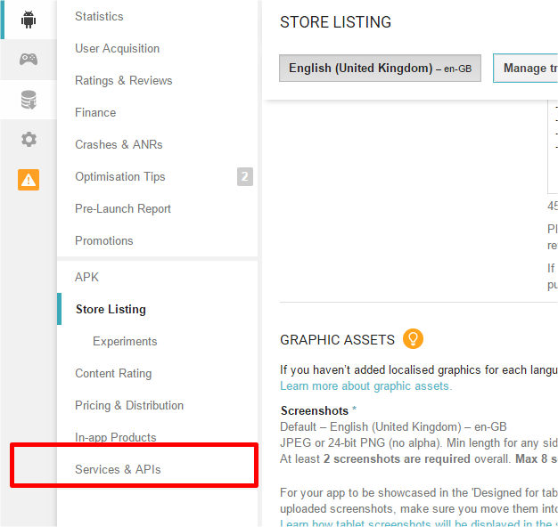
4. Here is your APK License Key  
   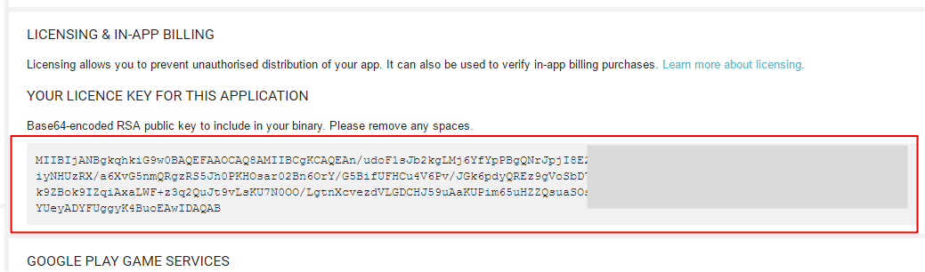

## **Get Game Services ID**

1. Check on Left sidebar , and you should click on **Gamepad Icon** , then if you haven’t create it you can create by click on **Add New Game Button** on right side  
   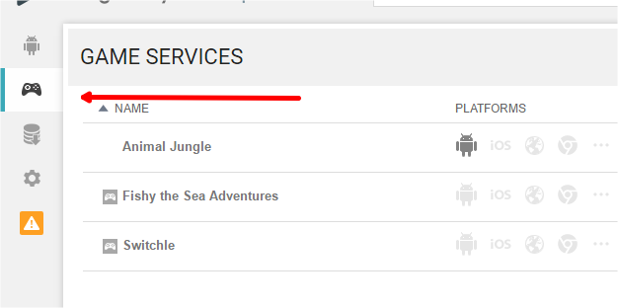
2. Then if you have create it fill all of them then you will get the Game Services ID like this pic below  
   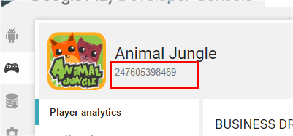

## **Get Leaderboard ID**

1. Check on Left sidebar , and you should click on **Gamepad Icon**
2. Click on your Game Name
3. Then just scroll down a bit , then click on **Leaderboards**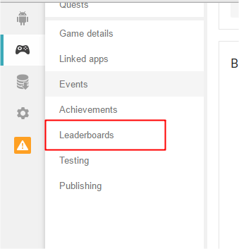
4. Then you can Create new Leaderboard by Click The Button There
5. Then you can copy the Leaderboard Code like this pic below  
   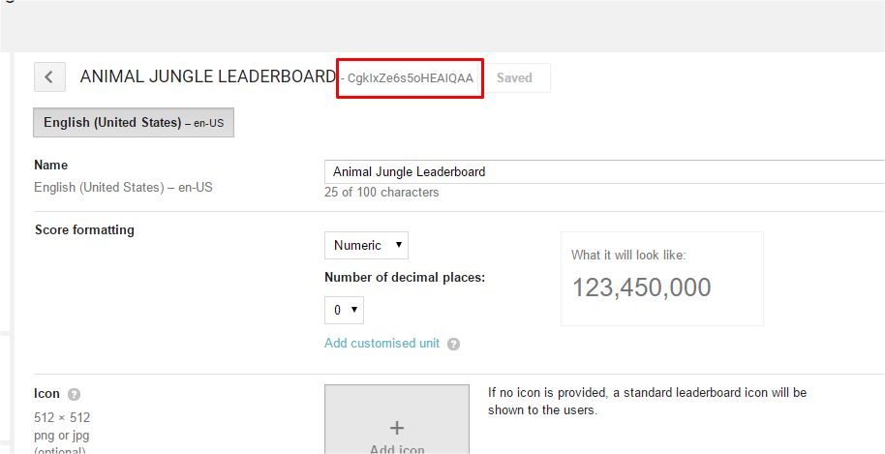

# Structure should you change

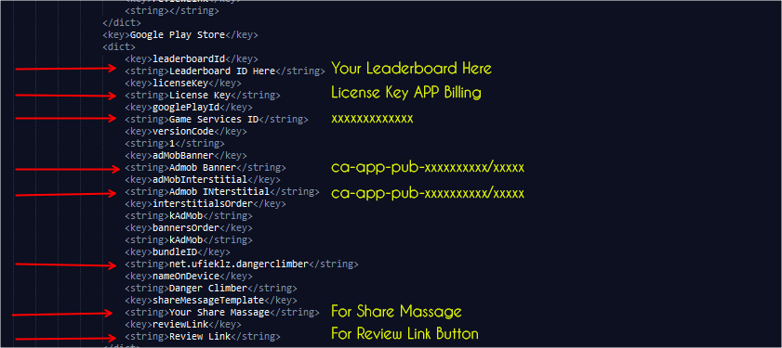

# How To Setup Danger Climber 2 on Eclipse

To setup this game is really simple and you can do this easily but still must do more for that , if you are newbie and don’t understand how to setup this game on eclipse , just follow my instructions below :

## **How To Import Eclipse Project**

1. Open You Eclipse Software
2. Right Click on Left bar or go to File > Import and an Import Windos Should pop Up  
     
   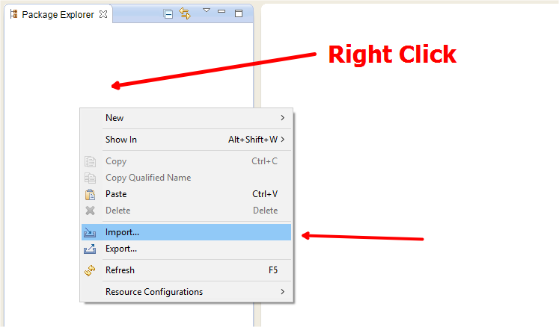
3. Select "Android" as the Import Source and double click the "Existing Android Source Code Into Workspace" field.   
     
   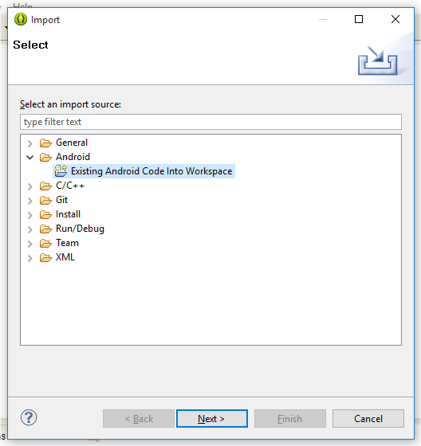
4. In the next window click the Browse button at the top. Browse to the Danger Climber 2 folder and click ok.
5. Then make sure you have the selection as shown below.  
     
   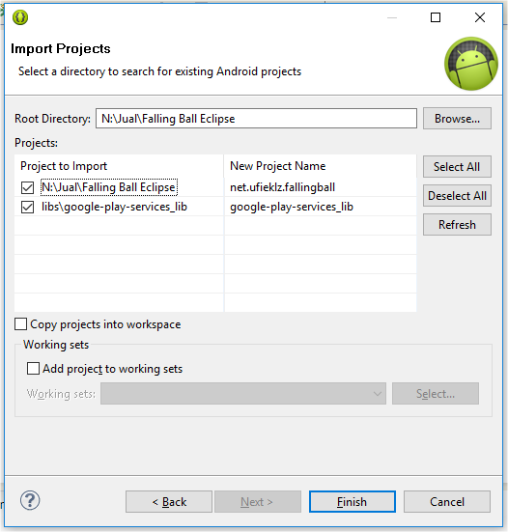
6. Click 'Finish' & let Eclipse import the project.
7. You should now be ready to customize your source code

If you still have errors make sure you have your google play services libraries imported. If you want to add them again just incase follow the steps below.

1. Right click on the project in the Project Explorer and hit the 'Properties' button
2. A new window will pop up, on the left side there are a bunch of tabs.
3. Click android and make sure you have the google play services libraries added
4. It should look like this.  
     
   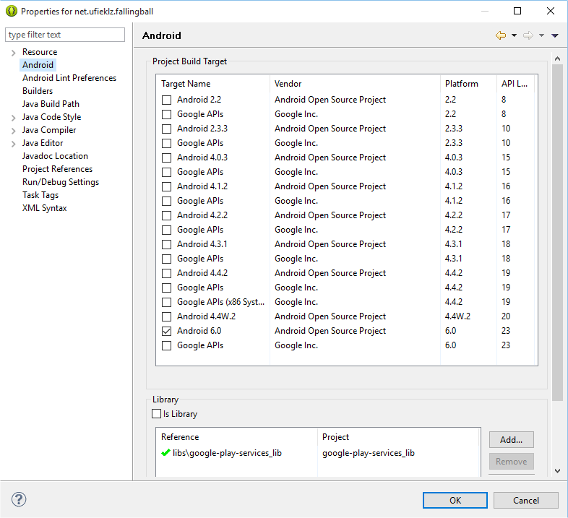
5. If there is none added, click Add and then simply add your google play services lib from there and click 'Apply' and 'Ok'.
6. Your code will not have any errors after this point.
7. If you do please contact support.

## Getting Rid of Errors

1. Right click Danger Climber 2 directory in eclipse > click properties. New pop will open.
2. Select android Lint preferences > click ignore all.
3. Click on apply button and you are ready to customise game code.

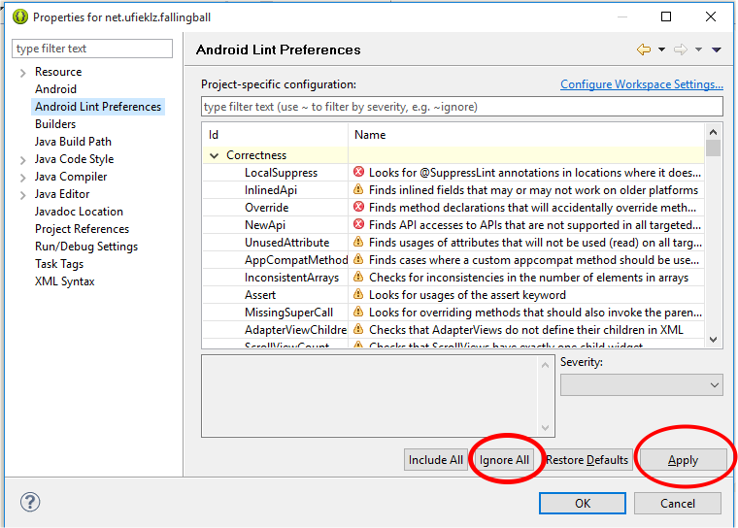

## **Rename Java Project (Game Project)**

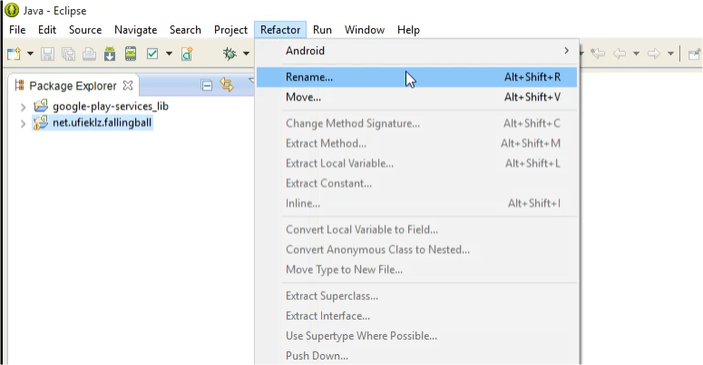

1. Click On your Project
2. Then go To Refactor > Rename
3. Rename Your Game then Click OK (check Update Reference)

## **Change Application Name Package**

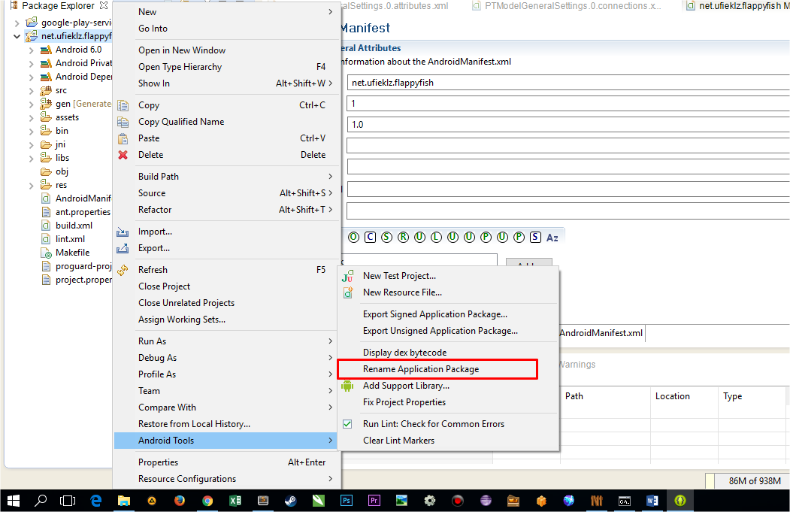

1. Right Click On Your Project
2. Go To Android Tools > Rename Application Package
3. Fill Your Name Package then Click OK

## **Change Version Code , Bundle ID , Name On Device and Admob Interstitial**

1. In your project go to the Assets folder
2. Under Assets, go to Data and then open PTModelGeneralSettings.0.attributes.xml
3. Replace the Marked Selections , for Version Code , Bundle ID , NOD and Admob Interstitial Only .  
     
   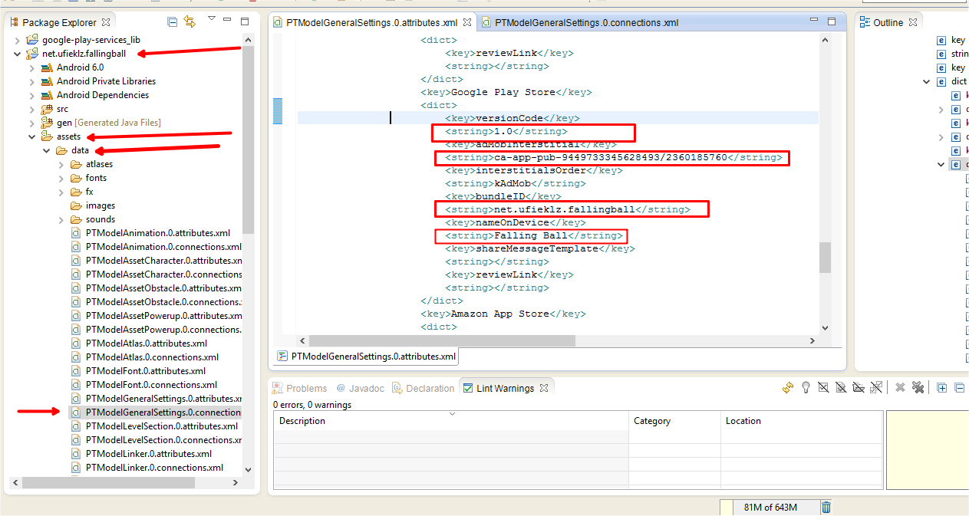
4. After entering these values, refractor your package name by right clicking the project
5. Go to **Refractor > Rename**, and enter the package name you put in the XML file above.
6. Done entering your values.

## **Change Leaderboard ID**

1. In your project go to the Assets folder
2. Under Assets, go to Data and then open PTModelGeneralSettings.0.attributes.xml
3. Replace the Marked Selections , for Leaderboard ID  
   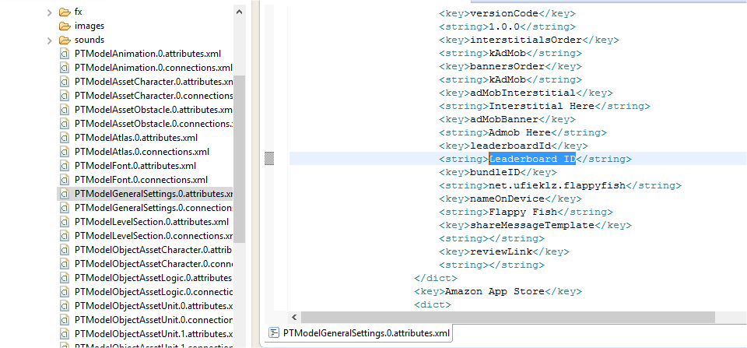
4. After entering these values, refractor your package name by right clicking the project
5. Go to **Refractor > Rename**, and enter the package name you put in the XML file above.
6. Done entering your values.

## Changing Game Icon and Splash Screen

### Change Game Icon

1. Go To Project Folder > Res > Drawable
2. And Replace the Icon.png  
     
   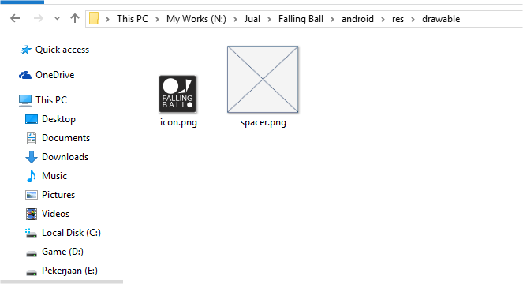

### Change Splash Screen

1. Got To Project Folder > Assets
2. And Replace Default.png  
     
   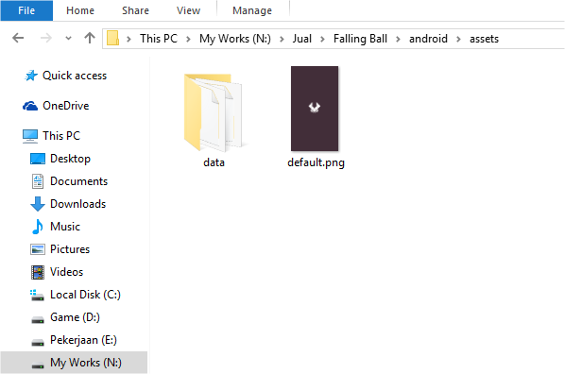

## Change Game Assets

1. Go to Your Project > Assets > Data
2. There are 2 folders you need to works with.

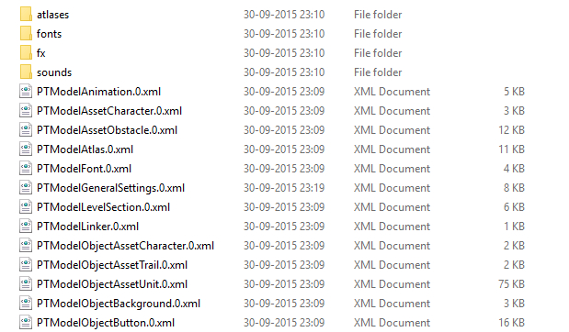

1. **Atlases,** which contains the image assets. I recommend using illustrator or photoshop and simply make your graphics in the atlas and replace the png with the one in the data folder.**(NOTE:*Do not change name of any file.Just change the assets and save with the same name.)***
2. **Sounds,**here all you need to do is replace the mp3 background music file with your own

# Thank You Again

Many Thanks once for buy this items , I hope this items usefull and you get what you want , if you have any questions or request anything about this game . You can Contact me on top page . Feel free to ask me and request anything . Please Rate this File and also keep waiting for next amazing Game Template . Thanks .

King Regards ,

**MobileGTS Production**