# FunnyFaceMaker

## Steps to import project in eclipse

* Click on File -> Import

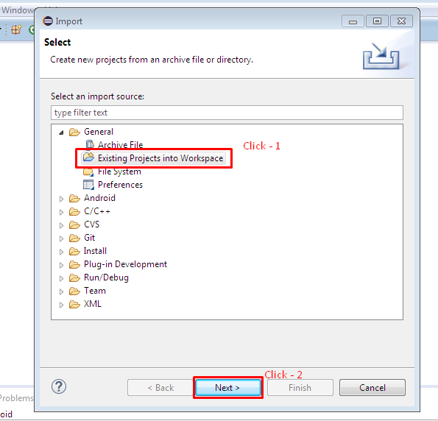

* Following below steps

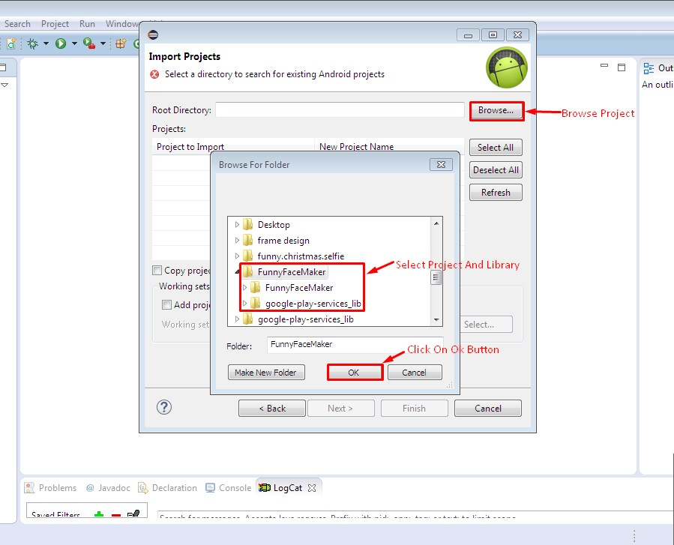

* successfully import project

## C:\Users\GT-3\Desktop\22.jpg

* When Project imporet after right click FunnyFaceMaker project and select Properties Then open dialog Follow steps

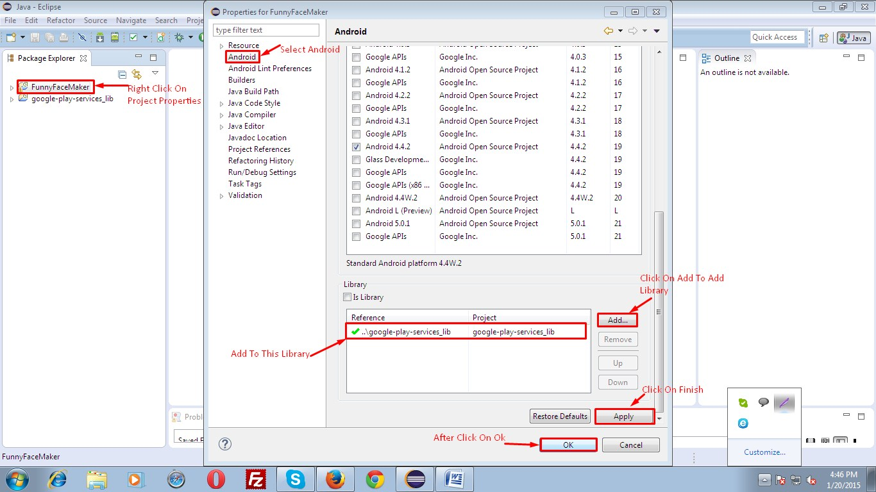  **2. Change Icon**

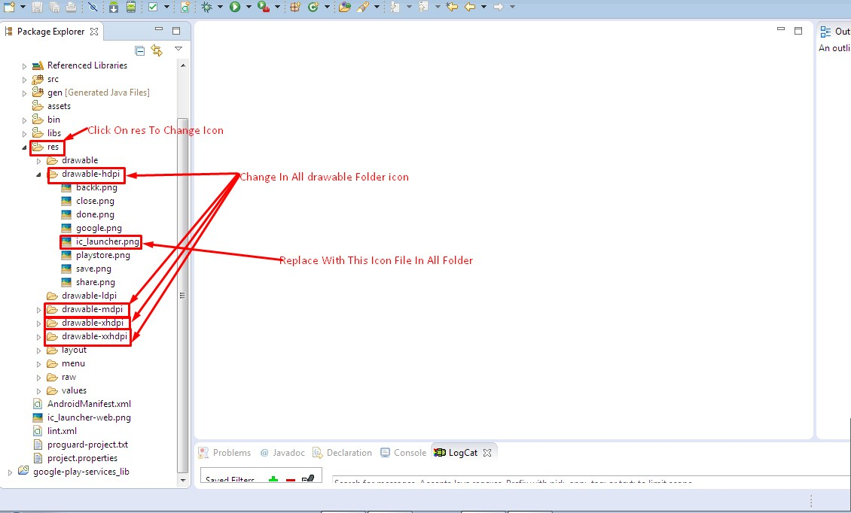

1. **Change startApp Id And Developer ID**

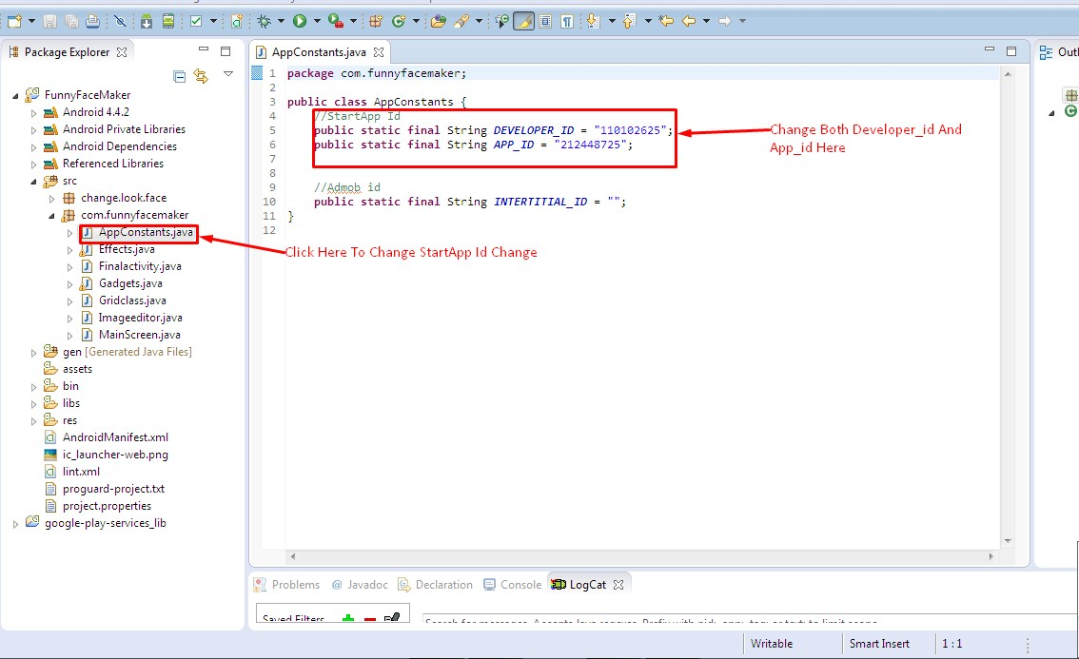

1. **Change Admob Intertitial Ads Id.** 