Men in Suit Photo Maker

Date Created: 7/2/2015 Author: Code Agent

Thanks for purchasing my product

Please follow below steps to set up and upload your app on play store.

About this product:

-This product is developed in eclipse SDK. You can do any customization with the code.

- You will create new app in few minutes if you have basic knowledge of java programming.

- App is integrated with admob. Admob will help you to earn revenue.

Features:

-splash screen-Capture your photo with suite.

-Choose suite designs from lot of attractive suit.

-Rotate your camera to 30 degree at all the direction to catch the exact photo.

-Simple guide for app to use. -About Us page of small introduction of company.

-Captured image folder.

-Ad mob integrated- banner and interstitials ads.

- Easy to use and customize.

-Rate us.

-Share app.

-More apps.

* How to import source code :

Please follow this video

<https://www.youtube.com/watch?v=Iw0VeDzR7Cg>

Please import 2 folders that is Men in suit, and google play service library

After importing 2 folders please add as library project in MenInSuit app

1. How to change admob id :

Go to res/values/strings.xml file

<string name=*"admob_banner"*>ca-app-pub-2691806550199991/6095167863</string>

<string name=*"admob_intersitials"*>ca-app-pub-2691806550199991/9048634267</string>

1. **How to change package name :**

Go to src*.* *com.example.meninsuit* you can put your company name for exa :

com.<company name*. meninsuit*

1. **How to change application name :**

Go to res/values/strings.xml file

<string name=*"app_name"*> MenInSuit </string>

1. **How to change graphics :**

You will get all the images in res\drawable, drawable-mdpi folder.

1. **How to add /change more suit images :**

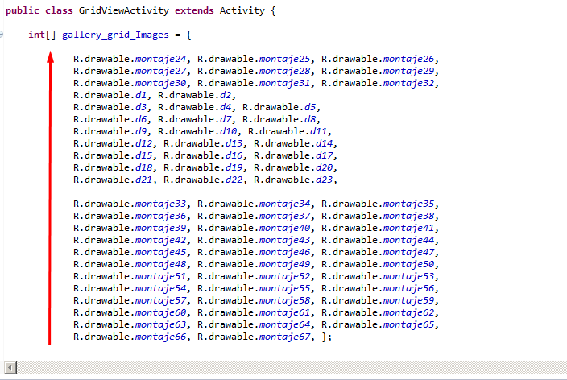

All images are putted in one array. You can see in above picture. If you want to customize it, Please change or add more images in this array. There are 2 java files that is CaptureActivity.java and other is GridViewActivity.java.

You need to change array in this 2 files.

Let me know if you have any issues : Mail id is : [codeagent0@gmail.com](mailto:codeagent0@gmail.com)

**Thank You.**