|  |  |
| --- | --- |
| **BARANGAY COUNCIL**  **Hon. Punong B. Arangay**  ***Punong Barangay***  **Hon. KAGAWAD 1**  ***Committee on Appropriation***  **Hon. KAGAWAD 2**  ***Committee on Environmental Protection / Health***  **Hon. KAGAWAD 3**  ***Committee on Human Rights***  ***Peace & Order***  **Hon. KAGAWAD 4**  ***Committee on Education / Women and Family Protection***  **Hon. KAGAWAD 5**  ***Committee on Rules and Privileges***  ***Ways & Means***  **Hon. KAGAWAD 6**  ***Committee on Infrastructure***  **Hon. KAGAWAD 7**  ***Committee on Cooperatives / Livelihood***  **Hon. SK CHAIRMAN**  ***S.K Chairman***  **BARANGAY SECRETARY**  ***Brgy. Secretary***  **BARANGAY TREASURER**  ***Brgy. Treasurer*** | **Control No.**  **{printPermit}**  **Date:**  **{processedAt}**  Nature of Business: **{natureOfBusiness}**  Name of Business: **{businessName}**  Proprietor: **{fullName}**  Permit No: **{permitNo}**  Address: **{address}**  Business Address: **{businessAddress}**  Status: **{status}**  Valid Until: **{validity}**  This Permit is being issued subject to existing rules and regulations, provided  However, that the necessary fees are paid to the Treasurer of the Barangay as assessed.  This is non-transferable and shall be deemed null and void upon failure by the  Owner to follow the said rules and regulations set forth by the Local Government Unit of General Trias.  Issued this  **{day}** day of  **{month}** , **{year}** at Barangay San Francisco, General Trias, Cavite upon request of the interested party.    Thumbmark    **Punong Barangay’s Name**  Punong Barangay |

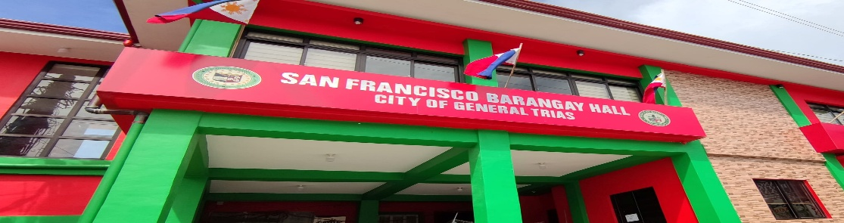

CTC #: **{ctcNo}**

Issued on: **{month} {day}, {year}**

Issued at: **{brgyName}**

OR #: **{orNo}**

**BARANGAY BUSINESS PERMIT**