|  |  |
| --- | --- |
| **BARANGAY COUNCIL**  **Hon. Punong B. Arangay**  ***Punong Barangay***  **Hon. KAGAWAD 1**  ***Committee on Appropriation***  **Hon. KAGAWAD 2**  ***Committee on Environmental Protection / Health***  **Hon. KAGAWAD 3**  ***Committee on Human Rights***  ***Peace & Order***  **Hon. KAGAWAD 4**  ***Committee on Education / Women and Family Protection***  **Hon. KAGAWAD 5**  ***Committee on Rules and Privileges***  ***Ways & Means***  **Hon. KAGAWAD 6**  ***Committee on Infrastracture***  **Hon. KAGAWAD 7**  ***Committee on Cooperatives / Livelihood***  **Hon. SK CHAIRMAN**  ***S.K Chairman***  **BARANGAY SECRETARY**  ***Brgy. Secretary***  **BARANGAY TREASURER**  ***Brgy. Treasurer*** | **Control No.**  **{printCertificate}**  **Date:**  **{processedAt}**  **To whom it may concern:**  **THIS IS TO CERTIFY** that the person whose name appeared below has **NO DEROGATORY** and/or **CRIMINAL RECORDS** file in this barangay. He/She is known to be a good moral character and law-abiding citizen in the community and complied with the requirements set by our barangay and has been verified as follows:  **Name:** **{fullName}** **Age:**  **{age}** years old  **Address:**  **{address}** Barangay San Francisco, City of General Trias, Cavite  Issued this  **{day}** day of  **{month}** , **{year}** at Barangay San Francisco, General Trias, Cavite upon request of the interested party for **{purpose}**  purposes.      Thumbmark  **Punong Barangay’s Name**  Punong Barangay |

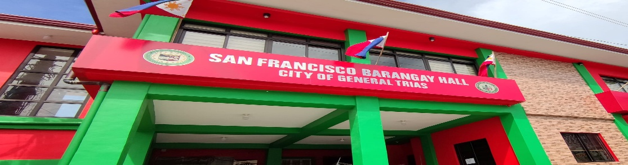

**BARANGAY CERTIFICATE**