Crystal Fountains Project

Erick Cantos

Student ID: #N01068423

December 22, 2017

**1. INTRODUCTION**

This report discusses the assembly and requirements of producing a wireless receiver that will later integrate with a Crystal Fountains DMX light. Scheduled events, and details about completion will be outlined in the report.

**2. AIM**

The aim of this report is to show the goal of completing a Crystal Fountains DMX light receiver, by presenting parts involved, and demonstrating scheduled events to complete the project. The report will also explore and opportunities and challenges faced during the progression. Later, it will integrate with a transmitter that will communicate wirelessly through DMX differential signals to be translated into single-ended signal for data handling in the module – handled by partner Heakeme Williams.

**3. BUDGET**

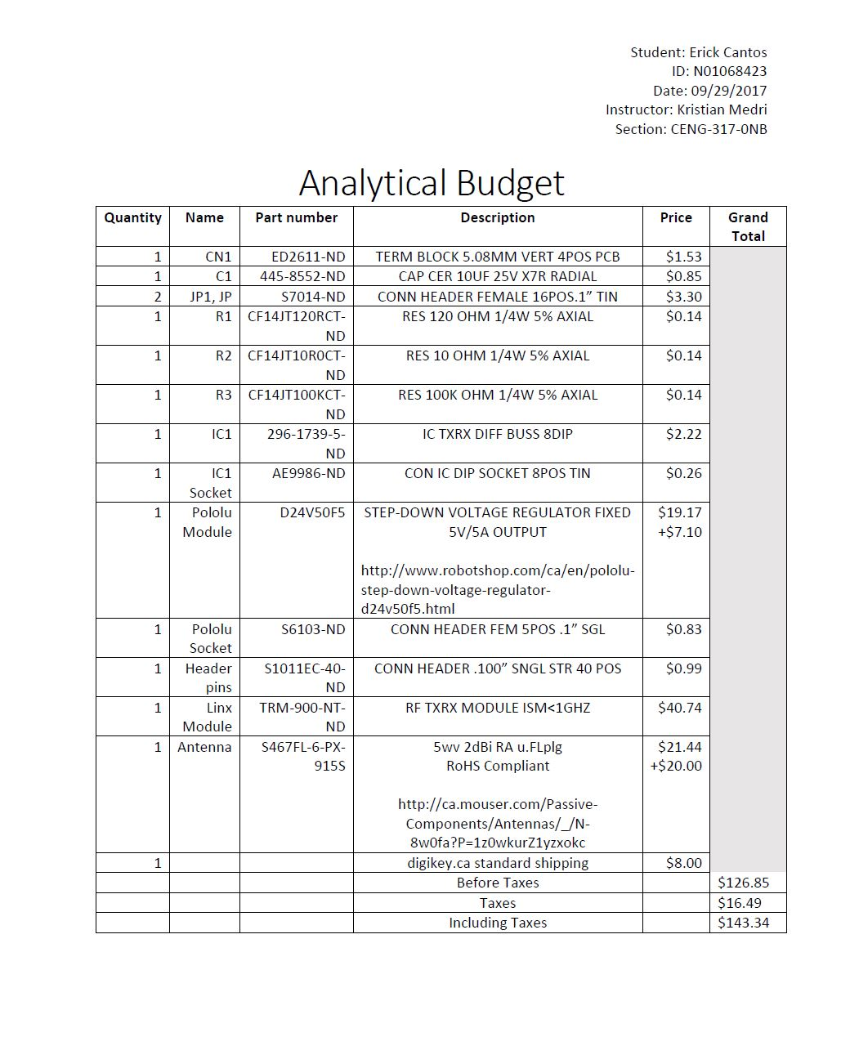

**4. SCHEDULE/CURRENT PROGRESS**

*September 8th - 15th*

* Utilized this week to complete proposal for Crystal Fountains Project. Proposal will include aim of project and a future database idea that I plan on integrating with a mobile application. The proposal is uploaded onto my blog.

*September 15th - 22nd*

* Future projections and scheduled events will be condensed into a Gant Project.

*September 22nd - 29th*

* All expenditures are taken into consideration and an analytical budget will be uploaded on my blog.

*October 13th – November 20th*

* **READING DAYS** – Discussions and planning will commence. Information from the prototype lab has directed me where and how to get my PCB designs.
* Ordered raspberry pi.

*November 20th – 24th*

* Raspberry pi has arrived by the courier. This week has been planned to set up the raspberry pi the operating system Raspbian Jesse.
* Investigate PCB designs further by accessing prototype lab.

*November 24th – December 1st*

* Finalized PCB designs, and have them submitted in Gerber file format to be printed in the prototype lab. Furthermore, since PCB design has been submitted, I will order my components ahead of time for soldering using my analytical budget.

*December 1st- December 8th*

* Parts arrived from Digi-key, and video documentation commenced. Furthermore, parts were taken to the prototype lab for immediate soldering. The Crystal Fountains group placard was created and uploaded onto my blog

*December 8th – 15th*

* Edited and composed a final build video to be submitted onto my blog. Build video with show a concatenation of parts arriving, parts assembly, and simple functionality of device.

*December 15th – 21st*

* All progress thus far will be documented into a technical report.

**5. PROBLEMS AND OPPURUNITIES**

This biggest problem that I faced is time management adjustments due to the arrival of parts. Since the parts arrived times that I did not anticipate I could not begin any hardware production until those components arrived. However, those challenges were overcome with rapid precise soldering with the direction and advice from Vlad and Kelly over in the prototype lab. Moving forward, I see opportunities during the winter break to finalize and record my device working with the RS linx module in the prototype lab.

**6. FINICIAL STAUS**

My original intent was to have a set budget of 200$ maximum. Fortunately, Humber College can provide me with the antenna which have reduced my overall expenditure (-$19.17 + -$7.10). Overall the amount I have spent is $100.58 before taxes and $113.65 after.