Name __________________________________ Mock Exam

- A government nutrition panel has determined that low income individuals do not obtain an adequate amount of calcium in their diets. Your job is to evaluate the cost effectiveness of various proposed remedies. Science behind the program suggests the only way to obtain an adequate amount of calcium is to consume four quarts of milk per week. The proposed remedy is:
Plan C: Government milk distribution. The government purchases four quarts of milk, then gives it to the low income consumer. Resale is prohibited.
Graph the original budget constraint and illustrate how this program affects the consumer’s budget constraint. One axis will be milk, the other will be “all other goods” which you can refer to as AOG. You can choose the income and prices.

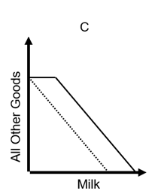
- The market for strawberries is
Demand: P = 20 – 2Q
Supply: P = 4 + 2Q
A $4 tax is put in place. What is the dead weight loss of this tax?

- You are choosing between two goods, X and Y, and your marginal utility from each is as shown in the following table. If your income is $9 and the prices of X and Y are $2 and $1, respectively, what quantities of each will you purchase to maximize utility? What total utility will you realize? Assume that, other things remaining unchanged, the price of X falls to $1. What quantities of X and Y will you now purchase?

Units of X | MU_{X} | Units of Y | MU_{Y}
1 | 10 | 1 | 8
2 | 8 | 2 | 7
3 | 6 | 3 | 6
4 | 4 | 4 | 5
5 | 3 | 5 | 4
6 | 2 | 6

- Cheese is made by identical firms where each firm’s long-run and marginal costs of production are:
𝐴𝑇𝐶=10−𝑞+0.05∗𝑞2 and 𝑀𝐶=0.5∗𝑞ATC=10−q+0.05∗q2 and MC=0.5∗q

where production (q) measures pounds of cheese.
- Suppose the price of cheese is $6 a pound, how many pounds of cheese does each firm produce?
- Is the firm profitable with this price?
- Will that profitability spur entry, exit, or neither?
- Suppose the price of cheese is $5 a pound, how many pounds of cheese does each firm produce?
- Is the firm profitable with this price?
- Will that profitability spur entry, exit, or neither?

- Label the following lines: MR, MC, AVC, ATC
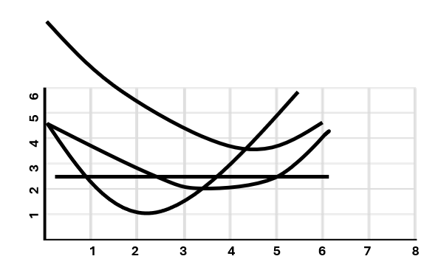
Should this firm shut down in the short run?
Should this firm shut down in the long run?

- You are a corrupt economist working in 1992 to help Archer Daniel Midland (ADM) to price fix Lysine with competitors. Lysine is an additive to animal feed. Even though this market is normally competitive, you and four other firms agree to coordinate output to act like a monopolist.
- Fill in the chart below which represents the collective accounting of this composite firm.
Revenue Data |  |  |  | Cost Data
Quantity of Output | Price | Total Revenue | Marginal Revenue | Average Total Cost | Total Cost | Marginal Cost | Profit (+) or Loss (-)
0 | $105 |  |  |  | $100
1 | 100 |  |  |  |  | $55
2 | 95 |  |  |  |  | 50
3 | 90 |  |  |  |  | 45
4 | 85 |  |  |  |  | 40
5 | 80 |  |  |  |  | 35
6 | 75 |  |  |  |  | 30
7 | 70 |  |  |  |  | 40
8 | 65 |  |  |  |  | 50
9 | 60 |  |  |  |  | 60
10 | 55 |  |  |  |  | 70

- What is the revenue maximizing level of output when these firms act as a monopoly?
- If they were instead competitive, what level of output would the market achieve?

- Below represents the decision by two companies to collude. Collusion requires suppressing output. If both firms collude, prices are high. If both firms cheat, they expand output and price falls. If one firms colludes and the other cheats, the cheating firm will make lots of sales at a slightly inflated price while the firm that continues to collude will lose market share.
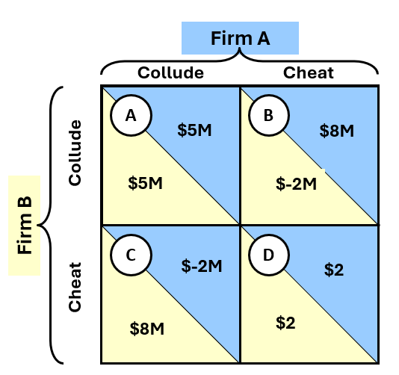
- Is there a dominant strategy?
- Because of models like this, the fact that we see collusion in the economy is a bit of a puzzle for economists. What do you think is missing from this model that explains why we see examples of companies colluding?

- Give 2 reasons HHI is not always a good indicator of the level of market competition.

- Which of the following statements is true:
- Amazon is a monopoly retailer because it is the largest retailer in the United States.
- There is no supply curve in a monopoly market.
- The large fixed costs of local power distribution make the marginal cost curve eventually turn up (have positive slope in the long run).
- Most governments fight monopolies wherever they can find them.

- The graph below illustrates a particular type of economic good. The original bundle chosen was A, and after the price change it was B. The budget lines are in gray and the utility curves are in black.
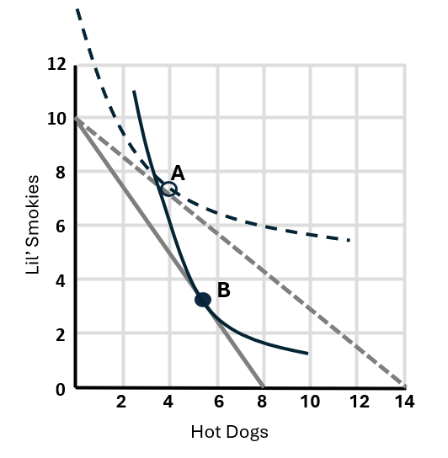
  - What happened to the price of Hot Dogs in this example in the move from A to B?
  - There is a major mistake in the way this graph is drawn. What is that thing?
  - What is the name of the good this figure is trying to illustrate (circle the best choice)?
- Normal good.
- Abnormal good.
- Giffen good
- Public good
- Inferior good

