**Fragmento de código 1:**

function hello() {

console.log('hello');

}

hello();

console.log('Dojo');

**Fragmento de código 2:**

function hello() {

console.log('hello');

return 15;

}

var result = hello();

console.log('result is', result);

**Fragmento de código 3:**

function numPlus(num) {

console.log('num is', num);

return num+15;

}

var result = numPlus(3);

console.log('result is', result);

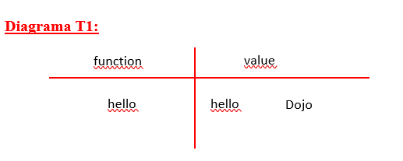

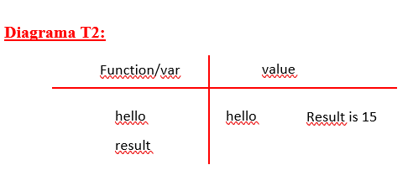

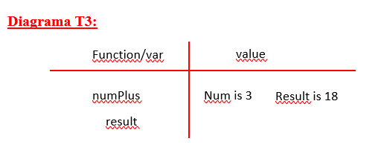

**Fragmento de código 4:**

var num = 15;

console.log(num);

function logAndReturn(num2){

console.log(num2);

return num2;

}

var result = logAndReturn(10);

console.log(result);

console.log(num);

**Fragmento de código 5:**

var num = 15;

console.log(num);

function timesTwo(num2){

console.log(num2);

return num2*2;

}

var result = timesTwo(10);

console.log(result);

console.log(num);

**Diagrama T4:**

Function/var

value

10

15

10

15

num

logAndReturn

**Diagrama T5:**

Function/var

value

20

15

10

15

num

timesTwo

**Fragmento de código 6:**

function timesTwoAgain(num) {

console.log('num is', num);

var y = num*2;

return y;

}

var result = timesTwoAgain(3) + timesTwoAgain(5);

console.log('result is', result);

**Fragmento de código 7:**

function sumNums(num1, num2) {

return num1+num2;

}

console.log(sumNums(2,3))

console.log(sumNums(3,5))

**Fragmento de código 8:**

function printSumNums(num1, num2) {

console.log(num1);

return num1+num2;

}

console.log(printSumNums(2,3))

console.log(printSumNums(3,5))

**Diagrama T6:**

Function/var

value

Num is 3

Num is 5

Result is 16

timesTwoAgain

y

**Diagrama T7:**

Function/var

value

sumNums

8

5

**Diagrama T8:**

Function/var

value

printSumNums

3

8

5

2

**Fragmento de código 9:**

function sumNums(num1, num2) {

var sum = num1 + num2;

console.log('sum is', sum);

return sum;

}

var result = sumNums(2,3) + sumNums(3,5);

console.log('result is', result);

**Fragmento de código 10:**

function sumNums(num1, num2) {

var sum = num1 + num2;

console.log('sum is', sum);

return sum;

}

var result = sumNums(2,3) + sumNums(3,sumNums(2,1)) + sumNums(sumNums(2,1),sumNums(2,3));

console.log('result is', result);

**Diagrama T9:**

Function/var

value

Result is 13

Sum is 8

Sum is 5

sumNums

sum

result

**Diagrama T10:**

Function/var

value

Result is 19

Sum is 8

Sum is 6

Sum is 5

sumNums

sum

result