Examen-EARM-1685564.R

Erick

2025-03-24

#Examen 24032025  
#Erick Alejandro Rodriguez Moctezuma. Matrícula:1685564  
  
set.seed(42)  
n <- 30  
altura <- rnorm(n,mean=170, sd=10)  
peso <- 0.5 * altura + rnorm(n, mean=0, sd=50)  
alturaantes <- rnorm(n, mean = 165, sd=8)  
t.test(altura, alturaantes, paired = T)

##   
## Paired t-test  
##   
## data: altura and alturaantes  
## t = 1.5419, df = 29, p-value = 0.1339  
## alternative hypothesis: true mean difference is not equal to 0  
## 95 percent confidence interval:  
## -1.357901 9.677329  
## sample estimates:  
## mean difference   
## 4.159714

plot(alturaantes)

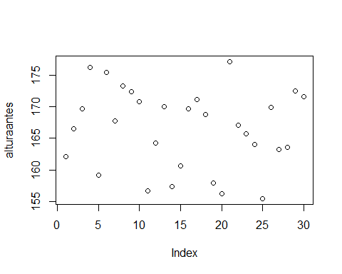

# Correlación -------------------------------------------------------------  
  
cor.test(altura,peso)

##   
## Pearson's product-moment correlation  
##   
## data: altura and peso  
## t = -0.45669, df = 28, p-value = 0.6514  
## alternative hypothesis: true correlation is not equal to 0  
## 95 percent confidence interval:  
## -0.4328468 0.2830512  
## sample estimates:  
## cor   
## -0.08598647

plot(altura,peso)

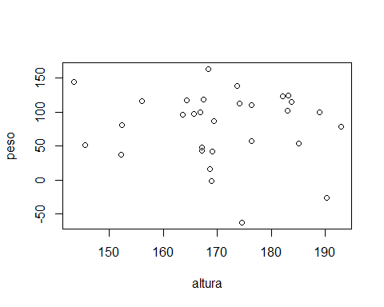

# ANOVA -------------------------------------------------------------------  
  
set.seed(123)  
suelo <- rep(c("Arcilloso","Arenoso", "Franco"), each=10)  
crecimiento <- c(  
 rnorm(10, mean=15,sd=2),  
 rnorm(10, mean=20,sd=2),  
 rnorm(10, mean=25,sd=2))  
  
datos <- data.frame(suelo=suelo, crecimiento=crecimiento)  
print(datos)

## suelo crecimiento  
## 1 Arcilloso 13.87905  
## 2 Arcilloso 14.53965  
## 3 Arcilloso 18.11742  
## 4 Arcilloso 15.14102  
## 5 Arcilloso 15.25858  
## 6 Arcilloso 18.43013  
## 7 Arcilloso 15.92183  
## 8 Arcilloso 12.46988  
## 9 Arcilloso 13.62629  
## 10 Arcilloso 14.10868  
## 11 Arenoso 22.44816  
## 12 Arenoso 20.71963  
## 13 Arenoso 20.80154  
## 14 Arenoso 20.22137  
## 15 Arenoso 18.88832  
## 16 Arenoso 23.57383  
## 17 Arenoso 20.99570  
## 18 Arenoso 16.06677  
## 19 Arenoso 21.40271  
## 20 Arenoso 19.05442  
## 21 Franco 22.86435  
## 22 Franco 24.56405  
## 23 Franco 22.94799  
## 24 Franco 23.54222  
## 25 Franco 23.74992  
## 26 Franco 21.62661  
## 27 Franco 26.67557  
## 28 Franco 25.30675  
## 29 Franco 22.72373  
## 30 Franco 27.50763

datos.aov<- aov(datos$crecimiento ~ datos$suelo)  
summary(datos.aov)

## Df Sum Sq Mean Sq F value Pr(>F)   
## datos$suelo 2 409.1 204.5 53.76 3.85e-10 ***  
## Residuals 27 102.7 3.8   
## ---  
## Signif. codes: 0 '***' 0.001 '**' 0.01 '*' 0.05 '.' 0.1 ' ' 1

boxplot(datos$crecimiento ~datos$suelo)

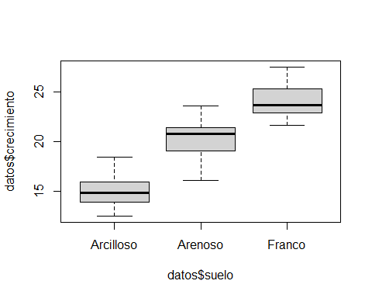

TukeyHSD(datos.aov)

## Tukey multiple comparisons of means  
## 95% family-wise confidence level  
##   
## Fit: aov(formula = datos$crecimiento ~ datos$suelo)  
##   
## $`datos$suelo`  
## diff lwr upr p adj  
## Arenoso-Arcilloso 5.267993 3.105081 7.430904 0.0000056  
## Franco-Arcilloso 9.001631 6.838720 11.164542 0.0000000  
## Franco-Arenoso 3.733638 1.570727 5.896550 0.0005978