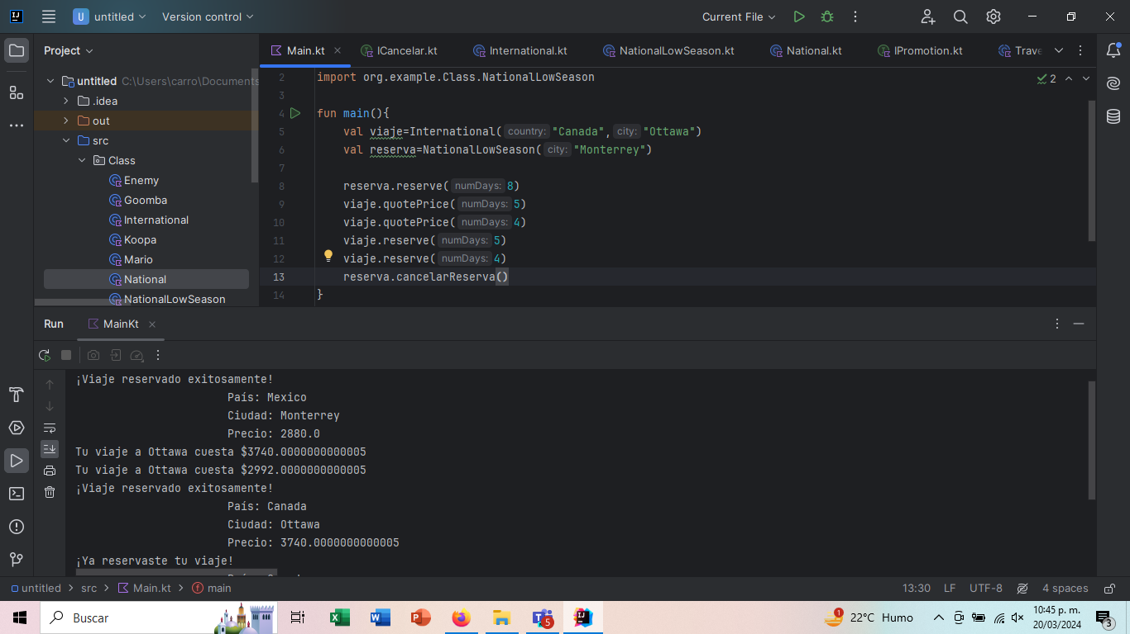

CLASE INTERNATIONAL  
package org.example.Class  
  
import org.example.Interfaces.ICancelar  
  
class International (override val country: String, override val city: String): Travel(),ICancelar {  
 protected val destination = *mapOf*(  
 "Alemania" *to mapOf*(  
  
 "Munich" *to* 980,  
 "Berlin" *to* 820,  
 "Francort" *to* 850  
 ),  
 "Chile" *to mapOf*(  
 "Santiago" *to* 643,  
 "Valparaiso" *to* 721  
 ),  
 "Canada" *to mapOf*(  
 "Vancouver" *to* 620,  
 "Ottawa" *to* 680,  
 "Montreal" *to* 600  
 )  
 )  
  
  
  
  
 override fun getPrice(numDays: Int):Double {  
 val fee = destination[country]?.get(city)?: 0  
 val impuesto:Double = when (country) {  
 "Alemania" -> 1.16  
 "Chile" -> 1.05  
 "Canada" -> 1.10  
 else -> 1.0 // Valor predeterminado si el país no está especificado  
 }  
  
 return fee.toDouble() \* numDays.toDouble() \* impuesto  
  
 }  
  
 override fun cancelarReserva() {  
 if (!reserved) {  
 *println*("No hay ninguna reserva para cancelar.")  
 } else {  
 reserved = false  
 paidAmount = 0.0  
 *println*("La reserva para el viaje a $city ha sido cancelada.")  
 }  
 }  
  
  
  
}

INTERFAS

package org.example.Interfaces  
interface ICancelar{  
  
 fun cancelarReserva()  
}

CLASSE NATIONALLOWSEASON

package org.example.Class  
  
import org.example.Interfaces.IPromotion  
  
class NationalLowSeason(city: String) : National(city), IPromotion {  
 override val discount = 10.0 //es porcentaje, o sea 10%  
 override val typeDiscount = 0.0 //0 para porcentaje, 1 para cantidad  
 override fun getPrice(numDays: Int): Double {  
 val amount:Double = super.getPrice(numDays)  
 return if (amount == 0.0) 0.0 else getDiscountPrice(amount)  
 }  
}

CLASSE NATIONAL

package org.example.Class  
  
import org.example.Interfaces.ICancelar  
  
open class National(override val city:String):Travel(),ICancelar {  
 override val country = "Mexico"  
  
 protected val fees = *mapOf*(  
 "Monterrey" *to* 400,  
 "Guadalajara" *to* 350,  
 "CDMX" *to* 360,  
 "San Cristóbal de las casas" *to* 240,  
 "San Miguel de Allende" *to* 320  
 )  
  
 override fun getPrice(numDays: Int): Double {  
 val fee = fees[city]  
 return if (fee==null) 0.0 else fee.toDouble()\*numDays  
 }  
 override fun cancelarReserva() {  
 if (!reserved) {  
 *println*("No hay ninguna reserva para cancelar.")  
 } else {  
 reserved = false  
 paidAmount = 0.0  
 *println*("La reserva para el viaje a $city ha sido cancelada.")  
 }  
 }  
  
}