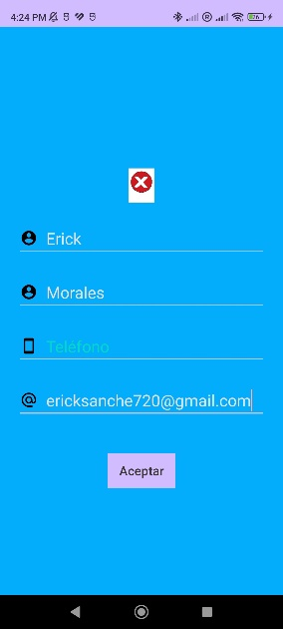 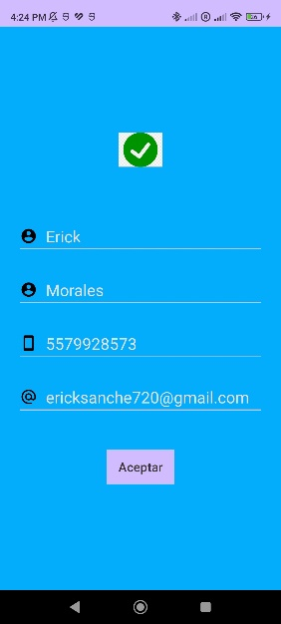 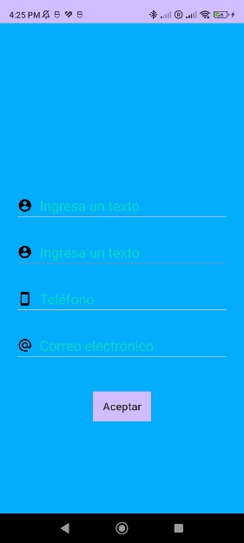

Archivo kotlin

package com.example.erickml  
  
import android.os.Bundle  
import android.view.View  
import android.widget.Button  
import android.widget.EditText  
import android.widget.ImageView  
import androidx.appcompat.app.AppCompatActivity  
  
class MainActivity : AppCompatActivity() {  
  
 private lateinit var btnAccept: Button  
 private lateinit var nombre: EditText  
 private lateinit var apellido: EditText  
 private lateinit var telefono: EditText  
 private lateinit var email: EditText  
 private lateinit var palomita: ImageView  
 private lateinit var tache: ImageView  
  
 override fun onCreate(savedInstanceState: Bundle?) {  
 super.onCreate(savedInstanceState)  
 setContentView(R.layout.*activity_main*)  
  
  
 nombre = findViewById(R.id.*nombre*)  
 apellido = findViewById(R.id.*apellido*)  
 telefono = findViewById(R.id.*telefono*)  
 email = findViewById(R.id.*email*)  
 btnAccept = findViewById(R.id.*btnAccept*)  
 palomita = findViewById(R.id.*palomita*)  
 tache = findViewById(R.id.*tache*)  
  
  
 palomita.*visibility* = View.*INVISIBLE* tache.*visibility* = View.*INVISIBLE* btnAccept.setOnClickListener **{** val nombreText = nombre.*text*.toString()  
 val apellidoText = apellido.*text*.toString()  
 val telefonoText = telefono.*text*.toString()  
 val emailText = email.*text*.toString()  
  
 if (nombreText.*isNotEmpty*() && apellidoText.*isNotEmpty*() && telefonoText.*isNotEmpty*() && emailText.*isNotEmpty*()) {  
  
 palomita.*visibility* = View.*VISIBLE* tache.*visibility* = View.*INVISIBLE* } else {  
  
 palomita.*visibility* = View.*INVISIBLE* tache.*visibility* = View.*VISIBLE* }  
 **}** }  
}

Layout

<?xml version="1.0" encoding="utf-8"?>  
  
<LinearLayout  
xmlns:android="http://schemas.android.com/apk/res/android"  
xmlns:app="http://schemas.android.com/apk/res-auto"  
xmlns:tools="http://schemas.android.com/tools"  
  
android:id="@+id/main"  
android:background="@color/azul"  
android:layout_width="match_parent"  
android:layout_height="match_parent"  
android:gravity="center"  
android:orientation="vertical"  
tools:context=".MainActivity">  
  
  
  
  
  
  
<ImageView  
 android:id="@+id/palomita"  
 android:layout_width="120dp"  
 android:layout_height="48dp"  
 android:src="@drawable/palomita"  
 />  
  
 <ImageView  
 android:id="@+id/tache"  
 android:layout_width="120dp"  
 android:layout_height="48dp"  
 android:src="@drawable/tache"  
 />  
  
  
  
  
<EditText  
 android:id="@+id/nombre"  
 android:hint="@string/add_text"  
 android:textColorHint="@color/colorAccent"  
 android:layout_width="match_parent"  
 android:layout_height="wrap_content"  
 android:layout_marginTop="24dp"  
 android:layout_marginHorizontal="24dp"  
 android:inputType="text"  
 android:drawableStart="@drawable/icono_nombre"  
 android:drawablePadding="12dp"  
 />  
 <EditText  
 android:id="@+id/apellido"  
 android:hint="@string/add_text"  
 android:textColorHint="@color/colorAccent"  
 android:layout_width="match_parent"  
 android:layout_height="wrap_content"  
 android:layout_marginTop="24dp"  
 android:layout_marginHorizontal="24dp"  
 android:inputType="text"  
 android:drawableStart="@drawable/icono_apellido"  
 android:drawablePadding="12dp"  
 />  
  
<EditText  
 android:id="@+id/telefono"  
 android:hint="@string/phone"  
 android:textColorHint="@color/colorAccent"  
 android:layout_width="match_parent"  
 android:layout_height="wrap_content"  
 android:layout_marginTop="24dp"  
 android:maxLength="10"  
 android:layout_marginHorizontal="24dp"  
 android:inputType="phone"  
 android:drawableStart="@drawable/icono_telefono"  
 android:drawablePadding="12dp"  
 />  
  
 <EditText  
 android:id="@+id/email"  
 android:hint="@string/correo_electronico"  
 android:textColorHint="@color/colorAccent"  
 android:layout_width="match_parent"  
 android:layout_height="wrap_content"  
 android:layout_marginTop="24dp"  
 android:maxLength="70"  
 android:layout_marginHorizontal="24dp"  
 android:inputType="textEmailAddress"  
 android:drawableStart="@drawable/icono_correo"  
 android:drawablePadding="12dp"  
 />  
  
 <Button  
 android:id="@+id/btnAccept"  
 android:layout_width="wrap_content"  
 android:layout_height="wrap_content"  
 android:paddingVertical="8dp"  
 android:paddingHorizontal="16dp"  
 android:background="@color/morado"  
 android:text="@string/accept_button"  
 android:textColor="@color/gris"  
 android:layout_marginTop="48dp"  
 />  
  
</LinearLayout>

Strings

<resources>  
 <string name="app_name">ErickML</string>  
 <string name="hello_text">Hola, Estas en la Sesión 1 del 2do Parcial!</string>  
 <string name="accept_button">Aceptar</string>  
 <string name="button_clicked">Haz dado click al botón!</string>  
 <string name="add_text">Ingresa un texto</string>  
 <string name="phone">Teléfono</string>  
 <string name="here_text">Aquí el texto del EditText</string>  
 <string name="correo_electronico">Correo electronico</string>  
  
</resources>

Colors

<?xml version="1.0" encoding="utf-8"?>  
<resources>  
 <color name="black">#FF000000</color>  
 <color name="white">#FFFFFFFF</color>  
 <color name="morado">#6A0259</color>  
 <color name="colorAccent">#03DAC5</color>  
 <color name="azul">#03ADFB</color>  
 <color name="gris">#3A3535</color>  
</resources>