Detection of Excess Returns in AI-Related Stocks
Erick Buitrago
Spring 2026

Abstract
This project examines whether AI-related stocks experienced statistically significant positive excess returns after the release of ChatGPT on November 30, 2022. Daily stock price data for the Magnificent Seven companies and SPY were collected from Yahoo Finance using the tidyquant package in R. Adjusted closing prices were used to calculate daily log returns, and excess returns were calculated by subtracting SPY returns from each stock’s return. The analysis focused on a 30-calendar-day window before and after the ChatGPT release. Visualizations, descriptive statistics, paired t-tests, and linear regression models were used to compare pre-event and post-event performance. The results did not provide strong statistical evidence that AI-related stocks had significantly higher excess returns after the ChatGPT release. The paired t-tests were not statistically significant, and the regression models showed that SPY returns were significant predictors, while the post-event indicator was not significant. Overall, the findings suggest that market movement explained stock returns more strongly than the ChatGPT event during this window.

Introduction
Recent advances in artificial intelligence, especially the release of ChatGPT, have increased investor attention toward major technology firms and the possibility of an “AI bubble.” Companies such as NVIDIA, Microsoft, Meta, Alphabet, Amazon, Apple, and Tesla are often connected to AI growth because of their roles in chips, cloud computing, software, platforms, and consumer technology.
This project examines whether AI-related assets showed statistically significant positive excess returns after the release of ChatGPT on November 30, 2022. In this project, “AI-related asset behavior” refers to changes in daily returns and excess returns before and after the ChatGPT release.
The main question of research is:
Do AI-related assets experience significant positive excess returns relative to the market after the release of ChatGPT?
To answer this question, this project will:
- Analyze daily returns and excess returns of major AI-related assets from 2020 to the present.
- Compare excess returns before and after the ChatGPT release.
- Evaluate performance relative to SPY.
- Test whether post-event excess returns are statistically greater than pre-event excess returns.
The hypotheses for the paired t-test are:
$$H_{0}:μ_{d}=0$$
$$H_{1}:μ_{d}>0$$
where $d=\text{post-event excess return}-\text{pre-event excess return}$.

Data Collection and Description
Daily stock price data will be collected from Yahoo Finance using the tidyquant package in R. The analysis will use adjusted closing prices to calculate daily log returns, market returns, excess returns, and a post-event indicator.
AI-related assets: The Magnificent Seven
Ticker | Company | AI Category
AAPL | Apple | AI Devices / Consumer Technology
AMZN | Amazon | AI Cloud / E-commerce
GOOGL | Alphabet | AI Search / Cloud
TSLA | Tesla | AI / Autonomous Driving
META | Meta | AI Platforms / Advertising
MSFT | Microsoft | AI Software / Cloud
NVDA | Nvidia | AI Chips / Hardware
Benchmark:
Ticker | Description
SPY | S&P 500 ETF used as the market benchmark
Key event:
- November 30, 2022: Release of ChatGPT
Relevant variables:
Variable | Type | Description
Date | Date | Trading day for each stock or benchmark
Symbol | Categorical | Stock ticker, such as NVDA, MSFT, or SPY
Adjusted closing price | Numeric | Closing price adjusted for stock splits and dividends
Daily return | Numeric | Log return calculated from adjusted closing prices
Market return | Numeric | Daily log return of SPY
Excess return | Numeric | Stock return minus SPY return
Post-event indicator | Binary | Equals 1 after the ChatGPT release and 0 before the release

Methodology
The analysis will focus on a 30-calendar-day window before and after the ChatGPT release on November 30, 2022. Visualizations will be used to examine stock price trends and excess return patterns. Descriptive statistics such as mean and standard deviation will be compared between pre-event and post-event excess returns.
Excess returns will be calculated as:
$$Excess Return=Stock Return-SPY Return$$
A paired t-test will be used to test whether average post-event excess returns are greater than average pre-event excess returns:
$$H_{0}:μ_{d}=0$$
$$H_{1}:μ_{d}>0$$
where $d=\text{post-event excess return}-\text{pre-event excess return}$.
A linear regression model will also be used to control market returns:
$$Stock Return=β_{0}+β_{1}SPY Return+β_{2}PostEvent+ϵ$$
In this model, $β_{2}$ measures whether stock returns were higher after the ChatGPT release, controlling overall market performance.

Return and Excess Return Calculation
Daily log returns are calculated using adjusted closing prices:
$$Daily Log Return=log\left(\frac{Adjusted Price_{t}}{Adjusted Price_{t-1}}\right)$$
Excess returns are calculated as:
$$Excess Return=Log Return-SPY Return$$
# Analysis and Results

Data Visualization
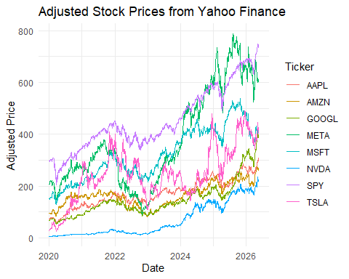
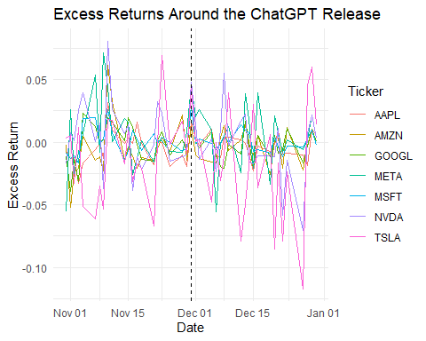

Descriptive Statistics
In the 30-calendar-day window around the ChatGPT release, the average log return across the selected stocks was negative, around -0.0027, and the average excess return was also slightly negative, around -0.00245. This suggests that, overall, the selected AI-related stocks did not strongly outperform SPY during this event window.

Paired T-Test
The paired t-test results do not provide statistically significant evidence that AI-related stocks had higher excess returns after the ChatGPT release. Although some stocks had positive average differences between post-event and pre-event excess returns, none of these differences were significant at the 5% level. Therefore, the paired t-tests do not support the alternative hypothesis.

Linear Regression
The regression model is:
$$Stock Return=β_{0}+β_{1}SPY Return+β_{2}PostEvent+ϵ$$
The regression results show that SPY return was statistically significant for all stocks, indicating that overall market movement was an important predictor of each stock’s return. However, the post-event indicator was not statistically significant for any stock. This suggests that after controlling SPY, the ChatGPT release did not produce a statistically significant increase in stock returns within the 30-calendar-day event window.

Model Diagnostics
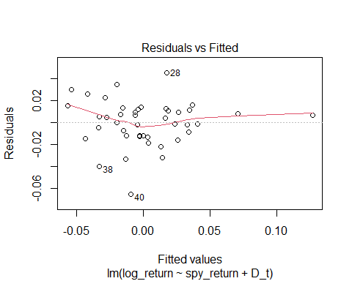
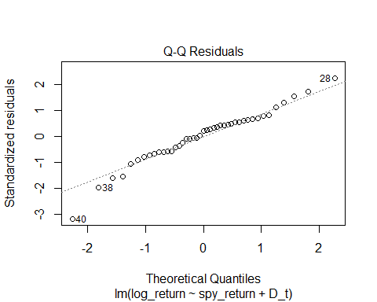
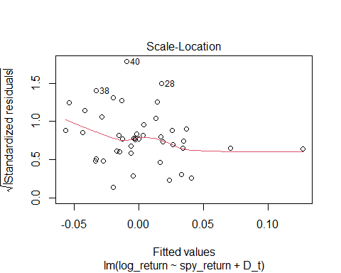
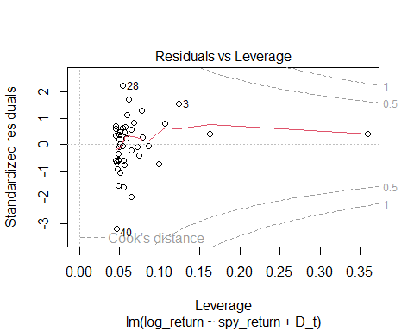
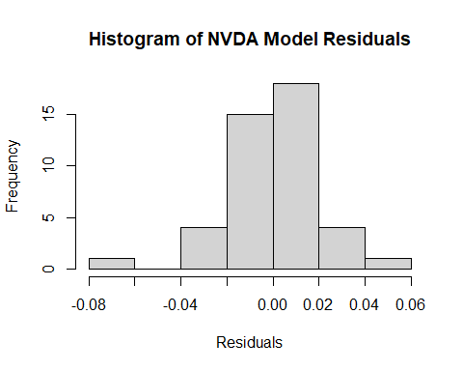
Model diagnostics were checked using NVDA as an example because NVIDIA is one of the most directly AI-related companies in the sample. The diagnostic plots help evaluate whether regression assumptions are reasonable. The residual histogram and regression diagnostic plots suggest that the model may have some deviations from normality and possible outliers, which is expected in short-window financial return data. This is a limitation of the analysis, but the regression still provides useful evidence about the relationship between NVDA returns, SPY returns, and the post-event period.

Conclusion
Overall, the results do not provide strong statistical evidence that the ChatGPT release caused significant positive excess returns for the selected AI-related stocks. The paired t-tests found no significant post-event increase in excess returns, and the regression models showed that the post-event indicator was not significant after controlling SPY. However, SPY return was significant across all models, showing that general market movement was an important driver of stock returns during the event window. Therefore, the hypothesis is not supported by the results in this analysis. A limitation is that the study focuses on one event and a short event window, so future research could compare other AI events such as DeepSeek or Claude Mythos separately.

References
Business Science. (n.d.). tidyquant: Tidy quantitative financial analysis. https://business-science.github.io/tidyquant/
Yahoo Finance. (n.d.). Historical stock price data. https://finance.yahoo.com/
OpenAI. (2022, November 30). Introducing ChatGPT. https://openai.com/index/chatgpt/
R Core Team. (2026). R: A language and environment for statistical computing. R Foundation for Statistical Computing. https://www.R-project.org/
Wickham, H., François, R., Henry, L., Müller, K., & Vaughan, D. (2023). dplyr: A grammar of data manipulation. https://dplyr.tidyverse.org/
Wickham, H. (2016). ggplot2: Elegant graphics for data analysis. Springer-Verlag New York.

Appendix

R Code
tickers <- c("AAPL", "AMZN", "GOOGL", "TSLA", "META", "MSFT", "NVDA", "SPY")
prices <- tq_get(
tickers,
from = "2020-01-01",
to = Sys.Date(),
get = "stock.prices"
)
head(prices)
## # A tibble: 6 × 8
## symbol date open high low close volume adjusted
## <chr> <date> <dbl> <dbl> <dbl> <dbl> <dbl> <dbl>
## 1 AAPL 2020-01-02 74.1 75.2 73.8 75.1 135480400 72.3
## 2 AAPL 2020-01-03 74.3 75.1 74.1 74.4 146322800 71.6
## 3 AAPL 2020-01-06 73.4 75.0 73.2 74.9 118387200 72.2
## 4 AAPL 2020-01-07 75.0 75.2 74.4 74.6 108872000 71.9
## 5 AAPL 2020-01-08 74.3 76.1 74.3 75.8 132079200 73.0
## 6 AAPL 2020-01-09 76.8 77.6 76.6 77.4 170108400 74.6
tail(prices)
## # A tibble: 6 × 8
## symbol date open high low close volume adjusted
## <chr> <date> <dbl> <dbl> <dbl> <dbl> <dbl> <dbl>
## 1 SPY 2026-05-15 742. 743. 738. 739. 60410800 739.
## 2 SPY 2026-05-18 740. 741. 733. 739. 47843900 739.
## 3 SPY 2026-05-19 735. 738. 732. 734. 54255900 734.
## 4 SPY 2026-05-20 736. 742. 734. 741. 45768000 741.
## 5 SPY 2026-05-21 739. 745. 737. 743. 43332200 743.
## 6 SPY 2026-05-22 746. 749. 744. 746. 41671800 746.
returns <- prices %>%
group_by(symbol) %>%
arrange(date) %>%
mutate(log_return = log(adjusted / lag(adjusted))) %>%
ungroup() %>%
na.omit()
head(returns)
## # A tibble: 6 × 9
## symbol date open high low close volume adjusted log_return
## <chr> <date> <dbl> <dbl> <dbl> <dbl> <dbl> <dbl> <dbl>
## 1 AAPL 2020-01-03 74.3 75.1 74.1 74.4 146322800 71.6 -0.00977
## 2 AMZN 2020-01-03 93.2 94.3 93.2 93.7 75288000 93.7 -0.0122
## 3 GOOGL 2020-01-03 67.4 68.7 67.4 68.1 23408000 67.5 -0.00524
## 4 TSLA 2020-01-03 29.4 30.3 29.1 29.5 266677500 29.5 0.0292
## 5 META 2020-01-03 207. 210. 207. 209. 11188400 207. -0.00531
## 6 MSFT 2020-01-03 158. 160. 158. 159. 21116200 150. -0.0125
SPY_returns <- returns %>%
filter(symbol == "SPY") %>%
select(date, spy_return = log_return)
head(SPY_returns)
## # A tibble: 6 × 2
## date spy_return
## <date> <dbl>
## 1 2020-01-03 -0.00760
## 2 2020-01-06 0.00381
## 3 2020-01-07 -0.00282
## 4 2020-01-08 0.00532
## 5 2020-01-09 0.00676
## 6 2020-01-10 -0.00288
excess_returns <- returns %>%
filter(symbol != "SPY") %>%
left_join(SPY_returns, by = "date") %>%
mutate(excess_return = log_return - spy_return)
head(excess_returns)
## # A tibble: 6 × 11
## symbol date open high low close volume adjusted log_return
## <chr> <date> <dbl> <dbl> <dbl> <dbl> <dbl> <dbl> <dbl>
## 1 AAPL 2020-01-03 74.3 75.1 74.1 74.4 146322800 71.6 -0.00977
## 2 AMZN 2020-01-03 93.2 94.3 93.2 93.7 75288000 93.7 -0.0122
## 3 GOOGL 2020-01-03 67.4 68.7 67.4 68.1 23408000 67.5 -0.00524
## 4 TSLA 2020-01-03 29.4 30.3 29.1 29.5 266677500 29.5 0.0292
## 5 META 2020-01-03 207. 210. 207. 209. 11188400 207. -0.00531
## 6 MSFT 2020-01-03 158. 160. 158. 159. 21116200 150. -0.0125
## # ℹ 2 more variables: spy_return <dbl>, excess_return <dbl>
releaseChatGPT <- as.Date("2022-11-30")
event_window <- excess_returns %>%
filter(date >= releaseChatGPT - 30,
date <= releaseChatGPT + 30) %>%
mutate(
D_t = ifelse(date >= releaseChatGPT, 1, 0),
period = ifelse(D_t == 1, "Post-event", "Pre-event")
)
event_window %>%
select(symbol, date, log_return, spy_return, excess_return, D_t, period) %>%
arrange(symbol, date)
## # A tibble: 301 × 7
## symbol date log_return spy_return excess_return D_t period
## <chr> <date> <dbl> <dbl> <dbl> <dbl> <chr>
## 1 AAPL 2022-10-31 -0.0155 -0.00725 -0.00828 0 Pre-event
## 2 AAPL 2022-11-01 -0.0177 -0.00439 -0.0133 0 Pre-event
## 3 AAPL 2022-11-02 -0.0380 -0.0254 -0.0126 0 Pre-event
## 4 AAPL 2022-11-03 -0.0433 -0.0104 -0.0330 0 Pre-event
## 5 AAPL 2022-11-04 -0.00195 0.0143 -0.0162 0 Pre-event
## 6 AAPL 2022-11-07 0.00389 0.00952 -0.00563 0 Pre-event
## 7 AAPL 2022-11-08 0.00417 0.00538 -0.00121 0 Pre-event
## 8 AAPL 2022-11-09 -0.0338 -0.0208 -0.0129 0 Pre-event
## 9 AAPL 2022-11-10 0.0852 0.0535 0.0317 0 Pre-event
## 10 AAPL 2022-11-11 0.0191 0.00963 0.00945 0 Pre-event
## # ℹ 291 more rows
ggplot(prices, aes(x = date, y = adjusted, color = symbol)) +
geom_line() +
labs(
title = "Adjusted Stock Prices from Yahoo Finance",
x = "Date",
y = "Adjusted Price",
color = "Ticker"
) +
theme_minimal()

ggplot(event_window, aes(x = date, y = excess_return, color = symbol)) +
geom_line() +
geom_vline(xintercept = releaseChatGPT, linetype = "dashed") +
labs(
title = "Excess Returns Around the ChatGPT Release",
x = "Date",
y = "Excess Return",
color = "Ticker"
) +
theme_minimal()

summary(event_window)
## symbol date open high
## Length:301 Min. :2022-10-31 Min. : 13.04 Min. : 13.78
## Class :character 1st Qu.:2022-11-14 1st Qu.: 90.50 1st Qu.: 91.18
## Mode :character Median :2022-11-30 Median :113.76 Median :116.27
## Mean :2022-11-29 Mean :124.57 Mean :126.45
## 3rd Qu.:2022-12-15 3rd Qu.:159.25 3rd Qu.:160.99
## Max. :2022-12-30 Max. :261.69 Max. :263.92
## low close volume adjusted
## Min. : 12.96 Min. : 13.22 Min. : 9200800 Min. : 13.20
## 1st Qu.: 88.23 1st Qu.: 89.98 1st Qu.: 30665100 1st Qu.: 89.52
## Median :111.02 Median :113.93 Median : 68086900 Median :113.04
## Mean :122.10 Mean :124.08 Mean :121364728 Mean :122.52
## 3rd Qu.:153.28 3rd Qu.:156.80 3rd Qu.:109536700 3rd Qu.:156.80
## Max. :254.31 Max. :257.22 Max. :710894000 Max. :250.10
## log_return spy_return excess_return D_t
## Min. :-0.121138 Min. :-0.0254164 Min. :-0.117187 Min. :0.0000
## 1st Qu.:-0.019788 1st Qu.:-0.0085432 1st Qu.:-0.012936 1st Qu.:0.0000
## Median :-0.004950 Median :-0.0017191 Median :-0.001215 Median :1.0000
## Mean :-0.002741 Mean :-0.0002908 Mean :-0.002450 Mean :0.5116
## 3rd Qu.: 0.012323 3rd Qu.: 0.0078034 3rd Qu.: 0.009415 3rd Qu.:1.0000
## Max. : 0.133912 Max. : 0.0534975 Max. : 0.080415 Max. :1.0000
## period
## Length:301
## Class :character
## Mode :character
##
##
##
window_aapl <- event_window %>% filter(symbol == "AAPL")
window_amzn <- event_window %>% filter(symbol == "AMZN")
window_googl <- event_window %>% filter(symbol == "GOOGL")
window_meta <- event_window %>% filter(symbol == "META")
window_msft <- event_window %>% filter(symbol == "MSFT")
window_nvda <- event_window %>% filter(symbol == "NVDA")
window_tsla <- event_window %>% filter(symbol == "TSLA")
head(window_aapl)
## # A tibble: 6 × 13
## symbol date open high low close volume adjusted log_return
## <chr> <date> <dbl> <dbl> <dbl> <dbl> <dbl> <dbl> <dbl>
## 1 AAPL 2022-10-31 153. 154. 152. 153. 97943200 151. -0.0155
## 2 AAPL 2022-11-01 155. 155. 149. 151. 80379300 148. -0.0177
## 3 AAPL 2022-11-02 149. 152. 145 145. 93604600 142. -0.0380
## 4 AAPL 2022-11-03 142. 143. 139. 139. 97918500 136. -0.0433
## 5 AAPL 2022-11-04 142. 143. 134. 138. 140814800 136. -0.00195
## 6 AAPL 2022-11-07 137. 139. 136. 139. 83374600 137. 0.00389
## # ℹ 4 more variables: spy_return <dbl>, excess_return <dbl>, D_t <dbl>,
## # period <chr>
paired_test_stock <- function(stock_window) {
before <- stock_window$excess_return[stock_window$D_t == 0]
after <- stock_window$excess_return[stock_window$D_t == 1]
n <- min(length(before), length(after))
t.test(after[1:n], before[1:n],
paired = TRUE,
alternative = "greater")
}
paired_test_stock(window_aapl)
##
## Paired t-test
##
## data: after[1:n] and before[1:n]
## t = 0.59906, df = 20, p-value = 0.2779
## alternative hypothesis: true mean difference is greater than 0
## 95 percent confidence interval:
## -0.004712905 Inf
## sample estimates:
## mean difference
## 0.00250815
paired_test_stock(window_amzn)
##
## Paired t-test
##
## data: after[1:n] and before[1:n]
## t = 0.58456, df = 20, p-value = 0.2827
## alternative hypothesis: true mean difference is greater than 0
## 95 percent confidence interval:
## -0.005620271 Inf
## sample estimates:
## mean difference
## 0.002881548
paired_test_stock(window_googl)
##
## Paired t-test
##
## data: after[1:n] and before[1:n]
## t = -0.19127, df = 20, p-value = 0.5749
## alternative hypothesis: true mean difference is greater than 0
## 95 percent confidence interval:
## -0.009734726 Inf
## sample estimates:
## mean difference
## -0.0009718055
paired_test_stock(window_meta)
##
## Paired t-test
##
## data: after[1:n] and before[1:n]
## t = 0.18879, df = 20, p-value = 0.4261
## alternative hypothesis: true mean difference is greater than 0
## 95 percent confidence interval:
## -0.01441754 Inf
## sample estimates:
## mean difference
## 0.001772173
paired_test_stock(window_msft)
##
## Paired t-test
##
## data: after[1:n] and before[1:n]
## t = 0.3259, df = 20, p-value = 0.3739
## alternative hypothesis: true mean difference is greater than 0
## 95 percent confidence interval:
## -0.004663941 Inf
## sample estimates:
## mean difference
## 0.001086626
paired_test_stock(window_nvda)
##
## Paired t-test
##
## data: after[1:n] and before[1:n]
## t = -0.81997, df = 20, p-value = 0.789
## alternative hypothesis: true mean difference is greater than 0
## 95 percent confidence interval:
## -0.02207604 Inf
## sample estimates:
## mean difference
## -0.007113493
paired_test_stock(window_tsla)
##
## Paired t-test
##
## data: after[1:n] and before[1:n]
## t = -0.42966, df = 20, p-value = 0.664
## alternative hypothesis: true mean difference is greater than 0
## 95 percent confidence interval:
## -0.02851065 Inf
## sample estimates:
## mean difference
## -0.005686012
model_aapl <- lm(log_return ~ spy_return + D_t, data = window_aapl)
model_amzn <- lm(log_return ~ spy_return + D_t, data = window_amzn)
model_googl <- lm(log_return ~ spy_return + D_t, data = window_googl)
model_meta <- lm(log_return ~ spy_return + D_t, data = window_meta)
model_msft <- lm(log_return ~ spy_return + D_t, data = window_msft)
model_nvda <- lm(log_return ~ spy_return + D_t, data = window_nvda)
model_tsla <- lm(log_return ~ spy_return + D_t, data = window_tsla)
summary(model_aapl); summary(model_amzn); summary(model_googl); summary(model_meta); summary(model_msft); summary(model_nvda); summary(model_tsla)
##
## Call:
## lm(formula = log_return ~ spy_return + D_t, data = window_aapl)
##
## Residuals:
## Min 1Q Median 3Q Max
## -0.021708 -0.005083 0.001339 0.004674 0.023341
##
## Coefficients:
## Estimate Std. Error t value Pr(>|t|)
## (Intercept) -0.005755 0.002034 -2.83 0.00725 **
## spy_return 1.533151 0.098570 15.55 < 2e-16 ***
## D_t 0.003958 0.002849 1.39 0.17234
## ---
## Signif. codes: 0 '***' 0.001 '**' 0.01 '*' 0.05 '.' 0.1 ' ' 1
##
## Residual standard error: 0.009314 on 40 degrees of freedom
## Multiple R-squared: 0.8582, Adjusted R-squared: 0.8511
## F-statistic: 121 on 2 and 40 DF, p-value: < 2.2e-16
##
## Call:
## lm(formula = log_return ~ spy_return + D_t, data = window_amzn)
##
## Residuals:
## Min 1Q Median 3Q Max
## -0.042078 -0.007569 -0.000558 0.006371 0.041601
##
## Coefficients:
## Estimate Std. Error t value Pr(>|t|)
## (Intercept) -0.006716 0.003064 -2.192 0.0343 *
## spy_return 1.810381 0.148491 12.192 4.74e-15 ***
## D_t 0.004706 0.004291 1.097 0.2794
## ---
## Signif. codes: 0 '***' 0.001 '**' 0.01 '*' 0.05 '.' 0.1 ' ' 1
##
## Residual standard error: 0.01403 on 40 degrees of freedom
## Multiple R-squared: 0.788, Adjusted R-squared: 0.7774
## F-statistic: 74.35 on 2 and 40 DF, p-value: 3.357e-14
##
## Call:
## lm(formula = log_return ~ spy_return + D_t, data = window_googl)
##
## Residuals:
## Min 1Q Median 3Q Max
## -0.035565 -0.006778 0.002203 0.009580 0.018703
##
## Coefficients:
## Estimate Std. Error t value Pr(>|t|)
## (Intercept) -0.0016586 0.0028178 -0.589 0.559
## spy_return 1.4737988 0.1365694 10.792 2.05e-13 ***
## D_t 0.0001059 0.0039467 0.027 0.979
## ---
## Signif. codes: 0 '***' 0.001 '**' 0.01 '*' 0.05 '.' 0.1 ' ' 1
##
## Residual standard error: 0.0129 on 40 degrees of freedom
## Multiple R-squared: 0.7452, Adjusted R-squared: 0.7325
## F-statistic: 58.5 on 2 and 40 DF, p-value: 1.328e-12
##
## Call:
## lm(formula = log_return ~ spy_return + D_t, data = window_meta)
##
## Residuals:
## Min 1Q Median 3Q Max
## -0.054415 -0.010774 -0.005203 0.014151 0.081128
##
## Coefficients:
## Estimate Std. Error t value Pr(>|t|)
## (Intercept) 0.003453 0.005452 0.633 0.53
## spy_return 1.635623 0.264248 6.190 2.56e-07 ***
## D_t 0.002961 0.007636 0.388 0.70
## ---
## Signif. codes: 0 '***' 0.001 '**' 0.01 '*' 0.05 '.' 0.1 ' ' 1
##
## Residual standard error: 0.02497 on 40 degrees of freedom
## Multiple R-squared: 0.4892, Adjusted R-squared: 0.4637
## F-statistic: 19.16 on 2 and 40 DF, p-value: 1.46e-06
##
## Call:
## lm(formula = log_return ~ spy_return + D_t, data = window_msft)
##
## Residuals:
## Min 1Q Median 3Q Max
## -0.0130731 -0.0043174 -0.0004044 0.0043630 0.0147871
##
## Coefficients:
## Estimate Std. Error t value Pr(>|t|)
## (Intercept) -0.0000955 0.0015959 -0.060 0.953
## spy_return 1.4871481 0.0773473 19.227 <2e-16 ***
## D_t 0.0019147 0.0022352 0.857 0.397
## ---
## Signif. codes: 0 '***' 0.001 '**' 0.01 '*' 0.05 '.' 0.1 ' ' 1
##
## Residual standard error: 0.007308 on 40 degrees of freedom
## Multiple R-squared: 0.9024, Adjusted R-squared: 0.8975
## F-statistic: 185 on 2 and 40 DF, p-value: < 2.2e-16
##
## Call:
## lm(formula = log_return ~ spy_return + D_t, data = window_nvda)
##
## Residuals:
## Min 1Q Median 3Q Max
## -0.064833 -0.012098 0.004348 0.011729 0.045205
##
## Coefficients:
## Estimate Std. Error t value Pr(>|t|)
## (Intercept) 0.004106 0.004552 0.902 0.373
## spy_return 2.299863 0.220623 10.424 5.75e-13 ***
## D_t -0.004212 0.006376 -0.661 0.513
## ---
## Signif. codes: 0 '***' 0.001 '**' 0.01 '*' 0.05 '.' 0.1 ' ' 1
##
## Residual standard error: 0.02085 on 40 degrees of freedom
## Multiple R-squared: 0.7344, Adjusted R-squared: 0.7212
## F-statistic: 55.32 on 2 and 40 DF, p-value: 3.04e-12
##
## Call:
## lm(formula = log_return ~ spy_return + D_t, data = window_tsla)
##
## Residuals:
## Min 1Q Median 3Q Max
## -0.099936 -0.020470 0.001189 0.023402 0.078668
##
## Coefficients:
## Estimate Std. Error t value Pr(>|t|)
## (Intercept) -0.012208 0.008858 -1.378 0.17580
## spy_return 1.408731 0.429328 3.281 0.00215 **
## D_t -0.003427 0.012407 -0.276 0.78378
## ---
## Signif. codes: 0 '***' 0.001 '**' 0.01 '*' 0.05 '.' 0.1 ' ' 1
##
## Residual standard error: 0.04057 on 40 degrees of freedom
## Multiple R-squared: 0.2161, Adjusted R-squared: 0.1769
## F-statistic: 5.513 on 2 and 40 DF, p-value: 0.00768
plot(model_nvda)

hist(residuals(model_nvda),
main = "Histogram of NVDA Model Residuals",
xlab = "Residuals")

shapiro.test(residuals(model_nvda))
##
## Shapiro-Wilk normality test
##
## data: residuals(model_nvda)
## W = 0.96436, p-value = 0.1997

