Codebook for dd3

2020-02-05 16:17:42

|  |  |
| --- | --- |
| Number of variables | 561 |

# Codebook summary table

|  |  |  |  |  |  |
| --- | --- | --- | --- | --- | --- |
| Label | Variable | Class | # unique values | Missing | Description |
|  | **BodyAccmean()X** | numeric | 2 | 0.00 % |  |
|  | **BodyAccmean()Y** | numeric | 2 | 0.00 % |  |
|  | **BodyAccmean()Z** | numeric | 2 | 0.00 % |  |
|  | **BodyAccstd()X** | numeric | 2 | 0.00 % |  |
|  | **BodyAccstd()Y** | numeric | 2 | 0.00 % |  |
|  | **BodyAccstd()Z** | numeric | 2 | 0.00 % |  |
|  | **BodyAccmad()X** | numeric | 2 | 0.00 % |  |
|  | **BodyAccmad()Y** | numeric | 2 | 0.00 % |  |
|  | **BodyAccmad()Z** | numeric | 2 | 0.00 % |  |
|  | **BodyAccmax()X** | numeric | 2 | 0.00 % |  |
|  | **BodyAccmax()Y** | numeric | 2 | 0.00 % |  |
|  | **BodyAccmax()Z** | numeric | 2 | 0.00 % |  |
|  | **BodyAccmin()X** | numeric | 2 | 0.00 % |  |
|  | **BodyAccmin()Y** | numeric | 2 | 0.00 % |  |
|  | **BodyAccmin()Z** | numeric | 2 | 0.00 % |  |
|  | **BodyAccsma()** | numeric | 2 | 0.00 % |  |
|  | **BodyAccenergy()X** | numeric | 2 | 0.00 % |  |
|  | **BodyAccenergy()Y** | numeric | 2 | 0.00 % |  |
|  | **BodyAccenergy()Z** | numeric | 2 | 0.00 % |  |
|  | **BodyAcciqr()X** | numeric | 2 | 0.00 % |  |
|  | **BodyAcciqr()Y** | numeric | 2 | 0.00 % |  |
|  | **BodyAcciqr()Z** | numeric | 2 | 0.00 % |  |
|  | **BodyAccentropy()X** | numeric | 2 | 0.00 % |  |
|  | **BodyAccentropy()Y** | numeric | 2 | 0.00 % |  |
|  | **BodyAccentropy()Z** | numeric | 2 | 0.00 % |  |
|  | **BodyAccarCoeff()X,1** | numeric | 2 | 0.00 % |  |
|  | **BodyAccarCoeff()X,2** | numeric | 2 | 0.00 % |  |
|  | **BodyAccarCoeff()X,3** | numeric | 2 | 0.00 % |  |
|  | **BodyAccarCoeff()X,4** | numeric | 2 | 0.00 % |  |
|  | **BodyAccarCoeff()Y,1** | numeric | 2 | 0.00 % |  |
|  | **BodyAccarCoeff()Y,2** | numeric | 2 | 0.00 % |  |
|  | **BodyAccarCoeff()Y,3** | numeric | 2 | 0.00 % |  |
|  | **BodyAccarCoeff()Y,4** | numeric | 2 | 0.00 % |  |
|  | **BodyAccarCoeff()Z,1** | numeric | 2 | 0.00 % |  |
|  | **BodyAccarCoeff()Z,2** | numeric | 2 | 0.00 % |  |
|  | **BodyAccarCoeff()Z,3** | numeric | 2 | 0.00 % |  |
|  | **BodyAccarCoeff()Z,4** | numeric | 2 | 0.00 % |  |
|  | **BodyAcccorrelation()X,Y** | numeric | 2 | 0.00 % |  |
|  | **BodyAcccorrelation()X,Z** | numeric | 2 | 0.00 % |  |
|  | **BodyAcccorrelation()Y,Z** | numeric | 2 | 0.00 % |  |
|  | **GravityAccmean()X** | numeric | 2 | 0.00 % |  |
|  | **GravityAccmean()Y** | numeric | 2 | 0.00 % |  |
|  | **GravityAccmean()Z** | numeric | 2 | 0.00 % |  |
|  | **GravityAccstd()X** | numeric | 2 | 0.00 % |  |
|  | **GravityAccstd()Y** | numeric | 2 | 0.00 % |  |
|  | **GravityAccstd()Z** | numeric | 2 | 0.00 % |  |
|  | **GravityAccmad()X** | numeric | 2 | 0.00 % |  |
|  | **GravityAccmad()Y** | numeric | 2 | 0.00 % |  |
|  | **GravityAccmad()Z** | numeric | 2 | 0.00 % |  |
|  | **GravityAccmax()X** | numeric | 2 | 0.00 % |  |
|  | **GravityAccmax()Y** | numeric | 2 | 0.00 % |  |
|  | **GravityAccmax()Z** | numeric | 2 | 0.00 % |  |
|  | **GravityAccmin()X** | numeric | 2 | 0.00 % |  |
|  | **GravityAccmin()Y** | numeric | 2 | 0.00 % |  |
|  | **GravityAccmin()Z** | numeric | 2 | 0.00 % |  |
|  | **GravityAccsma()** | numeric | 2 | 0.00 % |  |
|  | **GravityAccenergy()X** | numeric | 2 | 0.00 % |  |
|  | **GravityAccenergy()Y** | numeric | 2 | 0.00 % |  |
|  | **GravityAccenergy()Z** | numeric | 2 | 0.00 % |  |
|  | **GravityAcciqr()X** | numeric | 2 | 0.00 % |  |
|  | **GravityAcciqr()Y** | numeric | 2 | 0.00 % |  |
|  | **GravityAcciqr()Z** | numeric | 2 | 0.00 % |  |
|  | **GravityAccentropy()X** | numeric | 2 | 0.00 % |  |
|  | **GravityAccentropy()Y** | numeric | 2 | 0.00 % |  |
|  | **GravityAccentropy()Z** | numeric | 2 | 0.00 % |  |
|  | **GravityAccarCoeff()X,1** | numeric | 2 | 0.00 % |  |
|  | **GravityAccarCoeff()X,2** | numeric | 2 | 0.00 % |  |
|  | **GravityAccarCoeff()X,3** | numeric | 2 | 0.00 % |  |
|  | **GravityAccarCoeff()X,4** | numeric | 2 | 0.00 % |  |
|  | **GravityAccarCoeff()Y,1** | numeric | 2 | 0.00 % |  |
|  | **GravityAccarCoeff()Y,2** | numeric | 2 | 0.00 % |  |
|  | **GravityAccarCoeff()Y,3** | numeric | 2 | 0.00 % |  |
|  | **GravityAccarCoeff()Y,4** | numeric | 2 | 0.00 % |  |
|  | **GravityAccarCoeff()Z,1** | numeric | 2 | 0.00 % |  |
|  | **GravityAccarCoeff()Z,2** | numeric | 2 | 0.00 % |  |
|  | **GravityAccarCoeff()Z,3** | numeric | 2 | 0.00 % |  |
|  | **GravityAccarCoeff()Z,4** | numeric | 2 | 0.00 % |  |
|  | **GravityAcccorrelation()X,Y** | numeric | 2 | 0.00 % |  |
|  | **GravityAcccorrelation()X,Z** | numeric | 2 | 0.00 % |  |
|  | **GravityAcccorrelation()Y,Z** | numeric | 2 | 0.00 % |  |
|  | **BodyAccJerkmean()X** | numeric | 2 | 0.00 % |  |
|  | **BodyAccJerkmean()Y** | numeric | 2 | 0.00 % |  |
|  | **BodyAccJerkmean()Z** | numeric | 2 | 0.00 % |  |
|  | **BodyAccJerkstd()X** | numeric | 2 | 0.00 % |  |
|  | **BodyAccJerkstd()Y** | numeric | 2 | 0.00 % |  |
|  | **BodyAccJerkstd()Z** | numeric | 2 | 0.00 % |  |
|  | **BodyAccJerkmad()X** | numeric | 2 | 0.00 % |  |
|  | **BodyAccJerkmad()Y** | numeric | 2 | 0.00 % |  |
|  | **BodyAccJerkmad()Z** | numeric | 2 | 0.00 % |  |
|  | **BodyAccJerkmax()X** | numeric | 2 | 0.00 % |  |
|  | **BodyAccJerkmax()Y** | numeric | 2 | 0.00 % |  |
|  | **BodyAccJerkmax()Z** | numeric | 2 | 0.00 % |  |
|  | **BodyAccJerkmin()X** | numeric | 2 | 0.00 % |  |
|  | **BodyAccJerkmin()Y** | numeric | 2 | 0.00 % |  |
|  | **BodyAccJerkmin()Z** | numeric | 2 | 0.00 % |  |
|  | **BodyAccJerksma()** | numeric | 2 | 0.00 % |  |
|  | **BodyAccJerkenergy()X** | numeric | 2 | 0.00 % |  |
|  | **BodyAccJerkenergy()Y** | numeric | 2 | 0.00 % |  |
|  | **BodyAccJerkenergy()Z** | numeric | 2 | 0.00 % |  |
|  | **BodyAccJerkiqr()X** | numeric | 2 | 0.00 % |  |
|  | **BodyAccJerkiqr()Y** | numeric | 2 | 0.00 % |  |
|  | **BodyAccJerkiqr()Z** | numeric | 2 | 0.00 % |  |
|  | **BodyAccJerkentropy()X** | numeric | 2 | 0.00 % |  |
|  | **BodyAccJerkentropy()Y** | numeric | 2 | 0.00 % |  |
|  | **BodyAccJerkentropy()Z** | numeric | 2 | 0.00 % |  |
|  | **BodyAccJerkarCoeff()X,1** | numeric | 2 | 0.00 % |  |
|  | **BodyAccJerkarCoeff()X,2** | numeric | 2 | 0.00 % |  |
|  | **BodyAccJerkarCoeff()X,3** | numeric | 2 | 0.00 % |  |
|  | **BodyAccJerkarCoeff()X,4** | numeric | 2 | 0.00 % |  |
|  | **BodyAccJerkarCoeff()Y,1** | numeric | 2 | 0.00 % |  |
|  | **BodyAccJerkarCoeff()Y,2** | numeric | 2 | 0.00 % |  |
|  | **BodyAccJerkarCoeff()Y,3** | numeric | 2 | 0.00 % |  |
|  | **BodyAccJerkarCoeff()Y,4** | numeric | 2 | 0.00 % |  |
|  | **BodyAccJerkarCoeff()Z,1** | numeric | 2 | 0.00 % |  |
|  | **BodyAccJerkarCoeff()Z,2** | numeric | 2 | 0.00 % |  |
|  | **BodyAccJerkarCoeff()Z,3** | numeric | 2 | 0.00 % |  |
|  | **BodyAccJerkarCoeff()Z,4** | numeric | 2 | 0.00 % |  |
|  | **BodyAccJerkcorrelation()X,Y** | numeric | 2 | 0.00 % |  |
|  | **BodyAccJerkcorrelation()X,Z** | numeric | 2 | 0.00 % |  |
|  | **BodyAccJerkcorrelation()Y,Z** | numeric | 2 | 0.00 % |  |
|  | **BodyGyromean()X** | numeric | 2 | 0.00 % |  |
|  | **BodyGyromean()Y** | numeric | 2 | 0.00 % |  |
|  | **BodyGyromean()Z** | numeric | 2 | 0.00 % |  |
|  | **BodyGyrostd()X** | numeric | 2 | 0.00 % |  |
|  | **BodyGyrostd()Y** | numeric | 2 | 0.00 % |  |
|  | **BodyGyrostd()Z** | numeric | 2 | 0.00 % |  |
|  | **BodyGyromad()X** | numeric | 2 | 0.00 % |  |
|  | **BodyGyromad()Y** | numeric | 2 | 0.00 % |  |
|  | **BodyGyromad()Z** | numeric | 2 | 0.00 % |  |
|  | **BodyGyromax()X** | numeric | 2 | 0.00 % |  |
|  | **BodyGyromax()Y** | numeric | 2 | 0.00 % |  |
|  | **BodyGyromax()Z** | numeric | 2 | 0.00 % |  |
|  | **BodyGyromin()X** | numeric | 2 | 0.00 % |  |
|  | **BodyGyromin()Y** | numeric | 2 | 0.00 % |  |
|  | **BodyGyromin()Z** | numeric | 2 | 0.00 % |  |
|  | **BodyGyrosma()** | numeric | 2 | 0.00 % |  |
|  | **BodyGyroenergy()X** | numeric | 2 | 0.00 % |  |
|  | **BodyGyroenergy()Y** | numeric | 2 | 0.00 % |  |
|  | **BodyGyroenergy()Z** | numeric | 2 | 0.00 % |  |
|  | **BodyGyroiqr()X** | numeric | 2 | 0.00 % |  |
|  | **BodyGyroiqr()Y** | numeric | 2 | 0.00 % |  |
|  | **BodyGyroiqr()Z** | numeric | 2 | 0.00 % |  |
|  | **BodyGyroentropy()X** | numeric | 2 | 0.00 % |  |
|  | **BodyGyroentropy()Y** | numeric | 2 | 0.00 % |  |
|  | **BodyGyroentropy()Z** | numeric | 2 | 0.00 % |  |
|  | **BodyGyroarCoeff()X,1** | numeric | 2 | 0.00 % |  |
|  | **BodyGyroarCoeff()X,2** | numeric | 2 | 0.00 % |  |
|  | **BodyGyroarCoeff()X,3** | numeric | 2 | 0.00 % |  |
|  | **BodyGyroarCoeff()X,4** | numeric | 2 | 0.00 % |  |
|  | **BodyGyroarCoeff()Y,1** | numeric | 2 | 0.00 % |  |
|  | **BodyGyroarCoeff()Y,2** | numeric | 2 | 0.00 % |  |
|  | **BodyGyroarCoeff()Y,3** | numeric | 2 | 0.00 % |  |
|  | **BodyGyroarCoeff()Y,4** | numeric | 2 | 0.00 % |  |
|  | **BodyGyroarCoeff()Z,1** | numeric | 2 | 0.00 % |  |
|  | **BodyGyroarCoeff()Z,2** | numeric | 2 | 0.00 % |  |
|  | **BodyGyroarCoeff()Z,3** | numeric | 2 | 0.00 % |  |
|  | **BodyGyroarCoeff()Z,4** | numeric | 2 | 0.00 % |  |
|  | **BodyGyrocorrelation()X,Y** | numeric | 2 | 0.00 % |  |
|  | **BodyGyrocorrelation()X,Z** | numeric | 2 | 0.00 % |  |
|  | **BodyGyrocorrelation()Y,Z** | numeric | 2 | 0.00 % |  |
|  | **BodyGyroJerkmean()X** | numeric | 2 | 0.00 % |  |
|  | **BodyGyroJerkmean()Y** | numeric | 2 | 0.00 % |  |
|  | **BodyGyroJerkmean()Z** | numeric | 2 | 0.00 % |  |
|  | **BodyGyroJerkstd()X** | numeric | 2 | 0.00 % |  |
|  | **BodyGyroJerkstd()Y** | numeric | 2 | 0.00 % |  |
|  | **BodyGyroJerkstd()Z** | numeric | 2 | 0.00 % |  |
|  | **BodyGyroJerkmad()X** | numeric | 2 | 0.00 % |  |
|  | **BodyGyroJerkmad()Y** | numeric | 2 | 0.00 % |  |
|  | **BodyGyroJerkmad()Z** | numeric | 2 | 0.00 % |  |
|  | **BodyGyroJerkmax()X** | numeric | 2 | 0.00 % |  |
|  | **BodyGyroJerkmax()Y** | numeric | 2 | 0.00 % |  |
|  | **BodyGyroJerkmax()Z** | numeric | 2 | 0.00 % |  |
|  | **BodyGyroJerkmin()X** | numeric | 2 | 0.00 % |  |
|  | **BodyGyroJerkmin()Y** | numeric | 2 | 0.00 % |  |
|  | **BodyGyroJerkmin()Z** | numeric | 2 | 0.00 % |  |
|  | **BodyGyroJerksma()** | numeric | 2 | 0.00 % |  |
|  | **BodyGyroJerkenergy()X** | numeric | 2 | 0.00 % |  |
|  | **BodyGyroJerkenergy()Y** | numeric | 2 | 0.00 % |  |
|  | **BodyGyroJerkenergy()Z** | numeric | 2 | 0.00 % |  |
|  | **BodyGyroJerkiqr()X** | numeric | 2 | 0.00 % |  |
|  | **BodyGyroJerkiqr()Y** | numeric | 2 | 0.00 % |  |
|  | **BodyGyroJerkiqr()Z** | numeric | 2 | 0.00 % |  |
|  | **BodyGyroJerkentropy()X** | numeric | 2 | 0.00 % |  |
|  | **BodyGyroJerkentropy()Y** | numeric | 2 | 0.00 % |  |
|  | **BodyGyroJerkentropy()Z** | numeric | 2 | 0.00 % |  |
|  | **BodyGyroJerkarCoeff()X,1** | numeric | 2 | 0.00 % |  |
|  | **BodyGyroJerkarCoeff()X,2** | numeric | 2 | 0.00 % |  |
|  | **BodyGyroJerkarCoeff()X,3** | numeric | 2 | 0.00 % |  |
|  | **BodyGyroJerkarCoeff()X,4** | numeric | 2 | 0.00 % |  |
|  | **BodyGyroJerkarCoeff()Y,1** | numeric | 2 | 0.00 % |  |
|  | **BodyGyroJerkarCoeff()Y,2** | numeric | 2 | 0.00 % |  |
|  | **BodyGyroJerkarCoeff()Y,3** | numeric | 2 | 0.00 % |  |
|  | **BodyGyroJerkarCoeff()Y,4** | numeric | 2 | 0.00 % |  |
|  | **BodyGyroJerkarCoeff()Z,1** | numeric | 2 | 0.00 % |  |
|  | **BodyGyroJerkarCoeff()Z,2** | numeric | 2 | 0.00 % |  |
|  | **BodyGyroJerkarCoeff()Z,3** | numeric | 2 | 0.00 % |  |
|  | **BodyGyroJerkarCoeff()Z,4** | numeric | 2 | 0.00 % |  |
|  | **BodyGyroJerkcorrelation()X,Y** | numeric | 2 | 0.00 % |  |
|  | **BodyGyroJerkcorrelation()X,Z** | numeric | 2 | 0.00 % |  |
|  | **BodyGyroJerkcorrelation()Y,Z** | numeric | 2 | 0.00 % |  |
|  | **BodyAccMagmean()** | numeric | 2 | 0.00 % |  |
|  | **BodyAccMagstd()** | numeric | 2 | 0.00 % |  |
|  | **BodyAccMagmad()** | numeric | 2 | 0.00 % |  |
|  | **BodyAccMagmax()** | numeric | 2 | 0.00 % |  |
|  | **BodyAccMagmin()** | numeric | 2 | 0.00 % |  |
|  | **BodyAccMagsma()** | numeric | 2 | 0.00 % |  |
|  | **BodyAccMagenergy()** | numeric | 2 | 0.00 % |  |
|  | **BodyAccMagiqr()** | numeric | 2 | 0.00 % |  |
|  | **BodyAccMagentropy()** | numeric | 2 | 0.00 % |  |
|  | **BodyAccMagarCoeff()1** | numeric | 2 | 0.00 % |  |
|  | **BodyAccMagarCoeff()2** | numeric | 2 | 0.00 % |  |
|  | **BodyAccMagarCoeff()3** | numeric | 2 | 0.00 % |  |
|  | **BodyAccMagarCoeff()4** | numeric | 2 | 0.00 % |  |
|  | **GravityAccMagmean()** | numeric | 2 | 0.00 % |  |
|  | **GravityAccMagstd()** | numeric | 2 | 0.00 % |  |
|  | **GravityAccMagmad()** | numeric | 2 | 0.00 % |  |
|  | **GravityAccMagmax()** | numeric | 2 | 0.00 % |  |
|  | **GravityAccMagmin()** | numeric | 2 | 0.00 % |  |
|  | **GravityAccMagsma()** | numeric | 2 | 0.00 % |  |
|  | **GravityAccMagenergy()** | numeric | 2 | 0.00 % |  |
|  | **GravityAccMagiqr()** | numeric | 2 | 0.00 % |  |
|  | **GravityAccMagentropy()** | numeric | 2 | 0.00 % |  |
|  | **GravityAccMagarCoeff()1** | numeric | 2 | 0.00 % |  |
|  | **GravityAccMagarCoeff()2** | numeric | 2 | 0.00 % |  |
|  | **GravityAccMagarCoeff()3** | numeric | 2 | 0.00 % |  |
|  | **GravityAccMagarCoeff()4** | numeric | 2 | 0.00 % |  |
|  | **BodyAccJerkMagmean()** | numeric | 2 | 0.00 % |  |
|  | **BodyAccJerkMagstd()** | numeric | 2 | 0.00 % |  |
|  | **BodyAccJerkMagmad()** | numeric | 2 | 0.00 % |  |
|  | **BodyAccJerkMagmax()** | numeric | 2 | 0.00 % |  |
|  | **BodyAccJerkMagmin()** | numeric | 2 | 0.00 % |  |
|  | **BodyAccJerkMagsma()** | numeric | 2 | 0.00 % |  |
|  | **BodyAccJerkMagenergy()** | numeric | 2 | 0.00 % |  |
|  | **BodyAccJerkMagiqr()** | numeric | 2 | 0.00 % |  |
|  | **BodyAccJerkMagentropy()** | numeric | 2 | 0.00 % |  |
|  | **BodyAccJerkMagarCoeff()1** | numeric | 2 | 0.00 % |  |
|  | **BodyAccJerkMagarCoeff()2** | numeric | 2 | 0.00 % |  |
|  | **BodyAccJerkMagarCoeff()3** | numeric | 2 | 0.00 % |  |
|  | **BodyAccJerkMagarCoeff()4** | numeric | 2 | 0.00 % |  |
|  | **BodyGyroMagmean()** | numeric | 2 | 0.00 % |  |
|  | **BodyGyroMagstd()** | numeric | 2 | 0.00 % |  |
|  | **BodyGyroMagmad()** | numeric | 2 | 0.00 % |  |
|  | **BodyGyroMagmax()** | numeric | 2 | 0.00 % |  |
|  | **BodyGyroMagmin()** | numeric | 2 | 0.00 % |  |
|  | **BodyGyroMagsma()** | numeric | 2 | 0.00 % |  |
|  | **BodyGyroMagenergy()** | numeric | 2 | 0.00 % |  |
|  | **BodyGyroMagiqr()** | numeric | 2 | 0.00 % |  |
|  | **BodyGyroMagentropy()** | numeric | 2 | 0.00 % |  |
|  | **BodyGyroMagarCoeff()1** | numeric | 2 | 0.00 % |  |
|  | **BodyGyroMagarCoeff()2** | numeric | 2 | 0.00 % |  |
|  | **BodyGyroMagarCoeff()3** | numeric | 2 | 0.00 % |  |
|  | **BodyGyroMagarCoeff()4** | numeric | 2 | 0.00 % |  |
|  | **BodyGyroJerkMagmean()** | numeric | 2 | 0.00 % |  |
|  | **BodyGyroJerkMagstd()** | numeric | 2 | 0.00 % |  |
|  | **BodyGyroJerkMagmad()** | numeric | 2 | 0.00 % |  |
|  | **BodyGyroJerkMagmax()** | numeric | 2 | 0.00 % |  |
|  | **BodyGyroJerkMagmin()** | numeric | 2 | 0.00 % |  |
|  | **BodyGyroJerkMagsma()** | numeric | 2 | 0.00 % |  |
|  | **BodyGyroJerkMagenergy()** | numeric | 2 | 0.00 % |  |
|  | **BodyGyroJerkMagiqr()** | numeric | 2 | 0.00 % |  |
|  | **BodyGyroJerkMagentropy()** | numeric | 2 | 0.00 % |  |
|  | **BodyGyroJerkMagarCoeff()1** | numeric | 2 | 0.00 % |  |
|  | **BodyGyroJerkMagarCoeff()2** | numeric | 2 | 0.00 % |  |
|  | **BodyGyroJerkMagarCoeff()3** | numeric | 2 | 0.00 % |  |
|  | **BodyGyroJerkMagarCoeff()4** | numeric | 2 | 0.00 % |  |
|  | **V266** | numeric | 2 | 0.00 % |  |
|  | **V267** | numeric | 2 | 0.00 % |  |
|  | **V268** | numeric | 2 | 0.00 % |  |
|  | **V269** | numeric | 2 | 0.00 % |  |
|  | **V270** | numeric | 2 | 0.00 % |  |
|  | **V271** | numeric | 2 | 0.00 % |  |
|  | **V272** | numeric | 2 | 0.00 % |  |
|  | **V273** | numeric | 2 | 0.00 % |  |
|  | **V274** | numeric | 2 | 0.00 % |  |
|  | **V275** | numeric | 2 | 0.00 % |  |
|  | **V276** | numeric | 2 | 0.00 % |  |
|  | **V277** | numeric | 2 | 0.00 % |  |
|  | **V278** | numeric | 2 | 0.00 % |  |
|  | **V279** | numeric | 2 | 0.00 % |  |
|  | **V280** | numeric | 2 | 0.00 % |  |
|  | **V281** | numeric | 2 | 0.00 % |  |
|  | **V282** | numeric | 2 | 0.00 % |  |
|  | **V283** | numeric | 2 | 0.00 % |  |
|  | **V284** | numeric | 2 | 0.00 % |  |
|  | **V285** | numeric | 2 | 0.00 % |  |
|  | **V286** | numeric | 2 | 0.00 % |  |
|  | **V287** | numeric | 2 | 0.00 % |  |
|  | **V288** | numeric | 2 | 0.00 % |  |
|  | **V289** | numeric | 2 | 0.00 % |  |
|  | **V290** | numeric | 2 | 0.00 % |  |
|  | **BodyAccmaxIndsX** | numeric | 2 | 0.00 % |  |
|  | **BodyAccmaxIndsY** | numeric | 2 | 0.00 % |  |
|  | **BodyAccmaxIndsZ** | numeric | 2 | 0.00 % |  |
|  | **BodyAccmeanFreq()X** | numeric | 2 | 0.00 % |  |
|  | **BodyAccmeanFreq()Y** | numeric | 2 | 0.00 % |  |
|  | **BodyAccmeanFreq()Z** | numeric | 2 | 0.00 % |  |
|  | **BodyAccskewness()X** | numeric | 2 | 0.00 % |  |
|  | **BodyAcckurtosis()X** | numeric | 2 | 0.00 % |  |
|  | **BodyAccskewness()Y** | numeric | 2 | 0.00 % |  |
|  | **BodyAcckurtosis()Y** | numeric | 2 | 0.00 % |  |
|  | **BodyAccskewness()Z** | numeric | 2 | 0.00 % |  |
|  | **BodyAcckurtosis()Z** | numeric | 2 | 0.00 % |  |
|  | **BodyAccbandsEnergy()1,8** | numeric | 2 | 0.00 % |  |
|  | **BodyAccbandsEnergy()9,16** | numeric | 2 | 0.00 % |  |
|  | **BodyAccbandsEnergy()17,24** | numeric | 2 | 0.00 % |  |
|  | **BodyAccbandsEnergy()25,32** | numeric | 2 | 0.00 % |  |
|  | **BodyAccbandsEnergy()33,40** | numeric | 2 | 0.00 % |  |
|  | **BodyAccbandsEnergy()41,48** | numeric | 2 | 0.00 % |  |
|  | **BodyAccbandsEnergy()49,56** | numeric | 2 | 0.00 % |  |
|  | **BodyAccbandsEnergy()57,64** | numeric | 2 | 0.00 % |  |
|  | **BodyAccbandsEnergy()1,16** | numeric | 2 | 0.00 % |  |
|  | **BodyAccbandsEnergy()17,32** | numeric | 2 | 0.00 % |  |
|  | **BodyAccbandsEnergy()33,48** | numeric | 2 | 0.00 % |  |
|  | **BodyAccbandsEnergy()49,64** | numeric | 2 | 0.00 % |  |
|  | **BodyAccbandsEnergy()1,24** | numeric | 2 | 0.00 % |  |
|  | **BodyAccbandsEnergy()25,48** | numeric | 2 | 0.00 % |  |
|  | **V317** | numeric | 2 | 0.00 % |  |
|  | **V318** | numeric | 2 | 0.00 % |  |
|  | **V319** | numeric | 2 | 0.00 % |  |
|  | **V320** | numeric | 2 | 0.00 % |  |
|  | **V321** | numeric | 2 | 0.00 % |  |
|  | **V322** | numeric | 2 | 0.00 % |  |
|  | **V323** | numeric | 2 | 0.00 % |  |
|  | **V324** | numeric | 2 | 0.00 % |  |
|  | **V325** | numeric | 2 | 0.00 % |  |
|  | **V326** | numeric | 2 | 0.00 % |  |
|  | **V327** | numeric | 2 | 0.00 % |  |
|  | **V328** | numeric | 2 | 0.00 % |  |
|  | **V329** | numeric | 2 | 0.00 % |  |
|  | **V330** | numeric | 2 | 0.00 % |  |
|  | **V331** | numeric | 2 | 0.00 % |  |
|  | **V332** | numeric | 2 | 0.00 % |  |
|  | **V333** | numeric | 2 | 0.00 % |  |
|  | **V334** | numeric | 2 | 0.00 % |  |
|  | **V335** | numeric | 2 | 0.00 % |  |
|  | **V336** | numeric | 2 | 0.00 % |  |
|  | **V337** | numeric | 2 | 0.00 % |  |
|  | **V338** | numeric | 2 | 0.00 % |  |
|  | **V339** | numeric | 2 | 0.00 % |  |
|  | **V340** | numeric | 2 | 0.00 % |  |
|  | **V341** | numeric | 2 | 0.00 % |  |
|  | **V342** | numeric | 2 | 0.00 % |  |
|  | **V343** | numeric | 2 | 0.00 % |  |
|  | **V344** | numeric | 2 | 0.00 % |  |
|  | **V345** | numeric | 2 | 0.00 % |  |
|  | **V346** | numeric | 2 | 0.00 % |  |
|  | **V347** | numeric | 2 | 0.00 % |  |
|  | **V348** | numeric | 2 | 0.00 % |  |
|  | **V349** | numeric | 2 | 0.00 % |  |
|  | **V350** | numeric | 2 | 0.00 % |  |
|  | **V351** | numeric | 2 | 0.00 % |  |
|  | **V352** | numeric | 2 | 0.00 % |  |
|  | **V353** | numeric | 2 | 0.00 % |  |
|  | **V354** | numeric | 2 | 0.00 % |  |
|  | **V355** | numeric | 2 | 0.00 % |  |
|  | **V356** | numeric | 2 | 0.00 % |  |
|  | **V357** | numeric | 2 | 0.00 % |  |
|  | **V358** | numeric | 2 | 0.00 % |  |
|  | **V359** | numeric | 2 | 0.00 % |  |
|  | **V360** | numeric | 2 | 0.00 % |  |
|  | **V361** | numeric | 2 | 0.00 % |  |
|  | **V362** | numeric | 2 | 0.00 % |  |
|  | **V363** | numeric | 2 | 0.00 % |  |
|  | **V364** | numeric | 2 | 0.00 % |  |
|  | **V365** | numeric | 2 | 0.00 % |  |
|  | **V366** | numeric | 2 | 0.00 % |  |
|  | **V367** | numeric | 2 | 0.00 % |  |
|  | **V368** | numeric | 2 | 0.00 % |  |
|  | **V369** | numeric | 2 | 0.00 % |  |
|  | **BodyAccJerkmaxIndsX** | numeric | 2 | 0.00 % |  |
|  | **BodyAccJerkmaxIndsY** | numeric | 2 | 0.00 % |  |
|  | **BodyAccJerkmaxIndsZ** | numeric | 2 | 0.00 % |  |
|  | **BodyAccJerkmeanFreq()X** | numeric | 2 | 0.00 % |  |
|  | **BodyAccJerkmeanFreq()Y** | numeric | 2 | 0.00 % |  |
|  | **BodyAccJerkmeanFreq()Z** | numeric | 2 | 0.00 % |  |
|  | **BodyAccJerkskewness()X** | numeric | 2 | 0.00 % |  |
|  | **BodyAccJerkkurtosis()X** | numeric | 2 | 0.00 % |  |
|  | **BodyAccJerkskewness()Y** | numeric | 2 | 0.00 % |  |
|  | **BodyAccJerkkurtosis()Y** | numeric | 2 | 0.00 % |  |
|  | **BodyAccJerkskewness()Z** | numeric | 2 | 0.00 % |  |
|  | **BodyAccJerkkurtosis()Z** | numeric | 2 | 0.00 % |  |
|  | **BodyAccJerkbandsEnergy()1,8** | numeric | 2 | 0.00 % |  |
|  | **BodyAccJerkbandsEnergy()9,16** | numeric | 2 | 0.00 % |  |
|  | **BodyAccJerkbandsEnergy()17,24** | numeric | 2 | 0.00 % |  |
|  | **BodyAccJerkbandsEnergy()25,32** | numeric | 2 | 0.00 % |  |
|  | **BodyAccJerkbandsEnergy()33,40** | numeric | 2 | 0.00 % |  |
|  | **BodyAccJerkbandsEnergy()41,48** | numeric | 2 | 0.00 % |  |
|  | **BodyAccJerkbandsEnergy()49,56** | numeric | 2 | 0.00 % |  |
|  | **BodyAccJerkbandsEnergy()57,64** | numeric | 2 | 0.00 % |  |
|  | **BodyAccJerkbandsEnergy()1,16** | numeric | 2 | 0.00 % |  |
|  | **BodyAccJerkbandsEnergy()17,32** | numeric | 2 | 0.00 % |  |
|  | **BodyAccJerkbandsEnergy()33,48** | numeric | 2 | 0.00 % |  |
|  | **BodyAccJerkbandsEnergy()49,64** | numeric | 2 | 0.00 % |  |
|  | **BodyAccJerkbandsEnergy()1,24** | numeric | 2 | 0.00 % |  |
|  | **BodyAccJerkbandsEnergy()25,48** | numeric | 2 | 0.00 % |  |
|  | **V396** | numeric | 2 | 0.00 % |  |
|  | **V397** | numeric | 2 | 0.00 % |  |
|  | **V398** | numeric | 2 | 0.00 % |  |
|  | **V399** | numeric | 2 | 0.00 % |  |
|  | **V400** | numeric | 2 | 0.00 % |  |
|  | **V401** | numeric | 2 | 0.00 % |  |
|  | **V402** | numeric | 2 | 0.00 % |  |
|  | **V403** | numeric | 2 | 0.00 % |  |
|  | **V404** | numeric | 2 | 0.00 % |  |
|  | **V405** | numeric | 2 | 0.00 % |  |
|  | **V406** | numeric | 2 | 0.00 % |  |
|  | **V407** | numeric | 2 | 0.00 % |  |
|  | **V408** | numeric | 2 | 0.00 % |  |
|  | **V409** | numeric | 2 | 0.00 % |  |
|  | **V410** | numeric | 2 | 0.00 % |  |
|  | **V411** | numeric | 2 | 0.00 % |  |
|  | **V412** | numeric | 2 | 0.00 % |  |
|  | **V413** | numeric | 2 | 0.00 % |  |
|  | **V414** | numeric | 2 | 0.00 % |  |
|  | **V415** | numeric | 2 | 0.00 % |  |
|  | **V416** | numeric | 2 | 0.00 % |  |
|  | **V417** | numeric | 2 | 0.00 % |  |
|  | **V418** | numeric | 2 | 0.00 % |  |
|  | **V419** | numeric | 2 | 0.00 % |  |
|  | **V420** | numeric | 2 | 0.00 % |  |
|  | **V421** | numeric | 2 | 0.00 % |  |
|  | **V422** | numeric | 2 | 0.00 % |  |
|  | **V423** | numeric | 2 | 0.00 % |  |
|  | **V424** | numeric | 2 | 0.00 % |  |
|  | **V425** | numeric | 2 | 0.00 % |  |
|  | **V426** | numeric | 2 | 0.00 % |  |
|  | **V427** | numeric | 2 | 0.00 % |  |
|  | **V428** | numeric | 2 | 0.00 % |  |
|  | **V429** | numeric | 2 | 0.00 % |  |
|  | **V430** | numeric | 2 | 0.00 % |  |
|  | **V431** | numeric | 2 | 0.00 % |  |
|  | **V432** | numeric | 2 | 0.00 % |  |
|  | **V433** | numeric | 2 | 0.00 % |  |
|  | **V434** | numeric | 2 | 0.00 % |  |
|  | **V435** | numeric | 2 | 0.00 % |  |
|  | **V436** | numeric | 2 | 0.00 % |  |
|  | **V437** | numeric | 2 | 0.00 % |  |
|  | **V438** | numeric | 2 | 0.00 % |  |
|  | **V439** | numeric | 2 | 0.00 % |  |
|  | **V440** | numeric | 2 | 0.00 % |  |
|  | **V441** | numeric | 2 | 0.00 % |  |
|  | **V442** | numeric | 2 | 0.00 % |  |
|  | **V443** | numeric | 2 | 0.00 % |  |
|  | **V444** | numeric | 2 | 0.00 % |  |
|  | **V445** | numeric | 2 | 0.00 % |  |
|  | **V446** | numeric | 2 | 0.00 % |  |
|  | **V447** | numeric | 2 | 0.00 % |  |
|  | **V448** | numeric | 2 | 0.00 % |  |
|  | **BodyGyromaxIndsX** | numeric | 2 | 0.00 % |  |
|  | **BodyGyromaxIndsY** | numeric | 2 | 0.00 % |  |
|  | **BodyGyromaxIndsZ** | numeric | 2 | 0.00 % |  |
|  | **BodyGyromeanFreq()X** | numeric | 2 | 0.00 % |  |
|  | **BodyGyromeanFreq()Y** | numeric | 2 | 0.00 % |  |
|  | **BodyGyromeanFreq()Z** | numeric | 2 | 0.00 % |  |
|  | **BodyGyroskewness()X** | numeric | 2 | 0.00 % |  |
|  | **BodyGyrokurtosis()X** | numeric | 2 | 0.00 % |  |
|  | **BodyGyroskewness()Y** | numeric | 2 | 0.00 % |  |
|  | **BodyGyrokurtosis()Y** | numeric | 2 | 0.00 % |  |
|  | **BodyGyroskewness()Z** | numeric | 2 | 0.00 % |  |
|  | **BodyGyrokurtosis()Z** | numeric | 2 | 0.00 % |  |
|  | **BodyGyrobandsEnergy()1,8** | numeric | 2 | 0.00 % |  |
|  | **BodyGyrobandsEnergy()9,16** | numeric | 2 | 0.00 % |  |
|  | **BodyGyrobandsEnergy()17,24** | numeric | 2 | 0.00 % |  |
|  | **BodyGyrobandsEnergy()25,32** | numeric | 2 | 0.00 % |  |
|  | **BodyGyrobandsEnergy()33,40** | numeric | 2 | 0.00 % |  |
|  | **BodyGyrobandsEnergy()41,48** | numeric | 2 | 0.00 % |  |
|  | **BodyGyrobandsEnergy()49,56** | numeric | 2 | 0.00 % |  |
|  | **BodyGyrobandsEnergy()57,64** | numeric | 2 | 0.00 % |  |
|  | **BodyGyrobandsEnergy()1,16** | numeric | 2 | 0.00 % |  |
|  | **BodyGyrobandsEnergy()17,32** | numeric | 2 | 0.00 % |  |
|  | **BodyGyrobandsEnergy()33,48** | numeric | 2 | 0.00 % |  |
|  | **BodyGyrobandsEnergy()49,64** | numeric | 2 | 0.00 % |  |
|  | **BodyGyrobandsEnergy()1,24** | numeric | 2 | 0.00 % |  |
|  | **BodyGyrobandsEnergy()25,48** | numeric | 2 | 0.00 % |  |
|  | **V475** | numeric | 2 | 0.00 % |  |
|  | **V476** | numeric | 2 | 0.00 % |  |
|  | **V477** | numeric | 2 | 0.00 % |  |
|  | **V478** | numeric | 2 | 0.00 % |  |
|  | **V479** | numeric | 2 | 0.00 % |  |
|  | **V480** | numeric | 2 | 0.00 % |  |
|  | **V481** | numeric | 2 | 0.00 % |  |
|  | **V482** | numeric | 2 | 0.00 % |  |
|  | **V483** | numeric | 2 | 0.00 % |  |
|  | **V484** | numeric | 2 | 0.00 % |  |
|  | **V485** | numeric | 2 | 0.00 % |  |
|  | **V486** | numeric | 2 | 0.00 % |  |
|  | **V487** | numeric | 2 | 0.00 % |  |
|  | **V488** | numeric | 2 | 0.00 % |  |
|  | **V489** | numeric | 2 | 0.00 % |  |
|  | **V490** | numeric | 2 | 0.00 % |  |
|  | **V491** | numeric | 2 | 0.00 % |  |
|  | **V492** | numeric | 2 | 0.00 % |  |
|  | **V493** | numeric | 2 | 0.00 % |  |
|  | **V494** | numeric | 2 | 0.00 % |  |
|  | **V495** | numeric | 2 | 0.00 % |  |
|  | **V496** | numeric | 2 | 0.00 % |  |
|  | **V497** | numeric | 2 | 0.00 % |  |
|  | **V498** | numeric | 2 | 0.00 % |  |
|  | **V499** | numeric | 2 | 0.00 % |  |
|  | **V500** | numeric | 2 | 0.00 % |  |
|  | **V501** | numeric | 2 | 0.00 % |  |
|  | **V502** | numeric | 2 | 0.00 % |  |
|  | **V503** | numeric | 2 | 0.00 % |  |
|  | **V504** | numeric | 2 | 0.00 % |  |
|  | **V505** | numeric | 2 | 0.00 % |  |
|  | **V506** | numeric | 2 | 0.00 % |  |
|  | **V507** | numeric | 2 | 0.00 % |  |
|  | **V508** | numeric | 2 | 0.00 % |  |
|  | **V509** | numeric | 2 | 0.00 % |  |
|  | **V510** | numeric | 2 | 0.00 % |  |
|  | **V511** | numeric | 2 | 0.00 % |  |
|  | **BodyAccMagmaxInds** | numeric | 2 | 0.00 % |  |
|  | **BodyAccMagmeanFreq()** | numeric | 2 | 0.00 % |  |
|  | **BodyAccMagskewness()** | numeric | 2 | 0.00 % |  |
|  | **BodyAccMagkurtosis()** | numeric | 2 | 0.00 % |  |
|  | **BodyBodyAccJerkMagmean()** | numeric | 2 | 0.00 % |  |
|  | **BodyBodyAccJerkMagstd()** | numeric | 2 | 0.00 % |  |
|  | **BodyBodyAccJerkMagmad()** | numeric | 2 | 0.00 % |  |
|  | **BodyBodyAccJerkMagmax()** | numeric | 2 | 0.00 % |  |
|  | **BodyBodyAccJerkMagmin()** | numeric | 2 | 0.00 % |  |
|  | **BodyBodyAccJerkMagsma()** | numeric | 2 | 0.00 % |  |
|  | **BodyBodyAccJerkMagenergy()** | numeric | 2 | 0.00 % |  |
|  | **BodyBodyAccJerkMagiqr()** | numeric | 2 | 0.00 % |  |
|  | **BodyBodyAccJerkMagentropy()** | numeric | 2 | 0.00 % |  |
|  | **BodyBodyAccJerkMagmaxInds** | numeric | 2 | 0.00 % |  |
|  | **BodyBodyAccJerkMagmeanFreq()** | numeric | 2 | 0.00 % |  |
|  | **BodyBodyAccJerkMagskewness()** | numeric | 2 | 0.00 % |  |
|  | **BodyBodyAccJerkMagkurtosis()** | numeric | 2 | 0.00 % |  |
|  | **BodyBodyGyroMagmean()** | numeric | 2 | 0.00 % |  |
|  | **BodyBodyGyroMagstd()** | numeric | 2 | 0.00 % |  |
|  | **BodyBodyGyroMagmad()** | numeric | 2 | 0.00 % |  |
|  | **BodyBodyGyroMagmax()** | numeric | 2 | 0.00 % |  |
|  | **BodyBodyGyroMagmin()** | numeric | 2 | 0.00 % |  |
|  | **BodyBodyGyroMagsma()** | numeric | 2 | 0.00 % |  |
|  | **BodyBodyGyroMagenergy()** | numeric | 2 | 0.00 % |  |
|  | **BodyBodyGyroMagiqr()** | numeric | 2 | 0.00 % |  |
|  | **BodyBodyGyroMagentropy()** | numeric | 2 | 0.00 % |  |
|  | **BodyBodyGyroMagmaxInds** | numeric | 2 | 0.00 % |  |
|  | **BodyBodyGyroMagmeanFreq()** | numeric | 2 | 0.00 % |  |
|  | **BodyBodyGyroMagskewness()** | numeric | 2 | 0.00 % |  |
|  | **BodyBodyGyroMagkurtosis()** | numeric | 2 | 0.00 % |  |
|  | **BodyBodyGyroJerkMagmean()** | numeric | 2 | 0.00 % |  |
|  | **BodyBodyGyroJerkMagstd()** | numeric | 2 | 0.00 % |  |
|  | **BodyBodyGyroJerkMagmad()** | numeric | 2 | 0.00 % |  |
|  | **BodyBodyGyroJerkMagmax()** | numeric | 2 | 0.00 % |  |
|  | **BodyBodyGyroJerkMagmin()** | numeric | 2 | 0.00 % |  |
|  | **BodyBodyGyroJerkMagsma()** | numeric | 2 | 0.00 % |  |
|  | **BodyBodyGyroJerkMagenergy()** | numeric | 2 | 0.00 % |  |
|  | **BodyBodyGyroJerkMagiqr()** | numeric | 2 | 0.00 % |  |
|  | **BodyBodyGyroJerkMagentropy()** | numeric | 2 | 0.00 % |  |
|  | **BodyBodyGyroJerkMagmaxInds** | numeric | 2 | 0.00 % |  |
|  | **BodyBodyGyroJerkMagmeanFreq()** | numeric | 2 | 0.00 % |  |
|  | **BodyBodyGyroJerkMagskewness()** | numeric | 2 | 0.00 % |  |
|  | **BodyBodyGyroJerkMagkurtosis()** | numeric | 2 | 0.00 % |  |
|  | **ngle(tBodyAccMean,gravity)** | numeric | 2 | 0.00 % |  |
|  | **ngle(tBodyAccJerkMean),gravit** | numeric | 2 | 0.00 % |  |
|  | **ngle(tBodyGyroMean,gravityMea** | numeric | 2 | 0.00 % |  |
|  | **ngle(tBodyGyroJerkMean,gravit** | numeric | 2 | 0.00 % |  |
|  | **ngle(X,gravityMean)** | numeric | 2 | 0.00 % |  |
|  | **ngle(Y,gravityMean)** | numeric | 2 | 0.00 % |  |
|  | **ngle(Z,gravityMean)** | numeric | 2 | 0.00 % |  |

# Variable list

## BodyAccmean()X

|  |  |
| --- | --- |
| Feature | Result |
| Variable type | numeric |
| Number of missing obs. | 0 (0 %) |
| Number of unique values | 2 |
| Median | 0.28 |
| 1st and 3rd quartiles | 0.28; 0.28 |
| Min. and max. | 0.27; 0.28 |

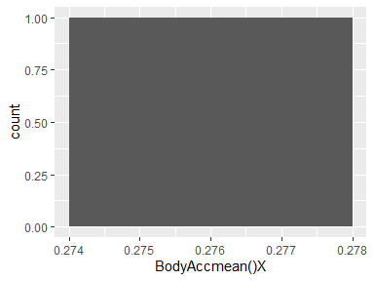

## BodyAccmean()Y

|  |  |
| --- | --- |
| Feature | Result |
| Variable type | numeric |
| Number of missing obs. | 0 (0 %) |
| Number of unique values | 2 |
| Median | -0.02 |
| 1st and 3rd quartiles | -0.02; -0.02 |
| Min. and max. | -0.02; -0.02 |

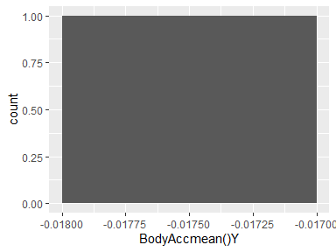

## BodyAccmean()Z

|  |  |
| --- | --- |
| Feature | Result |
| Variable type | numeric |
| Number of missing obs. | 0 (0 %) |
| Number of unique values | 2 |
| Median | -0.11 |
| 1st and 3rd quartiles | -0.11; -0.11 |
| Min. and max. | -0.11; -0.11 |

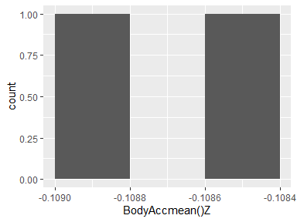

## BodyAccstd()X

|  |  |
| --- | --- |
| Feature | Result |
| Variable type | numeric |
| Number of missing obs. | 0 (0 %) |
| Number of unique values | 2 |
| Median | -0.78 |
| 1st and 3rd quartiles | -0.86; -0.69 |
| Min. and max. | -0.94; -0.61 |

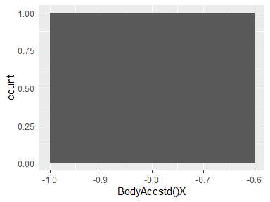

## BodyAccstd()Y

|  |  |
| --- | --- |
| Feature | Result |
| Variable type | numeric |
| Number of missing obs. | 0 (0 %) |
| Number of unique values | 2 |
| Median | -0.67 |
| 1st and 3rd quartiles | -0.75; -0.59 |
| Min. and max. | -0.84; -0.51 |

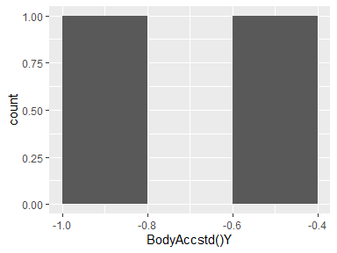

## BodyAccstd()Z

|  |  |
| --- | --- |
| Feature | Result |
| Variable type | numeric |
| Number of missing obs. | 0 (0 %) |
| Number of unique values | 2 |
| Median | -0.73 |
| 1st and 3rd quartiles | -0.79; -0.67 |
| Min. and max. | -0.85; -0.61 |

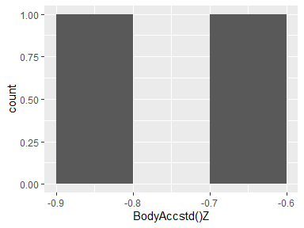

## BodyAccmad()X

|  |  |
| --- | --- |
| Feature | Result |
| Variable type | numeric |
| Number of missing obs. | 0 (0 %) |
| Number of unique values | 2 |
| Median | -0.79 |
| 1st and 3rd quartiles | -0.87; -0.71 |
| Min. and max. | -0.95; -0.63 |

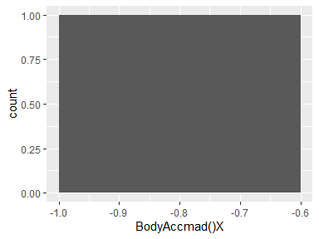

## BodyAccmad()Y

|  |  |
| --- | --- |
| Feature | Result |
| Variable type | numeric |
| Number of missing obs. | 0 (0 %) |
| Number of unique values | 2 |
| Median | -0.68 |
| 1st and 3rd quartiles | -0.76; -0.61 |
| Min. and max. | -0.84; -0.53 |

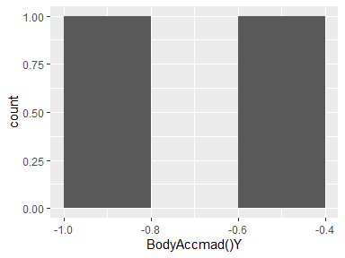

## BodyAccmad()Z

|  |  |
| --- | --- |
| Feature | Result |
| Variable type | numeric |
| Number of missing obs. | 0 (0 %) |
| Number of unique values | 2 |
| Median | -0.73 |
| 1st and 3rd quartiles | -0.79; -0.67 |
| Min. and max. | -0.85; -0.61 |

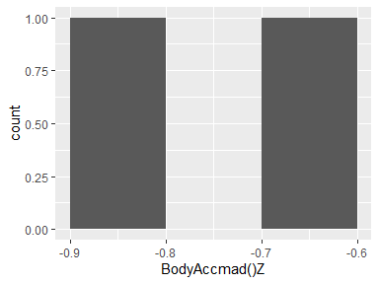

## BodyAccmax()X

|  |  |
| --- | --- |
| Feature | Result |
| Variable type | numeric |
| Number of missing obs. | 0 (0 %) |
| Number of unique values | 2 |
| Median | -0.67 |
| 1st and 3rd quartiles | -0.77; -0.57 |
| Min. and max. | -0.87; -0.47 |

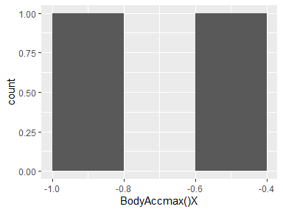

## BodyAccmax()Y

|  |  |
| --- | --- |
| Feature | Result |
| Variable type | numeric |
| Number of missing obs. | 0 (0 %) |
| Number of unique values | 2 |
| Median | -0.39 |
| 1st and 3rd quartiles | -0.43; -0.35 |
| Min. and max. | -0.47; -0.31 |

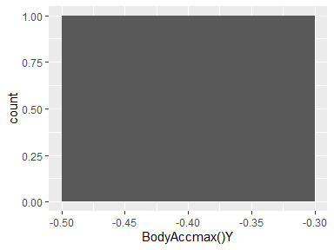

## BodyAccmax()Z

|  |  |
| --- | --- |
| Feature | Result |
| Variable type | numeric |
| Number of missing obs. | 0 (0 %) |
| Number of unique values | 2 |
| Median | -0.64 |
| 1st and 3rd quartiles | -0.68; -0.6 |
| Min. and max. | -0.72; -0.56 |

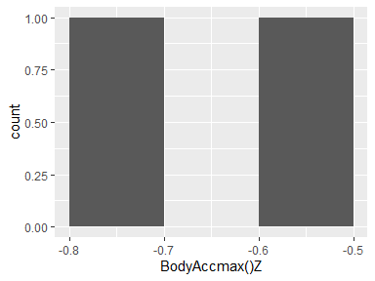

## BodyAccmin()X

|  |  |
| --- | --- |
| Feature | Result |
| Variable type | numeric |
| Number of missing obs. | 0 (0 %) |
| Number of unique values | 2 |
| Median | 0.65 |
| 1st and 3rd quartiles | 0.59; 0.72 |
| Min. and max. | 0.53; 0.78 |

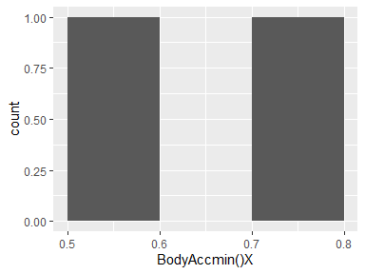

## BodyAccmin()Y

|  |  |
| --- | --- |
| Feature | Result |
| Variable type | numeric |
| Number of missing obs. | 0 (0 %) |
| Number of unique values | 2 |
| Median | 0.5 |
| 1st and 3rd quartiles | 0.45; 0.56 |
| Min. and max. | 0.39; 0.62 |

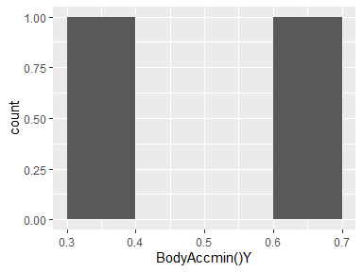

## BodyAccmin()Z

|  |  |
| --- | --- |
| Feature | Result |
| Variable type | numeric |
| Number of missing obs. | 0 (0 %) |
| Number of unique values | 2 |
| Median | 0.69 |
| 1st and 3rd quartiles | 0.64; 0.73 |
| Min. and max. | 0.6; 0.77 |

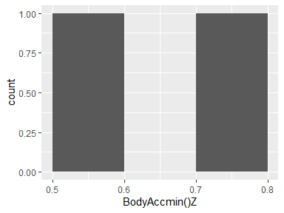

## BodyAccsma()

|  |  |
| --- | --- |
| Feature | Result |
| Variable type | numeric |
| Number of missing obs. | 0 (0 %) |
| Number of unique values | 2 |
| Median | -0.71 |
| 1st and 3rd quartiles | -0.8; -0.63 |
| Min. and max. | -0.88; -0.55 |

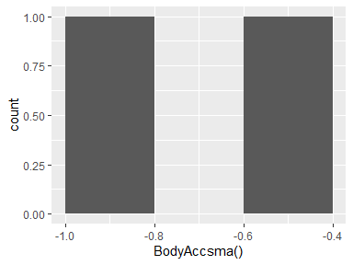

## BodyAccenergy()X

|  |  |
| --- | --- |
| Feature | Result |
| Variable type | numeric |
| Number of missing obs. | 0 (0 %) |
| Number of unique values | 2 |
| Median | -0.91 |
| 1st and 3rd quartiles | -0.95; -0.87 |
| Min. and max. | -1; -0.83 |

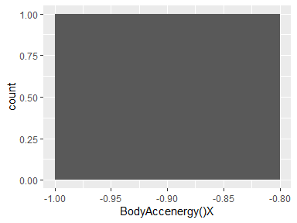

## BodyAccenergy()Y

|  |  |
| --- | --- |
| Feature | Result |
| Variable type | numeric |
| Number of missing obs. | 0 (0 %) |
| Number of unique values | 2 |
| Median | -0.95 |
| 1st and 3rd quartiles | -0.97; -0.93 |
| Min. and max. | -0.99; -0.9 |

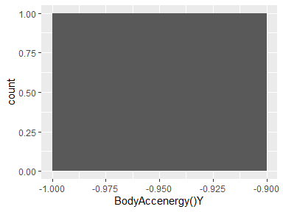

## BodyAccenergy()Z

|  |  |
| --- | --- |
| Feature | Result |
| Variable type | numeric |
| Number of missing obs. | 0 (0 %) |
| Number of unique values | 2 |
| Median | -0.92 |
| 1st and 3rd quartiles | -0.95; -0.89 |
| Min. and max. | -0.98; -0.85 |

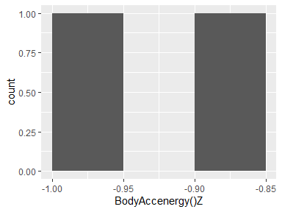

## BodyAcciqr()X

|  |  |
| --- | --- |
| Feature | Result |
| Variable type | numeric |
| Number of missing obs. | 0 (0 %) |
| Number of unique values | 2 |
| Median | -0.82 |
| 1st and 3rd quartiles | -0.89; -0.76 |
| Min. and max. | -0.96; -0.69 |

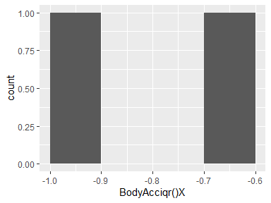

## BodyAcciqr()Y

|  |  |
| --- | --- |
| Feature | Result |
| Variable type | numeric |
| Number of missing obs. | 0 (0 %) |
| Number of unique values | 2 |
| Median | -0.76 |
| 1st and 3rd quartiles | -0.82; -0.7 |
| Min. and max. | -0.88; -0.64 |

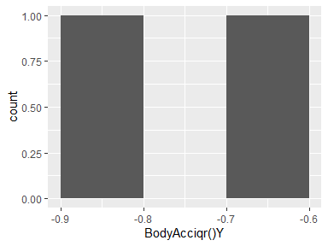

## BodyAcciqr()Z

|  |  |
| --- | --- |
| Feature | Result |
| Variable type | numeric |
| Number of missing obs. | 0 (0 %) |
| Number of unique values | 2 |
| Median | -0.75 |
| 1st and 3rd quartiles | -0.8; -0.69 |
| Min. and max. | -0.85; -0.64 |

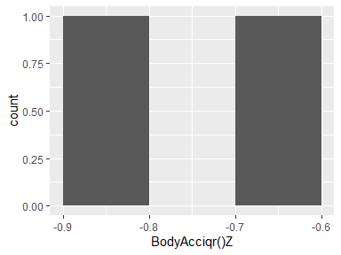

## BodyAccentropy()X

|  |  |
| --- | --- |
| Feature | Result |
| Variable type | numeric |
| Number of missing obs. | 0 (0 %) |
| Number of unique values | 2 |
| Median | -0.08 |
| 1st and 3rd quartiles | -0.09; -0.07 |
| Min. and max. | -0.1; -0.06 |

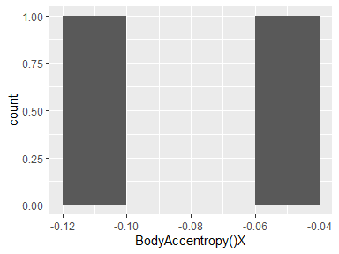

## BodyAccentropy()Y

|  |  |
| --- | --- |
| Feature | Result |
| Variable type | numeric |
| Number of missing obs. | 0 (0 %) |
| Number of unique values | 2 |
| Median | -0.12 |
| 1st and 3rd quartiles | -0.12; -0.11 |
| Min. and max. | -0.13; -0.1 |

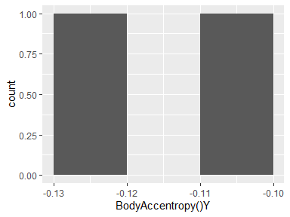

## BodyAccentropy()Z

|  |  |
| --- | --- |
| Feature | Result |
| Variable type | numeric |
| Number of missing obs. | 0 (0 %) |
| Number of unique values | 2 |
| Median | -0.15 |
| 1st and 3rd quartiles | -0.15; -0.14 |
| Min. and max. | -0.16; -0.14 |

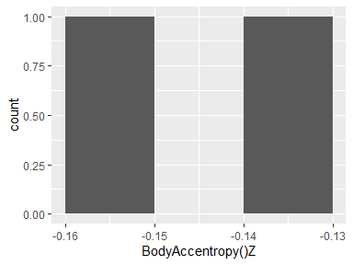

## BodyAccarCoeff()X,1

|  |  |
| --- | --- |
| Feature | Result |
| Variable type | numeric |
| Number of missing obs. | 0 (0 %) |
| Number of unique values | 2 |
| Median | -0.13 |
| 1st and 3rd quartiles | -0.13; -0.12 |
| Min. and max. | -0.14; -0.12 |

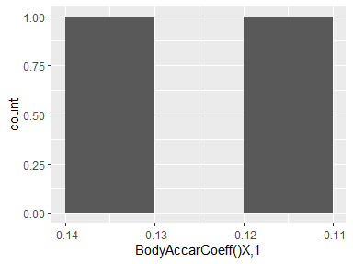

## BodyAccarCoeff()X,2

|  |  |
| --- | --- |
| Feature | Result |
| Variable type | numeric |
| Number of missing obs. | 0 (0 %) |
| Number of unique values | 2 |
| Median | 0.09 |
| 1st and 3rd quartiles | 0.09; 0.1 |
| Min. and max. | 0.08; 0.11 |

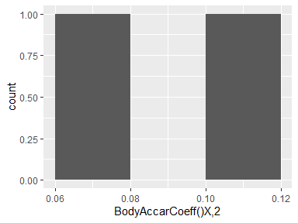

## BodyAccarCoeff()X,3

|  |  |
| --- | --- |
| Feature | Result |
| Variable type | numeric |
| Number of missing obs. | 0 (0 %) |
| Number of unique values | 2 |
| Median | -0.03 |
| 1st and 3rd quartiles | -0.03; -0.02 |
| Min. and max. | -0.04; -0.02 |

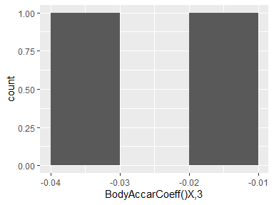

## BodyAccarCoeff()X,4

|  |  |
| --- | --- |
| Feature | Result |
| Variable type | numeric |
| Number of missing obs. | 0 (0 %) |
| Number of unique values | 2 |
| Median | 0.12 |
| 1st and 3rd quartiles | 0.12; 0.13 |
| Min. and max. | 0.12; 0.13 |

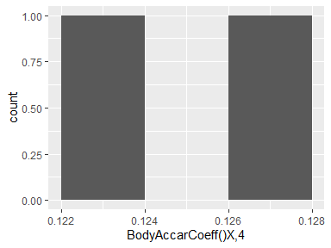

## BodyAccarCoeff()Y,1

|  |  |
| --- | --- |
| Feature | Result |
| Variable type | numeric |
| Number of missing obs. | 0 (0 %) |
| Number of unique values | 2 |
| Median | -0.04 |
| 1st and 3rd quartiles | -0.04; -0.03 |
| Min. and max. | -0.05; -0.03 |

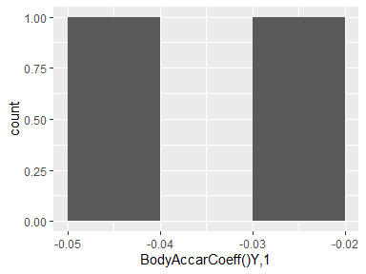

## BodyAccarCoeff()Y,2

|  |  |
| --- | --- |
| Feature | Result |
| Variable type | numeric |
| Number of missing obs. | 0 (0 %) |
| Number of unique values | 2 |
| Median | 0.02 |
| 1st and 3rd quartiles | 0.02; 0.03 |
| Min. and max. | 0.02; 0.03 |

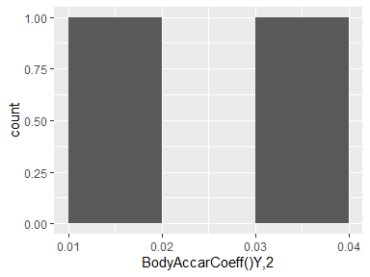

## BodyAccarCoeff()Y,3

|  |  |
| --- | --- |
| Feature | Result |
| Variable type | numeric |
| Number of missing obs. | 0 (0 %) |
| Number of unique values | 2 |
| Median | 0.16 |
| 1st and 3rd quartiles | 0.16; 0.16 |
| Min. and max. | 0.16; 0.16 |

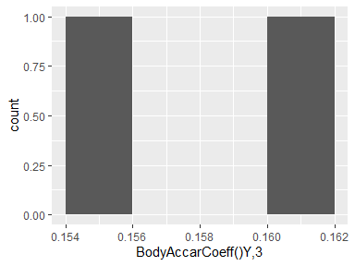

## BodyAccarCoeff()Y,4

|  |  |
| --- | --- |
| Feature | Result |
| Variable type | numeric |
| Number of missing obs. | 0 (0 %) |
| Number of unique values | 2 |
| Median | -0.02 |
| 1st and 3rd quartiles | -0.02; -0.02 |
| Min. and max. | -0.02; -0.02 |

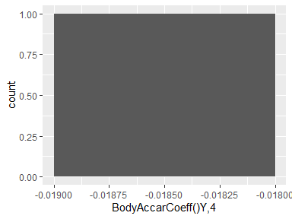

## BodyAccarCoeff()Z,1

|  |  |
| --- | --- |
| Feature | Result |
| Variable type | numeric |
| Number of missing obs. | 0 (0 %) |
| Number of unique values | 2 |
| Median | 0.01 |
| 1st and 3rd quartiles | 0.01; 0.02 |
| Min. and max. | 0.01; 0.02 |

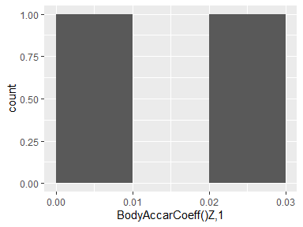

## BodyAccarCoeff()Z,2

|  |  |
| --- | --- |
| Feature | Result |
| Variable type | numeric |
| Number of missing obs. | 0 (0 %) |
| Number of unique values | 2 |
| Median | 0.02 |
| 1st and 3rd quartiles | 0.02; 0.03 |
| Min. and max. | 0.01; 0.04 |

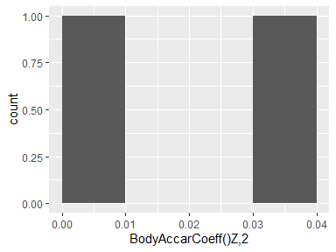

## BodyAccarCoeff()Z,3

|  |  |
| --- | --- |
| Feature | Result |
| Variable type | numeric |
| Number of missing obs. | 0 (0 %) |
| Number of unique values | 2 |
| Median | 0.04 |
| 1st and 3rd quartiles | 0.04; 0.04 |
| Min. and max. | 0.03; 0.05 |

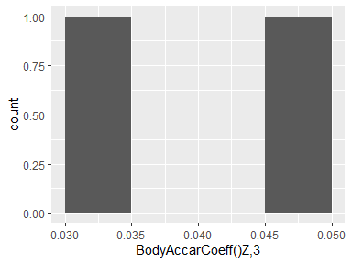

## BodyAccarCoeff()Z,4

|  |  |
| --- | --- |
| Feature | Result |
| Variable type | numeric |
| Number of missing obs. | 0 (0 %) |
| Number of unique values | 2 |
| Median | -0.08 |
| 1st and 3rd quartiles | -0.08; -0.08 |
| Min. and max. | -0.08; -0.08 |

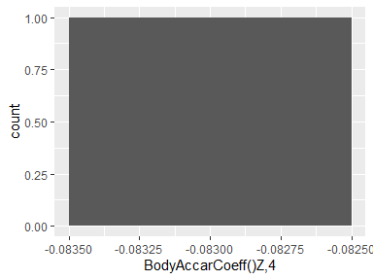

## BodyAcccorrelation()X,Y

|  |  |
| --- | --- |
| Feature | Result |
| Variable type | numeric |
| Number of missing obs. | 0 (0 %) |
| Number of unique values | 2 |
| Median | -0.14 |
| 1st and 3rd quartiles | -0.15; -0.13 |
| Min. and max. | -0.16; -0.12 |

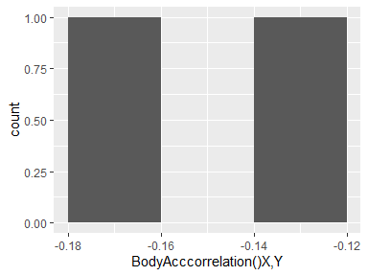

## BodyAcccorrelation()X,Z

|  |  |
| --- | --- |
| Feature | Result |
| Variable type | numeric |
| Number of missing obs. | 0 (0 %) |
| Number of unique values | 2 |
| Median | -0.19 |
| 1st and 3rd quartiles | -0.2; -0.19 |
| Min. and max. | -0.2; -0.19 |

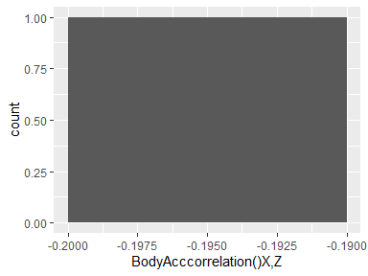

## BodyAcccorrelation()Y,Z

|  |  |
| --- | --- |
| Feature | Result |
| Variable type | numeric |
| Number of missing obs. | 0 (0 %) |
| Number of unique values | 2 |
| Median | 0.12 |
| 1st and 3rd quartiles | 0.11; 0.13 |
| Min. and max. | 0.1; 0.14 |

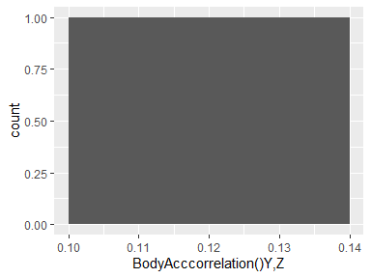

## GravityAccmean()X

|  |  |
| --- | --- |
| Feature | Result |
| Variable type | numeric |
| Number of missing obs. | 0 (0 %) |
| Number of unique values | 2 |
| Median | 0.8 |
| 1st and 3rd quartiles | 0.73; 0.86 |
| Min. and max. | 0.67; 0.92 |

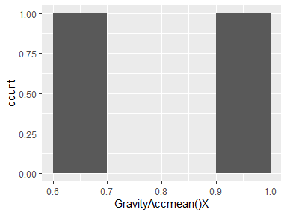

## GravityAccmean()Y

|  |  |
| --- | --- |
| Feature | Result |
| Variable type | numeric |
| Number of missing obs. | 0 (0 %) |
| Number of unique values | 2 |
| Median | -0.07 |
| 1st and 3rd quartiles | -0.11; -0.03 |
| Min. and max. | -0.14; 0 |

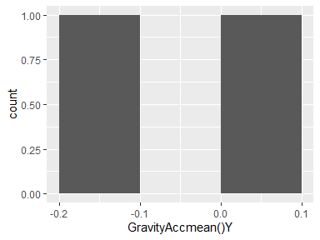

## GravityAccmean()Z

|  |  |
| --- | --- |
| Feature | Result |
| Variable type | numeric |
| Number of missing obs. | 0 (0 %) |
| Number of unique values | 2 |
| Median | 0.06 |
| 1st and 3rd quartiles | 0.05; 0.08 |
| Min. and max. | 0.04; 0.09 |

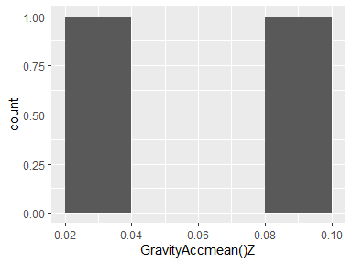

## GravityAccstd()X

|  |  |
| --- | --- |
| Feature | Result |
| Variable type | numeric |
| Number of missing obs. | 0 (0 %) |
| Number of unique values | 2 |
| Median | -0.97 |
| 1st and 3rd quartiles | -0.98; -0.97 |
| Min. and max. | -0.98; -0.97 |

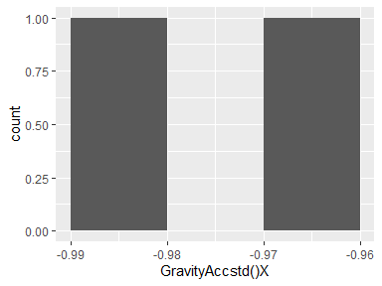

## GravityAccstd()Y

|  |  |
| --- | --- |
| Feature | Result |
| Variable type | numeric |
| Number of missing obs. | 0 (0 %) |
| Number of unique values | 2 |
| Median | -0.97 |
| 1st and 3rd quartiles | -0.97; -0.96 |
| Min. and max. | -0.98; -0.95 |

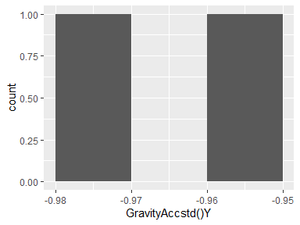

## GravityAccstd()Z

|  |  |
| --- | --- |
| Feature | Result |
| Variable type | numeric |
| Number of missing obs. | 0 (0 %) |
| Number of unique values | 2 |
| Median | -0.95 |
| 1st and 3rd quartiles | -0.96; -0.95 |
| Min. and max. | -0.97; -0.94 |

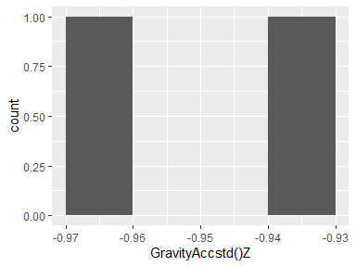

## GravityAccmad()X

|  |  |
| --- | --- |
| Feature | Result |
| Variable type | numeric |
| Number of missing obs. | 0 (0 %) |
| Number of unique values | 2 |
| Median | -0.97 |
| 1st and 3rd quartiles | -0.98; -0.97 |
| Min. and max. | -0.98; -0.97 |

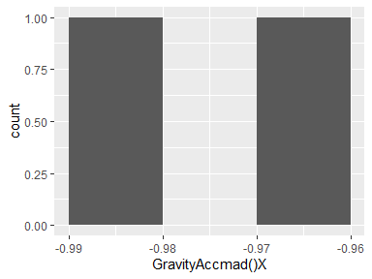

## GravityAccmad()Y

|  |  |
| --- | --- |
| Feature | Result |
| Variable type | numeric |
| Number of missing obs. | 0 (0 %) |
| Number of unique values | 2 |
| Median | -0.97 |
| 1st and 3rd quartiles | -0.97; -0.96 |
| Min. and max. | -0.98; -0.96 |

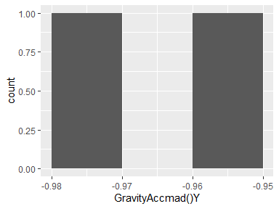

## GravityAccmad()Z

|  |  |
| --- | --- |
| Feature | Result |
| Variable type | numeric |
| Number of missing obs. | 0 (0 %) |
| Number of unique values | 2 |
| Median | -0.95 |
| 1st and 3rd quartiles | -0.96; -0.95 |
| Min. and max. | -0.97; -0.94 |

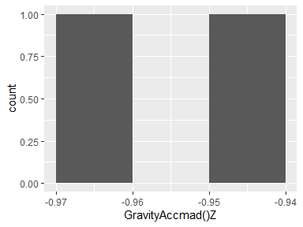

## GravityAccmax()X

|  |  |
| --- | --- |
| Feature | Result |
| Variable type | numeric |
| Number of missing obs. | 0 (0 %) |
| Number of unique values | 2 |
| Median | 0.73 |
| 1st and 3rd quartiles | 0.67; 0.8 |
| Min. and max. | 0.61; 0.86 |

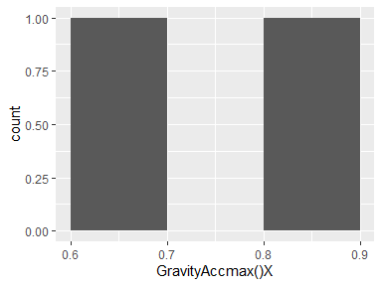

## GravityAccmax()Y

|  |  |
| --- | --- |
| Feature | Result |
| Variable type | numeric |
| Number of missing obs. | 0 (0 %) |
| Number of unique values | 2 |
| Median | -0.08 |
| 1st and 3rd quartiles | -0.12; -0.05 |
| Min. and max. | -0.15; -0.01 |

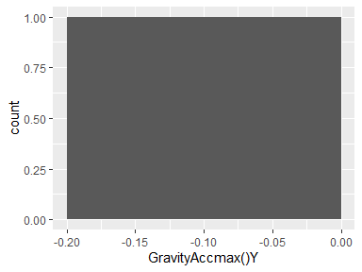

## GravityAccmax()Z

|  |  |
| --- | --- |
| Feature | Result |
| Variable type | numeric |
| Number of missing obs. | 0 (0 %) |
| Number of unique values | 2 |
| Median | 0.07 |
| 1st and 3rd quartiles | 0.06; 0.08 |
| Min. and max. | 0.04; 0.1 |

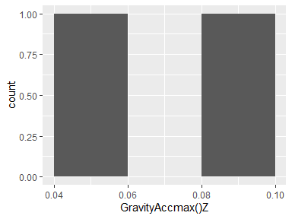

## GravityAccmin()X

|  |  |
| --- | --- |
| Feature | Result |
| Variable type | numeric |
| Number of missing obs. | 0 (0 %) |
| Number of unique values | 2 |
| Median | 0.81 |
| 1st and 3rd quartiles | 0.75; 0.87 |
| Min. and max. | 0.68; 0.93 |

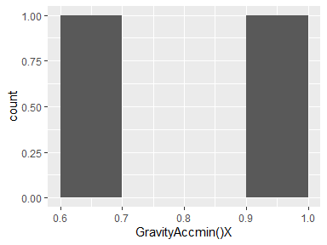

## GravityAccmin()Y

|  |  |
| --- | --- |
| Feature | Result |
| Variable type | numeric |
| Number of missing obs. | 0 (0 %) |
| Number of unique values | 2 |
| Median | -0.06 |
| 1st and 3rd quartiles | -0.09; -0.02 |
| Min. and max. | -0.13; 0.02 |

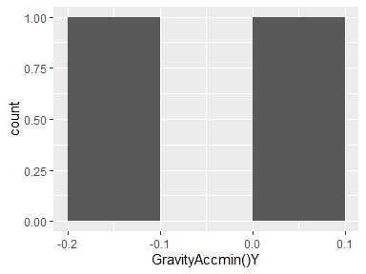

## GravityAccmin()Z

|  |  |
| --- | --- |
| Feature | Result |
| Variable type | numeric |
| Number of missing obs. | 0 (0 %) |
| Number of unique values | 2 |
| Median | 0.05 |
| 1st and 3rd quartiles | 0.04; 0.07 |
| Min. and max. | 0.02; 0.08 |

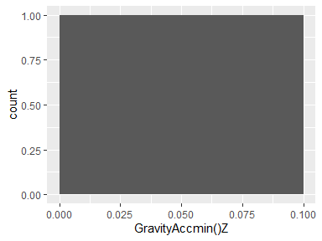

## GravityAccsma()

|  |  |
| --- | --- |
| Feature | Result |
| Variable type | numeric |
| Number of missing obs. | 0 (0 %) |
| Number of unique values | 2 |
| Median | -0.11 |
| 1st and 3rd quartiles | -0.12; -0.11 |
| Min. and max. | -0.13; -0.1 |

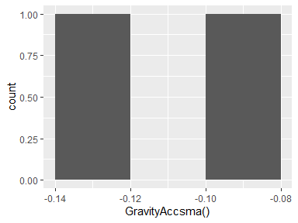

## GravityAccenergy()X

|  |  |
| --- | --- |
| Feature | Result |
| Variable type | numeric |
| Number of missing obs. | 0 (0 %) |
| Number of unique values | 2 |
| Median | 0.62 |
| 1st and 3rd quartiles | 0.53; 0.7 |
| Min. and max. | 0.45; 0.79 |

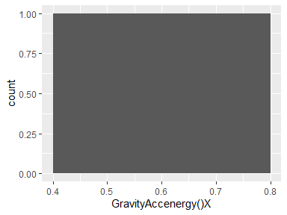

## GravityAccenergy()Y

|  |  |
| --- | --- |
| Feature | Result |
| Variable type | numeric |
| Number of missing obs. | 0 (0 %) |
| Number of unique values | 2 |
| Median | -0.82 |
| 1st and 3rd quartiles | -0.86; -0.77 |
| Min. and max. | -0.91; -0.72 |

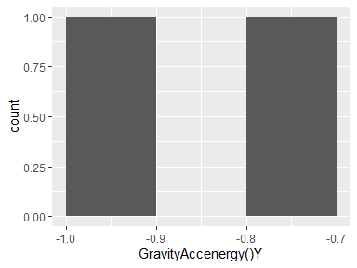

## GravityAccenergy()Z

|  |  |
| --- | --- |
| Feature | Result |
| Variable type | numeric |
| Number of missing obs. | 0 (0 %) |
| Number of unique values | 2 |
| Median | -0.86 |
| 1st and 3rd quartiles | -0.9; -0.81 |
| Min. and max. | -0.95; -0.76 |

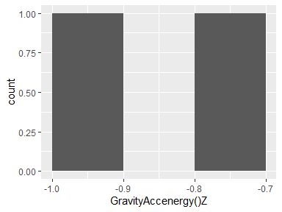

## GravityAcciqr()X

|  |  |
| --- | --- |
| Feature | Result |
| Variable type | numeric |
| Number of missing obs. | 0 (0 %) |
| Number of unique values | 2 |
| Median | -0.98 |
| 1st and 3rd quartiles | -0.98; -0.97 |
| Min. and max. | -0.98; -0.97 |

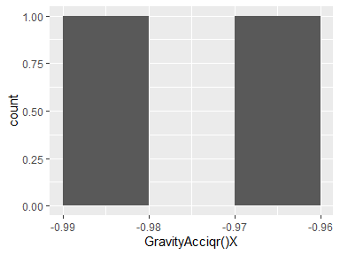

## GravityAcciqr()Y

|  |  |
| --- | --- |
| Feature | Result |
| Variable type | numeric |
| Number of missing obs. | 0 (0 %) |
| Number of unique values | 2 |
| Median | -0.97 |
| 1st and 3rd quartiles | -0.97; -0.96 |
| Min. and max. | -0.98; -0.96 |

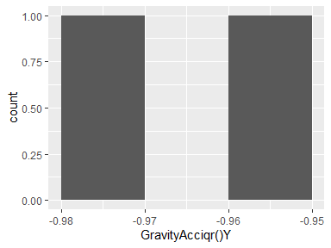

## GravityAcciqr()Z

|  |  |
| --- | --- |
| Feature | Result |
| Variable type | numeric |
| Number of missing obs. | 0 (0 %) |
| Number of unique values | 2 |
| Median | -0.96 |
| 1st and 3rd quartiles | -0.96; -0.95 |
| Min. and max. | -0.97; -0.94 |

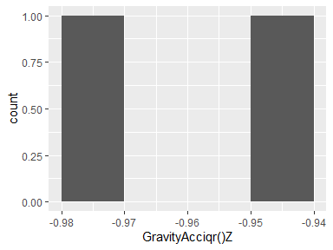

## GravityAccentropy()X

|  |  |
| --- | --- |
| Feature | Result |
| Variable type | numeric |
| Number of missing obs. | 0 (0 %) |
| Number of unique values | 2 |
| Median | -0.72 |
| 1st and 3rd quartiles | -0.74; -0.7 |
| Min. and max. | -0.76; -0.67 |

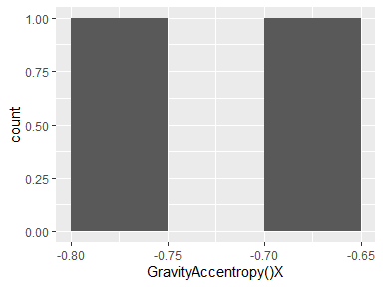

## GravityAccentropy()Y

|  |  |
| --- | --- |
| Feature | Result |
| Variable type | numeric |
| Number of missing obs. | 0 (0 %) |
| Number of unique values | 2 |
| Median | -0.93 |
| 1st and 3rd quartiles | -0.97; -0.9 |
| Min. and max. | -1; -0.87 |

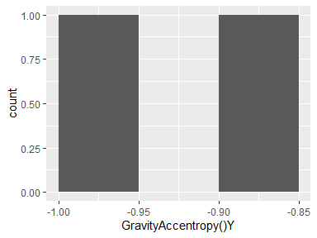

## GravityAccentropy()Z

|  |  |
| --- | --- |
| Feature | Result |
| Variable type | numeric |
| Number of missing obs. | 0 (0 %) |
| Number of unique values | 2 |
| Median | -0.72 |
| 1st and 3rd quartiles | -0.75; -0.7 |
| Min. and max. | -0.78; -0.67 |

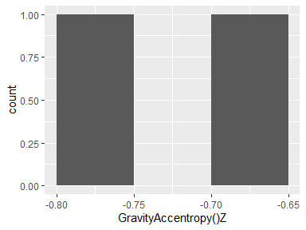

## GravityAccarCoeff()X,1

|  |  |
| --- | --- |
| Feature | Result |
| Variable type | numeric |
| Number of missing obs. | 0 (0 %) |
| Number of unique values | 2 |
| Median | -0.51 |
| 1st and 3rd quartiles | -0.51; -0.51 |
| Min. and max. | -0.51; -0.5 |

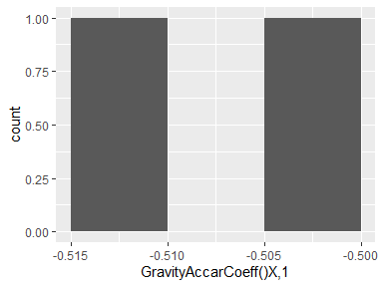

## GravityAccarCoeff()X,2

|  |  |
| --- | --- |
| Feature | Result |
| Variable type | numeric |
| Number of missing obs. | 0 (0 %) |
| Number of unique values | 2 |
| Median | 0.55 |
| 1st and 3rd quartiles | 0.55; 0.55 |
| Min. and max. | 0.54; 0.56 |

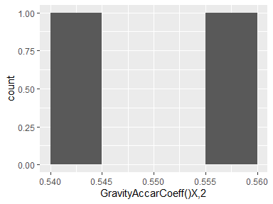

## GravityAccarCoeff()X,3

|  |  |
| --- | --- |
| Feature | Result |
| Variable type | numeric |
| Number of missing obs. | 0 (0 %) |
| Number of unique values | 2 |
| Median | -0.59 |
| 1st and 3rd quartiles | -0.59; -0.58 |
| Min. and max. | -0.6; -0.58 |

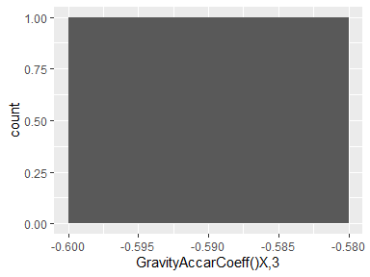

## GravityAccarCoeff()X,4

|  |  |
| --- | --- |
| Feature | Result |
| Variable type | numeric |
| Number of missing obs. | 0 (0 %) |
| Number of unique values | 2 |
| Median | 0.63 |
| 1st and 3rd quartiles | 0.62; 0.64 |
| Min. and max. | 0.62; 0.64 |

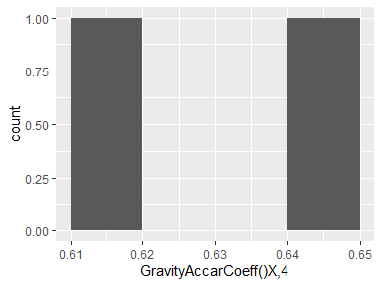

## GravityAccarCoeff()Y,1

|  |  |
| --- | --- |
| Feature | Result |
| Variable type | numeric |
| Number of missing obs. | 0 (0 %) |
| Number of unique values | 2 |
| Median | -0.34 |
| 1st and 3rd quartiles | -0.34; -0.34 |
| Min. and max. | -0.34; -0.34 |

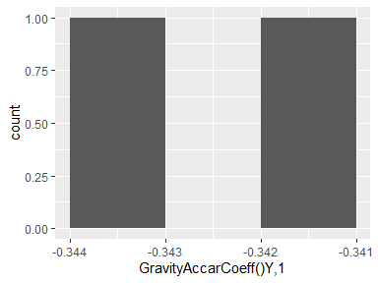

## GravityAccarCoeff()Y,2

|  |  |
| --- | --- |
| Feature | Result |
| Variable type | numeric |
| Number of missing obs. | 0 (0 %) |
| Number of unique values | 2 |
| Median | 0.33 |
| 1st and 3rd quartiles | 0.33; 0.33 |
| Min. and max. | 0.33; 0.33 |

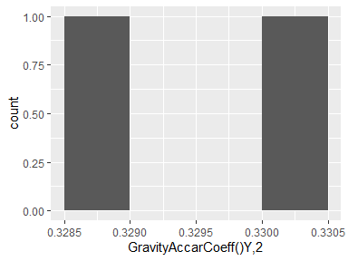

## GravityAccarCoeff()Y,3

|  |  |
| --- | --- |
| Feature | Result |
| Variable type | numeric |
| Number of missing obs. | 0 (0 %) |
| Number of unique values | 2 |
| Median | -0.36 |
| 1st and 3rd quartiles | -0.36; -0.36 |
| Min. and max. | -0.37; -0.36 |

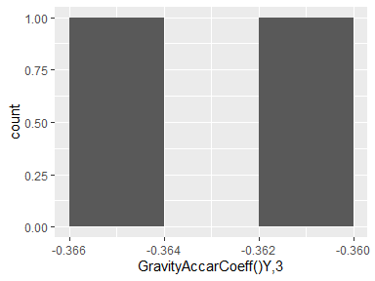

## GravityAccarCoeff()Y,4

|  |  |
| --- | --- |
| Feature | Result |
| Variable type | numeric |
| Number of missing obs. | 0 (0 %) |
| Number of unique values | 2 |
| Median | 0.42 |
| 1st and 3rd quartiles | 0.41; 0.42 |
| Min. and max. | 0.41; 0.42 |

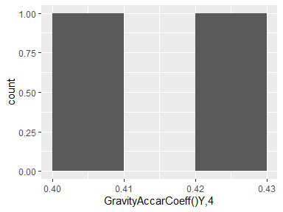

## GravityAccarCoeff()Z,1

|  |  |
| --- | --- |
| Feature | Result |
| Variable type | numeric |
| Number of missing obs. | 0 (0 %) |
| Number of unique values | 2 |
| Median | -0.43 |
| 1st and 3rd quartiles | -0.43; -0.43 |
| Min. and max. | -0.43; -0.43 |

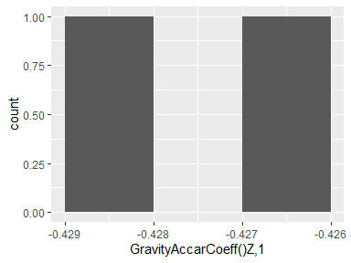

## GravityAccarCoeff()Z,2

|  |  |
| --- | --- |
| Feature | Result |
| Variable type | numeric |
| Number of missing obs. | 0 (0 %) |
| Number of unique values | 2 |
| Median | 0.45 |
| 1st and 3rd quartiles | 0.45; 0.45 |
| Min. and max. | 0.45; 0.45 |

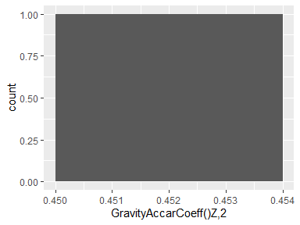

## GravityAccarCoeff()Z,3

|  |  |
| --- | --- |
| Feature | Result |
| Variable type | numeric |
| Number of missing obs. | 0 (0 %) |
| Number of unique values | 2 |
| Median | -0.48 |
| 1st and 3rd quartiles | -0.48; -0.48 |
| Min. and max. | -0.48; -0.48 |

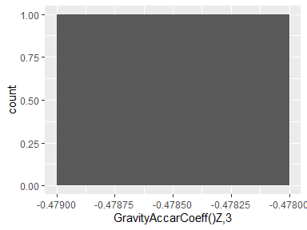

## GravityAccarCoeff()Z,4

|  |  |
| --- | --- |
| Feature | Result |
| Variable type | numeric |
| Number of missing obs. | 0 (0 %) |
| Number of unique values | 2 |
| Median | 0.5 |
| 1st and 3rd quartiles | 0.5; 0.5 |
| Min. and max. | 0.5; 0.51 |

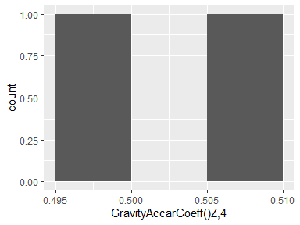

## GravityAcccorrelation()X,Y

|  |  |
| --- | --- |
| Feature | Result |
| Variable type | numeric |
| Number of missing obs. | 0 (0 %) |
| Number of unique values | 2 |
| Median | 0.27 |
| 1st and 3rd quartiles | 0.22; 0.31 |
| Min. and max. | 0.18; 0.36 |

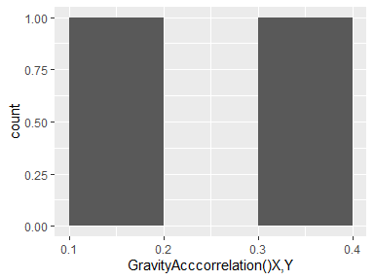

## GravityAcccorrelation()X,Z

|  |  |
| --- | --- |
| Feature | Result |
| Variable type | numeric |
| Number of missing obs. | 0 (0 %) |
| Number of unique values | 2 |
| Median | -0.16 |
| 1st and 3rd quartiles | -0.19; -0.14 |
| Min. and max. | -0.22; -0.11 |

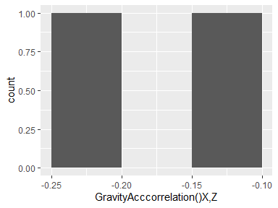

## GravityAcccorrelation()Y,Z

|  |  |
| --- | --- |
| Feature | Result |
| Variable type | numeric |
| Number of missing obs. | 0 (0 %) |
| Number of unique values | 2 |
| Median | 0.13 |
| 1st and 3rd quartiles | 0.11; 0.15 |
| Min. and max. | 0.08; 0.18 |

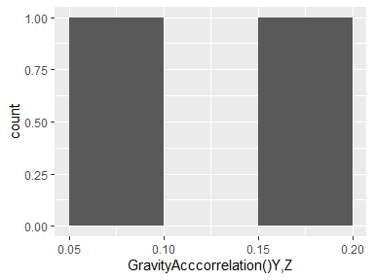

## BodyAccJerkmean()X

|  |  |
| --- | --- |
| Feature | Result |
| Variable type | numeric |
| Number of missing obs. | 0 (0 %) |
| Number of unique values | 2 |
| Median | 0.08 |
| 1st and 3rd quartiles | 0.08; 0.08 |
| Min. and max. | 0.08; 0.08 |

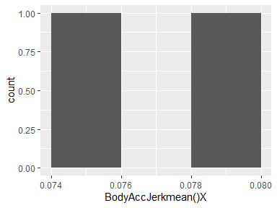

## BodyAccJerkmean()Y

|  |  |
| --- | --- |
| Feature | Result |
| Variable type | numeric |
| Number of missing obs. | 0 (0 %) |
| Number of unique values | 2 |
| Median | 0.01 |
| 1st and 3rd quartiles | 0.01; 0.01 |
| Min. and max. | 0.01; 0.01 |

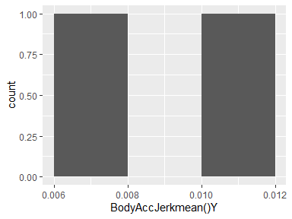

## BodyAccJerkmean()Z

|  |  |
| --- | --- |
| Feature | Result |
| Variable type | numeric |
| Number of missing obs. | 0 (0 %) |
| Number of unique values | 2 |
| Median | 0 |
| 1st and 3rd quartiles | 0; 0 |
| Min. and max. | 0; 0 |

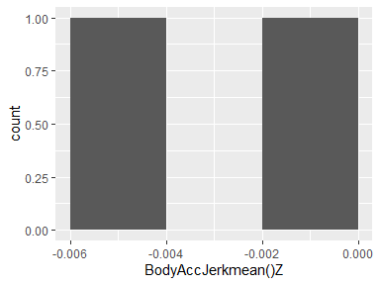

## BodyAccJerkstd()X

|  |  |
| --- | --- |
| Feature | Result |
| Variable type | numeric |
| Number of missing obs. | 0 (0 %) |
| Number of unique values | 2 |
| Median | -0.8 |
| 1st and 3rd quartiles | -0.87; -0.72 |
| Min. and max. | -0.95; -0.64 |

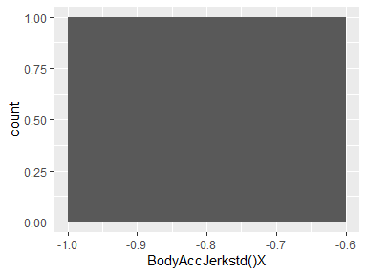

## BodyAccJerkstd()Y

|  |  |
| --- | --- |
| Feature | Result |
| Variable type | numeric |
| Number of missing obs. | 0 (0 %) |
| Number of unique values | 2 |
| Median | -0.77 |
| 1st and 3rd quartiles | -0.85; -0.69 |
| Min. and max. | -0.93; -0.61 |

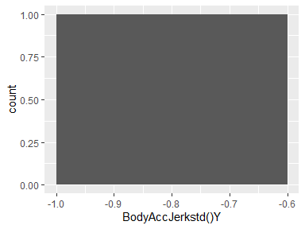

## BodyAccJerkstd()Z

|  |  |
| --- | --- |
| Feature | Result |
| Variable type | numeric |
| Number of missing obs. | 0 (0 %) |
| Number of unique values | 2 |
| Median | -0.86 |
| 1st and 3rd quartiles | -0.91; -0.81 |
| Min. and max. | -0.95; -0.76 |

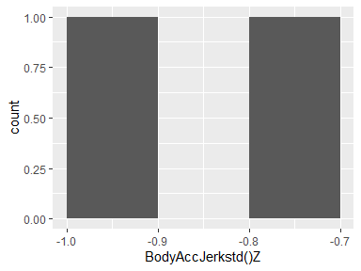

## BodyAccJerkmad()X

|  |  |
| --- | --- |
| Feature | Result |
| Variable type | numeric |
| Number of missing obs. | 0 (0 %) |
| Number of unique values | 2 |
| Median | -0.8 |
| 1st and 3rd quartiles | -0.88; -0.72 |
| Min. and max. | -0.96; -0.64 |

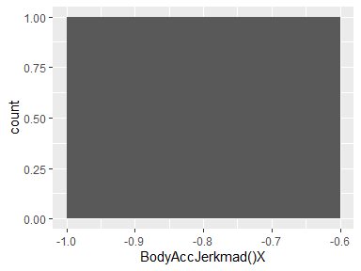

## BodyAccJerkmad()Y

|  |  |
| --- | --- |
| Feature | Result |
| Variable type | numeric |
| Number of missing obs. | 0 (0 %) |
| Number of unique values | 2 |
| Median | -0.76 |
| 1st and 3rd quartiles | -0.84; -0.68 |
| Min. and max. | -0.93; -0.59 |

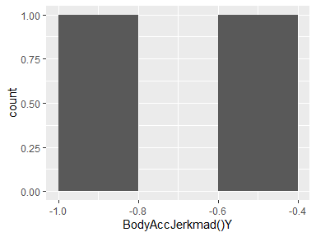

## BodyAccJerkmad()Z

|  |  |
| --- | --- |
| Feature | Result |
| Variable type | numeric |
| Number of missing obs. | 0 (0 %) |
| Number of unique values | 2 |
| Median | -0.86 |
| 1st and 3rd quartiles | -0.91; -0.81 |
| Min. and max. | -0.95; -0.76 |

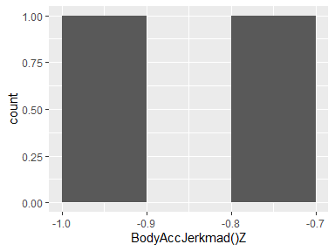

## BodyAccJerkmax()X

|  |  |
| --- | --- |
| Feature | Result |
| Variable type | numeric |
| Number of missing obs. | 0 (0 %) |
| Number of unique values | 2 |
| Median | -0.82 |
| 1st and 3rd quartiles | -0.88; -0.76 |
| Min. and max. | -0.94; -0.7 |

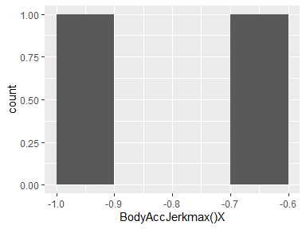

## BodyAccJerkmax()Y

|  |  |
| --- | --- |
| Feature | Result |
| Variable type | numeric |
| Number of missing obs. | 0 (0 %) |
| Number of unique values | 2 |
| Median | -0.84 |
| 1st and 3rd quartiles | -0.89; -0.8 |
| Min. and max. | -0.94; -0.75 |

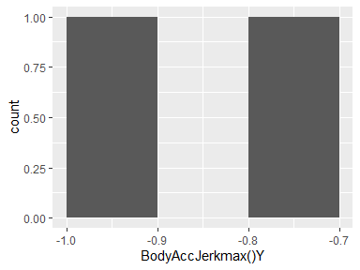

## BodyAccJerkmax()Z

|  |  |
| --- | --- |
| Feature | Result |
| Variable type | numeric |
| Number of missing obs. | 0 (0 %) |
| Number of unique values | 2 |
| Median | -0.89 |
| 1st and 3rd quartiles | -0.92; -0.85 |
| Min. and max. | -0.96; -0.82 |

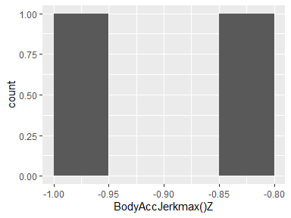

## BodyAccJerkmin()X

|  |  |
| --- | --- |
| Feature | Result |
| Variable type | numeric |
| Number of missing obs. | 0 (0 %) |
| Number of unique values | 2 |
| Median | 0.78 |
| 1st and 3rd quartiles | 0.7; 0.86 |
| Min. and max. | 0.62; 0.94 |

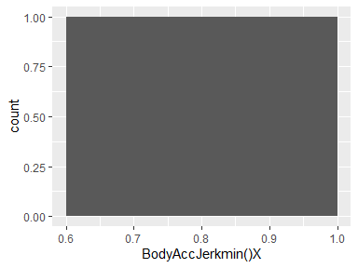

## BodyAccJerkmin()Y

|  |  |
| --- | --- |
| Feature | Result |
| Variable type | numeric |
| Number of missing obs. | 0 (0 %) |
| Number of unique values | 2 |
| Median | 0.81 |
| 1st and 3rd quartiles | 0.75; 0.87 |
| Min. and max. | 0.68; 0.93 |

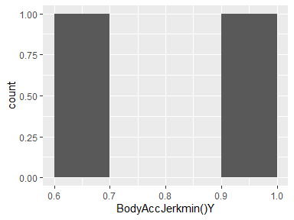

## BodyAccJerkmin()Z

|  |  |
| --- | --- |
| Feature | Result |
| Variable type | numeric |
| Number of missing obs. | 0 (0 %) |
| Number of unique values | 2 |
| Median | 0.84 |
| 1st and 3rd quartiles | 0.79; 0.89 |
| Min. and max. | 0.74; 0.94 |

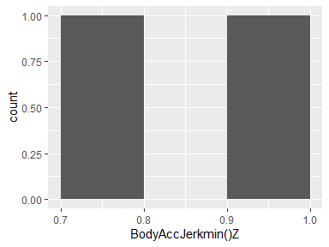

## BodyAccJerksma()

|  |  |
| --- | --- |
| Feature | Result |
| Variable type | numeric |
| Number of missing obs. | 0 (0 %) |
| Number of unique values | 2 |
| Median | -0.8 |
| 1st and 3rd quartiles | -0.87; -0.72 |
| Min. and max. | -0.95; -0.65 |

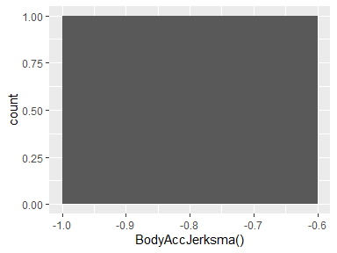

## BodyAccJerkenergy()X

|  |  |
| --- | --- |
| Feature | Result |
| Variable type | numeric |
| Number of missing obs. | 0 (0 %) |
| Number of unique values | 2 |
| Median | -0.92 |
| 1st and 3rd quartiles | -0.96; -0.89 |
| Min. and max. | -1; -0.85 |

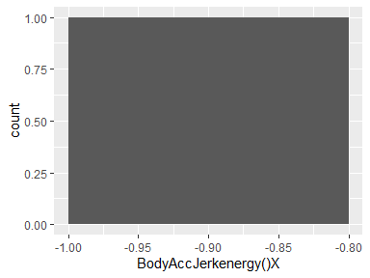

## BodyAccJerkenergy()Y

|  |  |
| --- | --- |
| Feature | Result |
| Variable type | numeric |
| Number of missing obs. | 0 (0 %) |
| Number of unique values | 2 |
| Median | -0.91 |
| 1st and 3rd quartiles | -0.95; -0.87 |
| Min. and max. | -1; -0.83 |

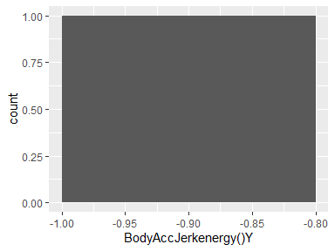

## BodyAccJerkenergy()Z

|  |  |
| --- | --- |
| Feature | Result |
| Variable type | numeric |
| Number of missing obs. | 0 (0 %) |
| Number of unique values | 2 |
| Median | -0.96 |
| 1st and 3rd quartiles | -0.98; -0.95 |
| Min. and max. | -1; -0.93 |

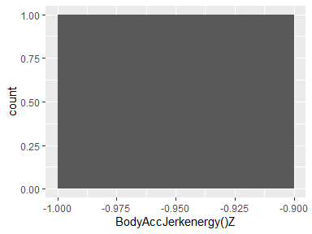

## BodyAccJerkiqr()X

|  |  |
| --- | --- |
| Feature | Result |
| Variable type | numeric |
| Number of missing obs. | 0 (0 %) |
| Number of unique values | 2 |
| Median | -0.8 |
| 1st and 3rd quartiles | -0.88; -0.71 |
| Min. and max. | -0.96; -0.63 |

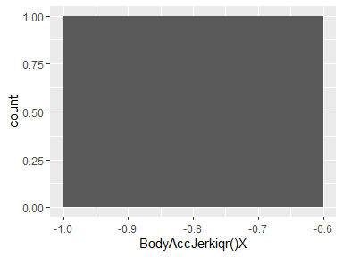

## BodyAccJerkiqr()Y

|  |  |
| --- | --- |
| Feature | Result |
| Variable type | numeric |
| Number of missing obs. | 0 (0 %) |
| Number of unique values | 2 |
| Median | -0.8 |
| 1st and 3rd quartiles | -0.87; -0.73 |
| Min. and max. | -0.94; -0.66 |

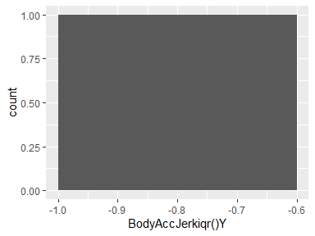

## BodyAccJerkiqr()Z

|  |  |
| --- | --- |
| Feature | Result |
| Variable type | numeric |
| Number of missing obs. | 0 (0 %) |
| Number of unique values | 2 |
| Median | -0.86 |
| 1st and 3rd quartiles | -0.91; -0.82 |
| Min. and max. | -0.96; -0.77 |

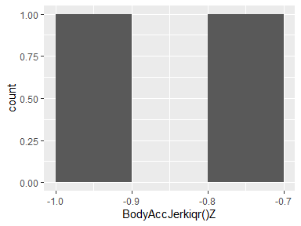

## BodyAccJerkentropy()X

|  |  |
| --- | --- |
| Feature | Result |
| Variable type | numeric |
| Number of missing obs. | 0 (0 %) |
| Number of unique values | 2 |
| Median | -0.21 |
| 1st and 3rd quartiles | -0.27; -0.15 |
| Min. and max. | -0.34; -0.08 |

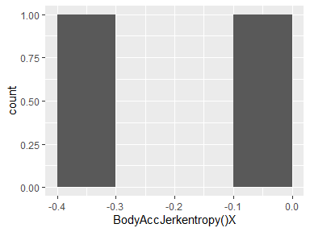

## BodyAccJerkentropy()Y

|  |  |
| --- | --- |
| Feature | Result |
| Variable type | numeric |
| Number of missing obs. | 0 (0 %) |
| Number of unique values | 2 |
| Median | -0.19 |
| 1st and 3rd quartiles | -0.24; -0.14 |
| Min. and max. | -0.28; -0.09 |

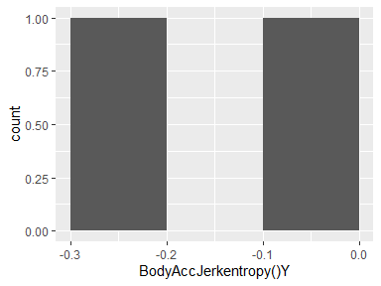

## BodyAccJerkentropy()Z

|  |  |
| --- | --- |
| Feature | Result |
| Variable type | numeric |
| Number of missing obs. | 0 (0 %) |
| Number of unique values | 2 |
| Median | -0.26 |
| 1st and 3rd quartiles | -0.33; -0.19 |
| Min. and max. | -0.39; -0.13 |

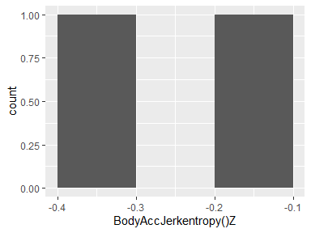

## BodyAccJerkarCoeff()X,1

|  |  |
| --- | --- |
| Feature | Result |
| Variable type | numeric |
| Number of missing obs. | 0 (0 %) |
| Number of unique values | 2 |
| Median | -0.11 |
| 1st and 3rd quartiles | -0.11; -0.11 |
| Min. and max. | -0.12; -0.11 |

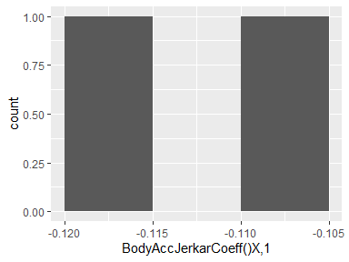

## BodyAccJerkarCoeff()X,2

|  |  |
| --- | --- |
| Feature | Result |
| Variable type | numeric |
| Number of missing obs. | 0 (0 %) |
| Number of unique values | 2 |
| Median | 0.17 |
| 1st and 3rd quartiles | 0.17; 0.17 |
| Min. and max. | 0.17; 0.17 |

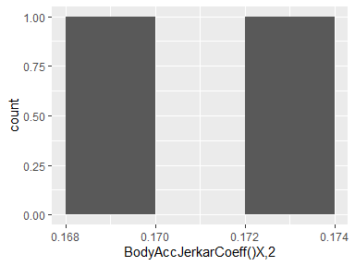

## BodyAccJerkarCoeff()X,3

|  |  |
| --- | --- |
| Feature | Result |
| Variable type | numeric |
| Number of missing obs. | 0 (0 %) |
| Number of unique values | 2 |
| Median | 0.07 |
| 1st and 3rd quartiles | 0.07; 0.07 |
| Min. and max. | 0.07; 0.08 |

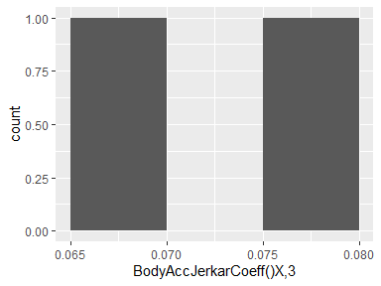

## BodyAccJerkarCoeff()X,4

|  |  |
| --- | --- |
| Feature | Result |
| Variable type | numeric |
| Number of missing obs. | 0 (0 %) |
| Number of unique values | 2 |
| Median | 0.13 |
| 1st and 3rd quartiles | 0.13; 0.13 |
| Min. and max. | 0.13; 0.13 |

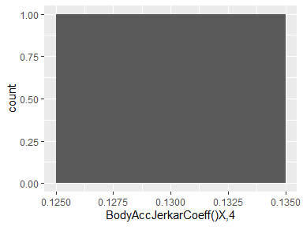

## BodyAccJerkarCoeff()Y,1

|  |  |
| --- | --- |
| Feature | Result |
| Variable type | numeric |
| Number of missing obs. | 0 (0 %) |
| Number of unique values | 2 |
| Median | -0.08 |
| 1st and 3rd quartiles | -0.08; -0.08 |
| Min. and max. | -0.09; -0.07 |

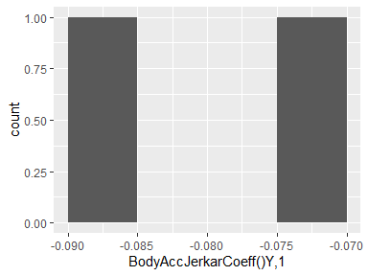

## BodyAccJerkarCoeff()Y,2

|  |  |
| --- | --- |
| Feature | Result |
| Variable type | numeric |
| Number of missing obs. | 0 (0 %) |
| Number of unique values | 2 |
| Median | 0.07 |
| 1st and 3rd quartiles | 0.07; 0.07 |
| Min. and max. | 0.07; 0.07 |

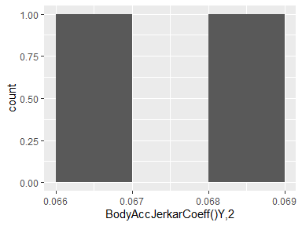

## BodyAccJerkarCoeff()Y,3

|  |  |
| --- | --- |
| Feature | Result |
| Variable type | numeric |
| Number of missing obs. | 0 (0 %) |
| Number of unique values | 2 |
| Median | 0.18 |
| 1st and 3rd quartiles | 0.18; 0.18 |
| Min. and max. | 0.17; 0.19 |

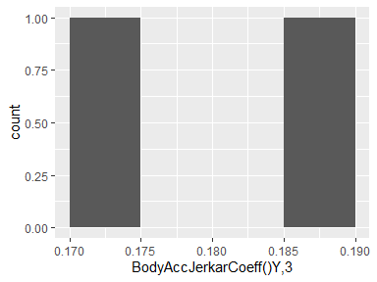

## BodyAccJerkarCoeff()Y,4

|  |  |
| --- | --- |
| Feature | Result |
| Variable type | numeric |
| Number of missing obs. | 0 (0 %) |
| Number of unique values | 2 |
| Median | 0.32 |
| 1st and 3rd quartiles | 0.32; 0.32 |
| Min. and max. | 0.31; 0.32 |

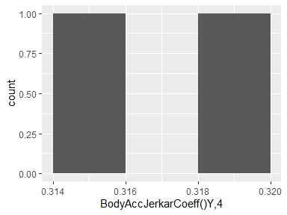

## BodyAccJerkarCoeff()Z,1

|  |  |
| --- | --- |
| Feature | Result |
| Variable type | numeric |
| Number of missing obs. | 0 (0 %) |
| Number of unique values | 2 |
| Median | -0.02 |
| 1st and 3rd quartiles | -0.03; -0.02 |
| Min. and max. | -0.03; -0.01 |

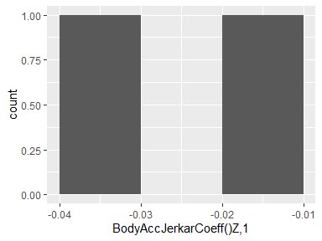

## BodyAccJerkarCoeff()Z,2

|  |  |
| --- | --- |
| Feature | Result |
| Variable type | numeric |
| Number of missing obs. | 0 (0 %) |
| Number of unique values | 2 |
| Median | 0.09 |
| 1st and 3rd quartiles | 0.09; 0.09 |
| Min. and max. | 0.09; 0.09 |

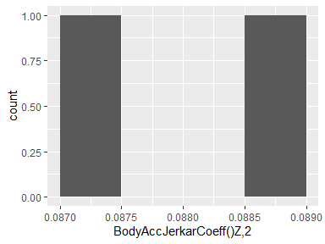

## BodyAccJerkarCoeff()Z,3

|  |  |
| --- | --- |
| Feature | Result |
| Variable type | numeric |
| Number of missing obs. | 0 (0 %) |
| Number of unique values | 2 |
| Median | 0.01 |
| 1st and 3rd quartiles | 0; 0.01 |
| Min. and max. | 0; 0.01 |

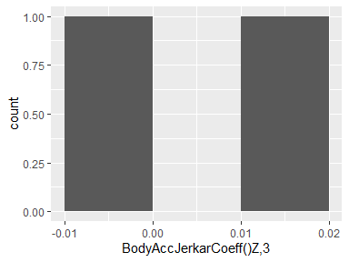

## BodyAccJerkarCoeff()Z,4

|  |  |
| --- | --- |
| Feature | Result |
| Variable type | numeric |
| Number of missing obs. | 0 (0 %) |
| Number of unique values | 2 |
| Median | 0.14 |
| 1st and 3rd quartiles | 0.14; 0.15 |
| Min. and max. | 0.14; 0.15 |

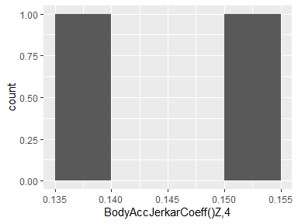

## BodyAccJerkcorrelation()X,Y

|  |  |
| --- | --- |
| Feature | Result |
| Variable type | numeric |
| Number of missing obs. | 0 (0 %) |
| Number of unique values | 2 |
| Median | -0.14 |
| 1st and 3rd quartiles | -0.14; -0.14 |
| Min. and max. | -0.14; -0.14 |

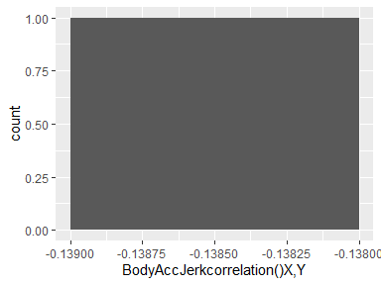

## BodyAccJerkcorrelation()X,Z

|  |  |
| --- | --- |
| Feature | Result |
| Variable type | numeric |
| Number of missing obs. | 0 (0 %) |
| Number of unique values | 2 |
| Median | 0.01 |
| 1st and 3rd quartiles | 0.01; 0.01 |
| Min. and max. | 0; 0.01 |

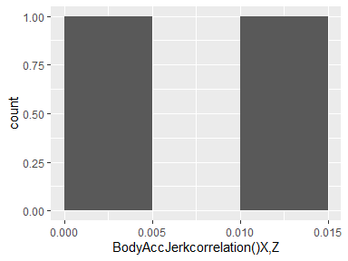

## BodyAccJerkcorrelation()Y,Z

|  |  |
| --- | --- |
| Feature | Result |
| Variable type | numeric |
| Number of missing obs. | 0 (0 %) |
| Number of unique values | 2 |
| Median | 0.08 |
| 1st and 3rd quartiles | 0.08; 0.08 |
| Min. and max. | 0.08; 0.08 |

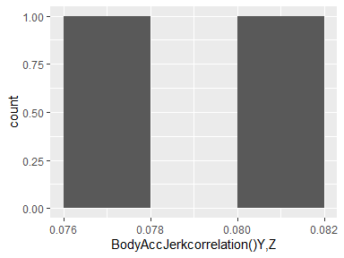

## BodyGyromean()X

|  |  |
| --- | --- |
| Feature | Result |
| Variable type | numeric |
| Number of missing obs. | 0 (0 %) |
| Number of unique values | 2 |
| Median | -0.03 |
| 1st and 3rd quartiles | -0.03; -0.03 |
| Min. and max. | -0.03; -0.03 |

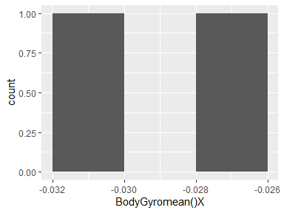

## BodyGyromean()Y

|  |  |
| --- | --- |
| Feature | Result |
| Variable type | numeric |
| Number of missing obs. | 0 (0 %) |
| Number of unique values | 2 |
| Median | -0.07 |
| 1st and 3rd quartiles | -0.07; -0.07 |
| Min. and max. | -0.07; -0.07 |

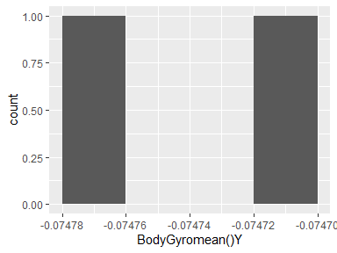

## BodyGyromean()Z

|  |  |
| --- | --- |
| Feature | Result |
| Variable type | numeric |
| Number of missing obs. | 0 (0 %) |
| Number of unique values | 2 |
| Median | 0.09 |
| 1st and 3rd quartiles | 0.09; 0.09 |
| Min. and max. | 0.09; 0.09 |

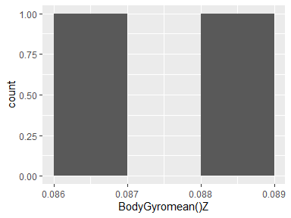

## BodyGyrostd()X

|  |  |
| --- | --- |
| Feature | Result |
| Variable type | numeric |
| Number of missing obs. | 0 (0 %) |
| Number of unique values | 2 |
| Median | -0.81 |
| 1st and 3rd quartiles | -0.86; -0.77 |
| Min. and max. | -0.9; -0.72 |

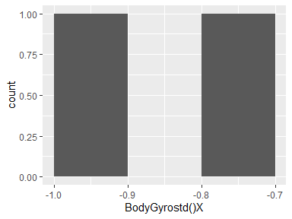

## BodyGyrostd()Y

|  |  |
| --- | --- |
| Feature | Result |
| Variable type | numeric |
| Number of missing obs. | 0 (0 %) |
| Number of unique values | 2 |
| Median | -0.8 |
| 1st and 3rd quartiles | -0.85; -0.74 |
| Min. and max. | -0.91; -0.68 |

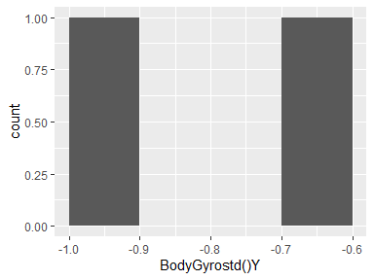

## BodyGyrostd()Z

|  |  |
| --- | --- |
| Feature | Result |
| Variable type | numeric |
| Number of missing obs. | 0 (0 %) |
| Number of unique values | 2 |
| Median | -0.77 |
| 1st and 3rd quartiles | -0.82; -0.71 |
| Min. and max. | -0.88; -0.65 |

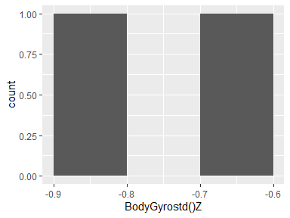

## BodyGyromad()X

|  |  |
| --- | --- |
| Feature | Result |
| Variable type | numeric |
| Number of missing obs. | 0 (0 %) |
| Number of unique values | 2 |
| Median | -0.82 |
| 1st and 3rd quartiles | -0.86; -0.77 |
| Min. and max. | -0.91; -0.73 |

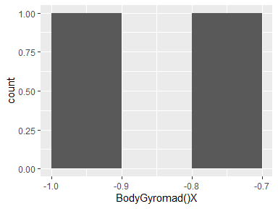

## BodyGyromad()Y

|  |  |
| --- | --- |
| Feature | Result |
| Variable type | numeric |
| Number of missing obs. | 0 (0 %) |
| Number of unique values | 2 |
| Median | -0.81 |
| 1st and 3rd quartiles | -0.86; -0.75 |
| Min. and max. | -0.92; -0.69 |

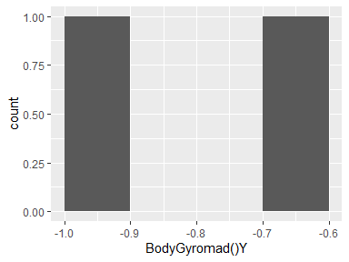

## BodyGyromad()Z

|  |  |
| --- | --- |
| Feature | Result |
| Variable type | numeric |
| Number of missing obs. | 0 (0 %) |
| Number of unique values | 2 |
| Median | -0.78 |
| 1st and 3rd quartiles | -0.83; -0.72 |
| Min. and max. | -0.89; -0.67 |

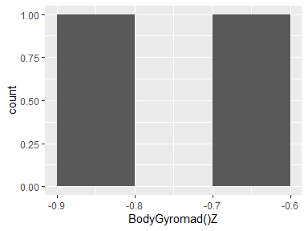

## BodyGyromax()X

|  |  |
| --- | --- |
| Feature | Result |
| Variable type | numeric |
| Number of missing obs. | 0 (0 %) |
| Number of unique values | 2 |
| Median | -0.72 |
| 1st and 3rd quartiles | -0.76; -0.68 |
| Min. and max. | -0.79; -0.65 |

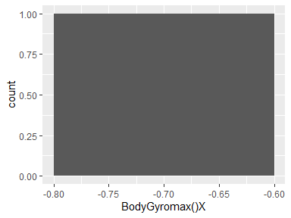

## BodyGyromax()Y

|  |  |
| --- | --- |
| Feature | Result |
| Variable type | numeric |
| Number of missing obs. | 0 (0 %) |
| Number of unique values | 2 |
| Median | -0.81 |
| 1st and 3rd quartiles | -0.85; -0.78 |
| Min. and max. | -0.89; -0.74 |

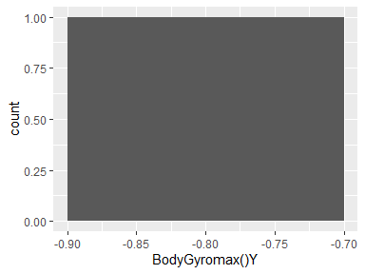

## BodyGyromax()Z

|  |  |
| --- | --- |
| Feature | Result |
| Variable type | numeric |
| Number of missing obs. | 0 (0 %) |
| Number of unique values | 2 |
| Median | -0.56 |
| 1st and 3rd quartiles | -0.6; -0.52 |
| Min. and max. | -0.65; -0.48 |

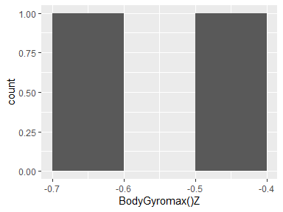

## BodyGyromin()X

|  |  |
| --- | --- |
| Feature | Result |
| Variable type | numeric |
| Number of missing obs. | 0 (0 %) |
| Number of unique values | 2 |
| Median | 0.7 |
| 1st and 3rd quartiles | 0.67; 0.74 |
| Min. and max. | 0.63; 0.77 |

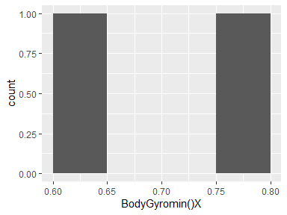

## BodyGyromin()Y

|  |  |
| --- | --- |
| Feature | Result |
| Variable type | numeric |
| Number of missing obs. | 0 (0 %) |
| Number of unique values | 2 |
| Median | 0.79 |
| 1st and 3rd quartiles | 0.76; 0.82 |
| Min. and max. | 0.73; 0.85 |

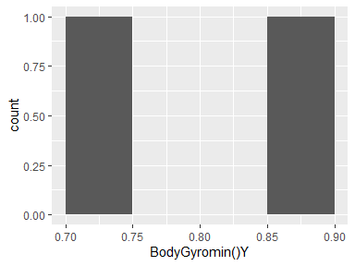

## BodyGyromin()Z

|  |  |
| --- | --- |
| Feature | Result |
| Variable type | numeric |
| Number of missing obs. | 0 (0 %) |
| Number of unique values | 2 |
| Median | 0.65 |
| 1st and 3rd quartiles | 0.6; 0.7 |
| Min. and max. | 0.56; 0.74 |

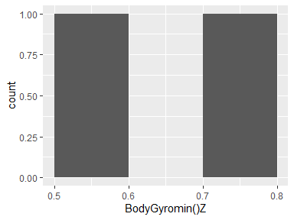

## BodyGyrosma()

|  |  |
| --- | --- |
| Feature | Result |
| Variable type | numeric |
| Number of missing obs. | 0 (0 %) |
| Number of unique values | 2 |
| Median | -0.71 |
| 1st and 3rd quartiles | -0.77; -0.66 |
| Min. and max. | -0.82; -0.6 |

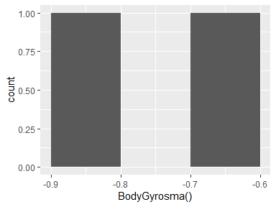

## BodyGyroenergy()X

|  |  |
| --- | --- |
| Feature | Result |
| Variable type | numeric |
| Number of missing obs. | 0 (0 %) |
| Number of unique values | 2 |
| Median | -0.95 |
| 1st and 3rd quartiles | -0.97; -0.92 |
| Min. and max. | -0.99; -0.9 |

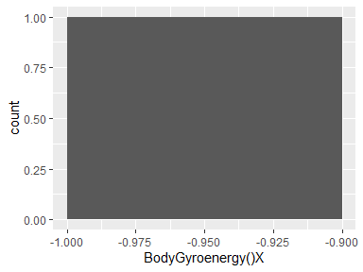

## BodyGyroenergy()Y

|  |  |
| --- | --- |
| Feature | Result |
| Variable type | numeric |
| Number of missing obs. | 0 (0 %) |
| Number of unique values | 2 |
| Median | -0.94 |
| 1st and 3rd quartiles | -0.97; -0.91 |
| Min. and max. | -0.99; -0.88 |

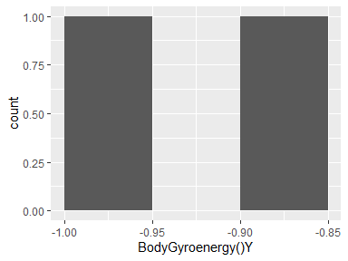

## BodyGyroenergy()Z

|  |  |
| --- | --- |
| Feature | Result |
| Variable type | numeric |
| Number of missing obs. | 0 (0 %) |
| Number of unique values | 2 |
| Median | -0.93 |
| 1st and 3rd quartiles | -0.95; -0.9 |
| Min. and max. | -0.98; -0.87 |

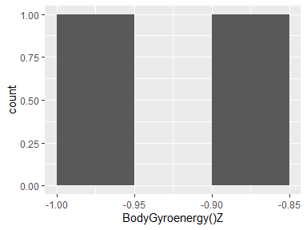

## BodyGyroiqr()X

|  |  |
| --- | --- |
| Feature | Result |
| Variable type | numeric |
| Number of missing obs. | 0 (0 %) |
| Number of unique values | 2 |
| Median | -0.82 |
| 1st and 3rd quartiles | -0.87; -0.78 |
| Min. and max. | -0.92; -0.73 |

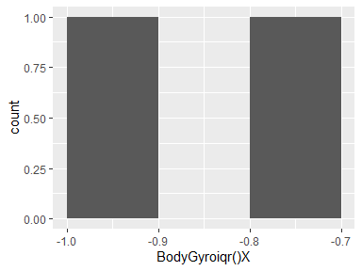

## BodyGyroiqr()Y

|  |  |
| --- | --- |
| Feature | Result |
| Variable type | numeric |
| Number of missing obs. | 0 (0 %) |
| Number of unique values | 2 |
| Median | -0.82 |
| 1st and 3rd quartiles | -0.88; -0.77 |
| Min. and max. | -0.93; -0.72 |

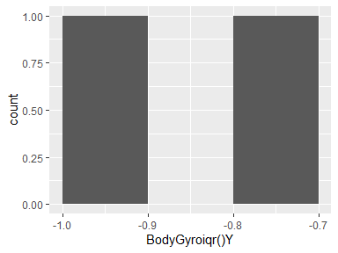

## BodyGyroiqr()Z

|  |  |
| --- | --- |
| Feature | Result |
| Variable type | numeric |
| Number of missing obs. | 0 (0 %) |
| Number of unique values | 2 |
| Median | -0.81 |
| 1st and 3rd quartiles | -0.86; -0.77 |
| Min. and max. | -0.91; -0.72 |

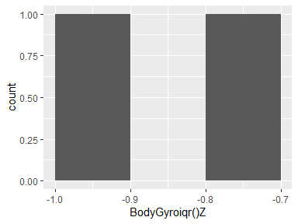

## BodyGyroentropy()X

|  |  |
| --- | --- |
| Feature | Result |
| Variable type | numeric |
| Number of missing obs. | 0 (0 %) |
| Number of unique values | 2 |
| Median | -0.16 |
| 1st and 3rd quartiles | -0.17; -0.15 |
| Min. and max. | -0.18; -0.14 |

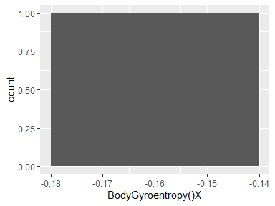

## BodyGyroentropy()Y

|  |  |
| --- | --- |
| Feature | Result |
| Variable type | numeric |
| Number of missing obs. | 0 (0 %) |
| Number of unique values | 2 |
| Median | -0.08 |
| 1st and 3rd quartiles | -0.09; -0.07 |
| Min. and max. | -0.1; -0.06 |

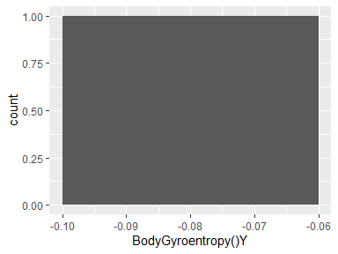

## BodyGyroentropy()Z

|  |  |
| --- | --- |
| Feature | Result |
| Variable type | numeric |
| Number of missing obs. | 0 (0 %) |
| Number of unique values | 2 |
| Median | -0.02 |
| 1st and 3rd quartiles | -0.04; 0.01 |
| Min. and max. | -0.06; 0.03 |

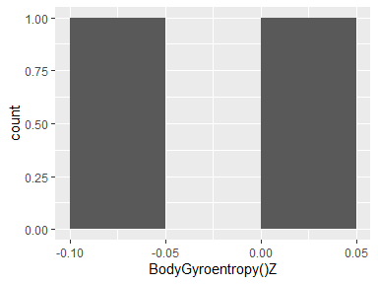

## BodyGyroarCoeff()X,1

|  |  |
| --- | --- |
| Feature | Result |
| Variable type | numeric |
| Number of missing obs. | 0 (0 %) |
| Number of unique values | 2 |
| Median | -0.23 |
| 1st and 3rd quartiles | -0.24; -0.23 |
| Min. and max. | -0.24; -0.22 |

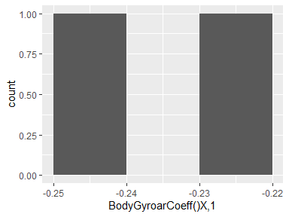

## BodyGyroarCoeff()X,2

|  |  |
| --- | --- |
| Feature | Result |
| Variable type | numeric |
| Number of missing obs. | 0 (0 %) |
| Number of unique values | 2 |
| Median | 0.14 |
| 1st and 3rd quartiles | 0.14; 0.15 |
| Min. and max. | 0.14; 0.15 |

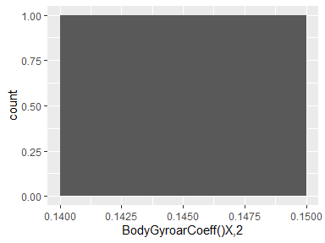

## BodyGyroarCoeff()X,3

|  |  |
| --- | --- |
| Feature | Result |
| Variable type | numeric |
| Number of missing obs. | 0 (0 %) |
| Number of unique values | 2 |
| Median | 0.14 |
| 1st and 3rd quartiles | 0.13; 0.14 |
| Min. and max. | 0.13; 0.14 |

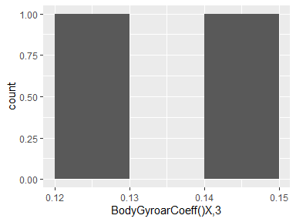

## BodyGyroarCoeff()X,4

|  |  |
| --- | --- |
| Feature | Result |
| Variable type | numeric |
| Number of missing obs. | 0 (0 %) |
| Number of unique values | 2 |
| Median | -0.08 |
| 1st and 3rd quartiles | -0.08; -0.08 |
| Min. and max. | -0.08; -0.08 |

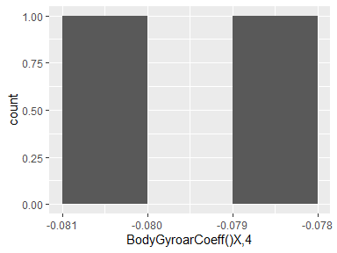

## BodyGyroarCoeff()Y,1

|  |  |
| --- | --- |
| Feature | Result |
| Variable type | numeric |
| Number of missing obs. | 0 (0 %) |
| Number of unique values | 2 |
| Median | -0.21 |
| 1st and 3rd quartiles | -0.21; -0.21 |
| Min. and max. | -0.21; -0.2 |

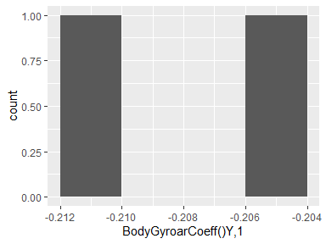

## BodyGyroarCoeff()Y,2

|  |  |
| --- | --- |
| Feature | Result |
| Variable type | numeric |
| Number of missing obs. | 0 (0 %) |
| Number of unique values | 2 |
| Median | 0.17 |
| 1st and 3rd quartiles | 0.17; 0.17 |
| Min. and max. | 0.16; 0.17 |

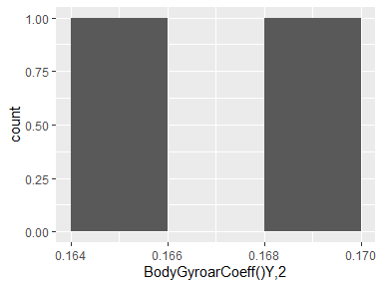

## BodyGyroarCoeff()Y,3

|  |  |
| --- | --- |
| Feature | Result |
| Variable type | numeric |
| Number of missing obs. | 0 (0 %) |
| Number of unique values | 2 |
| Median | -0.04 |
| 1st and 3rd quartiles | -0.04; -0.04 |
| Min. and max. | -0.04; -0.04 |

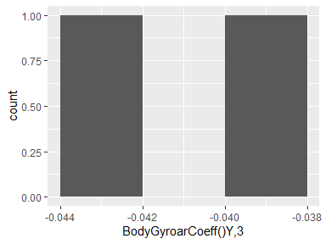

## BodyGyroarCoeff()Y,4

|  |  |
| --- | --- |
| Feature | Result |
| Variable type | numeric |
| Number of missing obs. | 0 (0 %) |
| Number of unique values | 2 |
| Median | 0.14 |
| 1st and 3rd quartiles | 0.14; 0.14 |
| Min. and max. | 0.14; 0.14 |

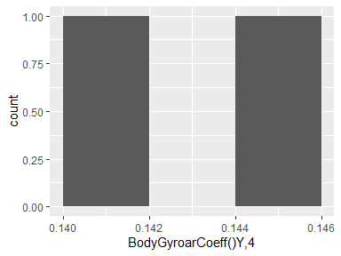

## BodyGyroarCoeff()Z,1

|  |  |
| --- | --- |
| Feature | Result |
| Variable type | numeric |
| Number of missing obs. | 0 (0 %) |
| Number of unique values | 2 |
| Median | -0.09 |
| 1st and 3rd quartiles | -0.1; -0.09 |
| Min. and max. | -0.1; -0.09 |

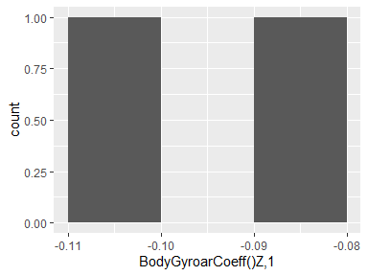

## BodyGyroarCoeff()Z,2

|  |  |
| --- | --- |
| Feature | Result |
| Variable type | numeric |
| Number of missing obs. | 0 (0 %) |
| Number of unique values | 2 |
| Median | 0.07 |
| 1st and 3rd quartiles | 0.06; 0.07 |
| Min. and max. | 0.06; 0.07 |

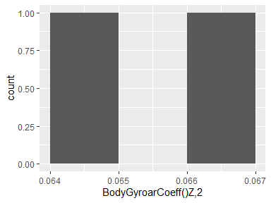

## BodyGyroarCoeff()Z,3

|  |  |
| --- | --- |
| Feature | Result |
| Variable type | numeric |
| Number of missing obs. | 0 (0 %) |
| Number of unique values | 2 |
| Median | 0 |
| 1st and 3rd quartiles | 0; 0.01 |
| Min. and max. | -0.01; 0.01 |

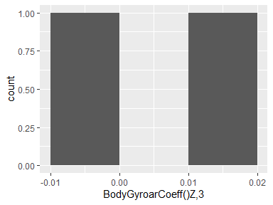

## BodyGyroarCoeff()Z,4

|  |  |
| --- | --- |
| Feature | Result |
| Variable type | numeric |
| Number of missing obs. | 0 (0 %) |
| Number of unique values | 2 |
| Median | 0.15 |
| 1st and 3rd quartiles | 0.15; 0.15 |
| Min. and max. | 0.15; 0.15 |

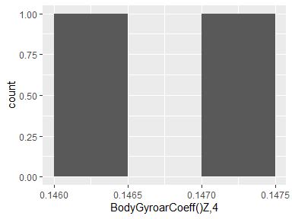

## BodyGyrocorrelation()X,Y

|  |  |
| --- | --- |
| Feature | Result |
| Variable type | numeric |
| Number of missing obs. | 0 (0 %) |
| Number of unique values | 2 |
| Median | -0.17 |
| 1st and 3rd quartiles | -0.18; -0.17 |
| Min. and max. | -0.18; -0.17 |

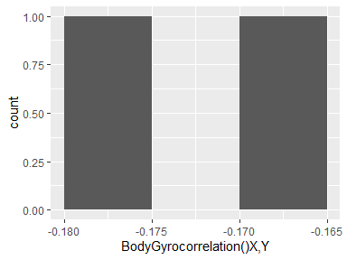

## BodyGyrocorrelation()X,Z

|  |  |
| --- | --- |
| Feature | Result |
| Variable type | numeric |
| Number of missing obs. | 0 (0 %) |
| Number of unique values | 2 |
| Median | 0 |
| 1st and 3rd quartiles | 0; 0.01 |
| Min. and max. | -0.01; 0.01 |

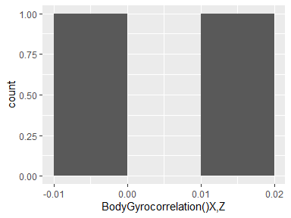

## BodyGyrocorrelation()Y,Z

|  |  |
| --- | --- |
| Feature | Result |
| Variable type | numeric |
| Number of missing obs. | 0 (0 %) |
| Number of unique values | 2 |
| Median | -0.1 |
| 1st and 3rd quartiles | -0.1; -0.1 |
| Min. and max. | -0.11; -0.09 |

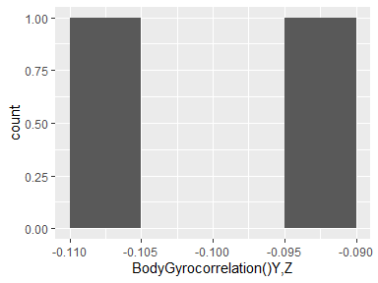

## BodyGyroJerkmean()X

|  |  |
| --- | --- |
| Feature | Result |
| Variable type | numeric |
| Number of missing obs. | 0 (0 %) |
| Number of unique values | 2 |
| Median | -0.1 |
| 1st and 3rd quartiles | -0.1; -0.1 |
| Min. and max. | -0.1; -0.1 |

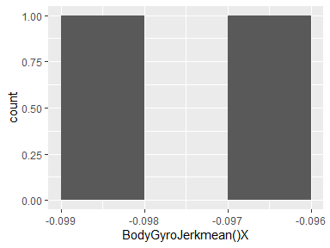

## BodyGyroJerkmean()Y

|  |  |
| --- | --- |
| Feature | Result |
| Variable type | numeric |
| Number of missing obs. | 0 (0 %) |
| Number of unique values | 2 |
| Median | -0.04 |
| 1st and 3rd quartiles | -0.04; -0.04 |
| Min. and max. | -0.04; -0.04 |

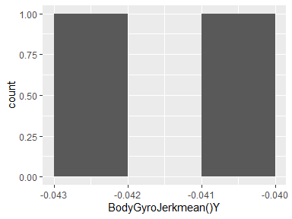

## BodyGyroJerkmean()Z

|  |  |
| --- | --- |
| Feature | Result |
| Variable type | numeric |
| Number of missing obs. | 0 (0 %) |
| Number of unique values | 2 |
| Median | -0.05 |
| 1st and 3rd quartiles | -0.05; -0.05 |
| Min. and max. | -0.05; -0.05 |

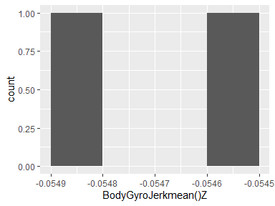

## BodyGyroJerkstd()X

|  |  |
| --- | --- |
| Feature | Result |
| Variable type | numeric |
| Number of missing obs. | 0 (0 %) |
| Number of unique values | 2 |
| Median | -0.83 |
| 1st and 3rd quartiles | -0.88; -0.78 |
| Min. and max. | -0.93; -0.73 |

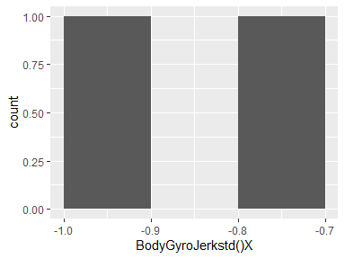

## BodyGyroJerkstd()Y

|  |  |
| --- | --- |
| Feature | Result |
| Variable type | numeric |
| Number of missing obs. | 0 (0 %) |
| Number of unique values | 2 |
| Median | -0.87 |
| 1st and 3rd quartiles | -0.91; -0.83 |
| Min. and max. | -0.95; -0.79 |

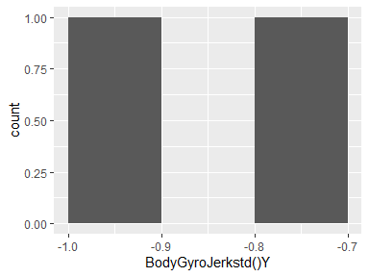

## BodyGyroJerkstd()Z

|  |  |
| --- | --- |
| Feature | Result |
| Variable type | numeric |
| Number of missing obs. | 0 (0 %) |
| Number of unique values | 2 |
| Median | -0.85 |
| 1st and 3rd quartiles | -0.9; -0.79 |
| Min. and max. | -0.95; -0.74 |

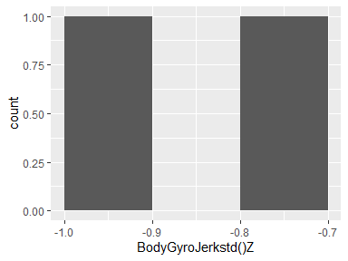

## BodyGyroJerkmad()X

|  |  |
| --- | --- |
| Feature | Result |
| Variable type | numeric |
| Number of missing obs. | 0 (0 %) |
| Number of unique values | 2 |
| Median | -0.84 |
| 1st and 3rd quartiles | -0.89; -0.78 |
| Min. and max. | -0.94; -0.73 |

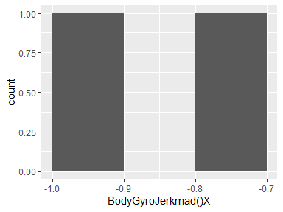

## BodyGyroJerkmad()Y

|  |  |
| --- | --- |
| Feature | Result |
| Variable type | numeric |
| Number of missing obs. | 0 (0 %) |
| Number of unique values | 2 |
| Median | -0.88 |
| 1st and 3rd quartiles | -0.92; -0.84 |
| Min. and max. | -0.96; -0.8 |

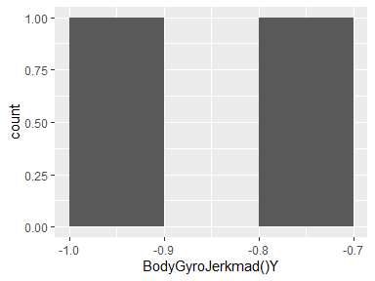

## BodyGyroJerkmad()Z

|  |  |
| --- | --- |
| Feature | Result |
| Variable type | numeric |
| Number of missing obs. | 0 (0 %) |
| Number of unique values | 2 |
| Median | -0.85 |
| 1st and 3rd quartiles | -0.91; -0.8 |
| Min. and max. | -0.96; -0.75 |

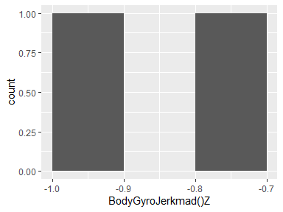

## BodyGyroJerkmax()X

|  |  |
| --- | --- |
| Feature | Result |
| Variable type | numeric |
| Number of missing obs. | 0 (0 %) |
| Number of unique values | 2 |
| Median | -0.84 |
| 1st and 3rd quartiles | -0.88; -0.79 |
| Min. and max. | -0.93; -0.75 |

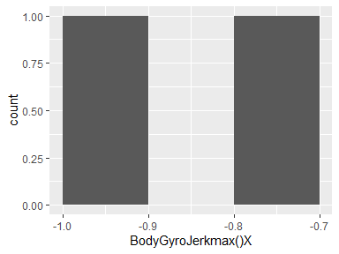

## BodyGyroJerkmax()Y

|  |  |
| --- | --- |
| Feature | Result |
| Variable type | numeric |
| Number of missing obs. | 0 (0 %) |
| Number of unique values | 2 |
| Median | -0.88 |
| 1st and 3rd quartiles | -0.92; -0.85 |
| Min. and max. | -0.95; -0.81 |

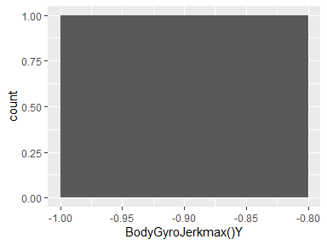

## BodyGyroJerkmax()Z

|  |  |
| --- | --- |
| Feature | Result |
| Variable type | numeric |
| Number of missing obs. | 0 (0 %) |
| Number of unique values | 2 |
| Median | -0.84 |
| 1st and 3rd quartiles | -0.89; -0.79 |
| Min. and max. | -0.94; -0.74 |

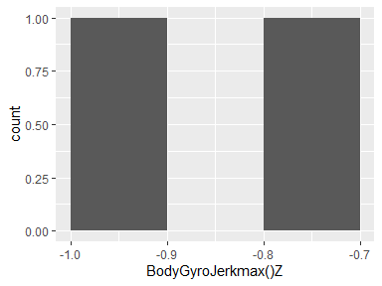

## BodyGyroJerkmin()X

|  |  |
| --- | --- |
| Feature | Result |
| Variable type | numeric |
| Number of missing obs. | 0 (0 %) |
| Number of unique values | 2 |
| Median | 0.85 |
| 1st and 3rd quartiles | 0.8; 0.89 |
| Min. and max. | 0.76; 0.93 |

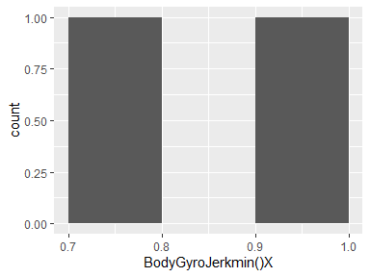

## BodyGyroJerkmin()Y

|  |  |
| --- | --- |
| Feature | Result |
| Variable type | numeric |
| Number of missing obs. | 0 (0 %) |
| Number of unique values | 2 |
| Median | 0.89 |
| 1st and 3rd quartiles | 0.86; 0.93 |
| Min. and max. | 0.83; 0.96 |

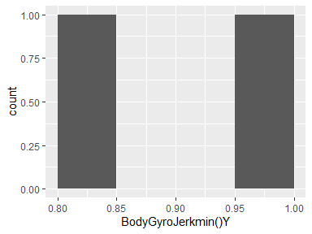

## BodyGyroJerkmin()Z

|  |  |
| --- | --- |
| Feature | Result |
| Variable type | numeric |
| Number of missing obs. | 0 (0 %) |
| Number of unique values | 2 |
| Median | 0.88 |
| 1st and 3rd quartiles | 0.84; 0.92 |
| Min. and max. | 0.8; 0.96 |

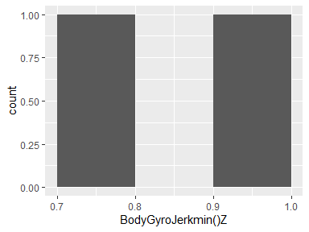

## BodyGyroJerksma()

|  |  |
| --- | --- |
| Feature | Result |
| Variable type | numeric |
| Number of missing obs. | 0 (0 %) |
| Number of unique values | 2 |
| Median | -0.86 |
| 1st and 3rd quartiles | -0.91; -0.81 |
| Min. and max. | -0.96; -0.77 |

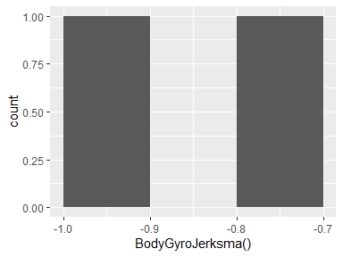

## BodyGyroJerkenergy()X

|  |  |
| --- | --- |
| Feature | Result |
| Variable type | numeric |
| Number of missing obs. | 0 (0 %) |
| Number of unique values | 2 |
| Median | -0.96 |
| 1st and 3rd quartiles | -0.98; -0.94 |
| Min. and max. | -1; -0.92 |

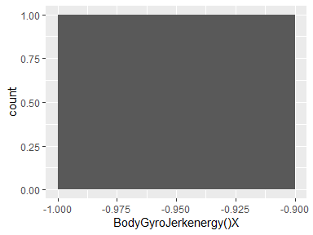

## BodyGyroJerkenergy()Y

|  |  |
| --- | --- |
| Feature | Result |
| Variable type | numeric |
| Number of missing obs. | 0 (0 %) |
| Number of unique values | 2 |
| Median | -0.97 |
| 1st and 3rd quartiles | -0.98; -0.95 |
| Min. and max. | -1; -0.94 |

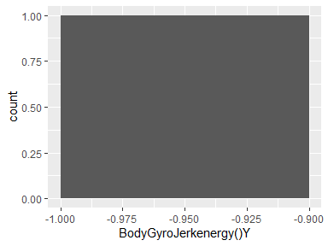

## BodyGyroJerkenergy()Z

|  |  |
| --- | --- |
| Feature | Result |
| Variable type | numeric |
| Number of missing obs. | 0 (0 %) |
| Number of unique values | 2 |
| Median | -0.96 |
| 1st and 3rd quartiles | -0.98; -0.94 |
| Min. and max. | -1; -0.92 |

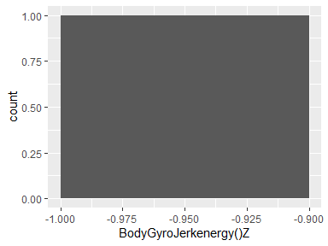

## BodyGyroJerkiqr()X

|  |  |
| --- | --- |
| Feature | Result |
| Variable type | numeric |
| Number of missing obs. | 0 (0 %) |
| Number of unique values | 2 |
| Median | -0.85 |
| 1st and 3rd quartiles | -0.9; -0.79 |
| Min. and max. | -0.95; -0.74 |

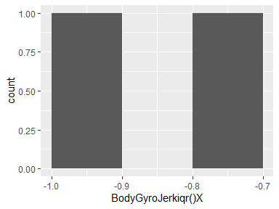

## BodyGyroJerkiqr()Y

|  |  |
| --- | --- |
| Feature | Result |
| Variable type | numeric |
| Number of missing obs. | 0 (0 %) |
| Number of unique values | 2 |
| Median | -0.89 |
| 1st and 3rd quartiles | -0.93; -0.85 |
| Min. and max. | -0.97; -0.81 |

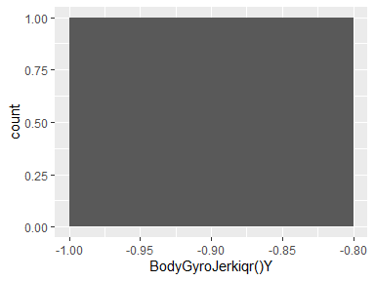

## BodyGyroJerkiqr()Z

|  |  |
| --- | --- |
| Feature | Result |
| Variable type | numeric |
| Number of missing obs. | 0 (0 %) |
| Number of unique values | 2 |
| Median | -0.87 |
| 1st and 3rd quartiles | -0.92; -0.82 |
| Min. and max. | -0.97; -0.77 |

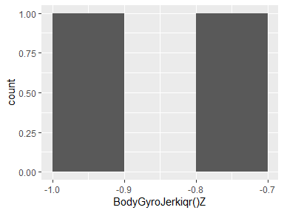

## BodyGyroJerkentropy()X

|  |  |
| --- | --- |
| Feature | Result |
| Variable type | numeric |
| Number of missing obs. | 0 (0 %) |
| Number of unique values | 2 |
| Median | -0.02 |
| 1st and 3rd quartiles | -0.03; -0.02 |
| Min. and max. | -0.03; -0.02 |

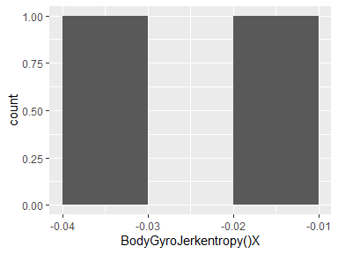

## BodyGyroJerkentropy()Y

|  |  |
| --- | --- |
| Feature | Result |
| Variable type | numeric |
| Number of missing obs. | 0 (0 %) |
| Number of unique values | 2 |
| Median | 0.01 |
| 1st and 3rd quartiles | 0; 0.01 |
| Min. and max. | 0; 0.02 |

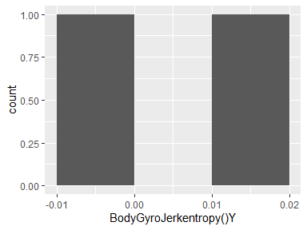

## BodyGyroJerkentropy()Z

|  |  |
| --- | --- |
| Feature | Result |
| Variable type | numeric |
| Number of missing obs. | 0 (0 %) |
| Number of unique values | 2 |
| Median | -0.07 |
| 1st and 3rd quartiles | -0.1; -0.04 |
| Min. and max. | -0.13; -0.02 |

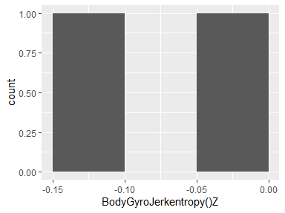

## BodyGyroJerkarCoeff()X,1

|  |  |
| --- | --- |
| Feature | Result |
| Variable type | numeric |
| Number of missing obs. | 0 (0 %) |
| Number of unique values | 2 |
| Median | -0.08 |
| 1st and 3rd quartiles | -0.09; -0.08 |
| Min. and max. | -0.09; -0.07 |

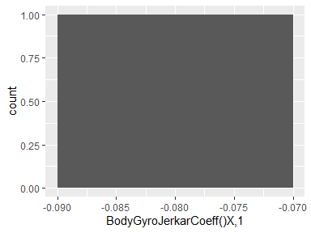

## BodyGyroJerkarCoeff()X,2

|  |  |
| --- | --- |
| Feature | Result |
| Variable type | numeric |
| Number of missing obs. | 0 (0 %) |
| Number of unique values | 2 |
| Median | 0.04 |
| 1st and 3rd quartiles | 0.04; 0.04 |
| Min. and max. | 0.04; 0.04 |

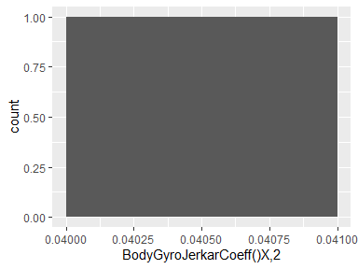

## BodyGyroJerkarCoeff()X,3

|  |  |
| --- | --- |
| Feature | Result |
| Variable type | numeric |
| Number of missing obs. | 0 (0 %) |
| Number of unique values | 2 |
| Median | 0.16 |
| 1st and 3rd quartiles | 0.16; 0.16 |
| Min. and max. | 0.16; 0.17 |

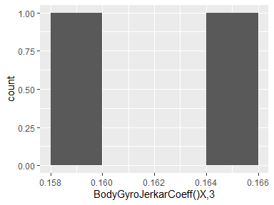

## BodyGyroJerkarCoeff()X,4

|  |  |
| --- | --- |
| Feature | Result |
| Variable type | numeric |
| Number of missing obs. | 0 (0 %) |
| Number of unique values | 2 |
| Median | 0.17 |
| 1st and 3rd quartiles | 0.17; 0.17 |
| Min. and max. | 0.16; 0.17 |

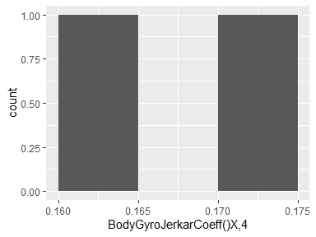

## BodyGyroJerkarCoeff()Y,1

|  |  |
| --- | --- |
| Feature | Result |
| Variable type | numeric |
| Number of missing obs. | 0 (0 %) |
| Number of unique values | 2 |
| Median | -0.17 |
| 1st and 3rd quartiles | -0.17; -0.16 |
| Min. and max. | -0.17; -0.16 |

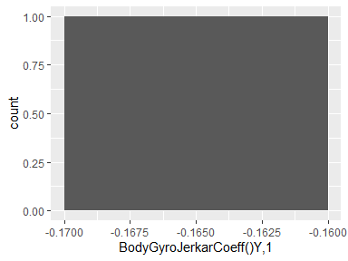

## BodyGyroJerkarCoeff()Y,2

|  |  |
| --- | --- |
| Feature | Result |
| Variable type | numeric |
| Number of missing obs. | 0 (0 %) |
| Number of unique values | 2 |
| Median | 0.2 |
| 1st and 3rd quartiles | 0.2; 0.2 |
| Min. and max. | 0.2; 0.2 |

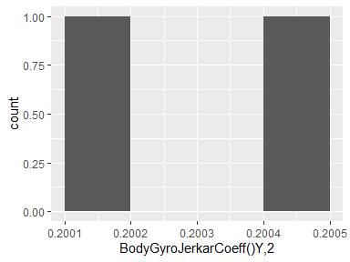

## BodyGyroJerkarCoeff()Y,3

|  |  |
| --- | --- |
| Feature | Result |
| Variable type | numeric |
| Number of missing obs. | 0 (0 %) |
| Number of unique values | 2 |
| Median | 0.09 |
| 1st and 3rd quartiles | 0.09; 0.09 |
| Min. and max. | 0.08; 0.09 |

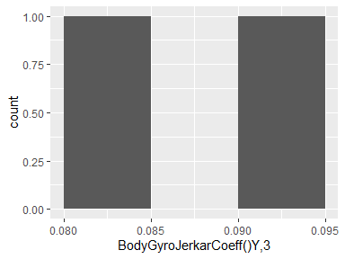

## BodyGyroJerkarCoeff()Y,4

|  |  |
| --- | --- |
| Feature | Result |
| Variable type | numeric |
| Number of missing obs. | 0 (0 %) |
| Number of unique values | 2 |
| Median | 0.08 |
| 1st and 3rd quartiles | 0.08; 0.08 |
| Min. and max. | 0.08; 0.08 |

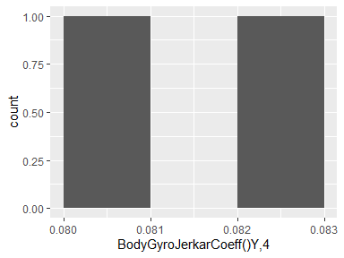

## BodyGyroJerkarCoeff()Z,1

|  |  |
| --- | --- |
| Feature | Result |
| Variable type | numeric |
| Number of missing obs. | 0 (0 %) |
| Number of unique values | 2 |
| Median | -0.04 |
| 1st and 3rd quartiles | -0.05; -0.04 |
| Min. and max. | -0.06; -0.03 |

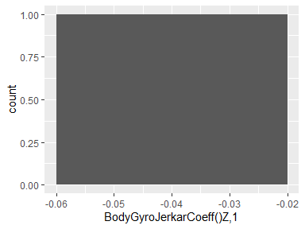

## BodyGyroJerkarCoeff()Z,2

|  |  |
| --- | --- |
| Feature | Result |
| Variable type | numeric |
| Number of missing obs. | 0 (0 %) |
| Number of unique values | 2 |
| Median | 0.05 |
| 1st and 3rd quartiles | 0.05; 0.05 |
| Min. and max. | 0.04; 0.05 |

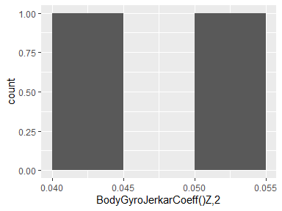

## BodyGyroJerkarCoeff()Z,3

|  |  |
| --- | --- |
| Feature | Result |
| Variable type | numeric |
| Number of missing obs. | 0 (0 %) |
| Number of unique values | 2 |
| Median | 0.09 |
| 1st and 3rd quartiles | 0.09; 0.09 |
| Min. and max. | 0.09; 0.1 |

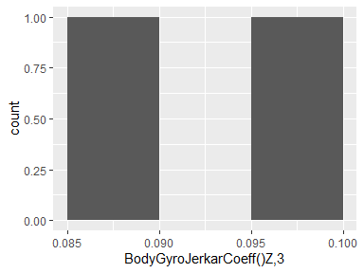

## BodyGyroJerkarCoeff()Z,4

|  |  |
| --- | --- |
| Feature | Result |
| Variable type | numeric |
| Number of missing obs. | 0 (0 %) |
| Number of unique values | 2 |
| Median | 0.04 |
| 1st and 3rd quartiles | 0.04; 0.04 |
| Min. and max. | 0.03; 0.04 |

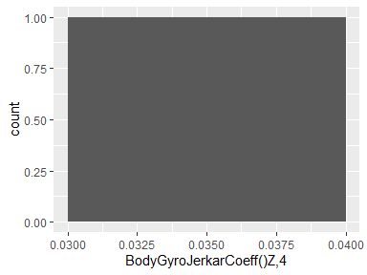

## BodyGyroJerkcorrelation()X,Y

|  |  |
| --- | --- |
| Feature | Result |
| Variable type | numeric |
| Number of missing obs. | 0 (0 %) |
| Number of unique values | 2 |
| Median | 0.04 |
| 1st and 3rd quartiles | 0.03; 0.04 |
| Min. and max. | 0.03; 0.04 |

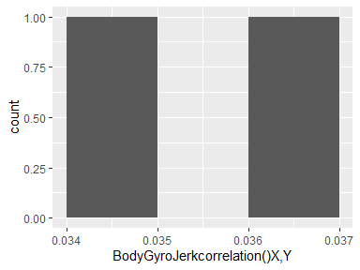

## BodyGyroJerkcorrelation()X,Z

|  |  |
| --- | --- |
| Feature | Result |
| Variable type | numeric |
| Number of missing obs. | 0 (0 %) |
| Number of unique values | 2 |
| Median | 0.05 |
| 1st and 3rd quartiles | 0.05; 0.05 |
| Min. and max. | 0.05; 0.05 |

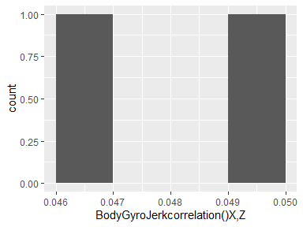

## BodyGyroJerkcorrelation()Y,Z

|  |  |
| --- | --- |
| Feature | Result |
| Variable type | numeric |
| Number of missing obs. | 0 (0 %) |
| Number of unique values | 2 |
| Median | -0.12 |
| 1st and 3rd quartiles | -0.12; -0.11 |
| Min. and max. | -0.12; -0.11 |

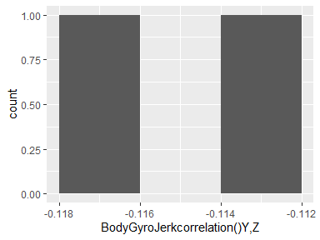

## BodyAccMagmean()

|  |  |
| --- | --- |
| Feature | Result |
| Variable type | numeric |
| Number of missing obs. | 0 (0 %) |
| Number of unique values | 2 |
| Median | -0.71 |
| 1st and 3rd quartiles | -0.79; -0.63 |
| Min. and max. | -0.87; -0.55 |

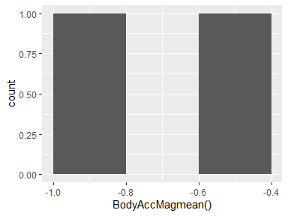

## BodyAccMagstd()

|  |  |
| --- | --- |
| Feature | Result |
| Variable type | numeric |
| Number of missing obs. | 0 (0 %) |
| Number of unique values | 2 |
| Median | -0.72 |
| 1st and 3rd quartiles | -0.78; -0.65 |
| Min. and max. | -0.84; -0.59 |

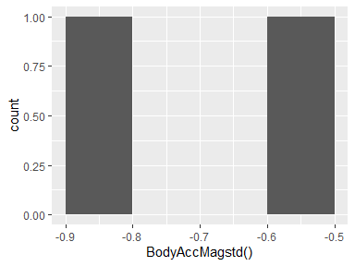

## BodyAccMagmad()

|  |  |
| --- | --- |
| Feature | Result |
| Variable type | numeric |
| Number of missing obs. | 0 (0 %) |
| Number of unique values | 2 |
| Median | -0.75 |
| 1st and 3rd quartiles | -0.81; -0.7 |
| Min. and max. | -0.86; -0.64 |

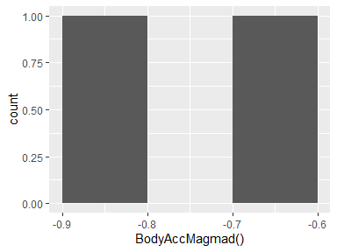

## BodyAccMagmax()

|  |  |
| --- | --- |
| Feature | Result |
| Variable type | numeric |
| Number of missing obs. | 0 (0 %) |
| Number of unique values | 2 |
| Median | -0.7 |
| 1st and 3rd quartiles | -0.78; -0.63 |
| Min. and max. | -0.85; -0.56 |

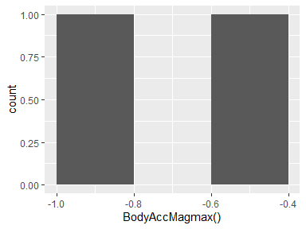

## BodyAccMagmin()

|  |  |
| --- | --- |
| Feature | Result |
| Variable type | numeric |
| Number of missing obs. | 0 (0 %) |
| Number of unique values | 2 |
| Median | -0.9 |
| 1st and 3rd quartiles | -0.93; -0.87 |
| Min. and max. | -0.97; -0.84 |

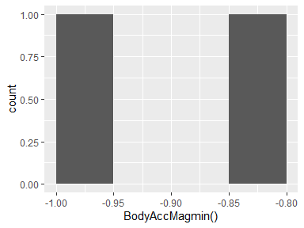

## BodyAccMagsma()

|  |  |
| --- | --- |
| Feature | Result |
| Variable type | numeric |
| Number of missing obs. | 0 (0 %) |
| Number of unique values | 2 |
| Median | -0.71 |
| 1st and 3rd quartiles | -0.79; -0.63 |
| Min. and max. | -0.87; -0.55 |

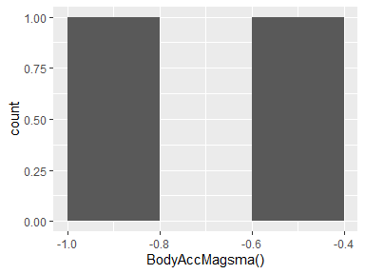

## BodyAccMagenergy()

|  |  |
| --- | --- |
| Feature | Result |
| Variable type | numeric |
| Number of missing obs. | 0 (0 %) |
| Number of unique values | 2 |
| Median | -0.88 |
| 1st and 3rd quartiles | -0.94; -0.83 |
| Min. and max. | -0.99; -0.78 |

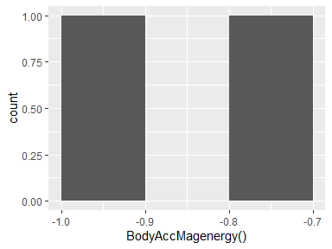

## BodyAccMagiqr()

|  |  |
| --- | --- |
| Feature | Result |
| Variable type | numeric |
| Number of missing obs. | 0 (0 %) |
| Number of unique values | 2 |
| Median | -0.79 |
| 1st and 3rd quartiles | -0.84; -0.75 |
| Min. and max. | -0.88; -0.7 |

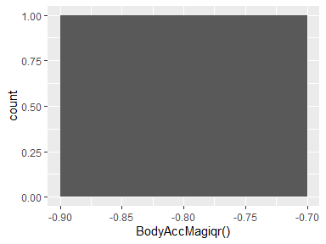

## BodyAccMagentropy()

|  |  |
| --- | --- |
| Feature | Result |
| Variable type | numeric |
| Number of missing obs. | 0 (0 %) |
| Number of unique values | 2 |
| Median | 0.15 |
| 1st and 3rd quartiles | 0.14; 0.16 |
| Min. and max. | 0.13; 0.16 |

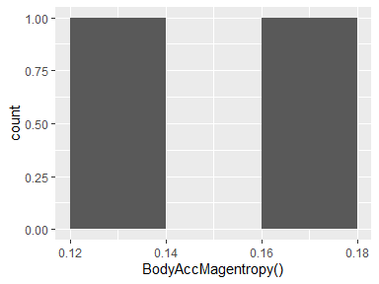

## BodyAccMagarCoeff()1

|  |  |
| --- | --- |
| Feature | Result |
| Variable type | numeric |
| Number of missing obs. | 0 (0 %) |
| Number of unique values | 2 |
| Median | -0.07 |
| 1st and 3rd quartiles | -0.07; -0.07 |
| Min. and max. | -0.07; -0.07 |

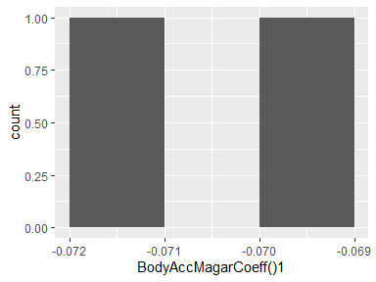

## BodyAccMagarCoeff()2

|  |  |
| --- | --- |
| Feature | Result |
| Variable type | numeric |
| Number of missing obs. | 0 (0 %) |
| Number of unique values | 2 |
| Median | 0.02 |
| 1st and 3rd quartiles | 0.02; 0.02 |
| Min. and max. | 0.02; 0.02 |

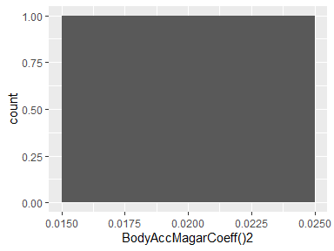

## BodyAccMagarCoeff()3

|  |  |
| --- | --- |
| Feature | Result |
| Variable type | numeric |
| Number of missing obs. | 0 (0 %) |
| Number of unique values | 2 |
| Median | 0.06 |
| 1st and 3rd quartiles | 0.06; 0.06 |
| Min. and max. | 0.06; 0.06 |

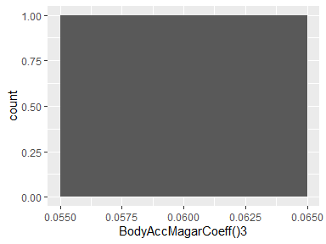

## BodyAccMagarCoeff()4

|  |  |
| --- | --- |
| Feature | Result |
| Variable type | numeric |
| Number of missing obs. | 0 (0 %) |
| Number of unique values | 2 |
| Median | -0.06 |
| 1st and 3rd quartiles | -0.06; -0.05 |
| Min. and max. | -0.06; -0.05 |

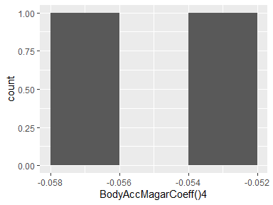

## GravityAccMagmean()

|  |  |
| --- | --- |
| Feature | Result |
| Variable type | numeric |
| Number of missing obs. | 0 (0 %) |
| Number of unique values | 2 |
| Median | -0.71 |
| 1st and 3rd quartiles | -0.79; -0.63 |
| Min. and max. | -0.87; -0.55 |

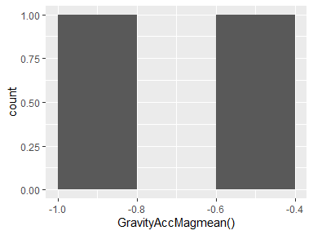

## GravityAccMagstd()

|  |  |
| --- | --- |
| Feature | Result |
| Variable type | numeric |
| Number of missing obs. | 0 (0 %) |
| Number of unique values | 2 |
| Median | -0.72 |
| 1st and 3rd quartiles | -0.78; -0.65 |
| Min. and max. | -0.84; -0.59 |

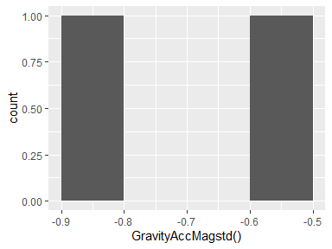

## GravityAccMagmad()

|  |  |
| --- | --- |
| Feature | Result |
| Variable type | numeric |
| Number of missing obs. | 0 (0 %) |
| Number of unique values | 2 |
| Median | -0.75 |
| 1st and 3rd quartiles | -0.81; -0.7 |
| Min. and max. | -0.86; -0.64 |

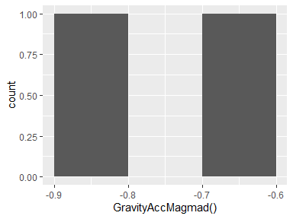

## GravityAccMagmax()

|  |  |
| --- | --- |
| Feature | Result |
| Variable type | numeric |
| Number of missing obs. | 0 (0 %) |
| Number of unique values | 2 |
| Median | -0.7 |
| 1st and 3rd quartiles | -0.78; -0.63 |
| Min. and max. | -0.85; -0.56 |

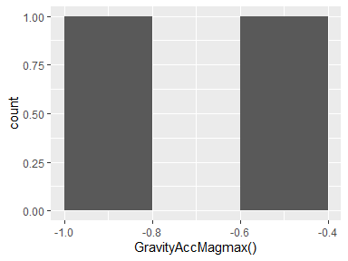

## GravityAccMagmin()

|  |  |
| --- | --- |
| Feature | Result |
| Variable type | numeric |
| Number of missing obs. | 0 (0 %) |
| Number of unique values | 2 |
| Median | -0.9 |
| 1st and 3rd quartiles | -0.93; -0.87 |
| Min. and max. | -0.97; -0.84 |

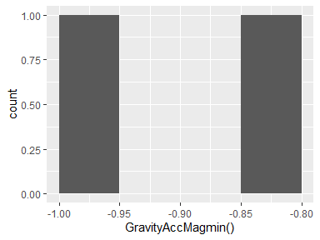

## GravityAccMagsma()

|  |  |
| --- | --- |
| Feature | Result |
| Variable type | numeric |
| Number of missing obs. | 0 (0 %) |
| Number of unique values | 2 |
| Median | -0.71 |
| 1st and 3rd quartiles | -0.79; -0.63 |
| Min. and max. | -0.87; -0.55 |

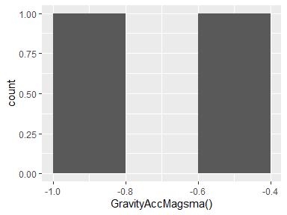

## GravityAccMagenergy()

|  |  |
| --- | --- |
| Feature | Result |
| Variable type | numeric |
| Number of missing obs. | 0 (0 %) |
| Number of unique values | 2 |
| Median | -0.88 |
| 1st and 3rd quartiles | -0.94; -0.83 |
| Min. and max. | -0.99; -0.78 |

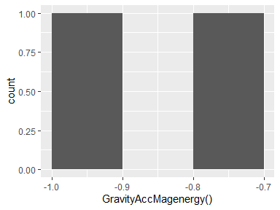

## GravityAccMagiqr()

|  |  |
| --- | --- |
| Feature | Result |
| Variable type | numeric |
| Number of missing obs. | 0 (0 %) |
| Number of unique values | 2 |
| Median | -0.79 |
| 1st and 3rd quartiles | -0.84; -0.75 |
| Min. and max. | -0.88; -0.7 |

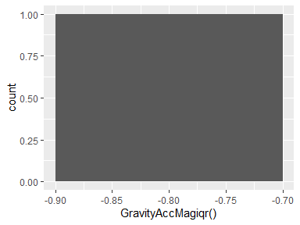

## GravityAccMagentropy()

|  |  |
| --- | --- |
| Feature | Result |
| Variable type | numeric |
| Number of missing obs. | 0 (0 %) |
| Number of unique values | 2 |
| Median | 0.15 |
| 1st and 3rd quartiles | 0.14; 0.16 |
| Min. and max. | 0.13; 0.16 |

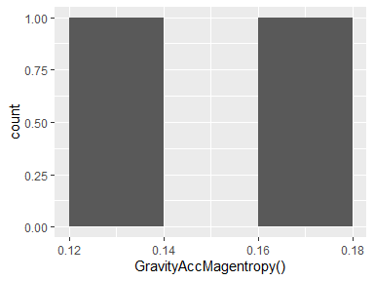

## GravityAccMagarCoeff()1

|  |  |
| --- | --- |
| Feature | Result |
| Variable type | numeric |
| Number of missing obs. | 0 (0 %) |
| Number of unique values | 2 |
| Median | -0.07 |
| 1st and 3rd quartiles | -0.07; -0.07 |
| Min. and max. | -0.07; -0.07 |

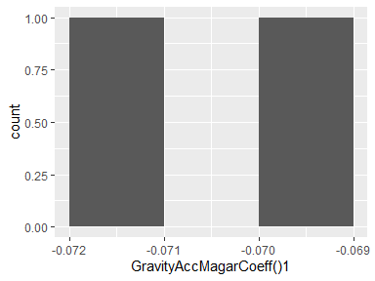

## GravityAccMagarCoeff()2

|  |  |
| --- | --- |
| Feature | Result |
| Variable type | numeric |
| Number of missing obs. | 0 (0 %) |
| Number of unique values | 2 |
| Median | 0.02 |
| 1st and 3rd quartiles | 0.02; 0.02 |
| Min. and max. | 0.02; 0.02 |

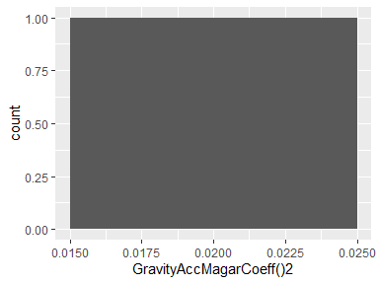

## GravityAccMagarCoeff()3

|  |  |
| --- | --- |
| Feature | Result |
| Variable type | numeric |
| Number of missing obs. | 0 (0 %) |
| Number of unique values | 2 |
| Median | 0.06 |
| 1st and 3rd quartiles | 0.06; 0.06 |
| Min. and max. | 0.06; 0.06 |

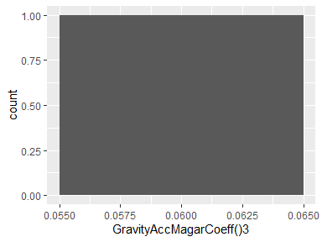

## GravityAccMagarCoeff()4

|  |  |
| --- | --- |
| Feature | Result |
| Variable type | numeric |
| Number of missing obs. | 0 (0 %) |
| Number of unique values | 2 |
| Median | -0.06 |
| 1st and 3rd quartiles | -0.06; -0.05 |
| Min. and max. | -0.06; -0.05 |

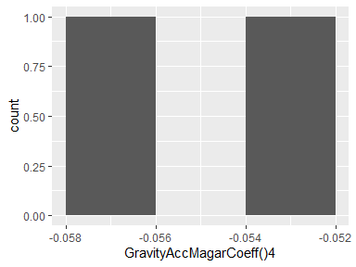

## BodyAccJerkMagmean()

|  |  |
| --- | --- |
| Feature | Result |
| Variable type | numeric |
| Number of missing obs. | 0 (0 %) |
| Number of unique values | 2 |
| Median | -0.8 |
| 1st and 3rd quartiles | -0.87; -0.72 |
| Min. and max. | -0.95; -0.65 |

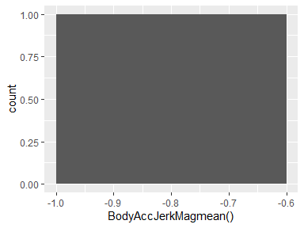

## BodyAccJerkMagstd()

|  |  |
| --- | --- |
| Feature | Result |
| Variable type | numeric |
| Number of missing obs. | 0 (0 %) |
| Number of unique values | 2 |
| Median | -0.78 |
| 1st and 3rd quartiles | -0.85; -0.7 |
| Min. and max. | -0.93; -0.63 |

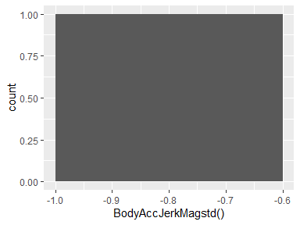

## BodyAccJerkMagmad()

|  |  |
| --- | --- |
| Feature | Result |
| Variable type | numeric |
| Number of missing obs. | 0 (0 %) |
| Number of unique values | 2 |
| Median | -0.79 |
| 1st and 3rd quartiles | -0.87; -0.72 |
| Min. and max. | -0.94; -0.65 |

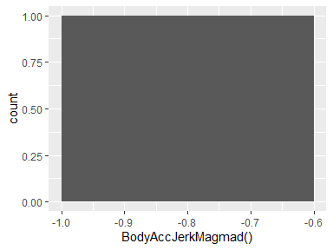

## BodyAccJerkMagmax()

|  |  |
| --- | --- |
| Feature | Result |
| Variable type | numeric |
| Number of missing obs. | 0 (0 %) |
| Number of unique values | 2 |
| Median | -0.78 |
| 1st and 3rd quartiles | -0.85; -0.71 |
| Min. and max. | -0.93; -0.64 |

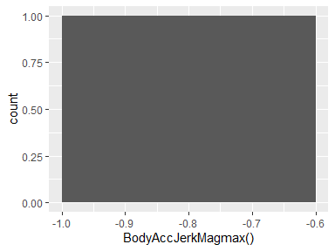

## BodyAccJerkMagmin()

|  |  |
| --- | --- |
| Feature | Result |
| Variable type | numeric |
| Number of missing obs. | 0 (0 %) |
| Number of unique values | 2 |
| Median | -0.87 |
| 1st and 3rd quartiles | -0.92; -0.83 |
| Min. and max. | -0.96; -0.79 |

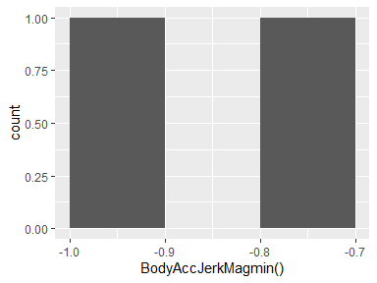

## BodyAccJerkMagsma()

|  |  |
| --- | --- |
| Feature | Result |
| Variable type | numeric |
| Number of missing obs. | 0 (0 %) |
| Number of unique values | 2 |
| Median | -0.8 |
| 1st and 3rd quartiles | -0.87; -0.72 |
| Min. and max. | -0.95; -0.65 |

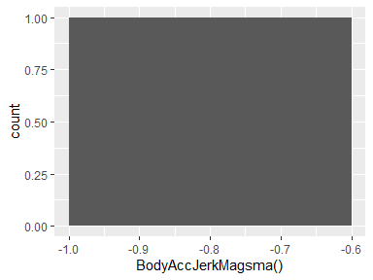

## BodyAccJerkMagenergy()

|  |  |
| --- | --- |
| Feature | Result |
| Variable type | numeric |
| Number of missing obs. | 0 (0 %) |
| Number of unique values | 2 |
| Median | -0.92 |
| 1st and 3rd quartiles | -0.96; -0.89 |
| Min. and max. | -1; -0.85 |

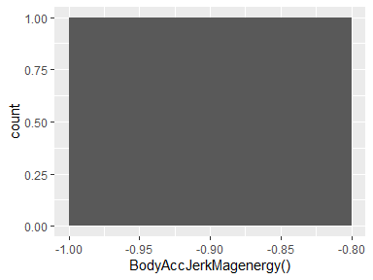

## BodyAccJerkMagiqr()

|  |  |
| --- | --- |
| Feature | Result |
| Variable type | numeric |
| Number of missing obs. | 0 (0 %) |
| Number of unique values | 2 |
| Median | -0.83 |
| 1st and 3rd quartiles | -0.89; -0.76 |
| Min. and max. | -0.95; -0.7 |

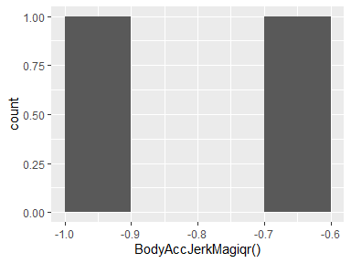

## BodyAccJerkMagentropy()

|  |  |
| --- | --- |
| Feature | Result |
| Variable type | numeric |
| Number of missing obs. | 0 (0 %) |
| Number of unique values | 2 |
| Median | -0.19 |
| 1st and 3rd quartiles | -0.26; -0.13 |
| Min. and max. | -0.32; -0.06 |

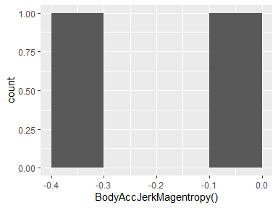

## BodyAccJerkMagarCoeff()1

|  |  |
| --- | --- |
| Feature | Result |
| Variable type | numeric |
| Number of missing obs. | 0 (0 %) |
| Number of unique values | 2 |
| Median | 0.09 |
| 1st and 3rd quartiles | 0.08; 0.09 |
| Min. and max. | 0.08; 0.09 |

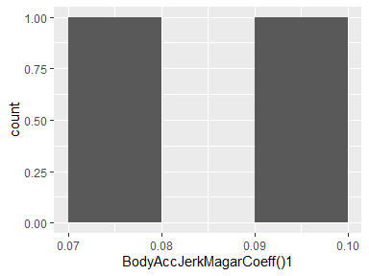

## BodyAccJerkMagarCoeff()2

|  |  |
| --- | --- |
| Feature | Result |
| Variable type | numeric |
| Number of missing obs. | 0 (0 %) |
| Number of unique values | 2 |
| Median | -0.04 |
| 1st and 3rd quartiles | -0.05; -0.04 |
| Min. and max. | -0.06; -0.03 |

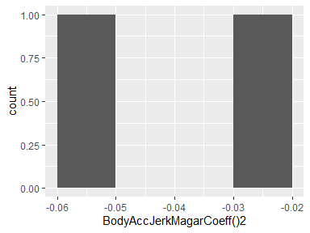

## BodyAccJerkMagarCoeff()3

|  |  |
| --- | --- |
| Feature | Result |
| Variable type | numeric |
| Number of missing obs. | 0 (0 %) |
| Number of unique values | 2 |
| Median | -0.09 |
| 1st and 3rd quartiles | -0.09; -0.09 |
| Min. and max. | -0.09; -0.09 |

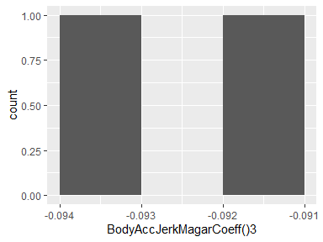

## BodyAccJerkMagarCoeff()4

|  |  |
| --- | --- |
| Feature | Result |
| Variable type | numeric |
| Number of missing obs. | 0 (0 %) |
| Number of unique values | 2 |
| Median | -0.04 |
| 1st and 3rd quartiles | -0.05; -0.04 |
| Min. and max. | -0.05; -0.04 |

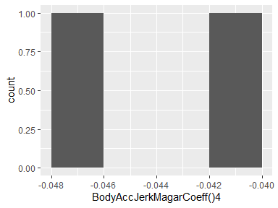

## BodyGyroMagmean()

|  |  |
| --- | --- |
| Feature | Result |
| Variable type | numeric |
| Number of missing obs. | 0 (0 %) |
| Number of unique values | 2 |
| Median | -0.71 |
| 1st and 3rd quartiles | -0.77; -0.66 |
| Min. and max. | -0.82; -0.61 |

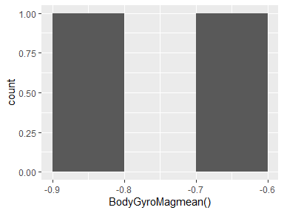

## BodyGyroMagstd()

|  |  |
| --- | --- |
| Feature | Result |
| Variable type | numeric |
| Number of missing obs. | 0 (0 %) |
| Number of unique values | 2 |
| Median | -0.74 |
| 1st and 3rd quartiles | -0.79; -0.7 |
| Min. and max. | -0.83; -0.66 |

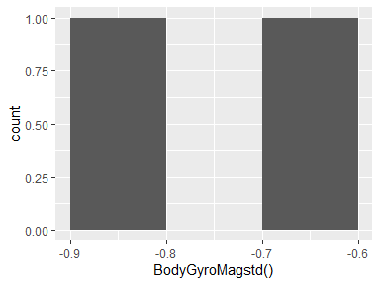

## BodyGyroMagmad()

|  |  |
| --- | --- |
| Feature | Result |
| Variable type | numeric |
| Number of missing obs. | 0 (0 %) |
| Number of unique values | 2 |
| Median | -0.72 |
| 1st and 3rd quartiles | -0.76; -0.67 |
| Min. and max. | -0.81; -0.63 |

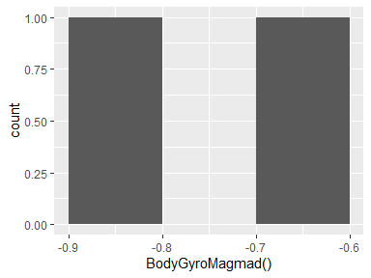

## BodyGyroMagmax()

|  |  |
| --- | --- |
| Feature | Result |
| Variable type | numeric |
| Number of missing obs. | 0 (0 %) |
| Number of unique values | 2 |
| Median | -0.77 |
| 1st and 3rd quartiles | -0.81; -0.73 |
| Min. and max. | -0.85; -0.7 |

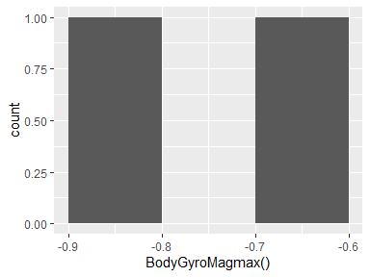

## BodyGyroMagmin()

|  |  |
| --- | --- |
| Feature | Result |
| Variable type | numeric |
| Number of missing obs. | 0 (0 %) |
| Number of unique values | 2 |
| Median | -0.81 |
| 1st and 3rd quartiles | -0.84; -0.77 |
| Min. and max. | -0.88; -0.73 |

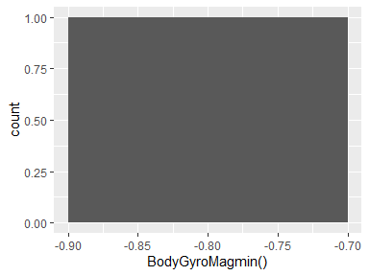

## BodyGyroMagsma()

|  |  |
| --- | --- |
| Feature | Result |
| Variable type | numeric |
| Number of missing obs. | 0 (0 %) |
| Number of unique values | 2 |
| Median | -0.71 |
| 1st and 3rd quartiles | -0.77; -0.66 |
| Min. and max. | -0.82; -0.61 |

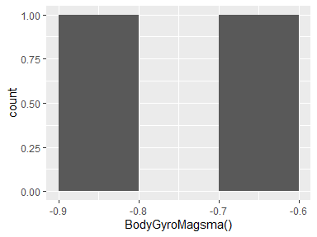

## BodyGyroMagenergy()

|  |  |
| --- | --- |
| Feature | Result |
| Variable type | numeric |
| Number of missing obs. | 0 (0 %) |
| Number of unique values | 2 |
| Median | -0.91 |
| 1st and 3rd quartiles | -0.94; -0.87 |
| Min. and max. | -0.98; -0.83 |

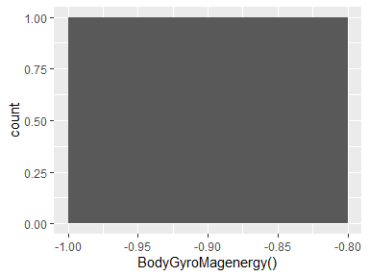

## BodyGyroMagiqr()

|  |  |
| --- | --- |
| Feature | Result |
| Variable type | numeric |
| Number of missing obs. | 0 (0 %) |
| Number of unique values | 2 |
| Median | -0.74 |
| 1st and 3rd quartiles | -0.78; -0.69 |
| Min. and max. | -0.82; -0.65 |

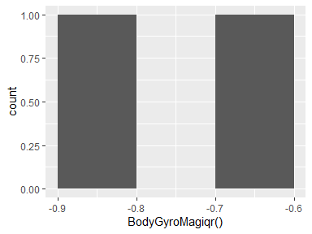

## BodyGyroMagentropy()

|  |  |
| --- | --- |
| Feature | Result |
| Variable type | numeric |
| Number of missing obs. | 0 (0 %) |
| Number of unique values | 2 |
| Median | 0.26 |
| 1st and 3rd quartiles | 0.25; 0.27 |
| Min. and max. | 0.24; 0.29 |

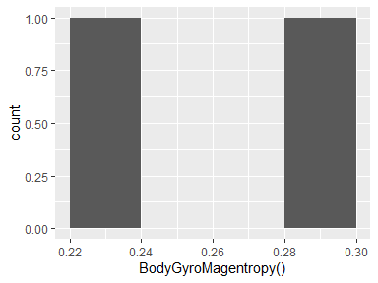

## BodyGyroMagarCoeff()1

|  |  |
| --- | --- |
| Feature | Result |
| Variable type | numeric |
| Number of missing obs. | 0 (0 %) |
| Number of unique values | 2 |
| Median | -0.03 |
| 1st and 3rd quartiles | -0.03; -0.03 |
| Min. and max. | -0.03; -0.02 |

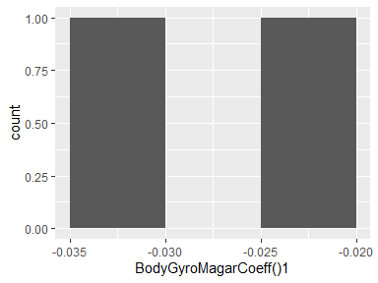

## BodyGyroMagarCoeff()2

|  |  |
| --- | --- |
| Feature | Result |
| Variable type | numeric |
| Number of missing obs. | 0 (0 %) |
| Number of unique values | 2 |
| Median | -0.07 |
| 1st and 3rd quartiles | -0.07; -0.07 |
| Min. and max. | -0.08; -0.07 |

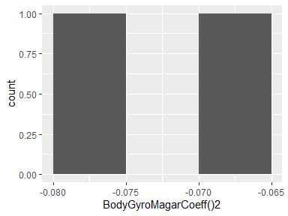

## BodyGyroMagarCoeff()3

|  |  |
| --- | --- |
| Feature | Result |
| Variable type | numeric |
| Number of missing obs. | 0 (0 %) |
| Number of unique values | 2 |
| Median | 0.11 |
| 1st and 3rd quartiles | 0.11; 0.11 |
| Min. and max. | 0.11; 0.11 |

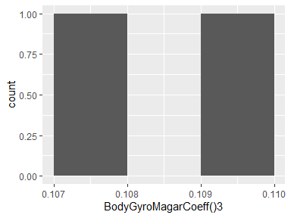

## BodyGyroMagarCoeff()4

|  |  |
| --- | --- |
| Feature | Result |
| Variable type | numeric |
| Number of missing obs. | 0 (0 %) |
| Number of unique values | 2 |
| Median | -0.05 |
| 1st and 3rd quartiles | -0.05; -0.05 |
| Min. and max. | -0.05; -0.05 |

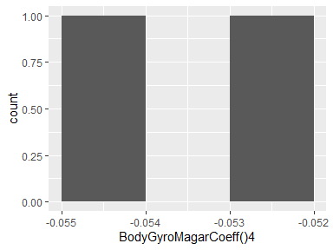

## BodyGyroJerkMagmean()

|  |  |
| --- | --- |
| Feature | Result |
| Variable type | numeric |
| Number of missing obs. | 0 (0 %) |
| Number of unique values | 2 |
| Median | -0.86 |
| 1st and 3rd quartiles | -0.91; -0.81 |
| Min. and max. | -0.96; -0.76 |

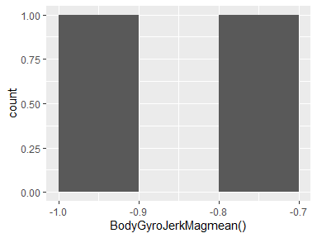

## BodyGyroJerkMagstd()

|  |  |
| --- | --- |
| Feature | Result |
| Variable type | numeric |
| Number of missing obs. | 0 (0 %) |
| Number of unique values | 2 |
| Median | -0.86 |
| 1st and 3rd quartiles | -0.9; -0.82 |
| Min. and max. | -0.94; -0.78 |

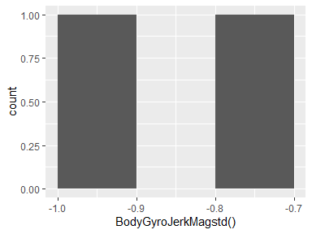

## BodyGyroJerkMagmad()

|  |  |
| --- | --- |
| Feature | Result |
| Variable type | numeric |
| Number of missing obs. | 0 (0 %) |
| Number of unique values | 2 |
| Median | -0.87 |
| 1st and 3rd quartiles | -0.91; -0.83 |
| Min. and max. | -0.95; -0.79 |

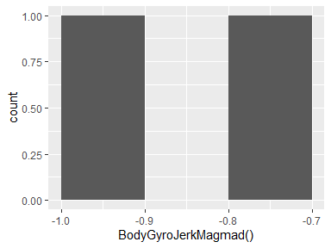

## BodyGyroJerkMagmax()

|  |  |
| --- | --- |
| Feature | Result |
| Variable type | numeric |
| Number of missing obs. | 0 (0 %) |
| Number of unique values | 2 |
| Median | -0.86 |
| 1st and 3rd quartiles | -0.9; -0.82 |
| Min. and max. | -0.94; -0.78 |

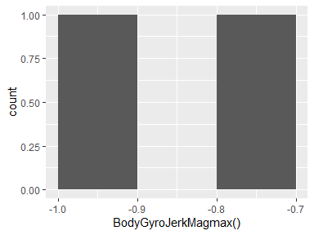

## BodyGyroJerkMagmin()

|  |  |
| --- | --- |
| Feature | Result |
| Variable type | numeric |
| Number of missing obs. | 0 (0 %) |
| Number of unique values | 2 |
| Median | -0.89 |
| 1st and 3rd quartiles | -0.93; -0.84 |
| Min. and max. | -0.97; -0.8 |

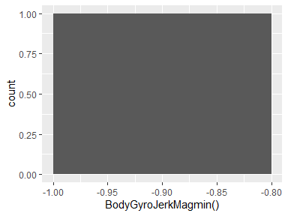

## BodyGyroJerkMagsma()

|  |  |
| --- | --- |
| Feature | Result |
| Variable type | numeric |
| Number of missing obs. | 0 (0 %) |
| Number of unique values | 2 |
| Median | -0.86 |
| 1st and 3rd quartiles | -0.91; -0.81 |
| Min. and max. | -0.96; -0.76 |

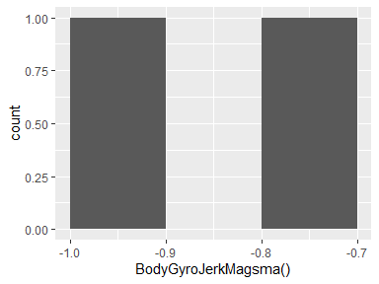

## BodyGyroJerkMagenergy()

|  |  |
| --- | --- |
| Feature | Result |
| Variable type | numeric |
| Number of missing obs. | 0 (0 %) |
| Number of unique values | 2 |
| Median | -0.97 |
| 1st and 3rd quartiles | -0.98; -0.95 |
| Min. and max. | -1; -0.93 |

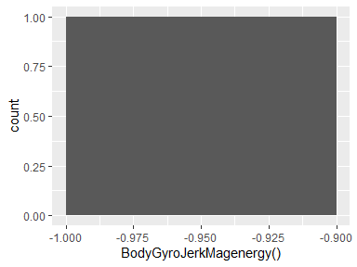

## BodyGyroJerkMagiqr()

|  |  |
| --- | --- |
| Feature | Result |
| Variable type | numeric |
| Number of missing obs. | 0 (0 %) |
| Number of unique values | 2 |
| Median | -0.88 |
| 1st and 3rd quartiles | -0.92; -0.84 |
| Min. and max. | -0.96; -0.81 |

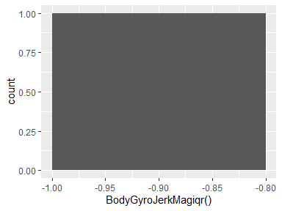

## BodyGyroJerkMagentropy()

|  |  |
| --- | --- |
| Feature | Result |
| Variable type | numeric |
| Number of missing obs. | 0 (0 %) |
| Number of unique values | 2 |
| Median | 0.11 |
| 1st and 3rd quartiles | 0.1; 0.12 |
| Min. and max. | 0.08; 0.13 |

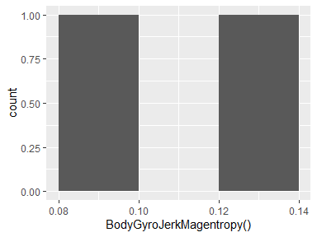

## BodyGyroJerkMagarCoeff()1

|  |  |
| --- | --- |
| Feature | Result |
| Variable type | numeric |
| Number of missing obs. | 0 (0 %) |
| Number of unique values | 2 |
| Median | 0.29 |
| 1st and 3rd quartiles | 0.29; 0.3 |
| Min. and max. | 0.29; 0.3 |

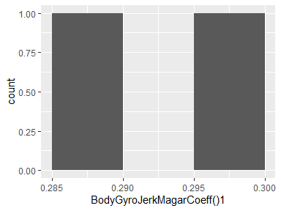

## BodyGyroJerkMagarCoeff()2

|  |  |
| --- | --- |
| Feature | Result |
| Variable type | numeric |
| Number of missing obs. | 0 (0 %) |
| Number of unique values | 2 |
| Median | -0.23 |
| 1st and 3rd quartiles | -0.23; -0.23 |
| Min. and max. | -0.23; -0.23 |

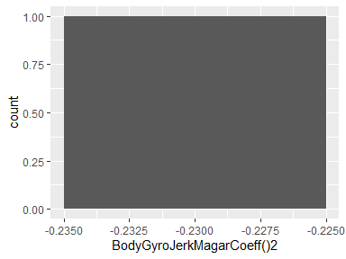

## BodyGyroJerkMagarCoeff()3

|  |  |
| --- | --- |
| Feature | Result |
| Variable type | numeric |
| Number of missing obs. | 0 (0 %) |
| Number of unique values | 2 |
| Median | -0.06 |
| 1st and 3rd quartiles | -0.06; -0.06 |
| Min. and max. | -0.06; -0.06 |

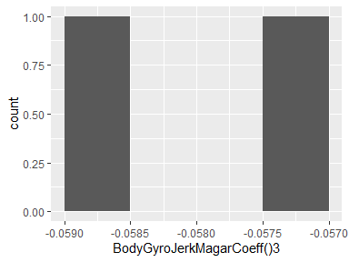

## BodyGyroJerkMagarCoeff()4

|  |  |
| --- | --- |
| Feature | Result |
| Variable type | numeric |
| Number of missing obs. | 0 (0 %) |
| Number of unique values | 2 |
| Median | -0.11 |
| 1st and 3rd quartiles | -0.12; -0.11 |
| Min. and max. | -0.12; -0.11 |

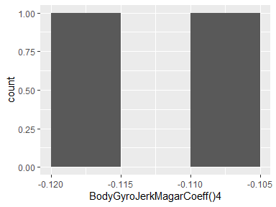

## V266

|  |  |
| --- | --- |
| Feature | Result |
| Variable type | numeric |
| Number of missing obs. | 0 (0 %) |
| Number of unique values | 2 |
| Median | -0.78 |
| 1st and 3rd quartiles | -0.86; -0.7 |
| Min. and max. | -0.95; -0.62 |

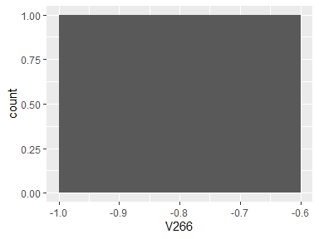

## V267

|  |  |
| --- | --- |
| Feature | Result |
| Variable type | numeric |
| Number of missing obs. | 0 (0 %) |
| Number of unique values | 2 |
| Median | -0.7 |
| 1st and 3rd quartiles | -0.78; -0.62 |
| Min. and max. | -0.86; -0.54 |

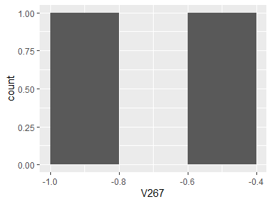

## V268

|  |  |
| --- | --- |
| Feature | Result |
| Variable type | numeric |
| Number of missing obs. | 0 (0 %) |
| Number of unique values | 2 |
| Median | -0.78 |
| 1st and 3rd quartiles | -0.84; -0.72 |
| Min. and max. | -0.9; -0.67 |

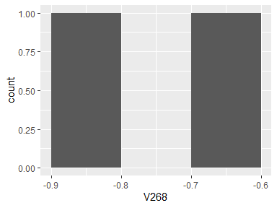

## V269

|  |  |
| --- | --- |
| Feature | Result |
| Variable type | numeric |
| Number of missing obs. | 0 (0 %) |
| Number of unique values | 2 |
| Median | -0.77 |
| 1st and 3rd quartiles | -0.86; -0.69 |
| Min. and max. | -0.94; -0.6 |

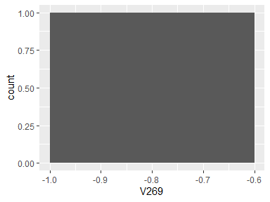

## V270

|  |  |
| --- | --- |
| Feature | Result |
| Variable type | numeric |
| Number of missing obs. | 0 (0 %) |
| Number of unique values | 2 |
| Median | -0.68 |
| 1st and 3rd quartiles | -0.76; -0.6 |
| Min. and max. | -0.83; -0.53 |

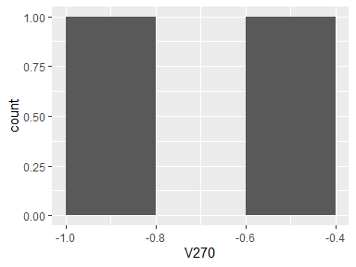

## V271

|  |  |
| --- | --- |
| Feature | Result |
| Variable type | numeric |
| Number of missing obs. | 0 (0 %) |
| Number of unique values | 2 |
| Median | -0.73 |
| 1st and 3rd quartiles | -0.78; -0.67 |
| Min. and max. | -0.84; -0.62 |

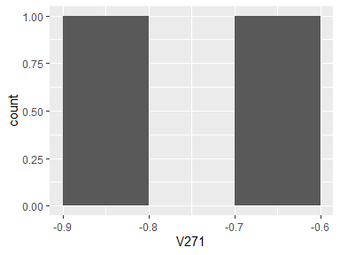

## V272

|  |  |
| --- | --- |
| Feature | Result |
| Variable type | numeric |
| Number of missing obs. | 0 (0 %) |
| Number of unique values | 2 |
| Median | -0.77 |
| 1st and 3rd quartiles | -0.86; -0.68 |
| Min. and max. | -0.94; -0.59 |

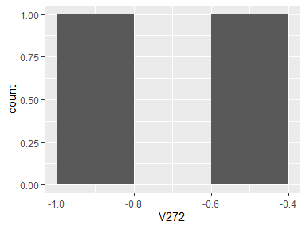

## V273

|  |  |
| --- | --- |
| Feature | Result |
| Variable type | numeric |
| Number of missing obs. | 0 (0 %) |
| Number of unique values | 2 |
| Median | -0.69 |
| 1st and 3rd quartiles | -0.77; -0.61 |
| Min. and max. | -0.86; -0.52 |

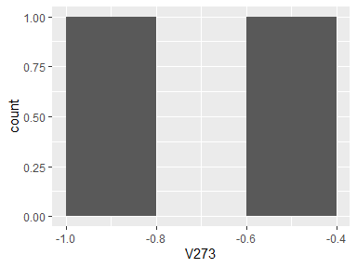

## V274

|  |  |
| --- | --- |
| Feature | Result |
| Variable type | numeric |
| Number of missing obs. | 0 (0 %) |
| Number of unique values | 2 |
| Median | -0.76 |
| 1st and 3rd quartiles | -0.82; -0.69 |
| Min. and max. | -0.88; -0.63 |

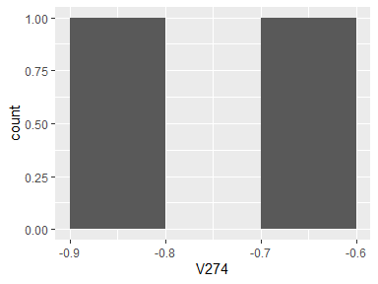

## V275

|  |  |
| --- | --- |
| Feature | Result |
| Variable type | numeric |
| Number of missing obs. | 0 (0 %) |
| Number of unique values | 2 |
| Median | -0.8 |
| 1st and 3rd quartiles | -0.87; -0.72 |
| Min. and max. | -0.94; -0.65 |

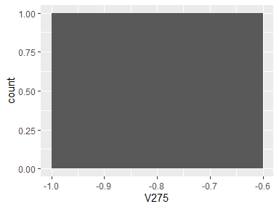

## V276

|  |  |
| --- | --- |
| Feature | Result |
| Variable type | numeric |
| Number of missing obs. | 0 (0 %) |
| Number of unique values | 2 |
| Median | -0.76 |
| 1st and 3rd quartiles | -0.81; -0.71 |
| Min. and max. | -0.86; -0.66 |

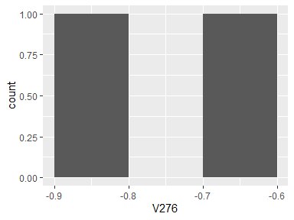

## V277

|  |  |
| --- | --- |
| Feature | Result |
| Variable type | numeric |
| Number of missing obs. | 0 (0 %) |
| Number of unique values | 2 |
| Median | -0.73 |
| 1st and 3rd quartiles | -0.77; -0.68 |
| Min. and max. | -0.82; -0.64 |

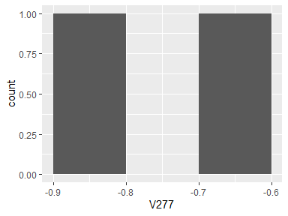

## V278

|  |  |
| --- | --- |
| Feature | Result |
| Variable type | numeric |
| Number of missing obs. | 0 (0 %) |
| Number of unique values | 2 |
| Median | -0.92 |
| 1st and 3rd quartiles | -0.95; -0.89 |
| Min. and max. | -0.98; -0.86 |

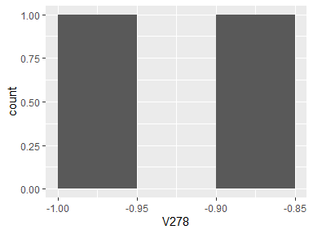

## V279

|  |  |
| --- | --- |
| Feature | Result |
| Variable type | numeric |
| Number of missing obs. | 0 (0 %) |
| Number of unique values | 2 |
| Median | -0.92 |
| 1st and 3rd quartiles | -0.95; -0.9 |
| Min. and max. | -0.97; -0.88 |

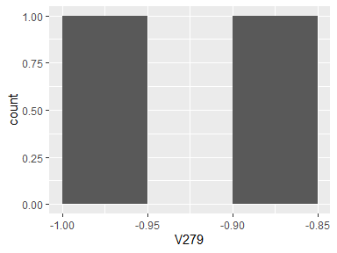

## V280

|  |  |
| --- | --- |
| Feature | Result |
| Variable type | numeric |
| Number of missing obs. | 0 (0 %) |
| Number of unique values | 2 |
| Median | -0.94 |
| 1st and 3rd quartiles | -0.96; -0.93 |
| Min. and max. | -0.97; -0.91 |

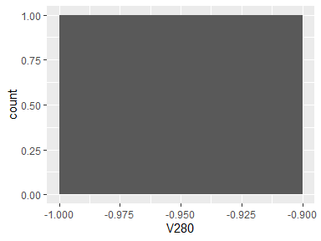

## V281

|  |  |
| --- | --- |
| Feature | Result |
| Variable type | numeric |
| Number of missing obs. | 0 (0 %) |
| Number of unique values | 2 |
| Median | -0.73 |
| 1st and 3rd quartiles | -0.81; -0.64 |
| Min. and max. | -0.9; -0.56 |

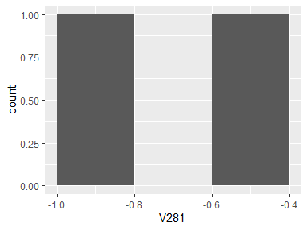

## V282

|  |  |
| --- | --- |
| Feature | Result |
| Variable type | numeric |
| Number of missing obs. | 0 (0 %) |
| Number of unique values | 2 |
| Median | -0.91 |
| 1st and 3rd quartiles | -0.96; -0.87 |
| Min. and max. | -1; -0.83 |

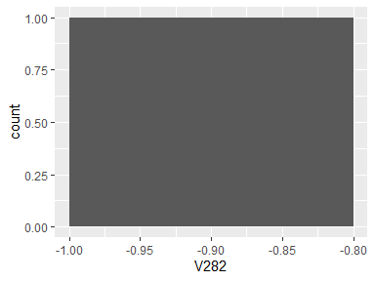

## V283

|  |  |
| --- | --- |
| Feature | Result |
| Variable type | numeric |
| Number of missing obs. | 0 (0 %) |
| Number of unique values | 2 |
| Median | -0.87 |
| 1st and 3rd quartiles | -0.93; -0.81 |
| Min. and max. | -0.98; -0.75 |

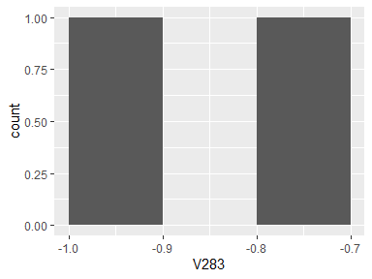

## V284

|  |  |
| --- | --- |
| Feature | Result |
| Variable type | numeric |
| Number of missing obs. | 0 (0 %) |
| Number of unique values | 2 |
| Median | -0.91 |
| 1st and 3rd quartiles | -0.95; -0.88 |
| Min. and max. | -0.99; -0.84 |

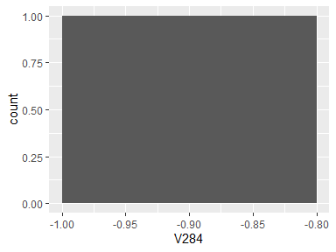

## V285

|  |  |
| --- | --- |
| Feature | Result |
| Variable type | numeric |
| Number of missing obs. | 0 (0 %) |
| Number of unique values | 2 |
| Median | -0.8 |
| 1st and 3rd quartiles | -0.87; -0.73 |
| Min. and max. | -0.94; -0.65 |

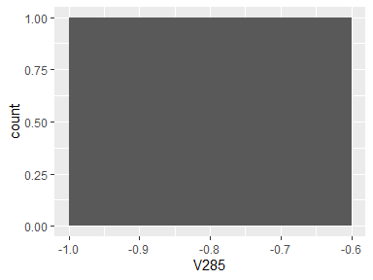

## V286

|  |  |
| --- | --- |
| Feature | Result |
| Variable type | numeric |
| Number of missing obs. | 0 (0 %) |
| Number of unique values | 2 |
| Median | -0.79 |
| 1st and 3rd quartiles | -0.86; -0.72 |
| Min. and max. | -0.92; -0.65 |

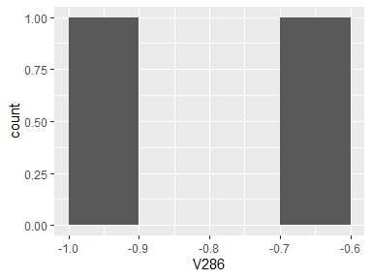

## V287

|  |  |
| --- | --- |
| Feature | Result |
| Variable type | numeric |
| Number of missing obs. | 0 (0 %) |
| Number of unique values | 2 |
| Median | -0.84 |
| 1st and 3rd quartiles | -0.89; -0.79 |
| Min. and max. | -0.94; -0.75 |

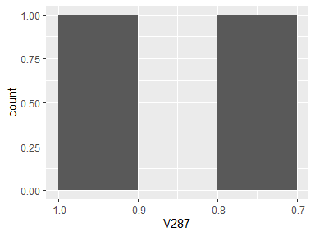

## V288

|  |  |
| --- | --- |
| Feature | Result |
| Variable type | numeric |
| Number of missing obs. | 0 (0 %) |
| Number of unique values | 2 |
| Median | -0.35 |
| 1st and 3rd quartiles | -0.42; -0.27 |
| Min. and max. | -0.5; -0.2 |

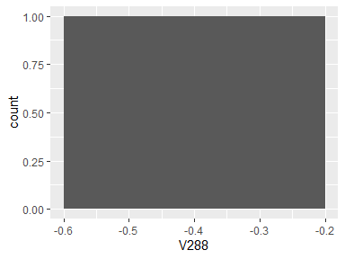

## V289

|  |  |
| --- | --- |
| Feature | Result |
| Variable type | numeric |
| Number of missing obs. | 0 (0 %) |
| Number of unique values | 2 |
| Median | -0.27 |
| 1st and 3rd quartiles | -0.32; -0.23 |
| Min. and max. | -0.36; -0.18 |

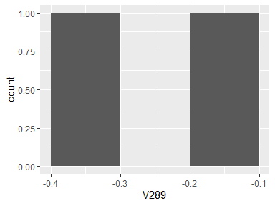

## V290

|  |  |
| --- | --- |
| Feature | Result |
| Variable type | numeric |
| Number of missing obs. | 0 (0 %) |
| Number of unique values | 2 |
| Median | -0.3 |
| 1st and 3rd quartiles | -0.34; -0.25 |
| Min. and max. | -0.39; -0.2 |

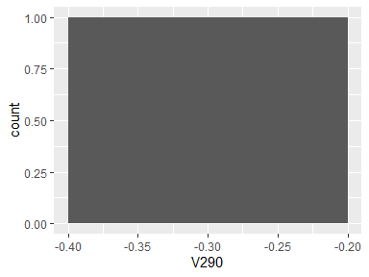

## BodyAccmaxIndsX

|  |  |
| --- | --- |
| Feature | Result |
| Variable type | numeric |
| Number of missing obs. | 0 (0 %) |
| Number of unique values | 2 |
| Median | -0.78 |
| 1st and 3rd quartiles | -0.79; -0.77 |
| Min. and max. | -0.81; -0.76 |

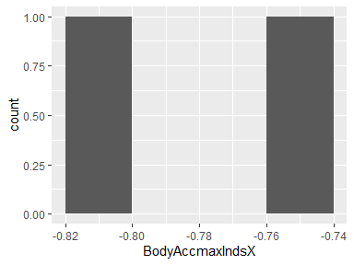

## BodyAccmaxIndsY

|  |  |
| --- | --- |
| Feature | Result |
| Variable type | numeric |
| Number of missing obs. | 0 (0 %) |
| Number of unique values | 2 |
| Median | -0.8 |
| 1st and 3rd quartiles | -0.8; -0.8 |
| Min. and max. | -0.8; -0.8 |

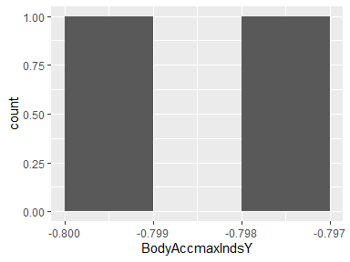

## BodyAccmaxIndsZ

|  |  |
| --- | --- |
| Feature | Result |
| Variable type | numeric |
| Number of missing obs. | 0 (0 %) |
| Number of unique values | 2 |
| Median | -0.88 |
| 1st and 3rd quartiles | -0.9; -0.86 |
| Min. and max. | -0.92; -0.84 |

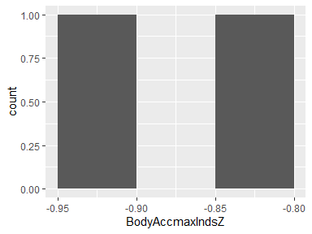

## BodyAccmeanFreq()X

|  |  |
| --- | --- |
| Feature | Result |
| Variable type | numeric |
| Number of missing obs. | 0 (0 %) |
| Number of unique values | 2 |
| Median | -0.23 |
| 1st and 3rd quartiles | -0.23; -0.23 |
| Min. and max. | -0.24; -0.22 |

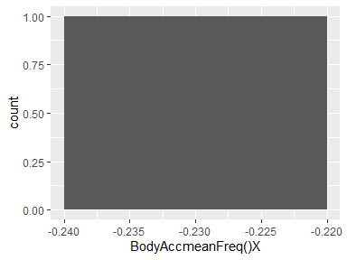

## BodyAccmeanFreq()Y

|  |  |
| --- | --- |
| Feature | Result |
| Variable type | numeric |
| Number of missing obs. | 0 (0 %) |
| Number of unique values | 2 |
| Median | 0.01 |
| 1st and 3rd quartiles | 0.01; 0.01 |
| Min. and max. | 0; 0.02 |

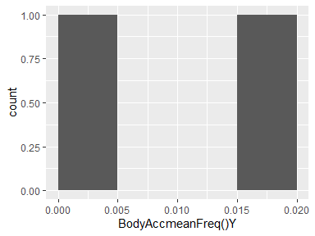

## BodyAccmeanFreq()Z

|  |  |
| --- | --- |
| Feature | Result |
| Variable type | numeric |
| Number of missing obs. | 0 (0 %) |
| Number of unique values | 2 |
| Median | 0.05 |
| 1st and 3rd quartiles | 0.05; 0.06 |
| Min. and max. | 0.05; 0.06 |

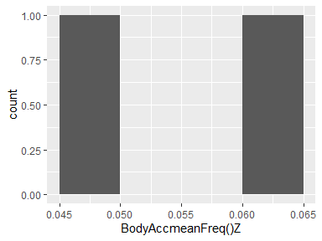

## BodyAccskewness()X

|  |  |
| --- | --- |
| Feature | Result |
| Variable type | numeric |
| Number of missing obs. | 0 (0 %) |
| Number of unique values | 2 |
| Median | -0.15 |
| 1st and 3rd quartiles | -0.16; -0.15 |
| Min. and max. | -0.17; -0.14 |

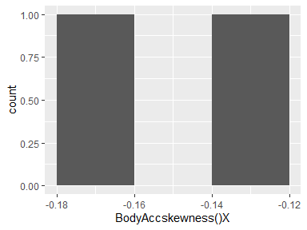

## BodyAcckurtosis()X

|  |  |
| --- | --- |
| Feature | Result |
| Variable type | numeric |
| Number of missing obs. | 0 (0 %) |
| Number of unique values | 2 |
| Median | -0.52 |
| 1st and 3rd quartiles | -0.55; -0.49 |
| Min. and max. | -0.58; -0.47 |

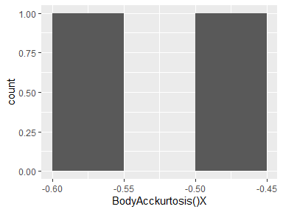

## BodyAccskewness()Y

|  |  |
| --- | --- |
| Feature | Result |
| Variable type | numeric |
| Number of missing obs. | 0 (0 %) |
| Number of unique values | 2 |
| Median | -0.31 |
| 1st and 3rd quartiles | -0.34; -0.29 |
| Min. and max. | -0.36; -0.27 |

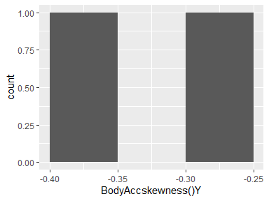

## BodyAcckurtosis()Y

|  |  |
| --- | --- |
| Feature | Result |
| Variable type | numeric |
| Number of missing obs. | 0 (0 %) |
| Number of unique values | 2 |
| Median | -0.65 |
| 1st and 3rd quartiles | -0.69; -0.62 |
| Min. and max. | -0.72; -0.58 |

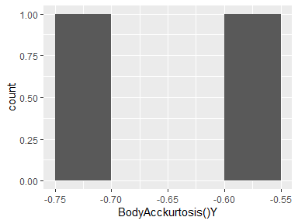

## BodyAccskewness()Z

|  |  |
| --- | --- |
| Feature | Result |
| Variable type | numeric |
| Number of missing obs. | 0 (0 %) |
| Number of unique values | 2 |
| Median | -0.28 |
| 1st and 3rd quartiles | -0.3; -0.26 |
| Min. and max. | -0.31; -0.24 |

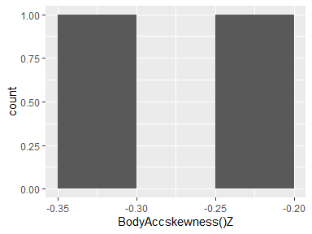

## BodyAcckurtosis()Z

|  |  |
| --- | --- |
| Feature | Result |
| Variable type | numeric |
| Number of missing obs. | 0 (0 %) |
| Number of unique values | 2 |
| Median | -0.54 |
| 1st and 3rd quartiles | -0.57; -0.51 |
| Min. and max. | -0.6; -0.48 |

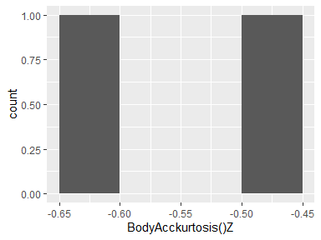

## BodyAccbandsEnergy()1,8

|  |  |
| --- | --- |
| Feature | Result |
| Variable type | numeric |
| Number of missing obs. | 0 (0 %) |
| Number of unique values | 2 |
| Median | -0.91 |
| 1st and 3rd quartiles | -0.95; -0.86 |
| Min. and max. | -1; -0.82 |

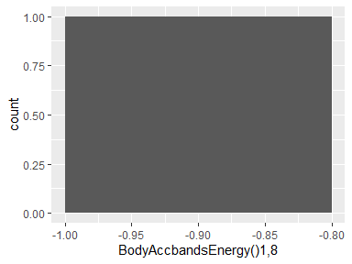

## BodyAccbandsEnergy()9,16

|  |  |
| --- | --- |
| Feature | Result |
| Variable type | numeric |
| Number of missing obs. | 0 (0 %) |
| Number of unique values | 2 |
| Median | -0.94 |
| 1st and 3rd quartiles | -0.97; -0.92 |
| Min. and max. | -1; -0.89 |

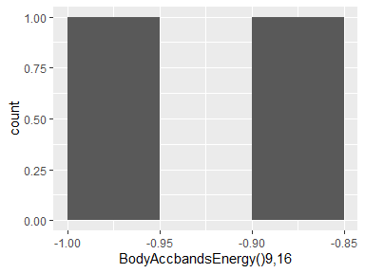

## BodyAccbandsEnergy()17,24

|  |  |
| --- | --- |
| Feature | Result |
| Variable type | numeric |
| Number of missing obs. | 0 (0 %) |
| Number of unique values | 2 |
| Median | -0.93 |
| 1st and 3rd quartiles | -0.96; -0.89 |
| Min. and max. | -1; -0.86 |

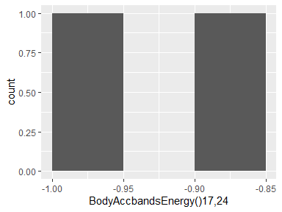

## BodyAccbandsEnergy()25,32

|  |  |
| --- | --- |
| Feature | Result |
| Variable type | numeric |
| Number of missing obs. | 0 (0 %) |
| Number of unique values | 2 |
| Median | -0.95 |
| 1st and 3rd quartiles | -0.97; -0.92 |
| Min. and max. | -1; -0.89 |

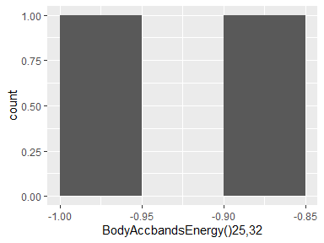

## BodyAccbandsEnergy()33,40

|  |  |
| --- | --- |
| Feature | Result |
| Variable type | numeric |
| Number of missing obs. | 0 (0 %) |
| Number of unique values | 2 |
| Median | -0.96 |
| 1st and 3rd quartiles | -0.98; -0.94 |
| Min. and max. | -1; -0.91 |

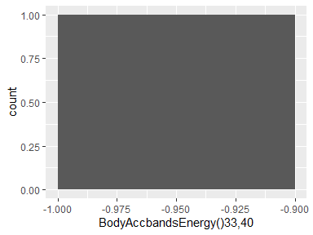

## BodyAccbandsEnergy()41,48

|  |  |
| --- | --- |
| Feature | Result |
| Variable type | numeric |
| Number of missing obs. | 0 (0 %) |
| Number of unique values | 2 |
| Median | -0.96 |
| 1st and 3rd quartiles | -0.98; -0.93 |
| Min. and max. | -1; -0.91 |

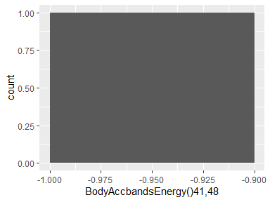

## BodyAccbandsEnergy()49,56

|  |  |
| --- | --- |
| Feature | Result |
| Variable type | numeric |
| Number of missing obs. | 0 (0 %) |
| Number of unique values | 2 |
| Median | -0.97 |
| 1st and 3rd quartiles | -0.99; -0.96 |
| Min. and max. | -1; -0.95 |

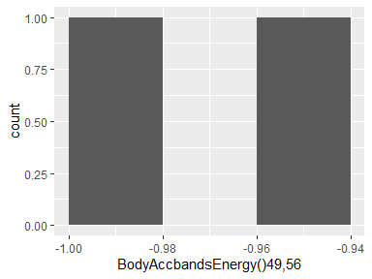

## BodyAccbandsEnergy()57,64

|  |  |
| --- | --- |
| Feature | Result |
| Variable type | numeric |
| Number of missing obs. | 0 (0 %) |
| Number of unique values | 2 |
| Median | -0.98 |
| 1st and 3rd quartiles | -0.99; -0.97 |
| Min. and max. | -1; -0.96 |

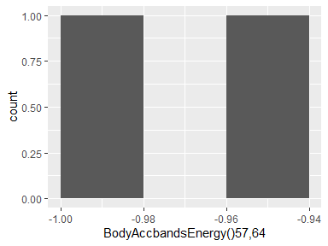

## BodyAccbandsEnergy()1,16

|  |  |
| --- | --- |
| Feature | Result |
| Variable type | numeric |
| Number of missing obs. | 0 (0 %) |
| Number of unique values | 2 |
| Median | -0.91 |
| 1st and 3rd quartiles | -0.95; -0.87 |
| Min. and max. | -1; -0.82 |

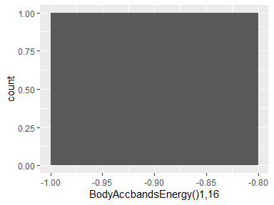

## BodyAccbandsEnergy()17,32

|  |  |
| --- | --- |
| Feature | Result |
| Variable type | numeric |
| Number of missing obs. | 0 (0 %) |
| Number of unique values | 2 |
| Median | -0.92 |
| 1st and 3rd quartiles | -0.96; -0.88 |
| Min. and max. | -1; -0.85 |

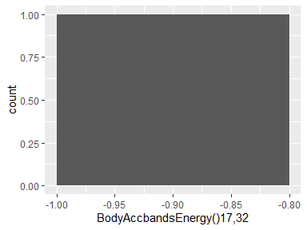

## BodyAccbandsEnergy()33,48

|  |  |
| --- | --- |
| Feature | Result |
| Variable type | numeric |
| Number of missing obs. | 0 (0 %) |
| Number of unique values | 2 |
| Median | -0.96 |
| 1st and 3rd quartiles | -0.98; -0.94 |
| Min. and max. | -1; -0.91 |

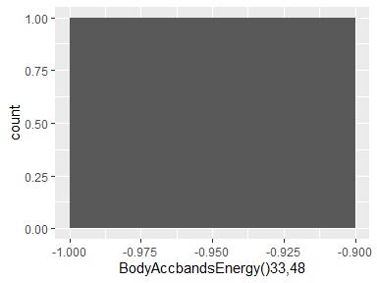

## BodyAccbandsEnergy()49,64

|  |  |
| --- | --- |
| Feature | Result |
| Variable type | numeric |
| Number of missing obs. | 0 (0 %) |
| Number of unique values | 2 |
| Median | -0.97 |
| 1st and 3rd quartiles | -0.99; -0.96 |
| Min. and max. | -1; -0.95 |

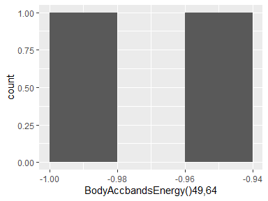

## BodyAccbandsEnergy()1,24

|  |  |
| --- | --- |
| Feature | Result |
| Variable type | numeric |
| Number of missing obs. | 0 (0 %) |
| Number of unique values | 2 |
| Median | -0.91 |
| 1st and 3rd quartiles | -0.95; -0.87 |
| Min. and max. | -1; -0.82 |

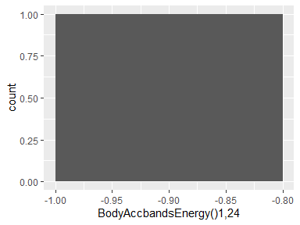

## BodyAccbandsEnergy()25,48

|  |  |
| --- | --- |
| Feature | Result |
| Variable type | numeric |
| Number of missing obs. | 0 (0 %) |
| Number of unique values | 2 |
| Median | -0.94 |
| 1st and 3rd quartiles | -0.97; -0.91 |
| Min. and max. | -1; -0.88 |

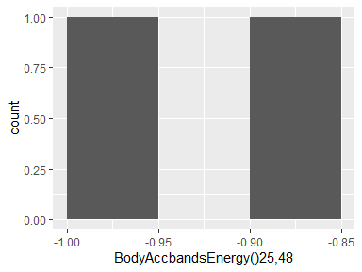

## V317

|  |  |
| --- | --- |
| Feature | Result |
| Variable type | numeric |
| Number of missing obs. | 0 (0 %) |
| Number of unique values | 2 |
| Median | -0.89 |
| 1st and 3rd quartiles | -0.93; -0.84 |
| Min. and max. | -0.98; -0.79 |

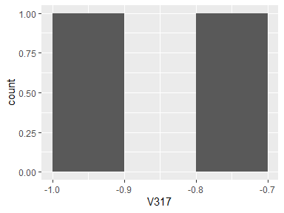

## V318

|  |  |
| --- | --- |
| Feature | Result |
| Variable type | numeric |
| Number of missing obs. | 0 (0 %) |
| Number of unique values | 2 |
| Median | -0.92 |
| 1st and 3rd quartiles | -0.96; -0.88 |
| Min. and max. | -1; -0.85 |

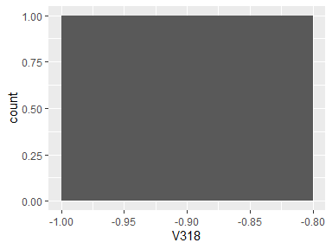

## V319

|  |  |
| --- | --- |
| Feature | Result |
| Variable type | numeric |
| Number of missing obs. | 0 (0 %) |
| Number of unique values | 2 |
| Median | -0.93 |
| 1st and 3rd quartiles | -0.96; -0.89 |
| Min. and max. | -1; -0.86 |

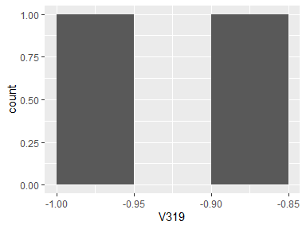

## V320

|  |  |
| --- | --- |
| Feature | Result |
| Variable type | numeric |
| Number of missing obs. | 0 (0 %) |
| Number of unique values | 2 |
| Median | -0.95 |
| 1st and 3rd quartiles | -0.97; -0.93 |
| Min. and max. | -1; -0.9 |

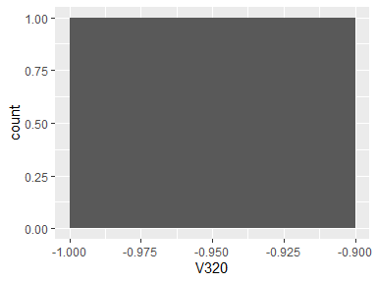

## V321

|  |  |
| --- | --- |
| Feature | Result |
| Variable type | numeric |
| Number of missing obs. | 0 (0 %) |
| Number of unique values | 2 |
| Median | -0.95 |
| 1st and 3rd quartiles | -0.97; -0.92 |
| Min. and max. | -1; -0.9 |

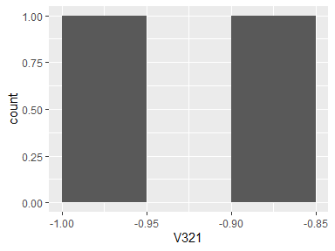

## V322

|  |  |
| --- | --- |
| Feature | Result |
| Variable type | numeric |
| Number of missing obs. | 0 (0 %) |
| Number of unique values | 2 |
| Median | -0.94 |
| 1st and 3rd quartiles | -0.97; -0.91 |
| Min. and max. | -0.99; -0.88 |

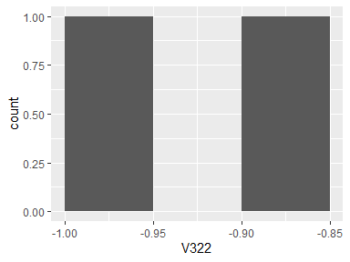

## V323

|  |  |
| --- | --- |
| Feature | Result |
| Variable type | numeric |
| Number of missing obs. | 0 (0 %) |
| Number of unique values | 2 |
| Median | -0.95 |
| 1st and 3rd quartiles | -0.97; -0.93 |
| Min. and max. | -0.99; -0.9 |

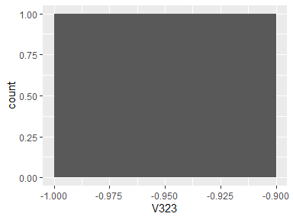

## V324

|  |  |
| --- | --- |
| Feature | Result |
| Variable type | numeric |
| Number of missing obs. | 0 (0 %) |
| Number of unique values | 2 |
| Median | -0.98 |
| 1st and 3rd quartiles | -0.99; -0.96 |
| Min. and max. | -1; -0.95 |

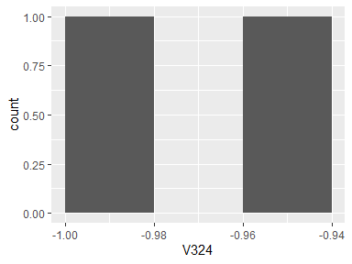

## V325

|  |  |
| --- | --- |
| Feature | Result |
| Variable type | numeric |
| Number of missing obs. | 0 (0 %) |
| Number of unique values | 2 |
| Median | -0.87 |
| 1st and 3rd quartiles | -0.93; -0.82 |
| Min. and max. | -0.98; -0.76 |

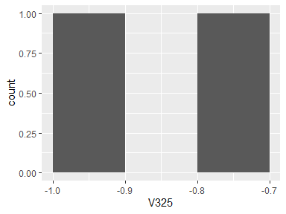

## V326

|  |  |
| --- | --- |
| Feature | Result |
| Variable type | numeric |
| Number of missing obs. | 0 (0 %) |
| Number of unique values | 2 |
| Median | -0.92 |
| 1st and 3rd quartiles | -0.96; -0.88 |
| Min. and max. | -1; -0.84 |

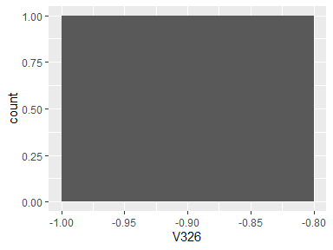

## V327

|  |  |
| --- | --- |
| Feature | Result |
| Variable type | numeric |
| Number of missing obs. | 0 (0 %) |
| Number of unique values | 2 |
| Median | -0.94 |
| 1st and 3rd quartiles | -0.97; -0.91 |
| Min. and max. | -0.99; -0.88 |

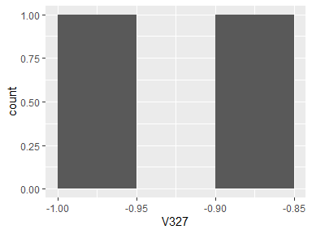

## V328

|  |  |
| --- | --- |
| Feature | Result |
| Variable type | numeric |
| Number of missing obs. | 0 (0 %) |
| Number of unique values | 2 |
| Median | -0.96 |
| 1st and 3rd quartiles | -0.98; -0.94 |
| Min. and max. | -1; -0.92 |

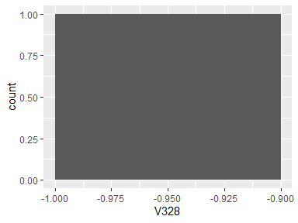

## V329

|  |  |
| --- | --- |
| Feature | Result |
| Variable type | numeric |
| Number of missing obs. | 0 (0 %) |
| Number of unique values | 2 |
| Median | -0.87 |
| 1st and 3rd quartiles | -0.93; -0.81 |
| Min. and max. | -0.98; -0.75 |

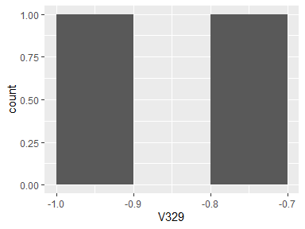

## V330

|  |  |
| --- | --- |
| Feature | Result |
| Variable type | numeric |
| Number of missing obs. | 0 (0 %) |
| Number of unique values | 2 |
| Median | -0.94 |
| 1st and 3rd quartiles | -0.97; -0.92 |
| Min. and max. | -1; -0.89 |

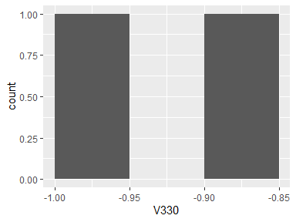

## V331

|  |  |
| --- | --- |
| Feature | Result |
| Variable type | numeric |
| Number of missing obs. | 0 (0 %) |
| Number of unique values | 2 |
| Median | -0.92 |
| 1st and 3rd quartiles | -0.95; -0.89 |
| Min. and max. | -0.98; -0.86 |

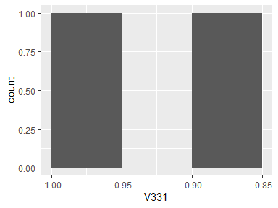

## V332

|  |  |
| --- | --- |
| Feature | Result |
| Variable type | numeric |
| Number of missing obs. | 0 (0 %) |
| Number of unique values | 2 |
| Median | -0.95 |
| 1st and 3rd quartiles | -0.97; -0.92 |
| Min. and max. | -1; -0.9 |

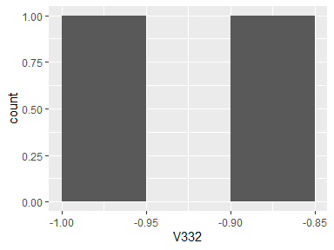

## V333

|  |  |
| --- | --- |
| Feature | Result |
| Variable type | numeric |
| Number of missing obs. | 0 (0 %) |
| Number of unique values | 2 |
| Median | -0.96 |
| 1st and 3rd quartiles | -0.98; -0.94 |
| Min. and max. | -1; -0.93 |

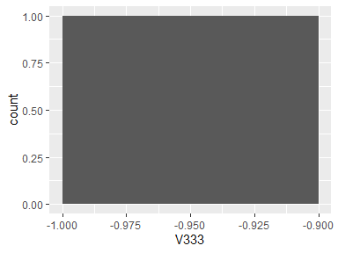

## V334

|  |  |
| --- | --- |
| Feature | Result |
| Variable type | numeric |
| Number of missing obs. | 0 (0 %) |
| Number of unique values | 2 |
| Median | -0.98 |
| 1st and 3rd quartiles | -0.99; -0.97 |
| Min. and max. | -1; -0.96 |

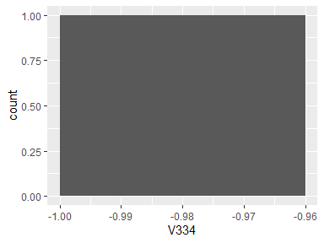

## V335

|  |  |
| --- | --- |
| Feature | Result |
| Variable type | numeric |
| Number of missing obs. | 0 (0 %) |
| Number of unique values | 2 |
| Median | -0.98 |
| 1st and 3rd quartiles | -0.99; -0.97 |
| Min. and max. | -1; -0.96 |

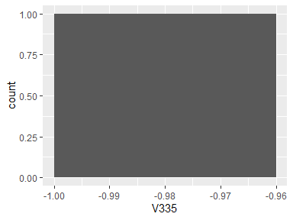

## V336

|  |  |
| --- | --- |
| Feature | Result |
| Variable type | numeric |
| Number of missing obs. | 0 (0 %) |
| Number of unique values | 2 |
| Median | -0.97 |
| 1st and 3rd quartiles | -0.98; -0.95 |
| Min. and max. | -1; -0.94 |

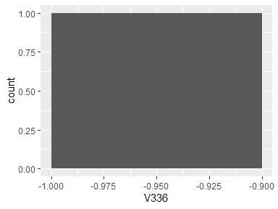

## V337

|  |  |
| --- | --- |
| Feature | Result |
| Variable type | numeric |
| Number of missing obs. | 0 (0 %) |
| Number of unique values | 2 |
| Median | -0.97 |
| 1st and 3rd quartiles | -0.98; -0.96 |
| Min. and max. | -1; -0.94 |

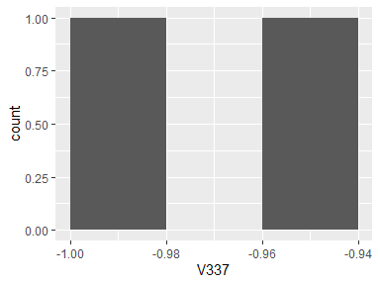

## V338

|  |  |
| --- | --- |
| Feature | Result |
| Variable type | numeric |
| Number of missing obs. | 0 (0 %) |
| Number of unique values | 2 |
| Median | -0.98 |
| 1st and 3rd quartiles | -0.99; -0.97 |
| Min. and max. | -1; -0.96 |

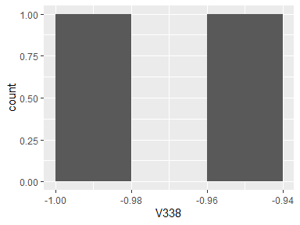

## V339

|  |  |
| --- | --- |
| Feature | Result |
| Variable type | numeric |
| Number of missing obs. | 0 (0 %) |
| Number of unique values | 2 |
| Median | -0.92 |
| 1st and 3rd quartiles | -0.95; -0.89 |
| Min. and max. | -0.99; -0.85 |

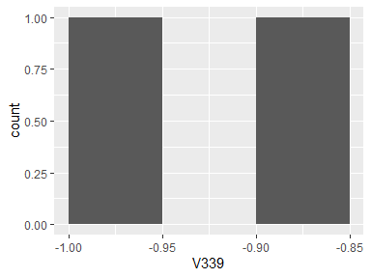

## V340

|  |  |
| --- | --- |
| Feature | Result |
| Variable type | numeric |
| Number of missing obs. | 0 (0 %) |
| Number of unique values | 2 |
| Median | -0.97 |
| 1st and 3rd quartiles | -0.98; -0.95 |
| Min. and max. | -1; -0.94 |

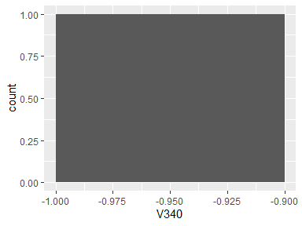

## V341

|  |  |
| --- | --- |
| Feature | Result |
| Variable type | numeric |
| Number of missing obs. | 0 (0 %) |
| Number of unique values | 2 |
| Median | -0.98 |
| 1st and 3rd quartiles | -0.99; -0.97 |
| Min. and max. | -1; -0.95 |

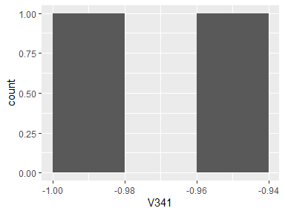

## V342

|  |  |
| --- | --- |
| Feature | Result |
| Variable type | numeric |
| Number of missing obs. | 0 (0 %) |
| Number of unique values | 2 |
| Median | -0.97 |
| 1st and 3rd quartiles | -0.98; -0.96 |
| Min. and max. | -1; -0.95 |

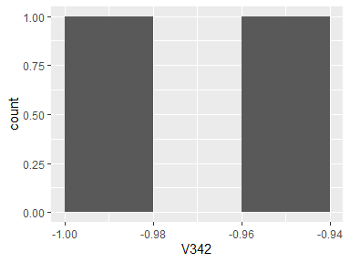

## V343

|  |  |
| --- | --- |
| Feature | Result |
| Variable type | numeric |
| Number of missing obs. | 0 (0 %) |
| Number of unique values | 2 |
| Median | -0.91 |
| 1st and 3rd quartiles | -0.95; -0.88 |
| Min. and max. | -0.99; -0.84 |

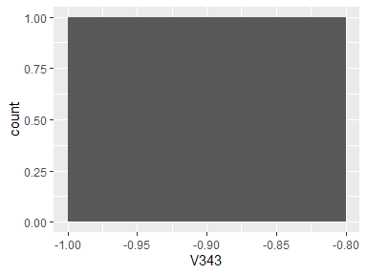

## V344

|  |  |
| --- | --- |
| Feature | Result |
| Variable type | numeric |
| Number of missing obs. | 0 (0 %) |
| Number of unique values | 2 |
| Median | -0.98 |
| 1st and 3rd quartiles | -0.99; -0.97 |
| Min. and max. | -1; -0.96 |

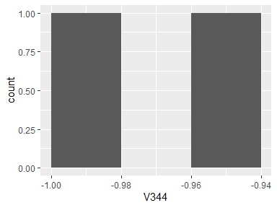

## V345

|  |  |
| --- | --- |
| Feature | Result |
| Variable type | numeric |
| Number of missing obs. | 0 (0 %) |
| Number of unique values | 2 |
| Median | -0.8 |
| 1st and 3rd quartiles | -0.88; -0.73 |
| Min. and max. | -0.95; -0.66 |

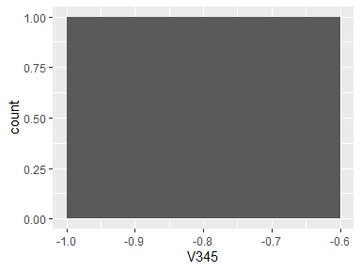

## V346

|  |  |
| --- | --- |
| Feature | Result |
| Variable type | numeric |
| Number of missing obs. | 0 (0 %) |
| Number of unique values | 2 |
| Median | -0.78 |
| 1st and 3rd quartiles | -0.85; -0.7 |
| Min. and max. | -0.93; -0.63 |

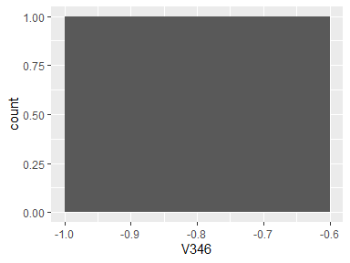

## V347

|  |  |
| --- | --- |
| Feature | Result |
| Variable type | numeric |
| Number of missing obs. | 0 (0 %) |
| Number of unique values | 2 |
| Median | -0.85 |
| 1st and 3rd quartiles | -0.9; -0.79 |
| Min. and max. | -0.95; -0.74 |

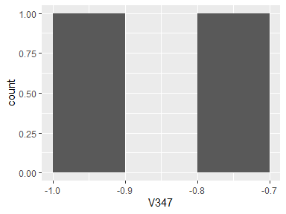

## V348

|  |  |
| --- | --- |
| Feature | Result |
| Variable type | numeric |
| Number of missing obs. | 0 (0 %) |
| Number of unique values | 2 |
| Median | -0.81 |
| 1st and 3rd quartiles | -0.88; -0.73 |
| Min. and max. | -0.96; -0.65 |

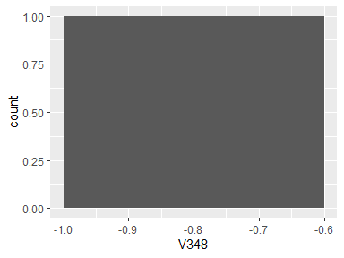

## V349

|  |  |
| --- | --- |
| Feature | Result |
| Variable type | numeric |
| Number of missing obs. | 0 (0 %) |
| Number of unique values | 2 |
| Median | -0.77 |
| 1st and 3rd quartiles | -0.85; -0.69 |
| Min. and max. | -0.93; -0.61 |

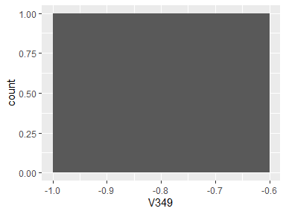

## V350

|  |  |
| --- | --- |
| Feature | Result |
| Variable type | numeric |
| Number of missing obs. | 0 (0 %) |
| Number of unique values | 2 |
| Median | -0.87 |
| 1st and 3rd quartiles | -0.91; -0.83 |
| Min. and max. | -0.96; -0.78 |

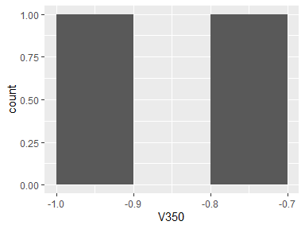

## V351

|  |  |
| --- | --- |
| Feature | Result |
| Variable type | numeric |
| Number of missing obs. | 0 (0 %) |
| Number of unique values | 2 |
| Median | -0.77 |
| 1st and 3rd quartiles | -0.86; -0.68 |
| Min. and max. | -0.95; -0.59 |

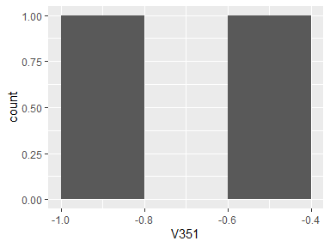

## V352

|  |  |
| --- | --- |
| Feature | Result |
| Variable type | numeric |
| Number of missing obs. | 0 (0 %) |
| Number of unique values | 2 |
| Median | -0.78 |
| 1st and 3rd quartiles | -0.85; -0.7 |
| Min. and max. | -0.93; -0.62 |

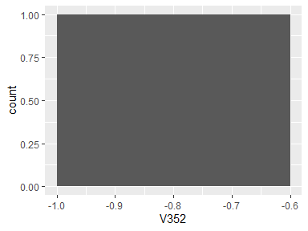

## V353

|  |  |
| --- | --- |
| Feature | Result |
| Variable type | numeric |
| Number of missing obs. | 0 (0 %) |
| Number of unique values | 2 |
| Median | -0.86 |
| 1st and 3rd quartiles | -0.91; -0.81 |
| Min. and max. | -0.95; -0.76 |

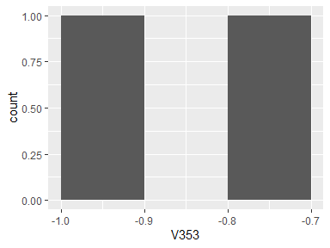

## V354

|  |  |
| --- | --- |
| Feature | Result |
| Variable type | numeric |
| Number of missing obs. | 0 (0 %) |
| Number of unique values | 2 |
| Median | -0.84 |
| 1st and 3rd quartiles | -0.9; -0.78 |
| Min. and max. | -0.97; -0.71 |

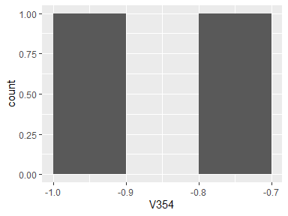

## V355

|  |  |
| --- | --- |
| Feature | Result |
| Variable type | numeric |
| Number of missing obs. | 0 (0 %) |
| Number of unique values | 2 |
| Median | -0.81 |
| 1st and 3rd quartiles | -0.88; -0.75 |
| Min. and max. | -0.94; -0.68 |

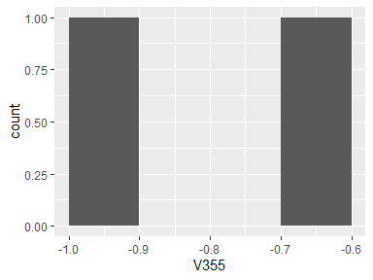

## V356

|  |  |
| --- | --- |
| Feature | Result |
| Variable type | numeric |
| Number of missing obs. | 0 (0 %) |
| Number of unique values | 2 |
| Median | -0.88 |
| 1st and 3rd quartiles | -0.92; -0.84 |
| Min. and max. | -0.96; -0.8 |

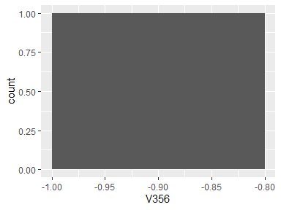

## V357

|  |  |
| --- | --- |
| Feature | Result |
| Variable type | numeric |
| Number of missing obs. | 0 (0 %) |
| Number of unique values | 2 |
| Median | -0.93 |
| 1st and 3rd quartiles | -0.96; -0.91 |
| Min. and max. | -0.98; -0.88 |

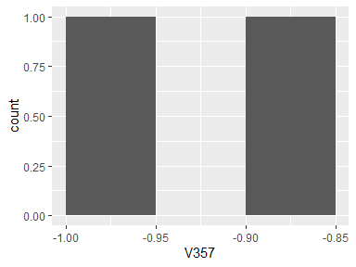

## V358

|  |  |
| --- | --- |
| Feature | Result |
| Variable type | numeric |
| Number of missing obs. | 0 (0 %) |
| Number of unique values | 2 |
| Median | -0.92 |
| 1st and 3rd quartiles | -0.94; -0.89 |
| Min. and max. | -0.97; -0.86 |

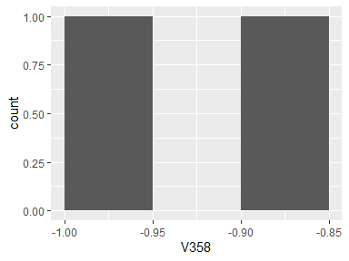

## V359

|  |  |
| --- | --- |
| Feature | Result |
| Variable type | numeric |
| Number of missing obs. | 0 (0 %) |
| Number of unique values | 2 |
| Median | -0.93 |
| 1st and 3rd quartiles | -0.95; -0.91 |
| Min. and max. | -0.97; -0.88 |

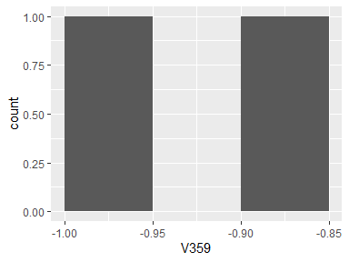

## V360

|  |  |
| --- | --- |
| Feature | Result |
| Variable type | numeric |
| Number of missing obs. | 0 (0 %) |
| Number of unique values | 2 |
| Median | -0.78 |
| 1st and 3rd quartiles | -0.86; -0.7 |
| Min. and max. | -0.94; -0.62 |

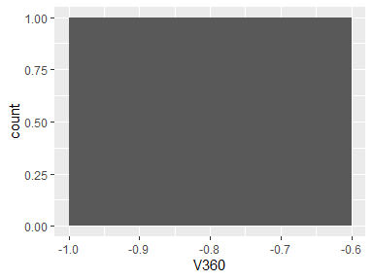

## V361

|  |  |
| --- | --- |
| Feature | Result |
| Variable type | numeric |
| Number of missing obs. | 0 (0 %) |
| Number of unique values | 2 |
| Median | -0.92 |
| 1st and 3rd quartiles | -0.96; -0.89 |
| Min. and max. | -1; -0.85 |

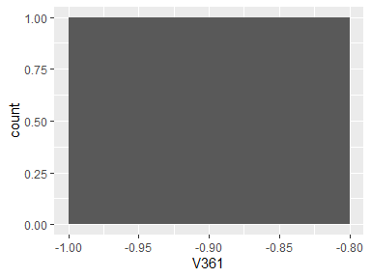

## V362

|  |  |
| --- | --- |
| Feature | Result |
| Variable type | numeric |
| Number of missing obs. | 0 (0 %) |
| Number of unique values | 2 |
| Median | -0.91 |
| 1st and 3rd quartiles | -0.95; -0.87 |
| Min. and max. | -1; -0.83 |

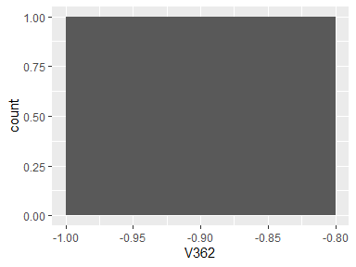

## V363

|  |  |
| --- | --- |
| Feature | Result |
| Variable type | numeric |
| Number of missing obs. | 0 (0 %) |
| Number of unique values | 2 |
| Median | -0.96 |
| 1st and 3rd quartiles | -0.98; -0.95 |
| Min. and max. | -1; -0.93 |

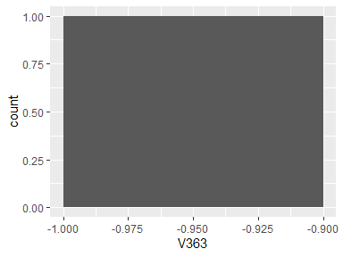

## V364

|  |  |
| --- | --- |
| Feature | Result |
| Variable type | numeric |
| Number of missing obs. | 0 (0 %) |
| Number of unique values | 2 |
| Median | -0.79 |
| 1st and 3rd quartiles | -0.87; -0.71 |
| Min. and max. | -0.95; -0.63 |

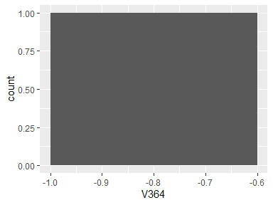

## V365

|  |  |
| --- | --- |
| Feature | Result |
| Variable type | numeric |
| Number of missing obs. | 0 (0 %) |
| Number of unique values | 2 |
| Median | -0.83 |
| 1st and 3rd quartiles | -0.89; -0.78 |
| Min. and max. | -0.94; -0.72 |

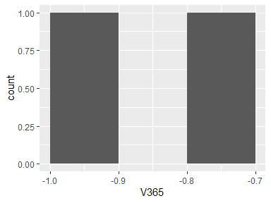

## V366

|  |  |
| --- | --- |
| Feature | Result |
| Variable type | numeric |
| Number of missing obs. | 0 (0 %) |
| Number of unique values | 2 |
| Median | -0.86 |
| 1st and 3rd quartiles | -0.91; -0.82 |
| Min. and max. | -0.95; -0.77 |

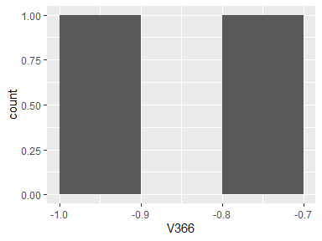

## V367

|  |  |
| --- | --- |
| Feature | Result |
| Variable type | numeric |
| Number of missing obs. | 0 (0 %) |
| Number of unique values | 2 |
| Median | -0.47 |
| 1st and 3rd quartiles | -0.58; -0.37 |
| Min. and max. | -0.68; -0.27 |

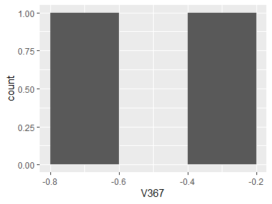

## V368

|  |  |
| --- | --- |
| Feature | Result |
| Variable type | numeric |
| Number of missing obs. | 0 (0 %) |
| Number of unique values | 2 |
| Median | -0.44 |
| 1st and 3rd quartiles | -0.53; -0.35 |
| Min. and max. | -0.62; -0.27 |

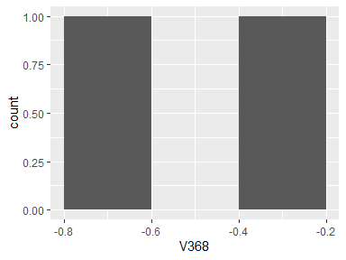

## V369

|  |  |
| --- | --- |
| Feature | Result |
| Variable type | numeric |
| Number of missing obs. | 0 (0 %) |
| Number of unique values | 2 |
| Median | -0.52 |
| 1st and 3rd quartiles | -0.59; -0.44 |
| Min. and max. | -0.67; -0.37 |

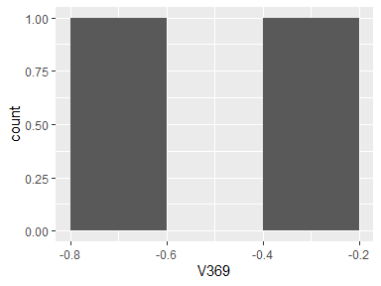

## BodyAccJerkmaxIndsX

|  |  |
| --- | --- |
| Feature | Result |
| Variable type | numeric |
| Number of missing obs. | 0 (0 %) |
| Number of unique values | 2 |
| Median | -0.41 |
| 1st and 3rd quartiles | -0.41; -0.4 |
| Min. and max. | -0.41; -0.4 |

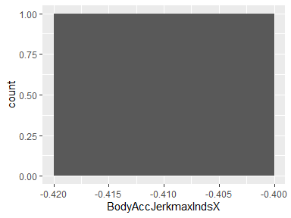

## BodyAccJerkmaxIndsY

|  |  |
| --- | --- |
| Feature | Result |
| Variable type | numeric |
| Number of missing obs. | 0 (0 %) |
| Number of unique values | 2 |
| Median | -0.4 |
| 1st and 3rd quartiles | -0.4; -0.4 |
| Min. and max. | -0.4; -0.4 |

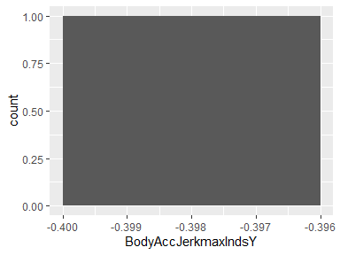

## BodyAccJerkmaxIndsZ

|  |  |
| --- | --- |
| Feature | Result |
| Variable type | numeric |
| Number of missing obs. | 0 (0 %) |
| Number of unique values | 2 |
| Median | -0.32 |
| 1st and 3rd quartiles | -0.32; -0.32 |
| Min. and max. | -0.32; -0.32 |

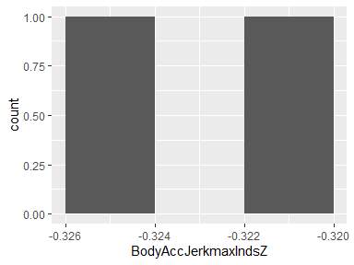

## BodyAccJerkmeanFreq()X

|  |  |
| --- | --- |
| Feature | Result |
| Variable type | numeric |
| Number of missing obs. | 0 (0 %) |
| Number of unique values | 2 |
| Median | -0.05 |
| 1st and 3rd quartiles | -0.05; -0.05 |
| Min. and max. | -0.05; -0.05 |

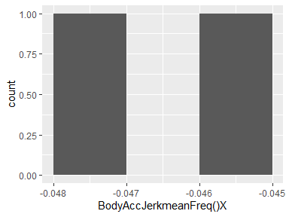

## BodyAccJerkmeanFreq()Y

|  |  |
| --- | --- |
| Feature | Result |
| Variable type | numeric |
| Number of missing obs. | 0 (0 %) |
| Number of unique values | 2 |
| Median | -0.22 |
| 1st and 3rd quartiles | -0.23; -0.22 |
| Min. and max. | -0.24; -0.21 |

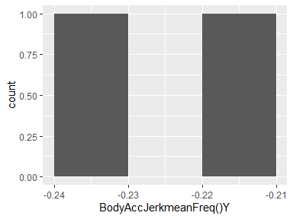

## BodyAccJerkmeanFreq()Z

|  |  |
| --- | --- |
| Feature | Result |
| Variable type | numeric |
| Number of missing obs. | 0 (0 %) |
| Number of unique values | 2 |
| Median | -0.11 |
| 1st and 3rd quartiles | -0.12; -0.11 |
| Min. and max. | -0.12; -0.1 |

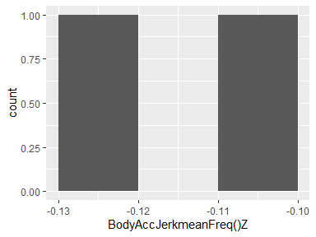

## BodyAccJerkskewness()X

|  |  |
| --- | --- |
| Feature | Result |
| Variable type | numeric |
| Number of missing obs. | 0 (0 %) |
| Number of unique values | 2 |
| Median | -0.33 |
| 1st and 3rd quartiles | -0.34; -0.32 |
| Min. and max. | -0.35; -0.32 |

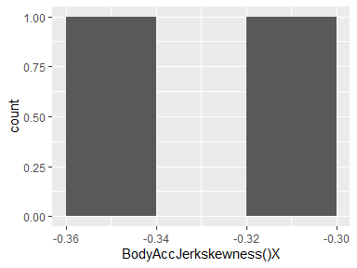

## BodyAccJerkkurtosis()X

|  |  |
| --- | --- |
| Feature | Result |
| Variable type | numeric |
| Number of missing obs. | 0 (0 %) |
| Number of unique values | 2 |
| Median | -0.74 |
| 1st and 3rd quartiles | -0.76; -0.73 |
| Min. and max. | -0.77; -0.71 |

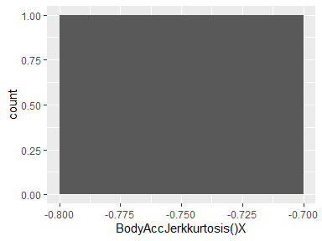

## BodyAccJerkskewness()Y

|  |  |
| --- | --- |
| Feature | Result |
| Variable type | numeric |
| Number of missing obs. | 0 (0 %) |
| Number of unique values | 2 |
| Median | -0.41 |
| 1st and 3rd quartiles | -0.42; -0.41 |
| Min. and max. | -0.42; -0.4 |

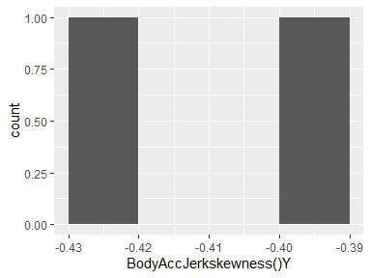

## BodyAccJerkkurtosis()Y

|  |  |
| --- | --- |
| Feature | Result |
| Variable type | numeric |
| Number of missing obs. | 0 (0 %) |
| Number of unique values | 2 |
| Median | -0.84 |
| 1st and 3rd quartiles | -0.85; -0.83 |
| Min. and max. | -0.86; -0.82 |

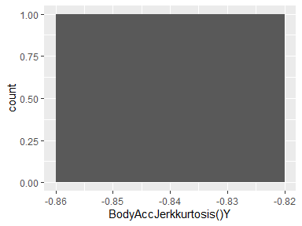

## BodyAccJerkskewness()Z

|  |  |
| --- | --- |
| Feature | Result |
| Variable type | numeric |
| Number of missing obs. | 0 (0 %) |
| Number of unique values | 2 |
| Median | -0.5 |
| 1st and 3rd quartiles | -0.51; -0.5 |
| Min. and max. | -0.52; -0.49 |

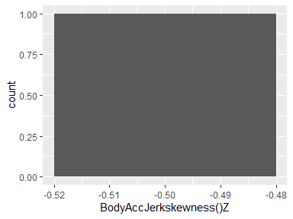

## BodyAccJerkkurtosis()Z

|  |  |
| --- | --- |
| Feature | Result |
| Variable type | numeric |
| Number of missing obs. | 0 (0 %) |
| Number of unique values | 2 |
| Median | -0.84 |
| 1st and 3rd quartiles | -0.85; -0.83 |
| Min. and max. | -0.86; -0.82 |

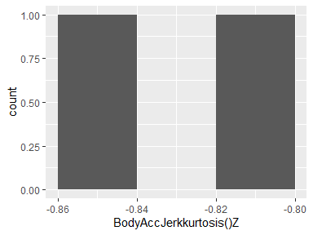

## BodyAccJerkbandsEnergy()1,8

|  |  |
| --- | --- |
| Feature | Result |
| Variable type | numeric |
| Number of missing obs. | 0 (0 %) |
| Number of unique values | 2 |
| Median | -0.93 |
| 1st and 3rd quartiles | -0.97; -0.9 |
| Min. and max. | -1; -0.87 |

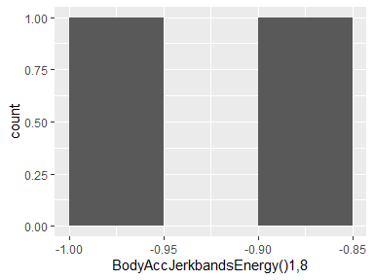

## BodyAccJerkbandsEnergy()9,16

|  |  |
| --- | --- |
| Feature | Result |
| Variable type | numeric |
| Number of missing obs. | 0 (0 %) |
| Number of unique values | 2 |
| Median | -0.94 |
| 1st and 3rd quartiles | -0.97; -0.91 |
| Min. and max. | -1; -0.89 |

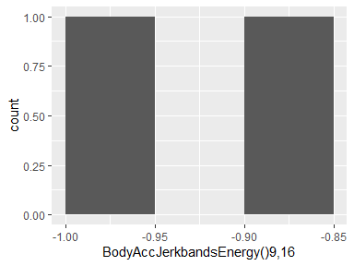

## BodyAccJerkbandsEnergy()17,24

|  |  |
| --- | --- |
| Feature | Result |
| Variable type | numeric |
| Number of missing obs. | 0 (0 %) |
| Number of unique values | 2 |
| Median | -0.94 |
| 1st and 3rd quartiles | -0.97; -0.9 |
| Min. and max. | -1; -0.87 |

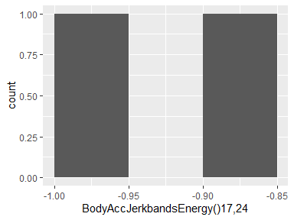

## BodyAccJerkbandsEnergy()25,32

|  |  |
| --- | --- |
| Feature | Result |
| Variable type | numeric |
| Number of missing obs. | 0 (0 %) |
| Number of unique values | 2 |
| Median | -0.95 |
| 1st and 3rd quartiles | -0.97; -0.92 |
| Min. and max. | -1; -0.9 |

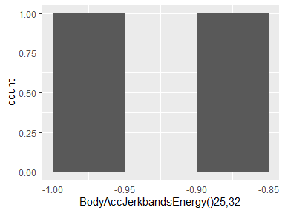

## BodyAccJerkbandsEnergy()33,40

|  |  |
| --- | --- |
| Feature | Result |
| Variable type | numeric |
| Number of missing obs. | 0 (0 %) |
| Number of unique values | 2 |
| Median | -0.96 |
| 1st and 3rd quartiles | -0.98; -0.94 |
| Min. and max. | -1; -0.92 |

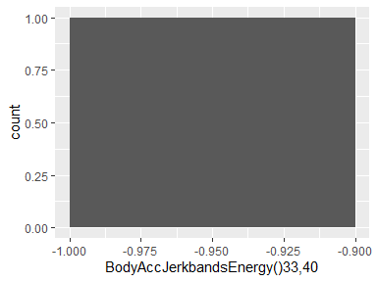

## BodyAccJerkbandsEnergy()41,48

|  |  |
| --- | --- |
| Feature | Result |
| Variable type | numeric |
| Number of missing obs. | 0 (0 %) |
| Number of unique values | 2 |
| Median | -0.95 |
| 1st and 3rd quartiles | -0.97; -0.93 |
| Min. and max. | -1; -0.9 |

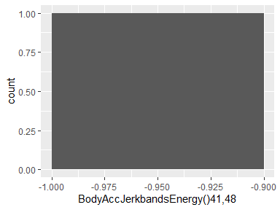

## BodyAccJerkbandsEnergy()49,56

|  |  |
| --- | --- |
| Feature | Result |
| Variable type | numeric |
| Number of missing obs. | 0 (0 %) |
| Number of unique values | 2 |
| Median | -0.97 |
| 1st and 3rd quartiles | -0.99; -0.96 |
| Min. and max. | -1; -0.95 |

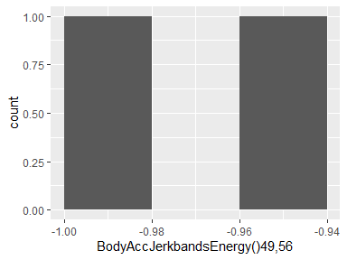

## BodyAccJerkbandsEnergy()57,64

|  |  |
| --- | --- |
| Feature | Result |
| Variable type | numeric |
| Number of missing obs. | 0 (0 %) |
| Number of unique values | 2 |
| Median | -0.99 |
| 1st and 3rd quartiles | -1; -0.99 |
| Min. and max. | -1; -0.98 |

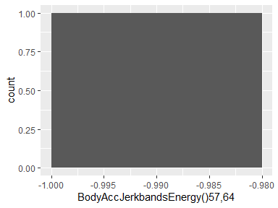

## BodyAccJerkbandsEnergy()1,16

|  |  |
| --- | --- |
| Feature | Result |
| Variable type | numeric |
| Number of missing obs. | 0 (0 %) |
| Number of unique values | 2 |
| Median | -0.93 |
| 1st and 3rd quartiles | -0.97; -0.9 |
| Min. and max. | -1; -0.87 |

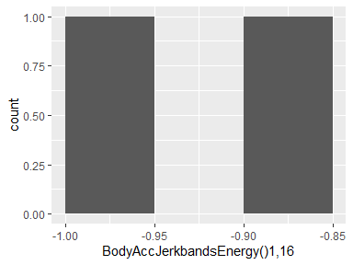

## BodyAccJerkbandsEnergy()17,32

|  |  |
| --- | --- |
| Feature | Result |
| Variable type | numeric |
| Number of missing obs. | 0 (0 %) |
| Number of unique values | 2 |
| Median | -0.93 |
| 1st and 3rd quartiles | -0.96; -0.89 |
| Min. and max. | -1; -0.85 |

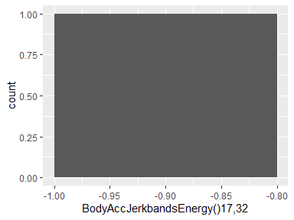

## BodyAccJerkbandsEnergy()33,48

|  |  |
| --- | --- |
| Feature | Result |
| Variable type | numeric |
| Number of missing obs. | 0 (0 %) |
| Number of unique values | 2 |
| Median | -0.95 |
| 1st and 3rd quartiles | -0.98; -0.93 |
| Min. and max. | -1; -0.91 |

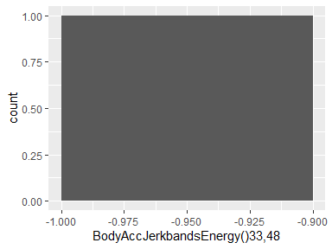

## BodyAccJerkbandsEnergy()49,64

|  |  |
| --- | --- |
| Feature | Result |
| Variable type | numeric |
| Number of missing obs. | 0 (0 %) |
| Number of unique values | 2 |
| Median | -0.97 |
| 1st and 3rd quartiles | -0.99; -0.96 |
| Min. and max. | -1; -0.94 |

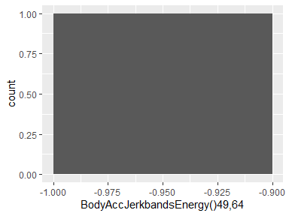

## BodyAccJerkbandsEnergy()1,24

|  |  |
| --- | --- |
| Feature | Result |
| Variable type | numeric |
| Number of missing obs. | 0 (0 %) |
| Number of unique values | 2 |
| Median | -0.92 |
| 1st and 3rd quartiles | -0.96; -0.88 |
| Min. and max. | -1; -0.85 |

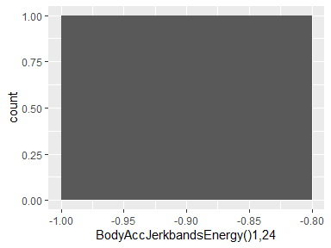

## BodyAccJerkbandsEnergy()25,48

|  |  |
| --- | --- |
| Feature | Result |
| Variable type | numeric |
| Number of missing obs. | 0 (0 %) |
| Number of unique values | 2 |
| Median | -0.93 |
| 1st and 3rd quartiles | -0.96; -0.9 |
| Min. and max. | -1; -0.86 |

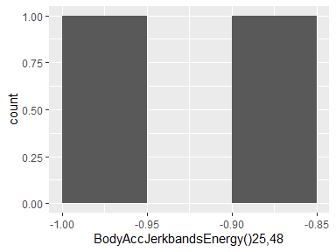

## V396

|  |  |
| --- | --- |
| Feature | Result |
| Variable type | numeric |
| Number of missing obs. | 0 (0 %) |
| Number of unique values | 2 |
| Median | -0.91 |
| 1st and 3rd quartiles | -0.96; -0.87 |
| Min. and max. | -1; -0.83 |

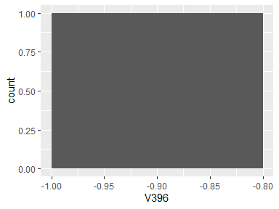

## V397

|  |  |
| --- | --- |
| Feature | Result |
| Variable type | numeric |
| Number of missing obs. | 0 (0 %) |
| Number of unique values | 2 |
| Median | -0.93 |
| 1st and 3rd quartiles | -0.97; -0.9 |
| Min. and max. | -1; -0.87 |

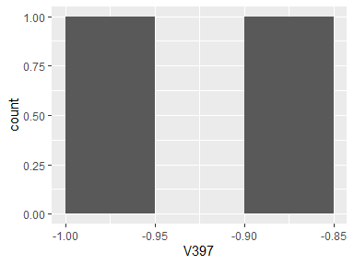

## V398

|  |  |
| --- | --- |
| Feature | Result |
| Variable type | numeric |
| Number of missing obs. | 0 (0 %) |
| Number of unique values | 2 |
| Median | -0.92 |
| 1st and 3rd quartiles | -0.96; -0.88 |
| Min. and max. | -1; -0.84 |

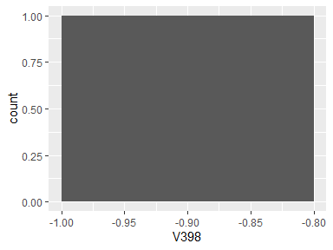

## V399

|  |  |
| --- | --- |
| Feature | Result |
| Variable type | numeric |
| Number of missing obs. | 0 (0 %) |
| Number of unique values | 2 |
| Median | -0.95 |
| 1st and 3rd quartiles | -0.98; -0.93 |
| Min. and max. | -1; -0.91 |

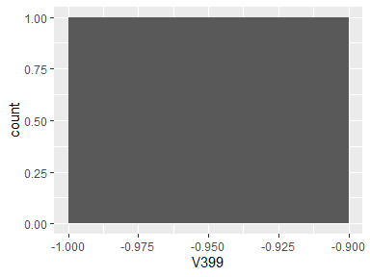

## V400

|  |  |
| --- | --- |
| Feature | Result |
| Variable type | numeric |
| Number of missing obs. | 0 (0 %) |
| Number of unique values | 2 |
| Median | -0.96 |
| 1st and 3rd quartiles | -0.98; -0.94 |
| Min. and max. | -1; -0.92 |

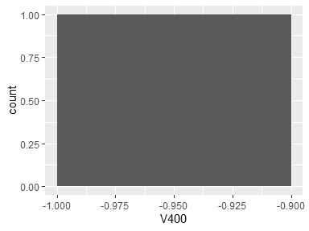

## V401

|  |  |
| --- | --- |
| Feature | Result |
| Variable type | numeric |
| Number of missing obs. | 0 (0 %) |
| Number of unique values | 2 |
| Median | -0.94 |
| 1st and 3rd quartiles | -0.97; -0.91 |
| Min. and max. | -1; -0.88 |

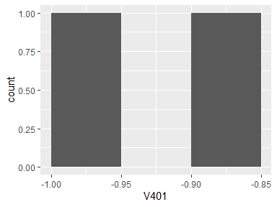

## V402

|  |  |
| --- | --- |
| Feature | Result |
| Variable type | numeric |
| Number of missing obs. | 0 (0 %) |
| Number of unique values | 2 |
| Median | -0.96 |
| 1st and 3rd quartiles | -0.98; -0.94 |
| Min. and max. | -1; -0.92 |

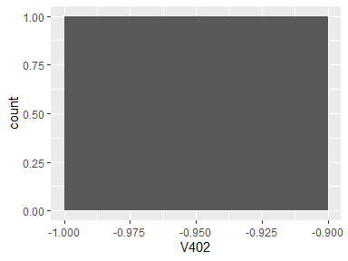

## V403

|  |  |
| --- | --- |
| Feature | Result |
| Variable type | numeric |
| Number of missing obs. | 0 (0 %) |
| Number of unique values | 2 |
| Median | -0.99 |
| 1st and 3rd quartiles | -0.99; -0.98 |
| Min. and max. | -1; -0.97 |

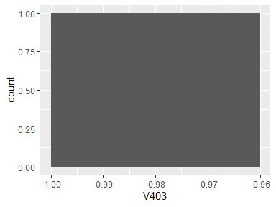

## V404

|  |  |
| --- | --- |
| Feature | Result |
| Variable type | numeric |
| Number of missing obs. | 0 (0 %) |
| Number of unique values | 2 |
| Median | -0.92 |
| 1st and 3rd quartiles | -0.96; -0.88 |
| Min. and max. | -1; -0.84 |

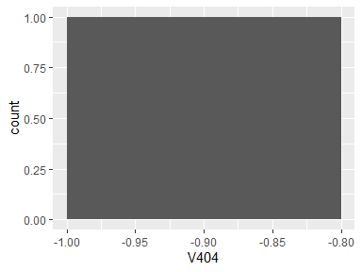

## V405

|  |  |
| --- | --- |
| Feature | Result |
| Variable type | numeric |
| Number of missing obs. | 0 (0 %) |
| Number of unique values | 2 |
| Median | -0.92 |
| 1st and 3rd quartiles | -0.96; -0.88 |
| Min. and max. | -1; -0.84 |

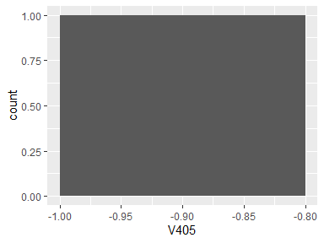

## V406

|  |  |
| --- | --- |
| Feature | Result |
| Variable type | numeric |
| Number of missing obs. | 0 (0 %) |
| Number of unique values | 2 |
| Median | -0.94 |
| 1st and 3rd quartiles | -0.97; -0.91 |
| Min. and max. | -1; -0.88 |

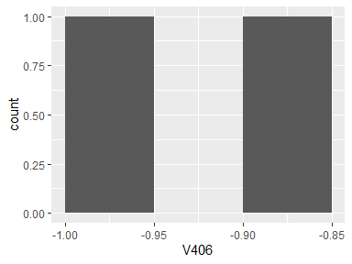

## V407

|  |  |
| --- | --- |
| Feature | Result |
| Variable type | numeric |
| Number of missing obs. | 0 (0 %) |
| Number of unique values | 2 |
| Median | -0.96 |
| 1st and 3rd quartiles | -0.98; -0.95 |
| Min. and max. | -1; -0.93 |

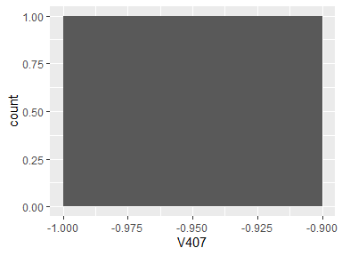

## V408

|  |  |
| --- | --- |
| Feature | Result |
| Variable type | numeric |
| Number of missing obs. | 0 (0 %) |
| Number of unique values | 2 |
| Median | -0.9 |
| 1st and 3rd quartiles | -0.95; -0.86 |
| Min. and max. | -1; -0.81 |

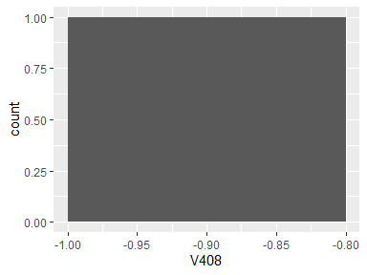

## V409

|  |  |
| --- | --- |
| Feature | Result |
| Variable type | numeric |
| Number of missing obs. | 0 (0 %) |
| Number of unique values | 2 |
| Median | -0.95 |
| 1st and 3rd quartiles | -0.97; -0.92 |
| Min. and max. | -1; -0.9 |

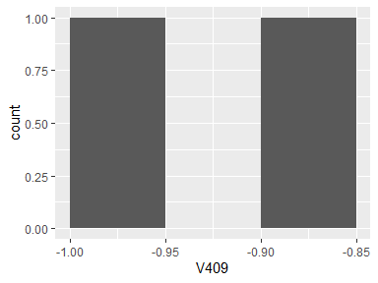

## V410

|  |  |
| --- | --- |
| Feature | Result |
| Variable type | numeric |
| Number of missing obs. | 0 (0 %) |
| Number of unique values | 2 |
| Median | -0.95 |
| 1st and 3rd quartiles | -0.97; -0.92 |
| Min. and max. | -1; -0.9 |

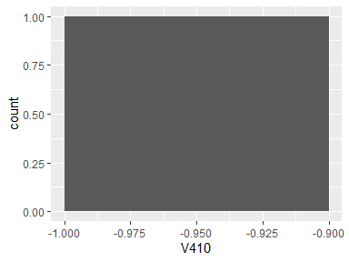

## V411

|  |  |
| --- | --- |
| Feature | Result |
| Variable type | numeric |
| Number of missing obs. | 0 (0 %) |
| Number of unique values | 2 |
| Median | -0.95 |
| 1st and 3rd quartiles | -0.97; -0.92 |
| Min. and max. | -1; -0.9 |

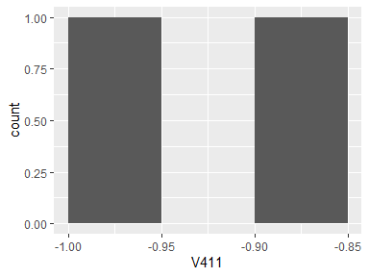

## V412

|  |  |
| --- | --- |
| Feature | Result |
| Variable type | numeric |
| Number of missing obs. | 0 (0 %) |
| Number of unique values | 2 |
| Median | -0.97 |
| 1st and 3rd quartiles | -0.98; -0.95 |
| Min. and max. | -1; -0.93 |

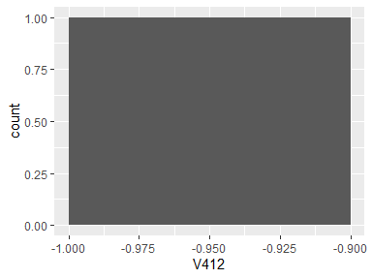

## V413

|  |  |
| --- | --- |
| Feature | Result |
| Variable type | numeric |
| Number of missing obs. | 0 (0 %) |
| Number of unique values | 2 |
| Median | -0.98 |
| 1st and 3rd quartiles | -0.99; -0.97 |
| Min. and max. | -1; -0.96 |

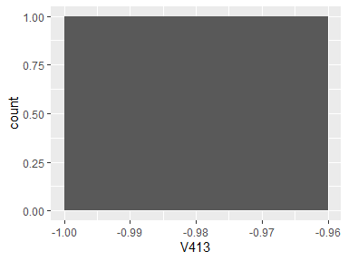

## V414

|  |  |
| --- | --- |
| Feature | Result |
| Variable type | numeric |
| Number of missing obs. | 0 (0 %) |
| Number of unique values | 2 |
| Median | -0.98 |
| 1st and 3rd quartiles | -0.99; -0.98 |
| Min. and max. | -1; -0.97 |

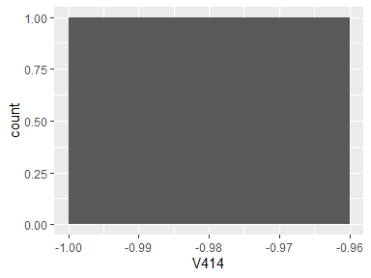

## V415

|  |  |
| --- | --- |
| Feature | Result |
| Variable type | numeric |
| Number of missing obs. | 0 (0 %) |
| Number of unique values | 2 |
| Median | -0.97 |
| 1st and 3rd quartiles | -0.98; -0.96 |
| Min. and max. | -1; -0.94 |

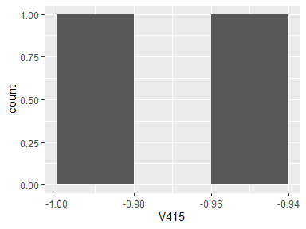

## V416

|  |  |
| --- | --- |
| Feature | Result |
| Variable type | numeric |
| Number of missing obs. | 0 (0 %) |
| Number of unique values | 2 |
| Median | -0.96 |
| 1st and 3rd quartiles | -0.98; -0.95 |
| Min. and max. | -1; -0.93 |

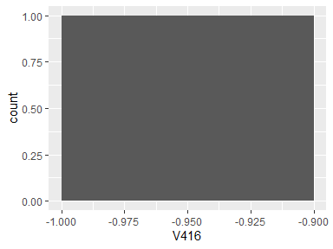

## V417

|  |  |
| --- | --- |
| Feature | Result |
| Variable type | numeric |
| Number of missing obs. | 0 (0 %) |
| Number of unique values | 2 |
| Median | -0.99 |
| 1st and 3rd quartiles | -0.99; -0.98 |
| Min. and max. | -1; -0.97 |

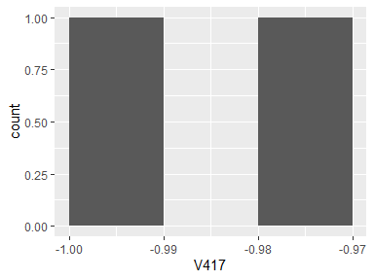

## V418

|  |  |
| --- | --- |
| Feature | Result |
| Variable type | numeric |
| Number of missing obs. | 0 (0 %) |
| Number of unique values | 2 |
| Median | -0.94 |
| 1st and 3rd quartiles | -0.97; -0.91 |
| Min. and max. | -1; -0.88 |

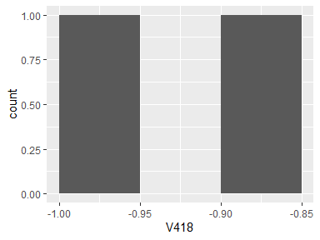

## V419

|  |  |
| --- | --- |
| Feature | Result |
| Variable type | numeric |
| Number of missing obs. | 0 (0 %) |
| Number of unique values | 2 |
| Median | -0.97 |
| 1st and 3rd quartiles | -0.99; -0.96 |
| Min. and max. | -1; -0.95 |

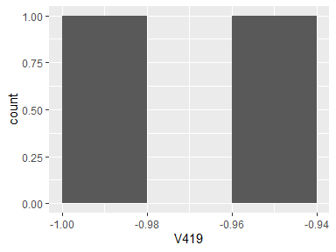

## V420

|  |  |
| --- | --- |
| Feature | Result |
| Variable type | numeric |
| Number of missing obs. | 0 (0 %) |
| Number of unique values | 2 |
| Median | -0.98 |
| 1st and 3rd quartiles | -0.99; -0.97 |
| Min. and max. | -1; -0.96 |

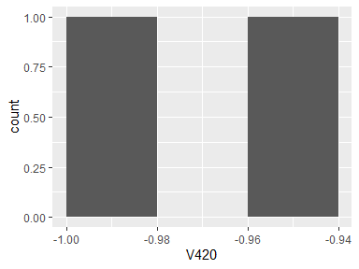

## V421

|  |  |
| --- | --- |
| Feature | Result |
| Variable type | numeric |
| Number of missing obs. | 0 (0 %) |
| Number of unique values | 2 |
| Median | -0.97 |
| 1st and 3rd quartiles | -0.98; -0.95 |
| Min. and max. | -1; -0.93 |

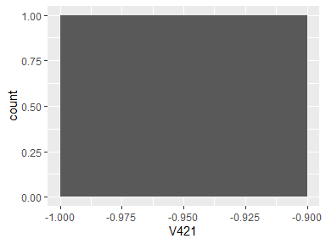

## V422

|  |  |
| --- | --- |
| Feature | Result |
| Variable type | numeric |
| Number of missing obs. | 0 (0 %) |
| Number of unique values | 2 |
| Median | -0.95 |
| 1st and 3rd quartiles | -0.97; -0.92 |
| Min. and max. | -1; -0.9 |

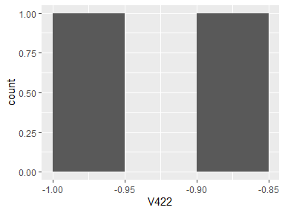

## V423

|  |  |
| --- | --- |
| Feature | Result |
| Variable type | numeric |
| Number of missing obs. | 0 (0 %) |
| Number of unique values | 2 |
| Median | -0.98 |
| 1st and 3rd quartiles | -0.99; -0.97 |
| Min. and max. | -1; -0.96 |

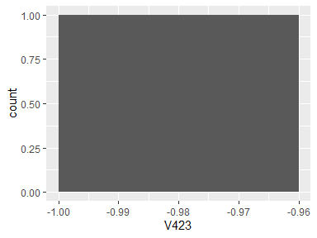

## V424

|  |  |
| --- | --- |
| Feature | Result |
| Variable type | numeric |
| Number of missing obs. | 0 (0 %) |
| Number of unique values | 2 |
| Median | -0.78 |
| 1st and 3rd quartiles | -0.84; -0.73 |
| Min. and max. | -0.89; -0.67 |

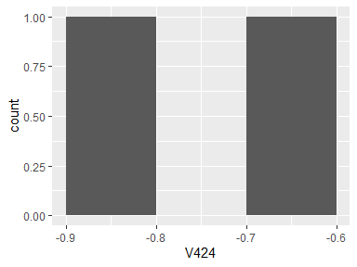

## V425

|  |  |
| --- | --- |
| Feature | Result |
| Variable type | numeric |
| Number of missing obs. | 0 (0 %) |
| Number of unique values | 2 |
| Median | -0.81 |
| 1st and 3rd quartiles | -0.87; -0.76 |
| Min. and max. | -0.92; -0.71 |

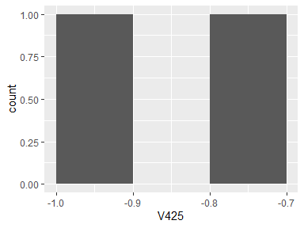

## V426

|  |  |
| --- | --- |
| Feature | Result |
| Variable type | numeric |
| Number of missing obs. | 0 (0 %) |
| Number of unique values | 2 |
| Median | -0.77 |
| 1st and 3rd quartiles | -0.83; -0.71 |
| Min. and max. | -0.89; -0.64 |

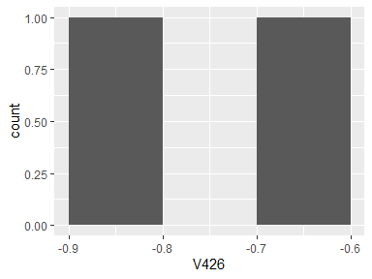

## V427

|  |  |
| --- | --- |
| Feature | Result |
| Variable type | numeric |
| Number of missing obs. | 0 (0 %) |
| Number of unique values | 2 |
| Median | -0.82 |
| 1st and 3rd quartiles | -0.86; -0.78 |
| Min. and max. | -0.91; -0.74 |

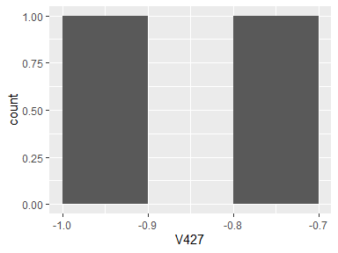

## V428

|  |  |
| --- | --- |
| Feature | Result |
| Variable type | numeric |
| Number of missing obs. | 0 (0 %) |
| Number of unique values | 2 |
| Median | -0.79 |
| 1st and 3rd quartiles | -0.85; -0.73 |
| Min. and max. | -0.91; -0.67 |

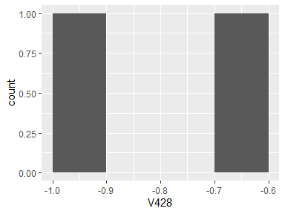

## V429

|  |  |
| --- | --- |
| Feature | Result |
| Variable type | numeric |
| Number of missing obs. | 0 (0 %) |
| Number of unique values | 2 |
| Median | -0.79 |
| 1st and 3rd quartiles | -0.84; -0.74 |
| Min. and max. | -0.89; -0.69 |

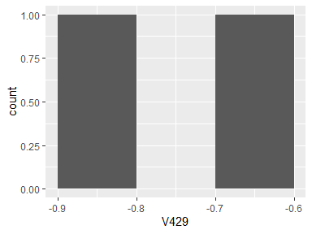

## V430

|  |  |
| --- | --- |
| Feature | Result |
| Variable type | numeric |
| Number of missing obs. | 0 (0 %) |
| Number of unique values | 2 |
| Median | -0.79 |
| 1st and 3rd quartiles | -0.84; -0.74 |
| Min. and max. | -0.89; -0.69 |

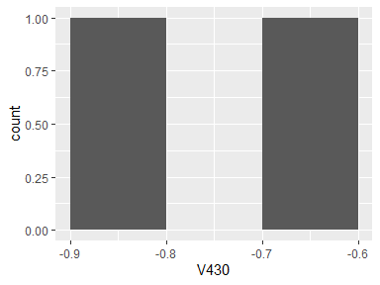

## V431

|  |  |
| --- | --- |
| Feature | Result |
| Variable type | numeric |
| Number of missing obs. | 0 (0 %) |
| Number of unique values | 2 |
| Median | -0.82 |
| 1st and 3rd quartiles | -0.87; -0.76 |
| Min. and max. | -0.92; -0.71 |

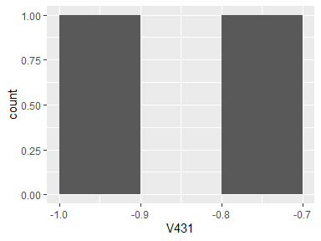

## V432

|  |  |
| --- | --- |
| Feature | Result |
| Variable type | numeric |
| Number of missing obs. | 0 (0 %) |
| Number of unique values | 2 |
| Median | -0.76 |
| 1st and 3rd quartiles | -0.83; -0.7 |
| Min. and max. | -0.89; -0.64 |

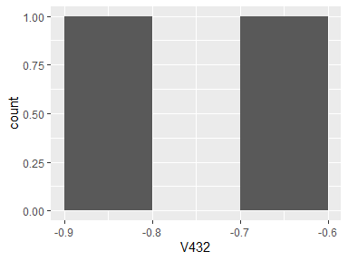

## V433

|  |  |
| --- | --- |
| Feature | Result |
| Variable type | numeric |
| Number of missing obs. | 0 (0 %) |
| Number of unique values | 2 |
| Median | -0.82 |
| 1st and 3rd quartiles | -0.86; -0.78 |
| Min. and max. | -0.91; -0.74 |

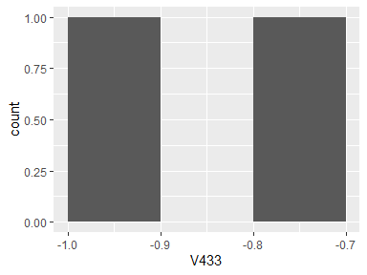

## V434

|  |  |
| --- | --- |
| Feature | Result |
| Variable type | numeric |
| Number of missing obs. | 0 (0 %) |
| Number of unique values | 2 |
| Median | -0.83 |
| 1st and 3rd quartiles | -0.87; -0.78 |
| Min. and max. | -0.92; -0.73 |

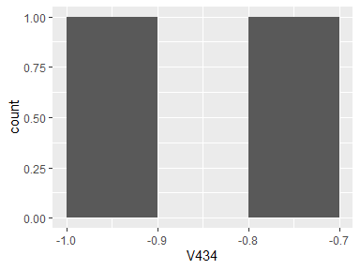

## V435

|  |  |
| --- | --- |
| Feature | Result |
| Variable type | numeric |
| Number of missing obs. | 0 (0 %) |
| Number of unique values | 2 |
| Median | -0.84 |
| 1st and 3rd quartiles | -0.87; -0.8 |
| Min. and max. | -0.91; -0.76 |

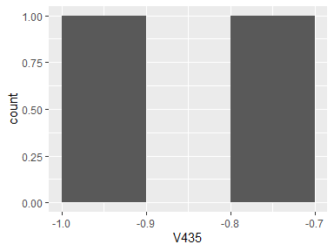

## V436

|  |  |
| --- | --- |
| Feature | Result |
| Variable type | numeric |
| Number of missing obs. | 0 (0 %) |
| Number of unique values | 2 |
| Median | -0.96 |
| 1st and 3rd quartiles | -0.97; -0.94 |
| Min. and max. | -0.98; -0.93 |

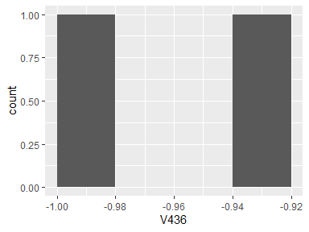

## V437

|  |  |
| --- | --- |
| Feature | Result |
| Variable type | numeric |
| Number of missing obs. | 0 (0 %) |
| Number of unique values | 2 |
| Median | -0.94 |
| 1st and 3rd quartiles | -0.96; -0.92 |
| Min. and max. | -0.97; -0.9 |

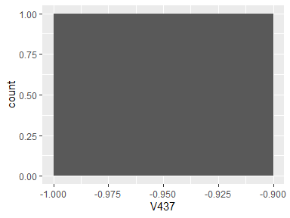

## V438

|  |  |
| --- | --- |
| Feature | Result |
| Variable type | numeric |
| Number of missing obs. | 0 (0 %) |
| Number of unique values | 2 |
| Median | -0.94 |
| 1st and 3rd quartiles | -0.96; -0.92 |
| Min. and max. | -0.97; -0.91 |

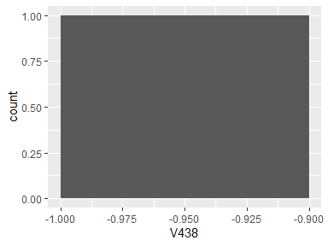

## V439

|  |  |
| --- | --- |
| Feature | Result |
| Variable type | numeric |
| Number of missing obs. | 0 (0 %) |
| Number of unique values | 2 |
| Median | -0.78 |
| 1st and 3rd quartiles | -0.84; -0.72 |
| Min. and max. | -0.9; -0.66 |

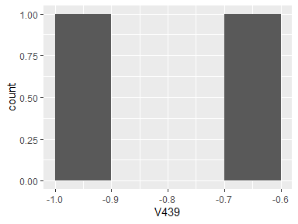

## V440

|  |  |
| --- | --- |
| Feature | Result |
| Variable type | numeric |
| Number of missing obs. | 0 (0 %) |
| Number of unique values | 2 |
| Median | -0.96 |
| 1st and 3rd quartiles | -0.98; -0.94 |
| Min. and max. | -0.99; -0.92 |

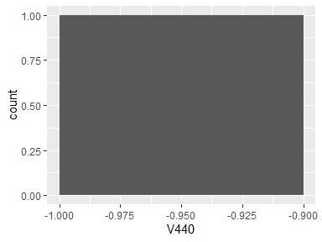

## V441

|  |  |
| --- | --- |
| Feature | Result |
| Variable type | numeric |
| Number of missing obs. | 0 (0 %) |
| Number of unique values | 2 |
| Median | -0.94 |
| 1st and 3rd quartiles | -0.97; -0.91 |
| Min. and max. | -1; -0.89 |

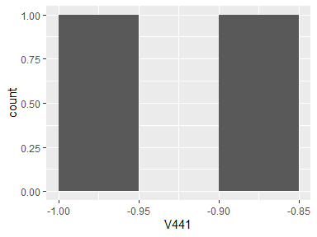

## V442

|  |  |
| --- | --- |
| Feature | Result |
| Variable type | numeric |
| Number of missing obs. | 0 (0 %) |
| Number of unique values | 2 |
| Median | -0.93 |
| 1st and 3rd quartiles | -0.96; -0.9 |
| Min. and max. | -0.99; -0.87 |

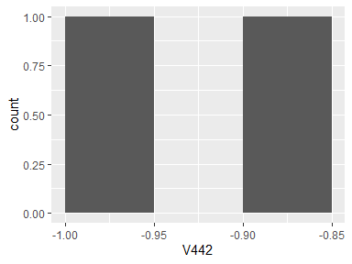

## V443

|  |  |
| --- | --- |
| Feature | Result |
| Variable type | numeric |
| Number of missing obs. | 0 (0 %) |
| Number of unique values | 2 |
| Median | -0.82 |
| 1st and 3rd quartiles | -0.87; -0.76 |
| Min. and max. | -0.93; -0.71 |

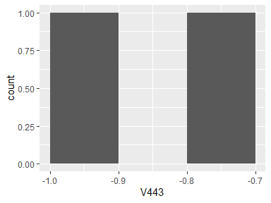

## V444

|  |  |
| --- | --- |
| Feature | Result |
| Variable type | numeric |
| Number of missing obs. | 0 (0 %) |
| Number of unique values | 2 |
| Median | -0.85 |
| 1st and 3rd quartiles | -0.89; -0.8 |
| Min. and max. | -0.94; -0.75 |

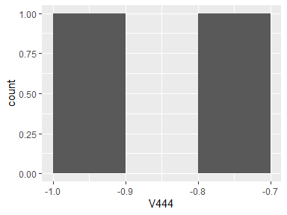

## V445

|  |  |
| --- | --- |
| Feature | Result |
| Variable type | numeric |
| Number of missing obs. | 0 (0 %) |
| Number of unique values | 2 |
| Median | -0.82 |
| 1st and 3rd quartiles | -0.87; -0.76 |
| Min. and max. | -0.93; -0.7 |

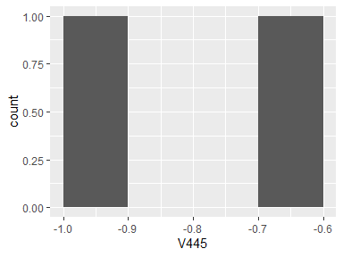

## V446

|  |  |
| --- | --- |
| Feature | Result |
| Variable type | numeric |
| Number of missing obs. | 0 (0 %) |
| Number of unique values | 2 |
| Median | -0.13 |
| 1st and 3rd quartiles | -0.15; -0.11 |
| Min. and max. | -0.17; -0.09 |

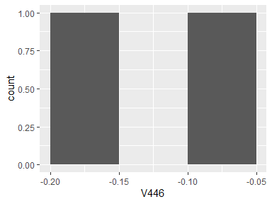

## V447

|  |  |
| --- | --- |
| Feature | Result |
| Variable type | numeric |
| Number of missing obs. | 0 (0 %) |
| Number of unique values | 2 |
| Median | -0.09 |
| 1st and 3rd quartiles | -0.11; -0.07 |
| Min. and max. | -0.13; -0.05 |

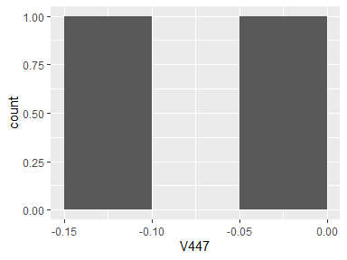

## V448

|  |  |
| --- | --- |
| Feature | Result |
| Variable type | numeric |
| Number of missing obs. | 0 (0 %) |
| Number of unique values | 2 |
| Median | -0.2 |
| 1st and 3rd quartiles | -0.22; -0.17 |
| Min. and max. | -0.25; -0.15 |

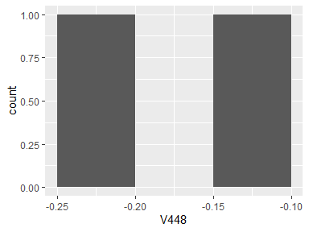

## BodyGyromaxIndsX

|  |  |
| --- | --- |
| Feature | Result |
| Variable type | numeric |
| Number of missing obs. | 0 (0 %) |
| Number of unique values | 2 |
| Median | -0.91 |
| 1st and 3rd quartiles | -0.92; -0.89 |
| Min. and max. | -0.93; -0.88 |

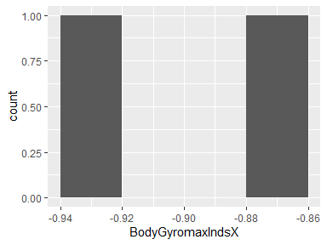

## BodyGyromaxIndsY

|  |  |
| --- | --- |
| Feature | Result |
| Variable type | numeric |
| Number of missing obs. | 0 (0 %) |
| Number of unique values | 2 |
| Median | -0.87 |
| 1st and 3rd quartiles | -0.9; -0.83 |
| Min. and max. | -0.94; -0.8 |

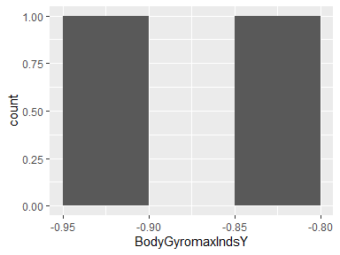

## BodyGyromaxIndsZ

|  |  |
| --- | --- |
| Feature | Result |
| Variable type | numeric |
| Number of missing obs. | 0 (0 %) |
| Number of unique values | 2 |
| Median | -0.87 |
| 1st and 3rd quartiles | -0.9; -0.84 |
| Min. and max. | -0.93; -0.81 |

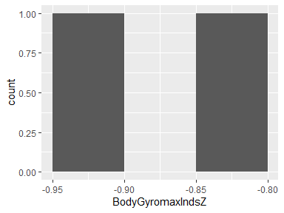

## BodyGyromeanFreq()X

|  |  |
| --- | --- |
| Feature | Result |
| Variable type | numeric |
| Number of missing obs. | 0 (0 %) |
| Number of unique values | 2 |
| Median | -0.1 |
| 1st and 3rd quartiles | -0.1; -0.1 |
| Min. and max. | -0.1; -0.1 |

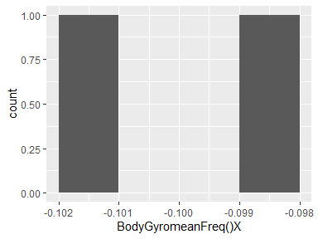

## BodyGyromeanFreq()Y

|  |  |
| --- | --- |
| Feature | Result |
| Variable type | numeric |
| Number of missing obs. | 0 (0 %) |
| Number of unique values | 2 |
| Median | -0.17 |
| 1st and 3rd quartiles | -0.17; -0.17 |
| Min. and max. | -0.17; -0.17 |

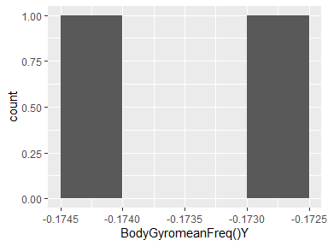

## BodyGyromeanFreq()Z

|  |  |
| --- | --- |
| Feature | Result |
| Variable type | numeric |
| Number of missing obs. | 0 (0 %) |
| Number of unique values | 2 |
| Median | -0.05 |
| 1st and 3rd quartiles | -0.05; -0.05 |
| Min. and max. | -0.05; -0.05 |

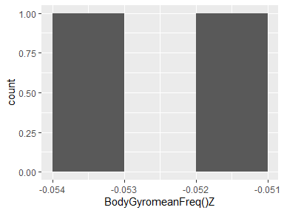

## BodyGyroskewness()X

|  |  |
| --- | --- |
| Feature | Result |
| Variable type | numeric |
| Number of missing obs. | 0 (0 %) |
| Number of unique values | 2 |
| Median | -0.2 |
| 1st and 3rd quartiles | -0.21; -0.19 |
| Min. and max. | -0.22; -0.18 |

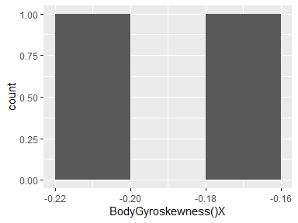

## BodyGyrokurtosis()X

|  |  |
| --- | --- |
| Feature | Result |
| Variable type | numeric |
| Number of missing obs. | 0 (0 %) |
| Number of unique values | 2 |
| Median | -0.54 |
| 1st and 3rd quartiles | -0.56; -0.52 |
| Min. and max. | -0.58; -0.49 |

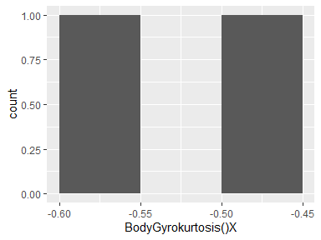

## BodyGyroskewness()Y

|  |  |
| --- | --- |
| Feature | Result |
| Variable type | numeric |
| Number of missing obs. | 0 (0 %) |
| Number of unique values | 2 |
| Median | -0.21 |
| 1st and 3rd quartiles | -0.23; -0.2 |
| Min. and max. | -0.25; -0.18 |

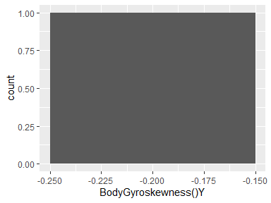

## BodyGyrokurtosis()Y

|  |  |
| --- | --- |
| Feature | Result |
| Variable type | numeric |
| Number of missing obs. | 0 (0 %) |
| Number of unique values | 2 |
| Median | -0.6 |
| 1st and 3rd quartiles | -0.63; -0.56 |
| Min. and max. | -0.66; -0.53 |

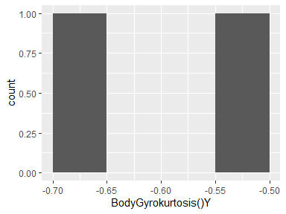

## BodyGyroskewness()Z

|  |  |
| --- | --- |
| Feature | Result |
| Variable type | numeric |
| Number of missing obs. | 0 (0 %) |
| Number of unique values | 2 |
| Median | -0.24 |
| 1st and 3rd quartiles | -0.26; -0.23 |
| Min. and max. | -0.27; -0.21 |

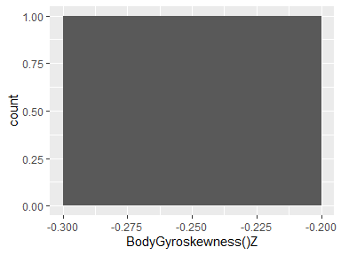

## BodyGyrokurtosis()Z

|  |  |
| --- | --- |
| Feature | Result |
| Variable type | numeric |
| Number of missing obs. | 0 (0 %) |
| Number of unique values | 2 |
| Median | -0.58 |
| 1st and 3rd quartiles | -0.61; -0.56 |
| Min. and max. | -0.64; -0.53 |

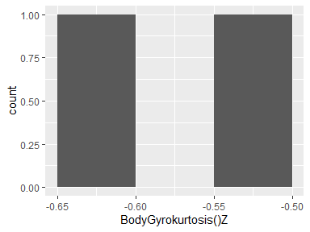

## BodyGyrobandsEnergy()1,8

|  |  |
| --- | --- |
| Feature | Result |
| Variable type | numeric |
| Number of missing obs. | 0 (0 %) |
| Number of unique values | 2 |
| Median | -0.96 |
| 1st and 3rd quartiles | -0.98; -0.95 |
| Min. and max. | -1; -0.93 |

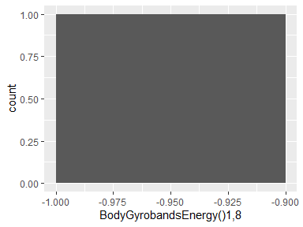

## BodyGyrobandsEnergy()9,16

|  |  |
| --- | --- |
| Feature | Result |
| Variable type | numeric |
| Number of missing obs. | 0 (0 %) |
| Number of unique values | 2 |
| Median | -0.95 |
| 1st and 3rd quartiles | -0.97; -0.93 |
| Min. and max. | -1; -0.91 |

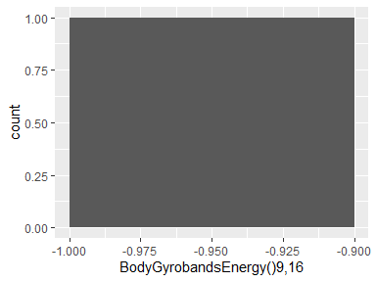

## BodyGyrobandsEnergy()17,24

|  |  |
| --- | --- |
| Feature | Result |
| Variable type | numeric |
| Number of missing obs. | 0 (0 %) |
| Number of unique values | 2 |
| Median | -0.96 |
| 1st and 3rd quartiles | -0.98; -0.94 |
| Min. and max. | -1; -0.92 |

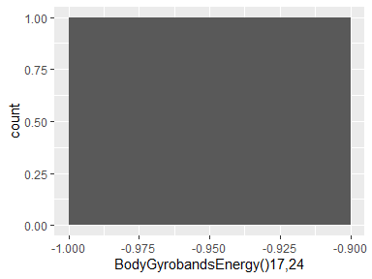

## BodyGyrobandsEnergy()25,32

|  |  |
| --- | --- |
| Feature | Result |
| Variable type | numeric |
| Number of missing obs. | 0 (0 %) |
| Number of unique values | 2 |
| Median | -0.98 |
| 1st and 3rd quartiles | -0.99; -0.97 |
| Min. and max. | -1; -0.96 |

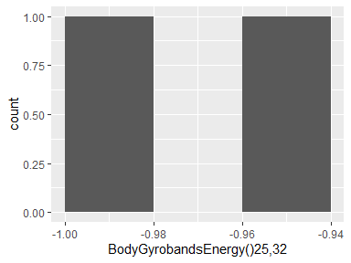

## BodyGyrobandsEnergy()33,40

|  |  |
| --- | --- |
| Feature | Result |
| Variable type | numeric |
| Number of missing obs. | 0 (0 %) |
| Number of unique values | 2 |
| Median | -0.97 |
| 1st and 3rd quartiles | -0.99; -0.96 |
| Min. and max. | -1; -0.95 |

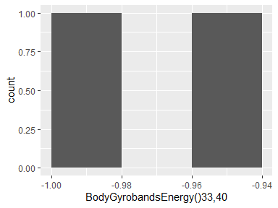

## BodyGyrobandsEnergy()41,48

|  |  |
| --- | --- |
| Feature | Result |
| Variable type | numeric |
| Number of missing obs. | 0 (0 %) |
| Number of unique values | 2 |
| Median | -0.98 |
| 1st and 3rd quartiles | -0.99; -0.96 |
| Min. and max. | -1; -0.95 |

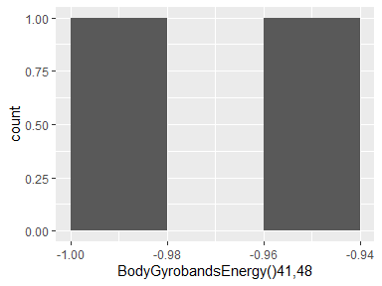

## BodyGyrobandsEnergy()49,56

|  |  |
| --- | --- |
| Feature | Result |
| Variable type | numeric |
| Number of missing obs. | 0 (0 %) |
| Number of unique values | 2 |
| Median | -0.98 |
| 1st and 3rd quartiles | -0.99; -0.97 |
| Min. and max. | -1; -0.96 |

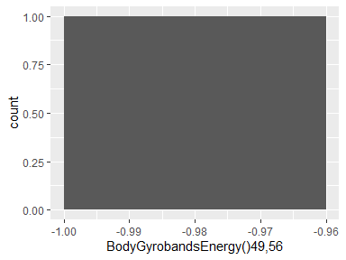

## BodyGyrobandsEnergy()57,64

|  |  |
| --- | --- |
| Feature | Result |
| Variable type | numeric |
| Number of missing obs. | 0 (0 %) |
| Number of unique values | 2 |
| Median | -0.99 |
| 1st and 3rd quartiles | -0.99; -0.98 |
| Min. and max. | -1; -0.98 |

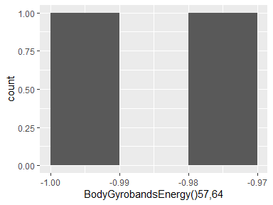

## BodyGyrobandsEnergy()1,16

|  |  |
| --- | --- |
| Feature | Result |
| Variable type | numeric |
| Number of missing obs. | 0 (0 %) |
| Number of unique values | 2 |
| Median | -0.96 |
| 1st and 3rd quartiles | -0.98; -0.94 |
| Min. and max. | -1; -0.92 |

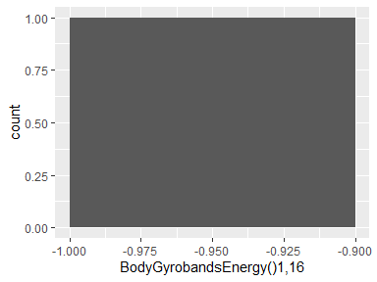

## BodyGyrobandsEnergy()17,32

|  |  |
| --- | --- |
| Feature | Result |
| Variable type | numeric |
| Number of missing obs. | 0 (0 %) |
| Number of unique values | 2 |
| Median | -0.96 |
| 1st and 3rd quartiles | -0.98; -0.94 |
| Min. and max. | -1; -0.92 |

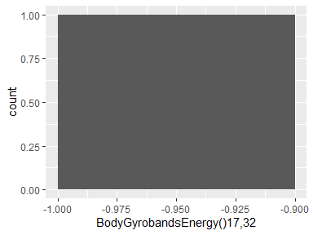

## BodyGyrobandsEnergy()33,48

|  |  |
| --- | --- |
| Feature | Result |
| Variable type | numeric |
| Number of missing obs. | 0 (0 %) |
| Number of unique values | 2 |
| Median | -0.97 |
| 1st and 3rd quartiles | -0.98; -0.96 |
| Min. and max. | -1; -0.95 |

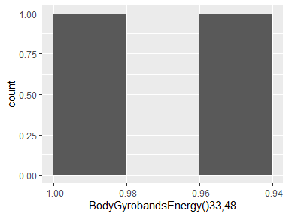

## BodyGyrobandsEnergy()49,64

|  |  |
| --- | --- |
| Feature | Result |
| Variable type | numeric |
| Number of missing obs. | 0 (0 %) |
| Number of unique values | 2 |
| Median | -0.98 |
| 1st and 3rd quartiles | -0.99; -0.98 |
| Min. and max. | -1; -0.97 |

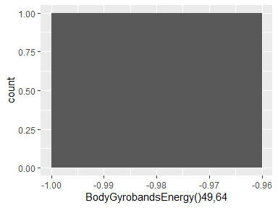

## BodyGyrobandsEnergy()1,24

|  |  |
| --- | --- |
| Feature | Result |
| Variable type | numeric |
| Number of missing obs. | 0 (0 %) |
| Number of unique values | 2 |
| Median | -0.96 |
| 1st and 3rd quartiles | -0.98; -0.94 |
| Min. and max. | -1; -0.92 |

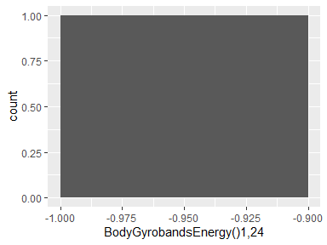

## BodyGyrobandsEnergy()25,48

|  |  |
| --- | --- |
| Feature | Result |
| Variable type | numeric |
| Number of missing obs. | 0 (0 %) |
| Number of unique values | 2 |
| Median | -0.98 |
| 1st and 3rd quartiles | -0.99; -0.97 |
| Min. and max. | -1; -0.95 |

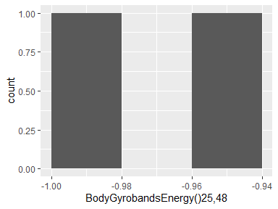

## V475

|  |  |
| --- | --- |
| Feature | Result |
| Variable type | numeric |
| Number of missing obs. | 0 (0 %) |
| Number of unique values | 2 |
| Median | -0.94 |
| 1st and 3rd quartiles | -0.97; -0.91 |
| Min. and max. | -0.99; -0.88 |

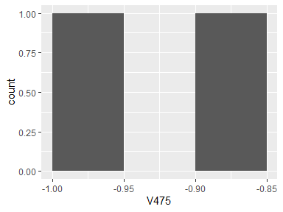

## V476

|  |  |
| --- | --- |
| Feature | Result |
| Variable type | numeric |
| Number of missing obs. | 0 (0 %) |
| Number of unique values | 2 |
| Median | -0.98 |
| 1st and 3rd quartiles | -0.99; -0.97 |
| Min. and max. | -1; -0.96 |

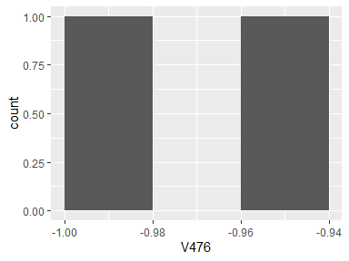

## V477

|  |  |
| --- | --- |
| Feature | Result |
| Variable type | numeric |
| Number of missing obs. | 0 (0 %) |
| Number of unique values | 2 |
| Median | -0.98 |
| 1st and 3rd quartiles | -0.99; -0.97 |
| Min. and max. | -1; -0.96 |

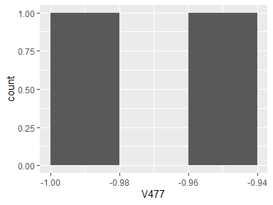

## V478

|  |  |
| --- | --- |
| Feature | Result |
| Variable type | numeric |
| Number of missing obs. | 0 (0 %) |
| Number of unique values | 2 |
| Median | -0.98 |
| 1st and 3rd quartiles | -0.99; -0.98 |
| Min. and max. | -1; -0.97 |

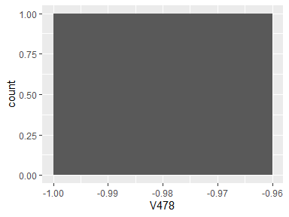

## V479

|  |  |
| --- | --- |
| Feature | Result |
| Variable type | numeric |
| Number of missing obs. | 0 (0 %) |
| Number of unique values | 2 |
| Median | -0.99 |
| 1st and 3rd quartiles | -0.99; -0.98 |
| Min. and max. | -1; -0.98 |

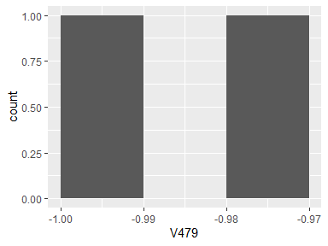

## V480

|  |  |
| --- | --- |
| Feature | Result |
| Variable type | numeric |
| Number of missing obs. | 0 (0 %) |
| Number of unique values | 2 |
| Median | -0.98 |
| 1st and 3rd quartiles | -0.99; -0.97 |
| Min. and max. | -1; -0.96 |

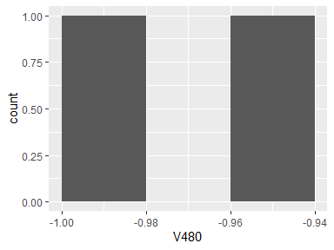

## V481

|  |  |
| --- | --- |
| Feature | Result |
| Variable type | numeric |
| Number of missing obs. | 0 (0 %) |
| Number of unique values | 2 |
| Median | -0.98 |
| 1st and 3rd quartiles | -0.99; -0.96 |
| Min. and max. | -1; -0.95 |

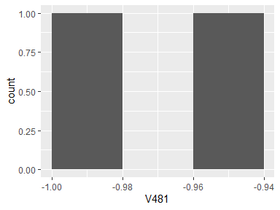

## V482

|  |  |
| --- | --- |
| Feature | Result |
| Variable type | numeric |
| Number of missing obs. | 0 (0 %) |
| Number of unique values | 2 |
| Median | -0.99 |
| 1st and 3rd quartiles | -0.99; -0.98 |
| Min. and max. | -1; -0.98 |

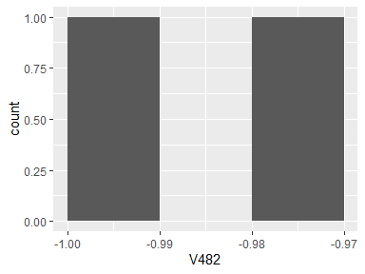

## V483

|  |  |
| --- | --- |
| Feature | Result |
| Variable type | numeric |
| Number of missing obs. | 0 (0 %) |
| Number of unique values | 2 |
| Median | -0.94 |
| 1st and 3rd quartiles | -0.97; -0.92 |
| Min. and max. | -1; -0.89 |

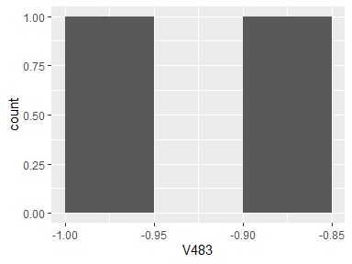

## V484

|  |  |
| --- | --- |
| Feature | Result |
| Variable type | numeric |
| Number of missing obs. | 0 (0 %) |
| Number of unique values | 2 |
| Median | -0.98 |
| 1st and 3rd quartiles | -0.99; -0.96 |
| Min. and max. | -1; -0.95 |

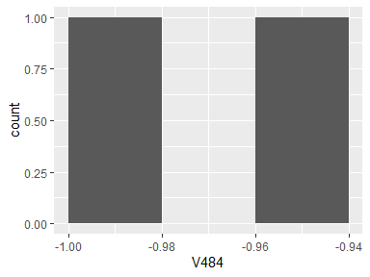

## V485

|  |  |
| --- | --- |
| Feature | Result |
| Variable type | numeric |
| Number of missing obs. | 0 (0 %) |
| Number of unique values | 2 |
| Median | -0.99 |
| 1st and 3rd quartiles | -0.99; -0.98 |
| Min. and max. | -1; -0.97 |

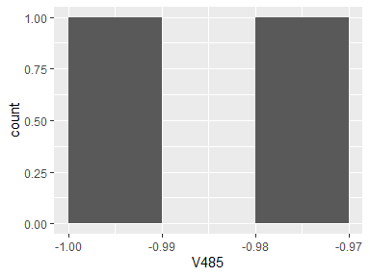

## V486

|  |  |
| --- | --- |
| Feature | Result |
| Variable type | numeric |
| Number of missing obs. | 0 (0 %) |
| Number of unique values | 2 |
| Median | -0.98 |
| 1st and 3rd quartiles | -0.99; -0.97 |
| Min. and max. | -1; -0.96 |

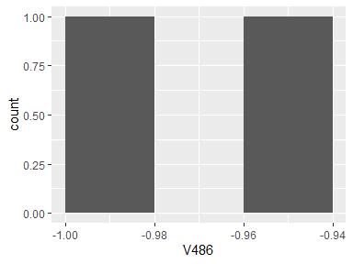

## V487

|  |  |
| --- | --- |
| Feature | Result |
| Variable type | numeric |
| Number of missing obs. | 0 (0 %) |
| Number of unique values | 2 |
| Median | -0.94 |
| 1st and 3rd quartiles | -0.97; -0.91 |
| Min. and max. | -1; -0.88 |

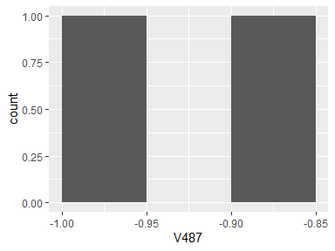

## V488

|  |  |
| --- | --- |
| Feature | Result |
| Variable type | numeric |
| Number of missing obs. | 0 (0 %) |
| Number of unique values | 2 |
| Median | -0.98 |
| 1st and 3rd quartiles | -0.99; -0.97 |
| Min. and max. | -1; -0.97 |

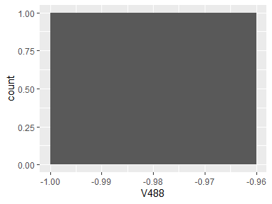

## V489

|  |  |
| --- | --- |
| Feature | Result |
| Variable type | numeric |
| Number of missing obs. | 0 (0 %) |
| Number of unique values | 2 |
| Median | -0.95 |
| 1st and 3rd quartiles | -0.97; -0.92 |
| Min. and max. | -0.99; -0.9 |

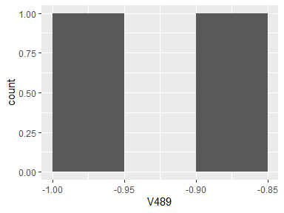

## V490

|  |  |
| --- | --- |
| Feature | Result |
| Variable type | numeric |
| Number of missing obs. | 0 (0 %) |
| Number of unique values | 2 |
| Median | -0.97 |
| 1st and 3rd quartiles | -0.98; -0.95 |
| Min. and max. | -1; -0.93 |

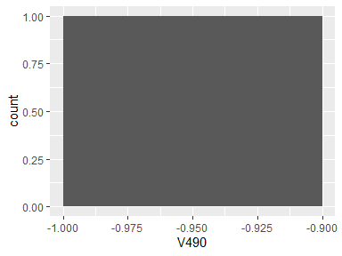

## V491

|  |  |
| --- | --- |
| Feature | Result |
| Variable type | numeric |
| Number of missing obs. | 0 (0 %) |
| Number of unique values | 2 |
| Median | -0.97 |
| 1st and 3rd quartiles | -0.98; -0.95 |
| Min. and max. | -1; -0.93 |

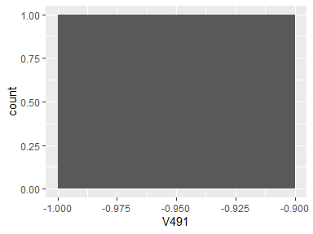

## V492

|  |  |
| --- | --- |
| Feature | Result |
| Variable type | numeric |
| Number of missing obs. | 0 (0 %) |
| Number of unique values | 2 |
| Median | -0.98 |
| 1st and 3rd quartiles | -0.99; -0.97 |
| Min. and max. | -1; -0.97 |

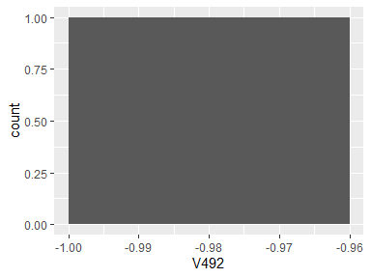

## V493

|  |  |
| --- | --- |
| Feature | Result |
| Variable type | numeric |
| Number of missing obs. | 0 (0 %) |
| Number of unique values | 2 |
| Median | -0.98 |
| 1st and 3rd quartiles | -0.99; -0.98 |
| Min. and max. | -1; -0.97 |

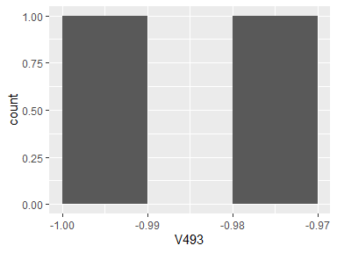

## V494

|  |  |
| --- | --- |
| Feature | Result |
| Variable type | numeric |
| Number of missing obs. | 0 (0 %) |
| Number of unique values | 2 |
| Median | -0.98 |
| 1st and 3rd quartiles | -0.99; -0.97 |
| Min. and max. | -1; -0.96 |

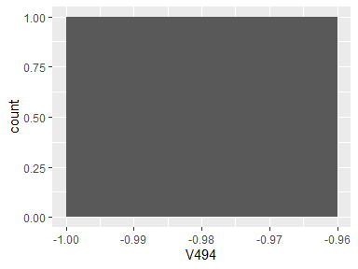

## V495

|  |  |
| --- | --- |
| Feature | Result |
| Variable type | numeric |
| Number of missing obs. | 0 (0 %) |
| Number of unique values | 2 |
| Median | -0.97 |
| 1st and 3rd quartiles | -0.98; -0.96 |
| Min. and max. | -1; -0.95 |

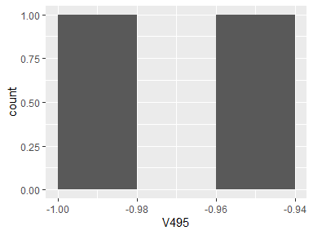

## V496

|  |  |
| --- | --- |
| Feature | Result |
| Variable type | numeric |
| Number of missing obs. | 0 (0 %) |
| Number of unique values | 2 |
| Median | -0.98 |
| 1st and 3rd quartiles | -0.99; -0.98 |
| Min. and max. | -1; -0.97 |

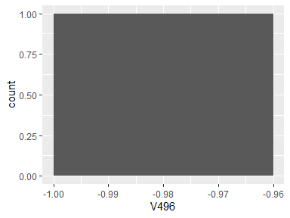

## V497

|  |  |
| --- | --- |
| Feature | Result |
| Variable type | numeric |
| Number of missing obs. | 0 (0 %) |
| Number of unique values | 2 |
| Median | -0.94 |
| 1st and 3rd quartiles | -0.96; -0.91 |
| Min. and max. | -0.99; -0.88 |

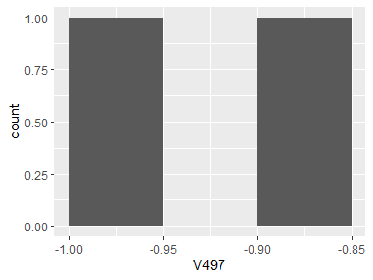

## V498

|  |  |
| --- | --- |
| Feature | Result |
| Variable type | numeric |
| Number of missing obs. | 0 (0 %) |
| Number of unique values | 2 |
| Median | -0.96 |
| 1st and 3rd quartiles | -0.98; -0.94 |
| Min. and max. | -1; -0.92 |

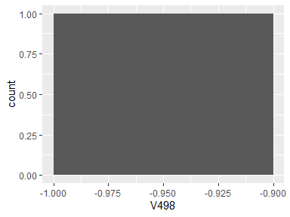

## V499

|  |  |
| --- | --- |
| Feature | Result |
| Variable type | numeric |
| Number of missing obs. | 0 (0 %) |
| Number of unique values | 2 |
| Median | -0.98 |
| 1st and 3rd quartiles | -0.99; -0.98 |
| Min. and max. | -1; -0.97 |

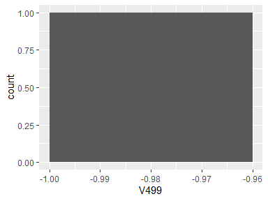

## V500

|  |  |
| --- | --- |
| Feature | Result |
| Variable type | numeric |
| Number of missing obs. | 0 (0 %) |
| Number of unique values | 2 |
| Median | -0.98 |
| 1st and 3rd quartiles | -0.99; -0.97 |
| Min. and max. | -1; -0.96 |

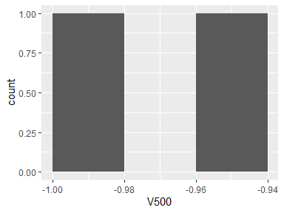

## V501

|  |  |
| --- | --- |
| Feature | Result |
| Variable type | numeric |
| Number of missing obs. | 0 (0 %) |
| Number of unique values | 2 |
| Median | -0.93 |
| 1st and 3rd quartiles | -0.96; -0.9 |
| Min. and max. | -0.99; -0.87 |

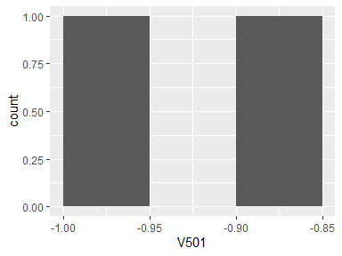

## V502

|  |  |
| --- | --- |
| Feature | Result |
| Variable type | numeric |
| Number of missing obs. | 0 (0 %) |
| Number of unique values | 2 |
| Median | -0.98 |
| 1st and 3rd quartiles | -0.99; -0.97 |
| Min. and max. | -1; -0.97 |

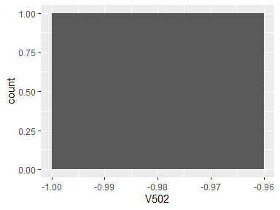

## V503

|  |  |
| --- | --- |
| Feature | Result |
| Variable type | numeric |
| Number of missing obs. | 0 (0 %) |
| Number of unique values | 2 |
| Median | -0.73 |
| 1st and 3rd quartiles | -0.8; -0.66 |
| Min. and max. | -0.88; -0.59 |

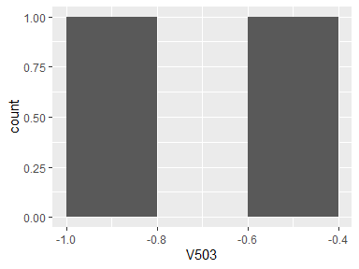

## V504

|  |  |
| --- | --- |
| Feature | Result |
| Variable type | numeric |
| Number of missing obs. | 0 (0 %) |
| Number of unique values | 2 |
| Median | -0.76 |
| 1st and 3rd quartiles | -0.81; -0.71 |
| Min. and max. | -0.85; -0.66 |

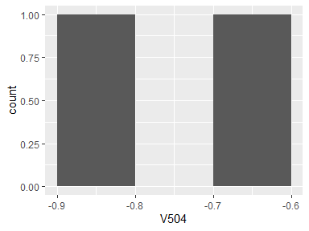

## V505

|  |  |
| --- | --- |
| Feature | Result |
| Variable type | numeric |
| Number of missing obs. | 0 (0 %) |
| Number of unique values | 2 |
| Median | -0.73 |
| 1st and 3rd quartiles | -0.79; -0.66 |
| Min. and max. | -0.85; -0.6 |

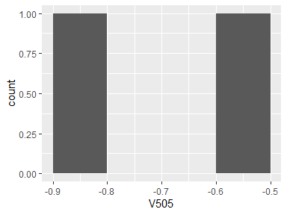

## V506

|  |  |
| --- | --- |
| Feature | Result |
| Variable type | numeric |
| Number of missing obs. | 0 (0 %) |
| Number of unique values | 2 |
| Median | -0.82 |
| 1st and 3rd quartiles | -0.85; -0.79 |
| Min. and max. | -0.88; -0.76 |

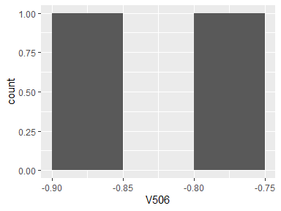

## V507

|  |  |
| --- | --- |
| Feature | Result |
| Variable type | numeric |
| Number of missing obs. | 0 (0 %) |
| Number of unique values | 2 |
| Median | -0.93 |
| 1st and 3rd quartiles | -0.95; -0.91 |
| Min. and max. | -0.97; -0.89 |

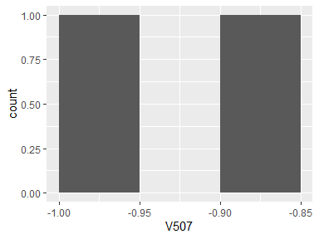

## V508

|  |  |
| --- | --- |
| Feature | Result |
| Variable type | numeric |
| Number of missing obs. | 0 (0 %) |
| Number of unique values | 2 |
| Median | -0.73 |
| 1st and 3rd quartiles | -0.8; -0.66 |
| Min. and max. | -0.88; -0.59 |

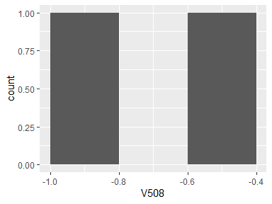

## V509

|  |  |
| --- | --- |
| Feature | Result |
| Variable type | numeric |
| Number of missing obs. | 0 (0 %) |
| Number of unique values | 2 |
| Median | -0.9 |
| 1st and 3rd quartiles | -0.95; -0.86 |
| Min. and max. | -0.99; -0.82 |

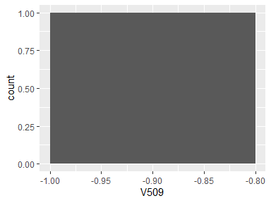

## V510

|  |  |
| --- | --- |
| Feature | Result |
| Variable type | numeric |
| Number of missing obs. | 0 (0 %) |
| Number of unique values | 2 |
| Median | -0.81 |
| 1st and 3rd quartiles | -0.87; -0.75 |
| Min. and max. | -0.93; -0.69 |

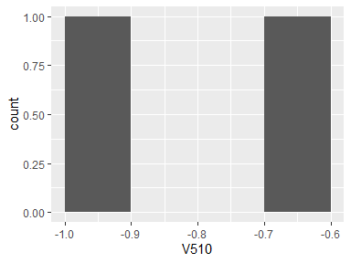

## V511

|  |  |
| --- | --- |
| Feature | Result |
| Variable type | numeric |
| Number of missing obs. | 0 (0 %) |
| Number of unique values | 2 |
| Median | -0.27 |
| 1st and 3rd quartiles | -0.31; -0.23 |
| Min. and max. | -0.35; -0.19 |

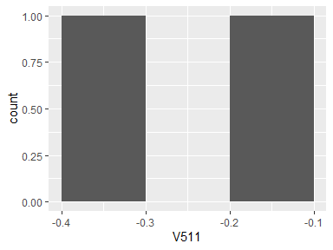

## BodyAccMagmaxInds

|  |  |
| --- | --- |
| Feature | Result |
| Variable type | numeric |
| Number of missing obs. | 0 (0 %) |
| Number of unique values | 2 |
| Median | -0.77 |
| 1st and 3rd quartiles | -0.78; -0.76 |
| Min. and max. | -0.79; -0.75 |

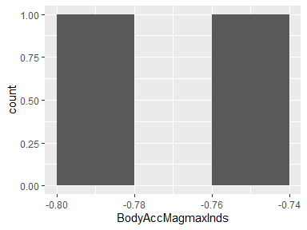

## BodyAccMagmeanFreq()

|  |  |
| --- | --- |
| Feature | Result |
| Variable type | numeric |
| Number of missing obs. | 0 (0 %) |
| Number of unique values | 2 |
| Median | 0.07 |
| 1st and 3rd quartiles | 0.07; 0.08 |
| Min. and max. | 0.07; 0.08 |

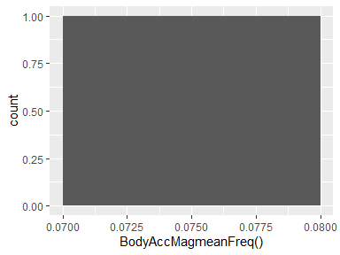

## BodyAccMagskewness()

|  |  |
| --- | --- |
| Feature | Result |
| Variable type | numeric |
| Number of missing obs. | 0 (0 %) |
| Number of unique values | 2 |
| Median | -0.39 |
| 1st and 3rd quartiles | -0.41; -0.37 |
| Min. and max. | -0.42; -0.35 |

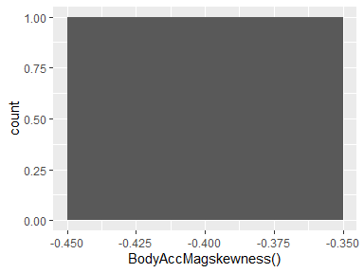

## BodyAccMagkurtosis()

|  |  |
| --- | --- |
| Feature | Result |
| Variable type | numeric |
| Number of missing obs. | 0 (0 %) |
| Number of unique values | 2 |
| Median | -0.68 |
| 1st and 3rd quartiles | -0.71; -0.66 |
| Min. and max. | -0.73; -0.63 |

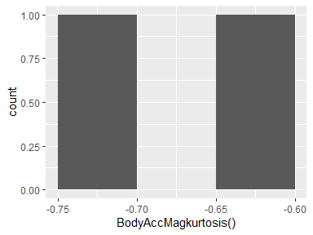

## BodyBodyAccJerkMagmean()

|  |  |
| --- | --- |
| Feature | Result |
| Variable type | numeric |
| Number of missing obs. | 0 (0 %) |
| Number of unique values | 2 |
| Median | -0.77 |
| 1st and 3rd quartiles | -0.85; -0.7 |
| Min. and max. | -0.93; -0.62 |

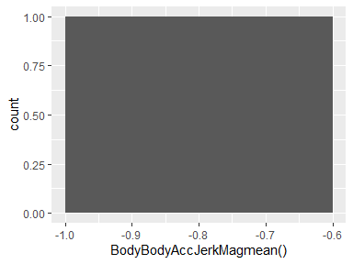

## BodyBodyAccJerkMagstd()

|  |  |
| --- | --- |
| Feature | Result |
| Variable type | numeric |
| Number of missing obs. | 0 (0 %) |
| Number of unique values | 2 |
| Median | -0.78 |
| 1st and 3rd quartiles | -0.85; -0.71 |
| Min. and max. | -0.93; -0.64 |

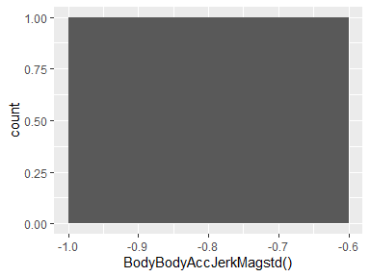

## BodyBodyAccJerkMagmad()

|  |  |
| --- | --- |
| Feature | Result |
| Variable type | numeric |
| Number of missing obs. | 0 (0 %) |
| Number of unique values | 2 |
| Median | -0.77 |
| 1st and 3rd quartiles | -0.85; -0.69 |
| Min. and max. | -0.92; -0.61 |

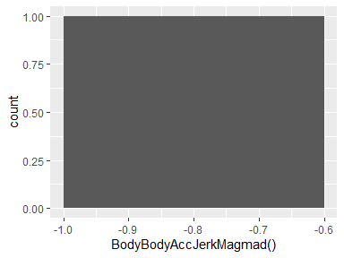

## BodyBodyAccJerkMagmax()

|  |  |
| --- | --- |
| Feature | Result |
| Variable type | numeric |
| Number of missing obs. | 0 (0 %) |
| Number of unique values | 2 |
| Median | -0.81 |
| 1st and 3rd quartiles | -0.87; -0.75 |
| Min. and max. | -0.94; -0.68 |

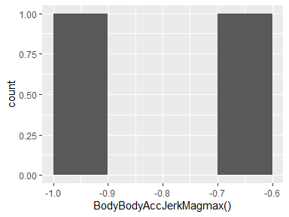

## BodyBodyAccJerkMagmin()

|  |  |
| --- | --- |
| Feature | Result |
| Variable type | numeric |
| Number of missing obs. | 0 (0 %) |
| Number of unique values | 2 |
| Median | -0.88 |
| 1st and 3rd quartiles | -0.92; -0.84 |
| Min. and max. | -0.96; -0.8 |

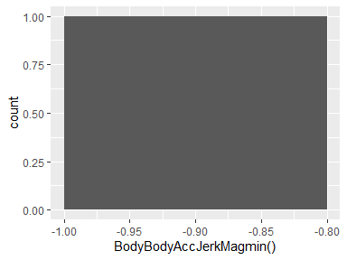

## BodyBodyAccJerkMagsma()

|  |  |
| --- | --- |
| Feature | Result |
| Variable type | numeric |
| Number of missing obs. | 0 (0 %) |
| Number of unique values | 2 |
| Median | -0.77 |
| 1st and 3rd quartiles | -0.85; -0.7 |
| Min. and max. | -0.93; -0.62 |

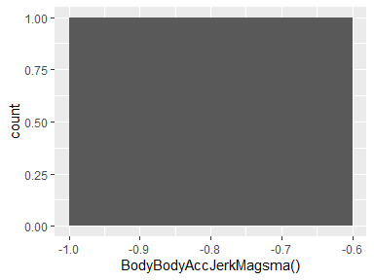

## BodyBodyAccJerkMagenergy()

|  |  |
| --- | --- |
| Feature | Result |
| Variable type | numeric |
| Number of missing obs. | 0 (0 %) |
| Number of unique values | 2 |
| Median | -0.92 |
| 1st and 3rd quartiles | -0.96; -0.88 |
| Min. and max. | -1; -0.84 |

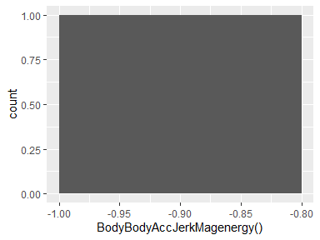

## BodyBodyAccJerkMagiqr()

|  |  |
| --- | --- |
| Feature | Result |
| Variable type | numeric |
| Number of missing obs. | 0 (0 %) |
| Number of unique values | 2 |
| Median | -0.81 |
| 1st and 3rd quartiles | -0.88; -0.74 |
| Min. and max. | -0.94; -0.68 |

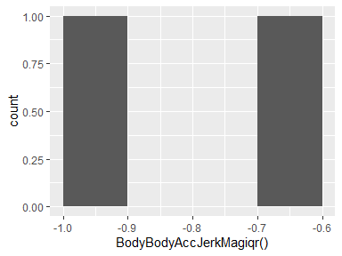

## BodyBodyAccJerkMagentropy()

|  |  |
| --- | --- |
| Feature | Result |
| Variable type | numeric |
| Number of missing obs. | 0 (0 %) |
| Number of unique values | 2 |
| Median | -0.51 |
| 1st and 3rd quartiles | -0.6; -0.42 |
| Min. and max. | -0.68; -0.34 |

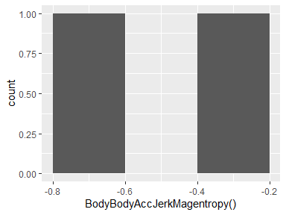

## BodyBodyAccJerkMagmaxInds

|  |  |
| --- | --- |
| Feature | Result |
| Variable type | numeric |
| Number of missing obs. | 0 (0 %) |
| Number of unique values | 2 |
| Median | -0.89 |
| 1st and 3rd quartiles | -0.9; -0.88 |
| Min. and max. | -0.9; -0.88 |

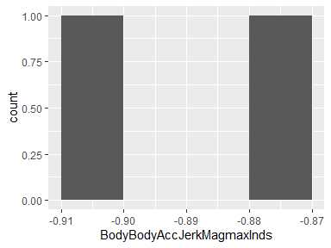

## BodyBodyAccJerkMagmeanFreq()

|  |  |
| --- | --- |
| Feature | Result |
| Variable type | numeric |
| Number of missing obs. | 0 (0 %) |
| Number of unique values | 2 |
| Median | 0.17 |
| 1st and 3rd quartiles | 0.17; 0.17 |
| Min. and max. | 0.16; 0.17 |

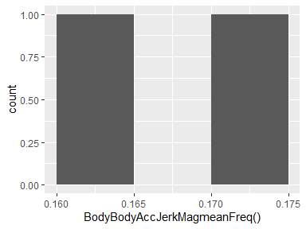

## BodyBodyAccJerkMagskewness()

|  |  |
| --- | --- |
| Feature | Result |
| Variable type | numeric |
| Number of missing obs. | 0 (0 %) |
| Number of unique values | 2 |
| Median | -0.32 |
| 1st and 3rd quartiles | -0.34; -0.31 |
| Min. and max. | -0.35; -0.3 |

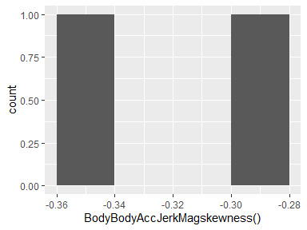

## BodyBodyAccJerkMagkurtosis()

|  |  |
| --- | --- |
| Feature | Result |
| Variable type | numeric |
| Number of missing obs. | 0 (0 %) |
| Number of unique values | 2 |
| Median | -0.66 |
| 1st and 3rd quartiles | -0.69; -0.63 |
| Min. and max. | -0.71; -0.6 |

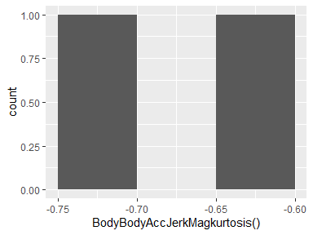

## BodyBodyGyroMagmean()

|  |  |
| --- | --- |
| Feature | Result |
| Variable type | numeric |
| Number of missing obs. | 0 (0 %) |
| Number of unique values | 2 |
| Median | -0.79 |
| 1st and 3rd quartiles | -0.83; -0.74 |
| Min. and max. | -0.88; -0.7 |

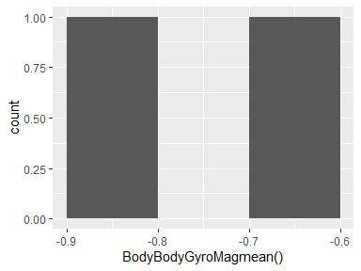

## BodyBodyGyroMagstd()

|  |  |
| --- | --- |
| Feature | Result |
| Variable type | numeric |
| Number of missing obs. | 0 (0 %) |
| Number of unique values | 2 |
| Median | -0.76 |
| 1st and 3rd quartiles | -0.8; -0.73 |
| Min. and max. | -0.83; -0.7 |

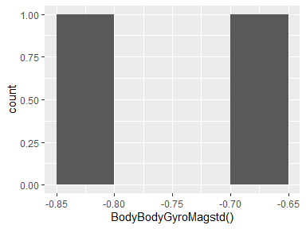

## BodyBodyGyroMagmad()

|  |  |
| --- | --- |
| Feature | Result |
| Variable type | numeric |
| Number of missing obs. | 0 (0 %) |
| Number of unique values | 2 |
| Median | -0.76 |
| 1st and 3rd quartiles | -0.8; -0.72 |
| Min. and max. | -0.85; -0.68 |

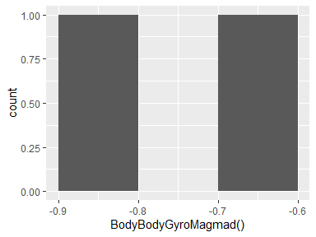

## BodyBodyGyroMagmax()

|  |  |
| --- | --- |
| Feature | Result |
| Variable type | numeric |
| Number of missing obs. | 0 (0 %) |
| Number of unique values | 2 |
| Median | -0.78 |
| 1st and 3rd quartiles | -0.8; -0.76 |
| Min. and max. | -0.83; -0.73 |

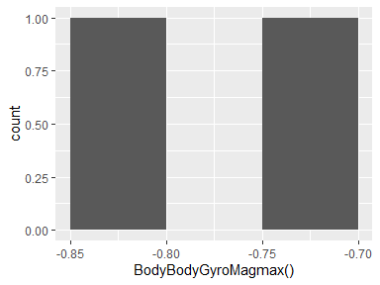

## BodyBodyGyroMagmin()

|  |  |
| --- | --- |
| Feature | Result |
| Variable type | numeric |
| Number of missing obs. | 0 (0 %) |
| Number of unique values | 2 |
| Median | -0.92 |
| 1st and 3rd quartiles | -0.94; -0.91 |
| Min. and max. | -0.96; -0.89 |

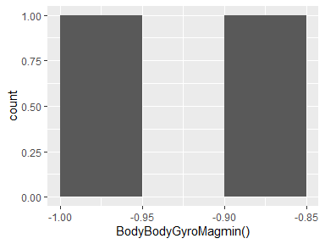

## BodyBodyGyroMagsma()

|  |  |
| --- | --- |
| Feature | Result |
| Variable type | numeric |
| Number of missing obs. | 0 (0 %) |
| Number of unique values | 2 |
| Median | -0.79 |
| 1st and 3rd quartiles | -0.83; -0.74 |
| Min. and max. | -0.88; -0.7 |

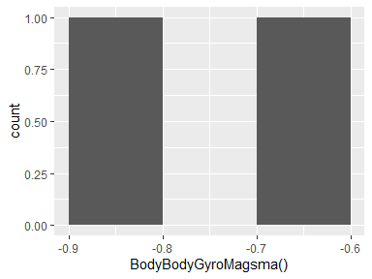

## BodyBodyGyroMagenergy()

|  |  |
| --- | --- |
| Feature | Result |
| Variable type | numeric |
| Number of missing obs. | 0 (0 %) |
| Number of unique values | 2 |
| Median | -0.93 |
| 1st and 3rd quartiles | -0.96; -0.91 |
| Min. and max. | -0.98; -0.88 |

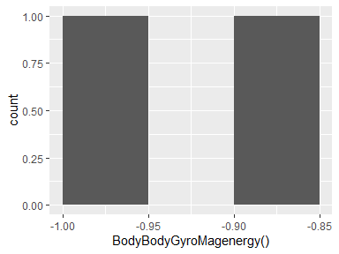

## BodyBodyGyroMagiqr()

|  |  |
| --- | --- |
| Feature | Result |
| Variable type | numeric |
| Number of missing obs. | 0 (0 %) |
| Number of unique values | 2 |
| Median | -0.82 |
| 1st and 3rd quartiles | -0.86; -0.77 |
| Min. and max. | -0.91; -0.72 |

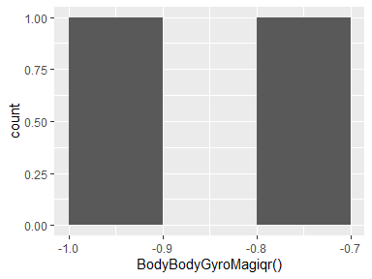

## BodyBodyGyroMagentropy()

|  |  |
| --- | --- |
| Feature | Result |
| Variable type | numeric |
| Number of missing obs. | 0 (0 %) |
| Number of unique values | 2 |
| Median | -0.12 |
| 1st and 3rd quartiles | -0.14; -0.1 |
| Min. and max. | -0.16; -0.08 |

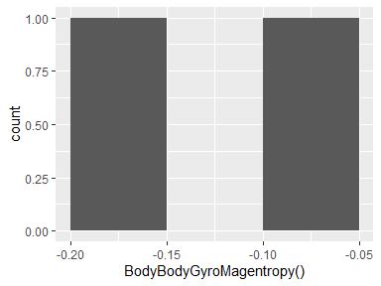

## BodyBodyGyroMagmaxInds

|  |  |
| --- | --- |
| Feature | Result |
| Variable type | numeric |
| Number of missing obs. | 0 (0 %) |
| Number of unique values | 2 |
| Median | -0.92 |
| 1st and 3rd quartiles | -0.93; -0.9 |
| Min. and max. | -0.95; -0.89 |

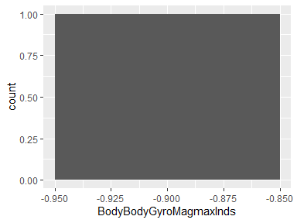

## BodyBodyGyroMagmeanFreq()

|  |  |
| --- | --- |
| Feature | Result |
| Variable type | numeric |
| Number of missing obs. | 0 (0 %) |
| Number of unique values | 2 |
| Median | -0.05 |
| 1st and 3rd quartiles | -0.05; -0.04 |
| Min. and max. | -0.05; -0.04 |

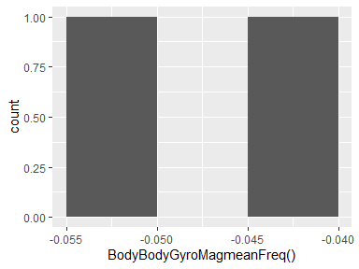

## BodyBodyGyroMagskewness()

|  |  |
| --- | --- |
| Feature | Result |
| Variable type | numeric |
| Number of missing obs. | 0 (0 %) |
| Number of unique values | 2 |
| Median | -0.29 |
| 1st and 3rd quartiles | -0.3; -0.28 |
| Min. and max. | -0.32; -0.26 |

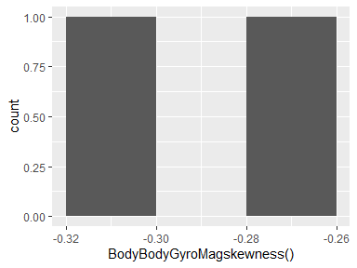

## BodyBodyGyroMagkurtosis()

|  |  |
| --- | --- |
| Feature | Result |
| Variable type | numeric |
| Number of missing obs. | 0 (0 %) |
| Number of unique values | 2 |
| Median | -0.62 |
| 1st and 3rd quartiles | -0.64; -0.6 |
| Min. and max. | -0.66; -0.58 |

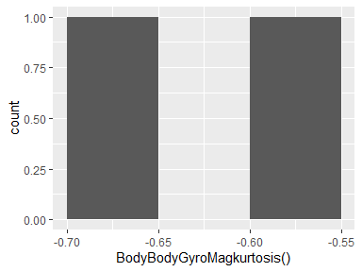

## BodyBodyGyroJerkMagmean()

|  |  |
| --- | --- |
| Feature | Result |
| Variable type | numeric |
| Number of missing obs. | 0 (0 %) |
| Number of unique values | 2 |
| Median | -0.86 |
| 1st and 3rd quartiles | -0.9; -0.82 |
| Min. and max. | -0.95; -0.78 |

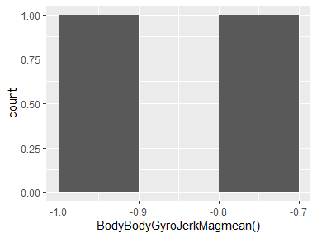

## BodyBodyGyroJerkMagstd()

|  |  |
| --- | --- |
| Feature | Result |
| Variable type | numeric |
| Number of missing obs. | 0 (0 %) |
| Number of unique values | 2 |
| Median | -0.87 |
| 1st and 3rd quartiles | -0.9; -0.83 |
| Min. and max. | -0.94; -0.79 |

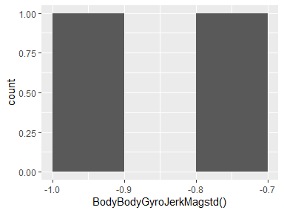

## BodyBodyGyroJerkMagmad()

|  |  |
| --- | --- |
| Feature | Result |
| Variable type | numeric |
| Number of missing obs. | 0 (0 %) |
| Number of unique values | 2 |
| Median | -0.85 |
| 1st and 3rd quartiles | -0.89; -0.81 |
| Min. and max. | -0.94; -0.77 |

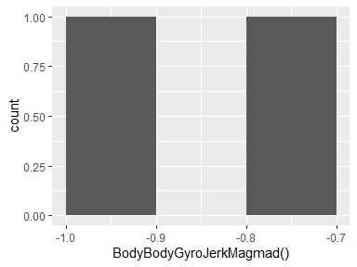

## BodyBodyGyroJerkMagmax()

|  |  |
| --- | --- |
| Feature | Result |
| Variable type | numeric |
| Number of missing obs. | 0 (0 %) |
| Number of unique values | 2 |
| Median | -0.88 |
| 1st and 3rd quartiles | -0.91; -0.84 |
| Min. and max. | -0.94; -0.81 |

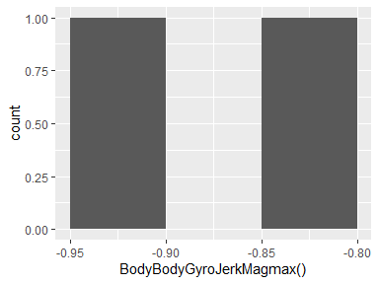

## BodyBodyGyroJerkMagmin()

|  |  |
| --- | --- |
| Feature | Result |
| Variable type | numeric |
| Number of missing obs. | 0 (0 %) |
| Number of unique values | 2 |
| Median | -0.92 |
| 1st and 3rd quartiles | -0.95; -0.9 |
| Min. and max. | -0.97; -0.87 |

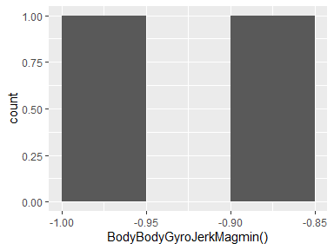

## BodyBodyGyroJerkMagsma()

|  |  |
| --- | --- |
| Feature | Result |
| Variable type | numeric |
| Number of missing obs. | 0 (0 %) |
| Number of unique values | 2 |
| Median | -0.86 |
| 1st and 3rd quartiles | -0.9; -0.82 |
| Min. and max. | -0.95; -0.78 |

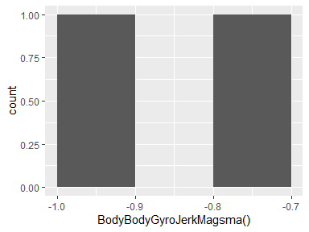

## BodyBodyGyroJerkMagenergy()

|  |  |
| --- | --- |
| Feature | Result |
| Variable type | numeric |
| Number of missing obs. | 0 (0 %) |
| Number of unique values | 2 |
| Median | -0.97 |
| 1st and 3rd quartiles | -0.98; -0.95 |
| Min. and max. | -1; -0.94 |

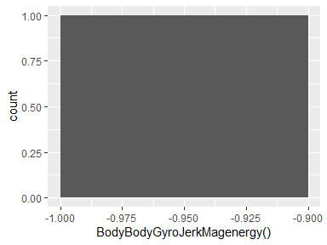

## BodyBodyGyroJerkMagiqr()

|  |  |
| --- | --- |
| Feature | Result |
| Variable type | numeric |
| Number of missing obs. | 0 (0 %) |
| Number of unique values | 2 |
| Median | -0.86 |
| 1st and 3rd quartiles | -0.9; -0.82 |
| Min. and max. | -0.94; -0.77 |

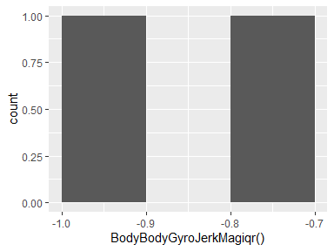

## BodyBodyGyroJerkMagentropy()

|  |  |
| --- | --- |
| Feature | Result |
| Variable type | numeric |
| Number of missing obs. | 0 (0 %) |
| Number of unique values | 2 |
| Median | -0.34 |
| 1st and 3rd quartiles | -0.38; -0.31 |
| Min. and max. | -0.41; -0.27 |

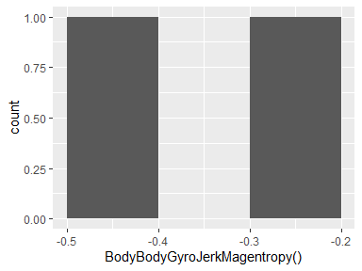

## BodyBodyGyroJerkMagmaxInds

|  |  |
| --- | --- |
| Feature | Result |
| Variable type | numeric |
| Number of missing obs. | 0 (0 %) |
| Number of unique values | 2 |
| Median | -0.9 |
| 1st and 3rd quartiles | -0.9; -0.9 |
| Min. and max. | -0.9; -0.9 |

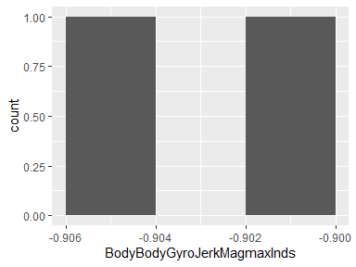

## BodyBodyGyroJerkMagmeanFreq()

|  |  |
| --- | --- |
| Feature | Result |
| Variable type | numeric |
| Number of missing obs. | 0 (0 %) |
| Number of unique values | 2 |
| Median | 0.13 |
| 1st and 3rd quartiles | 0.13; 0.13 |
| Min. and max. | 0.13; 0.14 |

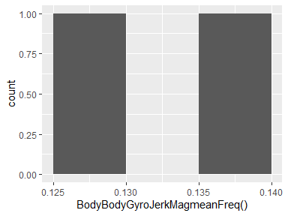

## BodyBodyGyroJerkMagskewness()

|  |  |
| --- | --- |
| Feature | Result |
| Variable type | numeric |
| Number of missing obs. | 0 (0 %) |
| Number of unique values | 2 |
| Median | -0.32 |
| 1st and 3rd quartiles | -0.33; -0.31 |
| Min. and max. | -0.34; -0.3 |

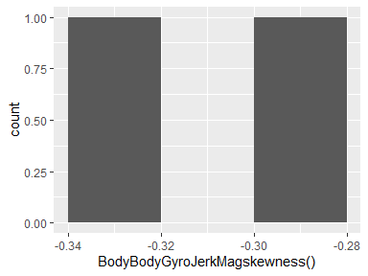

## BodyBodyGyroJerkMagkurtosis()

|  |  |
| --- | --- |
| Feature | Result |
| Variable type | numeric |
| Number of missing obs. | 0 (0 %) |
| Number of unique values | 2 |
| Median | -0.66 |
| 1st and 3rd quartiles | -0.68; -0.64 |
| Min. and max. | -0.7; -0.62 |

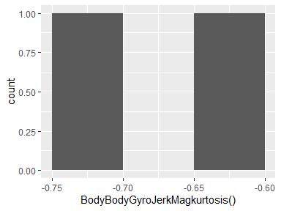

## ngle(tBodyAccMean,gravity)

|  |  |
| --- | --- |
| Feature | Result |
| Variable type | numeric |
| Number of missing obs. | 0 (0 %) |
| Number of unique values | 2 |
| Median | 0.01 |
| 1st and 3rd quartiles | 0.01; 0.01 |
| Min. and max. | 0.01; 0.01 |

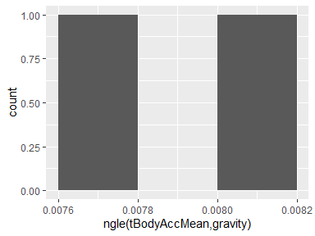

## ngle(tBodyAccJerkMean),gravit

|  |  |
| --- | --- |
| Feature | Result |
| Variable type | numeric |
| Number of missing obs. | 0 (0 %) |
| Number of unique values | 2 |
| Median | 0.01 |
| 1st and 3rd quartiles | 0; 0.01 |
| Min. and max. | 0; 0.01 |

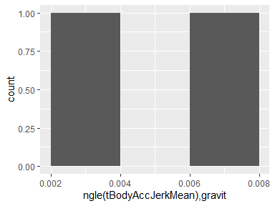

## ngle(tBodyGyroMean,gravityMea

|  |  |
| --- | --- |
| Feature | Result |
| Variable type | numeric |
| Number of missing obs. | 0 (0 %) |
| Number of unique values | 2 |
| Median | 0.02 |
| 1st and 3rd quartiles | 0.02; 0.02 |
| Min. and max. | 0.02; 0.02 |

[](codebook_dd3_files/figure-docx/Var-557-ngle(tBodyGyroMean,gravityMea-1.png)

## ngle(tBodyGyroJerkMean,gravit

|  |  |
| --- | --- |
| Feature | Result |
| Variable type | numeric |
| Number of missing obs. | 0 (0 %) |
| Number of unique values | 2 |
| Median | -0.01 |
| 1st and 3rd quartiles | -0.01; -0.01 |
| Min. and max. | -0.01; -0.01 |

[](codebook_dd3_files/figure-docx/Var-558-ngle(tBodyGyroJerkMean,gravit-1.png)

## ngle(X,gravityMean)

|  |  |
| --- | --- |
| Feature | Result |
| Variable type | numeric |
| Number of missing obs. | 0 (0 %) |
| Number of unique values | 2 |
| Median | -0.61 |
| 1st and 3rd quartiles | -0.66; -0.55 |
| Min. and max. | -0.72; -0.5 |

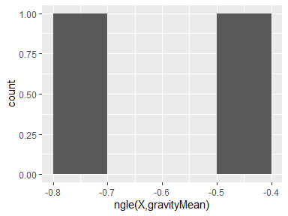

## ngle(Y,gravityMean)

|  |  |
| --- | --- |
| Feature | Result |
| Variable type | numeric |
| Number of missing obs. | 0 (0 %) |
| Number of unique values | 2 |
| Median | 0.12 |
| 1st and 3rd quartiles | 0.09; 0.15 |
| Min. and max. | 0.06; 0.18 |

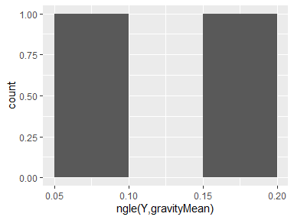

## ngle(Z,gravityMean)

|  |  |
| --- | --- |
| Feature | Result |
| Variable type | numeric |
| Number of missing obs. | 0 (0 %) |
| Number of unique values | 2 |
| Median | -0.03 |
| 1st and 3rd quartiles | -0.04; -0.02 |
| Min. and max. | -0.05; 0 |

