🏦 Document Checklist & Deferrals Management System

1. Executive Summary
This proposal outlines the development and implementation of a Document Checklist (DCL) and Deferrals Management System, enabling automated loan document processing through a structured digital platform. The system will allow relationship managers, compliance officers, and approvers to manage loan document collection, verification, and approval workflows without manual interventions, leveraging role-based portals and automated notifications. The solution will enhance operational efficiency, reduce processing costs, and increase the bank's compliance and audit readiness.
The proposed system will include:
- Role-based portals for Creators, Relationship Managers, Checkers, and Department Heads.
- Automated workflow for sequential document processing and deferral management.
- Real-time document tracking to ensure instant status updates and eliminate manual follow-ups.
- Comprehensive audit trails for regulatory compliance and process transparency.
The platform will standardize loan documentation processes, reduce turnaround time by over 60%, and eliminate document loss through digital tracking, while maintaining full compliance with banking regulations through encrypted storage and complete audit capabilities.

2. System Overview
- 2.1. Key Features
- Document Checklist Management:
  - Automated DCL Generation based on loan products
  - Document Upload & Verification
  - Sequential Workflow Processing
  - Deferral & Exception Handling
  - Real-time Status Tracking & Notifications
- Multi-Role Portal Access:
  - Creator Portal for checklist initiation and validation
  - Relationship Manager (RM) Portal for document submition
  - Checker Portal for compliance verification
  - Deferral Approver Portal for exception management
  - Admin Portal for system configuration and monitoring
- Real-Time Integration:
  - Document Management System for secure storage
  - Notification Service for email and in-app alerts
  - Audit System for compliance tracking
- Security and Authentication:
  - Role-Based Access Control (RBAC) for all users
  - Document Encryption at rest and in transit
  - Full Audit Trail for all system actions
  - Compliance with banking regulatory standards
- Reporting and Monitoring:
  - DCL Status Reports (pending, completed, deferred)
  - Turnaround Time (TAT) Analytics per user and department
  - Document Compliance Reports
  - Deferral Approval Tracking
  - Customizable Reports in bank-specific formats
  - Real-time Dashboard for process monitoring
- Workflow Automation:
  - Automated routing based on loan type and amount
  - Configurable approval chains for deferrals
  - SLA enforcement with escalation rules
  - Automated notifications at each workflow stage
  - Escalation management for overdue tasks
- Document Management:
  - Version control for uploaded documents
  - Digital signatures and verification stamps
  - Batch document processing
  - Search and retrieval across all checklists
  - Retention policy enforcement

3. System Architecture
3.1. High-Level Architecture
The Document & Checklist Management System will operate within the bank's existing infrastructure with two potential deployment models:
Option 1: External Workflow Management
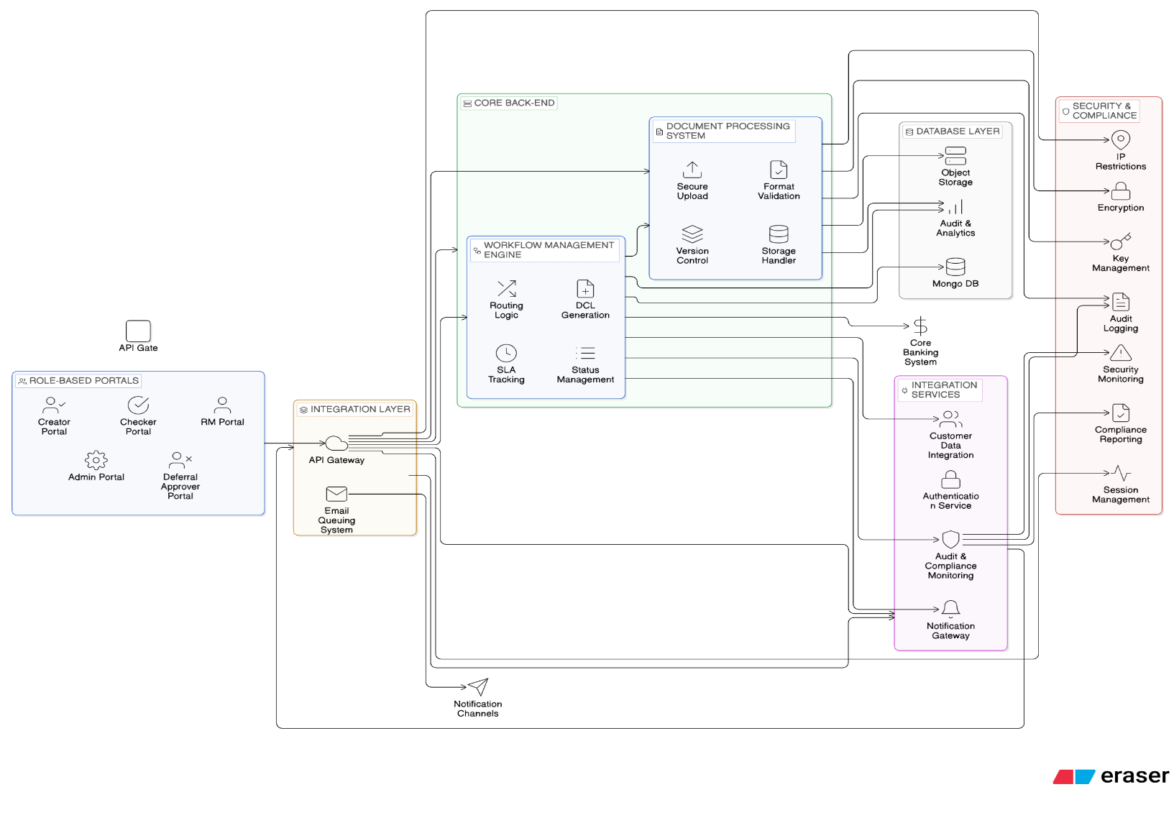

The proposed system will consist of the following components:
1. Front-End Systems:
- Role-Based Web Portals:
  - Creator Portal – For initiating DCLs and managing document.
  - RM Portal – For document collection, upload, and customer engagement.
  - Checker Portal – For compliance verification and approval/rejection.
  - Deferral Approver Portal – For managing exceptions and special approvals.
  - Admin Portal – For system configuration, user management, and reporting.
- User Interface Features:
  - Responsive design for desktop and mobile access
  - Real-time notifications and alerts
  - Document preview and annotation
  - Dashboard with workflow visualization
  - Search and filter capabilities across all DCLs
2. Back-End Systems:
- Workflow Management Engine:
  - DCL generation based on loan products
  - Sequential routing logic with conditional branching
  - SLA tracking with escalation rules
  - Status transition management and validation
- Document Processing System:
  - Secure document upload and storage
  - File format validation and conversion
  - Digital signature verification
  - Version control and audit trails

- Integration Services:
  - Customer Data Integration – For automated customer information retrieval.
  - Notification Gateway – For SMS, email, and in-app alerts.
  - Authentication Service – For SSO and user identity management
3. Security and Compliance Layer:
- Access Control:
  - Role-Based Access Control (RBAC) with granular permissions
  - Multi-factor authentication for sensitive operations
  - Session management with timeout policies
  - IP-based access restrictions
- Data Protection:
  - End-to-end encryption for document transmission
  - Secure key management system
  - Data masking for sensitive information
- Audit & Monitoring:
  - Comprehensive audit trail of all user actions
  - Real-time security monitoring and alerts
  - Compliance reporting for regulatory requirements
  - Activity logging with forensic capabilities
4. Integration Layer:
- API Gateway:
  - API endpoints for system integration
  - API version management and documentation
  - Request/response logging and monitoring
- Emails Queuing System:
  - Asynchronous processing for heavy operations
  - Event-driven architecture for workflow triggers
  - Retry mechanisms for failed integrations
  - Dead letter queue for error handling
5. Database Layer:
- Primary Database:
  - Stores DCL metadata, user profiles, workflow states
  - Supports NoSQL (MongoDB)
  - High availability with replication and failover
  - Indexed for performance on large datasets

- Document Storage:
  - Object storage for document files (S3-compatible)
  - Hierarchical organization by customer, loan, and document type
  - Backup and disaster recovery capabilities
- Audit & Reporting Database:
  - Time-series data for performance metrics
  - Immutable logs for compliance requirements
  - Data warehouse for analytical reporting

4. Functional Requirements
4.1. DCL Creation & Assignment (Creator)
- Creator logs into the system and selects loan product type from pre-configured templates
- System generates Document Checklist (DCL) with required documents based on loan parameters
- Creator assigns the DCL to a specific Relationship Manager (RM) by selecting from active RM list
- System validates loan eligibility and customer details against Core Banking System
- DCL status transitions to "Assigned to RM" with auto-generated notification
- Creator can track DCL progress through dashboard with real-time status updates
4.2. Document Collection & Upload (Relationship Manager)
- RM logs in and views "My Queue" showing all assigned DCLs sorted by priority and SLA
- RM opens specific DCL to view required document list with descriptions and format requirements
- System provides document upload interface.
- RM uploads each document, with system automatically extracting metadata (date, type, size)
- Each document status on RM staus changes to "Submitted" upon successful upload
- After all required documents are uploaded, RM submits complete DCL package back to Creator
- System validates document completeness before allowing submission
4.3. Document Verification & Validation (Creator)
- Creator reviews uploaded documents for completeness and compliance
- System provides side-by-side comparison with document requirements checklist
- Creator can request additional information or corrections via in-system comments
- Once all documents are verified, Creator updates DCL status.
- System performs automated checks for signatures, dates, and required fields
- Creator submits validated DCL package to assigned Checker with optional notes
4.4. Compliance Review & Approval (Checker)
- Checker accesses "Pending Approval" queue with DCLs sorted by loan amount and priority
- System provides document review interface with annotation and highlighting tools
- Checker reviews each document individually, with option to approve, reject, or request clarification
- Rejected documents require specific reasons and are returned to RM for correction
- If all documents are approved, "Final Approval" button becomes active
- Checker provides final approval, transitioning DCL status to "Completed"
- System triggers loan disbursement process in Core Banking System upon final approval
4.5. Deferral Request & Exception Handling
- RM initiates deferral request when unable to obtain specific required document
- System prompts for deferral reason, expected timeline, and supporting justification
- Deferral request is routed through configurable approval chain based on loan amount thresholds
- Each Department Head in approval chain reviews and approves/rejects with comments
- Approved deferrals create temporary exception with expiry date and monitoring alerts
- RM can upload deferred document before expiry, which routes directly to Checker for review
- System tracks all deferrals with reports on frequency, reasons, and approval rates
4.6. Loan Disbursement Automation
- Upon DCL completion, system automatically triggers loan disbursement workflow
- Integration with Core Banking System validates available credit limits and account status
- System generates disbursement instructions with verified customer banking details
- Funds transfer initiated with real-time status tracking
- Customer receives automated notification of disbursement with transaction details
- System updates loan status across all connected banking systems
4.7. Document Audit & Compliance Reporting
- System maintains complete audit trail of all DCL actions with timestamps and user identification
- Automated compliance reporting for regulatory requirements (KYC, AML, etc.)
- Document retention management with configurable archiving and deletion policies
- Searchable repository for historical document retrieval with access controls
- Automated alerts for expiring documents or compliance deadlines
- Integration with external audit and compliance monitoring systems
4.8. Real-time Monitoring & Dashboard
- Role-based dashboards showing key metrics: DCLs pending, completed.
- SLA tracking with color-coded alerts for approaching deadlines
- Workflow visualization showing current status and bottlenecks
- Performance metrics for each role: Creator efficiency, RM turnaround, Checker accuracy
- Real-time notifications for status changes, approvals, and escalations
- Mobile-responsive dashboards for on-the-go monitoring
- Comparison reports showing performance trends over time

5. Document & Workflow Process Flows

5.1. Standard DCL Workflow Processing

5.2. Deferral & Exception Processing

5.3. Integration & System Processing Flows

5.4. User Interaction & Notification Flows

6. Error Handling, Rejection & Retry Process Flows

7. Non-Functional Requirements

7.1. Reporting & Analytics
- DCL Performance Reports: Creator efficiency, RM turnaround time, Checker accuracy rates
- Workflow Status Reports: Pending, in-progress, completed, deferred DCLs by department
- SLA Compliance Reports: TAT adherence, escalation frequency, bottleneck analysis
- Document Quality Reports: Rejection rates, common errors, correction cycle times
- Customizable Reports: Bank-specific formats (PDF, Excel, CSV) with configurable filters
- Real-time Dashboards: Role-based views with drill-down capabilities
- Compliance Reports: Regulatory requirement tracking, audit trail completeness
- User Activity Reports: Login frequency, feature usage, productivity metrics

7.2. Security & Compliance
- Role-Based Access Control (RBAC): Granular permissions per user role and department
- Document Encryption: encryption for all stored documents
- Secure File Transfer
- Audit Trail: Immutable logs of all system actions.
- Data Masking: Sensitive information protection in logs and exports
- Session Management: Automatic timeout with configurable duration
- IP Restrictions: Whitelisting for internal network access
- Compliance Standards: Adherence to banking regulations.

7.3. Performance & Scalability
- Response Time:
- Concurrent Users:
- Document Upload:
- System Availability:
- API Performance:
- Database Performance:
- Scalability:
- Load Handling:
- Integration Latency:
- Cache Performance:

7.4. Usability & Accessibility
- User Interface:
- Mobile Responsive:
- Multi-language Support: Configurable language options (English primary)
- Offline Capabilities: Document upload queueing with sync when online
- Help & Support: Context-sensitive help and tutorials
- Keyboard Navigation: Full keyboard accessibility for all functions
- Screen Reader Compatible: Proper ARIA labels and semantic HTML

7.5. Reliability & Availability
- System Uptime: 99.5% overall availability with scheduled maintenance windows
- Disaster Recovery: RTO (Recovery Time Objective) < 4 hours, RPO (Recovery Point Objective) < 1 hour
- Data Integrity: Checksums and validation for all document transfers
- Error Handling: Graceful degradation with user-friendly error messages
- Monitoring: 24/7 system health monitoring with automated alerts
- Redundancy: Load-balanced application servers and database replication
- Backup Frequency: Daily incremental backups, weekly full backups
- Failover: Automatic failover for critical services with manual override

7.6. Maintainability & Extensibility
- Modular Architecture: Independent service components with clear interfaces
- API-First Design: Well-documented REST APIs for all functionality
- Configuration Management: Externalized configuration without code changes
- Logging Standards: Structured logging with log levels and correlation IDs
- Code Quality: Unit test coverage > 80%, integration test coverage > 70%
- Documentation: Comprehensive technical and user documentation
- Deployment Automation: CI/CD pipeline with automated testing
- Database Agnostic: Support for MongoDB database platforms

7.7. Integration Capabilities
- Core Banking Integration: Real-time and batch integration options
- Document Management Systems: Compatibility with major DMS platforms
- Notification Services: Integration with email and push notification providers
- Authentication Services: Support for Active Directory, LDAP, SSO
- Compliance Systems: Interfaces with regulatory reporting platforms
- API Standards: RESTful APIs with OpenAPI/Swagger documentation

