HealthConnect Rwanda
Week 7 Analytics Testing and Refinement Report
AnalystLab Africa Experience Lab | Data Analytics track | Updated 1 November 2026
The agreed independent review is complete. Source calculations reconcile, the exact Collected Revenue card matches 8,389,454,556, and two financial group controls match by user confirmation. All six supplied measure definitions were reviewed. The user confirmed the selected interactions, clearing of selections and chronological feedback months. Cross-track validation was not completed because no colleague from another track had been secured as of 1 November 2026.

Continuity from Week 6
Week 6 produced a MySQL script with 40 numbered analyses, a six-page Power BI report and business findings. Week 7 continued those files, preserved the original CSVs and tested the reliability of important outputs. The main dependency is incomplete appointment-parent coverage, which prevents many financial and feedback records from being attributed to a known facility, department or appointment month.

Verification approach
The uploaded SQL contains 39 implemented SELECT statements; question 33 records an unavailable service-revenue analysis. All 39 were executed against the CSVs in temporary SQLite with documented function and header mappings. Native MySQL was not executed by the assistant. Power BI evidence combines direct screenshot observation, six pasted DAX definitions, prior saved report definitions and user-confirmed comparisons and interactions. Formula review and user reports are identified separately from assistant-run source checks.
Control | Reference result | Evidence basis
Patients | 20,000 | Source count and user comparison
Appointments | 5,000 | Source count and user comparison
Facilities represented | 20 | Appointments and user comparison
Doctors represented | 350 | Appointments and user comparison
Registered doctors | 350 | One Doctor source copy and supplied DAX
Average satisfaction | 2.99 out of 5 | 21,064 source feedback records

Financial reconciliation and record coverage
Collected payments and reported monthly revenue are different measures. The supplied Collected Revenue DAX is SUM('HC_Payments'[AmountPaid]). Its measure home table does not change the source column being summed. The earlier comparison of approximately 1.13 billion and 8 billion mixed definitions rather than establishing a calculation error.
Financial measure | Source result | Interpretation
Total billed | 9,309,401,961 | Billing Amount
Collected payments | 8,389,454,556 | Payments AmountPaid
Outstanding balance | 919,947,405 | Billed less payments matched by bill
Positive balance bills | 11,887 | Bills with Amount greater than total paid
Reported monthly revenue | 1,132,677,500 | Separate 12-row summary scope
Insurance claims | 4,881,863,293.88 | Claim amounts are not additional proven receipts
Collections are 90.12% of billed amounts. The remaining balance is not evidence of a financial loss: the files do not provide the expense information required to determine profit. RWF is a documented assumption from the country master; transaction currency is not explicitly recorded.

Appointment linkage
Record type | Rows | Matched | Unmatched
Billing | 60,000 | 5,000 | 55,000
Diagnoses | 5,000 | 5,000 | 0
Laboratory tests | 5,000 | 2,272 | 2,728
Prescriptions | 5,000 | 4,003 | 997
Admissions | 5,000 | 586 | 4,414
Referrals | 4,708 | 415 | 4,293
Feedback | 21,064 | 1,756 | 19,308
All 60,000 payment rows link to bills in the source. Appointment-based collection groups account for 694,551,320, or 8.28% of payments. Another 7,694,903,236, or 91.72%, remains unattributed. Retain this amount as Blank or Unknown; do not allocate it to known facilities without evidence.

Financial chart refinement and visual check
Before refinement, the user reported the same Collected Revenue value for every facility and department. The saved charts used category fields from Hospital Facilities. The issue was investigated as a category-filtering problem, with the subsequent output and slicer response used to check whether category selections reached the payment calculations.
The proposed correction was to use the recorded FacilityID and DepartmentID from HC_Clinical_Appointments and inspect the existing active Appointments to Billing to Payments filter path if values still repeated. No automatic relationship edit or PBIX rewrite was performed.
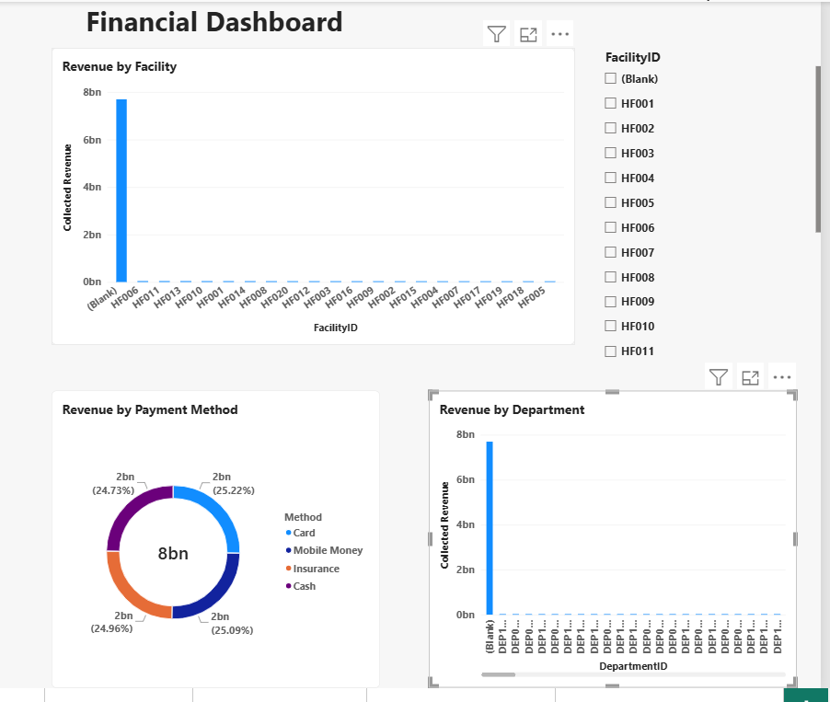
Figure 1 Supplied dashboard after the proposed correction 29 October 2026
The screenshot confirms the corrected grouping pattern. On 1 November, the full-value card shows 8,389,454,556. The user confirms HF006 = 40,224,830 and DEP181 = 5,681,113. The exact card image is included in the evidence folder. Financial slicer response and restoration when cleared passed by user report.

Test execution record
Source pass means the control was reproduced locally. Observed evidence includes the exact revenue-card screenshot. User reported pass identifies application comparisons and interactions confirmed in the conversation. Definition review covers the supplied DAX and its base measures. The accompanying detailed record retains objectives, scenarios, expected and actual results, issues, actions, retests, evidence and collaborating-track fields.
Test | Component | Actual result and evidence | Outcome
T01 | Executive KPIs | User confirmed 20,000 patients, 5,000 appointments, 20 facilities and 350 doctors. Source satisfaction is 2.99. Supplied DAX now confirms registered-doctor distinct counting and feedback Rating average. | Pass in scope
T02 | Financial definitions | Source reported revenue 1,132,677,500 differs from collections. The exact Power BI card shows 8,389,454,556, matching source payments and the supplied SUM definition. | Pass
T02c | Revenue chart groups | Initial repeated totals were corrected in the supplied screenshot. User confirms HF006 = 40,224,830 and DEP181 = 5,681,113, matching the two source controls. | Pass for sampled groups
T03 | Segments and filters | User confirms Male/Female chronic-condition comparisons, patient selection reset, financial facility-slicer response and restoration when cleared. Gender totals are 10,090 Male and 9,910 Female. | User reported pass
T04 | Clinical event grain | Current Q30 reproduced 5,000 events for each of four types, 20,000 overall. Source department-name lookup has no ambiguity. Unknown attribution retained. | Source pass
T05 | Department revenue | Current Q32 locally executes and sums to 8,389,454,556 including 7,694,903,236 Unknown. The historical duplicate ORDER BY is absent in the current upload. | Source pass
T06 | Missing appointment links | 60,000 bills preserved: 5,000 matched and 55,000 unmatched. Linked payments 694,551,320 plus unattributed payments 7,694,903,236 reconcile to the full total. | Source pass
T07 | Balances and statuses | Balance 919,947,405 across 11,887 positive-balance bills. Under the stated money-based classification, 39,961 source statuses differ; effective dates are unavailable. | Reconciled with limitation
T08 | Operational interpretation | Bed count uses distinct nonblank BedID; the occupied-over-total measure fits the 0% all-Available snapshot. Both definitions reviewed. Equipment time-based utilisation remains unsupported. | Definition and source pass
T09 | Feedback population | COUNTROWS confirms response grain; Poor Feedback filters Comment = Poor. Source controls are 21,064 responses, average 2.99, and 5,283 Poor comments. User confirms chronological months and the renamed chart. | Definition and display pass
T10 | Master assignments | 1,187 staff and 4,744 appointment facility assignments differ from their department-master facility association. Original recorded IDs preserved. | Limitation reproduced
T11 | Attendance scope | Seven appointment fields contain no attendance or no-show target. Missing parent IDs are a linkage gap. A no-show rate cannot be validated from these fields. | Not assessable

Validated findings and updated recommendations

Preserve source populations when joining
Current Q30 preserves 20,000 clinical events, with 5,000 in each of four record types. Q31 and Q32 preserve the complete payment total through left joins. Clinical counts, appointment counts and bill counts represent different record grains. Keep their definitions explicit and avoid joining multiple detail tables into one expanded fact table for totals.
The latest uploaded Q30 and Q32 already contained earlier corrections; the assistant verified their current source logic. Unchanged passed tests needed no repeat. The financial chart correction received a focused visual check.

Separate amounts from accounting claims
The outstanding balance reconciles to 919,947,405. Billing status disagrees with a stated money-based classification on 39,961 records. The rule classifies a bill as Paid when total payment is at least billed, Partially Paid when payment is positive but below billed, and Pending otherwise. Without effective dates, these differences do not prove every source status is wrong. Preserve the original status and report any calculated classification separately.

Qualify feedback comparisons
The overall average is 2.99 across 21,064 responses. The appointment-linked subset averages 2.93 across 1,756 responses. Facility and department satisfaction comparisons therefore describe that linked subset, not the full feedback population. Show response counts and avoid causal or clinic-wide conclusions from a small attributed sample.

Use precise time and utilisation descriptions
The uploaded baseline used Complain Trends with Appointment Month, sorted by Poor Feedback descending. The user confirms renaming the chart and arranging months chronologically. The supplied Poor Feedback measure filters Comment = Poor over COUNTROWS of feedback, confirming response grain. Its unfiltered source control is 5,283 Poor responses, with 422 linked to appointment months. The measure review and reported presentation checks pass; the trend remains an appointment-month proxy rather than a dated complaints series.
All 2,000 bed records are Available, supporting a status-snapshot occupancy of 0%. It does not establish occupancy or utilisation over time. Equipment inventory has no use hours or activity fields. Do not infer equipment utilisation or a need for more beds from these files alone.

Prioritise usable attendance data
The current appointment file has no attendance target. Missing references cannot be treated as no shows. Before selecting attendance-prediction features or recommending targeted interventions, establish an approved dataset with attendance outcomes, valid keys and an agreed cohort. Share these eligibility findings with the relevant HC-POD track and test the dependency jointly.

Limitations and actions before Week 8
Area | Limitation and impact | Required action or mitigation
Resources | The guide names HealthConnect_Appointment_Data.csv, a data dictionary and a clinic knowledge base; the continued Week 6 sources are the Rwanda healthcare files. | Clarify approved-resource continuity with the mentor. Keep the Week 6 originals and document any authorised mapping.
Attendance | No attendance or no-show field in the seven-column appointment source. | Do not publish a no-show rate from missing keys. Obtain or confirm the approved target and cohort.
Execution scope | Source verification used SQLite with MONTH and MONTHNAME equivalents and known BOM-header aliases. Power BI tests combine supplied definitions, screenshots and user confirmations. | Retain the provenance of each result. The assistant did not execute native MySQL or certify every untested model path.
Attribution | 55,000 bills and 19,308 feedback rows have no appointment parent. | Keep Unknown and linked-population denominators. Restore parents only from an authorised source.
Master assignments | 1,187 staff and 4,744 appointments conflict with department-master facility associations. | Preserve recorded IDs. Use an explicit attribution basis; avoid guessed facility reassignment.
Financial timing | No billing/payment/claim transaction dates or status-effective dates; no expense dataset. | Keep monthly reported revenue separate from undated collections. Do not infer payment timing, profitability or dated status errors.
Dashboard file | All five requested Power BI check groups are closed. The last uploaded PBIX predates the corrected screenshots and later supplied measure definitions. | Save the corrected PBIX from the user session and include it with the evidence. The documentation archive does not contain that updated dashboard file.
Age boundary | Q4 says above 65 but uses Age >= 65, giving 5,701 rows rather than 5,487 for Age > 65. | Use the description age 65 and above for the existing query, or deliberately change the threshold. No code edit is claimed.
Revenue Summary reports 60,809 appointments across its monthly rows. This is a reported count, not a maximum AppointmentID. Source analysis observed 60,000 distinct appointment references across files and 5,000 appointment-parent rows. A missing-ID range must not be inferred from the summary count.

Coverage of the official Data Analytics activities
The Week 7 guide lists 18 Data Analytics activities on page 7. Covered means addressed within the stated testing scope. The selected Power BI checks are now closed. The unavailable attendance target and the uncompleted actual cross-track activity remain explicit; this is not a claim that every assignment requirement was completed.
No | Guide activity | Coverage | Evidence or remaining work
1 | Review Week 6 outputs | Covered | Current SQL and six-page PBIX reviewed
2 | Prioritise outputs for testing | Covered | T01 to T11 identify KPI, join and scope checks
3 | Validate important KPIs | Covered in scope | Source controls and all six supplied measure definitions reviewed
4 | Compare dashboard and source values | Covered in scope | Exact revenue card observed; two group controls confirmed
5 | Test filters and calculations | Covered in scope | Patient and financial interactions and clearing confirmed
6 | Investigate inconsistent results | Covered | Revenue definitions, chart grouping and missing links investigated
7 | Validate important findings | Covered | Financial, clinical, feedback and inventory controls reproduced
8 | Reassess attendance and no shows | Not assessable | No attendance field; approved resource clarification pending
9 | Check conclusions across segments | Covered in scope | Male and Female chronic-condition comparisons confirmed
10 | Identify errors and weaknesses | Covered | Chart grouping, attribution and age boundary identified
11 | Refine unclear visualisations | Covered in scope | Financial grouping checked; feedback rename and month order confirmed
12 | Improve usability and interpretation | Covered in scope | Unknown attribution explained; selected slicer and reset checks passed
13 | Reassess recommendations | Covered | Recommendations reflect data coverage and unavailable metrics
14 | Identify findings for other tracks | Covered | Data eligibility and linkage findings identified for sharing
15 | Share findings with HC POD tracks | Not completed | No partner secured and no actual shared validation recorded
16 | Document changes | Covered | Issue log and financial before and after record included
17 | Retest refined outputs | Covered in scope | Exact total and sampled groups checked; interactions confirmed
18 | Document remaining limitations | Covered | Limitations and Week 8 actions recorded explicitly
The guide also requires one meaningful actual cross-track test, a concise project summary, testing evidence, applicable supporting files, accessible uploads and submission through the official form. Preparing documentation does not complete those external actions.

Cross track validation and readiness
Cross-track validation was not completed as of 1 November 2026. The user reported that no colleague from another track had been secured. Data Science was the proposed partner, but no actual joint test, exchanged output, joint refinement or cross-track retest is recorded. The independent checks and AI-assisted source verification do not count as collaboration with another internship track.
Collaboration component | Actual status
Partner from another track | None secured by the documentation update
Meaningful shared validation | Not completed
Outputs received or jointly compared | None recorded
Joint finding or improvement | Not demonstrated
Cross-track action and retest | Not completed
Evidence of actual collaboration | Not available

Prepared analytical contribution
Findings available for future sharing include the missing attendance target, appointment-parent coverage, financial definitions and linked-population denominators. A suitable dependency to test would be whether the available data supports a valid attendance-modelling cohort. These findings were identified for sharing; no delivery to a colleague or joint modelling decision is claimed.

Remaining actions
If an actual cross-track validation is completed before submission, replace the not-completed status with its real activity, result, action, retest where applicable and evidence. Otherwise retain the stated absence of collaboration.
Retain the documented source limitations and clarify approved-resource continuity with the mentor when possible. Do not infer a no-show rate from missing appointment links.
Save and upload the updated PBIX containing the financial chart correction. The earlier uploaded PBIX predates the screenshot and is not a verified final dashboard.
Upload the required files to the designated Drive folder, check mentor access, update GitHub where applicable and submit the official Week 7 form.

Original work plan and evidence index
The recovered earlier work plan contained 12 steps, rather than nine. It grouped the official activities into a practical sequence. The remaining collaboration and publication steps are distinct from the completed independent review.
Step | Original planned work | Status | Evidence or outstanding action
1 | Review Week 6 files and issues | Complete | Current files reviewed
2 | Write transition and testing record | Complete | Transition, controls and test record prepared
3 | Arrange a Data Science colleague and shared test | Not completed | No collaborating colleague secured as of 1 November
4 | Validate KPIs | Complete in scope | Source controls, exact revenue card and DAX definitions checked
5 | Test filters and findings | Complete in scope | Patient and financial interaction and reset checks confirmed
6 | Investigate inconsistencies and attendance | Covered with limits | No attendance target in current source
7 | Correct errors and improve visuals and insights | Done | Financial grouping and feedback rename confirmed
8 | Retest and save evidence | Done in scope | Exact total, two group controls and saved evidence checked
9 | Complete and document the shared test | Not completed | No actual shared test or evidence recorded
10 | Prepare the testing and refinement report | Prepared | This report
11 | Prepare the project summary | Prepared | Separate concise summary
12 | Update README and publish and submit | Partial | README prepared; final uploads and submission pending

Evidence index
E01 Official Week 7 assignment guide, Data Analytics activities and output on pages 7 and 8; collaboration on page 12; testing record on page 15; summary, submission and assessment on pages 16 to 19.
E02 Latest supplied rwanda healthcare.sql and rwanda(1).pbix. SQL implementation is MySQL; local data-logic verification used SQLite. No PostgreSQL conversion was made.
E03 evidence/source_verification_results.json and sql_query_execution.csv contain local calculation controls, execution scope and source hashes. Raw patient-level result sets are not included.
E04 documentation/HealthConnect_Week7_Testing_Record.md contains the detailed chronology and evidence provenance. Earlier failures and later source verification are kept distinguishable.
E05 evidence/financial_dashboard_after.png shows the corrected grouping pattern. evidence/collected_revenue_exact.png shows the exact total. The before state is user-reported; no before screenshot was supplied.
E06 Patient and sampled financial comparisons, financial and patient clearing, and chronological month order passed by user report. evidence/powerbi_checks.csv records the evidence type for each closed check.
E07 evidence/powerbi_measure_definitions.md records all six supplied DAX definitions, including the Total Beds and Total Feedback base measures.

