HealthConnect Rwanda

Final Analytics Report
AnalystLab Africa / Week 8 / Data Analytics Task 5
HealthConnect should start recording what happens to each booking before testing ways to reduce missed appointments. The available records can describe appointment workload, payments and patient feedback. They cannot establish a no-show rate, and incomplete appointment links limit facility comparisons.

Executive Dashboard Figures
These are the unfiltered figures. Each measure describes the population in its source table.
Measure | Final value | What it measures
Registered patients | 20,000 | Distinct patient IDs in the register.
Recorded appointments | 5,000 | Distinct booking IDs in the appointment extract.
Facilities | 20 | Distinct facility IDs across the source records.
Doctors | 350 | Distinct nonblank staff IDs with the Doctor role.
Collected revenue | RWF 8,389,454,556 | Payments received, including amounts without an appointment link.
Patient satisfaction | 2.99 / 5 | Mean rating across 21,064 feedback responses.

Dashboard Validation
Before correction, the facility and department charts repeated the overall collections total. After grouping by the facility and department IDs from Appointments, the charts showed different values. The exact collections card matched the source total. My sample checks also matched: HF006 showed RWF 40,224,830 and DEP181 showed RWF 5,681,113.
I confirmed that selecting a facility changed the financial visuals and clearing it restored the original view. I also confirmed that clearing a patient selection restored the patient charts and that the feedback chart months appeared in chronological order.

Recorded Appointments and Collections

Appointment Activity
The 5,000 booking records have dates from 1 January to 28 December 2026. Monthly counts ranged from 400 in May to 440 in March. The extract contains 1,694 follow-ups, 1,656 consultations and 1,650 emergency bookings. The counts describe recorded workload; there is no attendance outcome field.
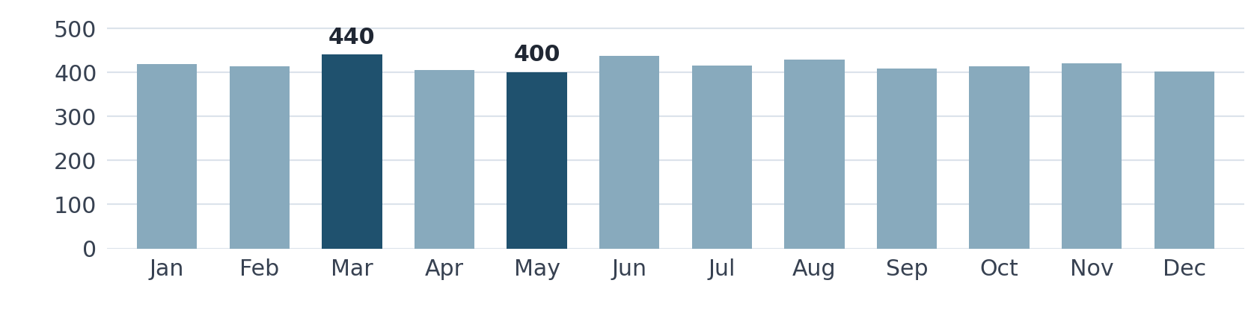
Figure 1. Recorded appointments by month in the 2026 extract.

Billing and Payment Coverage
Measure | Amount
Total billed | RWF 9,309,401,961
Collected payments | RWF 8,389,454,556
Outstanding billing balance | RWF 919,947,405
Payments linked to a recorded appointment | RWF 694,551,320
Payments without an appointment link | RWF 7,694,903,236
The named facility and department bars cover 8.28% of all payments. The rest is visible in the (Blank) group. Keep this group in the totals and verify facility and department assignments before using linked figures to rank performance.
The Revenue Summary separately reports RWF 1,132,677,500 across 12 months. Its accounting basis is unspecified, so keep it separate from collections. The outstanding balance measures billed less collected. The records do not establish overdue amounts or profitability.

Patient Support and Recommended Actions

Patient Experience and Capacity
Average satisfaction was 2.99 out of 5. Of 21,064 responses, 5,283 were tagged Poor and only 1,756 linked to a recorded appointment. Facility feedback summaries describe that linked subset. A feedback chart grouped by month uses the linked appointment date because feedback submission dates are absent.
All 2,000 bed records were marked Available. The dashboard’s 0.0% reflects recorded occupancy in that snapshot. Measuring utilisation over time requires dated occupancy records.

Answer to the Project Question
How can HealthConnect Clinic use data and AI to reduce missed appointments and improve the patient support experience? Start with a reliable record of whether each booking was attended, missed, cancelled or rescheduled. Once outcome coverage is sufficient, compare a reminder or easier rescheduling pilot with the existing process. Track no-show rates, completed reschedules and patient feedback.
An AI assistant could answer routine scheduling questions from approved clinic information and refer unresolved requests to staff. This analysis did not test an assistant or measure whether reminders reduce no-shows.

Reporting Priorities
Reconcile appointment links. Use the authoritative appointment register to match billing and payments. Monitor the share of payment value that can be attributed to a facility.
Improve feedback and capacity records. Capture feedback submission dates and valid booking references. Keep dated occupancy records before using bed data for resource planning.

Evidence and Scope
The Power BI results reflect my confirmed checks of the corrected dashboard. The older uploaded PBIX still has the previous chart fields. I will use the corrected saved copy for the demonstration. No cross-track exchange or joint validation has been completed.

