Conventional Oil Furnaces

Burner

Conventional designs of the burner do not gather for its maintainability. The burner is designed as a single solid attached to the nozzle. Since most furnaces operate at temperatures more than 18000C, such burners burn out and become non-functional after some few operations. Due to the solid design of such furnaces, replacements of such parts require overhauling. The choice of material plays a role in the frequency of maintenance.

Nozzle

Most designs use separate nozzles for pressurized air and oil. Such a design has proven to be inefficient since smoke emissions are frequently witnessed. It also introduces complexity in the design since the pressurized air nozzle has to be placed as the measured distance from the pressurized oil nozzle and this might not always be accurate.

Ignition

Ignition for conventional oil furnaces employs a flammable burner mounted on an insulator or even soaked in a highly flammable petroleum fuel. This method is unsafe since its control is limited. The use of highly flammable petroleum fuel for ignition also makes it expensive and borderline dangerous.

Emission

Combustion of oil in a good proportion of oxygen produces carbon dioxide. During oxygen deficiencies, carbon monoxide is released. If not detected and controlled such gases can be catastrophic. Since such emissions are invisible, conventional designs of this type of furnace do not gather for such hazards.

Oil Consumption

Conventional designs are based on the workability of the design. Its efficiency is rather given very minimal attention. The use of separate nozzles for the pressurized oil and air undermines the efficiency of the design. As such, the consumption of oil is rather higher.

Assembly

Processes

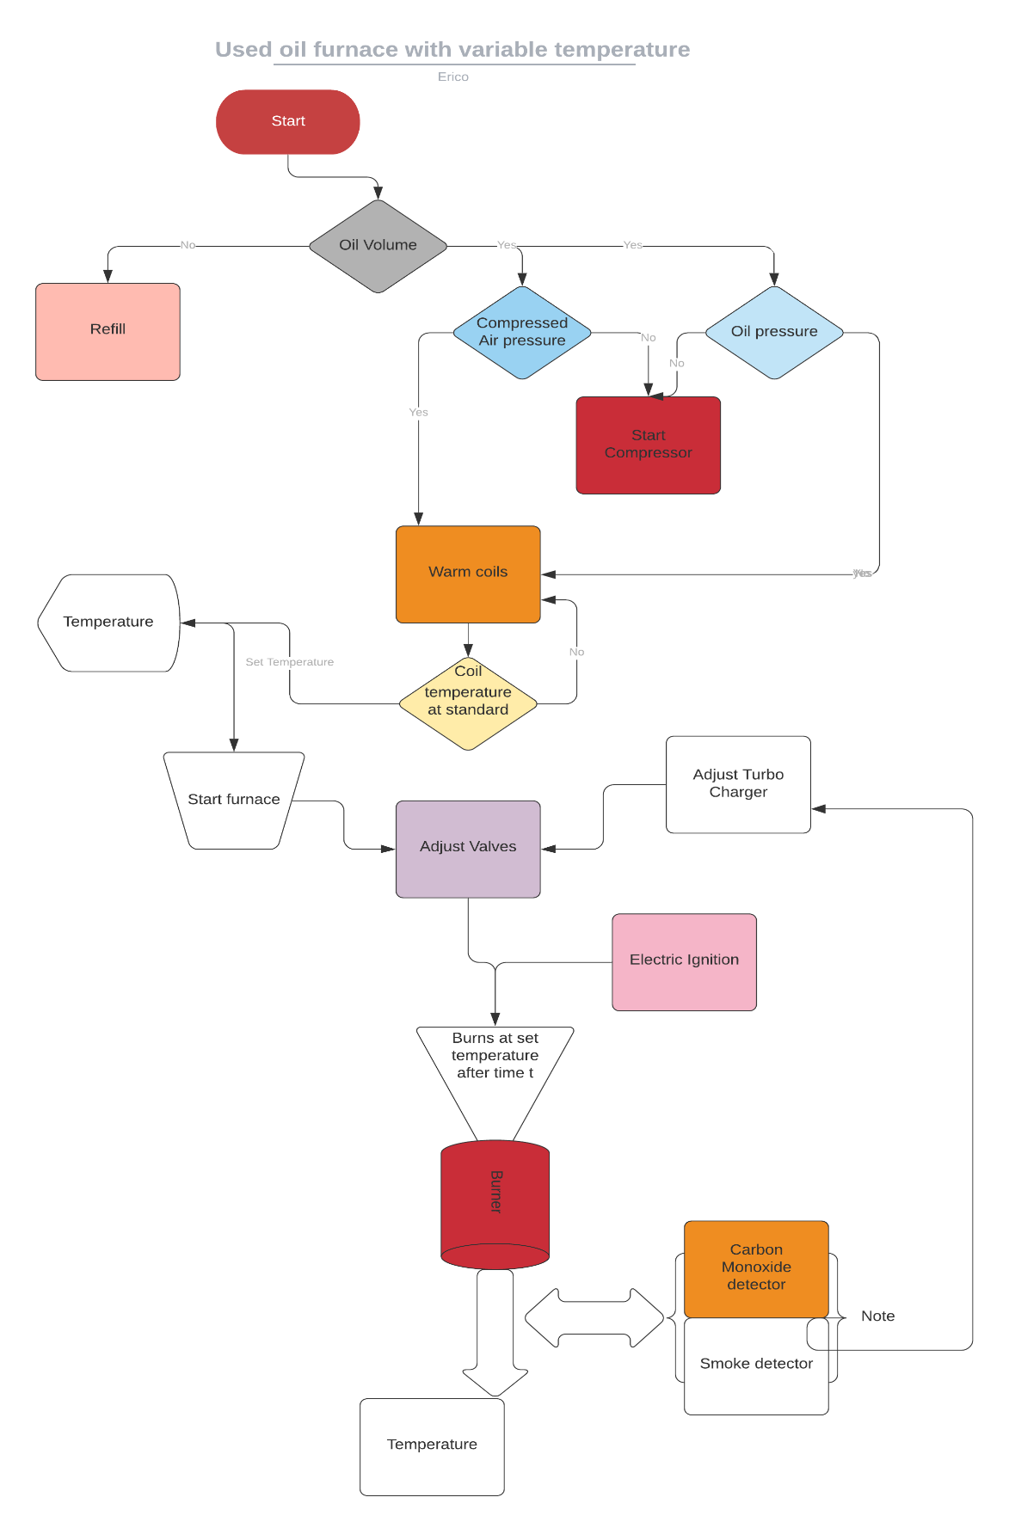

On powering on, the system automatically checks the volume of oil in the oil storage tank. This is determined by a **level sensor** installed in the tank. Depending on the volume, the system decides whether to refill the tank from an even bigger tank or raise an alert for a refill. If the required volume of oil is available the system then checks the pressure of oil in the tank and the pressure of compressed air in the air storage tank using **pressure sensors**. In any case, the pressure is below the required, the system automatically turns on the compressor to refill the two containers to the required pressure. Once the pressure requirements in the two containers are met, the system automatically switches off the compressors and starts warming the **coils** on the path of the pressurized oil to the injector. The compressor is turned on, and off to maintain constant pressure in the tank.

Once the coils warm to a standard base temperature, the user is then prompted on the interface to enter the **furnace operation temperature**. From this input, the system adjusts both the air and pressurized oil valves using **a stepper motor** connected to each of the valves. A supercharger is connected to the compressed air flow pipe through a **pneumatic motor** and a **pneumatic** **gear system** to magnify the speed of the airflow. It is also adjusted in proportion to the pressure along the airflow pipe. This is to ensure the maximum supply of oxygen to the combustion chamber and to reduce emissions.

The pressurized oil and compressed air mix evenly in the **coaxial swirl injector**. The injector is designed in such a way that it ensures oil is atomized and mixes evenly with enough amounts of oxygen. Once the flow of oil and pressurized air is steady, an **electric igniter** descends to the tip of the nozzle and sparks to ignite the mixture. It then retracts to a safer height since its material cannot withstand furnace temperatures.

The mixture burns at the burner. With the correct choice of material, the burner can achieve up to **18340C.** Around the burner are the **smoke detector**, **carbon monoxide detector, and a thermal gun**. These sensors continuously check the smoke, levels of carbon monoxide, and temperature at the output, and this information is transferred to the ECU which adjusts the supercharger, oil, and air valves to correct the values.