Conventional Oil Furnaces

Burner

Conventional designs of the burner do not gather for its maintainability. The burner is designed as a single solid attached to the nozzle. Since most furnaces operate at temperatures more than 18000C, such burners burn out and become non-functional after some few operations. Due to the solid design of such furnaces, replacements of such parts require overhauling. The choice of material plays a role in the frequency of maintenance.

Nozzle

Most designs use separate nozzles for pressurized air and oil. Such a design has proven to be inefficient since smoke emissions are frequently witnessed. It also introduces complexity in the design since the pressurized air nozzle has to be placed as the measured distance from the pressurized oil nozzle and this might not always be accurate.

Ignition

Ignition for conventional oil furnaces employs a flammable burner mounted on an insulator or even soaked in a highly flammable petroleum fuel. This method is unsafe since its control is limited. The use of highly flammable petroleum fuel for ignition also makes it expensive and borderline dangerous.

Emission

Combustion of oil in a good proportion of oxygen produces carbon dioxide. During oxygen deficiencies, carbon monoxide is released. If not detected and controlled such gases can be catastrophic. Since such emissions are invisible, conventional designs of this type of furnace do not gather for such hazards.

Oil Consumption

Conventional designs are based on the workability of the design. Its efficiency is rather given very minimal attention. The use of separate nozzles for the pressurized oil and air undermines the efficiency of the design. As such, the consumption of oil is rather higher.

Assembly

Processes

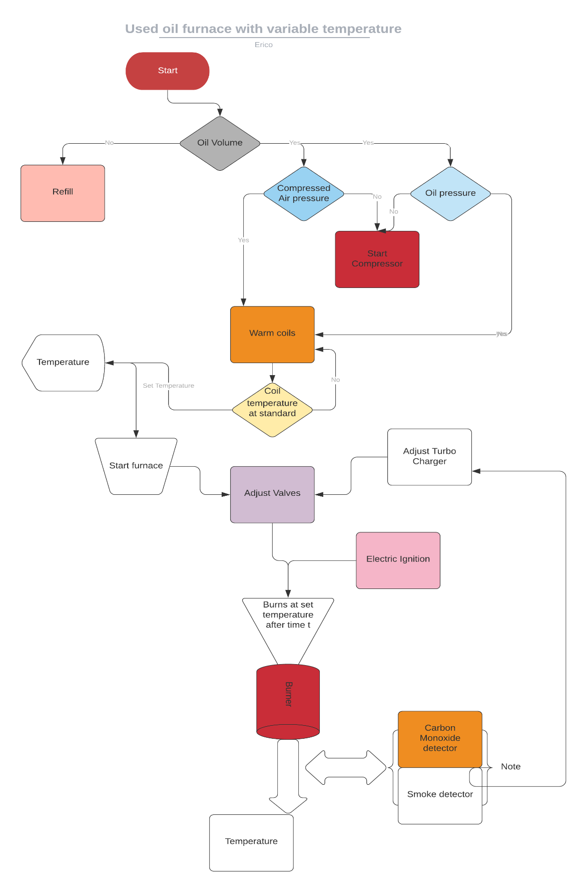

On powering on, the system automatically checks the volume of oil in the oil storage tank. This is determined by a **level sensor** installed in the tank. Depending on the volume, the system decides whether to refill the tank from an even bigger tank or raise an alert for a refill. If the required volume of oil is available the system then checks the pressure of oil in the tank and the pressure of compressed air in the air storage tank using **pressure sensors**. In any case, the pressure is below the required, the system automatically turns on the compressor to refill the two containers to the required pressure. Once the pressure requirements in the two containers are met, the system automatically switches off the compressors and starts warming the **coils** on the path of the pressurized oil to the injector. The compressor is turned on, and off to maintain constant pressure in the tank.

Once the coils warm to a standard base temperature, the user is then prompted on the interface to enter the **furnace operation temperature**. From this input, the system adjusts both the air and pressurized oil valves using **a stepper motor** connected to each of the valves. A supercharger is connected to the compressed air flow pipe through a **pneumatic motor** and a **pneumatic** **gear system** to magnify the speed of the airflow. It is also adjusted in proportion to the pressure along the airflow pipe. This is to ensure the maximum supply of oxygen to the combustion chamber and to reduce emissions.

The pressurized oil and compressed air mix evenly in the **coaxial swirl injector**. The injector is designed in such a way that it ensures oil is atomized and mixes evenly with enough amounts of oxygen. Once the flow of oil and pressurized air is steady, an **electric igniter** descends to the tip of the nozzle and sparks to ignite the mixture. It then retracts to a safer height since its material cannot withstand furnace temperatures.

The mixture burns at the burner. With the correct choice of material, the burner can achieve up to **18340C.** Around the burner are the **smoke detector**, **carbon monoxide detector, and a thermal gun**. These sensors continuously check the smoke, levels of carbon monoxide, and temperature at the output, and this information is transferred to the ECU which adjusts the supercharger, oil, and air valves to correct the values.

Cylinder modeling

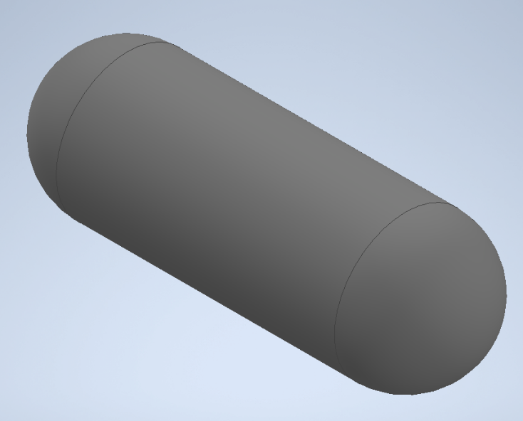

Fig 1.1 Cylinder

Thickness

The cylinder is designed to have to have the following dimensions:

Length: 3m

Internal Diameter: 800mm

The thickness of the cylinder has to be chosen carefully to achieve a recommended factor of safety for pressure vessels of between 3 and 6. To determine that, Clavarino’s equation is preferred to Lame’s equation since the cylinder is closed at both ends as shown in *figure 1.1*.

Clavarinos Equation

Clavarinos equation is used to determine the wall thickness of a cylinder. This is equation is applicable to cylinders with closed ends made of ductile materials. It is based on maximum principal strain theory.



*Fig 1.2 Clavarinos Formula*

Where:

P is the internal pressure, N/m2

D is the internal diameter, m

S is the allowable tensile stress, N/m2

t is the thickness of the material shell, m

µ is the poison’s ratio

Material

The material of the cylinder is chosen to meet the following objectives:

1. The material should be light (weight). This allows for bigger sizes without the limit of weight.
2. It should be less rusty.
3. Carbon content should not exceed a 1/8 of its total mass

Above objectives narrows down the search of the material to Carbon fiber or Fiber Glass. The amount of carbon in carbon fiber makes it a lesser attractive choice as compared to Fiber Glass even though it has a higher ultimate tensile strength. Fiber Glass is therefore chosen for the design of the cylinder.

Standard fiber glass has the following properties:

1. Ultimate tensile strength 1950-2000Mpa
2. Poisson’s ration 0.23

Computing the ultimate thickness

To compute the ultimate thickness of the cylinder, the value of internal pressure of the cylinder can be assumed and the thickness computed. This method involves several guesses to obtain an ultimate internal pressure for a factor of safety of between 3 and 6.

Instead, a MATLAB script can be written to compute the ultimate internal pressure and thickness for a factor of safety between 3 and 6. The script is a shown below:

clc

clear

p_fos **=** 3**;** % recommended factor of safety for pressure vessels is between 3.0 - 6.0

D **=** 800**;** % internal diameter 800mm

S **=** 1950 **\*** 10**^**6**;** % Ultimate tensile strength for Fiber glass

u **=** 0.23**;** % poissons ratio for fiber glass

t **=** **[**0**,**0.001**];** % 1000th of a meter starting thickness

P **=** **[**0**,**0**];**

figure**(**1**);**

plot**(**P**,**t**,**"x"**);**

i **=** 2**;**

**while(**1**)**

i **=** i**+**1**;**

% internal pressure

P**(**i**)=** **(**S**\*((((**2**\***t**(**i**-**1**)/**D**)+**1**)^**2**)-**1**))/((**1**-**2**\***u**)+(**1**+**u**)*(((**2**\***t**(**i**-**1**)/**D**)+**1**)^**2**));**

t_fos **=** S**/**P**(**i**);** % factor of safety(fos)

% if fos is below the recommended value,break

**if(**t_fos **<** p_fos**)**

**break**

**end**

hold on

t**(**i**)=** t**(**i**-**1**)+**0.01**;** % 0.01 increment thickness

plot**(**P**(**1**:**i**),**t**(**1**:**i**),**"x"**);**

**end**

title**(**"Thickness against Internal Pressure"**)**

ylabel**(**"Thickness(m)"**);**

xlabel**(**"Pressure(Pa)"**)**

legend**(**"Shell Thickness vs internal pressure"**)**

hold off

This script however, has a downside. The simulation involves computing more than 10,000 values for only a factor of safety below 30. MATLAB is super slow for this kind of computation.

An alternative C++ script can be written to speed up the computation. This is as shown below.

#include "matplotlibcpp.h"

#include <cmath>

**namespace** plt **=** matplotlibcpp**;**

int main**(){**

// declare constants

const int p_fos **=** 3**;** // recommended factor of safety for pressure vessels is between 3.0 - 6.0

const int D **=** 800**;** // internal diameter 800mm

const int S **=** **(**1950 **\*** std**::**pow**(**10**,**6**));** // Ultimate tensile strength for Fiber glass

const float u **=** 0.23**;** // poissons ratio for fiber glass

// prepare the data

std**::**vector**<**double**>** t**,**P**;**

t**.**emplace_back**(**0.001**);**// 1000th starting thickness

P**.**emplace_back**(**0**);**// 0 starting pressure

**while(**1**){**

double temp **=** **(**S**\*(**std**::**pow**(((**2**\***t**.**back**()/**D**)+**1**),**2**)-**1**))/((**1**-**2**\***u**)+(**1**+**u**)\***std**::**pow**(((**2**\***t**.**back**()/**D**)+**1**),**2**));**

P**.**emplace_back**(**temp**);**

t**.**emplace_back**((**t**.**back**()** **+** 0.1**));**// increment thickness by 0.01

float _fos **=** **(**S **/** P**.**back**());** // compute factor of safety

printf**(**"%f\n"**,**_fos**);**

**if(**_fos **<** 3**){**

**break;**

**}**

**}**

printf**(**"Ultimate pressure: %f\n"**,**P**.**back**());**

plt**::**figure_size**(**1300**,**768**);**

plt**::**named_plot**(**"Thickness vs Internal pressure"**,**P**,**t**);**

plt**::**title**(**"Thickness Vs Internal pressure"**);**

plt**::**legend**();**

plt**::**show**();**

**}**

The script computes both the internal pressure and factor of safety with varying thickness and stops when the factor of safety goes below 3. It then plot the relation between the thickness of the cylinder shell and the internal pressure. The plot is as shown below.

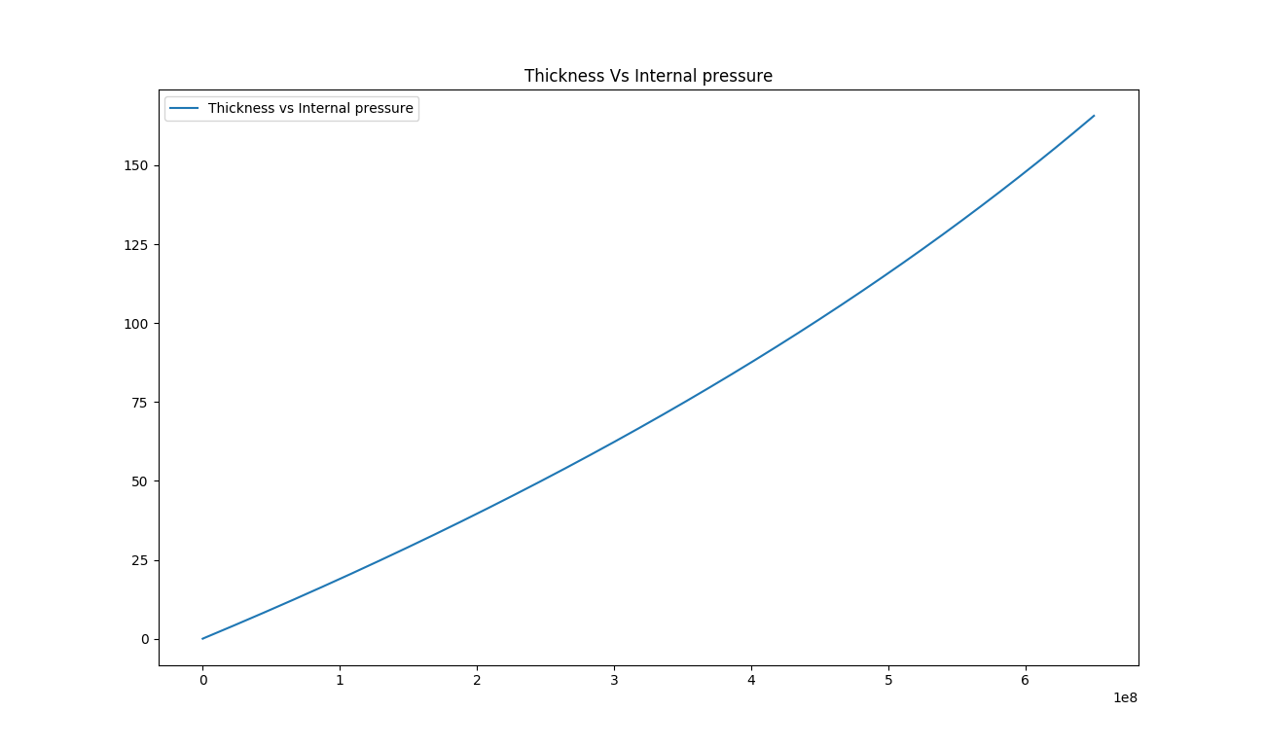

*Fig 1.2 Thickness against Internal pressure*

This shows that the relation between the internal pressure and the thickness of cylinder is linear. From the computation, it is also obtained that internal pressure of the cylinder for a factor of safety 3 is 650.042MPa. and thickness 42.075mm as shown below:

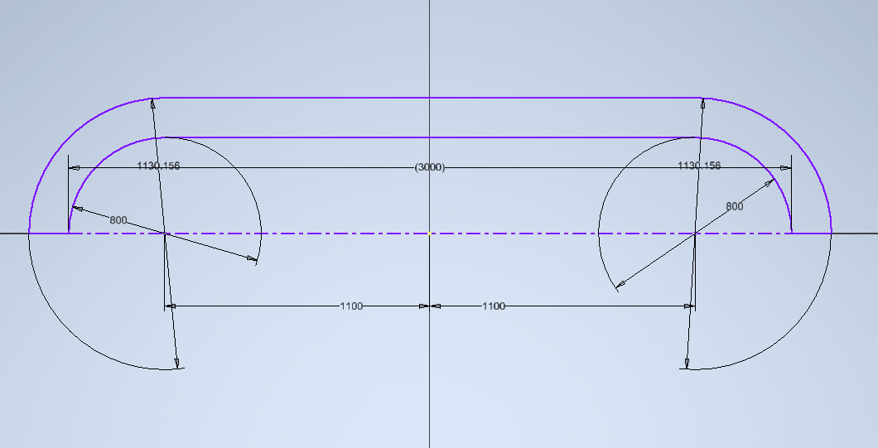

*Fig 1.3 Actual dimensions of the cylinder*

Atomizer

An atomizer is required to deliver the pressurized oil under high pressure to the combustion unit in a tiniest sprays possible. There are three viable designs for the atomizer: coaxial swirl injector, pintle injector and self-impinging injector. From the above designs the coaxial swirl injector was selected due its ease of fabrication compared to the pintle injector and self-impinging injector. The injector is expected to deliver the pressurized oil with ideal flow characteristics and atomize the fuel adequately.

Coaxial Swirl Injector

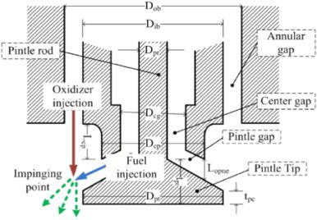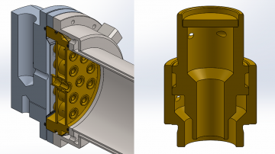

*Fig 1,1 Coaxial Swirl Injector*

Coaxial swirl injector performs the primary function of feeding oil to the combustion chamber. The design of this injector for oil furnace meets the following functional requirements;

1. The oil injector must be able to inject oil into the combustion chamber at the correct ratio and correct flow rates. For this reason the discharge coefficient of the injector must be determinable.
2. The oil injector should ensure complete mixing of oil with air to avoid undesired combustion with might result in the emission of carbon monoxide.
3. The oil injector must facilitate a primary pressure drop of between 10-20% to prevent discharged oil from flowing back into the injection system and causing an explosion.

Design

This swirl injector will consist of two primary parts; the inner element and the outer element. The two elements are placed on different levels separated by a separator plate. The inner element takes in pressurized oil tangentially which causes the liquid to swirl along the wall of the inner section. The pressurized oil enters the outer section tangentially as well and swirls along the wall of the outer element. This results in the pressurized air leaving the inner element in the shape of a cone which collides with the cone formed by the outer element. In this way the pressurized oil and pressurized air each leave each of the elements in a cylindrical manner colliding and atomizing due to the high pressure and velocity of the flow. The configuration is as displayed in figure 1.

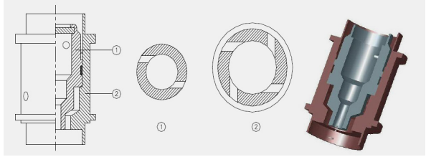

*Fig 1.2 Swirl Injector Exploded View*

This configuration meets the functional requirements of any fuel injector system .The efficiency of the injector for oil of any density can reach as high as 95%. The swirl injector has the following advantages;

1. The design is highly scalable since the assembly can be made bigger by adding the number of swirl elements in the assembly.
2. The swirl and assembly are relatively easy to machine
3. The swirl offers high atomization which is crucial for the conversion of chemical energy to thermal energy
4. The swirl element offers adjustable flow parameters allowing the assembly to create oxygen rich zones and oil rich zones.
5. Swirl elements offer the ability to vary the velocity of the fuel which can enhance the mixing of the pressurized air and pressurized oil.

The disadvantages of swirl injectors are:

1. They are a relatively new type of injector with fewer developed optimization characteristics
2. They require high dimensional accuracy for high performance

The other types of injector designs considered were;

Assembly and Fabrication

The development of the design was done by separating the assembly into five distinct parts:

1. Separator plate
2. Base plate
3. Swirler cap
4. Inner swirl element
5. Outer swirler element

**Swirl Assembly**

The parts were drawn on Autodesk Inventor for the 3D representation. The individual parts were then assembled. A cross section of the assembly is shown below.

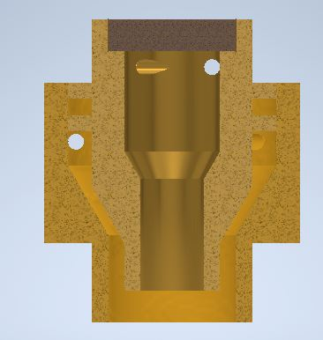

*Fig 1.3 Cross section of the assembly*

MasterCAM was then used to show the fabrication processes.

The cap was machined using a CNC lathe. The first process was facing the stock. This was followed by a rough surface turning on the outer diameter profile followed by a finishing process on the surface. The part was then cut off from the stock using a grooving tool. The tool paths are shown below:

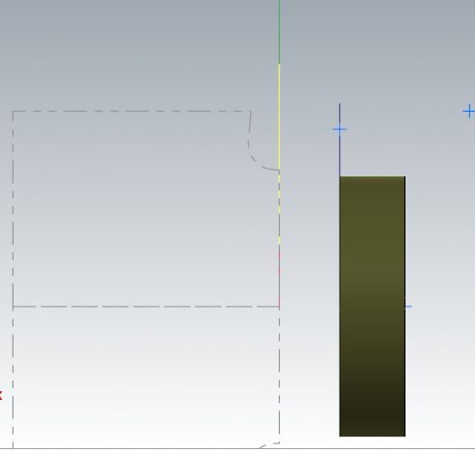

*Fig 1.4 Cap Machining*

The inner element was machined using a CNC lathe. The first process was facing using a right hand turning tool. A rough turning operation was then used to bring the dimensions to closer tolerance of the desired profile. A grooving operation was then used to machine the flanges on the profile. A grooving tool was also used to finish the tapered turning on the end of the part. A finishing turning operation was then done to bring the part to the required dimensions. A diameter 4 drill was then used to drill through the entire part. A diameter 8 drill was then used to a depth of 9mm. An internal grooving tool is then used to finalize the internal profile. The part was then cut off from the stock using a grooving tool. The holes were machined using a five axis milling machine. The figure below some of the generated tool paths.

~~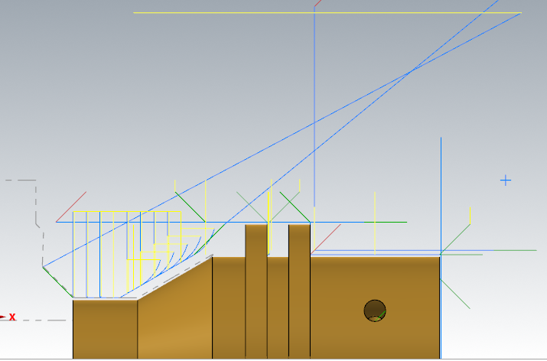~~

*Fig 1.5 Inner element of the swirler*

The outer element was machined using a CNC lathe. The first process was facing. This was followed by a rough turning operation on the profile. A grooving tool was then used to machine the end on the profile where there is a diameter change. The outer element was then finalized with a finishing turning operation. For the internal profile a drill of diameter 8 is passed through the entire stock. THis is followed by a drilling with a 12 mm drill to a depth of 12.12mm. The internal profile is then finalized by an internal turning operation. The part was then cut off from the stock using a grooving tool. The holes were machined using a 5 axis milling machine.

~~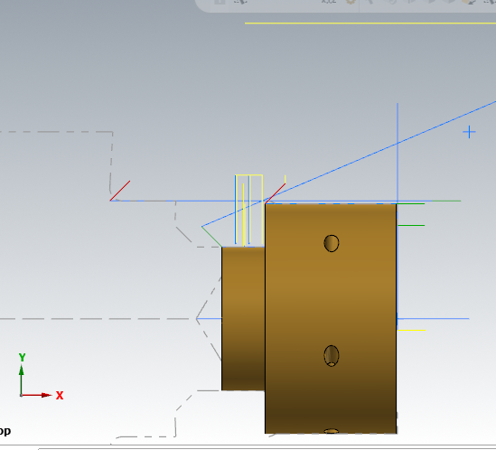~~

*Fig 1.6 Outer element of the swirler*

**Base plate**

The stock of this part was as defined:

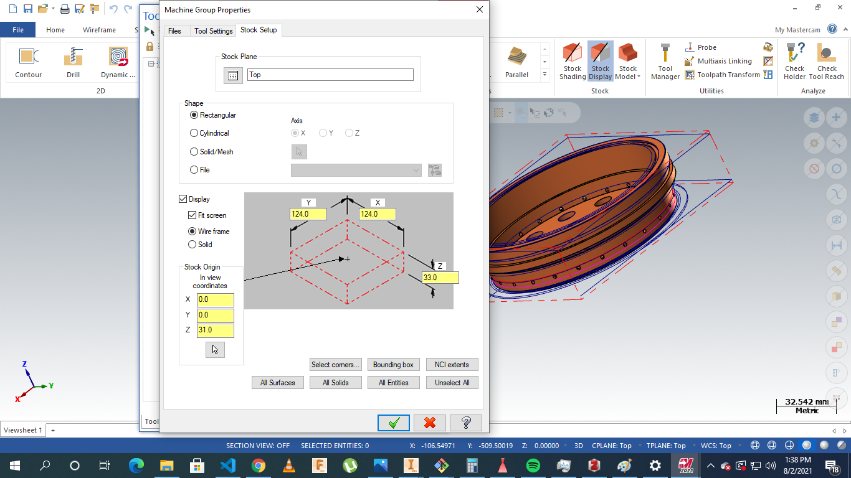

*Fig 1.7 Base plate machining*

The operations were to conducted on a five axis milling. The processes involved include: facing, contour milling drilling slot milling and multi-axis drilling.

The parts were milled as the material to be used was brass.

Operations are highlighted below:

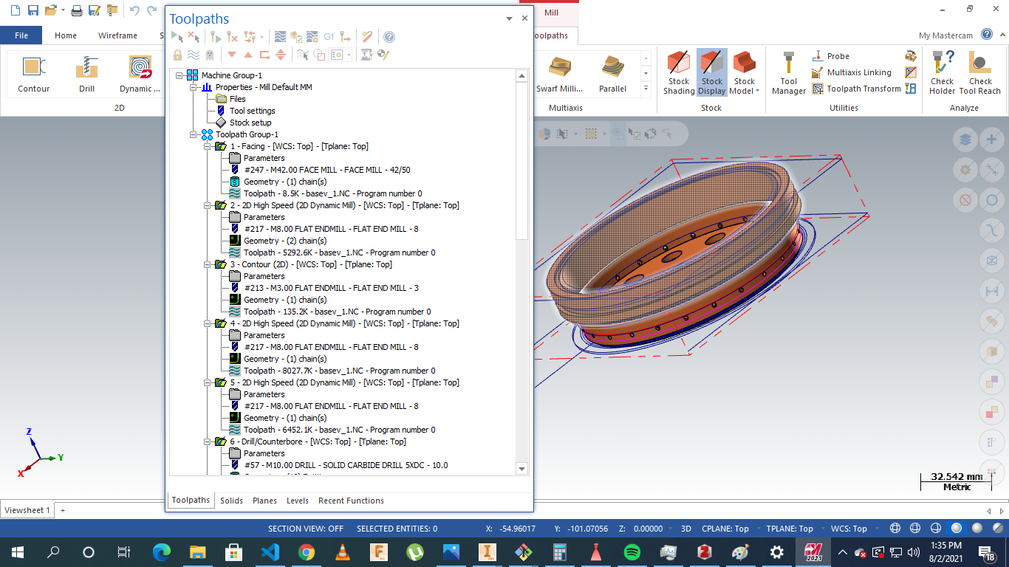

*Fig 1.8 Base Plate total operations*

**Separator plate**

The stock was as defined:

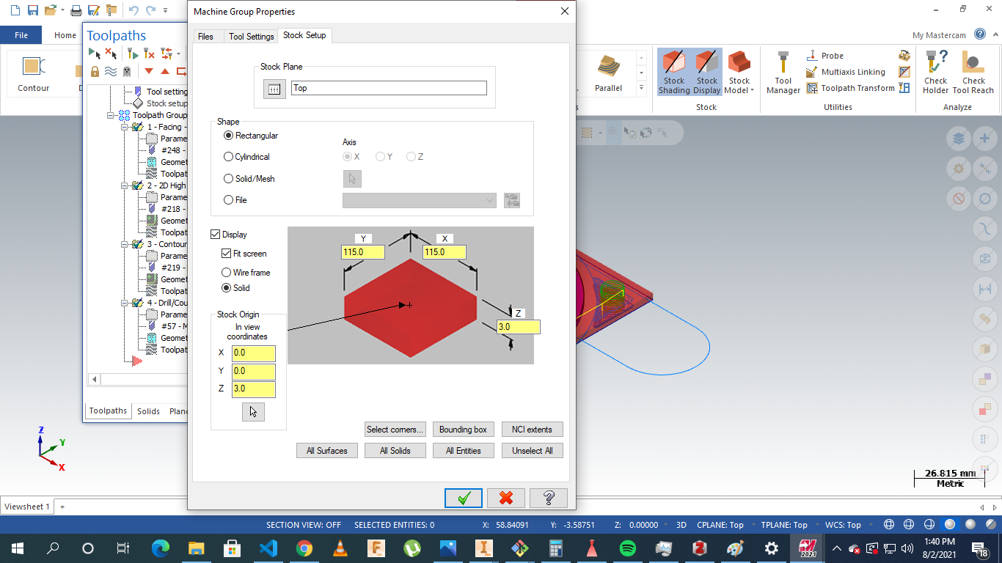

*Fig 1.9 Separator plate stock Setup*

The operations involved: facing, drilling,contouring and parting.

The processes were as displayed :

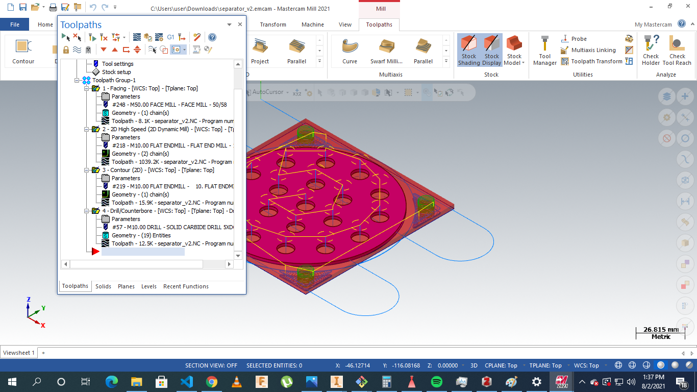

*Fig 2.0 Stock Plate Machining Instructions*

# 

References

[L.-J. Yang and Q.-F. Fu, ‘Theoretical Investigation on the Dynamics of a Gas-Liquid Coaxial Swirl Injector’, *J. Propuls. Power*, vol. 27, no. 1, pp. 144–150, 2011.](https://www.zotero.org/google-docs/?tOBzsF)

H. Belal, A. Makled, and M. Al-Sanabawy, “Vaporization-controlled simplified model for liquid propellant rocket engine combustion chamber design,” IOP Conference Series: Materials Science and Engineering, vol. 610, p. 012088, Oct. 2019, doi: 10.1088/1757-899X/610/1/012088.

Edge, E. (2021). Clavarinos equation thick-walled cylinders of ductile material Calculator and formula. Retrieved 7 August 2021, from <https://www.engineersedge.com/calculators/clavarinos_equation_thickwalled_cylinders_15620.htm>