Cylinder modeling

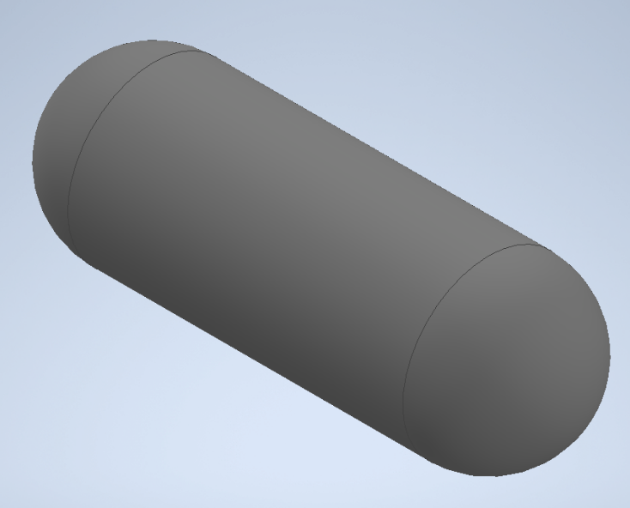

Fig 1.1 Cylinder

Thickness

The cylinder is designed to have to have the following dimensions:

Length: 3m

Internal Diameter: 800mm

The thickness of the cylinder has to be chosen carefully to achieve a recommended factor of safety for pressure vessels of between 3 and 6. To determine that, Clavarino’s equation is preferred to Lame’s equation since the cylinder is closed at both ends as shown in *figure 1.1*.

Clavarinos Equation

Clavarinos equation is used to determine the wall thickness of a cylinder. This is equation is applicable to cylinders with closed ends made of ductile materials. It is based on maximum principal strain theory.



*Fig 1.2 Clavarinos Formula*

Where:

P is the internal pressure, N/m2

D is the internal diameter, m

S is the allowable tensile stress, N/m2

t is the thickness of the material shell, m

µ is the poison’s ratio

Material

The material of the cylinder is chosen to meet the following objectives:

1. The material should be light (weight). This allows for bigger sizes without the limit of weight.
2. It should be less rusty.
3. Carbon content should not exceed a 1/8 of its total mass

Above objectives narrows down the search of the material to Carbon fiber or Fiber Glass. The amount of carbon in carbon fiber makes it a lesser attractive choice as compared to Fiber Glass even though it has a higher ultimate tensile strength. Fiber Glass is therefore chosen for the design of the cylinder.

Standard fiber glass has the following properties:

1. Ultimate tensile strength 1950-2000Mpa
2. Poisson’s ration 0.23

Computing the ultimate thickness

To compute the ultimate thickness of the cylinder, the value of internal pressure of the cylinder can be assumed and the thickness computed. This method involves several guesses to obtain an ultimate internal pressure for a factor of safety of between 3 and 6.

Instead, a MATLAB script can be written to compute the ultimate internal pressure and thickness for a factor of safety between 3 and 6. The script is a shown below:

clc

clear

p_fos **=** 3**;** % recommended factor of safety for pressure vessels is between 3.0 - 6.0

D **=** 800**;** % internal diameter 800mm

S **=** 1950 **\*** 10**^**6**;** % Ultimate tensile strength for Fiber glass

u **=** 0.23**;** % poissons ratio for fiber glass

t **=** **[**0**,**0.001**];** % 1000th of a meter starting thickness

P **=** **[**0**,**0**];**

figure**(**1**);**

plot**(**P**,**t**,**"x"**);**

i **=** 2**;**

**while(**1**)**

i **=** i**+**1**;**

% internal pressure

P**(**i**)=** **(**S**\*((((**2**\***t**(**i**-**1**)/**D**)+**1**)^**2**)-**1**))/((**1**-**2**\***u**)+(**1**+**u**)*(((**2**\***t**(**i**-**1**)/**D**)+**1**)^**2**));**

t_fos **=** S**/**P**(**i**);** % factor of safety(fos)

% if fos is below the recommended value,break

**if(**t_fos **<** p_fos**)**

**break**

**end**

hold on

t**(**i**)=** t**(**i**-**1**)+**0.01**;** % 0.01 increment thickness

plot**(**P**(**1**:**i**),**t**(**1**:**i**),**"x"**);**

**end**

title**(**"Thickness against Internal Pressure"**)**

ylabel**(**"Thickness(m)"**);**

xlabel**(**"Pressure(Pa)"**)**

legend**(**"Shell Thickness vs internal pressure"**)**

hold off

This script however, has a downside. The simulation involves computing more than 10,000 values for only a factor of safety below 30. MATLAB is super slow for this kind of computation.

An alternative C++ script can be written to speed up the computation. This is as shown below.

#include "matplotlibcpp.h"

#include <cmath>

**namespace** plt **=** matplotlibcpp**;**

int main**(){**

// declare constants

const int p_fos **=** 3**;** // recommended factor of safety for pressure vessels is between 3.0 - 6.0

const int D **=** 800**;** // internal diameter 800mm

const int S **=** **(**1950 **\*** std**::**pow**(**10**,**6**));** // Ultimate tensile strength for Fiber glass

const float u **=** 0.23**;** // poissons ratio for fiber glass

// prepare the data

std**::**vector**<**double**>** t**,**P**;**

t**.**emplace_back**(**0.001**);**// 1000th starting thickness

P**.**emplace_back**(**0**);**// 0 starting pressure

**while(**1**){**

double temp **=** **(**S**\*(**std**::**pow**(((**2**\***t**.**back**()/**D**)+**1**),**2**)-**1**))/((**1**-**2**\***u**)+(**1**+**u**)\***std**::**pow**(((**2**\***t**.**back**()/**D**)+**1**),**2**));**

P**.**emplace_back**(**temp**);**

t**.**emplace_back**((**t**.**back**()** **+** 0.1**));**// increment thickness by 0.01

float _fos **=** **(**S **/** P**.**back**());** // compute factor of safety

printf**(**"%f\n"**,**_fos**);**

**if(**_fos **<** 3**){**

**break;**

**}**

**}**

printf**(**"Ultimate pressure: %f\n"**,**P**.**back**());**

plt**::**figure_size**(**1300**,**768**);**

plt**::**named_plot**(**"Thickness vs Internal pressure"**,**P**,**t**);**

plt**::**title**(**"Thickness Vs Internal pressure"**);**

plt**::**legend**();**

plt**::**show**();**

**}**

The script computes both the internal pressure and factor of safety with varying thickness and stops when the factor of safety goes below 3. It then plot the relation between the thickness of the cylinder shell and the internal pressure. The plot is as shown below.

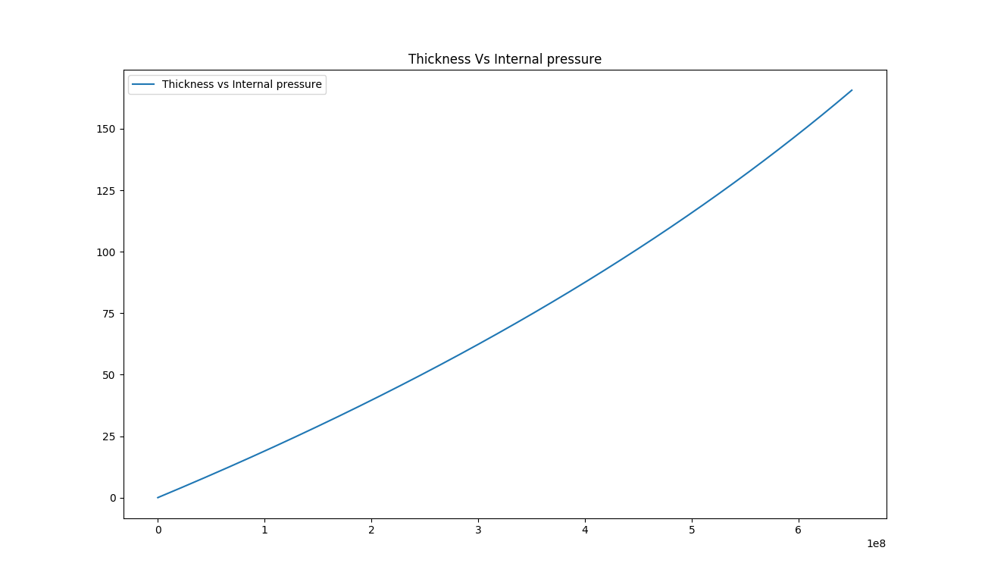

*Fig 1.2 Thickness against Intenal pressure*

This shows that the relation between the internal pressure and the thickness of cylinder is linear. From the computation, it is also obtained that internal pressure of the cylinder for a factor of safety 3 is 650.042MPa. and thickness 42.075mm as shown below:

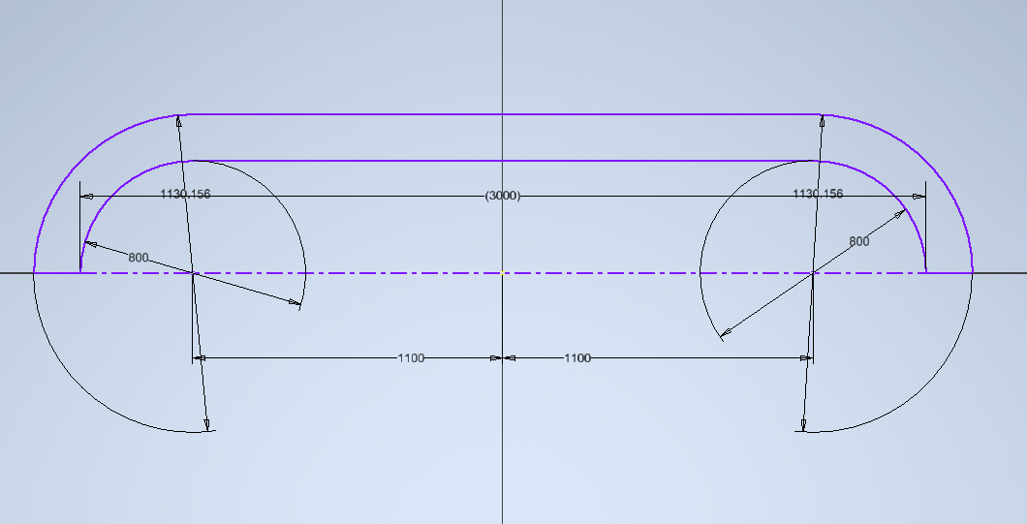

*Fig 1.3 Actual dimensions of the cylinder*

References

Edge, E. (2021). Clavarinos equation thick-walled cylinders of ductile material Calculator and formula. Retrieved 7 August 2021, from <https://www.engineersedge.com/calculators/clavarinos_equation_thickwalled_cylinders_15620.htm>