Atomizer

An atomizer is required to deliver the pressurized oil under high pressure to the combustion unit in a tiniest sprays possible. There are three viable designs for the atomizer: coaxial swirl injector, pintle injector and self-impinging injector. From the above designs the coaxial swirl injector was selected due its ease of fabrication compared to the pintle injector and self-impinging injector. The injector is expected to deliver the pressurized oil with ideal flow characteristics and atomize the fuel adequately.

Coaxial Swirl Injector

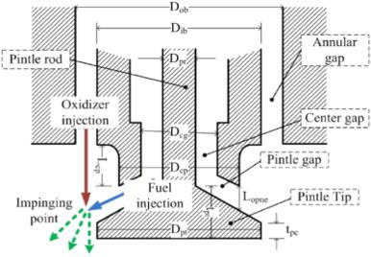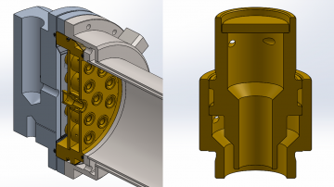

*Fig 1,1 Coaxial Swirl Injector*

Coaxial swirl injector performs the primary function of feeding oil to the combustion chamber. The design of this injector for oil furnace meets the following functional requirements;

1. The oil injector must be able to inject oil into the combustion chamber at the correct ratio and correct flow rates. For this reason the discharge coefficient of the injector must be determinable.
2. The oil injector should ensure complete mixing of oil with air to avoid undesired combustion with might result in the emission of carbon monoxide.
3. The oil injector must facilitate a primary pressure drop of between 10-20% to prevent discharged oil from flowing back into the injection system and causing an explosion.

Design

This swirl injector will consist of two primary parts; the inner element and the outer element. The two elements are placed on different levels separated by a separator plate. The inner element takes in pressurized oil tangentially which causes the liquid to swirl along the wall of the inner section. The pressurized oil enters the outer section tangentially as well and swirls along the wall of the outer element. This results in the pressurized air leaving the inner element in the shape of a cone which collides with the cone formed by the outer element. In this way the pressurized oil and pressurized air each leave each of the elements in a cylindrical manner colliding and atomizing due to the high pressure and velocity of the flow. The configuration is as displayed in figure 1.

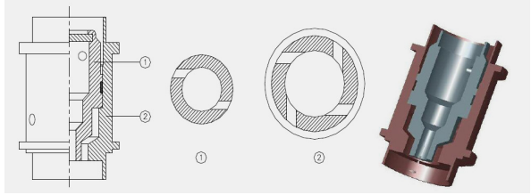

*Fig 1.2 Swirl Injector Exploded View*

This configuration meets the functional requirements of any fuel injector system .The efficiency of the injector for oil of any density can reach as high as 95%. The swirl injector has the following advantages;

1. The design is highly scalable since the assembly can be made bigger by adding the number of swirl elements in the assembly.
2. The swirl and assembly are relatively easy to machine
3. The swirl offers high atomization which is crucial for the conversion of chemical energy to thermal energy
4. The swirl element offers adjustable flow parameters allowing the assembly to create oxygen rich zones and oil rich zones.
5. Swirl elements offer the ability to vary the velocity of the fuel which can enhance the mixing of the pressurized air and pressurized oil.

The disadvantages of swirl injectors are:

1. They are a relatively new type of injector with fewer developed optimization characteristics
2. They require high dimensional accuracy for high performance

The other types of injector designs considered were;

Assembly and Fabrication

The development of the design was done by separating the assembly into five distinct parts:

1. Separator plate
2. Base plate
3. Swirler cap
4. Inner swirl element
5. Outer swirler element

**Swirl Assembly**

The parts were drawn on Autodesk Inventor for the 3D representation. The individual parts were then assembled. A cross section of the assembly is shown below.

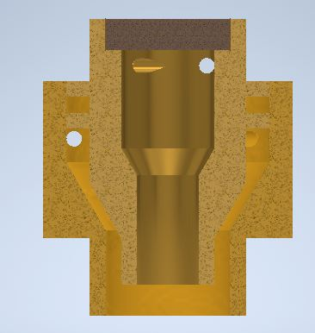

*Fig 1.3 Cross section of the assembly*

MasterCAM was then used to show the fabrication processes.

The cap was machined using a CNC lathe. The first process was facing the stock. This was followed by a rough surface turning on the outer diameter profile followed by a finishing process on the surface. The part was then cut off from the stock using a grooving tool. The tool paths are shown below:

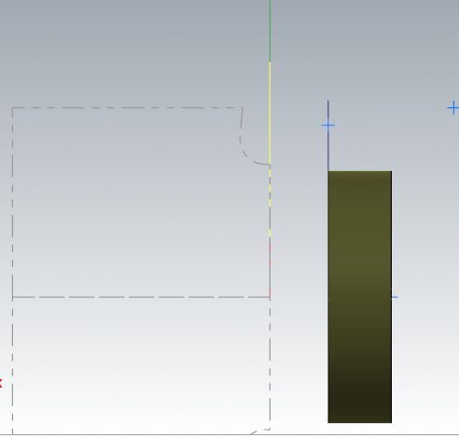

*Fig 1.4 Cap Machining*

The inner element was machined using a CNC lathe. The first process was facing using a right hand turning tool. A rough turning operation was then used to bring the dimensions to closer tolerance of the desired profile. A grooving operation was then used to machine the flanges on the profile. A grooving tool was also used to finish the tapered turning on the end of the part. A finishing turning operation was then done to bring the part to the required dimensions. A diameter 4 drill was then used to drill through the entire part. A diameter 8 drill was then used to a depth of 9mm. An internal grooving tool is then used to finalize the internal profile. The part was then cut off from the stock using a grooving tool. The holes were machined using a five axis milling machine. The figure below some of the generated tool paths.

~~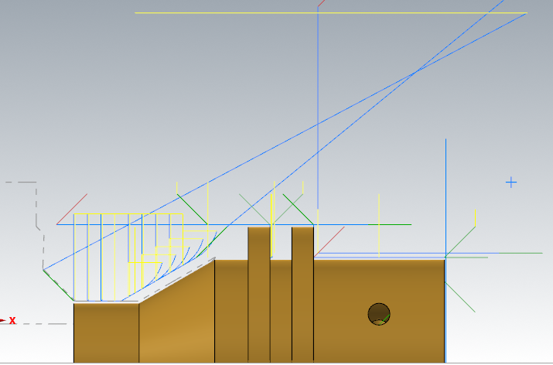~~

*Fig 1.5 Inner element of the swirler*

The outer element was machined using a CNC lathe. The first process was facing. This was followed by a rough turning operation on the profile. A grooving tool was then used to machine the end on the profile where there is a diameter change. The outer element was then finalized with a finishing turning operation. For the internal profile a drill of diameter 8 is passed through the entire stock. THis is followed by a drilling with a 12 mm drill to a depth of 12.12mm. The internal profile is then finalized by an internal turning operation. The part was then cut off from the stock using a grooving tool. The holes were machined using a 5 axis milling machine.

~~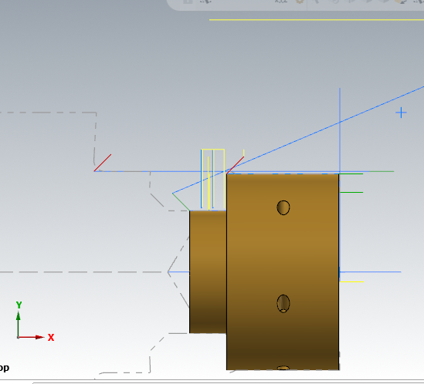~~

*Fig 1.6 Outer element of the swirler*

**Base plate**

The stock of this part was as defined:

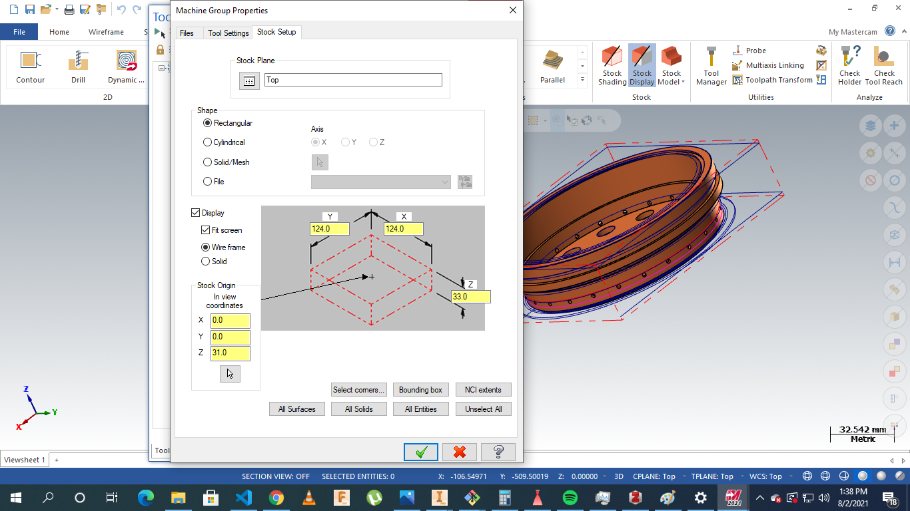

*Fig 1.7 Base plate machining*

The operations were to conducted on a five axis milling. The processes involved include: facing, contour milling drilling slot milling and multi-axis drilling.

The parts were milled as the material to be used was brass.

Operations are highlighted below:

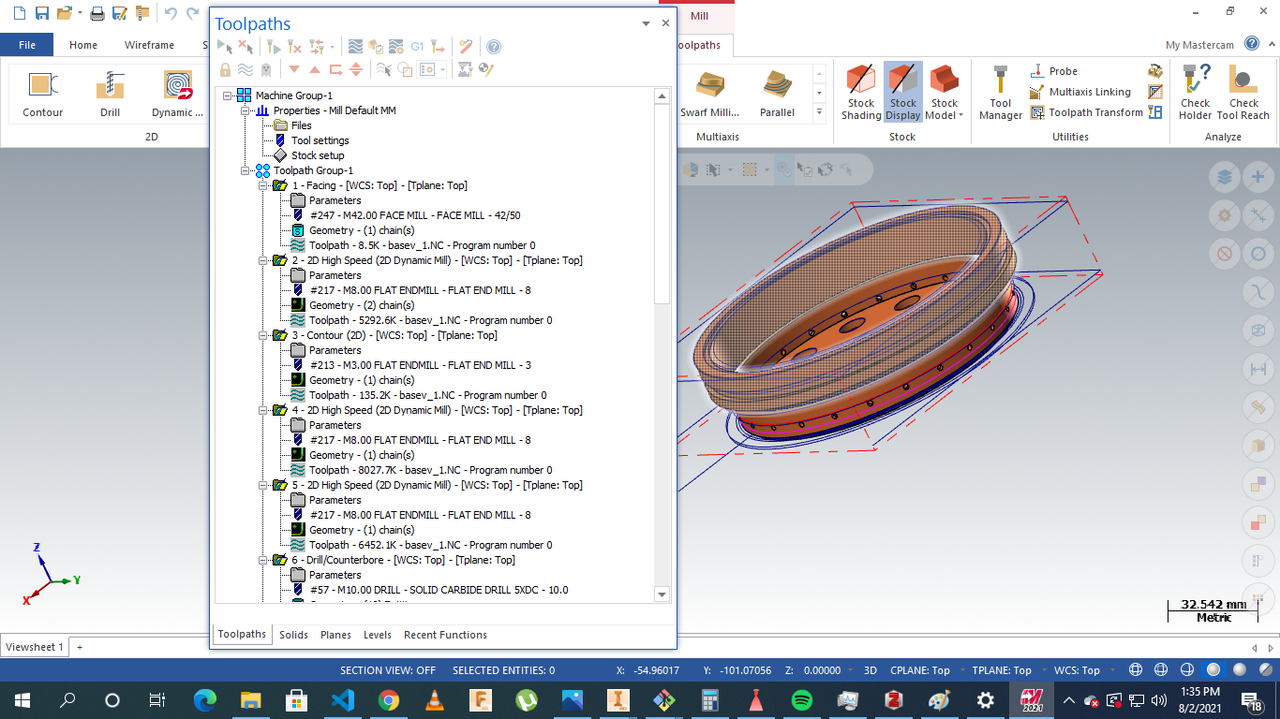

*Fig 1.8 Base Plate total operations*

**Separator plate**

The stock was as defined:

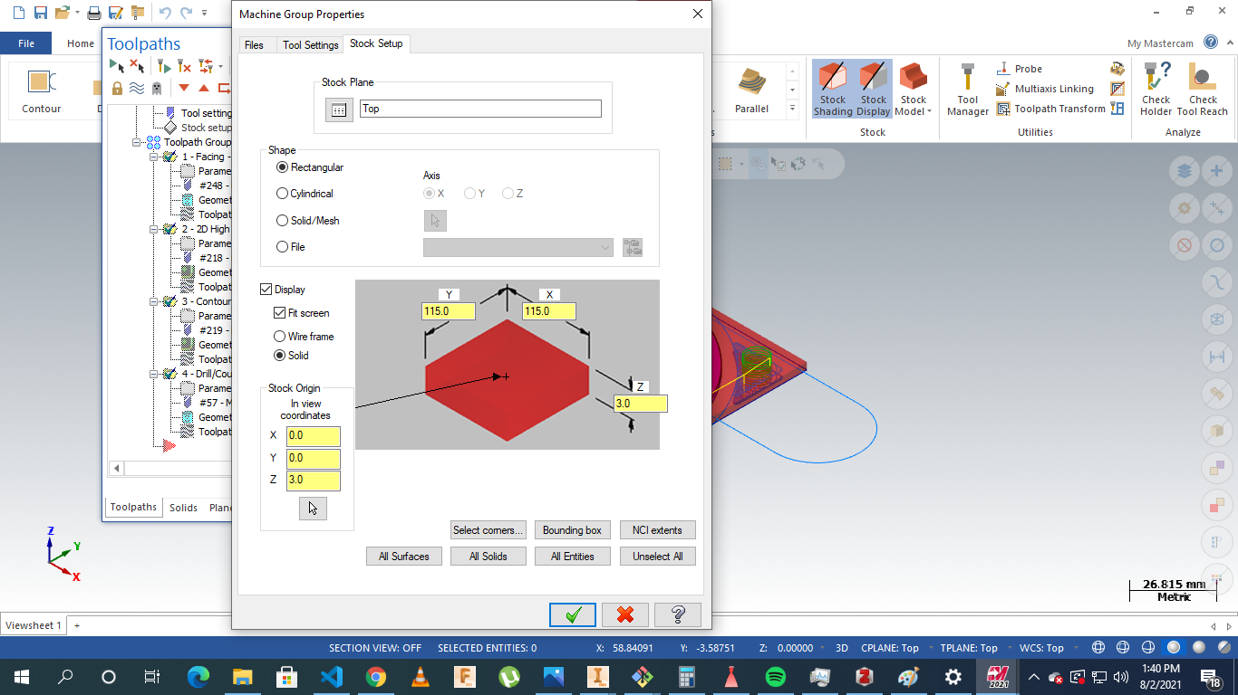

*Fig 1.9 Separator plate stock Setup*

The operations involved: facing, drilling,contouring and parting.

The processes were as displayed :

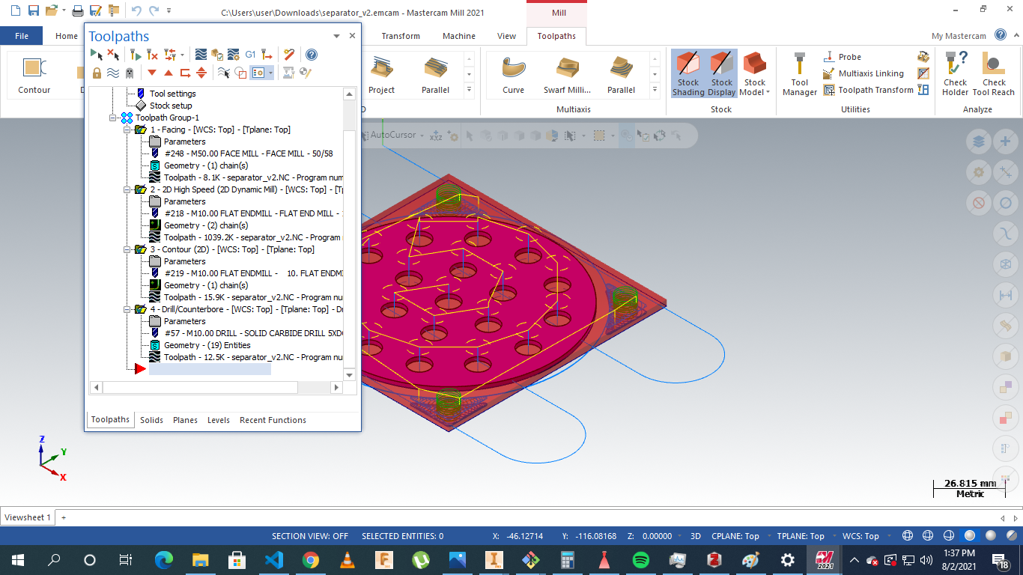

*Fig 2.0 Stock Plate Machining Instructions*

# 

References

[[1] L.-J. Yang and Q.-F. Fu, ‘Theoretical Investigation on the Dynamics of a Gas-Liquid Coaxial Swirl Injector’, *J. Propuls. Power*, vol. 27, no. 1, pp. 144–150, 2011.](https://www.zotero.org/google-docs/?tOBzsF)

2. [1]H. Belal, A. Makled, and M. Al-Sanabawy, “Vaporization-controlled simplified model for liquid propellant rocket engine combustion chamber design,” IOP Conference Series: Materials Science and Engineering, vol. 610, p. 012088, Oct. 2019, doi: 10.1088/1757-899X/610/1/012088.