**JOMO KENYATTA UNIVERSITY OF AGRICULTURE AND TECHNOLOGY**

**COLLLEGE OF ENGINEERING AND TECHNOLOGY**

**SCHOOL OF MATERIALS AND MECHANICAL ENGINEEERING**

**BACHELOR OF SCIENCE IN MECHATRONIC ENGINEERING**

**MANUFACTURING TECHNOLOGY**

**DESIGN REPORT**

**EMG2440**

**GROUP MEMBERS**

**ERIC KIPNG’ENO ENM221-0068/2017**

**JUMA JOEL MWIMALI ENM221-0060/2017**

**Abstract**

Unlike the conventional bridge making procedures that involved making of bridges from a single point, the recent advances in the field of civil engineering has seen the bridge making take a different turn especially on a busy site. It involves developing of bulk construction parts in pieces and from different places and sliding together to the construction site where they are then assembled to come up with the final piece of engineering. The conventional bridge making technique nonetheless involved sliding of construction of parts and equipments on rough paths and between heavy metal surfaces with help of pneumatics, a process that generated high friction between moving parts sometimes leading to failure.

Our proposed design allows for the modularization and distribution of the process modules. It entirely involves replacing the conventional sliding techniques on rough paths and between heavy metal surfaces with a die set (a modification of the caster wheel) to reduce on friction thereby facilitating easy siding. Unlike the conventional caster wheel with normal 15 degrees castor angle, out proposed design, proposes a slight modification of the caster wheel angle to zero degrees and elimination of bearings. However, it also introduces complexity to the project since such parts weigh hundreds of tones. Therefore, we propose the use of High Carbon steel in the manufacture of the die set, to reduce on the stress exerted by the body.

We begin our design process by comparing the normal castor wheel to the proposed die set. We came up with 3D drawings of both the caster wheel and the die in Autodesk Inventor as per the normal dimensions after which we performed stress analysis to be specific static stress analysis and finite element analysis to parts that were complex. Stress analysis will enable us visualize the behavior of both the die set and the castor wheel under in real word environment therefore make design modifications where necessary.

It is expected that our proposed design will be a breakthrough to the already existing techniques as it will eliminate the much experienced friction in the conventional sliding techniques. Nonetheless, the choice of High Carbon steel, high strength steel will reduce on wear and tear and thereby eliminating the need of frequent servicing. From Finite Element Analysis and stress analysis, the results are in tandem to our expectations. The modifications reduced on the maximum stress experienced by the body hence the die set will be ideal in real life situation.

**Design Selection Process**

The design selection process involved consideration of three main factors: the castor angle, the choice of material and the stress analysis.

**Choice of Material**

We considered three materials in the manufacture of the die set, the malleable iron, high carbon steel and stainless steel. The forces that these components will experience must be known in order to appropriately characterize them. The forces in the components are attributable to the top plate's deflection, which is substantial due to the top plate’s length and thinness, as well as the fact that it is only supported at two ends by the axle supports. A static force study was conducted on the top plate while considering the maximum allowable loads to determine of the three which material is less likely to undergo deflection.

The top plate model that was used was a 136mm by 82mm rectangular block with for drilled holes each of 10mm in diameter. It was analyzed using Finite Element Analysis (FEA) because of the complex nature of the geometry. The thin nature of the top plate required that a shell mesh was performed. The figure below shows the representative model of the panel.

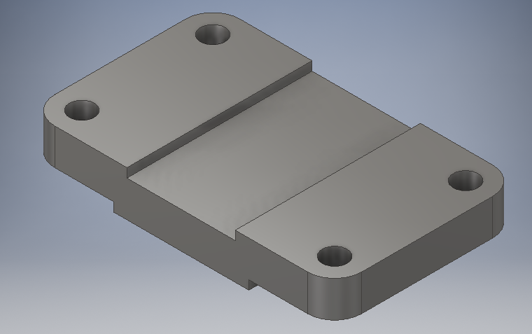

The initial step in the FEA was to define the shell characteristics and mesh the panel using Autodesk Inventor. This model was created with the default mesh relevance. Where and are the maximum and lowest face sizes, respectively. On both the flange risers on either end of the top plate, four fixed supports were used. In all circumstances, gravity is the only force acting on the panel. The gravity force will spread the load evenly across the panel. Below is a diagram of the fixed support placement.

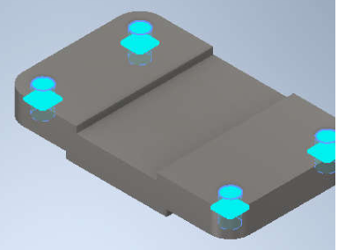

The fixed supports have been placed on this face as this is the intended location for the axle support grip.

# High carbon steel

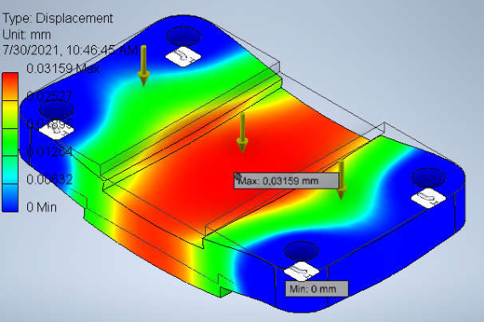

The top plate under maximum allowable load of 100000N with high carbon steel as the material was found to have a maximum deflection of 0.03159m.

# Stainless steel

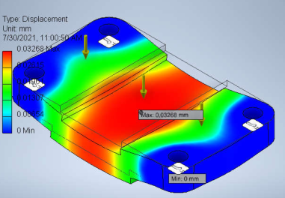

The top plate with stainless steel as the material and with the same loading conditions had a maximum deflection of 0.03268m

# Malleable iron

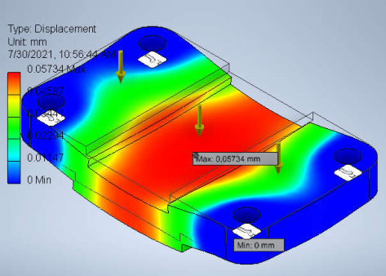

Under the same applied conditions, the top plate with malleable iron as the material was found to have a maximum deflection of 0.05734m

From the above analysis, the top plate under the same loading conditions experienced different deflection depending with the material. High carbon steel had the least deflection, followed by stainless steel while malleable iron had the maximum deflection.

# Material Specification

|  |  |  |  |
| --- | --- | --- | --- |
| Material | High Carbon Steel | Stainless steel | Malleable iron |
| Yield Strength | 275MPa | 215MPa | 241MPa |
| density | 7900Kg/m3 |  |  |
| elongation | 55 |  |  |

**Stress Analysis (Effect of castor angle)**

# Die set (castor angle is zero)

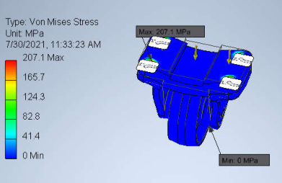

The force was distributed uniformly on the die set based on the stress analysis. The two ends were thought to be fixed to the ground. The results reveal that the frame can support the applied force with the least amount of stress. However, the die set appears to be displaced as a result of the imparted force. Its goal is to add a spring and an absorber to alleviate body stress.

# Castor wheel (castor angle 150)

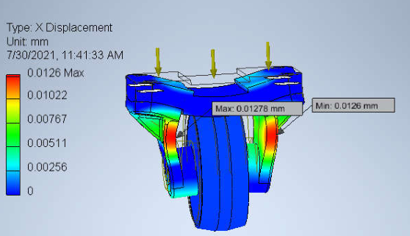

The stress acting on the frame is minimal, according to the stress analysis. As a result, the model should be able to bear the applied load. However, based on this simulation, the top plate is seen bending as a result of the force. It is suggested that the top plate be attached to a support beam to lessen the bending sensation.

From the analysis of the effect of material on the maximum deflection of the die set and the modification of the castor angle, we came to a conclusion that:

* Among the three selected materials: high carbon steel, stainless steel and malleable iron, high carbon steel would be best suited for this application. This is so since it give minimum deflection under the same loading conditions thereby minimal chances of failure or breakages. Besides high carbon steel have very high strength, extreme hardness and resistance to wear, and moderate ductility, a measure of a material's ability to tolerate being deformed without actually breaking.
* The modification of the original castor angle of the castor wheel from 150 to 00 for the die set reduced on the maximum stress experienced by the die set. Besides, the castor wheel with 150 castor angle underwent some deflection in the axle support as compared to the die set which had minimum deflection.

It was based on these two factor s that we decided to manufacture of die set using high carbon steel and with a 00 angle castor wheel based on the excellent properties it exhibited as per our analysis.

**Conceptual Design**

**Machining processes**

# Top Plate

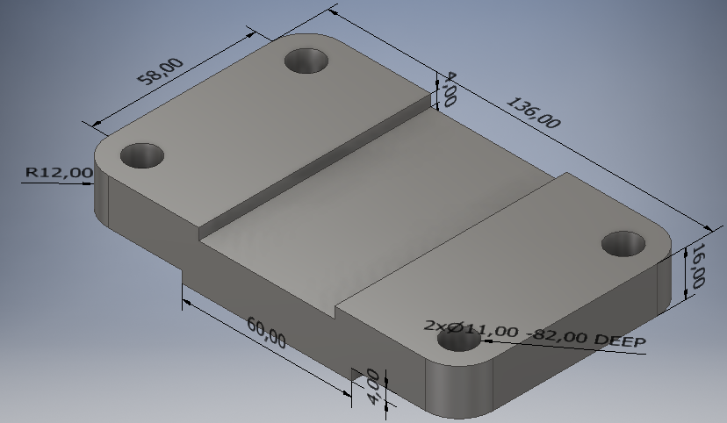

It is a 136mm by 82 mm by 16mm with four 11mm diameter holes

**PART DESIGN:** - design with machining in mind.

**2D MILLING (16mm flat mill)**

- Stock material removal.

- Top groove milling (2mm).

- 2 side grooves milling (2mm).

- Filleting (12mm radius).

**MILLING:** - Milling with mounting in mind.

**DRILLING** (10mm drill)

- Guided drilling (5mm then 10mm)

# Axle Support

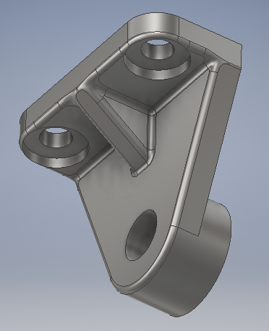

Connects the wheel axle and the top plate

* **Three part machining**

**2D MILLING**

- Stock material removal.

**2D ADAPTIVE MILLING**

- Milling pockets around the rib.

- Milling the gradient of the rib.

- Filleting edges.

- Drilling by milling.

**FINISHING**

- Ball mill for smooth rib gradient.

# Wheel

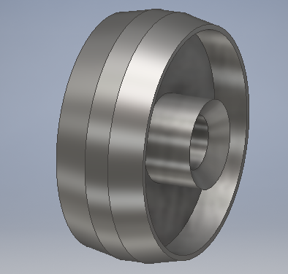

Interfaces with either the rail or the ground

**2D MILLING**

**-** Stock extra material removal.

**2D CONTOUR MILLING**

**-** chamfer milling

**DRILLING BY MILLING**

**-** Circular milling with increasing feed rate.

**Note: - Machining time**

**- Symmetric two part milling.**

# Axle

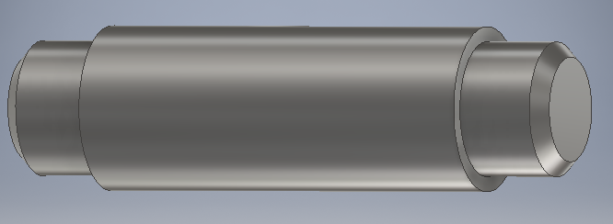

Supports the wheel. Cylindrical, 21.9mm O.D. , 17.9mm I.D. , and 78mm length.

**FACING**

**-** Removal extra stock material.

**PATTERN TURNING**

- Pattern: chamfer, side parting

**NOTE: -** two part milling (symmetric)

**Engineering Assembly Drawing**

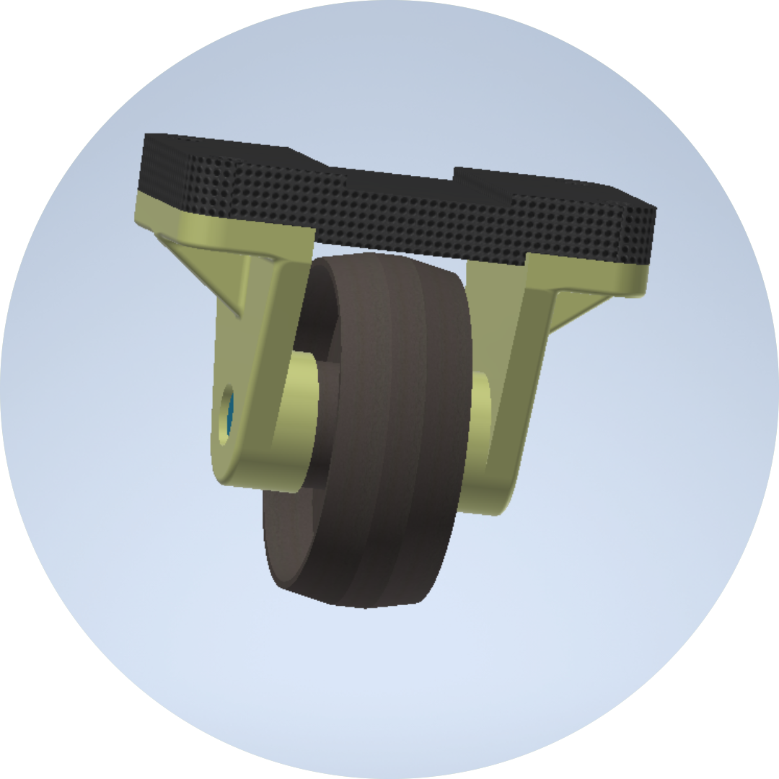

**Exploded view**

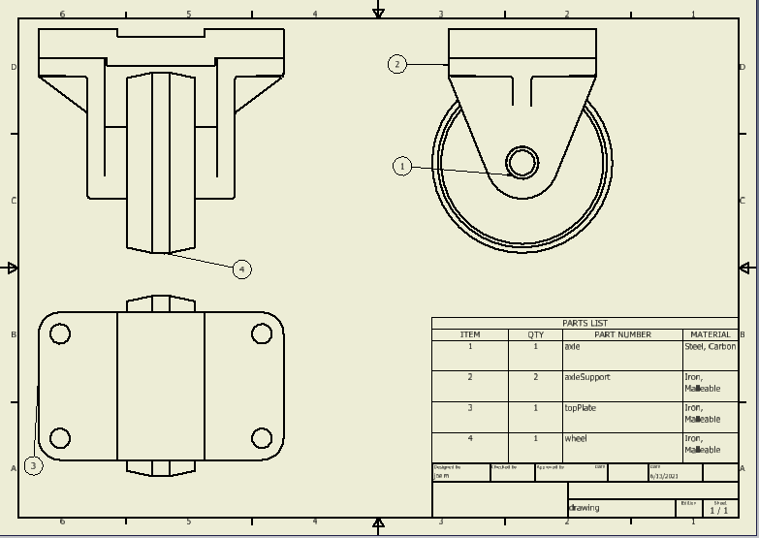

**References**

Groover, M. P. (2020). *Fundamentals of modern manufacturing: materials, processes, and systems*. John Wiley & Sons.

Kalpakjian, S. (1984). *Manufacturing processes for engineering materials*. Pearson Education India.

Altintas, Y., & Ber, A. A. (2001). Manufacturing automation: metal cutting mechanics, machine tool vibrations, and CNC design. *Appl. Mech. Rev.*, *54*(5), B84-B84.