Problem
In efforts to optimize production of plants, controlling the environmental conditions around the plant is also key. Growing plants in a controlled green house environment proofs to be insufficient for some plants. Light intensity is one of the parameters that when carefully controlled guarantees optimized production. Light intensity levels of around 100,000 lux is required for the growth of the plant. In a green house, the intensity of light can range from 3000 lux to around 130000 lux. At 4000 lux, the growth of a plant is inhibited.
Proposal
At winter, light intensity in a green house could go as low as 3,000 lux. To boost this to a level that will not inhibit the growth of the plant, requires the use of artificial source of light. Using the two light sources requires great control in order to ensure that maximum light intensity required by a plant is not exceeded, and also energy is saved. By detecting and measuring the intensity of solar UV light using a sensor module, we can be able to measure the intensities of the solar UV. Using this data, we can be able to control an artificial source of UV light using incandescent UV light.
Solution’s Problem
When measuring solar UV light while the artificial UV light is ON, the recorded data will not be accurate due to the noise from the artificial UV source. The solution to this problem can be re-calibrating the solar UV light sensor module to be able to measure solar UV light in presence of artificial UV light by factoring in the noise from the artificial light source. Another simpler solution is to use a digital signal processing algorithm to factor in the noise in the data and produce more reliable and accurate data.

Data flow chart
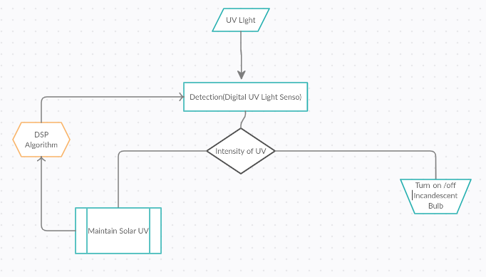

Project Setup
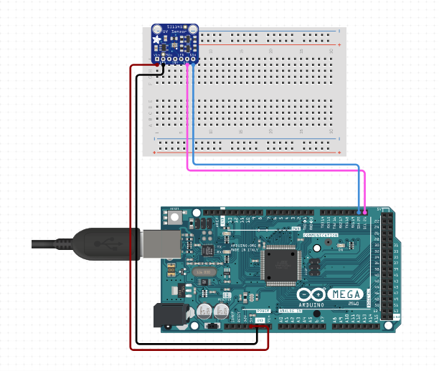
This represents only a part of the project. This shows the a SI1145 Digital Solar UV light sensor connected to Arduino Mega 2560.
Data from the Digital UV light sensor will be inaccurate in the presence of artificial source of UV light.

Actual project setup
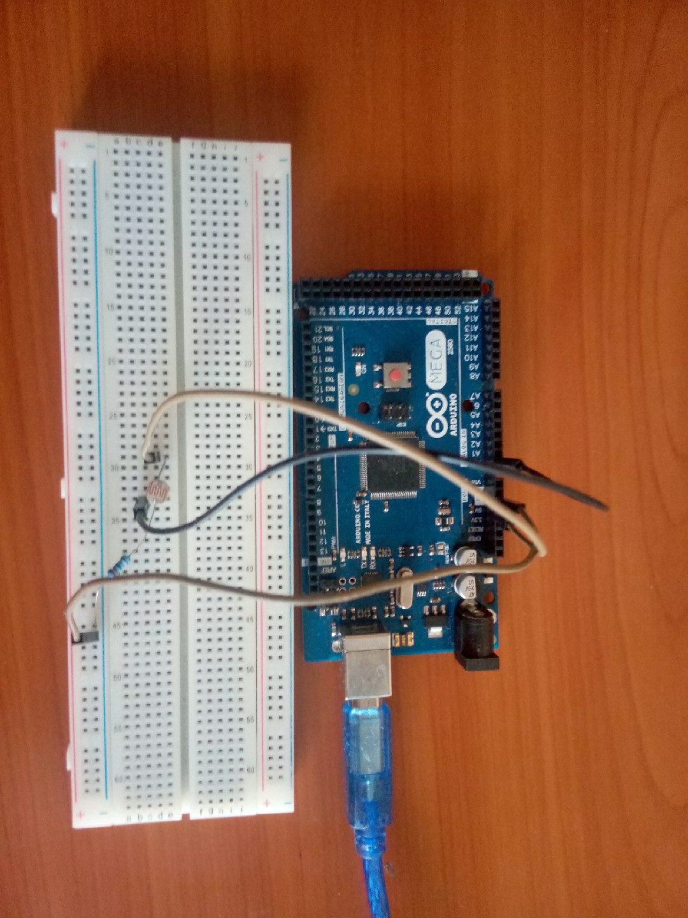

The actual setup uses LDR resistor in place of Digital Solar UV module. Light intensity is captured by the resistor and data is plotted real time using matplotlib as below.
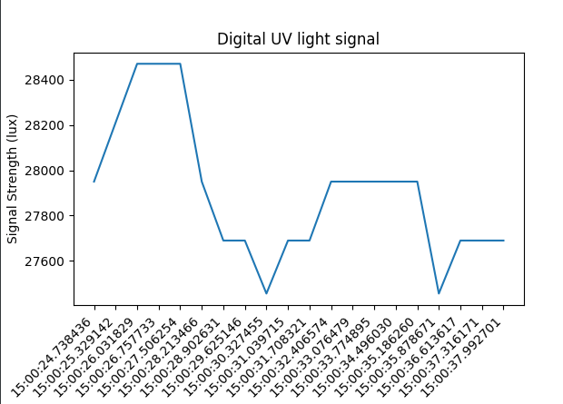

Jitter in data sampling
Jitter is the main cause of misalignment in electrical and optical data streams resulting to bit errors.
Way of detecting jitter
By using an real time sampling oscilloscope connected across the Digital sensor module, we can measure jitter to the highest bit rate. The oscilloscope is set to plot a time-interval error then by using a fast fourier transform of the timing error plot scaled to 1MHz/div reveals the frequency of the jitter.
Digital Signal Filtering
By using an IIR digital signal filtering algorithm, we can be able to filter out the noise from the artificial source of UV light.
IIR Filter
This is a network of several filter of the same kind, organized such that the output of one filter is the input of the next filter. At every stage the results are refined such that at the end of the pipeline of filters, the results have very minimal noise. This is done real time as the data from the sensors are detected. The same data is used in the filter.

Links Used
Topic: Jitter in data sampling, Link: https://www.edn.com/measure-jitter-three-ways/
Topic: Intro to signal processing, Link: https://www.researchgate.net/publication/324727059_IIR_based_digital_filter_design_and_performance_analysis

