**My task:**

My task on the game TurnAround Was mostly level design and handling some minor fixes and features as I was the one to merge it all on my scenes.

Making level was what took me the longest time.

# Task :

## Arrow :

I did the arrow to show the next gravity rotation because otherwise it was hard to plan a route as it was.

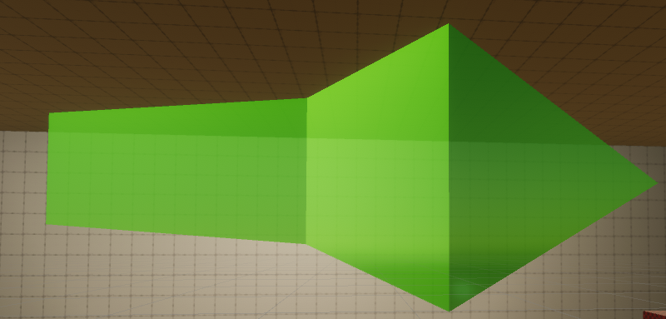

# Death zone :

These zone kill the player on collision.

# Robot vending maching :

This is the Robot machine I made.

# Level design

My biggest challenge was to think the levels in the 6 directions.

My biggest regret is that I don’t feel like I did a good enough job to make maps to show how the gameplay could have been.

To be honest, if we had worked a little more on the game, I feel like we could do something very fun, but I am satisfied.

Vending Maching:

https://sketchfab.com/3d-models/low-poly-vending-machine-1f698b4d051f46d282b6c6a044b50e0a