**Eric Williams-Phillips**

**CSD 310 Module 1 | Assignment 1.2**

**Part 1 Screenshot:**

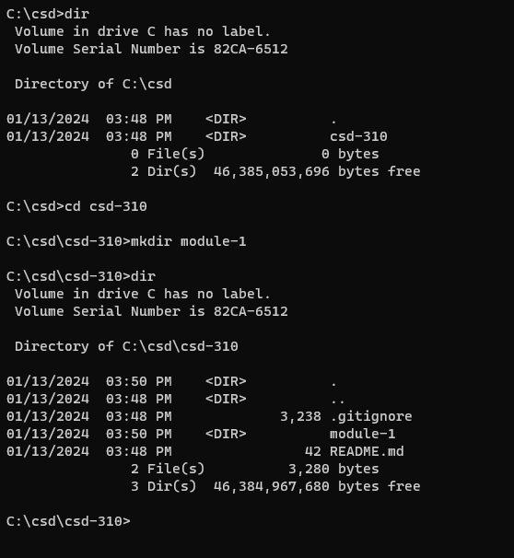

**Part 2 Screenshot:**

Link to Repository - <https://github.com/EricsMemory/csd-310>