# California State University, Fresno

# DEPARTMENT OF COMPUTER SCIENCE

|  |  |  |  |  |  |
| --- | --- | --- | --- | --- | --- |
| Class: | **Algorithms & Data Structures** | | | Semester: | **Fall 2020** |
|  | | | | | |
| Points |  | Document author: | **Eric Smrkovsky** | | |
|  | Author’s email: | [**EricSmrk@mail.fresnostate.edu**](mailto:EricSmrk@mail.fresnostate.edu) | | |
| Laboratory number: | **Lab 1** | | |
|  | | | | | |

**1. Statement of Objectives**

Introduce the elements of this experiment. Include a description of the objectives, scope, significance, and major accomplishments of this lab. Briefly explain what is covered in this report.

The objective of this lab is to understand two types of linear data structures. The linked list is represented with nodes and pointers while the stack is represented using an array. The scope of this lab is held within understanding *only* linear data structures and will probably become tools that I can use to build larger data structures. While coding up this lab, I was able to review some of the difficult coding problems that I learned in CSCi 41 while refreshing my mind on how these two common data structures are constructed with pseudocode as well as C++ code. I will now explain how I was able to complete the lab, what I learned, a problem I had, and I will share the materiel I viewed to help me finish.

**2. Experimental Procedure**

List the procedure used in this lab. Include how you approached the question and why.

***Stack:*** After reviewing how to code classes in C++ I read over the hints and started to code each step one at a time. I paid close attention in the lab so I could have a good understanding of some of the extra precautions needed. This includes knowledge of “stack underflow” and “stack overflow” within pop and push methods.

***Linked list:*** After reviewing how to code structs, I reviewed a lab that I did in CSCi 41 where we coded a doubly linked list in C++. I read over the hints and started to code each step one at a time. I paid close attention in the lab so I could have a good understanding of some of the extra precautions needed. This includes basic knowledge of how pointers work in C++ as well as how to traverse a linked list by using a temp variable. I am still unsure if I did this in the most efficient way, it seems that if I were to keep track of the number of nodes as they were created, I might have been able to avoid having to traverse the list to delete nodes.

**3. Analysis**

Discuss the experimental results. Include the screenshots of the results.

Both programs came out well for me, and I believe that I did them correctly. I made sure that my output matched the expected output for both problems. I followed every step in the order that they were presented and I was able to achieve the results that I expected.

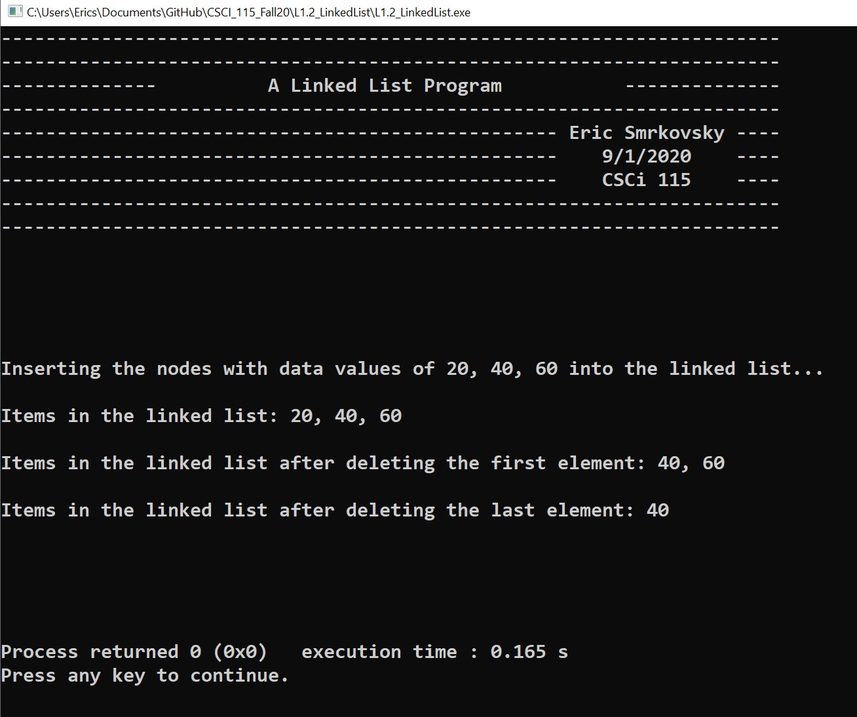

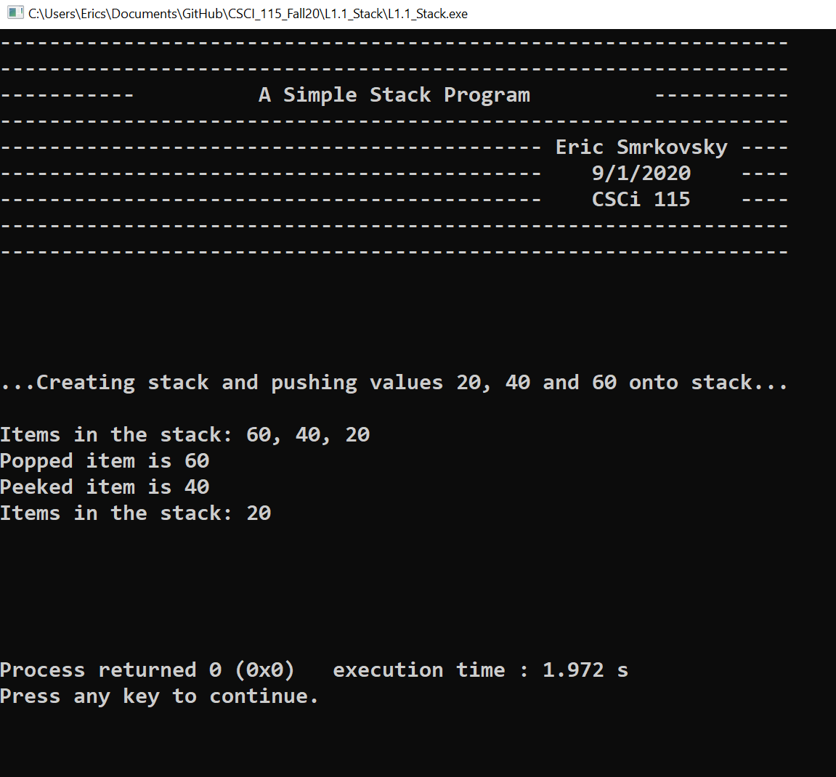

**4. Encountered Problems**

Describe the issues you faced and how you tackled them. Also, you can explain if you could not solve the issue. You should also include errors and discrepancies.

***Stack:*** This program went well for me; I did not have any issues.

***Linked list:*** I struggled at first with this program because I tried to write a class for the linked list methods. I was running into errors and I could not figure out why. So, I reverted to only using function definitions and was able to successfully complete the lab.

**5. Conclusions**

Summarize your conclusions with a list of what you learnt in this lab.

I learned how to write my own insertion and deletion methods pertaining to list data structures. I was able to sharpen my C++ coding skills when it comes to pointers, classes and understanding how to access memory locations. I also learned that I should start sooner with coding these labs, because it seems that they will take up about 10 hours of my time this week. I look forward to the rest of this class, challenge accepted.

**6. References**

List the references used in this report.

***Stack:***

https://www.cplusplus.com/doc/tutorial/classes/

***Linked list:***

<https://www.learncpp.com/cpp-tutorial/47-structs/>

https://www.cplusplus.com/doc/tutorial/classes/

https://www.cplusplus.com/doc/tutorial/pointers/

https://www.codesdope.com/blog/article/c-linked-lists-in-c-singly-linked-list/

Code from my CSCi 41 class with Dr. Jamison at FCC