**Amazon Data Visualization Analysis**

**#1** (总体极端评分比一般评分数量更多）

After extracting all product’s star rating from the Amazon dataset, the histogram illustrates the distribution of products across different ratings (from 0 to 5, inclusive). The number of products rated **5 stars** is the **highest**, while the count of products rated below 1 star, although smaller, is still significantly higher than the number of products rated between 1 and 4 stars.

This distribution may suggest that **users are more inclined to** **leave reviews when they feel extremely satisfied or dissatisfied, whereas they are less likely to provide feedback for products they find average or unremarkable**.

**#2** (实用性强的家居个护类产品为amazon平台的消费主流)

category vs bought in last month

By aggregating the boughtInLastMonth field to calculate the sales for each category, it was observed that Kitchen & Dining emerged as the category with the highest sales volume, followed by Hair Care Products and Industrial & Scientific, among others.

This can indicate that, **essential and practical household categories that related to daily life dominate the consumer purchasing behavior on Amazon.** Amazon’s main consumer demographic tend to allocate their spending towards functional, necessary household and personal care products.

**#3** (高折扣未必吸引高销量，见#5的correlation)

discount vs bought in lats month

Significant discounts can sometimes boost sales. The plot has some high sales points at the higher discount levels, which suggest that certain products may have attracted significant purchases due to extreme discounts.

However, this plot also shows that the majority of products maintain lower sales volumes even at higher discount rates. This suggests that **although higher discounts may have a positive impact on sales in some cases, the correlation is not that strong**.

(Discounts alone do not determine sales volume; other factors such as price, star rating, or even targeted audience demographic also play crucial roles)

**#4**

category vs rating

This output highlighted the top five categories with the highest and lowest average ratings.

Gift Cards received the highest average rating, and we can see that **products related to everyday use and have practical value yield high satisfaction**, such as Health & Household and Kitchen & Dining.

Conversely, **Computer Servers** had the lowest average rating. Among the low-rated categories, technically complex or higher-priced items, such as **Computer Servers** and **Smart Home Thermostats**, tended to receive lower scores. This could be attributed to h**igh user expectations or the complexity of use,** which may result in **dissatisfaction**.

(结合上文#2可知，高销量的category倾向于有更高的rating，两者correlation见#5，which means amazon的消费者行为更容易受评分影响？后期与temu进行比较)

**#5**

some noticeable correlation:

**Stars and Price (-0.082226):** Although this correlation is not too strong, the correlation between star ratings and price is slightly negative, indicating a potential trend that higher prices might elevate consumer expectations. When these expectations are not met, it can lead to lower ratings.

(比较temu数据，amazon的消费者是否对产品有更高的期待？)

**Stars and Discount (-0.077894)**: The correlation between ratings and discount is also low and negative, indicating that the size of a discount does not directly determine a product’s rating.

Higher discounts might be perceived by consumers as a sign of low quality or reduced value, potentially impacting ratings negatively.

**Stars and BoughtInLastMonth (0.062862):** This positive correlation between monthly sales and ratings, suggesting that products with higher ratings may experience slightly higher sales.

(同样，对比temu数据，可知评分对于不同平台的消费者影响差异)

**BoughtInLastMonth and Discount (-0.088046)**: There is a weak negative correlation between monthly sales and discount, which implies that while higher discounts may boost sales for certain products, not all discounted products achieve high sales. (#3)

（amazon和temu对于打折产品的追随程度是否有不同？）

**BoughtInLastMonth and Price (-0.027494)**: The negative correlation between price and monthly sales volume indicates that higher-priced products tend to have lower sales volumes.

**#6**

**Product Distribution by Target Audience:**

It is evident that the "Children" category has a significantly higher number of products compared to the "Women" and "Men" categories. It indicates a high market demand for children's items on Amazon (family-oriented and child-focused consumers).

**Average Stars Rating by Target Audience**

Although the differences in average ratings among the target audiences are minimal, the slightly higher rating for products aimed at men may indicate that these products are more successful in meeting consumer expectations.

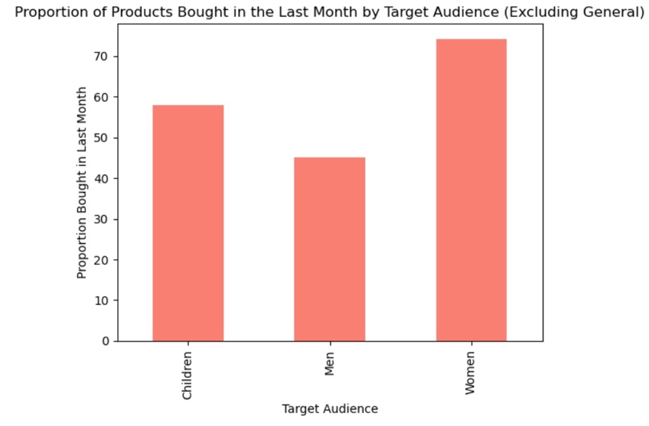

**Proportion of Products Bought in the Last Month by Target Audience**

The higher purchase activity for products targeted at women indicates that female consumers exhibit higher purchase frequency. This trend may be related to women's consumer habits in certain categories, such as beauty and skincare products, where frequent purchases are more common.

The data suggests that Amazon successfully meets the needs of female consumers, who may be driving a significant portion of the platform’s transactions due to their active shopping habits.

（可对比temu销量较好的category，来分析两者的主要消费群体差别）

**Average Price by Target Audience**

The higher average price for male-targeted products likely reflects the tendency for male consumer items, such as electronics or outdoor equipment, to be priced higher. These items are typically less frequently purchased due to their higher cost and longer usage lifespan

（所以男性在Proportion of Products Bought in the Last Month by Target Audience中表现一般）

Women generally tend to make more frequent purchases across a wider range of product categories. female-targeted products might include items such as beauty products, skincare, and household goods, which are more affordable on average, but often consumed more regularly and need to be replenished frequently, driving higher purchase activity.

The lower price for children’s products aligns with expectations, as products for this demographic are generally more affordable.