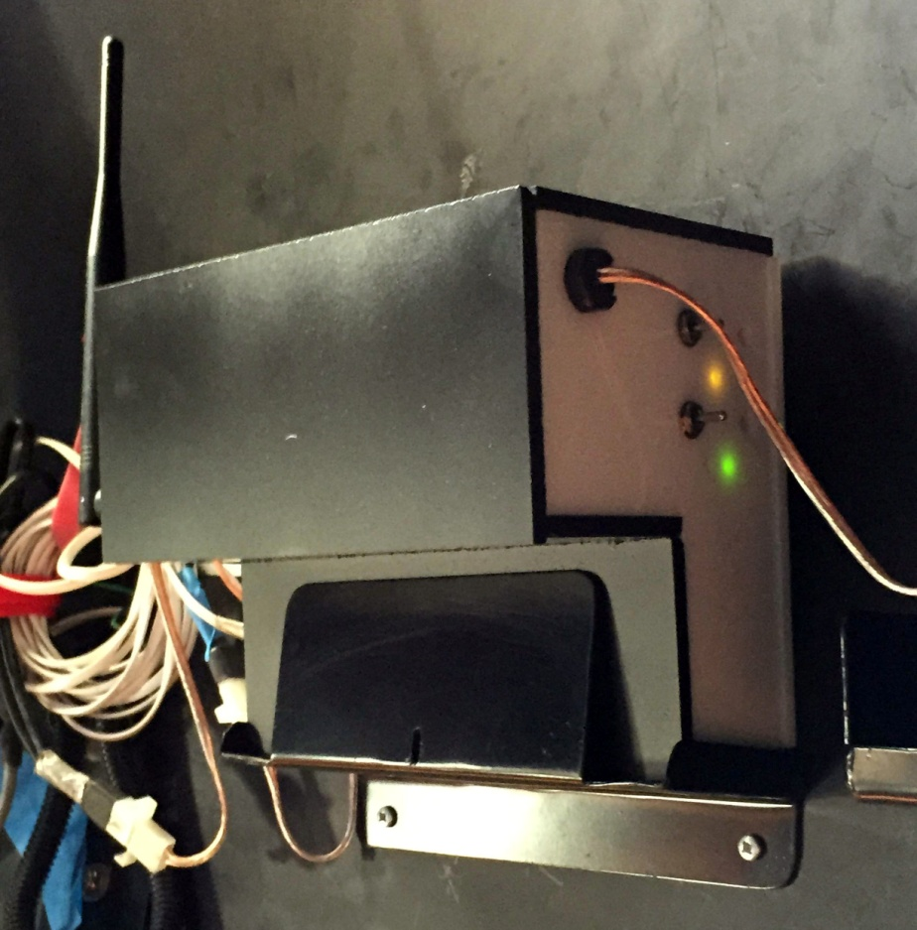

Shutter Controller

**BrewSky Observatory**

**Robert Brewington**

**eridanibrew@gmail.com**

**4/28/2015**

[Type the author name]

[Type the abstract of the document here. The abstract is typically a short summary of the contents of the document. Type the abstract of the document here. The abstract is typically a short summary of the contents of the document.]

Contents

***Replacement for Foster System Shutter Controller*** 3

Overview 3

Design Points 4

Construction Notes 6

Construction Details 7

ShutterControl 11

Manual Operation 11

SimpleShutter 12

SimpleShutter Controls 12

Shutter Operations 14

Options Tab 15

Configuration Tab 16

Shutter Controller

Replacement for Foster System Shutter Controller

# Overview

Since the initial implementation of my Exploradome I have been frustrated by the Foster System shutter controller. The Rotation controller has worked well, although it seems to have some minor problems working with ACP. Also, the hardware seems to work well in both the rotation and shutter units. However, the shutter software is error prone and has been difficult to work with. For the last 3 revisions of the Foster software my shutter has been completely inoperable. So, I decided to build a replacement unit for the shutter controller. I continue to use the Foster unit for rotation; the new unit only handles opening and closing the shutter.

My system is an Exploradome I 8 foot dome with Foster Automated Rotation and Shutter controller system. I use ACP for imaging. The observatory has a dedicated HP desktop computer (Win 7 64 bit). The observatory is generally operated remotely.



Figure . Controller mounted on dome wall. The two switches allow manual operation. The Yellow LED flashes indicating internet communications; the green LEDs indicate the shutters are closed.

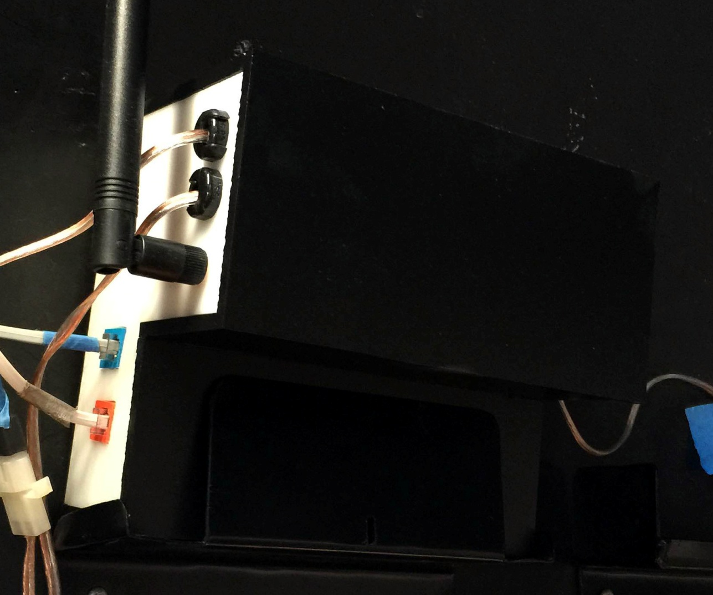

Figure . Opposite side of controller, showing the WiFi antenna, power to shutter motors, and RJ11 connections for shutter limit switches.

# Design Points

* The shutter controller is based on an Arduino Atmega 2560. I started with an R3 Uno, but discovered that the shields used all of the available pins. I need a number of pins for status LEDs, shutter switches, etc.

The Arduino uses 2 shields.

1. One is the Adafruit cc3000 shield which provides wireless internet access from a computer. It uses the Adafruit_cc3000 library to implement a server in the Arduino.
2. The second shield is the Monster Motor shield from Sparkfun. This shield provides the high current required by the DC motors in the shutter. I was very nervous when I first connected power to the shield, but it worked perfectly. Sparkfun provides a sample program showing how to work with the shield. I basically created functions to run the motors based on their code.

* 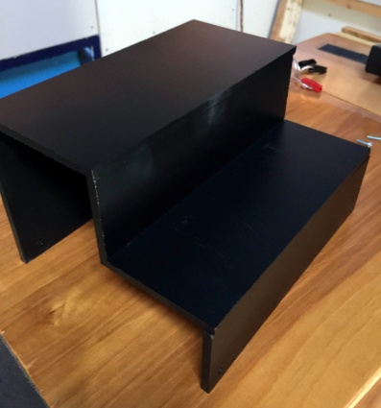The controller is encased in a box made from 1/4 inch plexiglass. It turns out that plexiglass is somewhat translucent, and the Motor shield has a very bright LED indicating power. This caused the entire box to glow red, which is not good in the observatory! I fixed this by a) placing a small piece of tape over the LED, and b) painting the white plexiglass with black spray paint.

Figure . Controller cover painted black to block LED light.

* 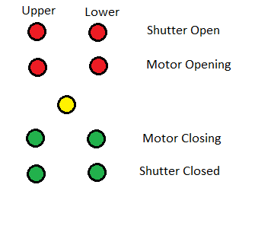There are 9 small (3 mm) status LEDs on the side of the box. I was concerned that these would be too bright, but the 1000 ohm resistor keeps the current low enough that they are suitably dim. The LEDs mirror the lights in the program SimpleShutter.

One yellow LED is the "heartbeat ". When power is applied it is steady for 15-20 seconds while the Arduino connects to the network. Subsequently it flashes roughly once per second when it checks for incoming commands.

Each motor (upper and lower shutter) has 4 LEDs. The top red LED indicates the Open limit switch is active. The bottom green LED indicates the Closed switch is active. The other red LED is on while the motor is running to open the shutter. The second green LED indicates the motor is running to close the shutter.

* Two SPDT switches on the side of the box allow manual manipulation of the shutters. Opening and closing operations correctly stop based on the limit switches, but there are no other checks on the shutter positions. For example, you could potentially try to open the lower shutter while the upper shutter is still closed; this can cause shutter damage. The assumption is that manual operation means you are present and not doing something stupid.
* Power to the Arduino comes from the same 35A power supply used to perform dome rotation. The 12V supply comes into the terminal block on the base of the box. From there, the 12V runs directly to the Monster Motor shield for application to the motors.

The 12V supply is also routed to the small circuit board, where a SWADJ3 voltage regulator takes the voltage down to about 7.2V. This voltage is then supplied to the Arduino via the Vin pin. The Arduino can be supplied by 12V directly, but this might generate a lot of heat (the Arduino includes its own voltage regulator to get the voltage down to 5V). The Arduino needs about 1-2 amps to run the itself and the two shields. The cc3000 in particular can draw momentary power when running its radio; too little power can lead to strange internet communication problems.

* The small circuit board also includes a TMP36 temperature sensor. It is powered by the 5V pin on the Arduino, supplying a voltage to pin A10. The SimpleShutter program displays the temperature in degrees Fahrenheit. See the instructable on the Adafruit site for using the TMP36 chip.
* The small circuit board also uses a small voltage divider across the 12V supply to run a voltage to pin A8. This allows SimpleShutter to display the current voltage to the controller.
* Note that the shutter limit switches are normally closed; they become open when the switch is engaged. In the RJ11 connector pins 1&4 reflect the Shutter Open switch while pins 2&3 reflect the Shutter Closed switch. I imagine that different installations could be different:)

# Construction Notes

* The box is sized to fit the existing bracket already mounted on the dome. The top portion is thicker than the original Foster controller to accommodate the height of the Arduino stack (the shields add significant height, especially because I used double headers to connect the shields). This served two purposes:

1. this leaves more space between the shields. I am nervous about generating too much heat in the shields.
2. The shields can have conflicts, needing to use the same pins. In this case the two shields only have one pin in conflict- they both expect to use pin 10. My solution was to cut the header pin for pin 10, so pin 10 does not propagate to the motor shield. I then connect pin 45 to pin 10 on the motor shield. The Arduino sketch then uses pin 45 instead of pin 10, but the shield sees the signal on pin 10.

* I had to manually cut holes for the RS232 ports using a coping saw, then sizing them using a Dremel tool. Run the Dremel on low speed to avoid having the plexiglass melt.

I also had to use the Dremel to enlarge 1/2" holes drilled for the strain relief grommets. Strangely, 1/2" holes were too small for the grommets while 5/8" holes were too large.

* My original manual switches did not have a long enough threaded shaft to reach through the plexiglass. I had to find switches with a 3/8" shaft to allow the mounting nut to screw on.
* The status LEDs are connected to the Arduino using extension jumper cables. Unfortunately the LED wires do not fasten tightly to the connector, so I added a bit of glue from a hot glue gun to hold the wire to the connector.

# Construction Details

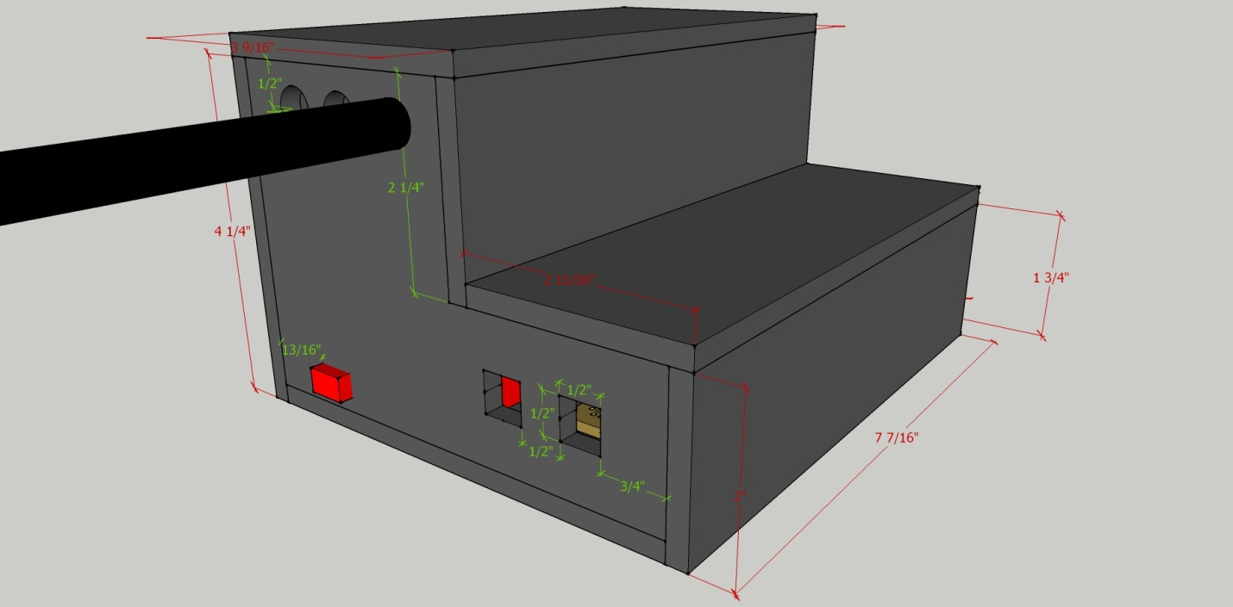

Figure . Controller dimensions.

Here are views of the interior of the box. I wired directly to the LEDs and manual switches rather than using an intermediate circuit board. I used nylon screws to attach the Arduino and circuit board to the box. The RJ11 connectors were glued.

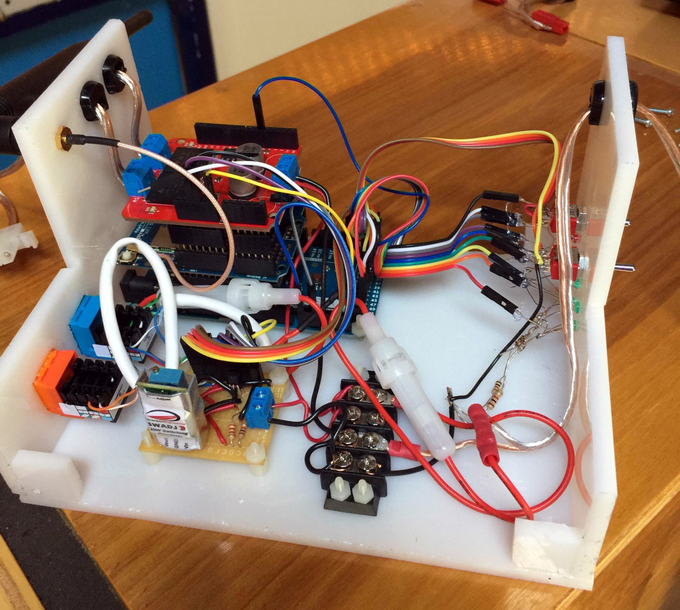

Figure . Interior of controller

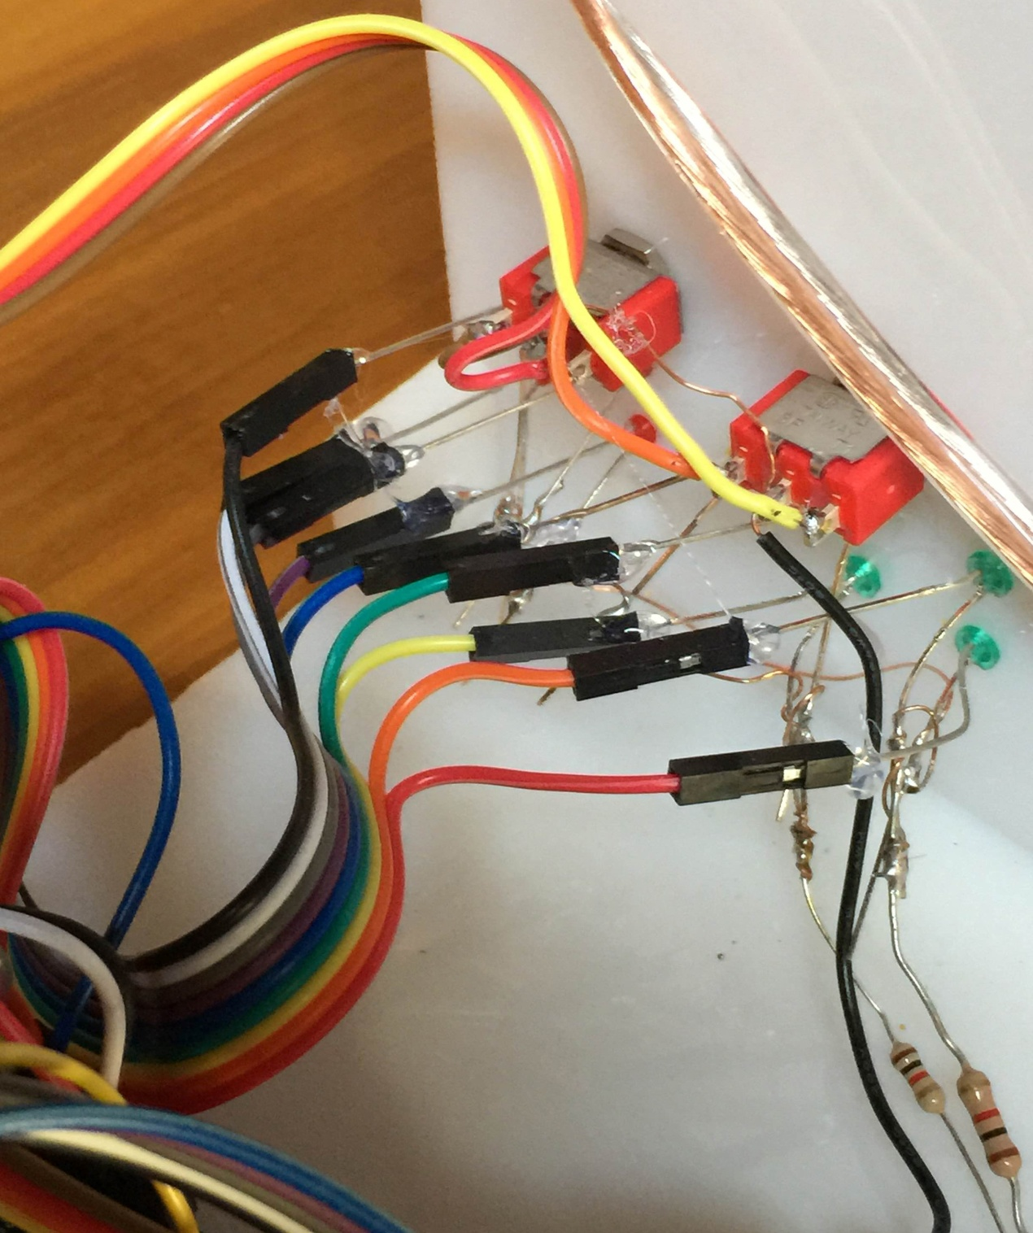

Figure . Extension cables connecting the LED wires to the Arduino. Note the hot glue used to ensure the connectors stay in place.

This image shows the headers between the shields. Note the cut header pin for pin 10.

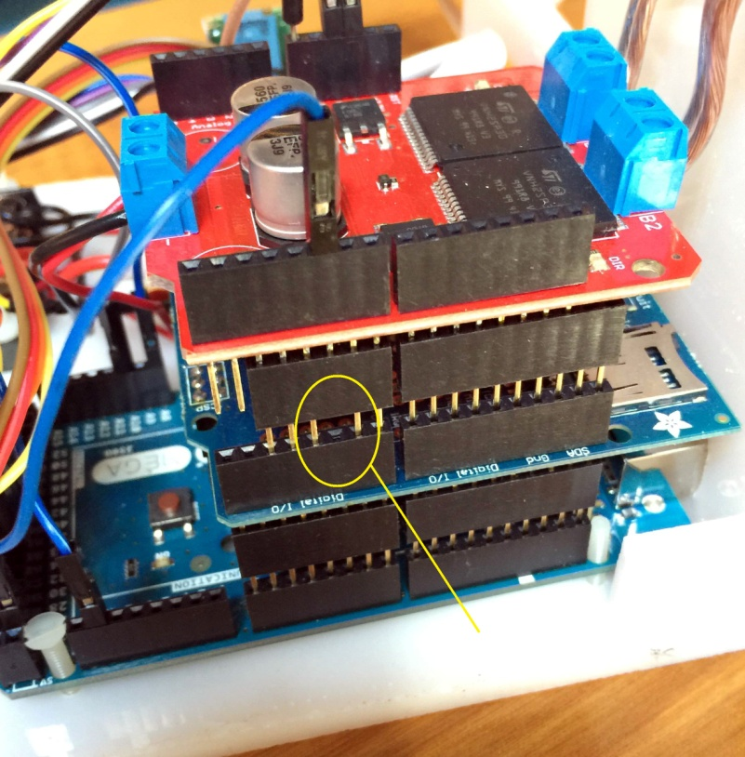

Figure . Double headers used for the shields. Note the clipped pin 10 so the red motor shield does not receive pin 10 from the Arduino. The blue connector routes pin 45 to pin 10 on the motor shield.

This image shows the wiring between the components. The circuit board on the left is how I wired it (my second version). I set the wire colors to match the actual jumper wires used, so I can reconnect the wires if they come apart in the future.

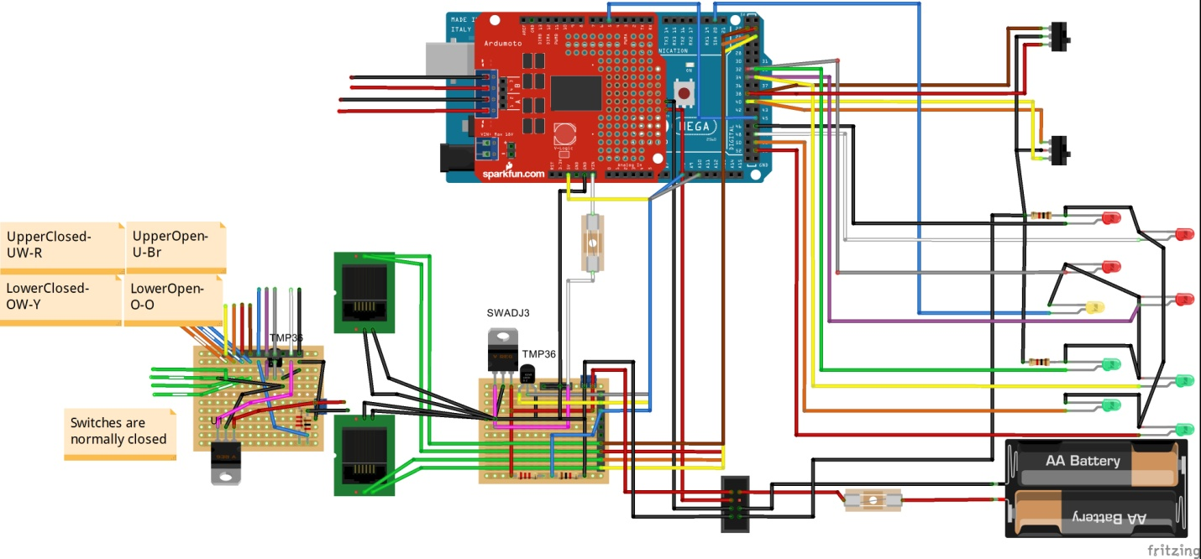

Figure . Wiring of the controller components

# ShutterControl

The Arduino is programmed with the version 1.06 IDE. The main sketch is *ShutterControl.ino*, and has two supporting files:

*ShutterIO.ino* - handles the motor functions

*cc3000.ino* - handles communications with the wireless shield.

To install the ShutterIO sketch into the Arduino, you need to install the Arduino IDE. You also need to install the Adafruit_CC3000 libraries.

Note: you will need to set your WiFi name and password in the Arduino code before it is installed. The IP address of the Arduino is initialized by one of the Adafruit sample programs.

Connect the Arduino through a USB cable and download from the IDE into the Arduino. This process can be done from another computer, it does not have to be the observatory computer. Once the Arduino is loaded it retains the program even when powered off. When the Arduino is powered, or the internal Rest button is pressed, the program restarts.

When the program starts, the yellow status LED on the side of the box lights steadily while the Internet communications are established. The yellow LED then blinks steadily every second or so; each blink corresponds to checking for a connection request from the controlling program SimpleShutter which provides a user interface to send the Arduino commands to open or close shutters.

# Manual Operation

When in steady state mode (flashing yellow LED) the user can manually open and close the shutters using the switches on the side of the case (See Figure 1 for the switches and the yellow LED). The left switch Opens/Closes the upper shutter; push the switch from the center position (off) to the upper position to open the shutter, push the switch to the downward position to close the shutter. The right switch works the same for the lower shutter.

This functionality is intended for use when doing shutter testing or doing maintenance tasks.

# SimpleShutter

The manual switches are available for debugging purposes, but it is expected normal operation will be through the program SimpleShutter. This program sends commands and receives status from with the Arduino through WiFi. It performs more checking for inappropriate operations to avoid damaging the shutters; the switches do little checking.

SimpleShutter can be run interactively to perform a variety of shutter operations. It can also be run from the command line with either "open" or "close" options. In this case, "open" causes both shutters to be opened. "Close" closes the two shutters. The command line option allows the shutter to be controlled from scripts. In particular I have observatory startup and shutdown ACP scripts which can open/close the shutters.

Note that SimpleShutter is NOT an Ascom driver. ACP still uses the Foster Systems AstroMC Ascom driver to control the dome. AstroMC is configured with Automatic Shutter disabled. Note that in the current AstroMC version this generates an error to ACP:(

### SimpleShutter Controls

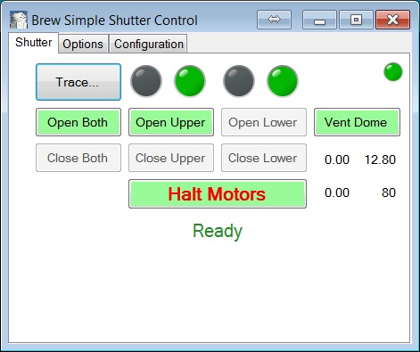

Figure . Basic SimpleShutter screen. Both shutters are closed.

**Open/Close buttons**. The opening and closing buttons are enabled/disabled based on the current status of the shutters. In Figure 9 the shutters are closed; hence one cannot close them again. Note that you also cannot open the lower shutter while the upper shutter is closed; in this state the upper shutter physically overlaps the lower. Attempting to open the lower shutter pushes against the upper, which can lead to damage of the lower shutter (yes, I have "tested" this).

Open Both / Close Both combine the operations for the two shutters. For example, Open Both first opens the upper shutter, then opens the lower.

The Halt Motors button is always available for emergency use.

**Status Light**. The small light at the upper right indicates current status of the system.

***Green*** - WiFi communications are working; SimpleShutter is successfully communicating with the Arduino about once per second.

***Red*** - communications have failed.

***Yellow*** - SimpleShutter is trying to connect to the Arduino.

***Blue*** - A shutter operation is active, for example opening the shutter.

A tooltip on the light reminds you of the meanings.

**Trace...** This button toggles a logging dialog which shows communication details between SimpleShutter and the Arduino.

**Switch Lights**. The 4 large lights indicate the current status of the Opened and closed switches. Each shutter has a switch indicating the shutter is closed; this condition is displayed as a green light (green implies safe). A second switch gets pressed when the shutter is completely open. This situation lights the Open light as Red, indicating that the observatory is in a potentially dangerous open situation.

Tooltips on the lights remind you which light is which.

Generally, a shutter is in one of these states:

* Closed light green, Open switch gray. The shutter is closed.
* Closed light gray, Open switch red. Shutter is open.
* Both lights gray. The shutter is in between, neither open or closed.
* If two lights are on at the same time for a shutter, somehow both the open and closed switches are active. Something is wrong!

**Vent Dome**. Sometimes it is useful to open the upper shutter slightly, perhaps to cool off or to let in light while working. Clicking this button runs the Open process for 3 seconds by default; see the Configuration tab to adjust this time as desired.

Once the Dome is vented, use Close Upper to close the upper shutter.

**Measurements**. Under the Vent button four values are reported. Tooltips remind you what they are.

**Voltage**. 12.80 in Figure 9. This shows the rough voltage being supplied by the external power supply to the controller. The voltage is measured by the Arduino ADC, and is probably +/- 1 volt.

**Temperature**. A temperature device is mounted in the controller, again read by the Arduino. I worry about the controller mounted on the dome wall in the Arizona heat.

**Upper and Lower current**. While a motor is running, the current draw is reported by the Arduino motor shield. I do not know what the units are; I made a weak attempt to make them amps, but have yet to actually measure them independently. The values might at least indicate whether the motor is running. My system typically shows 0.5-1.0 for the upper shutter and 1.1 to 1.6 for the lower.

### Shutter Operations

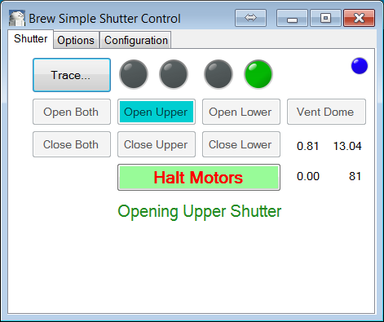

Figure . The upper shutter is opening. The upper shutter is "in between", neither open nor closed. The Blue status and cyan button indicate the operation is in progress.

Clicking on the "Open Upper" button shows the screen in Figure 10. The small status light at the upper right indicates the operation is in progress. Note that the Upper Shutter Closed light is off; the shutter has stopped engaging that switch. The active button is colored cyan indicating the operation is in progress.

While the designated motor is running, the LED lights on the side of the controller indicate which motor is running, as well as the switch status.

The Halt Motors button can be pressed to immediately stop the motors. The operation can also time out based on the times set in the Configuration Tab.

When the open operation completes, we see the following: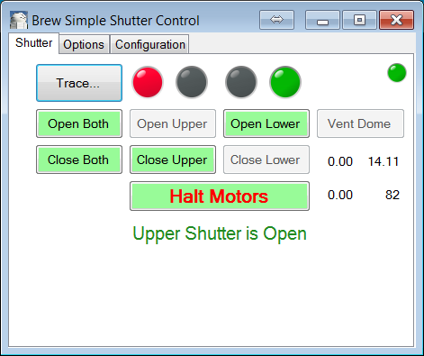

Figure . Upper Shutter open. The Open switch is Red, indicating the Upper shutter is open. I can no longer Open the upper shutter.

### Options Tab

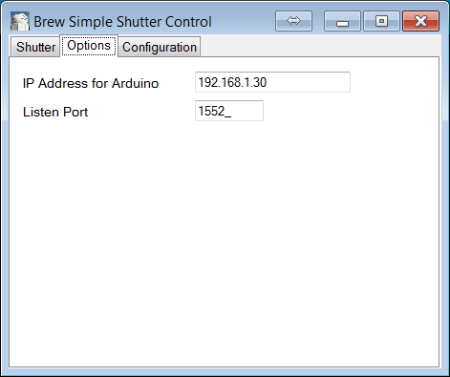

Figure . Options tab.

This screen configures the WiFi IP address of the Arduino controller and the port used for socket communication.

Note: you will need to set your WiFi name and password in the Arduino code before it is installed.

### Configuration Tab

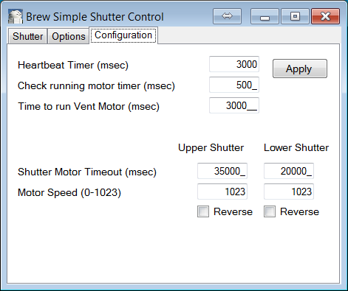

Figure . Configuration tab.

**Heartbeat Timer**. This specifies how often SimpleShutter communicates with the Arduino to check status. The time is in milliseconds; this example shows 3 seconds.

**Check running motor timer**. While an operation is active, SimpleShutter checks with the controller more often. In this case every 1/2 second.

**Vent Time**. When the Vent button is clicked, this is the amount of time the motor runs (or until the shutter is completely open).

**Shutter Motor Timeout**. Each shutter has a separate timeout. When a Both operation is performed (i.e., Open Both) the total time is allowed for the operation. This cuts off the motor in the event a switch fails, for example.

**Motor Speed**. This value 0-1023 is the PWM value for the current being provided to the motor. A value of zero runs no current, 1023 is top speed. A value of 256 provides a duty cycle pulse on 1/4 of the time.

Note that slower speeds will not allow the motor to run. In my system the motors do not run at speeds below 600.

**Reverse**. This reverses the direction of the motor. Your system could be wired differently, requiring the polarity of the output current to be reversed.