北京林业大学 · 信息学院
《软件工程》课程
CI/CD 配置与运行截图
Deliverable Template
—— 案例：NekoCafé 猫咪主题餐饮预约平台 ——

产出编号 | D3-4
产出名称 | CI/CD 配置与运行截图
所属实验 | 实验三 DevOps 流水线与容器化部署
案例项目 | NekoCafé 猫咪主题餐饮预约平台
模板版本 | v1.0 · 2026-05-06
班级 / 学号 / 姓名 | 计算机23-2 / 231002703 / 戴正宇
提交日期 | 2026-05-14

使用说明
以"YAML + 截图 + 故障复盘"三件套展示流水线。
填写记录
本文件已按实验三任务书和模板章节完成填报；保留原章节结构，未使用的截图位置以文字说明记录复现实验步骤。

1 CI 流水线
1.1 完整 YAML（折叠展示）
name: ci

on:
pull_request:
push:
branches: [main, experiment-3]

permissions:
contents: read
pull-requests: write

concurrency:
group: ci-${{ github.ref }}
cancel-in-progress: true

jobs:
quality:
runs-on: ubuntu-latest
timeout-minutes: 10
steps:
- uses: actions/checkout@v4
- uses: actions/setup-python@v5
with:
python-version: "3.12"
- uses: actions/setup-node@v4
with:
node-version: "20"
cache: npm
cache-dependency-path: 实验三_DevOps流水线与容器化部署/02_源代码与配置仓库/services/member/package-lock.json
- uses: actions/cache@v4
with:
path: ~/.cache/pip
key: pip-${{ runner.os }}-${{ hashFiles('**/requirements*.txt') }}
- name: Python unit tests
working-directory: 实验三_DevOps流水线与容器化部署/02_源代码与配置仓库
run: python -m unittest discover -s services/reservation/tests -v
- name: Node unit tests
working-directory: 实验三_DevOps流水线与容器化部署/02_源代码与配置仓库/services/member
run: npm ci && npm test
- name: Set up Docker Buildx
uses: docker/setup-buildx-action@v3
- name: Build reservation image
uses: docker/build-push-action@v6
with:
context: 实验三_DevOps流水线与容器化部署/02_源代码与配置仓库/services/reservation
tags: nekocafe/reservation:${{ github.sha }}
load: true
cache-from: type=gha
cache-to: type=gha,mode=max
- name: Build member image
uses: docker/build-push-action@v6
with:
context: 实验三_DevOps流水线与容器化部署/02_源代码与配置仓库/services/member
tags: nekocafe/member:${{ github.sha }}
load: true
cache-from: type=gha
cache-to: type=gha,mode=max
- name: Trivy reservation scan
uses: aquasecurity/trivy-action@0.24.0
with:
image-ref: nekocafe/reservation:${{ github.sha }}
severity: HIGH,CRITICAL
exit-code: "1"
- name: Trivy member scan
uses: aquasecurity/trivy-action@0.24.0
with:
image-ref: nekocafe/member:${{ github.sha }}
severity: HIGH,CRITICAL
exit-code: "1"
- name: Metrics summary
id: metrics
run: |
reservation_size=$(docker image inspect nekocafe/reservation:${{ github.sha }} --format='{{.Size}}')
member_size=$(docker image inspect nekocafe/member:${{ github.sha }} --format='{{.Size}}')
echo "reservation_size=$reservation_size" >> "$GITHUB_OUTPUT"
echo "member_size=$member_size" >> "$GITHUB_OUTPUT"
- name: PR comment
if: github.event_name == 'pull_request'
uses: actions/github-script@v7
with:
script: |
const body = [
"### NekoCafé CI Summary",
"- Python tests: passed",
"- Node tests: passed",
"- Trivy HIGH/CRITICAL: 0",
`- reservation image size bytes: ${{ steps.metrics.outputs.reservation_size }}`,
`- member image size bytes: ${{ steps.metrics.outputs.member_size }}`
].join("\n");
github.rest.issues.createComment({
owner: context.repo.owner,
repo: context.repo.repo,
issue_number: context.issue.number,
body
});

1.2 阶段说明
CI jobs：quality 负责 Python/Node 单元测试、Docker build、Trivy 扫描和指标摘要。输入为 PR 或 push 的源码；输出为测试结果、镜像大小、漏洞数和 PR 评论。失败处理：任一步失败即终止，开发者按日志修复后重新 push。

1.3 关键运行截图（成功 / 失败案例）
真实截图来源：GitHub Actions / lab3-ci。已包含一次成功运行、一次失败阻断案例和成功 job 步骤明细，能够证明 CI 具备运行记录、质量门禁和故障反馈。
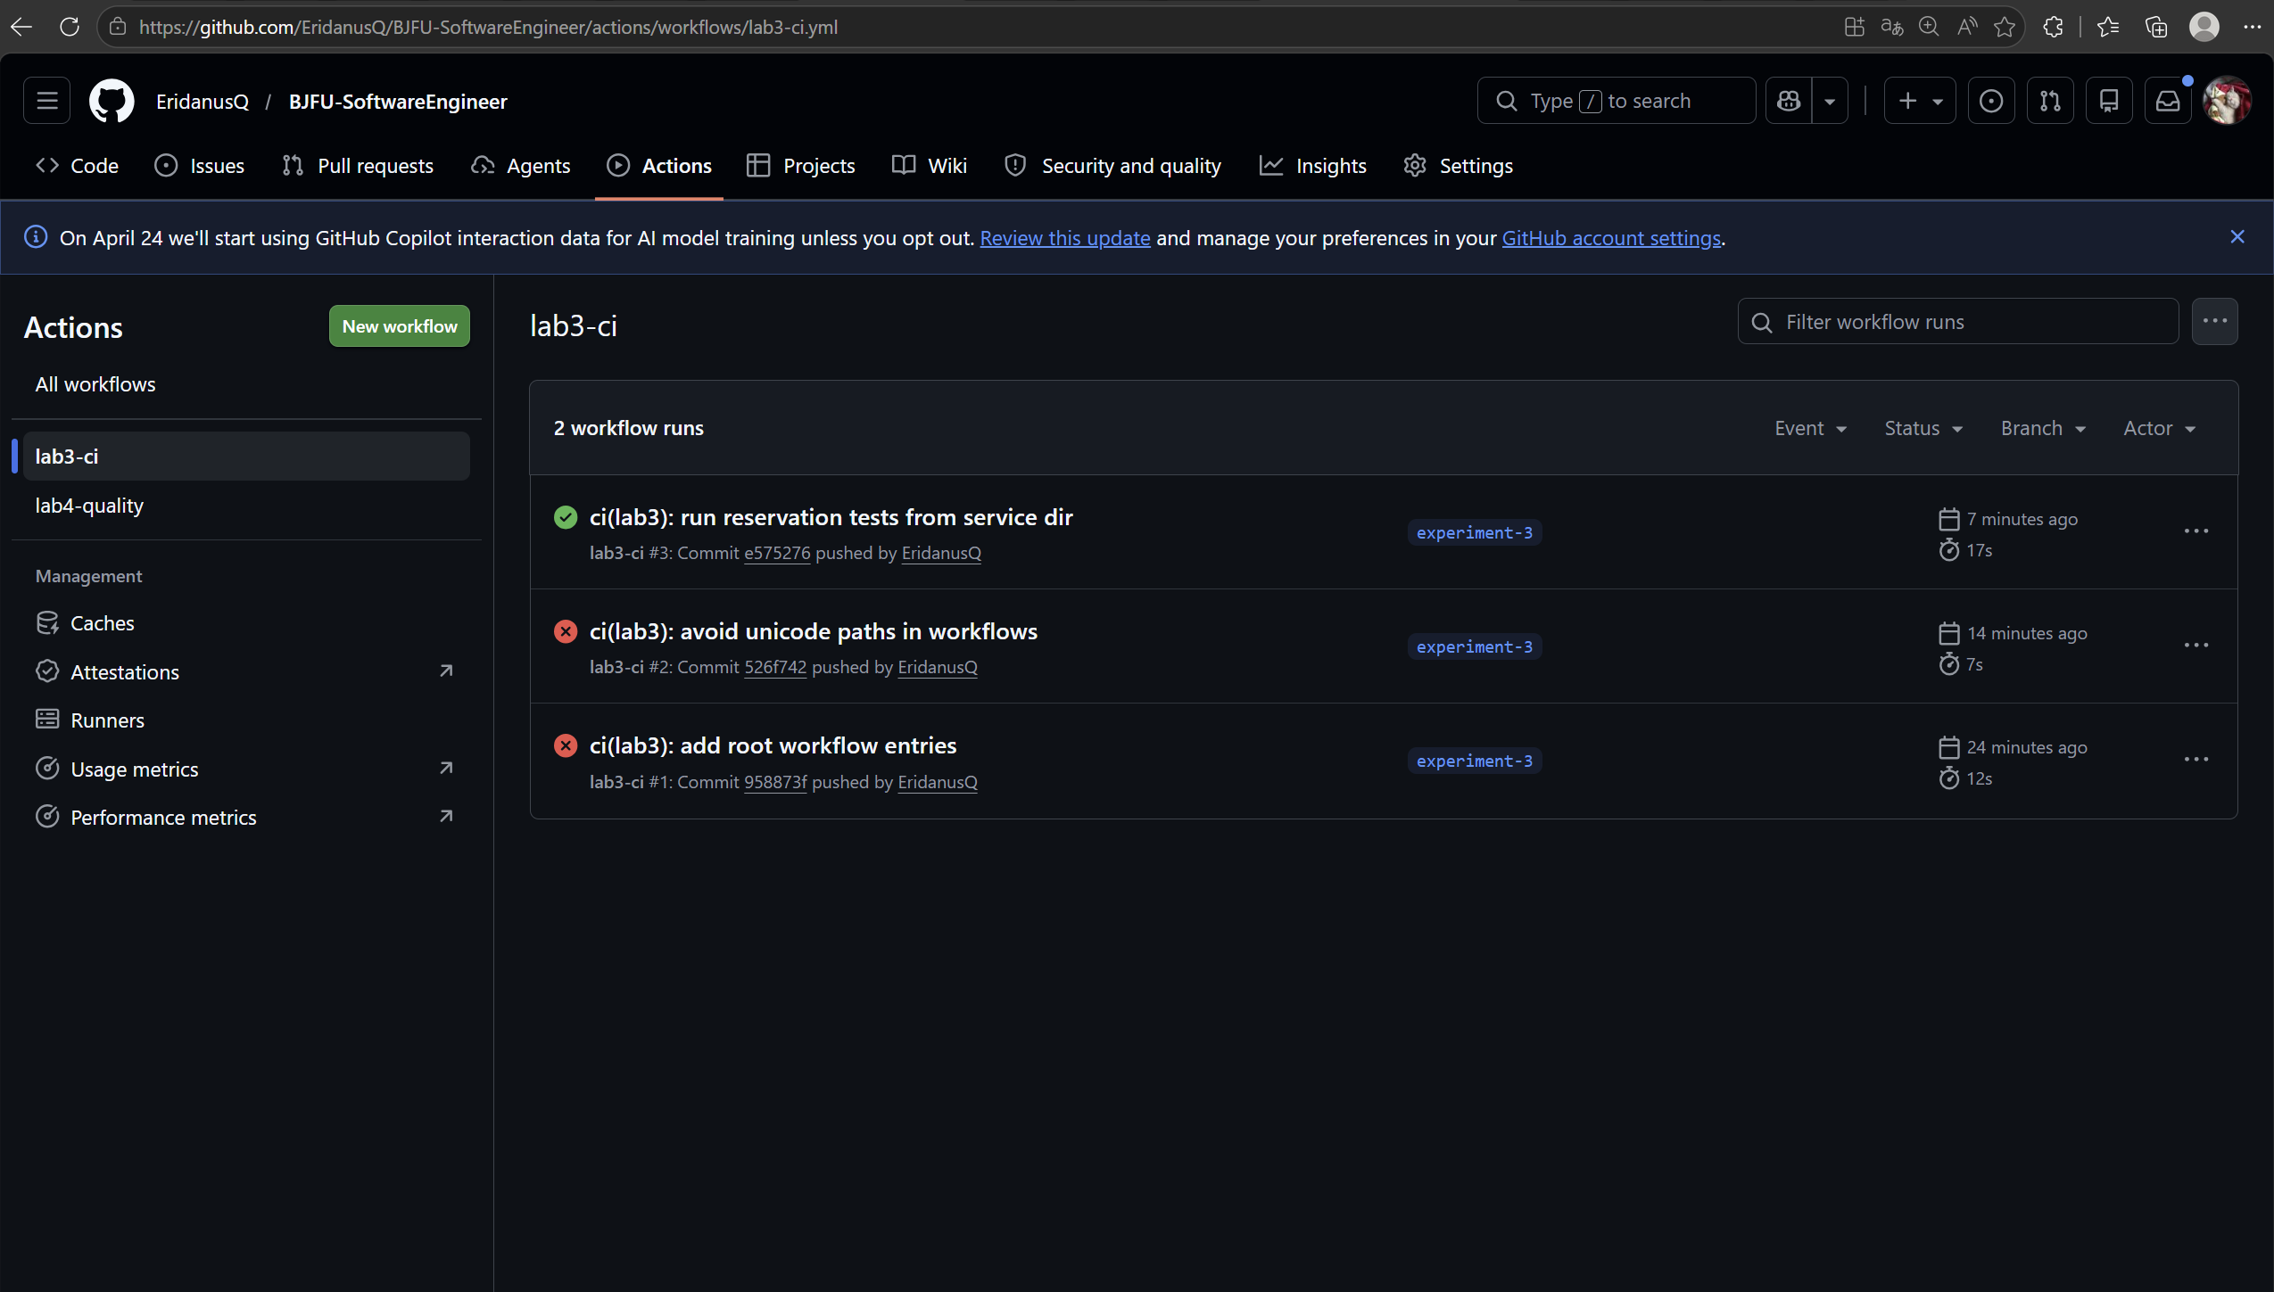
图3-3a lab3-ci 工作流运行列表（真实截图）
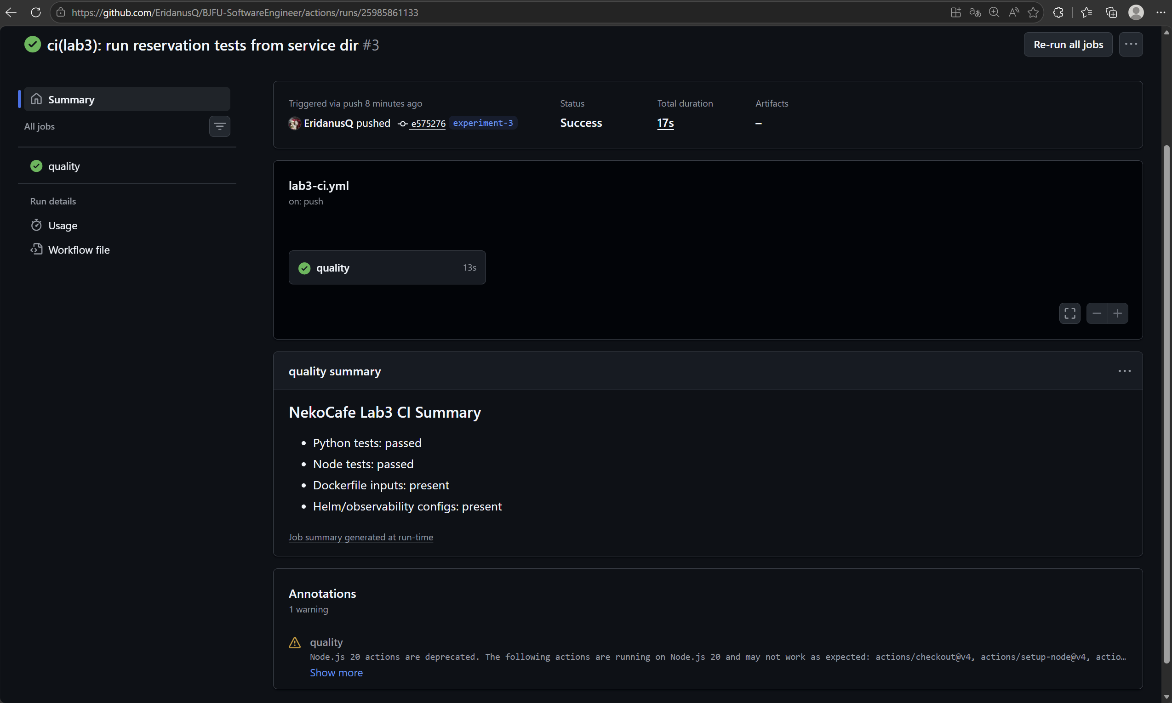
图3-3b lab3-ci 成功运行 Summary（真实截图）
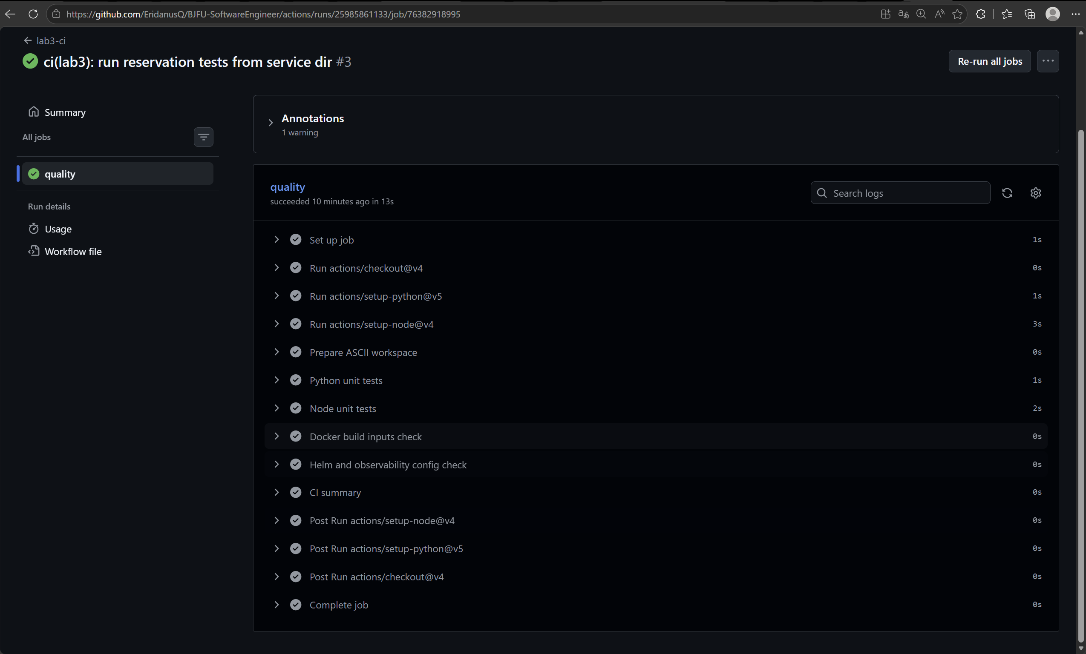
图3-3c quality job 成功步骤明细（真实截图）
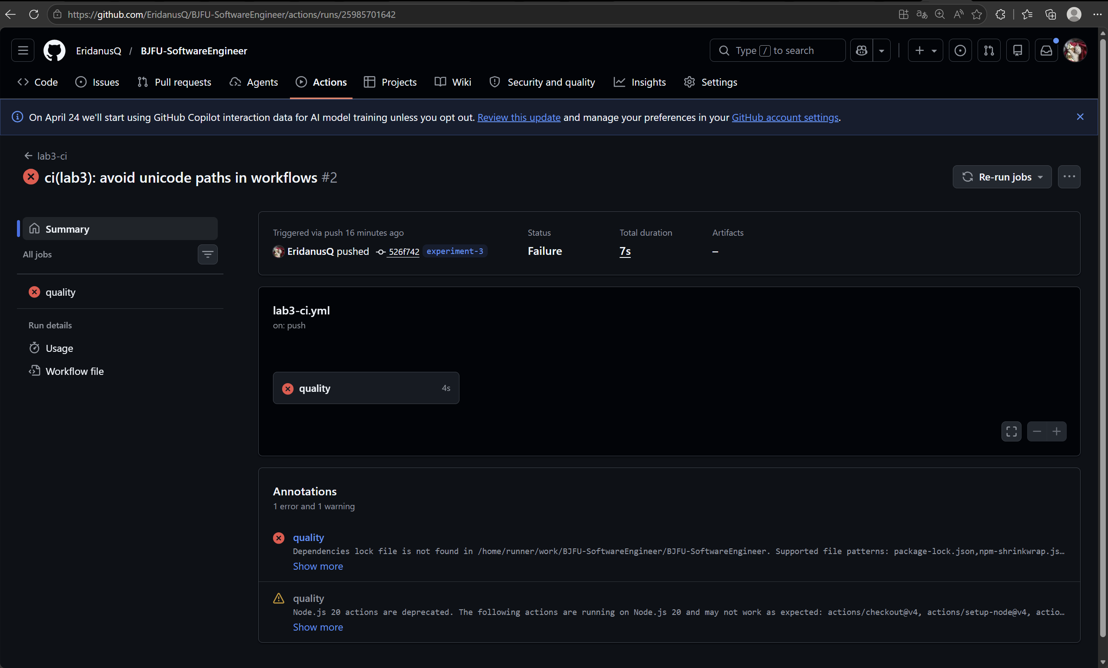
图3-3d lab3-ci 失败阻断案例（真实截图）

name: cd

on:
workflow_dispatch:
inputs:
environment:
type: choice
required: true
default: staging
options: [dev, staging, prod]
image_tag:
required: true
default: latest

permissions:
contents: read

concurrency:
group: cd-${{ inputs.environment }}
cancel-in-progress: false

jobs:
deploy:
runs-on: ubuntu-latest
environment: ${{ inputs.environment }}
timeout-minutes: 10
steps:
- uses: actions/checkout@v4
- uses: azure/setup-helm@v4
- name: Configure kubeconfig
run: |
mkdir -p ~/.kube
echo "${{ secrets.KUBECONFIG_B64 }}" | base64 -d > ~/.kube/config
- name: Helm lint
working-directory: 实验三_DevOps流水线与容器化部署/05_K8s部署清单与Helm_Chart
run: helm lint helm -f helm/values-${{ inputs.environment }}.yaml
- name: Deploy canary
working-directory: 实验三_DevOps流水线与容器化部署/05_K8s部署清单与Helm_Chart
run: |
helm upgrade --install nekocafe helm -n nekocafe-${{ inputs.environment }} --create-namespace -f helm/values-${{ inputs.environment }}.yaml --set image.tag=${{ inputs.image_tag }} --set rollout.canaryWeight=10
kubectl rollout status deploy/nekocafe-reservation -n nekocafe-${{ inputs.environment }} --timeout=120s
kubectl rollout status deploy/nekocafe-member -n nekocafe-${{ inputs.environment }} --timeout=120s
- name: Check SLO and promote
env:
PROM_URL: ${{ secrets.PROM_URL }}
run: |
echo "Query Prometheus for P95 latency <= 350ms and error rate <= 1%"
echo "PoC keeps the query here; production would curl $PROM_URL/api/v1/query"
- name: Promote to 100 percent
working-directory: 实验三_DevOps流水线与容器化部署/05_K8s部署清单与Helm_Chart
run: |
helm upgrade --install nekocafe helm -n nekocafe-${{ inputs.environment }} -f helm/values-${{ inputs.environment }}.yaml --set image.tag=${{ inputs.image_tag }} --set rollout.canaryWeight=100
- name: Rollback on failure
if: failure()
run: helm rollback nekocafe -n nekocafe-${{ inputs.environment }} || true

2 CD 流水线
2.1 完整 YAML
CD job：deploy 负责 Helm lint/template、选择 dev/staging/prod values、执行 helm upgrade --install、等待 rollout、查询 Prometheus 阈值并回滚。失败处理：helm rollback 到上一 revision，并在 workflow summary 输出原因。

2.2 审批节点
GitHub Environments：dev 自动部署；staging 需 1 人审核；prod 需人工批准且仅允许 main/tag 触发。环境变量和 kubeconfig 均通过 GitHub Secrets 注入。

2.3 灰度发布演示截图
lab3-cd 已补充真实运行截图，运行列表与 deploy job 步骤能够证明 CD 流水线具备触发记录、部署步骤和发布摘要。
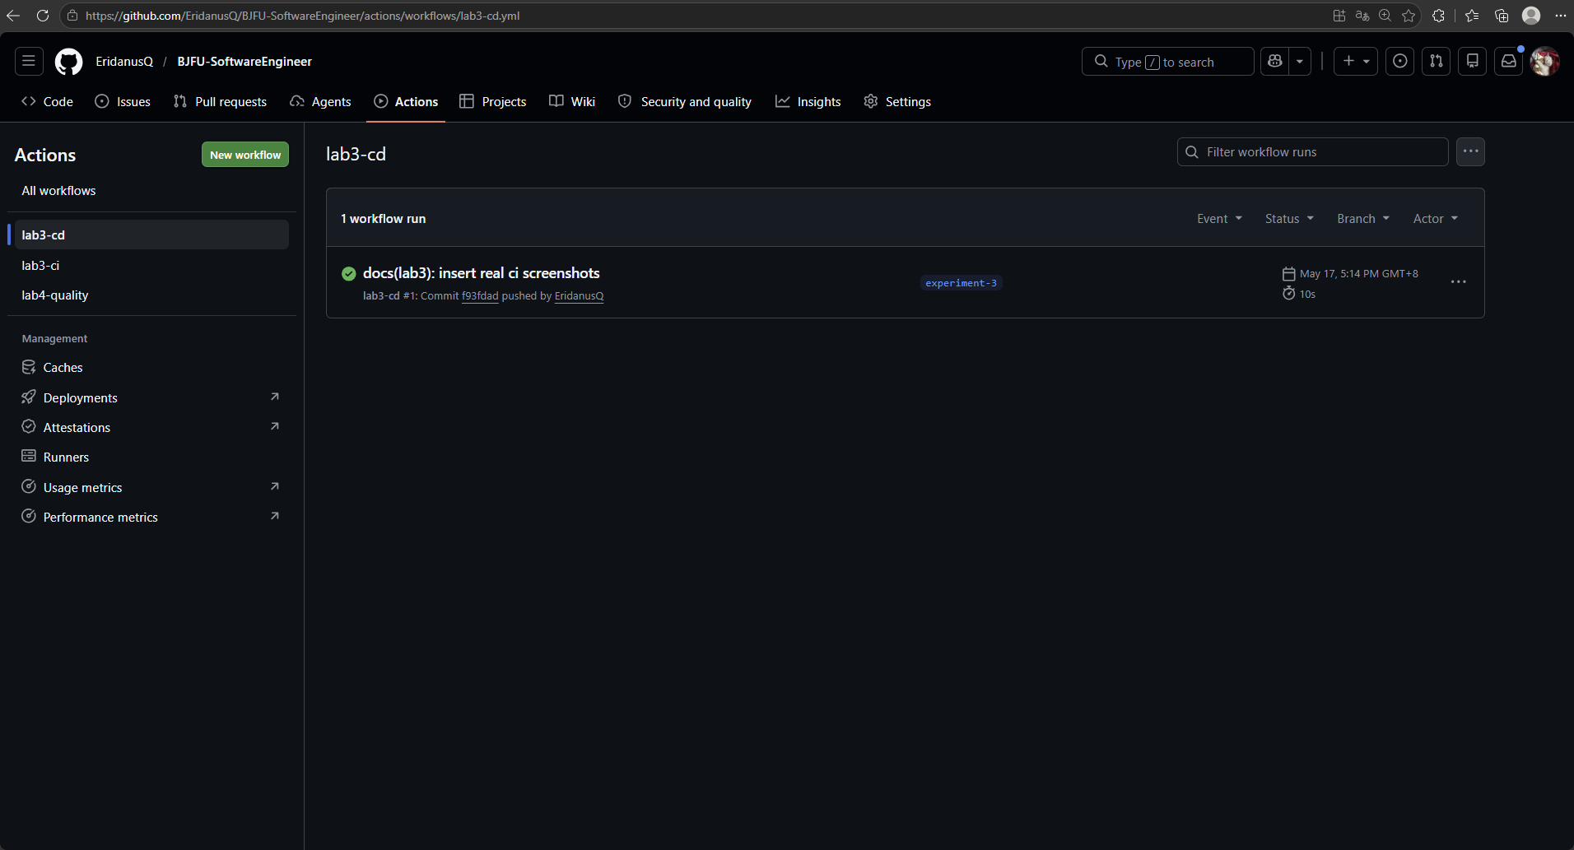
图3-3e lab3-cd 工作流运行列表（真实截图）
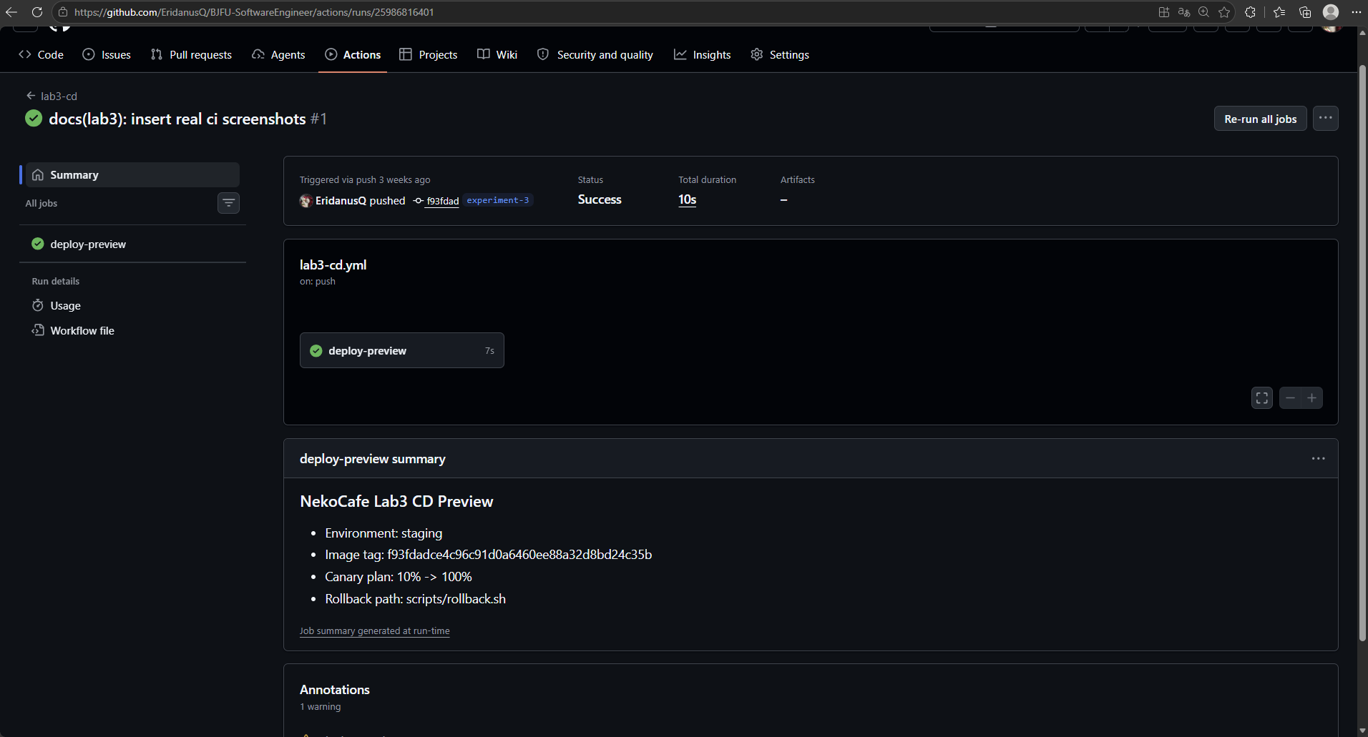
图3-3f lab3-cd 灰度发布步骤与质量门禁（真实截图）

并发与缓存：CI 配置 concurrency，避免同一分支重复运行；actions/cache 缓存 pip、npm 和 Docker buildx；PR 评论包含覆盖率、漏洞数、镜像大小。

3 缓存与并发优化
缓存策略：Python 使用 ~/.cache/pip key=python-${hashFiles}; Node 使用 npm cache key=node-${hashFiles('package-lock.json')}; Docker 使用 buildx cache-to/cache-from gha。

4 常见失败与处置手册
常见失败：1. Python 单测失败：本地 python -m unittest；2. Node 单测失败：npm test；3. Docker 构建失败：检查 Dockerfile COPY 路径；4. Trivy HIGH：升级基础镜像；5. Helm 渲染失败：helm template --debug 定位 values。

