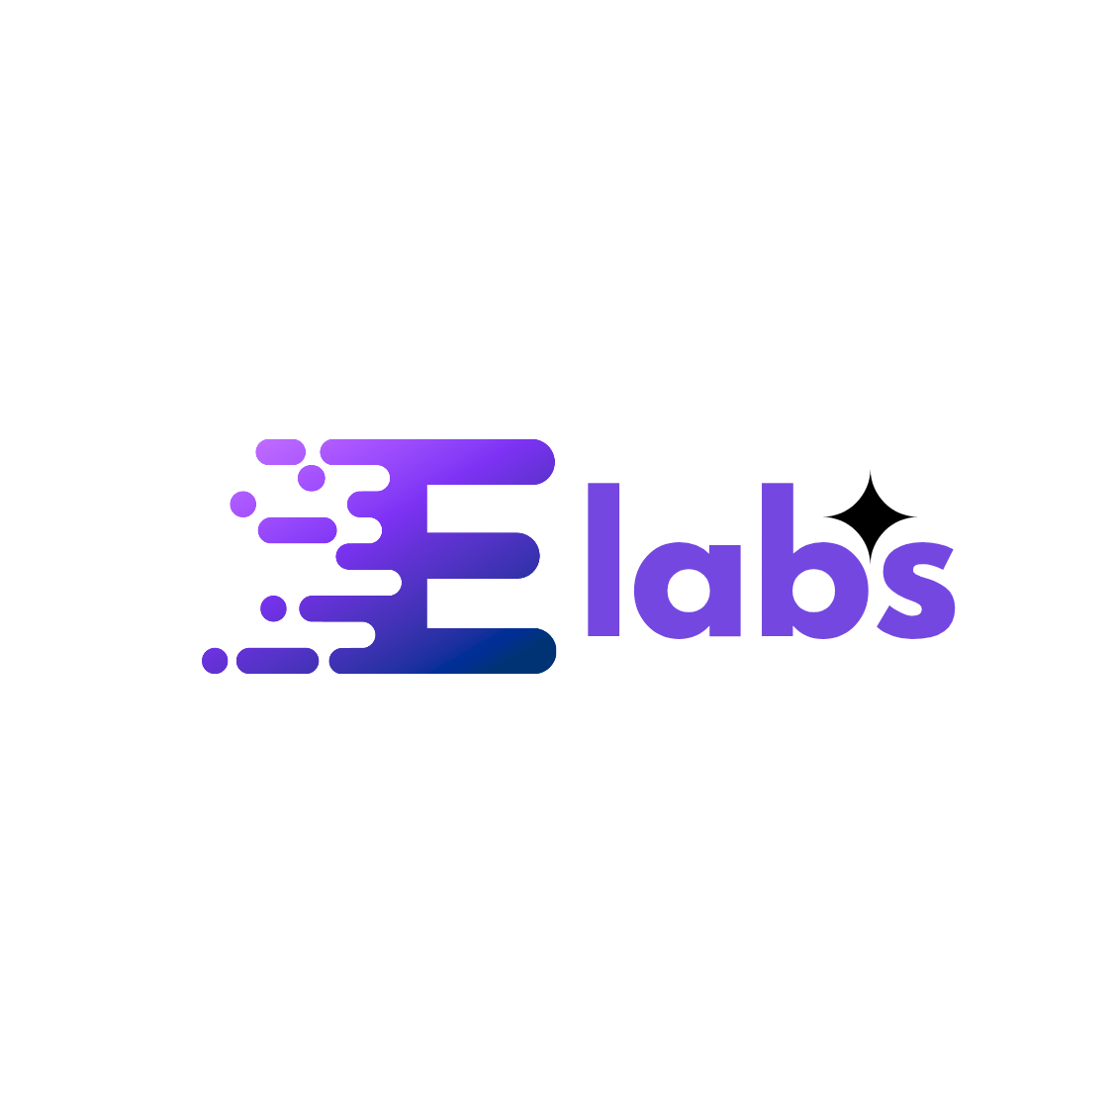
Project Charter: EriduBrain

DATE: 2/12/2026

Project Summary
The EriduBrain project's current phase is to transition the application from a standalone, simulated cloud environment to a fully-functional, real-world cloud cost optimization and resource management tool. This involves integrating the application with a live Google Cloud Project to scan real assets, fetch metrics, and complete the end-to-end remediation workflow.

Project Goals
* Enable EriduBrain to scan and analyze real Google Cloud resources, replacing all hardcoded mock data.
* Integrate the Google Cloud Asset Inventory API and Cloud Monitoring API for real-time asset and metrics data ingestion.
* Implement secure OAuth 2.0 authentication for user GCP account access.
* Establish a proven end-to-end loop for identifying, analyzing, reporting, and remediating cloud waste on live infrastructure.

Deliverables
* Updated Backend (main.py): Implementation of the scan_live_infrastructure() function using AssetServiceClient and MetricServiceClient.
* Updated Frontend (App.jsx): Code to call the new live /scan endpoint instead of the local simulation.
* Cloud Deployment: Redeployment of the EriduBrain API to Cloud Run with necessary service account permissions (Cloud Asset Viewer, Compute Viewer, Monitoring Viewer).
* Validation Protocol: Successful execution of the protocol to find and remediate a test resource (eridu-test-bait-01), proving real-world capability.

Scope and Exclusion
In-Scope: - Transition from mock data to real-time scanning of Compute Engine VMs, CPU utilization, and other relevant assets. - Implementation of the core cost/risk analysis logic defined in the Knowledge Base (e.g., ZOMBIE VMs, Rightsizing, Orphaned Disks). - Authentication and Authorization setup (IAM roles, Service Account permissions). Out-of-Scope: - Full-scale integration across multiple cloud providers. - Development of new optimization rules beyond the existing Knowledge Base. - Implementation of the full 'Settings' or 'Resources' views (which are noted as available in the full version).

Benefits & Costs
Benefits: - Real-World Capability: EriduBrain transitions from a demo to a functional cloud management tool. - Cost Reduction: Ability to identify and recommend termination/rightsizing for idle resources and orphaned assets, leading to potential monthly savings. - Risk Management: Automated risk scoring for identified infrastructure inefficiencies. Costs: - Engineering time for implementing the three phases (Authentication, Backend update, Frontend update). - Operational costs of the Cloud Run service and associated Google Cloud resources in the cloud-green-x project.

Appendix:
* Knowledge Base/Optimization Rules (ZOMBIE VMs, CARBON PENALTY, RIGHTSIZING, ORPHANED DISKS, etc.)
* Detailed Implementation Plan (Phase 1, 2, and 3 steps).
* Validation Protocol and Testing Scenarios.
* All necessary GCP/Cloud Shell deployment commands and configuration for project cloud-green-x.

