[**Object Oriented Programming**](https://classroom.google.com/c/MzE5ODA0ODMwMzI1)

**Lab Assignment –4**

Name: - E.Vaishnavi

RegNo: 20BCS044

**Problem-1 Solution:-**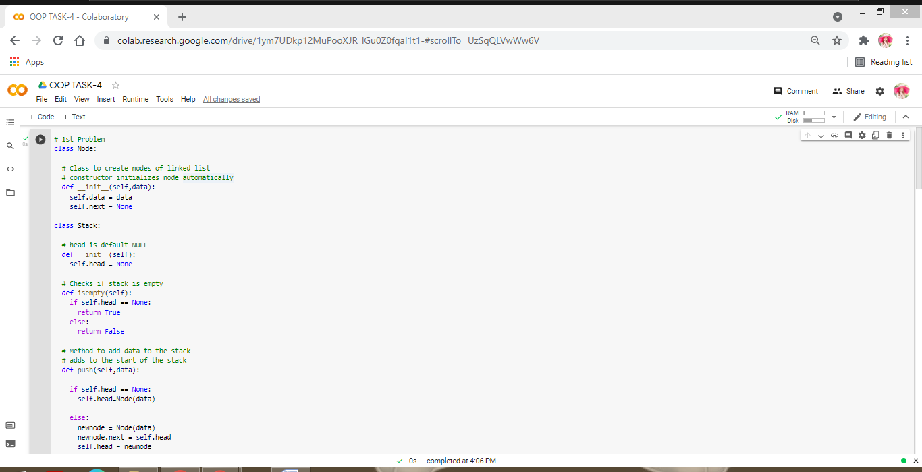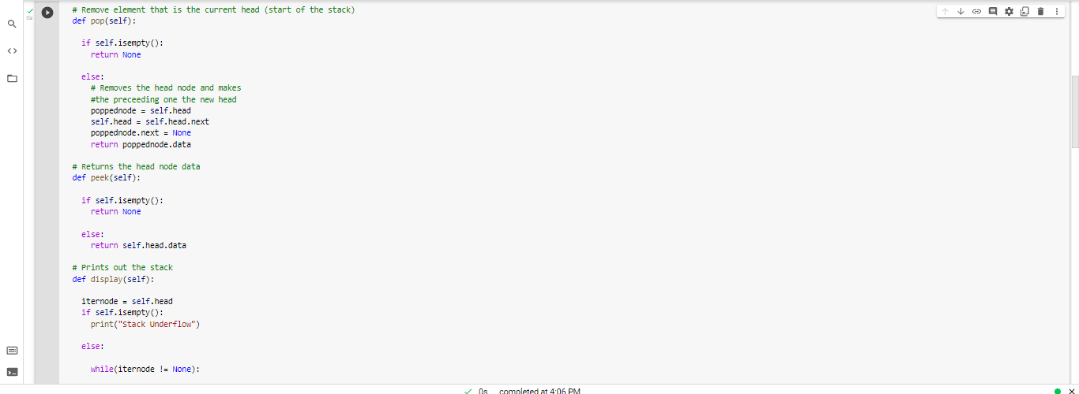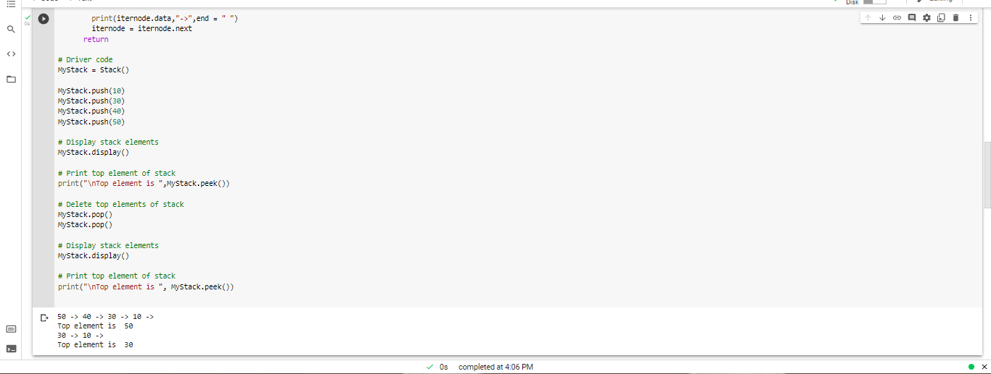

**Problem-2 Solution:-**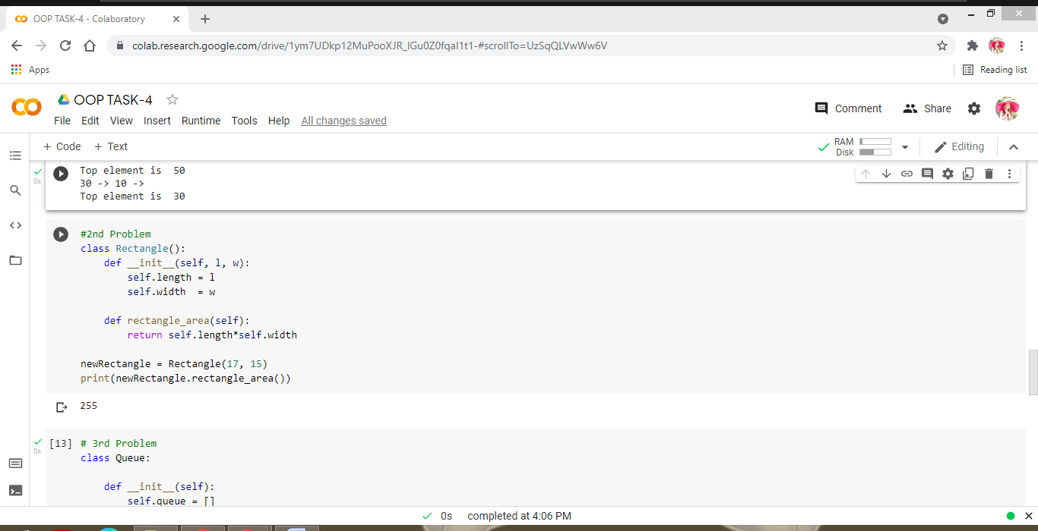

**Problem-3 Solution:-**