DBI202 - Assignment
Group 3

Member:

Name | ID
Nguyễn Đức An | CE201460
Phong Nguyễn Nhật Lam | CE200024
Đặng Lâm Mỹ Khánh | CE200080
Trương Ngọc Thảo Trân | CE180290
Ngô Kiến Tường | CE200920
Nguyễn Phi Trường | CE200923

- Project Rationale

The Trend: The demand for Virtual Private Servers (VPS) is surging due to the boom in Cloud Computing.
The Problem: Manual management of physical Servers and IP pools is highly prone to errors (e.g., IP conflicts, resource overload
The Objective: Build an automated system to strictly manage resources, auto-allocate IPs, and ensure data integrity.
- Description of the system's business:

- Customer Management: Customers register accounts to access the cloud infrastructure and manage their rented virtual servers.
- Resource Management: Ability to add, delete, and monitor physical servers, IP pools, and various VPS service packages (Student, Gamer, Enterprise).
- Payment Management: Automatically calculate rental costs based on usage time and generate secure billing invoices upon service termination.
- Policy & Quota Management: Enforce system rules, such as limiting each customer to a maximum of 05 virtual machines to ensure fair resource distribution.

- ER model of the system:

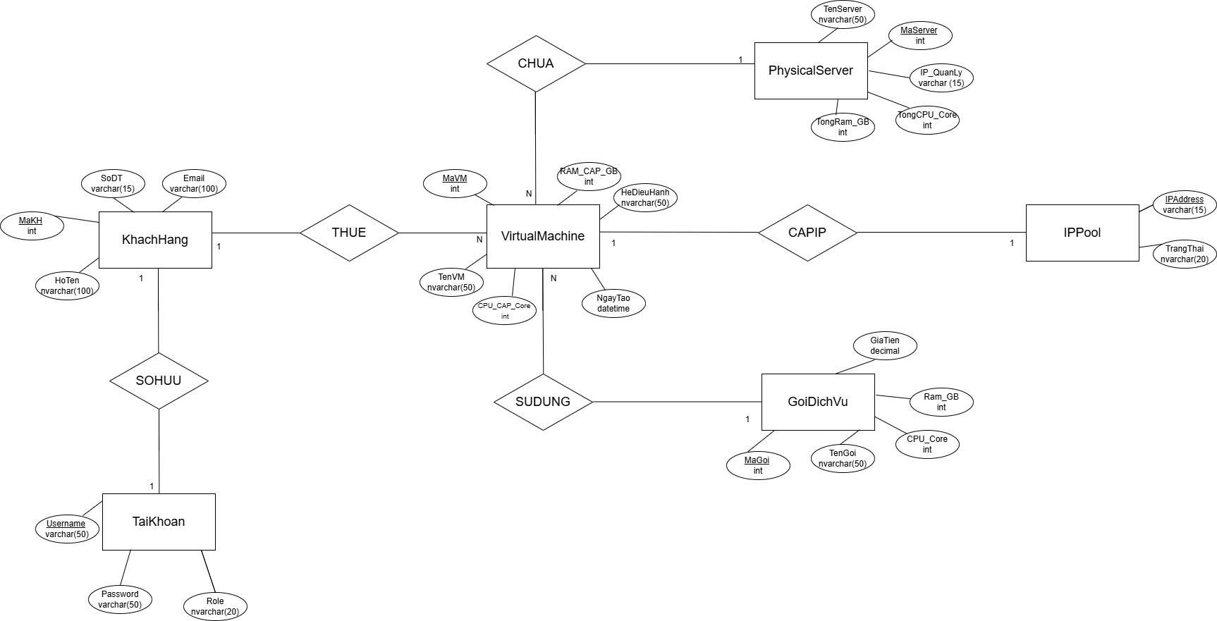

- Relational model (moving from ER model):
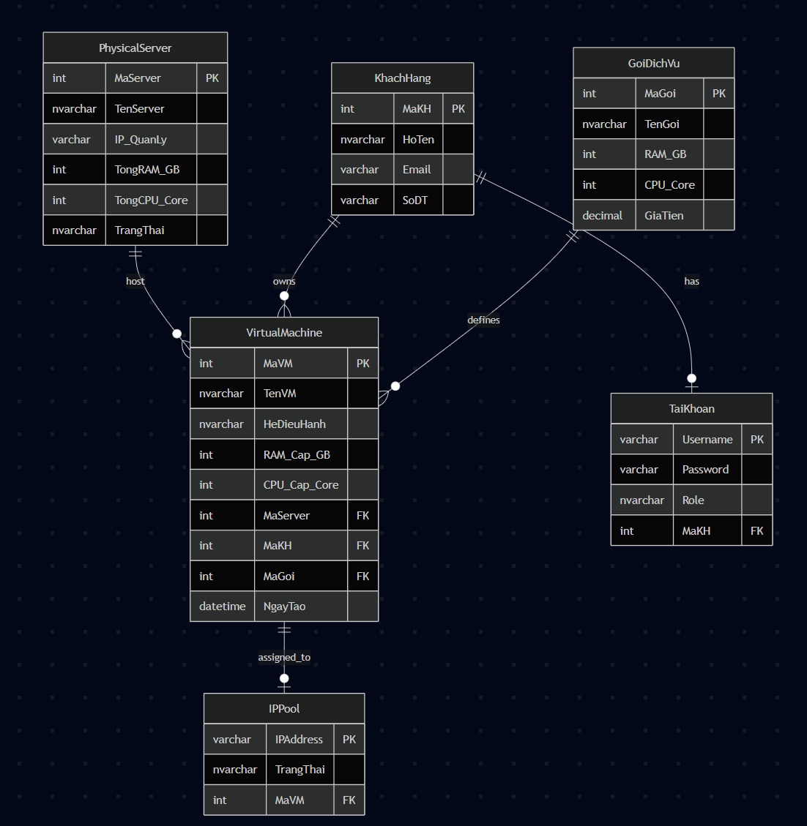
- Data Directory

KhachHang
Column Name | Data Type | Size | Constraints | Description
MaKH | INT | 4 bytes | Primary Key, IDENTITY(1,1) | Unique identifier for the customer (auto-increment).
HoTen | NVARCHAR | 100 | NULL | Full name of the customer.
Email | VARCHAR | 100 | UNIQUE | Email address (Must be unique).
SoDT | VARCHAR | 15 | NULL | Contact phone number.

TaiKhoan
Column Name | Data Type | Size | Constraints | Description
Username | VARCHAR | 50 | Primary Key | System login username.
Password | VARCHAR | 50 | NOT NULL | Login password.
Role | NVARCHAR | 20 | NOT NULL | User role ('Admin' or 'User').
MaKH | INT | 4 bytes | Foreign Key, NULL | Foreign key referencing Customer ID (NULL for Admin).

PhysicalServer
Column Name | Data Type | Size | Constraints | Description
MaServer | INT | 4 bytes | Primary Key, IDENTITY(1,1) | Unique identifier for the physical server (auto-increment).
TenServer | NVARCHAR | 50 | NOT NULL | Name of the physical server.
IP_QuanLy | VARCHAR | 15 | UNIQUE | Management IP address of the server.
TongRAM_GB | INT | 4 bytes | NULL | Total RAM capacity in GB.
TongCPU_Core | INT | 4 bytes | NULL | Total CPU cores.
TrangThai | NVARCHAR | 20 | DEFAULT N'Hoạt động' | Operating status of the server.

GoiDichVu
Column Name | Data Type | Size | Constraints | Description
MaGoi | INT | 4 bytes | Primary Key, IDENTITY(1,1) | Service package ID (auto-increment).
TenGoi | NVARCHAR | 50 | NULL | Name of the service package.
RAM_GB | INT | 4 bytes | NULL | RAM capacity of the package (GB).
CPU_Core | INT | 4 bytes | NULL | CPU cores of the package.
GiaTien | DECIMAL | (18,0) | NULL | Rental price of the package (VND).

VirtualMachine
Column Name | Data Type | Size | Constraints | Description
MaVM | INT | 4 bytes | Primary Key, IDENTITY(1,1) | Unique identifier for the VPS.
TenVM | NVARCHAR | 50 | NULL | Name of the VPS assigned by the customer.
HeDieuHanh | NVARCHAR | 50 | NULL | Installed Operating System.
RAM_Cap_GB | INT | 4 bytes | NULL | Actual RAM allocated to the VM.
CPU_Cap_Core | INT | 4 bytes | NULL | Actual CPU allocated to the VM.
MaServer | INT | 4 bytes | Foreign Key | Reference to the parent Physical Server.
MaKH | INT | 4 bytes | Foreign Key | Reference to the Customer owning the VM.
MaGoi | INT | 4 bytes | Foreign Key | Reference to the applied Service Package.
NgayTao | DATETIME | 8 bytes | DEFAULT GETDATE() | Creation date and time of the VM.

IPPool
Column Name | Data Type | Size | Constraints | Description
IPAddress | VARCHAR | 15 | Primary Key | Static IPv4 address.
TrangThai | NVARCHAR | 20 | DEFAULT N'Trống' | Usage status (Empty/Used).
MaVM | INT | 4 bytes | Foreign Key, NULL | Assigned VM ID. NULL if Empty.

- Conclusion

The V-Cloud Infrastructure Management System has been successfully developed, meeting the core requirements of a modern VPS rental service by integrating a Python GUI with an SQL Server database.
Key Achievements:
- Automation: Streamlined VM deployment by automatically allocating hardware resources (RAM, CPU) and static IPs using Stored Procedures.
- Data Security: Implemented robust Database Triggers to enforce business policies, such as limiting user quotas (max 5 VMs) and automatically releasing IPs upon VM deletion.
- User Experience: Delivered separate, easy-to-use dashboards for both Administrators and Customers.
Future Enhancements: Future versions can be expanded to include a dynamic "Pay-as-you-go" billing system and real-time server performance monitoring.

