4.1. Problem Definition
Business Email Compromise (BEC) is an email-based cyber threat where attackers impersonate trusted individuals or organizations to deceive victims into transferring money, sharing confidential information, or performing unauthorized actions. In this project, the threat focuses on poisoned or adversarial BEC emails, which are modified versions of clean BEC emails designed to bypass detection systems.
The main actor in this case is the attacker who creates or modifies BEC emails to avoid being detected. The defender is the security team or email security system that needs to identify whether an email is clean or poisoned/adversarial.
The input data of the system is email text, including the subject and body of each email. These text fields are combined and processed before being converted into numerical features using TF-IDF.
The desired output is a binary classification result:
- 0 = Clean BEC email
- 1 = Poisoned / Adversarial BEC email
The goal of this project is not to detect normal spam or legitimate emails. Instead, the project focuses specifically on distinguishing clean BEC emails from poisoned or adversarial BEC emails.

4.2. Related Background and Literature Review
1. KEY CONCEPTS SUMMARY
Business Email Compromise (BEC)
BEC has already been defined in Section 4.1. In this section, BEC is considered from a research perspective as a social-engineering email threat that often does not rely on malware links or attachments. This makes BEC difficult for traditional signature-based filters to detect and creates a strong reason to apply machine learning and text-based analysis.
Adversarial Email
Adversarial emails are electronic messages modified with deliberate text perturbations designed to bypass spam filters or machine learning-based security classifiers while remaining fully readable to human victims. Common techniques include:
- Homoglyph Substitution: Replacing standard Latin letters with visually identical characters from other character sets, such as Cyrillic or Greek (e.g., replacing Latin 'a' with Cyrillic 'а').
- Zero-Width Character Injection: Inserting invisible Unicode control characters (such as U+200B, U+200C, or U+200D) within target keywords (e.g., transforming "payment" into a visually similar version with hidden zero-width characters between letters).
These methods fragment word tokens, causing traditional string-matching tools and word-level tokenizers to fail.
Text Classification
Text classification is a core Natural Language Processing (NLP) task that assigns predefined category labels to unstructured text documents. In the domain of email security, it is framed as a supervised learning problem where a model analyzes textual features (such as the subject line and email body) to classify incoming messages into specific categories, including benign, spam, or phishing/BEC.
In this project, text classification is used specifically to distinguish between clean BEC emails and poisoned/adversarial BEC emails.
2. LITERATURE REVIEW
- Paper 1: Cidon et al. [1] presented a high-precision BEC detection system. The authors demonstrated that while attackers easily evade traditional signature filters through identity spoofing and social engineering, combining NLP-based linguistic feature extraction (intent, financial urgency) with email header metadata yields high detection accuracy. This supports using machine learning for statistical text analysis against non-malware threats.
- Paper 2: Boucher and Anderson [2] investigated imperceptible Unicode attacks against NLP systems. They proved that inserting character-level adversarial noise (such as zero-width spaces or homoglyphic substitutions) forces standard tokenizers to fragment target keywords into isolated letters. This effectively deletes critical indicators from the model's vocabulary while keeping the text perfectly readable to human victims.
3. METHODOLOGY RATIONALE
Rationale for choosing Machine Learning + TF-IDF:
Machine learning with TF-IDF was selected because it is computationally efficient, interpretable, and suitable for sparse text data. It also provides a strong baseline for comparing multiple classifiers in adversarial BEC detection.
4. REFERENCE DATASETS: BEC-1 & BEC-2
Context and Role of BEC-1 and BEC-2:
The Springer BEC-1 and BEC-2 datasets were reviewed as background references only. They were not used for model training or testing in this project. These datasets helped the team understand human-validated BEC examples and how synthetic BEC emails can be evaluated from both human and automated system perspectives.
4.3. Dataset and Data Understanding
4.3.1 Dataset Description
This project uses the Kaggle Adversarial BEC Email Dataset, a synthetic dataset designed for research on Business Email Compromise (BEC) detection. The dataset contains clean BEC email templates and their adversarially modified counterparts, allowing researchers to evaluate the robustness of machine learning models against email manipulation attacks.
The dataset is suitable for binary text classification tasks where the objective is to distinguish between clean BEC emails and poisoned/adversarial BEC emails.
4.3.2 Dataset Source
- Source: Kaggle – Adversarial BEC Email Dataset
- Purpose: Classification of clean BEC emails and poisoned/adversarial BEC emails using machine learning.
- Files used:
  - synthetic_emails.csv
  - synthetic_emails_poisoned.csv
Each file contains 4,211 email samples, resulting in a total of 8,422 records before filtering and preprocessing.
4.3.3 Dataset Schema
Each dataset contains three attributes:
Column | Data Type | Description
subject | Text | Subject line of the email.
body | Text | Main content of the email.
label | Integer | Original label column; the final target labels are newly created as 0 and 1.

After preprocessing, the project compares each clean email with its poisoned version. Email pairs that are identical are removed, while modified pairs are retained. New binary labels are then assigned:
- 0: Clean BEC email
- 1: Poisoned (adversarial) BEC email
This produces the final dataset used for training and evaluation.
4.3.4 Class Distribution
Initially, both source files contain the same number of email samples (4,211 records each). After filtering identical pairs and assigning new labels, the clean and poisoned emails are merged into a binary classification dataset.
The resulting dataset contains two balanced classes:
- Class 0: Clean BEC emails
- Class 1: Poisoned BEC emails
Maintaining a balanced class distribution helps reduce model bias and improves the reliability of evaluation metrics such as Accuracy, Precision, Recall, and F1-score.
4.3.5 Data Quality Issues
Several data quality issues were identified during dataset exploration.
Missing values
A small number of missing values exist in all three columns.
- Subject: 30 missing values
- Body: 60 missing values
- Label: 30 missing values
These records should be removed or handled during preprocessing to prevent errors during feature extraction and model training.
Synthetic Data
The dataset is synthetically generated rather than collected from real organizational email systems. Although synthetic data provides a safe and controllable environment for experimentation, it cannot fully capture the diversity and complexity of real-world BEC attacks.
Lack of Legitimate Emails
The dataset mainly focuses on clean BEC templates and their adversarially modified versions. It does not include a wide variety of ordinary business emails unrelated to BEC. Consequently, a model trained solely on this dataset may achieve high experimental performance while experiencing reduced generalization when deployed in real enterprise environments.
Limited Email Structure
Each record contains only three textual fields (subject, body, and label). Important contextual information such as sender identity, recipient information, timestamps, email headers, attachments, and URLs is unavailable, limiting the amount of security-related information that can be learned by the model.
Overall, despite these limitations, the dataset remains appropriate for evaluating adversarial text classification techniques and comparing different machine learning algorithms for BEC detection.

4.4. Preprocessing and Feature Engineering
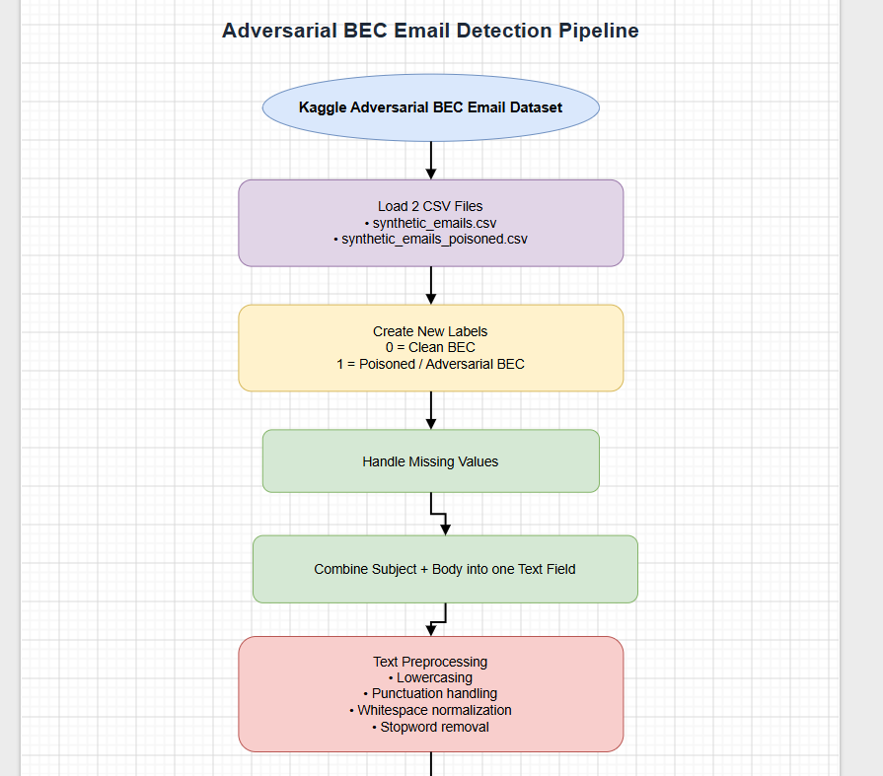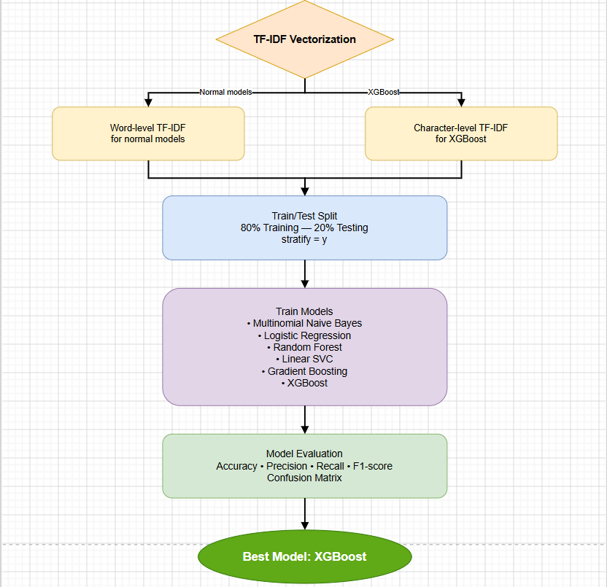
Figure 1. Overall machine learning pipeline of the proposed BEC detection system.
4.4.1 Text Cleaning: Lowercasing, Removing Punctuation, and Removing Stopwords
- Lowercasing: All text characters are converted to lowercase using .lower(). This unifies variations of the same word (e.g., "URGENT", "Urgent", and "urgent" are reduced to a single token).
- Removing Punctuation: Special characters and punctuation symbols are stripped out via text.translate(str.maketrans('', '', string.punctuation)). This isolates terms and ensures symbols do not distort token boundaries (e.g., changing "invoice!" or "account," to raw words).
Note: The standard preprocessing pipeline uses word-level TF-IDF after text cleaning. However, for the XGBoost experiment, a separate character-level TF-IDF setting was used to better capture small adversarial text changes such as typos, hidden characters, or structural modifications.
- Whitespace Trimming: Consecutive spaces, newline characters, and tabs are normalized into a single space using the regular expression re.sub(r'\s+', ' ', text).strip() to ensure consistent formatting.
- Removing Stopwords: The text is tokenized into individual words, and high-frequency grammatical functional terms (such as "i", "me", "the", "and", "or", "into") are filtered out. A predefined set of basic English stopwords is used for this purpose, preventing non-informative words from dominating the feature space.
4.4.2 Combining Subject and Body
- Missing Value Imputation: Missing values within the subject and body columns are filled with empty strings ("") via .fillna("") to avoid truncation errors during concatenation.
Text Integration: The subject string and the body string are concatenated together, separated by a single whitespace character, into a newly engineered feature column named text:
- df["text"] = df["subject"] + " " + df["body"]
This integration ensures that critical metadata context from the subject line directly supports the textual semantics found in the email body during training.
4.4.3 TF-IDF Vectorization
Because machine learning models require numerical inputs instead of raw text, the preprocessed email text was converted into TF-IDF features using Scikit-learn's TfidfVectorizer.
TF-IDF assigns higher weights to terms that are important in a specific email but less common across the whole corpus. This helps the model focus on meaningful BEC-related indicators such as "wire", "invoice", "routing", "overdue", and "swift", while reducing the influence of common words that appear frequently in many emails.
In this project, word-level TF-IDF was used for the standard machine learning models, while character-level TF-IDF was used for the XGBoost experiment to better capture small adversarial text changes.
4.5. Modeling
The model training stage is systematically structured to evaluate a diverse range of classifiers, starting from classical probabilistic algorithms to advanced gradient-boosted ensembles. This comprehensive benchmarking ensures a robust evaluation of model capability under word-level and character-level textual feature representations. All workflows are strictly encapsulated inside Scikit-learn pipelines to enforce rigorous data isolation during validation.
4.5.1 Baseline Model
- Algorithm: Multinomial Naive Bayes (Multinomial NB).
- Rationale: Multinomial Naive Bayes is a foundational probabilistic classifier widely recognized as a benchmark in natural language processing (NLP) and text classification. Based on Bayes' theorem with the assumption of strong conditional independence between features, it performs highly efficiently with low computational complexity and serves as an empirical starting point to measure the performance growth of more complex architectures.
- Hyperparameters:
  - alpha = 0.5: Laplace smoothing parameter to eliminate zero probability issues for vocabulary words absent from the training set.
  - sublinear_tf = True: Logs the term frequency (1 + log(TF)) to suppress potential dominance from highly repetitive words.
4.5.2 Main Models
1. Logistic Regression
- Rationale: A classical and highly robust linear classification algorithm that excels on high-dimensional sparse matrices generated by TF-IDF vectorization. It applies a sigmoid function to map linear combinations of text features to a probability range between 0 and 1, facilitating rapid convergence and clear feature coefficient interpretability.
- Hyperparameters:
  - max_iter = 1000: Increases the iteration ceiling to guarantee optimization solver convergence on high-dimensional boundaries.
  - random_state = 42: Fixed seed to guarantee experiment reproducibility.
2. Linear Support Vector Classification (Linear SVC)
- Rationale: Linear SVC is historically highly successful at text classification. It attempts to find a separating hyperplane that maximizes the geometric margin between data classes. SVC handles high-dimensional, sparse text vectors exceptionally well, resisting overfitting even when the vocabulary count matches or exceeds the sample size.
- Hyperparameters:
  - random_state = 42
3. Random Forest
- Rationale: Random Forest is an ensemble learning algorithm that builds multiple decision trees and combines their predictions to improve stability and reduce overfitting. In this project, it is used as one of the main models to compare with linear models and boosting-based methods on TF-IDF text features.

- Hyperparameters:
  - random_state = 42
4. Gradient Boosting Classifier
- Rationale: An ensemble method belonging to the Boosting family, which sequentially generates weak decision trees where each successor model corrects the residual errors of its predecessor. This enables the architecture to map complex non-linear combinations and multi-word semantic interactions that standard linear models typically fail to recognize.
- Hyperparameters:
  - random_state = 42
5. XGBoost Classifier (Extreme Gradient Boosting)
- Rationale: A highly scalable and regularized optimization of the gradient boosting framework designed to maximize execution speed and combat overfitting. For this specific challenge, XGBoost is integrated with a specialized text processing strategy: preserving punctuation and executing a Character-level TF-IDF Vectorizer (with an N-gram range of 2 to 4). This design is strategically vital because adversarial and poisoned Business Email Compromise (BEC) attempts often rely on deliberate typos, hidden punctuation injections, or structural anomalies to deceive standard word-level filters. Evaluating sub-word character segments combined with XGBoost's deep non-linear splitting power allows the system to identify the finest structural anomalies.
- Hyperparameters:
  - n_estimators = 300: The tree count is elevated to 300 to sufficiently cover the vast character sequence feature space.
  - learning_rate = 0.1: Step size shrinkage prevents overfitting and stabilizes convergence.
  - max_depth = 6: Controls tree complexity by limiting depth to 6.
  - subsample = 0.8 and colsample_bytree = 0.8: Randomly samples 80% of rows and 80% of columns per tree to enhance structural diversity.
  - eval_metric = 'logloss': Directs optimization towards standard binary logistic loss.
4.5.3 Hyperparameter Summary Table
Model Class | Algorithm | Primary Configured Hyperparameters | Strategic Objective
Baseline | Multinomial NB | alpha=0.5, sublinear_tf=True | Benchmarks performance and smooths vocabulary gaps.
Main Model | Logistic Regression | max_iter=1000, random_state=42 | Converges linear boundaries over large sparse matrices.
Main Model | Linear SVC | random_state=42 | Computes maximum-margin separating hyperplanes.
Main Model | Random Forest | random_state=42 | Combines multiple decision trees to improve stability and reduce overfitting.
Main Model | Gradient Boosting | random_state=42 | Maps complex non-linear patterns and multi-word semantic ties.
Main Model | XGBoost | n_estimators=300, learning_rate=0.1, max_depth=6, subsample=0.8, colsample_bytree=0.8 | Classifies advanced adversarial text changes via structural characters.

4.6. Evaluation
Experimental Environment
- The experiments were conducted using Python and Jupyter Notebook on a Windows operating system. The main libraries included Pandas, NumPy, Scikit-learn, Matplotlib, Seaborn, and XGBoost. Since the models are classical machine learning models, GPU acceleration was not required, and the experiments were executed on CPU.
The models were evaluated using Accuracy, Precision, Recall, F1-score, Classification Report, and Confusion Matrix. These metrics help compare how well each model can classify clean BEC and poisoned/adversarial BEC emails.
The performance results of the six models are shown below:
Model | Accuracy | Precision | Recall | F1-score
Multinomial Naive Bayes | 0.8042 | 0.9737 | 0.6245 | 0.7609
Logistic Regression | 0.8189 | 0.8683 | 0.7511 | 0.8054
Random Forest | 0.7811 | 0.8276 | 0.7089 | 0.7636
Linear SVC | 0.7832 | 0.8045 | 0.7468 | 0.7746
Gradient Boosting | 0.8589 | 0.8571 | 0.8608 | 0.8589
XGBoost | 0.9558 | 0.9538 | 0.9578 | 0.9558

Based on the results, XGBoost achieved the best performance among all tested models. It reached the highest Accuracy, Precision, Recall, and F1-score. This shows that XGBoost was the most effective model for distinguishing clean BEC emails from poisoned/adversarial BEC emails.
Multinomial Naive Bayes was used as the baseline model. It achieved high Precision but low Recall, which means it made confident poisoned email predictions but missed many poisoned samples. Logistic Regression performed better than the baseline, while Gradient Boosting achieved the second-best result with balanced Precision and Recall.
In cybersecurity tasks, Recall is especially important because a false negative means that a poisoned or adversarial BEC email is incorrectly classified as clean. This is dangerous because the email may bypass the detection system. Since XGBoost achieved the highest Recall, it was selected as the best model for the final demo.
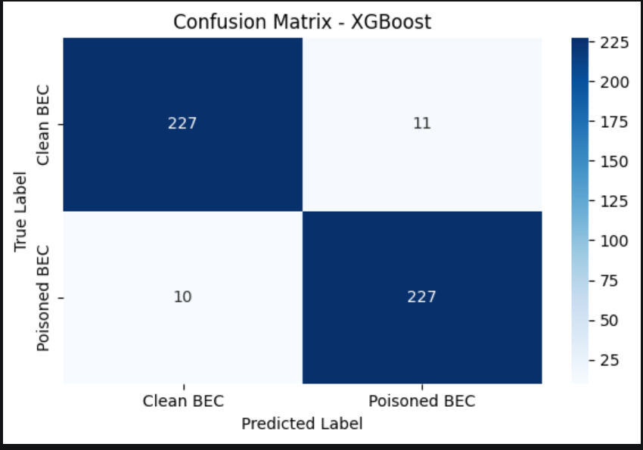
Figure 2 shows the confusion matrix of XGBoost, presenting the number of correct and incorrect predictions for clean BEC and poisoned/adversarial BEC emails.

4.7. Security Interpretation
The performance of the BEC detection system should not be evaluated solely by its overall accuracy. In cybersecurity applications, the consequences of incorrect predictions are often much more important than a small improvement in classification accuracy. Therefore, False Positive (FP) and False Negative (FN) errors must be carefully analyzed.
False Positive (FP)
A False Positive occurs when a clean BEC email is incorrectly classified as a poisoned/adversarial BEC email.
Potential impacts include:
- Clean BEC samples may be incorrectly flagged as poisoned/adversarial.
- Security analysts may need to review more emails manually.
- The system may generate unnecessary alerts.
- Too many false positives may reduce trust in the detection system.
Although False Positives increase review workload, they are usually less dangerous than False Negatives because the suspicious email is still detected and can be inspected manually.
False Negative (FN)
A False Negative occurs when a poisoned/adversarial BEC email is incorrectly classified as a clean BEC email.
Potential impacts include:
- Poisoned/adversarial BEC emails may bypass the detection system.
- The attacker’s modified email may be treated as clean.
- The system may fail to detect adversarial manipulation techniques.
- This can increase the risk of financial fraud or sensitive information leakage.
For this project, False Negatives are more critical than False Positives because they allow poisoned/adversarial BEC emails to pass through as clean emails.
Security Perspective
In practical deployment, the objective of a BEC detection system is to minimize False Negatives while maintaining an acceptable False Positive rate. A slightly higher False Positive rate is often acceptable because suspicious emails can still be reviewed manually, whereas a single False Negative may result in successful financial fraud or data leakage.
Therefore, evaluation metrics such as Precision, Recall, and F1-score should be considered together rather than relying only on overall accuracy. A high Recall indicates that the model successfully detects most poisoned/adversarial BEC emails, making it more suitable for real-world cybersecurity applications.
Overall, minimizing False Negatives while maintaining high Precision provides a balanced and effective defense against Business Email Compromise attacks.

4.8. Robustness and Limitation Analysis
Despite the encouraging performance metrics achieved by the evaluated machine learning models, an assessment of the proposed system within a Security Operations Center (SOC) framework uncovers several significant constraints.
- Adversarial Evasion Techniques: The reliance on TF-IDF for feature extraction presents a notable weakness. As TF-IDF utilizes exact lexical matching, the system is susceptible to evasion via text obfuscation, such as character substitution (homoglyphs) or intentional misspellings. These tactics allow poisoned/adversarial content to bypass detection, thereby inflating the False Negative rate.
- Concept Drift: The model relies on static, historical training data derived from past Business Email Compromise (BEC) tactics, techniques, and procedures (TTPs). Given the dynamic nature of cybersecurity threats, the shifting landscape of social engineering—such as the transition from gift card fraud to cryptocurrency scams—means that the model’s efficacy will degrade over time without a systematic, continuous retraining pipeline.
- Label Noise and Annotation Bias: The reliance on open-source datasets (e.g., Kaggle, Springer) introduces the risk of label noise. As the classification between clean BEC emails and poisoned/adversarial BEC emails can be subjective, inconsistencies in the ground truth can be propagated through the learning algorithm, potentially skewing the model's decision boundaries.
- Generalization Constraints: The model’s performance is tightly coupled with its training corpus, which is exclusively in English. Consequently, the system lacks the ability to generalize to non-English languages or to specialized domain-specific communications, thereby limiting its applicability to English-speaking corporate environments.
- Privacy and Regulatory Compliance: The NLP pipeline necessitates the deep inspection of raw email bodies to detect BEC anomalies. Handling highly sensitive corporate data—including financial agreements and Personally Identifiable Information (PII)—presents substantial privacy risks. Deployment in a real-world setting would require stringent adherence to regulatory frameworks, such as GDPR, necessitating the implementation of rigorous data anonymization protocols prior to inference.

4.9. Deployment Thinking
This process requires not only a low-latency software system architecture but must also address the core challenges of cyberspace: Adversarial Nature and Concept Drift. Based on the system's limitation analysis, the team's deployment strategy focuses on implementing the most robust model (XGBoost), ensuring the capability for continuous data drift monitoring, and managing a privacy-compliant feedback loop.
4.9.1. Real-world Pipeline Execution Modeling
In a real-world environment, the system does not call the fit() function to retrain every time new data arrives. The system is divided into two distinct streams: Offline Training and Online Inference, operating on a microservice architecture.
- Serialization & Containerization: Instead of utilizing Multinomial Naive Bayes as the primary baseline, the production system will package the team's optimal pipeline: the XGBoost Classifier combined with a Character-level TF-IDF Vectorizer (n-gram 2 to 4). The model-serving API can be deployed with FastAPI or Flask and packaged with Docker to ensure consistent deployment.
- Real-world Email Inference Flow:
  - Email Ingestion: When an email enters the organization's network, the Mail Gateway will temporarily intercept it at the edge layer.
  - API Request: The Gateway extracts both the Subject line and the Body text of the email.
  - Pipeline Execution (Adversarial Tuned): The input data will undergo rigorous processing steps:
    - Text Integration: The system will automatically perform Missing Value Imputation and concatenate the subject string with the body text into a single textual feature to preserve contextual integrity.
    - Light Text Normalization: The system performs lowercasing, missing-value handling, and whitespace normalization. For the XGBoost deployment pipeline, punctuation and unusual character patterns should be preserved when necessary because they may contain adversarial signals.
    - Character-level Vectorization: Character-level TF-IDF is used to capture sub-word changes such as misspellings, punctuation injections, and homoglyph-like patterns that may be missed by word-level filters.
    - Classification: The XGBoost model, configured with 300 decision trees (n_estimators=300), will output a prediction and return an adversarial-risk score or confidence score.
    - Actionable Response:
- In practical deployment, a BEC defense system must prioritize minimizing False Negatives (missed poisoned/adversarial BEC emails), as a single bypass can result in data leakage or severe financial loss.

- If the confidence score exceeds the established risk threshold, the email will automatically be redirected to the Quarantine zone for manual review.
4.9.2. System Users and Security Considerations
The system utilizes a "Human-in-the-loop" approach, serving two primary user groups with distinct access privileges and interaction flows:
1. End-Users (Corporate Employees):
- End-users can report incorrectly blocked emails as safe. However, these reports must be manually reviewed by security analysts before being used for retraining to prevent data poisoning.
2. SOC Team (Security Operations Center / System Administrators):
- Threshold Tuning: The SOC Team may dynamically adjust the classification threshold depending on the operational context. They may accept a slightly higher False Positive rate to ensure the False Negative rate remains at an absolute minimum, thus safeguarding the organization's assets.
- Data Curation: Security analysts will manually review and validate the "Report Safe" submissions before relabeling and integrating them into the future training corpus.
4.9.3. Monitoring, Logging, and Regulatory Compliance Strategy
A. Privacy and Regulatory Compliance:
- The NLP pipeline necessitates the deep inspection of raw email bodies, which may contain highly sensitive corporate agreements and Personally Identifiable Information (PII).
- To ensure strict adherence to regulatory frameworks such as GDPR, the system's logging mechanisms must implement rigorous data anonymization protocols prior to inference or storage.
B. Drift Monitoring:
- The system should monitor adversarial evasion patterns and concept drift. If model performance decreases or new BEC tactics appear, the SOC team should collect new data and retrain the model.
4.10. Conclusion and Future Work
This project developed a machine learning-based approach to classify clean BEC emails and poisoned/adversarial BEC emails. The team built a complete text classification pipeline, including data loading, preprocessing, TF-IDF feature extraction, model training, and evaluation.
Six machine learning models were trained and compared: Multinomial Naive Bayes, Logistic Regression, Random Forest, Linear SVC, Gradient Boosting, and XGBoost. Among these models, XGBoost achieved the best performance with an Accuracy of 0.9558 and an F1-score of 0.9558.
The project shows that machine learning techniques can be useful for detecting adversarial BEC email patterns. However, the project still has some limitations. The dataset is synthetic and does not contain legitimate non-BEC emails, so the system should not be considered a normal spam detection system.
In future work, the project could be improved by using more real-world email data, adding legitimate email samples, testing more adversarial attack methods, and including additional features such as email headers, sender behavior, and time-based patterns.
Team Contribution
Full Name | Student ID | Main Responsibilities | Document Contribution | Code / Implementation Contribution
Phong Nguyễn Nhật Lam | CE200024 | Leader, final report and source package integration; metric and result checking; slide review; presentation | 16.67% | 16.67%
Nguyễn Phi Trường | CE200923 | Related work; literature review; methodology rationale; Multinomial Naive Bayes support; presentation | 16.67% | 16.67%
Huỳnh Phúc Khang | CE200271 | Dataset understanding; data quality analysis; class distribution; Random Forest support; security interpretation; presentation | 16.67% | 16.67%
Ngô Kiến Tường | CE200920 | Preprocessing; feature engineering; modeling explanation; pipeline diagram; Logistic Regression support; presentation | 16.67% | 16.67%
Nguyễn Đức An | CE201460 | XGBoost model; deployment thinking; demo support; slide preparation support; presentation | 16.67% | 16.67%
Đặng Lâm Mỹ Khánh | CE200080 | Robustness and limitation analysis; Linear SVC support; slide preparation support; presentation | 16.67% | 16.67%
Declaration of AI Tool Usage
The team used AI tools such as ChatGPT to support language refinement, report organization, and explanation improvement. The implementation, dataset processing, model training, evaluation results, and final decisions were reviewed and verified by the team. The team remains fully responsible for the accuracy, integrity, and originality of the submitted project.
REFERENCES
[1] A. Cidon, A. Gavish, I. Bleier, N. Korshun, M. Schweighauser, and A. Shah, "High precision detection of business email compromise," in Proceedings of the 2019 conference on empirical methods in natural language processing, 2019.

[2] N. Boucher and R. Anderson, "Bad characters: Imperceptible NLP attacks," in IEEE Symposium on Security and Privacy (SP), 2022.

