Assignment 3 – Front End Requirements Report

Erik Koning: 10191998

Hunter Orr: 10149217

Zheng Peng: 20009736

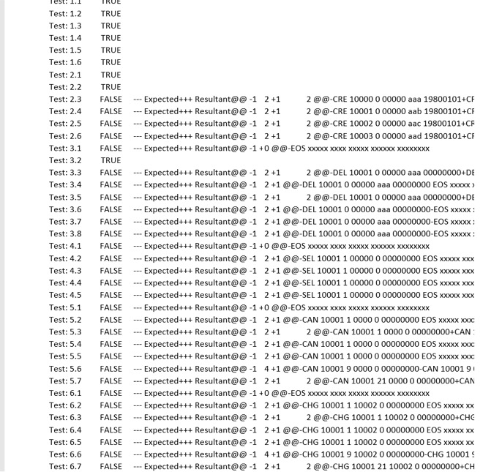

From this result we were able to determine that some of our expected output files had mistakes in them. We modified the expected output files to better match what we wanted to see from the program similar to below, filling in the blanks with Xs instead of 0s.

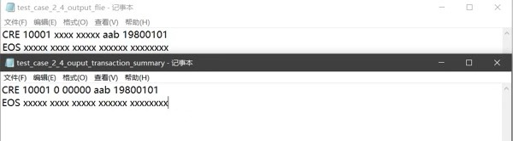

The second issue that arose is that some of the test cases do not generate result files or skip over several commands. We set the input file path to the direct test case we want (test case 2.3 at this time). We add print statements in testing.py to print the path of files to check the code get a right path or not. The code dose show the print statements when the output files are not the same, but show the path when output files (test case 1.5) are the same.

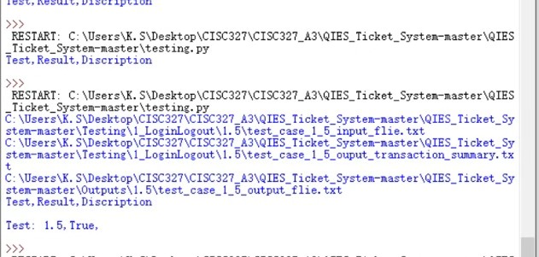

The third issue that we dealt with had to do with the output files again. This time two identical files were not being correctly compared. In this case, return conversion between windows and other operating systems was an issue which we had to solve at this point in the project. Once fixed, these false negatives were removed and the testing program ran much smoother.