How to Refill Brady Rolls
This guide shows you how to use the Brady Roll Refill Box to read a roll, check whether it can be refilled, and restore the remaining label count or continuous roll length.
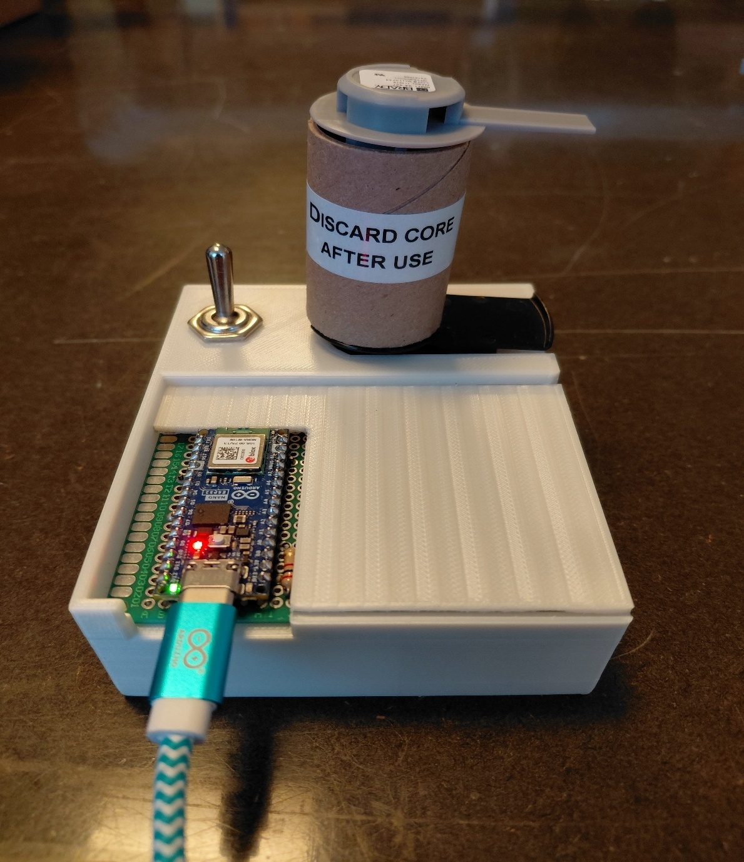
Arduino DS2431 Automatic BRC Refill Tool

Contents
Background 2
How To: Using the Arduino Brady Roll Refill Box 3
1. Connecting the Label Roll 3
2. Reading the Roll Status 3
3. Reading the LEDs 4
4. Refilling the Roll 4
5. Optional: Permanent Locking 5
Troubleshooting 5

Background
Each supported Brady label roll contains a DS2431 EEPROM (Smart Cell). The printer reads static media information from the chip and updates a small dynamic area as material is used. The refill box reads the same data and restores only the dynamic remaining-value field; it does not modify the roll's static media definition or its protection registers.
The current refill program is intentionally limited to the BRC Smart Cell format, identified by the bytes 42 52 43 (ASCII “BRC”) at the start of EEPROM memory. Legacy / non-BRC layouts are treated as read-only so the program does not guess at an unknown memory layout.
Two refill modes are supported: count-based media (die-cut labels and sleeves), where the tool restores the nominal label quantity, and continuous M6C media, where the tool restores the nominal roll length. Continuous length is stored as a 24-bit value in thousandths of an inch.
Note: Some Brady rolls appear to leave the factory with an internal counter slightly above the nominal quantity (for example, about 10% extra). This tool refills count-based media to the nominal quantity stored in the Smart Cell, not to any factory overage.

A refill is only allowed when the Smart Cell passes its validation checks and Page 3 is still writable. A permanently write-protected Page 3 cannot be refilled.

How To: Using the Arduino Brady Roll Refill Box
The interface box automatically reads the installed roll, identifies the supported media layout, checks CRC/checksum data, and shows whether the roll is ready for refill. Nothing is written merely by inserting a roll; the physical switch must be flipped after detection.
Note: Contact can be unreliable. If the roll is not detected, slide it gently back and forth or bend the contact pins upward slightly.

1. Connecting the Label Roll
1. Power on the Arduino box.
2. Open the Serial Monitor at 9600 baud if you want to see the full EEPROM/status information.
3. Slide the roll into the connector so the metal pads make reliable contact with the pins.
4. Wait for the Arduino to detect and decode the Smart Cell. Do not flip the switch until the status has finished printing.
LED behaviour during detection:
• White - System starting
• Yellow - Waiting/searching for a roll
• Magenta - Roll detected and being decoded

2. Reading the Roll Status
For a supported BRC roll, the Serial Monitor shows the ROM ID, part number, media type, CRC/checksum status, current remaining value, full value, and Page 3 write status. If PRINT_FULL_DUMP_ON_INSERT is enabled, pages 0-3 and the control bytes are also printed.
Typical ready status:
Brady BRC format: OK
Part number: <detected roll>
Media type: DIE-CUT / COUNT BASED or CONTINUOUS
Dynamic checksum: OK
Page 3: OPEN / WRITABLE
ROLL READY FOR REFILL
For count-based media, the program shows the nominal label quantity and current remaining count. For continuous M6C media, it shows the nominal full roll length and remaining length in inches, feet and metres.

3. Reading the LEDs
LED | Meaning
White | System starting
Yellow | Waiting for a roll / no chip detected
Magenta | Roll detected; reading and decoding Smart Cell
Green | Supported roll is ready for refill, or refill completed successfully
Blue | Readable but refill is disabled (for example legacy/non-BRC, unsupported layout, or not safely refillable)
Red | Validation/write failure, or a refill attempt could not be completed

4. Refilling the Roll
1. Insert the roll and wait until the Serial Monitor shows ROLL READY FOR REFILL and the LED is green.
2. Check that the detected part number and full value look reasonable for the roll you inserted.
3. Flip the hardware switch once. One physical switch movement causes one refill attempt.
4. Keep the roll firmly connected while the scratchpad and EEPROM verification run.
5. Wait for REFILL SUCCESSFUL and EEPROM verification: OK before removing the roll.
Recommended workflow: Refill a roll when it starts getting low. If the stored value already equals the nominal full value, the program skips the EEPROM write.
What the switch writes: Count-based BRC media is restored to the nominal label quantity; continuous M6C media is restored to the nominal full length. Reserved dynamic bytes are preserved, the dynamic checksum is recalculated, and static media/protection data is left unchanged.
A successful operation ends with Scratchpad verification: OK, EEPROM verification: OK and REFILL SUCCESSFUL in the Serial Monitor.

5. Optional: Permanent Locking
The refill program itself never writes the DS2431 protection registers. If you deliberately want to freeze the counter so the printer can no longer change it, use the separate locking program from the earlier interface-box workflow.
Caution: Permanent locking is irreversible. Once Page 3 is write-protected, the refill program cannot update the remaining counter again. Use refill-as-needed if you want to keep the roll reusable and adjustable.

Troubleshooting
Roll not detected
• Make sure the roll is fully seated and the metal pads are touching the connector pins.
• Slide the roll slightly back and forth or bend the contact pins upward slightly if needed.
• Check USB power/cable and press reset if communication has stopped.
LEGACY / UNSUPPORTED SMART CELL / BRC format: NOT FOUND - The Smart Cell uses a layout that this refill program intentionally leaves read-only. Do not bypass the BRC checks to force a write.
Page 3: WRITE PROTECTED - The dynamic counter page is permanently protected and cannot be refilled. This is expected on rolls previously locked with the locking program.
Capacity marker not found / unsupported BRC layout - The roll is BRC, but the program cannot safely determine its nominal full value. Keep it read-only until the layout is mapped.
Dynamic checksum invalid / Static CRC invalid - Re-seat the roll and read it again to rule out poor contact. If the error is repeatable, do not refill it.
Printer gives a ribbon warning after the roll is detected - The label media has been detected, but the installed ribbon is not recommended. Install the correct ribbon series; this is separate from the refill operation.
Printer still does not detect the roll - A successful Arduino read does not guarantee that the printer supports that Smart Cell generation or media family. Legacy/non-BRC media may still be rejected by the printer.
Refill tool strategy: read first, validate, then write only the supported dynamic counter row.

