Big Mountain Resort, a ski resort located in Montana which offers spectacular views of Glacier National Park and Flathead National Forest. Big Mountain has access to 105 trails and roughly 350,000 people ski or snowboard at Big Mountain and riders of all levels and abilities enjoy the resort every year. These are serviced by 11 lifts, 2 T-bars, 1 magic carpet for novice skiers, and the longest run is named Hellfire which is 3.3 miles in length. The base elevations 4,464 ft, and the summit is 6,817 ft with a vertical drop of 2,353 ft. Also, Big Mountain has installed an additional chair lift to increase the distribution of visitors across the mountain, which added $1,540,000 operating cost this season.

Big Mountain Resorts' pricing strategy is to charge a premium above the average price in its market segment and is aware of limitations. They are looking to capitalize on its facilities by determining how important some facilities are compared to others which hamper the investment strategy.

Also, the business wants a data driven model regarding a better value for their ticket price and changes that they can support higher ticket price. The business also looking for guidance in cutting costs without undermining the ticket price or even support a higher ticket price.

*Problem Statement:*

**Does the data support an increase in the ticket price or/ and provide possible insight into operational and investment strategy?**

*Initial Data Observations: (Data wrangling)*

*- 330 resorts in the US which is part of the same market*

*- fastEight: # of fast eight chairs*

*- more than 50% is unknown and mostly zeros - useless*

*- About 14% of the rows have no price data - useless*

*- Silverton Mountain has SkiableTerrain_ac of 26,819, which was changes to 1,819*

*- NightSkiing_ac missing 43%*

*- AdultWeekend & AdultWeekday has 15% - 16% missing ticket price*

*- daysOpenLastYear missing 16%*

*- TerrainParks missing 16%*

*- projectedDaysOpen missing 14%*

*- Snow Making_ac missing 14%*

*- Added two additional fields*

*- state population*

*- state area in square miles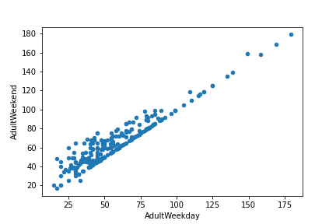*

*- 11 ski resorts in Montana charge same ticket price*

*- Weekend prices being higher than weekday prices seem restricted to sub $100 resorts*

*Data Analysis:*

Our current price of $81.00 is the highest in the state of Montana but the model predicted $95.87 as our new ticket price. Cross-validation method was used to provide an expected mean absolute error of $10.39, which supported room for an increase in our ticket price.

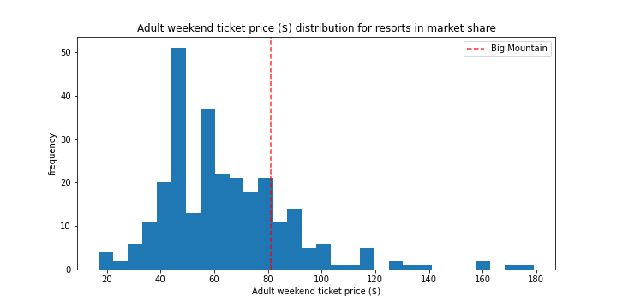

Features that came up as important in the modeling included:

a) vertical_drop

b) Snow Making_ac

c) total_chairs

d) fastQuads

e) Runs

f) LongestRun_mi

g) trams

h) SkiableTerrain_ac

During our EDA, it was discovered that summit and base elevation are quite highly correlated. Also, an interesting positive correlation between the ratio of night skiing area with the number of resorts per capita, and negatively correlated with the number of resorts in each state.

Snow Making_ac, Runs, and fastQuads had a reasonable correlation that stood out but resort_night_skiing_state_ratio seems most correlated with the ticket price. As well as total_chairs, and Runs are well correlated with ticket price but the total skiable terrain area is not as useful as an area with snowmaking.

1) Close up to 10 of the least used runs.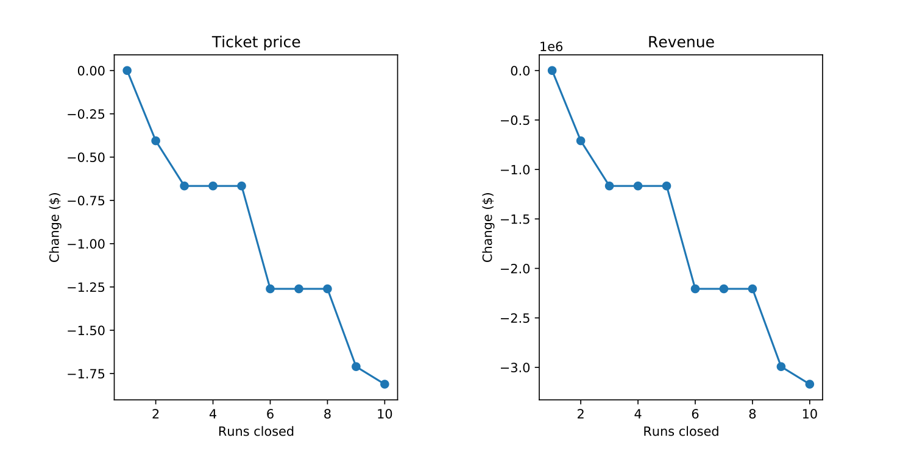

According to for figures above, the model says closing one run makes no difference. Closing 2 and 3 successively reduces support for the ticket price. If Big Mountain closes down three runs, it seems they may as well close down 4 or 5 as there's no further loss in the ticket price.

The scenarios below are using our model, which supports ticket price increase for Big mountain. The model is assuming recently added lifts with visitors on average of 350,000 for five days.

1) Big Mountain is adding a run, increasing the vertical drop by 150 feet, and installing an additional chair lift.

* This scenario increases support for ticket price by $1.99 and could expect to be $3,474,638 annually

2) In this scenario, you are repeating the previous one but adding 2 acres of snow making.

* This scenario increases support for ticket price by $1.99 and could expect to be $3,474,638 annually

3) This scenario calls for increasing the longest run by .2 miles and guaranteeing its snow coverage by adding 4 acres of snow making capability.

* No difference whatsoever. Although the longest run feature was used in the linear model, the random forest model (the one we chose because of its better performance) only has longest run way down in the feature importance list.