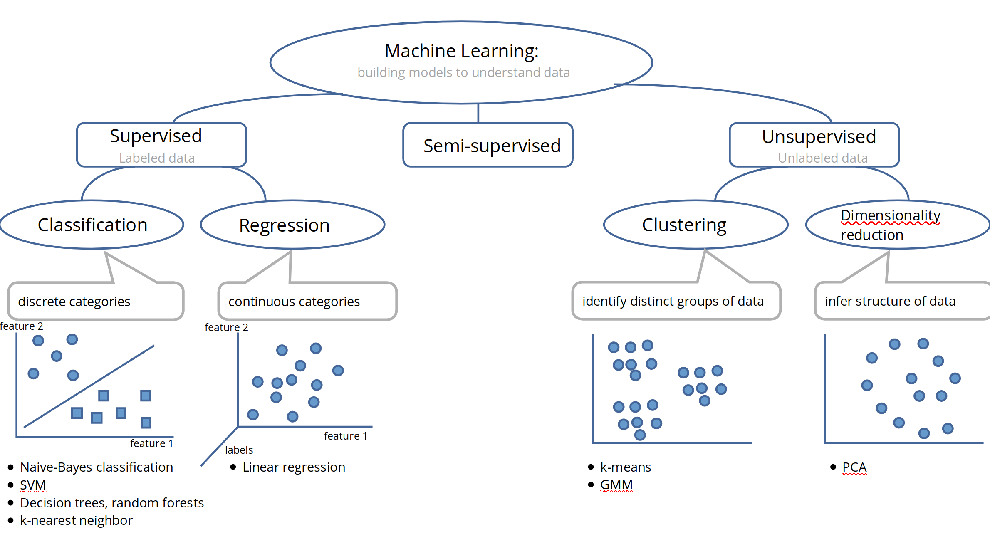
Please refer to the following for preparation on the respective topics:

- SVM: https://machinelearningmastery.com/support-vector-machines-for-machine-learning/
- k-nearest Neighbor: https://machinelearningmastery.com/k-nearest-neighbors-for-machine-learning/
- Linear Regression: https://machinelearningmastery.com/linear-regression-for-machine-learning/
- K-means Clustering: https://brilliant.org/wiki/k-means-clustering/
- GMM: https://brilliant.org/wiki/gaussian-mixture-model/
- PCA: https://medium.com/@aptrishu/understanding-principle-component-analysis-e32be0253ef0

