

Road Trip Companion

Final Project Report

DT211c

BSc in Computer Science Infrastructure

**Erik Grunnér**

**C17412636**

**Supervisor**

School of Computer Science

Technological University, Dublin

**Date**

Abstract

The Goal of this project is to develop a mobile app which functions as both a road trip planning application and acts as a local guide while on the trip. Mainly focused on Driving but should work for walking/cycling trips.

The app will be split into two main functions:

* The Planning Phase – This is where to start off the User would enter both starting point and destination, similarly to any other navigation app. Then timing estimations would be presented along with possible on route destinations for each timeframe. Following that will come more in-depth look at the selected route with checkboxes for all desired stops. Finally, a calculated estimation for total trip length.
* The Travel Phase – This would be where the actual navigation would take place. Alongside this would be an (optional) interactive experience guiding you through the areas you visit and suggesting additional smaller pitstops; This could include bathroom breaks, petrol stops or mainly extra destinations such as viewing points or short activities.

I hope to be able to publicly launch on the Play Store for it to be available to anyone.

Declaration

I hereby declare that the work described in this dissertation is, except where otherwise stated, entirely my own work and has not been submitted as an exercise for a degree at this or any other university.

Signed:

_________________________

Erik Grunnér

Date

Acknowledgements

Table of Contents

1. Introduction 7

1.1. Project Background 7

1.2. Project Description 8

1.3. Project Aims and Objectives 8

1.4. Project Scope 8

1.5. Thesis Roadmap 8

2. Literature Review 9

2.1. Introduction 9

2.2. Alternative Existing Solutions to Your Problem 9

2.3. Technologies researched 13

Google API & Mapbox 14

Ionic with angular 14

2.4. Other Research you’ve done 14

Mobile App Environment 14

2.5. Existing Final Year Projects 15

2.6. Conclusions 16

3. Experiment Design 17

3.1 Introduction 17

3.2. Software Methodology 17

Waterfall 17

Agile 17

Extreme 18

SCRUM 19

3.3. Overview of System 19

3.4. Front-End 19

3.5. Middle-Tier 19

3.6. Back-End 19

3.7. Conclusions 19

4. Experiment Development 20

4.1. Introduction 20

4.2. Software Development 20

4.3. Front-End 20

4.4. Middle-Tier 20

4.5. Back-End 20

4.6. Conclusions 20

5. Testing and Evaluation 21

5.1. Introduction 21

5.2. System Testing 21

5.3. System Evaluation 21

5.4. Conclusions 21

6. Conclusions and Future Work 22

6.1. Introduction 22

6.2. Conclusions 22

6.3. Future Work 22

Bibliography 23

# 1. Introduction

## Project Background

While travelling over the years in various places I’ve found that my lack of knowledge of the area and lack of special awareness to that new area has led to my missing out on various visits and activities. The goal of this app will eliminate all of this while also preserving the sense of adventure that comes along with a holiday.

In my research I identified two similar mobile apps

* Road Trippers has a similar concept, the main difference being that they create curated guides to specific areas, all within the United States, Canada, Australia and New Zealand. This style of curation over automation means that users are being suggested the same trips and have a more limited range of options for their trip. It is also possible to create personal trips but this is not the focus of the app. In my research this functionality is lacking in many ways.
* Google Trips also has similar app but puts focus on visiting specific areas or cities. This is different in that the journey is not a focus to the trip, but that the journey is an afterthought, i.e. travel is only treated as travel and not a part of the experience.

Fitzgerald C *et al.* (2010) has an abandoned patent application for a recommender system designed for navigation, which would be similar to one part of my proposed project. Although it specifies itself based on a property database, rather than looking for open license data.

Further Reading into a Personalised trip recommender based on points of interest proved to be similar in that time is a focus in their recommender system and this would relate more closely to how I wish to implement the recommender system into the navigational system for on the go recommendations.

Fitzgerald C, Vis D, inventors. Advice engine delivering personalized search results and customized roadtrip plans. United States patent application US 12/113,911. 2010 Dec 9.means of transportation.

Roadtrippers. 2020. *Discover The Best Diners, Scenic Spots, Attractions, Hotels, And Much More With Over A Million Amazing Points Of Interest. Roadtrippers Has Places You Just Won’T Find Anywhere Else!*. [online] Available at: <https://maps.roadtrippers.com/> [Accessed 12 October 2020].

Google Trips. 2020. Looking for your trips and travel research? Sign in to the Google Account where you receive confirmation emails to see your booked reservations and travel [ online] Available at: < https://www.google.com/travel/[/> [Accessed 12 October 2020].

Lim, Kwan Hui & Chan, Jeffrey & Leckie, Christopher & Karunasekera, Shanika. (2018). Personalized trip recommendation for tourists based on user interests, points of interest visit durations and visit recency. Knowledge and Information Systems. 54. 375-406. 10.1007/s10115-017-1056-y.

## Project Description

An overview of the project

Include a diagram

## Project Aims and Objectives

Overall aim and some milestones along the way to achieve the aim

* Data processing and generation of map points
* Collaborative Recommendation System
* Multi user interaction
* Android application

## Project Scope

The main parts to the system focus on UX design and are based on developing the recommender system that goes along with the application.

The mapping service and real time navifation services will be taken from API’s to facilitate the rest of the projcts function.

## Thesis Roadmap

One sentence summary of the following chapters

# 2. Literature Review

## 2.1. Introduction

In this chapter multiple projects which relate to this one will be discussed in order to gain insight into the reasons for their design choices. This is very useful as we know that each of them went through their own design process and have inherent knowledge baked into the applications.

## 2.2. Alternative Existing Solutions to Your Problem

To evaluate these two systems an adjusted set of Nielsen’s Heuristics will be used. Heuristic evaluation is in essence a way to measure a systems usability by going through a series of checks. By using this type of inspection one can identify usability design flaws in each system. Each check should test against specific design principals which I have altered to suit the needs of these types of navigation apps.

1. **Visibility of system status**:  
   The system’s ability to keep the users informed on the state of system with the right outputs. This becomes especially important with safety concerns in mind due to the nature of the apps. In this case we have both driving and setting up as two modes it should be in.
2. **Match between system and the real world**:  
   This refers to the system’s ability to convey its information in a reasonable way so that the user can understand. This would include the appropriate language and the use of real-world phrases and terms. We can realise this as how well the app represents the possibilities of a road trip and how well it can guide you when you are on the trip.
3. **User control and freedom**:  
   Allows for the users to remain in control of the system without having to go through unnecessary processes, clearly marked options should be available.
4. **Consistency and standards**:  
   The structure of the system should follow its own conventions and be clearly structured for the users to understand.
5. **Error prevention**:  
   A properly designed system would be better than good error prevention but nonetheless checks with the users before committing to options can help prevent further errors.
6. **Recognition rather than recall**:  
   The users should be able to intuitively navigate around the system rather than having to take to the manual. Following industry standards can help in user’s recognition of system functions. This point relates to safety during the navigation stage.
7. **Flexibility and efficiency of use**:  
   The use of shortcuts or” Accelerators” can be a good way of adding flexibility and efficiency for the advanced users while also not impeding the experience from the new user’s point of view.
8. **Aesthetic and minimalist design**:  
   The design of a system plays a large role in how the users interacts with it especially in a navigation application. The right information must be shown at appropriate times and should not interfere with driving.
9. **Help users recognize, diagnose, and recover from errors**:  
   Error messages should present in plain language as to allow any users to understand the problem and/or allows for some solution to the issue.
10. **Help and documentation**:  
    A system which does not not need explicit documentation is always preferable but does not rule out the fact that proper and structured documentation can aid in helping users with many specific problems.

The Software being investigated and reviewed with the help of these Heuristics included Road Trippers and Google Trips. Grading each application will be from 1 to 5 on each of the 10 Heuristics listed above, with a small explanation for each scoring. In order to do this, I will try and perform the same of similar trips on a small scale in my locality. I hope this will give me enough to work with regarding the evaluation. The grading system scores:

1. Unusable
2. Bad design implementation
3. Usable but nothing more or less
4. Good implementation of design
5. Excellent implementation of design

Google Trips

1. **Visibility of system status**: 3  
   The actual navigation on the system is very good but it lacks integration of the whole trip and its status.
2. **Match between system and the real world**: 4  
   Google trips does a very good job of organising all the different activities into groups and making searching an easy task.
3. **User control and freedom**: 2  
   While the setup process is very extensive and has lots of options, there is no app to accompany the web setup and instead saved points of interest are sent to Google maps where the route still needs to be created.
4. **Consistency and standards**: 3  
   The separation of the web app and google maps led to a lot of frustration when the trips changed form on the mobile app.
5. **Error prevention**: 3  
   Rerouting when wrong turns are taken.
6. **Recognition rather than recall**: 4  
   The extensive use of symbols and concise descriptions made sure that navigation of the system was always known.
7. **Flexibility and efficiency of use**: 2  
   While a user can change things on the go , as the trip creation tool is on the website it gets very awkward to edit the trip when it has been converted for use on google maps.
8. **Aesthetic and minimalist design**: 4

The design was very clear for the most part and provided a clear view of what functions were available and what information the system wished to show the user.

1. **Help users recognize, diagnose, and recover from errors**: 3

Overall lack of clarity in regards to the trips integration to the app.

1. **Help and documentation**: 4

There is very thorough documentation on the site. Everything is tabbed for organisation and FAQ’s are intermingled to make searching for them easier.

Overall the separation between the web application and the fact that google maps is supposed to be the mobile frontend to use google trips to be very awkward and made it difficult to use while on real-world trips.

Road Trippers

1. **Visibility of system status**: 3  
   The separation of the full road trip and having to route to individual points makes it harder to fully realise your progress of the whole trip. This is most evident when multiple stops are nearby each other.
2. **Match between system and the real world**: 4  
   Much in the same way as the previous app, this had excellence relation between the system and the real world.
3. **User control and freedom**: 2  
   The creation of trips is where it was very lacking. While it is possible the app seems to aim at delivering curated trips to the users. Although the user must create an account in order to use any of the curated trips.
4. **Consistency and standards**: 5  
   Both the mobile and web app have been rigorously designed and match up quite well. There are very few inconsistencies.
5. **Error prevention**: 2  
   the navigation is badly implemented into the apps workflow. Each specific stop needs to be selected and routed to, rather than a more integrated feel. This would be difficult for use while driving.
6. **Recognition rather than recall**: 5  
   The layout and use of symbols were used in a similar way to google trips but in general the limits of the system to only roads trips made for an more specific but easier experience.
7. **Flexibility and efficiency of use**: 4  
   The creation of new route is quite limited on the mobile application.
8. **Aesthetic and minimalist design**: 5  
   The Aesthetic of both the web and mobile app had great attention to detail and provided a good experience.
9. **Help users recognize, diagnose, and recover from errors**: 4

Most of the app is very clearly laid out and has an intuitive nature.

1. **Help and documentation**: 4  
   In terms of help, a fleshed out help page on the website which is easily viewable on a mobile device provided great assistance.

To summarise the majority of the app to be well laid out and functional. The only real issue is the navigation being split up into chunks of routes in between places. This becomes a problem when stops are nearby each other.

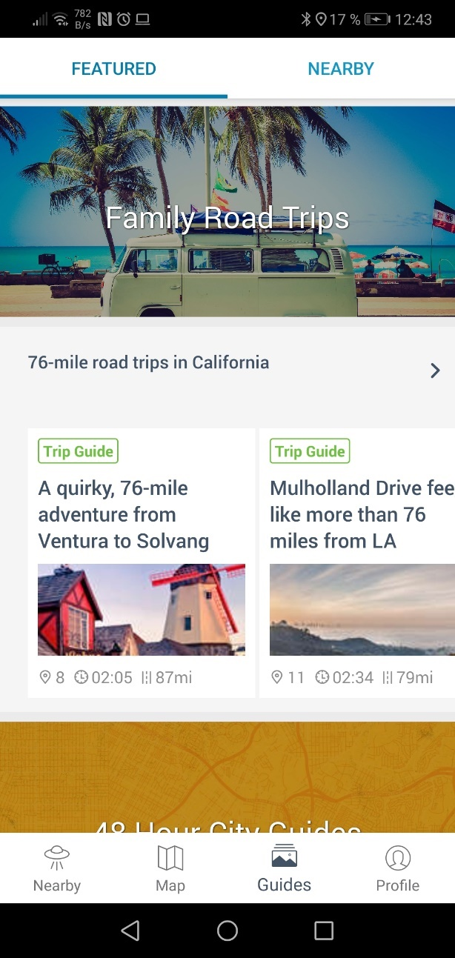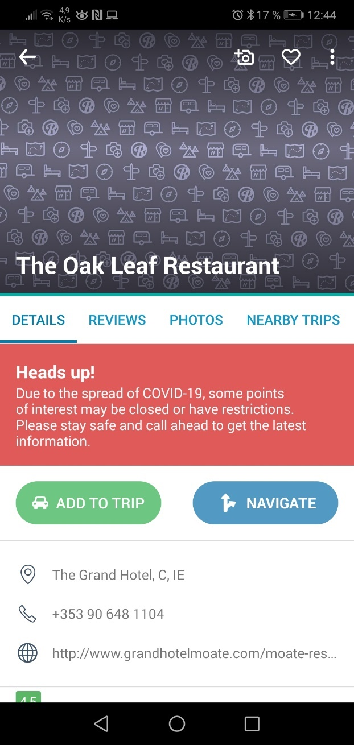

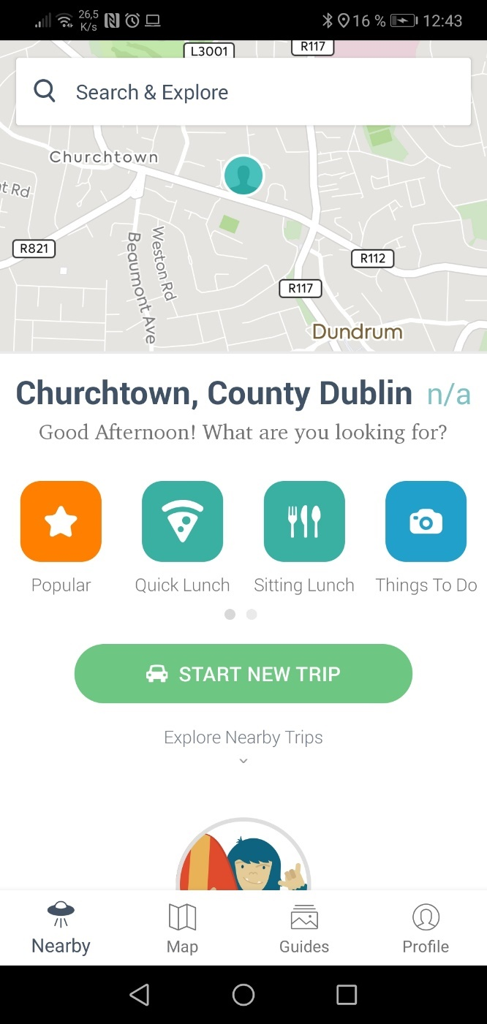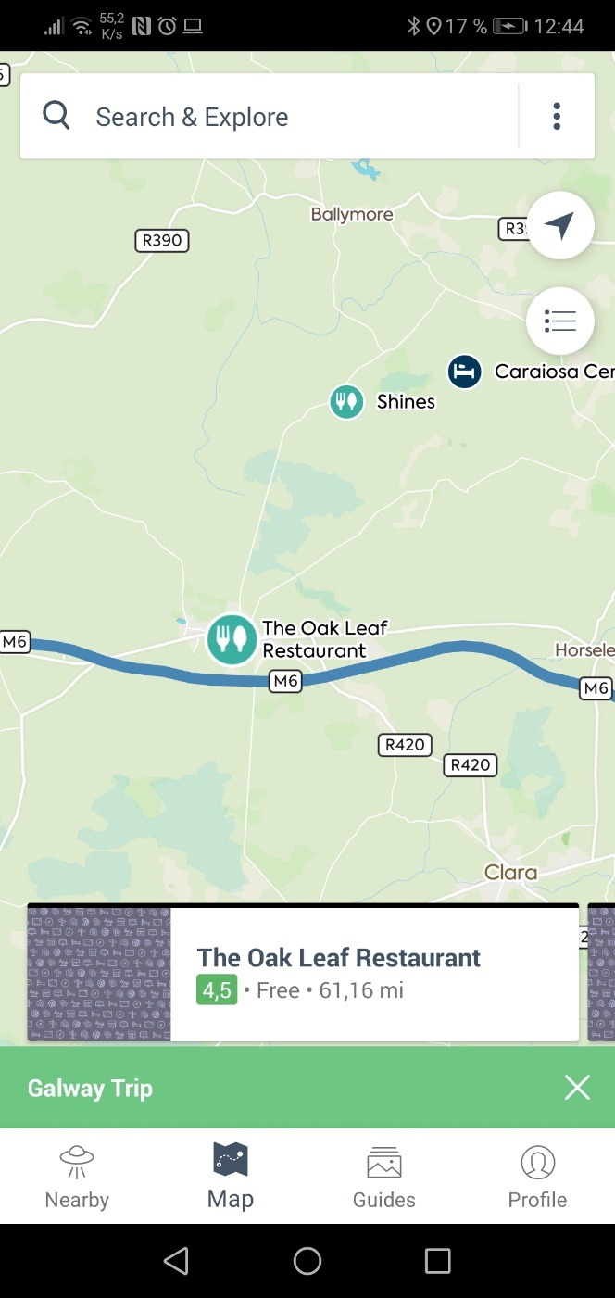

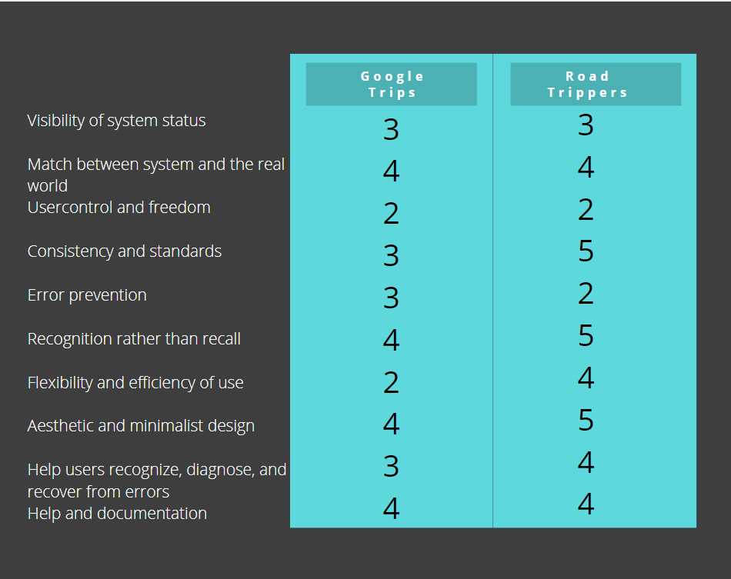

This chart shows what two similar applications do well and what they do badly. Starting from the top it is clear that the system status does have some good qualities that can be drawn from but namely the overall focus on the road trip needs to be considered when making the design for this system. The second metric shows how well both systems take in and show real world data, but this also considered their live navigation. User control and freedom is something that will be handled completely differently and should be well researched in the testing phase of the wireframe mock-ups. The standards will have taken inspiration from the unique but consistent styling Road Trippers managed to implement. The error prevention also needs careful evaluation while designing the new app. Aesthetic design combined with minimalism will be very important in this type of app and as has been shown contributes to the usability of the app while on the road. By creating the system in a simple and modular way the users will not be prone to errors which is important in a real-time task like navigation. Documentation is key to resolving any issues without intervention.

From here we can draw some conclusions on the requirements the system will need based on these evaluations on similar systems.

Requirements

* Simple well-defined UI
* Real time navigation
* Multiple user inputs
* Users should not be overwhelmed while information while driving
* Continuous recommendations should appear during the journey
* Search by map, voice, and text
* Save, edit and share trips
* In app documentation (simple things)(help section)
* ^possible first time tutorial

UI

Map Service geolocation

Real time navigation

Voice commands

Multi user inputs/ user profiles

Hybrid app

Database/cloud service

Programming language

## 2.3. Technologies researched

In this section technologies which will be relevant to the development of this application will be reviewed and compared. Comparisons between competing technologies will help to tease out helpful features that can be more specific to the use case. This research is very core to the development of the process and can help answering what possibilities can be achieved through API’s or what may need to be developed.

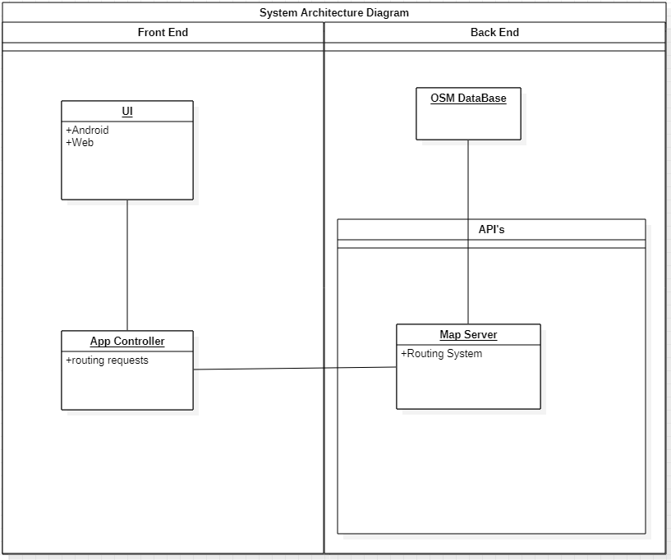

### Google API & Mapbox

In order to perform all of my map related services within my road trip app two technologies have been primarily considered, Google maps API and Mapbox. One of the first considerations was what type of map data is available to use with each of the platforms. While google collects its own data Mapbox works with data collected from OpenStreetMap, an open source map data company. Another advantage MapBox offered over Google was that offline maps was available; while not necessarily a reason to choose one over the other is a welcome feature. Both companies offer free usage of the service for very low volume traffic which is perfect for development.

### Ionic & React Native

Ionic is a framework based on angular JS. This means languages like HTML5, CSS and JavaScript are used. It offers lots of pros like Faster development time, good reliability and great design.

React is a frame Work based on JavaScript and is used to build apps natively on both iOS and Android. The developer then uses the same JS codebase to compile each app natively.

## 2.4. Other Research you’ve done

### Mobile App Environment

When choosing between the options available for mobile app development there are a number of features that need to be considered. In this section those features along with choices made will be discussed

Native or hybrid

Native apps are apps which are written specifically for one operating system. This could include iOS or Android. Native apps tend to be simpler and more straightforward due to the fact that they need to cater for less variables. A native app has more direct access to a device’s hardware and firmware. This results in more efficient code and faster applications.

Developing in native can also have its drawbacks, namely restricting the userbase to that operating system. It also restricts the developer to staying on that operating system into the future as a switch to another OS will incur lots of work in redevelopment. Certain functionality may not be easily transferred over to another OS.

Developing in hybrid tends to be build upon web technologies. Ranging from JavaScript, typescript, html and CSS. The main advantage to doing this is the ability to port the application to almost any device or OS. Development in these languages tend to be faster that in a native app.

One of the main drawbacks to developing in this way would be the performance of the app

## 2.5. Existing Final Year Projects

**Project 1**

**Title:** Travel Assistant

**Student:** Cillian McCabe

**Description (brief):**

This projects aim was to provide improved useful travel information to navigational apps by means of collecting personal data through any sort of mobile or fitness device. The data would then be processed through a machine learning algorithm to provide more accurate time estimations for that specific user when navigating in the future.

Complexities: Extracting enough useful data from the user to provide accurate results from a machine learning algorithm. This also forms a challenge in how to organize the collected data into useful results.

Technical Architectures: Weka(machine Learning), Android, Google Fit Google Maps, Realm Database

Evaluation: This project delivers more accurate data to navigational tools and helps users save time in the real world by providing more accurate estimated times.

As it requires data for the machine learning to takes place, time must be invested in the application before any usable benefits can be seen.

**Project 2**

**Title:** Driving Instructor Assistor

**Student:** Baolach Morrison

**Description (brief):**

This project aims to provide an android app to assist driving instructors while on a lesson. It keeps track of all records and business info. As well as managing these responsibilities it provides map data for places the instructor can teach certain techniques for driving ie 3 point turn.

Complexities: AS this is a real-world based app this means that comprehensive testing must be implemented and would have to checked against real-world tests as opposed to another style of application. This app is to be used by an instructor who is responsible for unexperienced drivers so it must be quick to use and not distracting.

Technical Architectures: Android studio, Java, Django, Python, Django REST framework.

Evaluation: This project give a useful application to Driving instructors by adding time saving features, namely documenting financial and business documents and by helping plan lessons by saving specific points on maps for testing driving skills.

Having to manually input these places does however mean that the database is user generated. Meaning that an instructor will need to be adding places to the DB while/after using the app.

## 2.6. Conclusions

UX requirements.

# 3. Experiment Design

## 3.1 Introduction

## 3.2. Software Methodology

### Waterfall

The waterfall design methodology takes its name due to the rigid order its uses when going through steps. There are 7 steps involved in its design. The idea is that each step is done in order and once completed you would move onto the next step. This approach can be useful for fast development cycles; however, it does not allow for any flexibility in the stages. One cannot go back to design when in the testing process.

1. **Conception:** This is where the basic idea for the project is thought up along with basic conclusions around its pros and cons.
2. **Initiation:** Now a team is assembled and the objectives along with deliverables will be defined.
3. **Requirement gathering and analysis**: The feasibility of the proposal should be evaluated, and a set of requirements laid out.
4. **Design:**Now a design spec will be laid and analysed in order to see what the final product should look like and what is needed to be done in order to get to that point.
5. **Implementation/Coding:** Coding will now begin to implement all that set out in the design phase
6. **Testing:** After all coding is completed testing is performed before the delivery of the product.
7. **Maintenance:** This part is up to the relationship the customer wants to maintain after the delivery of the product.

### Agile

The Agile programming methodology refers to a range of techniques but defines a general principal as to how they should act and perform. Rather than a long-term ridged plan such as the waterfall model Agile focus’s on smaller iterative steps with deliverables being expected much sooner. This structure is repeated in a number of cycles. This type of approach allows for a lot more testing to be incorporated into the process. The customer is much more involved in this type of process as it develops.

Most agile processes follow this structure where you can go back and forth as needed

* Plan
* Design
* Develop
* Test
* Analyse
* Meet

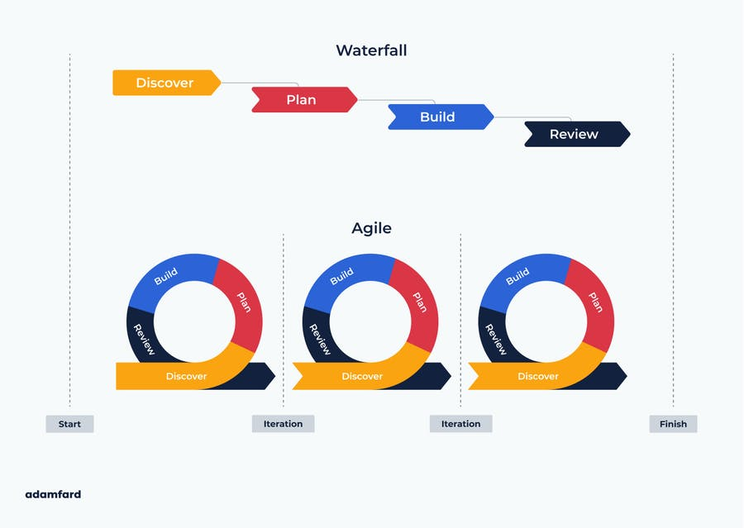

### Extreme

“XP is a lightweight methodology for small to medium sized teams developing software in the face of vague or rapidly changing requirements” -Kent Beck

Extreme programming puts a lot of focus on customer satisfaction. XP is a time saving methodology so would fit projects with a tight time frame. And relies on 5 core values:

* Communication
* Simplicity
* Feedback
* Courage
* Respect

Its cycles consists of the following steps

* Plan
* Design
* Code
* Test
* Deliver/increment

One problem that arises when considering XP is the pair-programming concept as I will be working the coding myself this will not be possible. 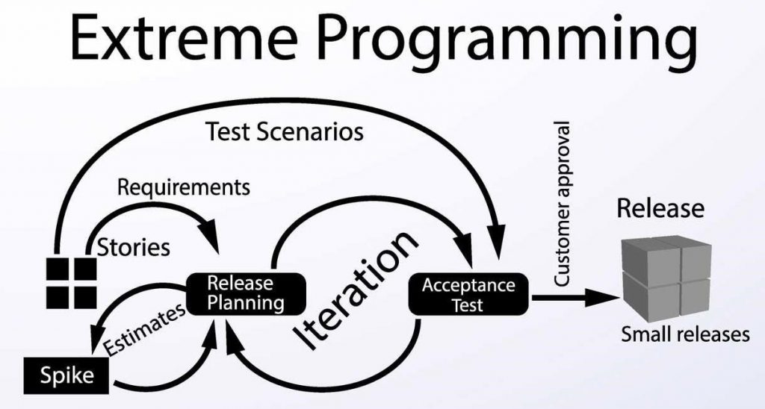

### SCRUM

This methodology puts a lot of its focus on teamwork. Within scrum time is segmented into sprints. This is where a team of people are tasked with completing an allocated workload in a specific timeframe. Scrum is designed to react to unknown challenges during development.

Roles include Product Owner, Scrum Master and the development team. The Owner is there to provide updates requirements. The master manages the team and communicated to the Owner and the Team handles all actual development.

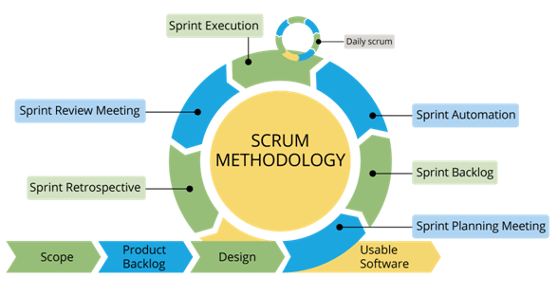

When comparing scum to XP I see Xp’s shorter iterations with smaller deliverables to be more suitable to my timeframe as it promotes faster and more manageable workloads.

## 3.3. Overview of System

Include a diagram

## 3.4. Front-End

Including screen prototypes and Use Cases

## 3.5. Middle-Tier

## 3.6. Back-End

Including ERDs, and maybe ISDs

## 3.7. Conclusions

# 4. Experiment Development

## 4.1. Introduction

## 4.2. Software Development

## 4.3. Front-End

## 4.4. Middle-Tier

## 4.5. Back-End

## 4.6. Conclusions

# 5. Testing and Evaluation

## 5.1. Introduction

## 5.2. System Testing

## 5.3. System Evaluation

## 5.4. Conclusions

# 6. Conclusions and Future Work

## 6.1. Introduction

## 6.2. Conclusions

## 6.3. Future Work

# Bibliography