Response: We thank the reviewer for these suggestions. In response we have conducted three separate analyses: first, we evaluated the methodology of using symbolic regression on a new similarity-separated benchmark split. Then, we compared the original frozen expressions with individual metrics on the original test set and a new similarity-based split. Lastly, we evaluated the frozen equations against newly fetched experimental affinities.

To assess the methodology of using symbolic regression compared with ipTM, PAE and dG individually as well as a naive baseline score in which the three metrics are multiplied together (called the default score), we first created a new homology-aware split. Briefly, samples were grouped by receptor sequence homology (≥30% identity, ≥80% coverage of either sequence, E-value ≤ 0.001), or peptide global edit similarity ≥0.8. Connected groups, including decoys, could not cross the fitting/test boundary. The fitting set contained 488 real complexes and 434 synthetic decoys; the test set contained 129 real complexes and 94 decoys.

We fitted regression (denoted as R) and classification (denoted as C) expressions using AlphaFold descriptors, Boltz descriptors, or both. Fitting and scaling used only the fitting set. Overall, the regression expressions had higher Pearson correlation with log-affinity than the tested single-metric baselines and the naive combination in all three settings. For classification, AlphaFold expressions performed similarly to ipTM and negative peptide pAE while most Boltz and combined expressions improved on the corresponding baselines. This shows that the general methodology of creating expressions is sound, even on a more strict homology-aware split.

Feature set | Pearson r across nonconstant R expressions | Highest single-metric Pearson r | AUROC across C expressions | Highest single-metric AUROC
AlphaFold | 0.515–0.548 | 0.479 | 0.823–0.830 | 0.826
Boltz | 0.500–0.570 | 0.318 | 0.836–0.860 | 0.841
Combined | 0.513–0.560 | 0.479 | 0.829–0.881 | 0.841

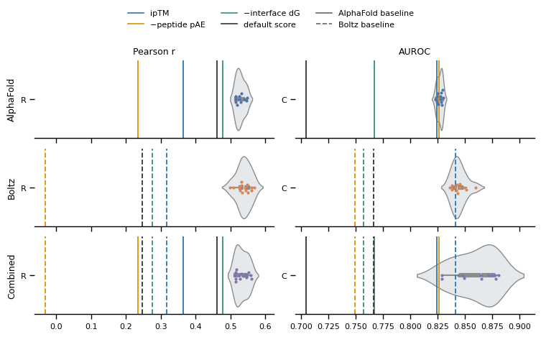
Figure: Evaluation of symbolic regression on a homology-aware test split. Rows show expressions using AlphaFold, Boltz or combined descriptors. Each point represents a final expression from the corresponding search, with violins showing their performance distribution. Pearson correlation is evaluated on 129 real complexes; AUROC uses these complexes and 94 synthetic decoys. Vertical lines show ipTM, negative peptide PAE, negative interface dG and the default score, ipTM * PAE * (−dG). Solid and dashed lines denote AlphaFold and Boltz baselines, respectively.

Then, we compared the frozen v2 expressions with the suggested metrics (ipTM, PAE and dG) on the regression and classification tasks separately. We show the AlphaFold, Boltz and Combined equations separately. For regression we show both the R-expression and RxC (regression multiplied by classification), and for classification we show C and RxC. We also show the default score for each model. As can be seen in the figures below, the R-expressions had higher correlation with experimental log-affinity than the individual metrics and the default score. Pearson r was 0.52, 0.47 and 0.51 for AlphaFold, Boltz and Combined, respectively. For classification, C and RxC performed similarly, with AUROC around 0.93, 0.88 and 0.92 for the three model settings. The differences from ipTM and negative peptide PAE were often modest, particularly for AlphaFold.

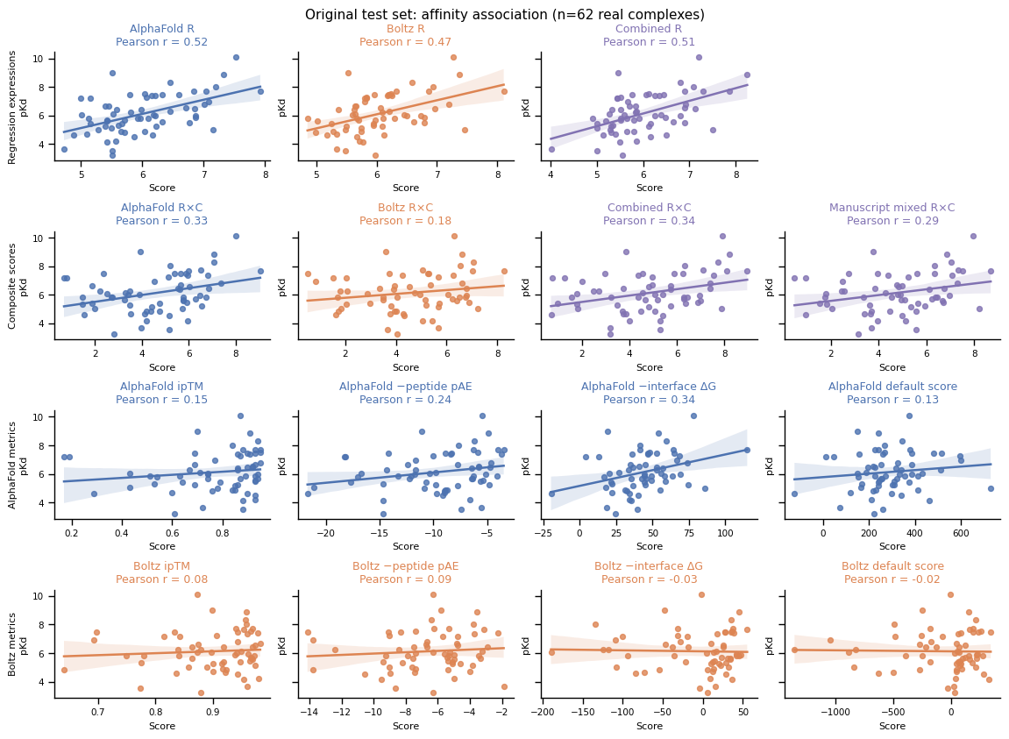
Figure: Frozen R and RxC expressions compared with AlphaFold and Boltz metrics on 62 real complexes. Lines show linear regression with 95% bootstrap confidence bands.

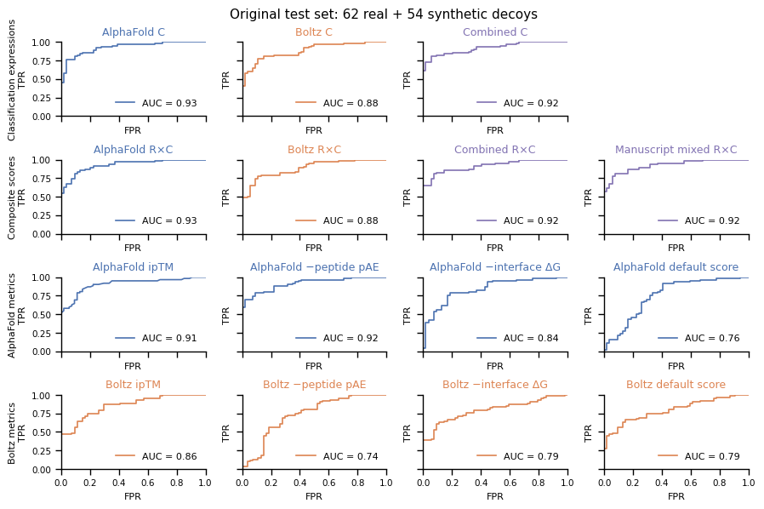
Figure: Classification performance for 62 real complexes and 54 synthetic decoys. C and RxC are compared with the individual metrics and default score from each model.

Lastly, we evaluated the frozen equations against independent experimental affinities. We fetched 53 receptor–peptide pairs across 16 targets from Madhu et al. (2026, https://doi.org/10.64898/2026.07.03.735260), which was published after the reported structural training cutoffs of both models. The affinities were measured using fluorescence polarization and converted to pKd. Complexes were predicted from receptor templates and peptide sequences without experimental complex poses or binding-site information, i.e., slightly differing from the evaluation presented in the manuscript where we require a template structure and known binding site. One prediction with an extreme computed AlphaFold interface energy was excluded from the primary figure, leaving 52 pairs.

On this dataset, the v2 R-expressions gave Pearson r = 0.54, 0.54 and 0.55 for AlphaFold, Boltz and Combined, respectively. For comparison, ipTM gave r = 0.49 for AlphaFold and 0.54 for Boltz. The corresponding v2 RxC expressions gave r = 0.33, 0.48 and 0.38, while the original manuscript mixed RxC score gave r = 0.40. Thus, the R-expressions retained affinity correlation on independent measurements, but did not consistently improve on ipTM. Multiplying R by C did not improve the affinity correlation for these v2 expressions. This cohort contains affinity measurements but no experimental negative class, so it supports affinity comparisons rather than a separate classification benchmark.

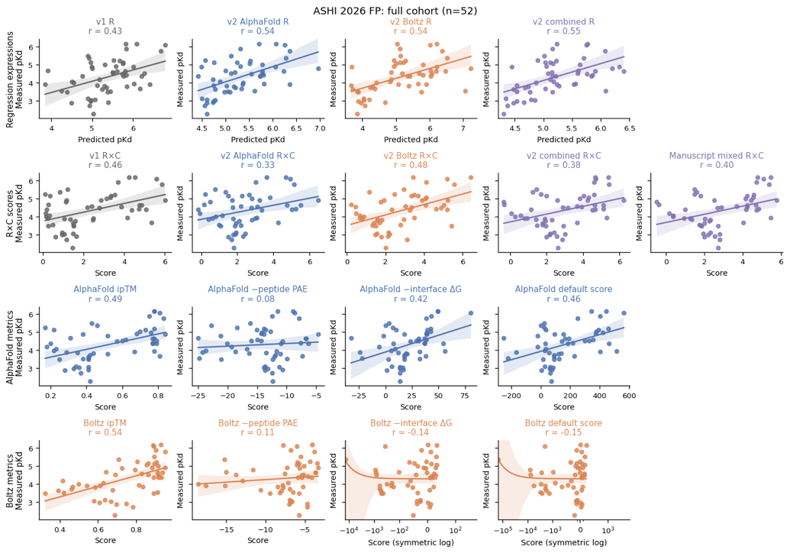
Figure: Frozen R and RxC expressions and metric baselines on 52 external complexes. Lines show linear regression with 95% bootstrap confidence bands. The Boltz energy and default-score panels use symmetric-log axes for display; fits and Pearson correlations use the raw scores.

Removing pairs with similar peptides or targets in the original equation-development data, using the same similarity criteria defined above, left just 11 complexes across five targets. The AlphaFold, Boltz and Combined R-expressions gave Pearson r = 0.81, 0.79 and 0.80, respectively.

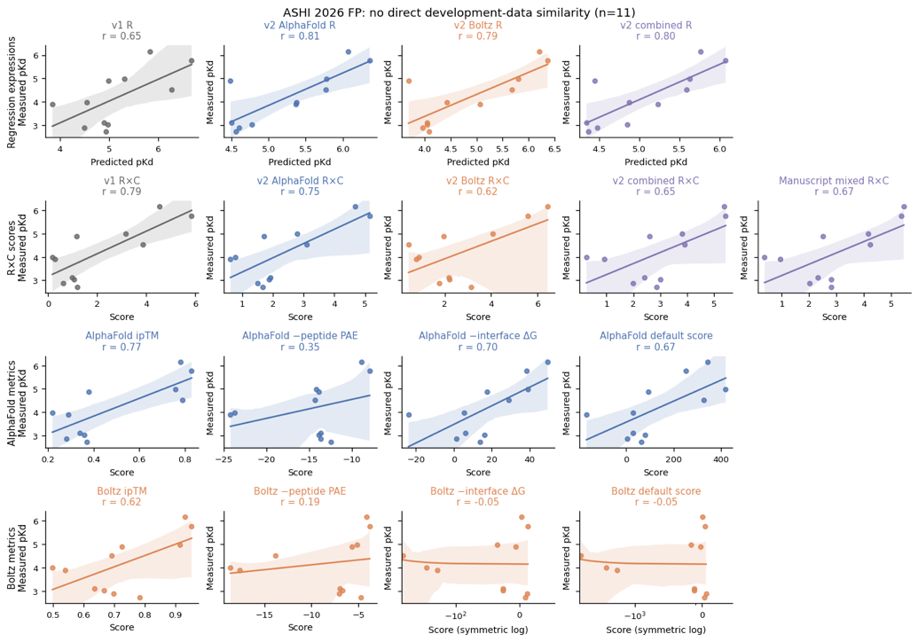
Figure: External subset without qualifying direct similarity to the original equation-development data, n = 11. Lines show linear regression with 95% bootstrap confidence bands.

Overall, these analyses show that the general methodology of creating an equation from structural and confidence metrics can outperform single metrics and naïve combinations, including on a stricter homology-aware split. The frozen equations also retained correlations with independent experimental affinities, although ipTM performed comparably and RxC did not consistently improve on R alone. We want to clarify that our intention was to derive a single objective in a data-driven manner, with the combination of variables determined by the data. We will make this purpose clear in the manuscript and describe the score as an objective for candidate prioritization, with performance depending on the task and dataset.

