Reviewer #4 (Remarks to the Author):

The authors have clarified that the composite objective is intended for candidate prioritization rather than quantitative affinity prediction. However, its generalizability and added value over simpler scoring metrics remain insufficiently established. I suggest two complementary evaluations: (i) construct a held-out subset of the existing benchmark by excluding complexes similar to the training structures of the exact AlphaFold2-Multimer and Boltz checkpoints used, with explicit similarity criteria and reporting of retained sample sizes and performance before and after filtering; and (ii) evaluate the frozen objective on independent peptide–protein binding measurements published after the relevant model-specific training cutoffs. The latter does not require experimentally resolved complex structures: complexes can be predicted from sequences, and their scores compared with experimental binding affinities.

On these held-out sets, please compare the composite objective with single-metric baselines, including ipTM alone, negative peptide pAE, and interface energy alone, reporting both discrimination and affinity-ranking performance where appropriate. This would establish whether combining the classification and affinity expressions provides incremental value beyond the individual metrics. Neither test set should be used for feature selection, objective selection, or tuning.

Response: We thank the reviewer for these suggestions. In response we have conducted three separate analyses: first, we evaluated the methodology of using symbolic regression on a new similarity-separated benchmark split. Then, we compared the original frozen expressions with individual metrics on the original test set and a new similarity-based split. Lastly, we evaluated the frozen equations against newly fetched experimental affinities.

To assess the methodology of using symbolic regression compared with ipTM, PAE and dG individually as well as a naive baseline score in which the three metrics are multiplied together (called the default score), we first created a new homology-aware split. Briefly, samples were grouped by receptor sequence homology (≥30% identity, ≥80% coverage of either sequence, E-value ≤ 0.001), or peptide global edit similarity ≥0.8. Connected groups, including decoys, could not cross the fitting/test boundary. The fitting set contained 488 real complexes and 434 synthetic decoys; the test set contained 129 real complexes and 94 decoys.

We fitted regression (denoted as R) and classification (denoted as C) expressions using AlphaFold descriptors, Boltz descriptors, or both. Fitting and scaling used only the fitting set. Overall, the regression expressions had higher Pearson correlation with log-affinity than the tested single-metric baselines and the naive combination in all three settings. For classification, AlphaFold expressions performed similarly to ipTM and negative peptide pAE while some Boltz and combined expressions improved on the corresponding baselines. This shows that the general methodology of creating expressions is sound, even on a more strict homology-aware split.

Feature set | Pearson r across nonconstant R expressions | Highest single-metric Pearson r | AUROC across C expressions | Highest single-metric AUROC
AlphaFold | 0.515–0.548 | 0.479 | 0.823–0.830 | 0.826
Boltz | 0.500–0.570 | 0.318 | 0.836–0.860 | 0.841
Combined | 0.513–0.560 | 0.479 | 0.829–0.881 | 0.841

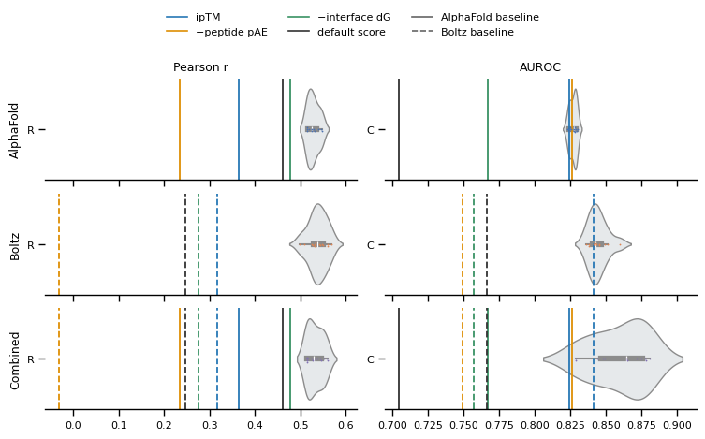
Figure:

Then, we compared the frozen expressions with the suggested metrics (ipTM, PAE, dG) on the regression and classification tasks separately. We show the AlphaFold, Boltz and Combined equations separately. For regression we show both just the R-expression and the combined RxC (regression multiplied by classification) expressions, and for classification we show C and RxC. We separate the metrics for AlphaFold and Boltz, and create a “default score” which is a naively created combined score where we multiply iPTM, PAE and dG together. As can be seen in the figures below, the equations

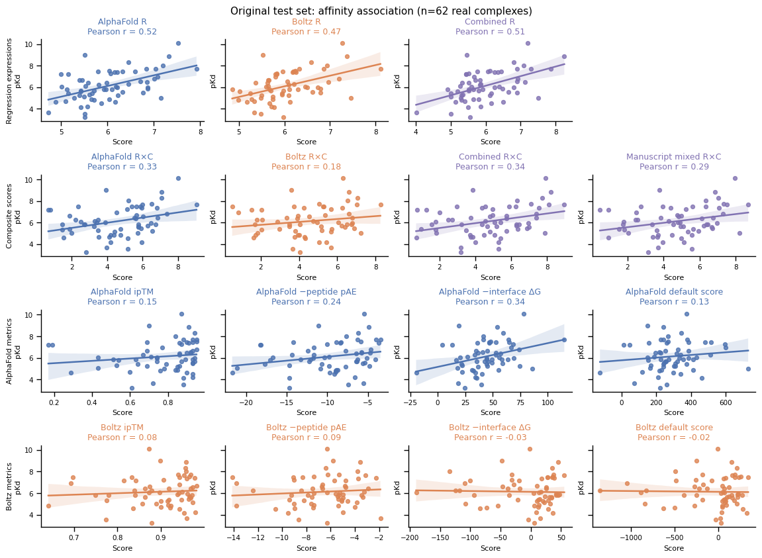
Figure:

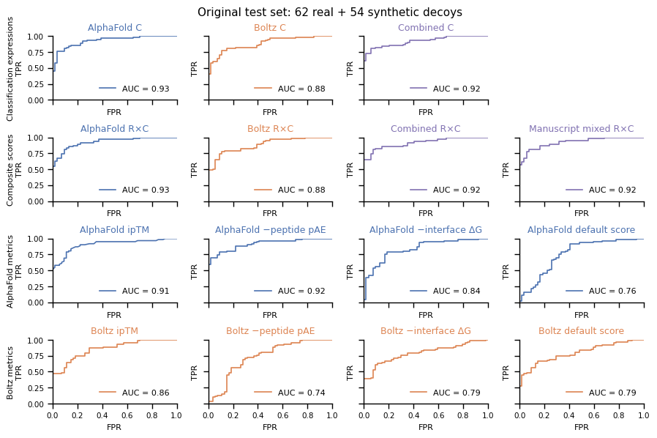
Figure:

Lastly, we evaluated frozen equations against independent experimental affinities. We fetched 53 receptor–peptide pairs across 16 targets from Madhu et al. (2026). This study contains structures not included in the training set of either model. Complexes were predicted from receptor templates and peptide sequences without experimental complex poses or binding-site information, i.e., slightly differing from the evaluation presented in the manuscript.

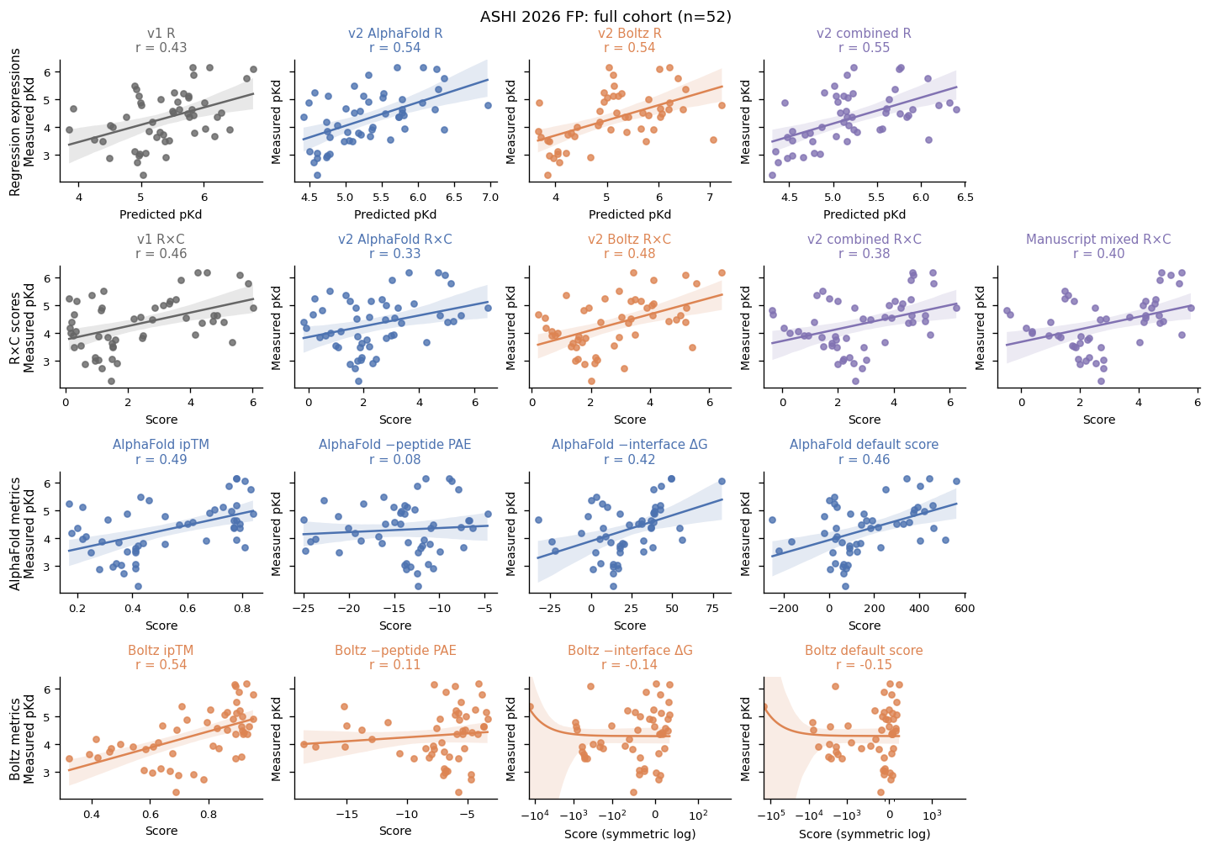
Figure. Regression expressions and metric baselines on the primary external panel, n = 52. Classification and composite statistics are reported in the text above.

Removing all similar peptides or targets using the same similarity metrics defined previously resulted in just 11 complexes being left, and while this is a small sample size, the general trends seen in the complete cohort remained.
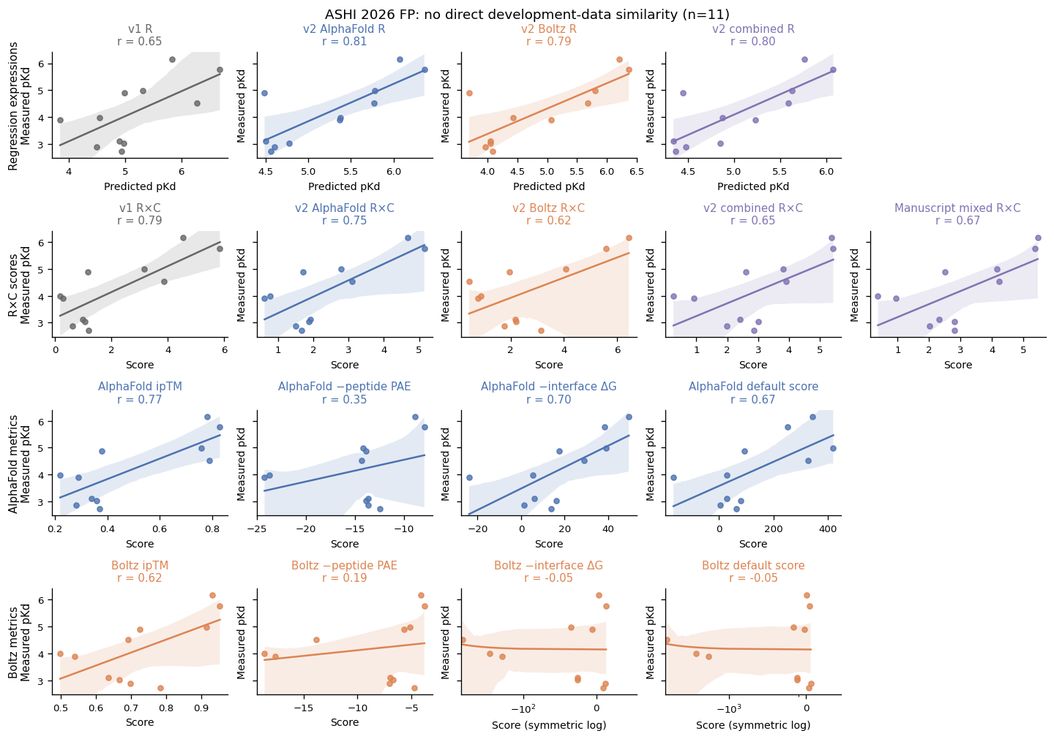
Figure: External subset without direct similarity to equation-development data, n = 11.

Overall, this analysis shows that the general methodology of creating an equation using metrics can outperform single metrics and naïve baselines. We want to clarify that our intention was to derive a single objective in a data-driven manner, instead of selecting an arbitrary combination of variables.

