Response: We thank the reviewer for these suggestions. In response we have conducted three separate analyses: first, we evaluated the methodology of using symbolic regression on a new similarity-separated benchmark split. Then, we compared the original frozen expressions with individual metrics on the original test set and a new similarity-based split. Lastly, we evaluated the frozen equations against newly fetched experimental affinities.

To assess the methodology of using symbolic regression compared with ipTM, PAE and dG individually as well as a naive baseline score in which the three metrics are multiplied together (called the default score), we first created a new homology-aware split. Briefly, samples were grouped by receptor sequence homology (≥30% identity, ≥80% coverage of either sequence, E-value ≤ 0.001), or peptide global edit similarity ≥0.8. Connected groups, including decoys, could not cross the fitting/test boundary.

We fitted regression (denoted as R) and classification (denoted as C) expressions using AlphaFold descriptors, Boltz descriptors, or both. Fitting and scaling used only the fitting set. Overall, the regression expressions had higher Pearson correlation with log-affinity than the tested single-metric baselines and the naive combination in all three settings. For classification, AlphaFold expressions performed similarly to ipTM and negative peptide pAE while most Boltz and combined expressions improved on the corresponding baselines. This shows that the general methodology of creating expressions is sound, even on a more strict homology-aware split.

Feature set | Pearson r across nonconstant R expressions | Highest single-metric Pearson r | AUROC across C expressions | Highest single-metric AUROC
AlphaFold | 0.515–0.548 | 0.479 | 0.823–0.830 | 0.826
Boltz | 0.500–0.570 | 0.318 | 0.836–0.860 | 0.841
Combined | 0.513–0.560 | 0.479 | 0.829–0.881 | 0.841

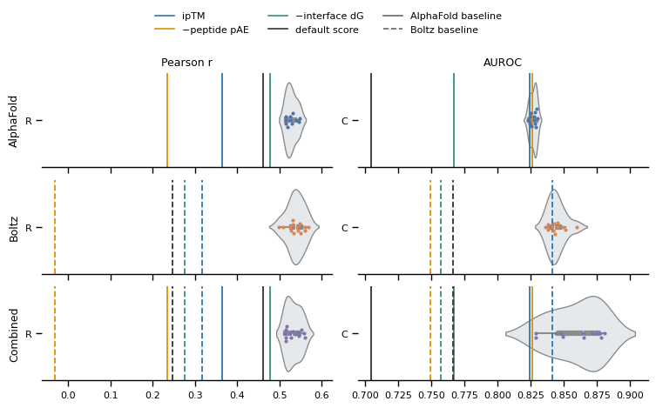
Figure: Evaluation of symbolic regression on a homology-aware test split. Rows show expressions using AlphaFold, Boltz or combined descriptors. Each point represents a final expression from the corresponding search, with violins showing their performance distribution. Pearson correlation is evaluated on 129 real complexes; AUROC uses these complexes and 94 synthetic decoys. Vertical lines show ipTM, negative peptide PAE, negative interface dG and the default score, ipTM * PAE * (−dG). Solid and dashed lines denote AlphaFold and Boltz baselines, respectively.

Then, we compared the frozen v2 expressions with the suggested metrics (ipTM, PAE and dG) on the regression and classification tasks separately. We show the AlphaFold, Boltz and Combined equations separately. For regression we show both the R-expression and RxC (regression multiplied by classification), and for classification we show C and RxC. We also show the default score for each model. As can be seen in the figure below, the R-expressions had higher correlation with experimental log-affinity than the individual metrics and the default score. Pearson r was 0.52, 0.47 and 0.51 for AlphaFold, Boltz and Combined, respectively. For classification, C and RxC performed similarly, with AUROC around 0.93, 0.88 and 0.92 for the three model settings. The differences from ipTM and negative peptide PAE were often modest, particularly for AlphaFold.

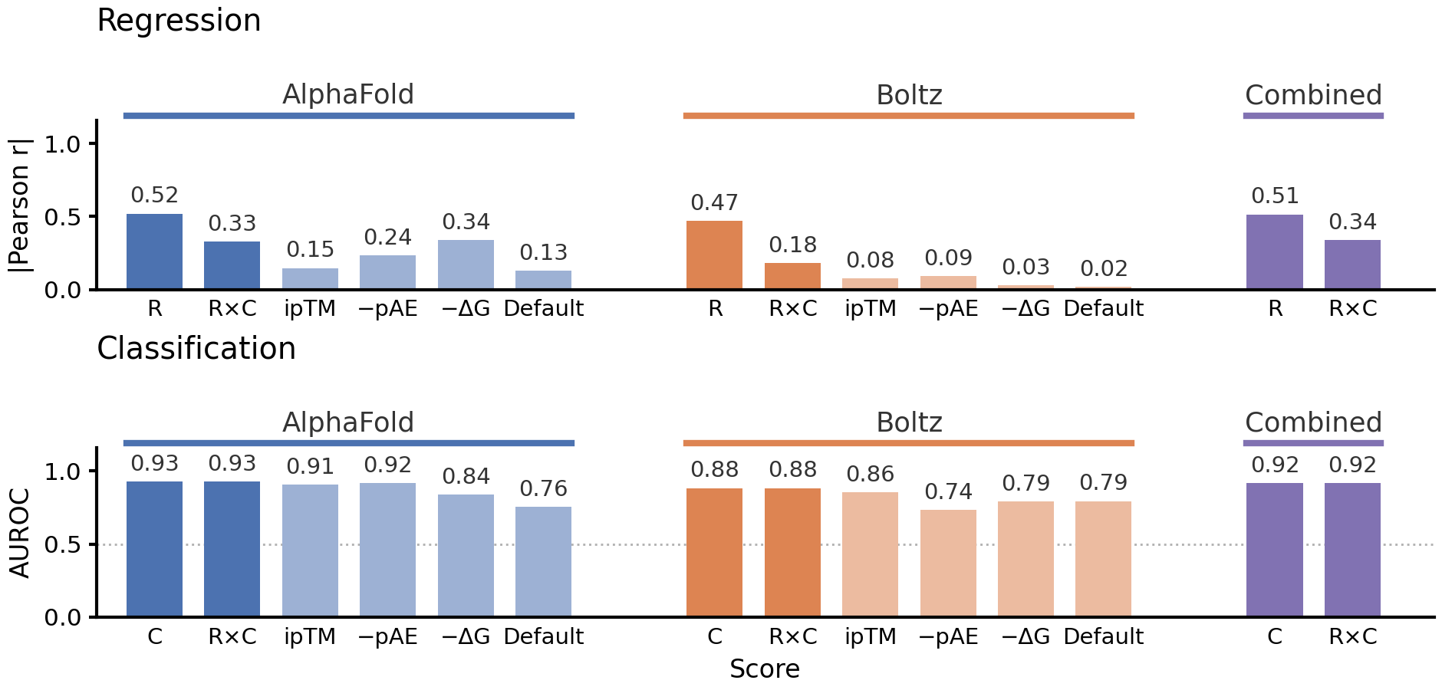
Figure: Frozen R, C and RxC expressions compared with metric baselines on the original test set. Top: absolute Pearson r for R and RxC on 62 real complexes. Bottom: AUROC for C and RxC on these complexes and 54 synthetic decoys. Dark bars show equations and lighter bars show individual metrics and the default score.

Lastly, we evaluated the frozen equations against independent experimental affinities. We fetched 53 receptor–peptide pairs across 16 targets from Madhu et al. (2026, https://doi.org/10.64898/2026.07.03.735260), which was published after the reported structural training cutoffs of both models. The affinities were measured using fluorescence polarization and converted to pKd. Complexes were predicted from receptor templates and peptide sequences without experimental complex poses or binding-site information, i.e., slightly differing from the evaluation presented in the manuscript where we require a template structure and known binding site. One prediction with an extreme computed AlphaFold interface energy was excluded from the primary figure, leaving 52 pairs. On this dataset, we could only compare the regression equations since there are no non-binders. Overall, the equations outperformed or matches the individual metrics. It always improved on the default naïve score.

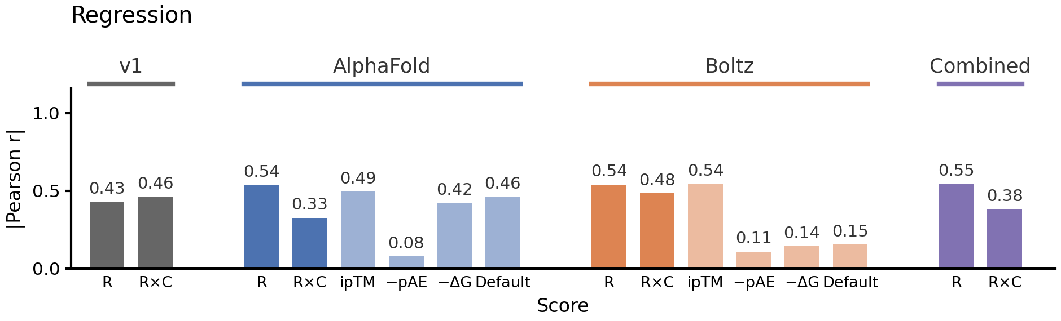
Figure: Absolute Pearson r for frozen R and RxC expressions and metric baselines on 52 external complexes. Bars are grouped by predictor. Dark bars show equations; lighter bars show individual metrics and the default score.

Removing pairs with similar peptides or targets in the original equation-development data left just 11 complexes across five targets. The AlphaFold, Boltz and Combined R-expressions gave Pearson r = 0.81, 0.79 and 0.80, respectively.

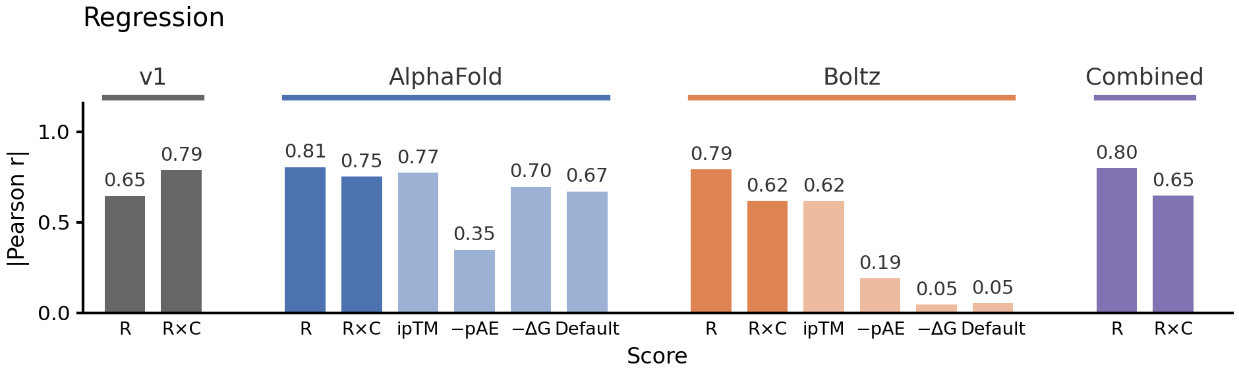
Figure: The same comparison for the external subset without qualifying direct similarity to the original equation-development data, n = 11. Bars show absolute Pearson r.

Overall, these analyses show that the general methodology of creating an equation from structural and confidence metrics can outperform single metrics and naïve combinations, including on a stricter homology-aware split. The frozen equations also retained correlations with independent experimental affinities, although ipTM performed comparably and RxC did not consistently improve on R alone. We want to clarify that our intention was to derive a single objective in a data-driven manner, with the combination of variables determined by the data. We will make this purpose clear in the manuscript and describe the score as an objective for candidate prioritization, with performance depending on the task and dataset.

