The authors have clarified that the composite objective is intended for candidate prioritization rather than quantitative affinity prediction. However, its generalizability and added value over simpler scoring metrics remain insufficiently established. I suggest two complementary evaluations: (i) construct a held-out subset of the existing benchmark by excluding complexes similar to the training structures of the exact AlphaFold2-Multimer and Boltz checkpoints used, with explicit similarity criteria and reporting of retained sample sizes and performance before and after filtering; and (ii) evaluate the frozen objective on independent peptide–protein binding measurements published after the relevant model-specific training cutoffs. The latter does not require experimentally resolved complex structures: complexes can be predicted from sequences, and their scores compared with experimental binding affinities.

On these held-out sets, please compare the composite objective with single-metric baselines, including ipTM alone, negative peptide pAE, and interface energy alone, reporting both discrimination and affinity-ranking performance where appropriate. This would establish whether combining the classification and affinity expressions provides incremental value beyond the individual metrics. Neither test set should be used for feature selection, objective selection, or tuning.

Internal: I don’t want to convey that superiority is key. Other papers use these metrics (dG, ipTM, PAE, etc) to filter, however, there is rarely a rational besides that these should be optimized. To create a single score and in a data-driven way identify what that score should be, we used symbolic regression. It turns out that it tends to use these already known metrics. On the external validation dataset, we don’t outperform ipTM – that’s fine. It remains that the field uses more things than just ipTM. We will clarify this in the manuscript (this is a very small part of manuscript and is in the supplementary). Overall, we do see however, that using symbolic regression to combine metrics can outperform.

Response: We thank the reviewer for these suggestions. In response we have conducted several experiments as suggested.

First, we evaluated the methodology of using symbolic regression with available metrics to identify a score, and compared it with ipTM, peptide PAE, interface dG. This was done on a new split with no overlapping targets or peptides with the training set. The results from a single search can be seen below. Each scatter represents an identified equation and these are compared on both the regression and classification task with the aforementioned metrics of the respective models (AlpahFold2 Multimer top, Boltz-2 middle, and both models bottom). The equations consistently outperform all basic metrics on the regression task across all three model settings. For classification, ipTM and peptide PAE perform comparably using AlphaFold2, while ipTM performs comparably with Boltz-2. Using metrics from both models, the equations outperform metrics.

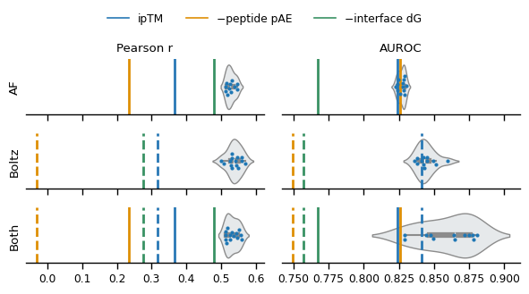
Second,

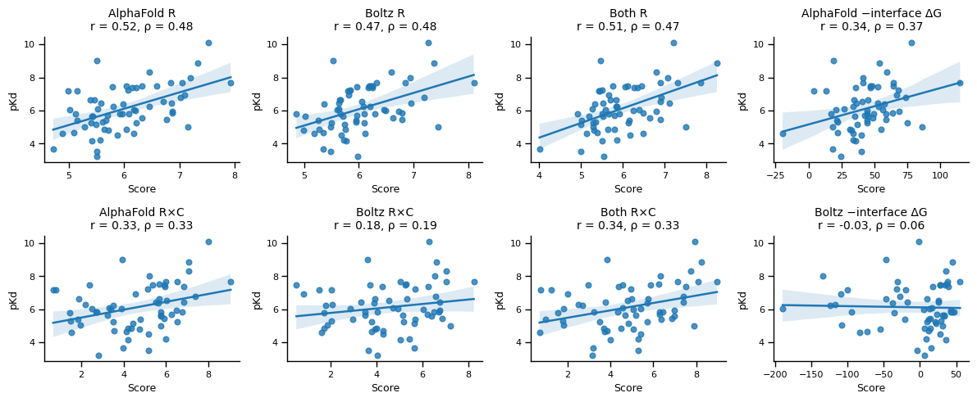

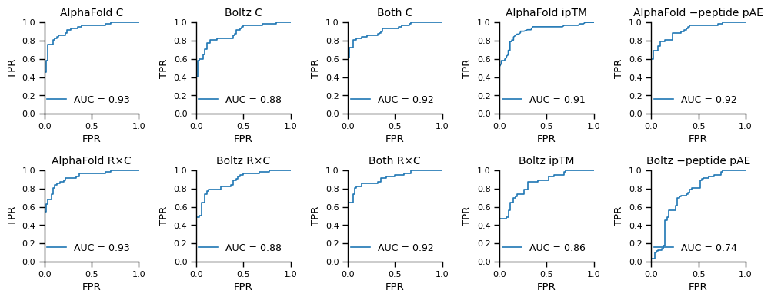

We also show metrics after just …

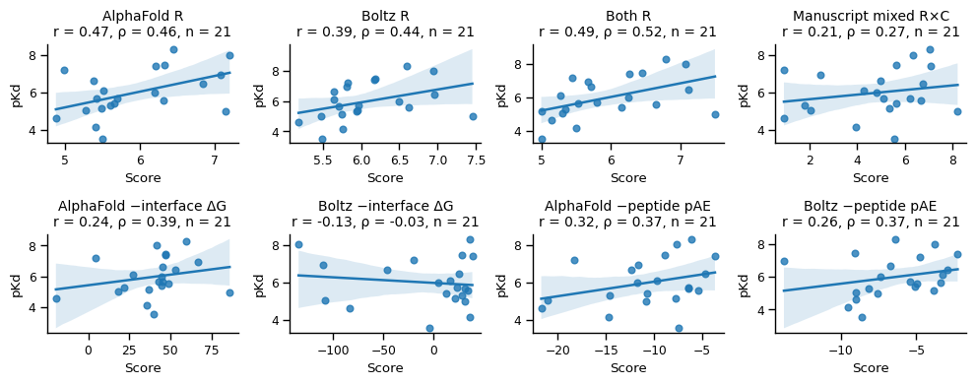
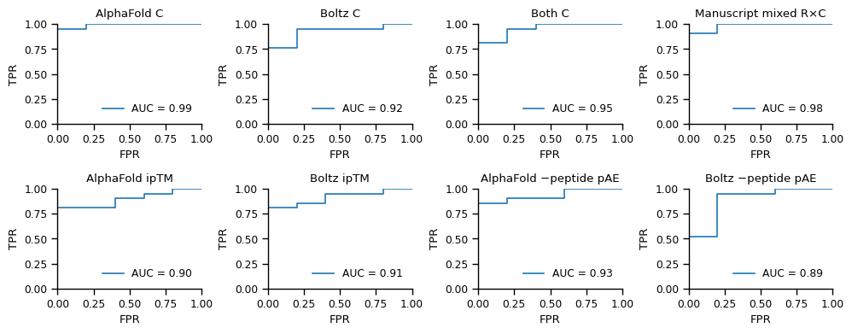

Lastly, [EXTERNAL VALIDATION METHOD AND RESULTS]

Overall,

